Vastu/Nashik/06/32014/2301224
22/20-325-RPV
Date: 15.03.2023

To,
The Branch Manager,
Union Bank of India
RLP Nashik Branch
Nawandar Sankul, 1366, Racca Colony, Near Soni Paithani, Sharanpur Road,
Nashik – 422 002, State – Maharashtra, Country – India.

Sub: Vetting of Supplementary Agreement

Sir,

With reference to above subject, we have evaluated the Vetting of Supplementary Agreement for Residential Flat No. A-502, 5th Floor, A-Wing, “Akshar Vishwa”, Survey No. 197 / 1 to 10(P) /198/ 199/ 1/ 200(P)/ 201, Plot No. 161 to 166 & 179 to 184, Near Audumber Banquet & Lawns, Village - Mhasrul, Meri- Rasbihari Link Road, Taluka & District - Nashik, PIN - 422 004, State - Maharashtra, Country – India belongs to Mr. Gajanan Namdeo Surywanshi & Mrs. Nayana Gajanan Surywanshi.

We have verified the rates quoted as per current market rates. Details of Vetting of Supplementary Agreement considered as per copy of Vetting of Supplementary Agreement between Mr. Gajanan Namdeo Surywanshi & Mrs. Nayana Gajanan Surywanshi (First Party). Mr. Pankaj Pravin Bhai Pokar (Second Party) received on dated March 2024. The Vetting of Supplementary Agreement amount is Rs. 5,00,000/- (Rupees Five Lakh Only)

The said Cost Vetting Certificate is valid upto next 6 months Only.

Thanking you

Sincerely yours

Sharadkumar B. Chalikwar
Govt. Reg. Valuer
Chartered Engineer (India)
Reg. No. (N) CCIT/1-14/52/2008-09

Vetting of Supplementary Agreement
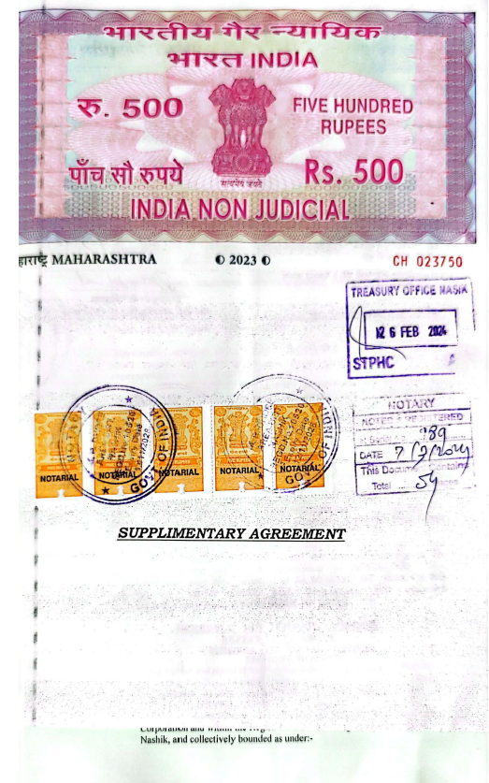
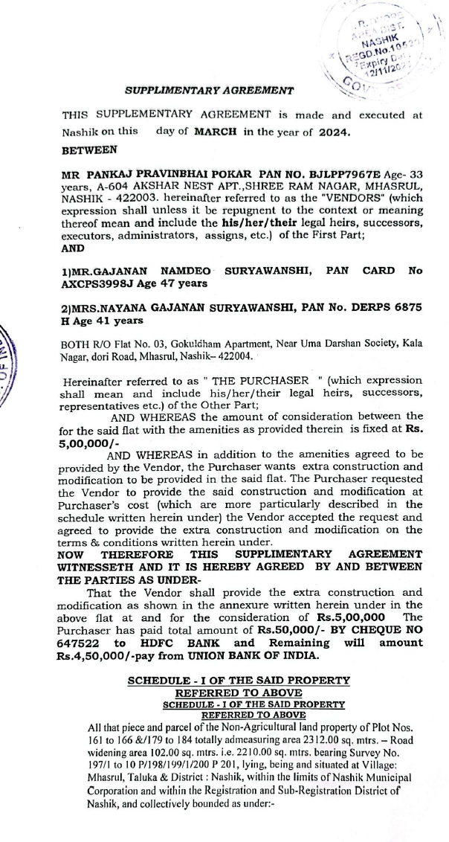

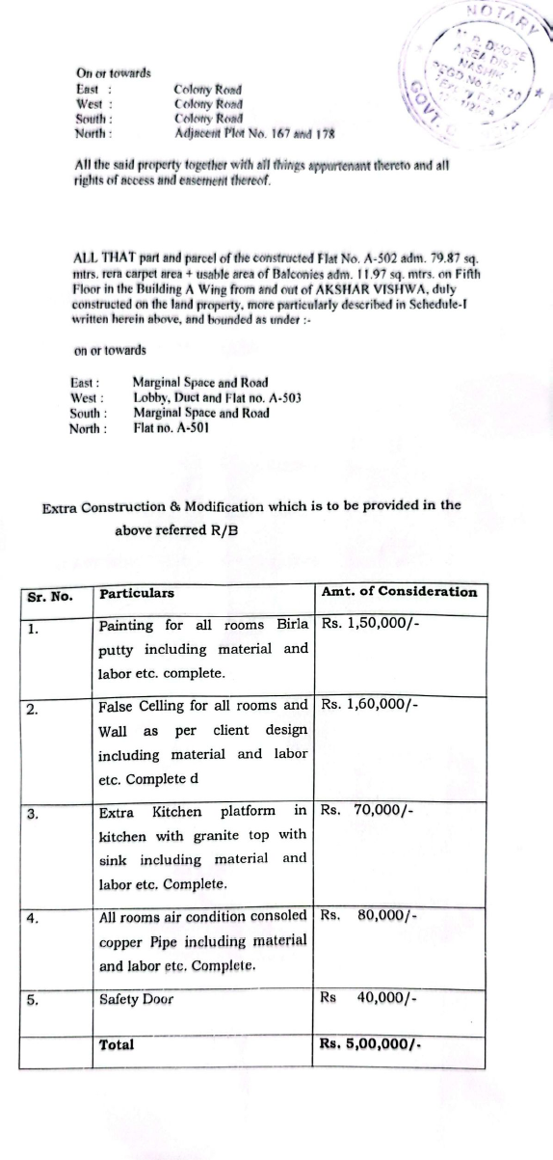
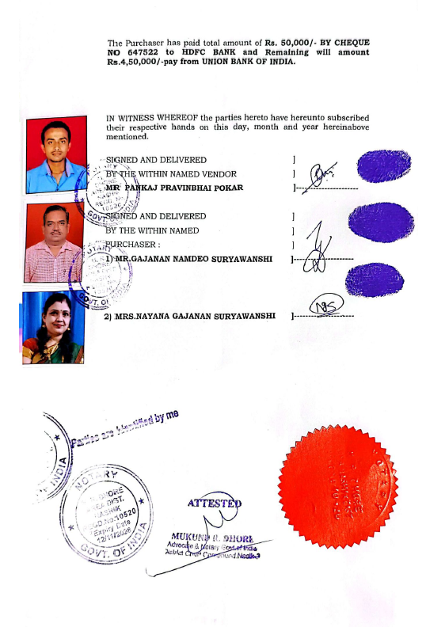

The Vetting of Supplementary Agreement amount is Rs. 5,00,000/- (Rupees Five Lakh Only)

