Valuation Report of the Immovable Property
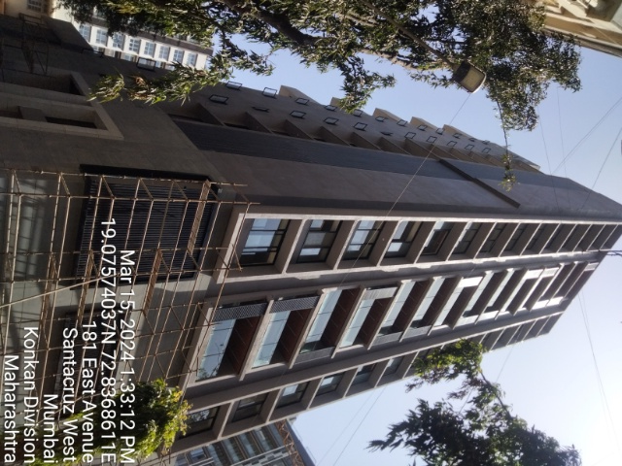

Details of the property under consideration:

Name of Client : Mr. Ankur Kashyap Shah (Flat No. 701) &
Kashmita Corporation (Flat No. 702)

Residential Flat No. 701 (erstwhile Flat No. 1 & 2 as per Development Agreement), 7th Habitable Floor, “Platina”, East Avenue (Sharadchandra Chatterjee Road), Santacruz (West), Mumbai – 400 054,
State – Maharashtra, Country – India

Latitude Longitude: 19°04'31.8"N 72°50'12.5"E

Intended User:

Private Valuation

Vastu/Mumbai/03/2024/7687/2305626
19/26-374-VSU
Date: 19.03.2024

VALUATION OPINION REPORT

This is to certify that the property bearing Residential Flat No. 701 (erstwhile Flat No. 1 & 2 as per Development Agreement), 7th Habitable Floor, “Platina”, East Avenue (Sharadchandra Chatterjee Road), Santacruz (West), Mumbai – 400 054, State – Maharashtra, Country – India belongs to Mr. Ankur Kashyap Shah (Flat No. 701) & Kashmita Corporation (Flat No. 702).

Boundaries of the property.

North | : | Casa Bianca
South | : | Avanti Society
East | : | East Ave Road
West | : | Villa Velloze
Considering various parameters recorded, existing economic scenario, and the information that is available with reference to the development of neighborhood and method selected for valuation, we are of the opinion that, the property premises can be assessed for Government Value as on possession date i.e. 21.02.2024 at ` 7,17,34,466.00 (Rupees Seven Crore Seventeen Lakh Thirty Four Thousand Four Hundred Sixty Six Only).

The valuation of the property is based on the documents produced by the concern. Legal aspects have not been taken into considerations while preparing this valuation report.

Hence certified

For Vastukala Architects & Engineers

Sharadkumar B. Chalikwar
Govt. Reg. Valuer
Chartered Engineer (India)
Reg. No. (N) CCIT/1-14/52/2008-09
Encl: Valuation report.
VALUATION REPORT (IN RESPECT OF FLAT)
I | General
1. | Purpose for which the valuation is made |  |  | : | To assess Government Value as on possession date i.e. 21.02.2024 of the property.
2. | a) | Date of inspection |  | : | 15.03.2024
 | b) | Date on which the valuation is made |  | : | 19.03.2024
3. | List of documents produced for perusal:  - Copy of Agreement (Permanent Alternate Accommodation) dated 27.05.2021 between M/s. P. R. Landmarks LLP (Developer) and Mr. Ankur Kashyap Shah (Member) – Flat No. 701  - Copy of Agreement (Permanent Alternate Accommodation) dated 27.05.2021 between M/s. P. R. Landmarks LLP (Developer) and Kashmita Corporation (Member - Flat No. 702  - Copy of Possession Letter dated 21.02.2024 in the name of Mr. Ankur Shah & Kashmita Corporation issued by P. R. Landmarks LLP - Residential Flat No. 701 (erstwhile Flat No. 1 & 2 as per Development Agreement)  - Copy of Occupancy Certificate vide No. CHE / WS / 0924 / H / 337 (New) / OCC / 1 / New of 20.02.2024 issued by MCGM.
4. | Name of the owner(s) and his / their address (es) with Phone no. (details of share of each owner in case of joint ownership) |  |  | : | Mr. Ankur Kashyap Shah (Flat No. 701) &  Kashmita Corporation (Flat No. 702)  Address: Residential Flat No. 701 (erstwhile Flat No. 1 & 2 as per Development Agreement), 7th Habitable Floor, “Platina”, East Avenue (Sharadchandra Chatterjee Road), Santacruz (West), Mumbai – 400054, State – Maharashtra, Country – India  Contact Person:  Mr. Ankur Shah (Owner)  Mobile No.: 98197 00700  Joint ownership  Details of share of each owner not available.
5. | Brief description of the property (Including Leasehold / freehold etc.) |  |  | : | The property is a Residential flat is located on 7th Habitable Floor. The composition of Residential Flat No. 701 (erstwhile Flat No. 1 & 2 as per Development Agreement) is 4 Bedrooms + Living Room + Kitchen + Passage + 4 WC - Bath (i.e. 4 BHK). Finishing work of the building was in progress. It is at 850 M. travel distance from Khar railway station.
6. | Location of property |  |  | :
 | a) |  | Plot No. / Survey No. | : | Plot No. 17
 | b) |  | Door No. | : | Residential Flat No. 701 (erstwhile Flat No. 1 & 2 as per Development Agreement)
 | c) |  | C.T.S. No. / Village | : | CTS No. G/516, Village Bandra
 | d) |  | Ward / Taluka | : | Taluka – Andheri
 | e) |  | Mandal / District | : | District – Mumbai Suburban
 | f) |  | Date of issue and validity of layout of approved map / plan. | : | As Occupancy Certificate is available it is assumed that the construction is as per Sanctioned Plan.
 | g) |  | Approved map / plan issuing authority | :
 | h) |  | Whether genuineness or authenticity of approved map/ plan is verified | :
 | i) |  | Any other comments by our empanelled valuers on authentic of approved plan
7. | Postal address of the property |  |  | : | Residential Flat No. 701 (erstwhile Flat No. 1 & 2 as per Development Agreement), 7th Habitable Floor, “Platina”, East Avenue (Sharadchandra Chatterjee Road), Santacruz (West), Mumbai – 400 054, State – Maharashtra, Country – India
8. | City / Town |  |  | : | Mumbai
 | Residential area |  |  | : | Yes
 | Commercial area |  |  | : | No
 | Industrial area |  |  | : | No
9. | Classification of the area |  |  | :
 | i) High / Middle / Poor |  |  | : | High Class
 | ii) Urban / Semi Urban / Rural |  |  | : | Urban
10. | Coming under Corporation limit / Village Panchayat / Municipality |  |  | : | Village – Bandra G  Municipal Corporation of Greater Mumbai
11. | Whether covered under any State / Central Govt. enactments (e.g., Urban Land Ceiling Act) or notified under agency area/ scheduled area / cantonment area |  |  | : | No
12. | Boundaries of the property |  |  |  | As per Site | As per documents
 | North |  |  | : | Casa Bianca | CTS No. 517
 | South |  |  | : | Avanti Society | CTS No. 515
 | East |  |  | : | East Ave Road | CTS No. 514
 | West |  |  | : | Villa Velloze | By Road called East Avenue, now (Sharad Chandra Chatterjee Road), Santacruz West
13 | Dimensions of the site |  |  |  | N. A. as property under consideration is a flat in an apartment building.
 |  |  |  |  | A As per the Deed | B Actuals
 | North |  |  | : | - | -
 | South |  |  | : | - | -
 | East |  |  | : | - | -
 | West |  |  | : | - | -
14. | Extent of the site |  |  | :
Carpet Area in Sq. Ft. = 1,621.00
(Area as per actual site measurement of Flat No. 701 (erstwhile Flat No. 1 & 2 as per Development Agreement).

Area as per Agreement:
Flat No. | Carpet area (Sq. Ft.) | Carpet area (Sq. M.)
701 | 1,078.00 | 100.15
702 | 534.00 | 49.61
TOTAL | 1,612.00 | 149.76

Area as per Index II considered for valuation:

Flat No. | Built up area (Sq. M.) | Car parking (Nos.)
701 | 120.18 | S23 & P201
702 | 59.52 | S24
TOTAL | 179.70 | -

14.1 | Latitude, Longitude & Co-ordinates of Flat |  |  | : | 19°04'31.8"N 72°50'12.5"E
15. | Extent of the site considered for Valuation (least of 13A& 13B) |  |  | :
  Flat No. | Built up area (Sq. M.) | Car parking (Nos.)
  701 | 120.18 | S23, & P201
  702 | 59.52 | S24
  TOTAL | 179.70 | -
16 | Whether occupied by the owner / tenant? If occupied by tenant since how long? Rent received per month. |  |  | : | Vacant at the time of visit
II | APARTMENT BUILDING
 | Nature of the Apartment |  |  | : | Residential
 | Location |  |  | :
 | C.T.S. No. |  |  | : | CTS No. G/516, Village Bandra
 | Block No. |  |  | : | -
 | Ward No. |  |  | : | -
 | Village / Municipality / Corporation |  |  | : | Village – Bandra G  Municipal Corporation of Greater Mumbai
 | Door No., Street or Road (Pin Code) |  |  | : | Residential Flat No. 701 (erstwhile Flat No. 1 & 2 as per Development Agreement), 7th Habitable Floor, “Platina”, East Avenue (Sharadchandra Chatterjee Road), Santacruz (West), Mumbai – 400 054, State – Maharashtra, Country – India
 | Description of the locality Residential / Commercial / Mixed |  |  | : | Residential
 | Year of Construction |  |  | : | 2024 (As per Occupancy Certificate)
 | Number of Floors |  |  | : | Stilt + 1st and 2nd for Podium Parking + 1st to 12th and 14th + 15th (Part) upper floors (As per Occupancy Certificate)
 | Type of Structure |  |  | : | R.C.C. Framed Structure
 | Number of Dwelling units in the building |  |  | : | 1 Flat on 7th Floor
 | Quality of Construction |  |  | : | Good
 | Appearance of the Building |  |  | : | Good
 | Maintenance of the Building |  |  | : | Good
 | Facilities Available |  |  | :
 | Lift |  |  | : | 3 lifts and 2 Car lifts
 | Protected Water Supply |  |  | : | Municipal Water supply
 | Underground Sewerage |  |  | : | Connected to Municipal Sewerage System
 | Car parking - Open / Covered |  |  | : | Stilt and Podium
 | Is Compound wall existing? |  |  | : | Yes
 | Is pavement laid around the building |  |  | : | Yes
III | FLAT
1 | The floor in which the Flat is situated |  |  | : | 7th Habitable Floor
2 | Door No. of the Flat |  |  | : | Residential Flat No. 701 (erstwhile Flat No. 1 & 2 as per Development Agreement)
3 | Specifications of the Flat |  |  | :
 | Roof |  |  | : | R.C.C. Slab
 | Flooring |  |  | : | Italian Marble flooring
 | Doors |  |  | : | Teakwood door frame with MS shutters
 | Windows |  |  | : | Aluminum sliding window
 | Fittings |  |  | : | Concealed plumbing with C.P. fittings. Electrical wiring with Concealed.
 | Finishing |  |  | : | Cement Plastering
4 | House Tax |  |  | :
 | Assessment No. |  |  | : | Details not available
 | Tax paid in the name of: |  |  | : | Details not available
 | Tax amount: |  |  | : | Details not available
5 | Electricity Service connection No.: |  |  | : | Details not available
 | Meter Card is in the name of: |  |  | : | Details not available
6 | How is the maintenance of the Flat? |  |  | : | Good
7 | Sale Deed executed in the name of |  |  | : | Mr. Ankur Kashyap Shah (Flat No. 701) &  Kashmita Corporation (Flat No. 702)
8 | What is the undivided area of land as per Sale Deed? |  |  | : | Details not available
9 | What is the plinth area of the Flat? |  |  | :
  Flat No. | Built up area (Sq. M.) | Car parking  (Nos.)
  701 | 120.18 | S23, & P201
  702 | 59.52 | S24
  TOTAL | 179.70 | -
10 | What is the floor space index (app.) |  |  | : | As per MCGM norms
11 | What is the Carpet Area of the Flat? |  |  | : | Carpet Area in Sq. Ft. = 1,621.00  (Area as per actual site measurement of Flat No. 701 (erstwhile Flat No. 1 & 2 as per Development Agreement)  Area as per Agreement:
  Flat No. | Carpet area (Sq. Ft.) | Carpet area (Sq. M.)
  701 | 1,078.00 | 100.15
  702 | 534.00 | 49.61
  TOTAL | 1,612.00 | 149.76
12 | Is it Posh / I Class / Medium / Ordinary? |  |  | : | Posh class
13 | Is it being used for Residential or Commercial purpose? |  |  | : | Residential purpose
14 | Is it Owner-occupied or let out? |  |  | : | Vacant at the time of visit
IV | MARKETABILITY |  |  | :
1 | How is the marketability? |  |  | : | Good
2 | What are the factors favouring for an extra Potential Value? |  |  | : | Located in developed area
3 | Any negative factors are observed which affect the market value in general? |  |  | : | No
V | Rate |  |  | :
1 | Guideline rate obtained from the Registrar's office (an evidence thereof to be enclosed) |  |  | : | ` 3,64,560.00 per Sq. M.  As per Ready Reckoner Guidelines:  - The flat located from 5th to 10th floor should be increased by 5%  - 15% for Mechanical Car parking and 25% for Podium car parking of rate considered for flat.  Rate arrived at:  - Flat - ` 3,82,788.00 per Sq. M.  - Mechanical Stilt car parking – ` 57,418.00 per Sq. M.  - Podium car parking – ` 95,697.00 per Sq. M.
2 | Age of the building |  |  | : | Just completed (2024)
3 | Life of the building estimated |  |  | : | 60 years Subject to proper, preventive periodic maintenance & structural repairs.
 | Remarks:

Government value as on possession date i.e. 21.02.2024 of the property

Sr. No. | Description | Built up area (Sq. M.) | Rate per  Unit (`) | Estimated  Value (`)
 | Flat No. 701
 | Flat | 120.18 | 3,82,788.00 | 4,60,03,462.00
 | Mechanical car parking - S23 | 14.00 | 57,418.00 | 8,03,852.00
 | Podium car parking - P201 | 14.00 | 95,697.00 | 13,39,758.00
 | Flat No. 702
 | Flat | 59.52 | 3,82,788.00 | 2,27,83,542.00
 | Mechanical car parking - S24 | 14.00 | 57,418.00 | 8,03,852.00
 | GOVERNMENT VALUE |  |  | 7,17,34,466.00

For Vastukala Architects & Engineers

Sharadkumar B. Chalikwar
Govt. Reg. Valuer
Chartered Engineer (India)
Reg. No. (N) CCIT/1-14/52/2008-09
Actual site photographs
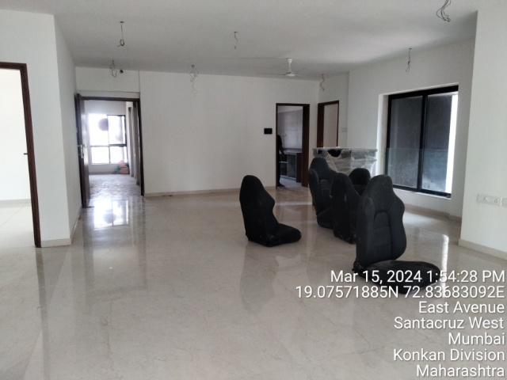
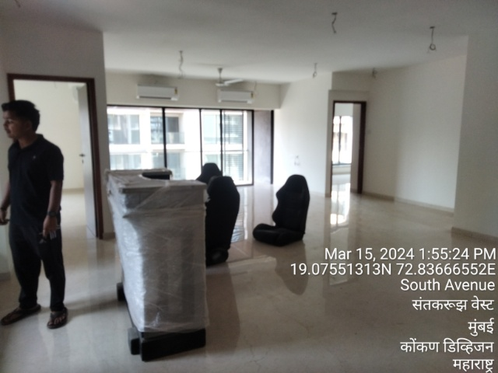

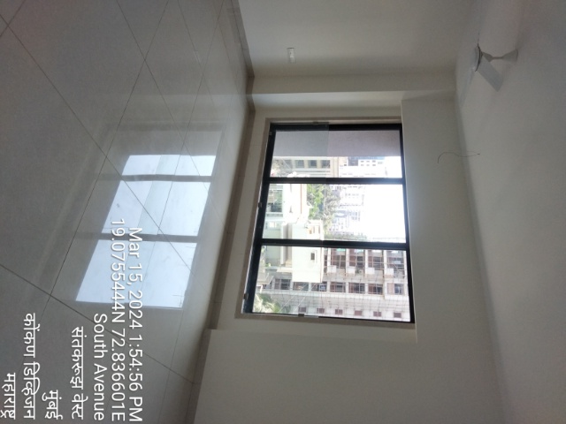
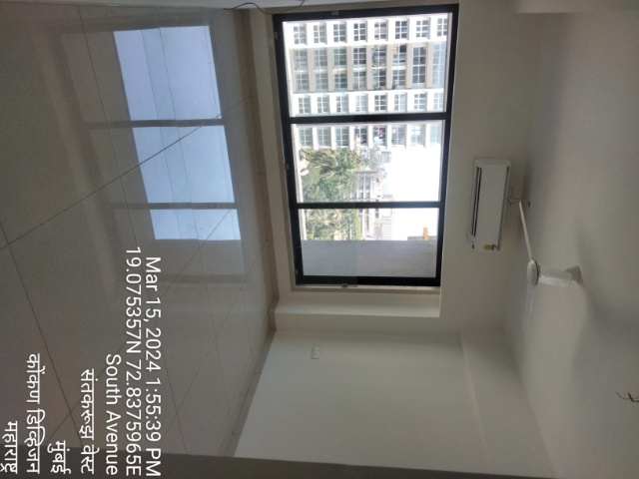
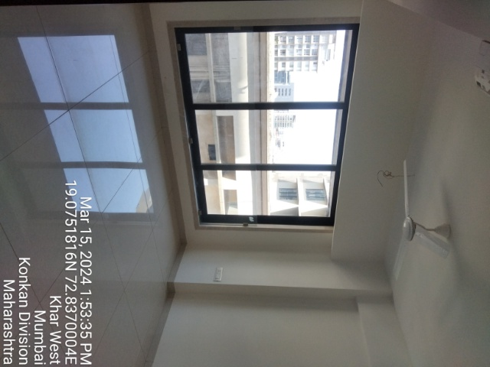

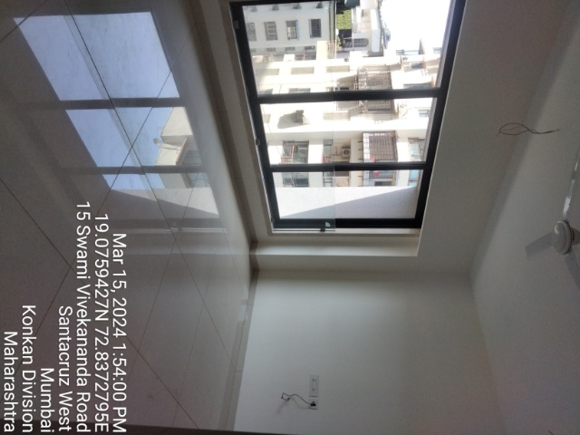
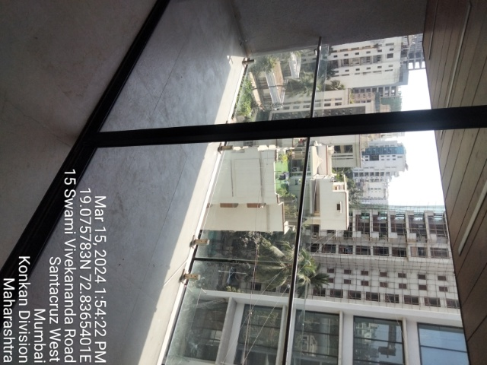
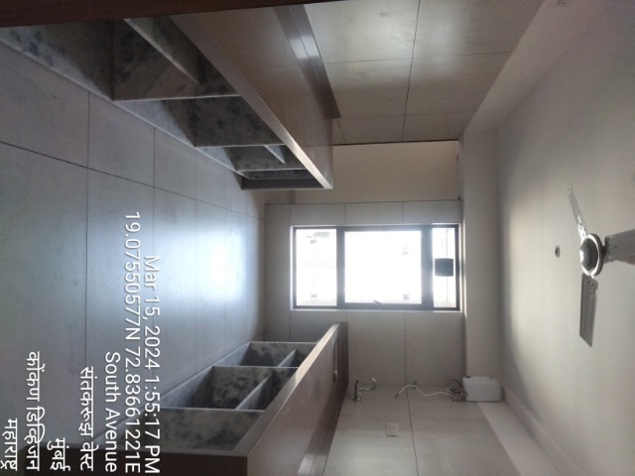
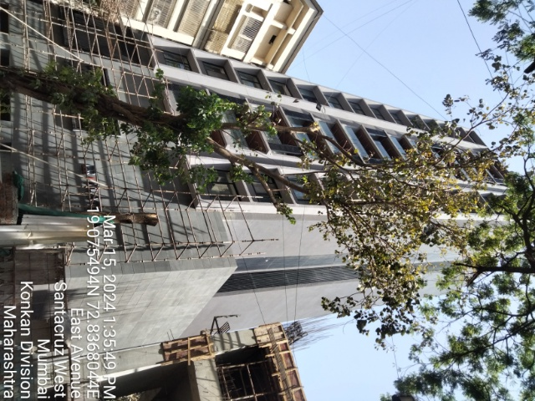
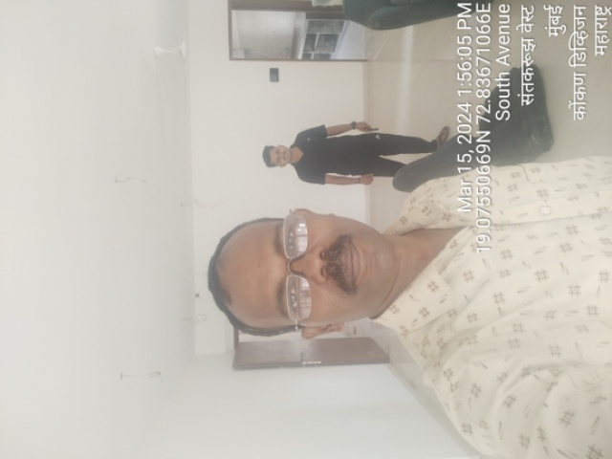
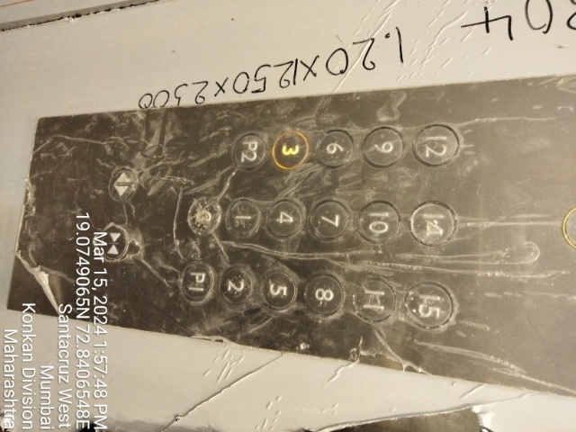
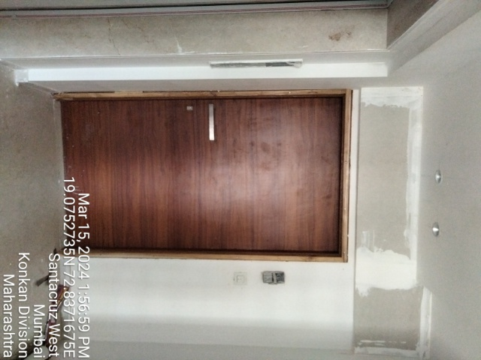
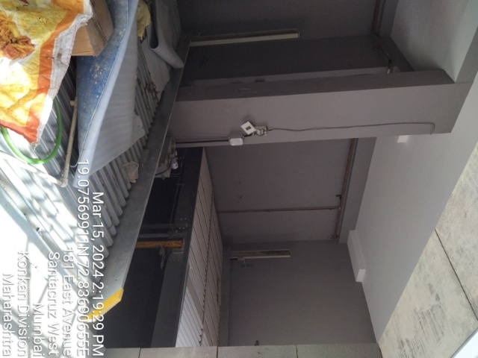
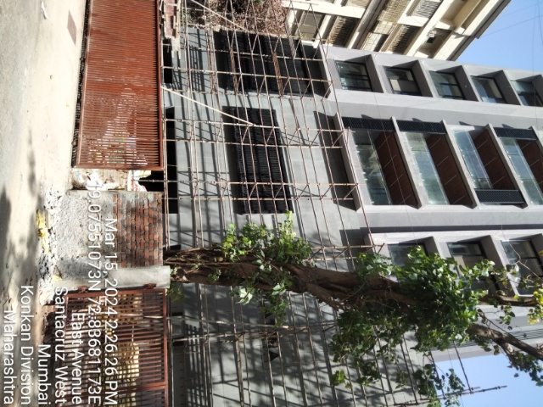
Actual site photographs
Route Map of the property
Site u/r
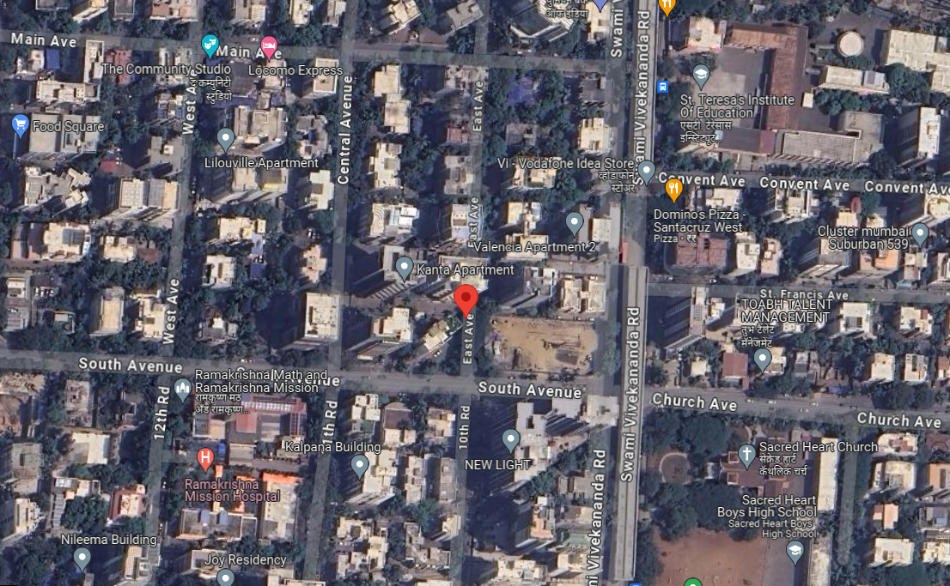

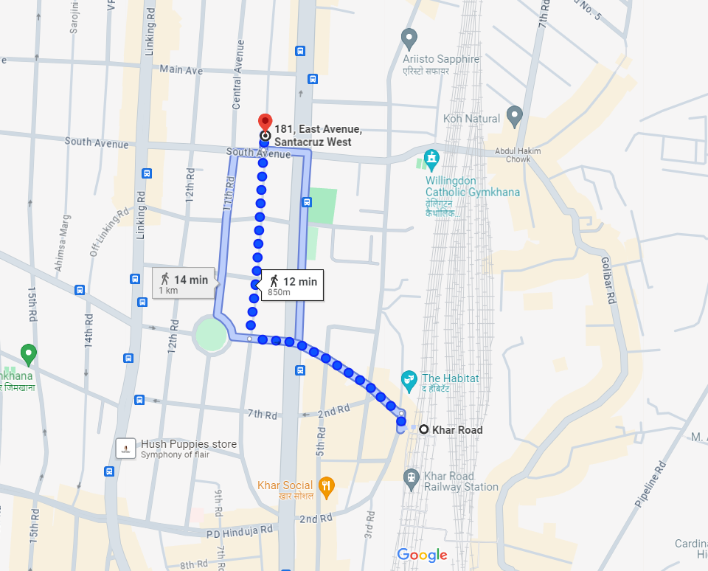



Latitude Longitude: 19°04'31.8"N 72°50'12.5"E

Note: The Blue line shows the route to site from nearest railway station (Khar – 850 M.)
Ready Reckoner Rate
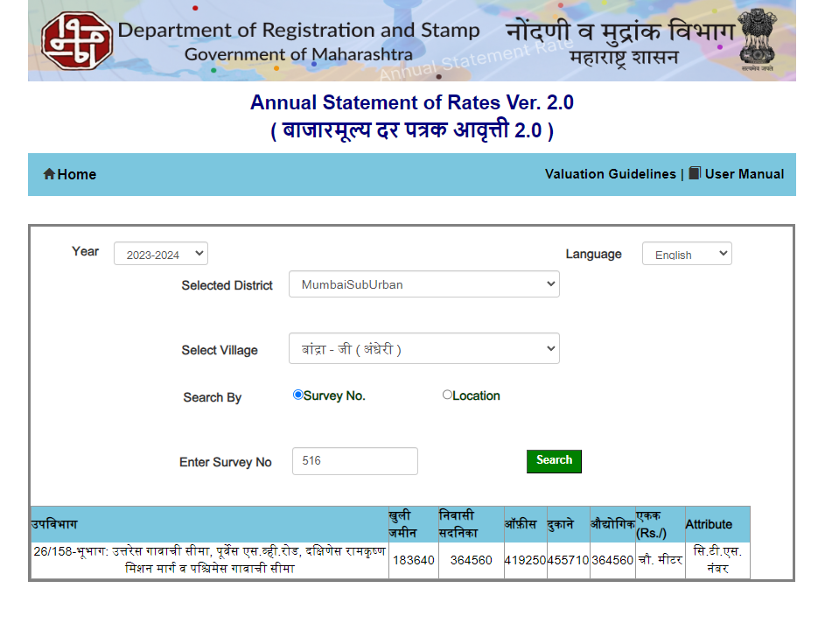

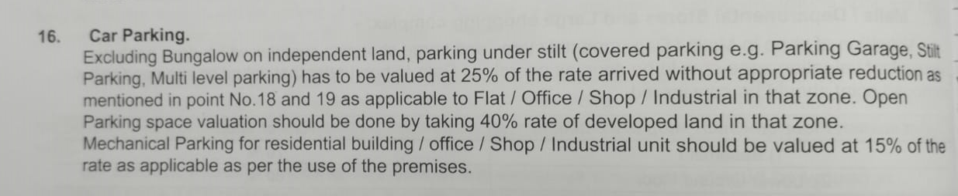

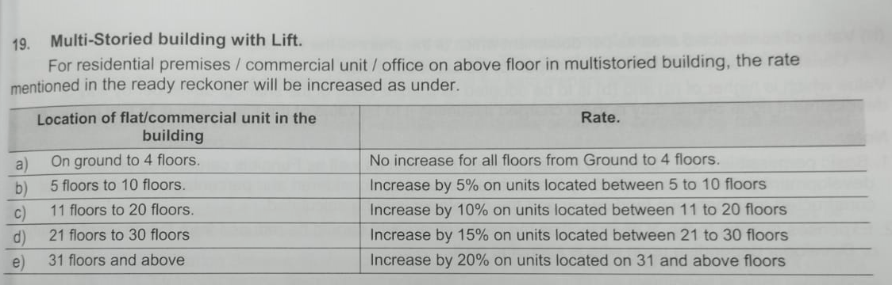

Sr. | Particulars | Valuer comment
 | Background information of the asset being valued; | The property under consideration is owned by Mr. Ankur Kashyap Shah (Flat No. 701) & Kashmita Corporation (Flat No. 702)
 | Purpose of valuation and appointing authority | As per the request to assess Government value as on possession date i.e. 21.02.2024 of the property.
 | Identity of the valuer and any other experts involved in the valuation; | Sharad B. Chalikwar – Regd. Valuer  Tushar Bhuvad – Valuation Engineer  Vaishali Sarmalkar – Technical Manager
 | Disclosure of valuer interest or conflict, if any; | We have no interest, either direct or indirect, in the property valued. Further to state that we do not have relation or any connection with property owner / applicant directly or indirectly. Further to state that we are an independent Valuer and in no way related to property owner / applicant
 | Date of appointment, valuation date and date of  report; | Date of Appointment – 15.03.2024  Valuation Date – 18.03.2024  Date of Report – 18.03.2024
 | Inspections and/or investigations undertaken; | Physical Inspection done on 15.03.2024
 | Nature and sources of the information used or relied upon; | - Ready Reckoner rates / Circle rates
 | Procedures adopted in carrying out the valuation and valuation standards followed; | Government Rate as per Ready Reckoner 2024 issued by Government.
 | Restrictions on use of the report, if any; | This valuation is for the use of the party to whom it is addressed and for no other purpose. No responsibility is accepted to any third party who may use or rely on the whole or any part of this valuation. The valuer has no pecuniary interest that would conflict with the proper valuation of the property.
 | Major factors that were taken into account during the valuation; | Current market conditions, demand and supply position, Residential Flat size, location, upswing in real estate prices, sustained demand for Residential Flat, all-round development of commercial and residential application in the locality etc.
 | Caveats, limitations and disclaimers to the extent they explain or elucidate the limitations faced by valuer, which shall not be for the purpose of limiting his responsibility for the valuation report. | Attached

Assumptions, Disclaimers, Limitations & Qualifications
Value Subject to Change
The subject appraisal exercise is based on prevailing market dynamics as on 19th March 2024 and does not take into account any unforeseeable developments which could impact the same in the future.
Our Investigations
We are not engaged to carry out all possible investigations in relation to the subject property. Where in our report we identify certain limitations to our investigations, this is to enable the reliant party to instruct further investigations where considered appropriate or where we recommend as necessary prior to reliance. Vastukala Architects & Engineers is not liable for any loss occasioned by a decision not to conduct further investigations
Assumptions
Assumptions are a necessary part of undertaking valuations. Vastukala Architects & Engineers adopts assumptions for the purpose of providing valuation advise because some matters are not capable of accurate calculations or fall outside the scope of our expertise, or out instructions. The reliant party accepts that the valuation contains certain specific assumptions and acknowledge and accept the risk of that if any of the assumptions adopted in the valuation are incorrect, then this may have an effect on the valuation.
Information Supplied by Others
The appraisal is based on the information provided by the client. The same has been assumed to be correct and has been used for appraisal exercise. Where it is stated in the report that another party has supplied information to Vastukala Architects & Engineers, this information is believed to be reliable but Vastukala Architects & Engineers can accept no responsibility if this should prove not to be so.
Future Matters
To the extent that the valuation includes any statement as to a future matter, that statement is provided as an estimate and/or opinion based on the information known to Vastukala Architects & Engineers at the date of this document. Vastukala Architects & Engineers does not warrant that such statements are accurate or correct.
Map and Plans
Any sketch, plan or map in this report is included to assist the reader while visualising the property and assume no responsibility in connection with such matters.
Site Details
Based on inputs received from Client and site visit conducted, we understand that the subject property is Residential Flat, admeasuring total Built up Area in Sq. Ft. (As per valuation table) in the name of Mr. Ankur Kashyap Shah (Flat No. 701) & Kashmita Corporation (Flat No. 702). Further, Vastukala Architects & Engineers has assumed that the subject property is free from any encroachment and is available as on the date of the appraisal.
Property Title
Based on our discussion with the Client, we understand that the subject property is owned by Mr. Ankur Kashyap Shah (Flat No. 701) & Kashmita Corporation (Flat No. 702). For the purpose of this appraisal exercise, we have assumed that the subject property has a clear title and is free from any encumbrances, disputes and claims. Vastukala Architects & Engineers has made no further enquiries with the relevant local authorities in this regard and does not certify the property as having a clear and marketable title. Further, no legal advice regarding the title and ownership of the subject property has been obtained for the purpose of this appraisal exercise. It has been assumed that the title deeds are clear and marketable.
Environmental Conditions
We have assumed that the subject property is not contaminated and is not adversely affected by any existing or proposed environmental law and any processes which are carried out on the property are regulated by environmental legislation and are properly licensed by the appropriate authorities.
Area
Based on the information provided by the Client, we understand that the Residential Flat, admeasuring Built up Area in Sq. Ft. (As per valuation table)
Condition & Repair
In the absence of any information to the contrary, we have assumed that there are no abnormal ground conditions, nor archaeological remains present which might adversely affect the current or future occupation, development or value of the property. The property is free from rat, infestation, structural or latent defect. No currently known deleterious or hazardous materials or suspect techniques will be used in the construction of or subsequent alteration or additions to the property and comments made in the property details do not purport to express an opinion about, or advise upon, the condition of uninspected parts and should not be taken as making an implied representation or statement about such parts
Valuation Methodology
For the purpose of this valuation exercise, the valuation methodology used is Direct Comparison Approach / Method and proposed Current use / Existing use premise is considered for this assignment.
The Direct Comparison Approach involves a comparison of the property being valued to similar properties that have actually been sold in arms - length transactions or are offered for sale. This approach demonstrates what buyers have historically been willing to pay (and sellers willing to accept) for similar properties in an open and competitive market and is particularly useful in estimating the value of the Flat and properties that are typically traded on a unit basis.
In case of inadequate recent transaction activity in the subject micro-market, the appraiser would collate details of older transactions. Subsequently, the appraiser would analyse rental / capital value trends in the subject micro-market in order to calculate the percentage increase / decrease in values since the date of the identified transactions. This percentage would then be adopted to project the current value of the same.
Where reliance has been placed upon external sources of information in applying the valuation methodologies, unless otherwise specifically instructed by Client and/or stated in the valuation, Vastukala Architects & Engineers has not independently verified that information and Vastukala Architects & Engineers does not advise nor accept it as reliable. The person or entity to whom the report is addressed acknowledges and accepts the risk that if any of the unverified information in the valuation is incorrect, then this may have an effect on the valuation.
Not a Structural Survey
We state that this is a valuation report and not a structural survey

Other
All measurements, areas and ages quoted in our report are approximate
Legal
We have not made any allowances with respect to any existing or proposed local legislation relating to taxation on realization of the sale value of the subject property. Vastukala Architects & Engineers is not required to give testimony or to appear in court by reason of this appraisal report, with reference to the property in question, unless arrangement has been made thereof. Further, no legal advice on any aspects has been obtained for the purpose of this appraisal exercise
Property specific assumptions
Based on inputs received from the client and site visit conducted, we understand that the subject property is Residential Flat, admeasuring total Built up Area in Sq. Ft. (As per valuation table)

ASSUMPTIONS, CAVEATS, LIMITATION AND DISCLAIMERS
1. We assume no responsibility for matters of legal nature affecting the property appraised or the title thereto, nor do we render our opinion as to the title, which is assumed to be good and marketable.
2. The property is valued as though under responsible ownership.
3. It is assumed that the property is free of liens and encumbrances.
4. It is assumed that there are no hidden or unapparent conditions of the subsoil or structure that would render it more or less valuable. No responsibility is assumed for such conditions or for engineering that might be required to discover such factors.
5. There is no direct/ indirect interest in the property valued.
6. The rates for valuation of the property are in accordance with the Govt. approved rates.

For Vastukala Architects & Engineers

Sharadkumar B. Chalikwar
Govt. Reg. Valuer
Chartered Engineer (India)
Reg. No. (N) CCIT/1-14/52/2008-09

