Valuation Report of the Immovable Property

**Details of the property under consideration:**

Name of Client / Proposed Purchaser: **Ms. Mamta Manohar Gupta**

Name of Owner: **Wheelabrator Alloy Castings Ltd.**

Flat No. 1002, 10th floor, Tower - 2 **"Citrus"**, Runwal Forests, L. B. S. Marg,

Kanjurmarg (West), Mumbai - 400 078

# **Latitude Longitude - 19°08'12.5"N 72°55'51.4"E**

**Valuation Done for:**

**State Bank of India**

**HLST Ghatkopar Branch**

Hotel Airways Bldg, LBS Marg, Opp. Damodar Park ,

Ghatkopar (Wast) Mumbai - 400 086

-

# **Vastukala Consultants (I) Pvt. Ltd.**

Mumbai • Nanded • Navi Mumbai • Aurangabad

Vastu/SBI/Mumbai/12/2015/13023

17/05-190-SH

Date: 17.12.2015

# **VALUATION OPINION REPORT**

The property bearing Flat No. 1002, 10th floor, Tower - 2 **"Citrus"**, Runwal Forests, L. B. S. Marg, Kanjurmarg (West), Mumbai - 400 078 belongs to **Wheelabrator Alloy Castings Ltd.** Name of Client / Proposed Purchaser: **Ms. Mamta Manohar Gupta**.

|  |  |  |
| --- | --- | --- |
| Boundaries of the property. | | |
| North | : | Internal Road | |
| South | : | Internal Road | |
| East | : | Tower - 3 | |
| West | : | Tower - 1 | |
|  |  |  | |

Considering various parameters recorded, existing economic scenario, and the information that is available with reference to the development of neighborhood and method selected for valuation, we are of the opinion that, the property premises along with business premium can be assessed and valued for this particular purpose at **` 1,09,27,500.00** (**Rupees One Crore Nine Lac Twenty Seven Thousand Five Hundred Only**)**.** As 5.00% construction work is completed the proportionate realizable value as on today is **` 5,46,375.00 (Rupees Five Lac Forty Six Thousand Three Hundred Seventy Five Only)**

The valuation of the property is based on the documents produced by the concern. Legal aspects have not been taken into considerations while preparing this valuation report.

Hence certified

**[**

## Sharad B. Chalikwar

Chartered Engineer (India)

Govt. Reg. Valuer

Reg. No. (N) CCIT/1-14/52/2008-09

**Valuation Report of Immovable Property**

|  |  |  |  |  |  |  |  |  |  |  |  |  |  |  |  |  |  |  |  |  |  |  |  |  |  |  |  |  |  |  |  |  |  |  |  |  |  |
| --- | --- | --- | --- | --- | --- | --- | --- | --- | --- | --- | --- | --- | --- | --- | --- | --- | --- | --- | --- | --- | --- | --- | --- | --- | --- | --- | --- | --- | --- | --- | --- | --- | --- | --- | --- | --- | --- |
| **1.** | **Customer Details** | | | | | | | | | | | | | | | | | | | | | | | | | | | | | | | | | | | | |
|  | Name of Client / Proposed Purchaser: | | | **Ms. Mamta Manohar Gupta** | | | | | | | | | | | | | | | | | | | | | | | | | | | | | | | | | |
| Name(s) of the owner(s). | | | **Wheelabrator Alloy Castings Ltd.** | | | | | | | | | | | | | | | | | | | | | | | | | | | | | | | | | |
|  | Application No. | | |  | | | | | | | | | | | | | | | | | | | | | | | | | | | | | | | | | |
| **2** | **Property Details** | | | | | | | | | | | | | | | | | | | | | | | | | | | | | | | | | | | | |
|  | Address | | | | | | | | | | Flat No. 1002, 10th floor, Tower - 2 **"Citrus"**, Runwal Forests, L. B. S. Marg, Kanjurmarg (West), Mumbai - 400 078 | | | | | | | | | | | | | | | | | | | | | | | | | | |
|  | Nearby Landmark / Google Map Independent access to the property | | | | | | | | | | Landmark: Near Jai Oil Company **Latitude Longitude -** **19°08'12.5"N 72°55'51.4"E** | | | | | | | | | | | | | | | | | | | | | | | | | | |
| **3** | **Document Details** | | | | | | | | | Name of Approving Authority | | | | | | | | | | | | | | | |  | | | | | | | | | | | |
|  | **Layout Plan** | | | | No | | | | | Details not provided | | | | | | | | | | | | | | | | Approval No. | | | | | Details not provided | | | | | | |
|  | **Building Plan** | | | | No | | | | | Details not provided | | | | | | | | | | | | | | | | Approval No. | | | | | Details not provided | | | | | | |
|  | **Construction Permission** | | | | No | | | | | Details not provided | | | | | | | | | | | | | | | | Approval No. | | | | | Details not provided | | | | | | |
|  | **Legal Documents** | | | | Yes | | | | | 1. Copy of Tripartite agreement dated 27.10.2015 | | | | | | | | | | | | | | | | | | | | | | | | | | | |
| **4.** | **Physical Details** | | | | | | | | | | | | | | | | | | | | | | | | | | | | | | | | | | | | |
|  | **Adjoining Properties** | | | **East** | | | | | | | | | | | **West** | | | | | | | | | | **North** | | | | | | | **South** | | | | | |
|  | **As on site** | | | Tower - 3 | | | | | | | | | | | Tower - 1 | | | | | | | | | | Internal Road | | | | | | | Internal Road | | | | | |
|  | **As per document** | | | Details not provided | | | | | | | | | | | Details not provided | | | | | | | | | | Details not provided | | | | | | | Details not provided | | | | | |
|  | **Matching of Boundaries** | | | - | | | | | | | | **Plot Demarcated** | | | | Yes | | | | | | **Approved land use** | | | | | | Residential | | | | **Type of Property** | | | | Residential Flat | |
|  | **No. of rooms** | Living /Dining | | | | | | 1 | | | | Bed Rooms | | | | 1 ½ | | | | | | Toilets | | | | | | 1 | | | | Kitchen | | | | 1 | |
|  |  |  | | | | | | | | | | | | | | | | | | | | | | | | | | | | | | | | | | | |
|  | **Total no. of Floors** | Proposed 3 Basements + Stilt + 36 upper floors | | | | | | **Floor on which the property is located** | | | | 10th Floor | | | | **Approx. Age of the property** | | | | | | Under Construction Building | | | | | | **Residual age of the property** | | | | 60years (after completion) | | | | **Type of structure :** - R.C.C. Framed Structure | |
| **5** | **Tenure/ Occupancy Details – Under Construction Building** | | | | | | | | | | | | | | | | | | | | | | | | | | | | | | | | | | | | |
|  | Status of Tenure | | | | | | N.A. | | | | | | **No. of years of Occupancy** | | | | | | | | N.A. | | | | | | | | **Relationship of tenant or owner** | | | | | N.A. | | | |
| **6.** | **Stage of Construction** | | | | | | | | | | | | | | | | | | | | | | | | | | | | | | | | | | | | |
|  | Stage of construction | | | | | | Under Construction Building | | | | | | **If under construction, extent of completion** | | | | | | | | | | | | | | | | Foundation work is in progress. (05%) | | | | | | | | |
| **7.** | **Violations if any observed** | | | | | | | | | | | | | | | | | | | | | | | | | | | | | | | | | | | | |
|  | Nature and extent of violations | | | | | | | | | | | | | | | | - | | | | | | | | | | | | | | | | | | | | |
| **8** | **Area Details of the Property** | | | | | | | | | | | | | | | | | | | | | | | | | | | | | | | | | | | | |
|  | **Site Area**  in Sq. Ft. | | **Carpet area = 452.00 (Area as per Tripartite Agreement)** | | | | | | | | | | | Plinth area / Built up area in Sq. Ft (Carpet area+20%) | | | | | | | | | | 542.40 | | | | | | Saleable Area in Sq. Ft (Built up area + 30%) | | | | | | | 705.00 |
|  | Remarks: | |  | | | | | | | | | | | | | | | | | | | | | | | | | | | | | | | | | | |
|  | Present/Expected Income from the property | | | | | ` 21,000.00 expected rental income per month after completion | | | | | | | | | | | | | | | | | | | | | | | | | | | | | | | |
| **9** | **Valuation** | | | | | | | | | | | | | | | | | | | | | | | | | | | | | | | | | | | | |
|  | 1. Mention the value as per Government Approved Rates also | | | | | | | | | | | | | | | | | | | | | | | | | | | | | | | | | | | | |
| Guideline rate obtained from the Stamp Duty Ready Reckoner | | | | | | | | | | | | | | | | | | ` 1,29,675.00 per Sq. M. i.e. ` 12,047.15 per Sq. Ft. | | | | | | | | | | | | | | | | | | |
| 1. In case of variation of 20% or more in the valuation proposed by the valuer and the Guideline value provided in the State Govt. notification or Income Tax Gazette justification on variation has to be given. | | | | | | | | | | | | | | | | | | | | | | | | | | | | | | | | | | | | |
| Indicator | | | | | | | | | | | | | | | | | | | | | | | | | | | | | | | | | | | | |
| Property: Residential Flat 1BHK at Runwal Forests, Kanjurmarg Source: 99acres.com  Saleable Area: 725.00 Sq. Ft.  Expected Price: ` 1,01,00,000.00 Expected Rate/Sq. Ft: ` 13,931.00 per Sq. Ft. | | | | | | | | | | | | | | | | | | | | | | | | | | | | | | | | | | | | |
| Considering the above indicator of sale, current market conditions, demand and supply position, Flat size, location, upswing in real estate prices, sustained demand for Residential Flat, all round development of commercial and residential application in the locality etc. We estimate ` 15,500.00 per Sq. Ft. of area. (Inclusive of site and general development, compound walls, MS gates, drainage systems, water tanks and other infrastructure facilities and amenities). | | | | | | | | | | | | | | | | | | | | | | | | | | | | | | | | | | | | |
| **Summary of Valuation** | | | | | | | | | | | | | | | | | | | | | | | | | | | | | | | | | | | | |
|  | | | | | | | | | | | | | | | | | | | | | | | | | | | | | | | | | | | | |
| 1. Guideline Value | | | | | | | | | | | | | | | | | | |  | | | | | | | | | | | | | | | | | |
|  | | | | | | | | | | | | | | | | | | | Area in Sq. Ft. | | | | | | | Rate in ` | | | | | | Value in ` | | | | |
| Built up area | | | | | | | | | | | | | | | | | | | 542.40 | | | | | | | 12,047.15 | | | | | | 65,34,373.99 | | | | |
| 1. Fair Market Value of the Property | | | | | | | | | | | | | | | | | | |  | | | | | | | | | | | | | | | | | |
| Saleable Area | | | | | | | | | | | | | | | | | | | 705.00 Sq. Ft. | | | | | | | | | | | | | | | | | |
| Prevailing market rate | | | | | | | | | | | | | | | | | | | ` 15,500.00 per Sq. Ft. | | | | | | | | | | | | | | | | | |
| Total Value of the property | | | | | | | | | | | | | | | | | | | ` 1,09,27,500.00 | | | | | | | | | | | | | | | | | |
| 1. Realizable Value of the Property | | | | | | | | | | | | | | | | | | ` 98,34,750.00 | | | | | | | | | | | | | | | | | | |
| 1. Distress / Force Sale Value | | | | | | | | | | | | | | | | | | ` 87,42,000.00 | | | | | | | | | | | | | | | | | | |
| 1. Insurable Value of the Assets | | | | | | | | | | | | | | | | | | ` 18,98,400.00 | | | | | | | | | | | | | | | | | | |
| **10** | **Assumptions /Remarks** | | | | | | | | | | | | | | | | | | | | | | | | | | | | | | | | | | | | |
|  | 1. Qualification in TIR / Mitigation Suggested, if any | | | | | | | | | | | | | | | | | TIR Not Provided | | | | | | | | | | | | | | | | | | | |
|  | 1. Property is SARFAESI compliant | | | | | | | | | | | | | | | | | As per Title Investigation report | | | | | | | | | | | | | | | | | | | |
|  | 1. Whether property belongs to social infrastructure like hospital, school, old age home etc. | | | | | | | | | | | | | | | | | No | | | | | | | | | | | | | | | | | | | |
|  | 1. Whether entire piece of land on which the unit is set up/property is situated has been mortgaged or to be mortgaged | | | | | | | | | | | | | | | | | Information not available | | | | | | | | | | | | | | | | | | | |
|  | 1. Details of last two transection in the locality / area to be provided, if available | | | | | | | | | | | | | | | | | Details attached | | | | | | | | | | | | | | | | | | | |
|  | 1. Any other aspect which has relevance on the value or marketability of the property | | | | | | | | | | | | | | | | | Indicator of sale, current market conditions, demand and supply position, Flat size, location, upswing in real estate prices, sustained demand for Residential Flat, all round development of commercial and residential application in the locality etc. | | | | | | | | | | | | | | | | | | | |
| **11** | **Declaration** | | | | | | | | 1. The property was inspected by me / our representative personally on 15.12.2015 2. The undersigned does not have any direct / indirect interest in the above property. 3. The information furnished herein is true and correct to the best of our knowledge. 4. I have submitted Valuation report directly to the Bank. | | | | | | | | | | | | | | | | | | | | | | | | | | | | |
| **12** | **Name, address & signature of valuer** | | | | | | | | **Vastukala Consultants (I) Pvt. Ltd.**  Ackruti Star, 1st Floor, 121, Central Road, MIDC, Andheri (East), Mumbai - 400 093 | | | | | | | | | | | | | |  | | | | | | | | | | | | | | |
| **S. B. Chalikwar**  Chartered Engineer (India)  Govt. Reg. Valuer  Reg. No. (N) CCIT/1-14/52/2008-09 | | | | | | | | | | | | Date of valuation:  17.12.2015 | | |
| **13** | **Enclosures Documents & Photographs** | | | | | | | | 1. Valuation Report 2. Satellite Location Map 3. Location cum Route Map from Nearest Railway Station 4. Photographs of the property | | | | | | | | | | | | | | | | | | | | | | | | | | | | |

### [

[

Actual site photographs

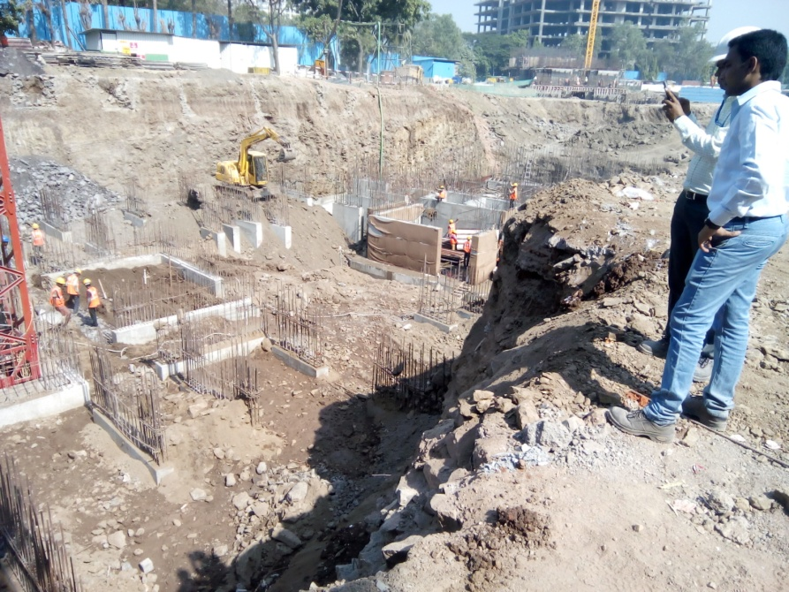

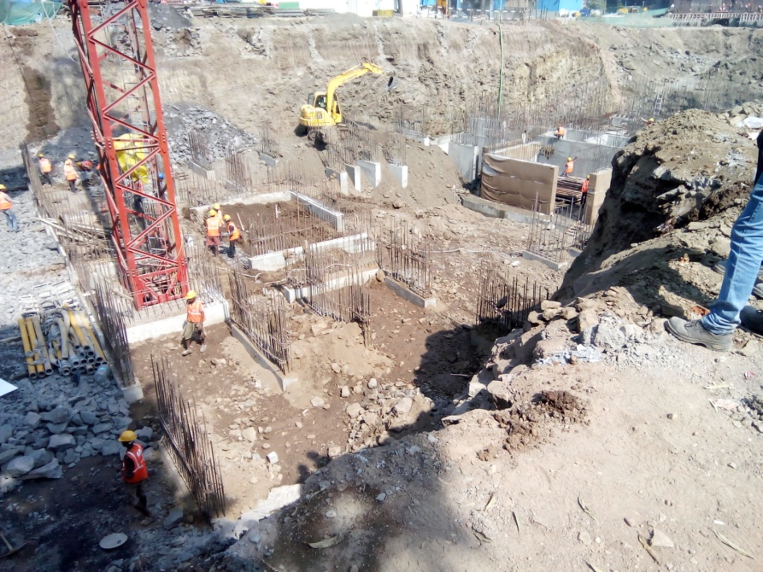 Route Map of the property

**Site u/r**

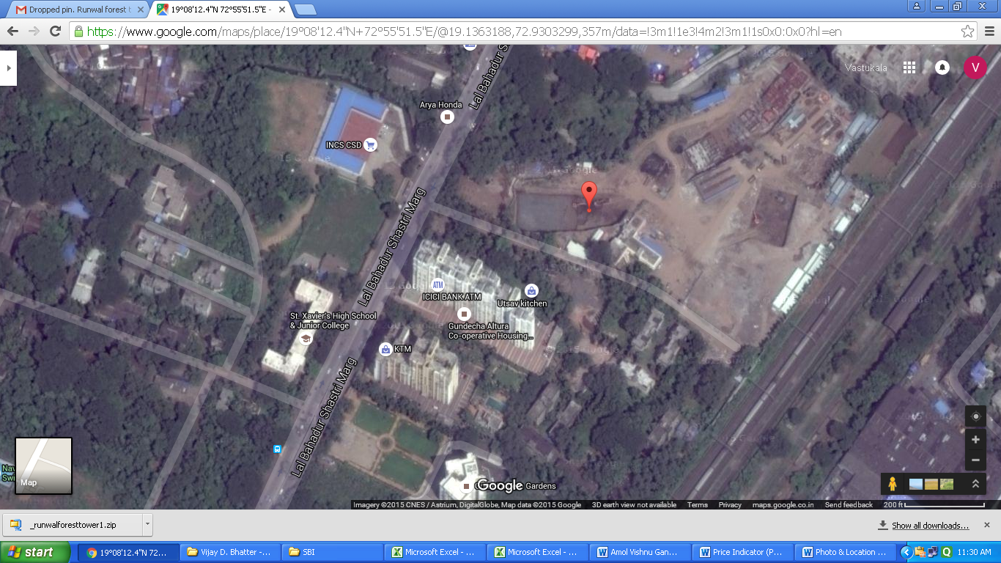

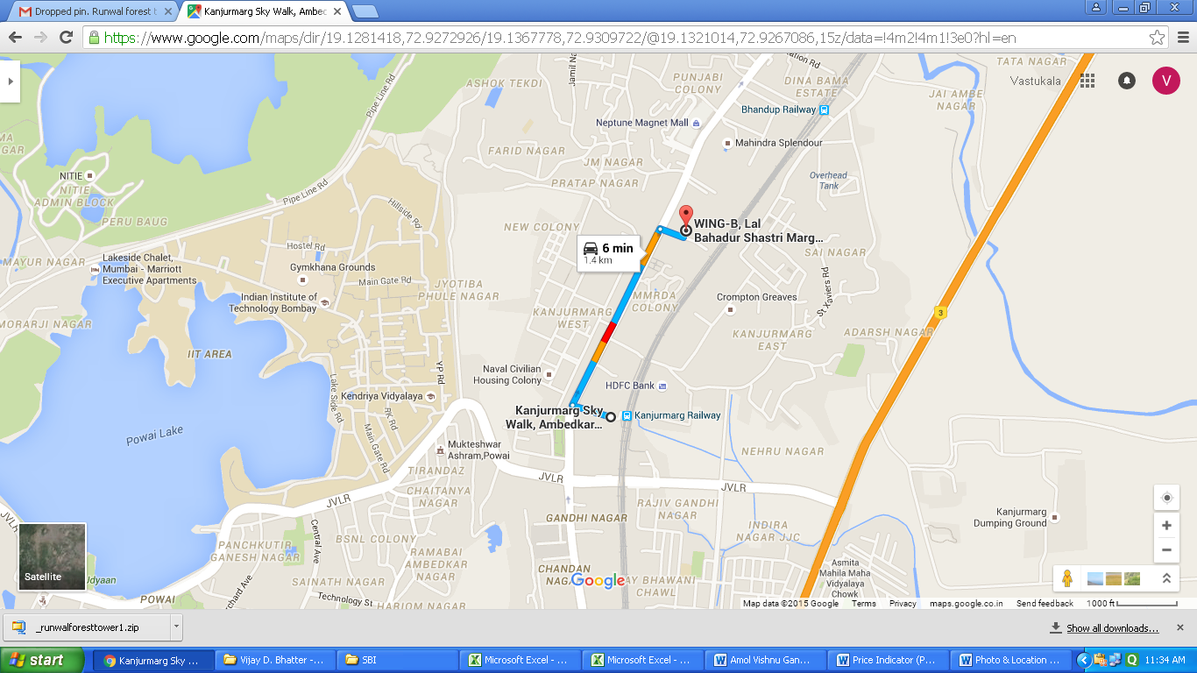

# **Latitude Longitude - 19°08'12.5"N 72°55'51.4"E**

**Note:** The Blue line shows the route to site from nearest railway station (Kanjurmarg - 1.4 km)

**Price Indicator**

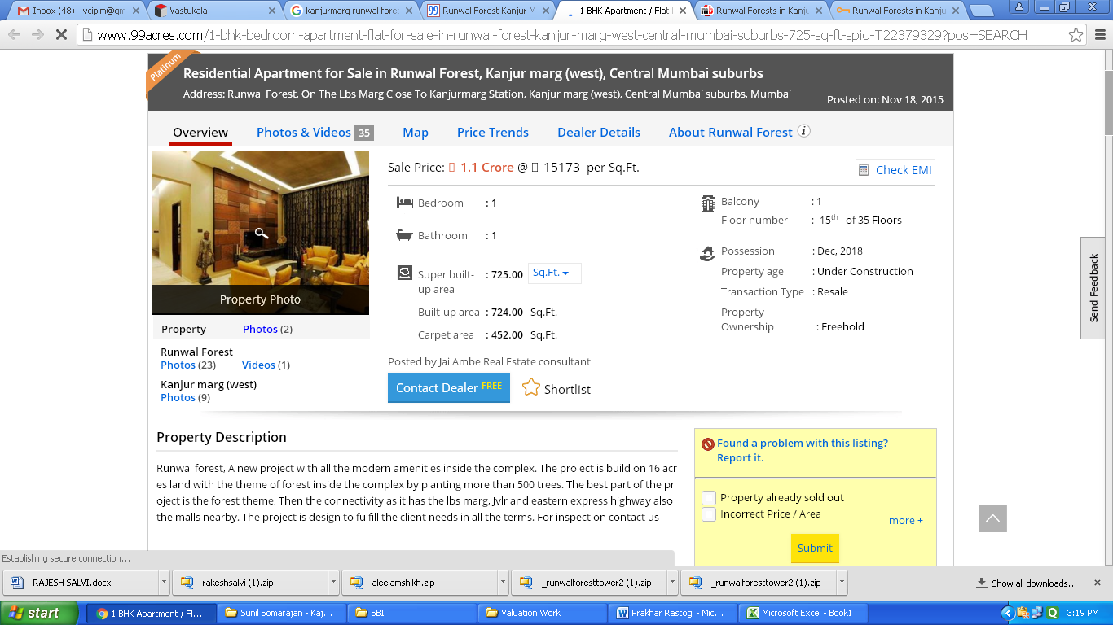

**DEFINITION OF VALUE FOR THIS SPECIFIC PURPOSE**

This exercise is to assess **Fair Market Value** of the property under reference as on **17.12.2015.**

The term **Fair Market Value** is defined as

*“The most probable price, as of a specified date, in cash, terms equivalent to cash, or in other precisely revealed terms for which the specified property rights would sell after reasonable exposure in a competitive market under all conditions requisite to a fair sale, with the buyer and seller each acting prudently knowledgeably and for self-interest assuming that neither is under undue duress”.*

Fundamental assumptions and conditions presumed in this definition are:

1. Buyer and seller are motivated by self-interest.

2. Buyer and seller are well informed and are acting prudently.

3. The property is exposed for a reasonable time on the open market.

4. Payment is made in cash or equivalent or in specified financing terms.

#### UNDER LYING ASSUMPTIONS

1. We assume no responsibility for matters of legal nature affecting the property appraised or the title thereto, nor do we render our opinion as to the title, which is assumed to be good and marketable.

2. The property is valued as though under responsible ownership.

3. It is assumed that the property is free of liens and encumbrances.

4. It is assumed that there are no hidden or unapparent conditions of the subsoil or structure that would render it more or less valuable. No responsibility is assumed for such conditions or for engineering that might be required to discover such factors.

## Sharad B. Chalikwar

Chartered Engineer (India)

Govt. Reg. Valuer

Reg. No. (N) CCIT/1-14/52/2008-09

**DECLARATION OF PROFESSIONAL FEES CHARGED**

We hereby declare that, our professional fees are not contingent upon the valuation findings. However, if the statute AND/OR clients demands that, the fees should be charged on the percentage of assessed value then, with the full knowledge of the AND/OR end user, it is being charged accordingly.

# **VALUATION OF THE PROPERTY PREMISES**

Considering various parameters recorded herein above, existing economic scenario, and the information that is available with reference to the development of neighborhood and method selected for valuation, we are of the opinion that, the property premises along with business premium can be assessed and valued for this particular **` 1,09,27,500.00** (**Rupees One Crore Nine Lac Twenty Seven Thousand Five Hundred Only**)**.** As 5.00% construction work is completed the proportionate realizable value as on today is **` 5,46,375.00 (Rupees Five Lac Forty Six Thousand Three Hundred Seventy Five Only)**

# **STATEMENT OF LIMITING CONDITIONS**

1. Assumptions are made to the best of our knowledge and belief. Reliance is based on the information furnished to us by the identifier AND/OR client.

2. The valuer shall not be responsible for matters of legal nature that affects the value and opinion expressed by us.

3. If our appearance is required, we will be pleased to appear and give the necessary clarification, provided the fees for each appearance (excluding traveling, dearness allowance and out of pocket expenses) is pre-determined before the acceptance of the assignment under reference.

4. In no event shall the valuer be held responsible or liable for special, direct, indirect or consequential damages, as the assignment has been completed on best efforts, available knowledge and in good intentions of persons concerned and belief.

5. **If it is proved that there is an apparent negligence on the part of a valuer,** liability of this assignment (whether arising from this assignment, negligence or whatsoever) is limited in respect of anyone event or series of events to the actual loss or damage sustained subject to maximum of 80% of the professional fees for the services rendered and in any case not exceeding the amount of ` 1,000/- (Rupees one Thousand Only). **All the claims against us shall expire after three month from the date of submission of the valuation report provided by us.**

6. We hereby declare that, the information furnished above is true and correct to the best of our knowledge and belief. We have no direct or indirect interest in the assets valued. We have not been convicted of any offence and sentenced to a term of imprisonment. We have not been found guilty of misconduct in our professional capacity.

## Sharad B. Chalikwar

Chartered Engineer (India)

Govt. Reg. Valuer

Reg. No. (N) CCIT/1-14/52/2008-09