Report Prepared for : M/s. Nandivardhan Group (Builders & Developers)

Report Prepared By : Mr. Sharadkumar B. Chalikwar – Govt. Registered Valuer
Valuation of Project Kesarbaug for 11UA

Contents
Contents 2
1. Executive Summary of Valuation 3
1.1. Appointment of Valuer: 3
1.2. Assets to be Valued: 4
1.3. Details consider for valuation: 4
1.4. Summary of Valuation: 4
2. Scope of Work: 5
3. Valuation Date and Report Date 5
4. Methodology 5
4.1. Basis (Bases) of Value – Stamp Duty Value 6
4.1.1. Determination of fair market value for inventory. 6
4.2. Premise of Value 7
4.2.1. Highest and Best Use 7
5. Disclosure of Valuer’s Interest 7
6. About the Assets: 7
6.1. About the Project: Kesar Baug 7
6.2. Location Advantages: 8
6.3. Rera Phase wise Details: 9
6.4. Tower wise Details 9
7. Conditions and Major Assumptions: 9
7.1. Conditions: 9
7.2. Assumptions 9
7.3. Nature and Source of Information Used or Relied Upon: 10
7.4. Date of Site inspection / site Visit: 10
7.5. Site Observation: 10
8. VALUATION REPORT IN RESPECT OF IMMOVABLE PROPERTY 11
8.1. Valuation Report 11
8.2. Specifications of construction (floor-wise) in respect of 15
8.3. Actual site photographs 16
8.4. Route Map of the property 20
8.5. Ready Reckoner 2021 – 22 21
9. Details of assets: 22
10. Guideline for valuation 23
11. Land Valuation with Structure: 24
11.1. Land & Structure Details 24
11.1.1. Land Value: - 24
11.1.1.1. Method 1: 24
11.1.1.2. Method 2: 24
12. Summary of Valuation: 25
13. Conclusion 26

Executive Summary of Valuation

Determination of fair market value as on 31.03.2022 (under Rule-11UA) for land with tenant’s right of building known as "Kesarbaug", on Property Bearing CTS No. 1/62 of Dadar Naigaon Division, Plot No. 40 of Naigaon Estate Scheme No. 60, B. T. Deorukhkar Marg and Dr. B. A. Road, Village - Naigaon, Dadar (East), Mumbai - 400 014, State - Maharashtra, Country – India.

Appointment of Valuer:

Mr. Amit Kedia of Nandivardhan Group (Builders & Developers) has appointed M/s Vastukala Consultants (I) Pvt. Ltd. - Sharadkumar B. Chalikwar - Registered Valuer – Immovable Property to provide an opinion on Determination of fair market value as on 31.03.2022 (under Rule-11UA) for land with tenant’s right of building known as "Kesarbaug", on Property Bearing CTS No. 1/62 of Dadar Naigaon Division, Plot No. 40 of Naigaon Estate Scheme No. 60, B. T. Deorukhkar Marg and Dr. B. A. Road, Village - Naigaon, Dadar (East), Mumbai - 400 078, State - Maharashtra, Country – India.

Vide valuers Appointment Email dated 17.02.2022
Type of Assets | Immovable Properties
Name of the Valuer | Sharadkumar B. Chalikwar
Registration number of the Valuer | Reg. No. (N) CCIT/1-14/52/2008-09
E-mail Id | manoj@vastukala.org
Address | Vastukala Consultants (I) Pvt. Ltd., 121, Ackruti Star, Central Road, MIDC, Andheri (East), Mumbai – 400093, State - Maharashtra, Country - India

Assets to be Valued:

Determination of fair market value as on 31.03.2022 (under Rule-11UA) for land with tenant’s right of building known as "Kesarbaug", on Property Bearing CTS No. 1/62 of Dadar Naigaon Division, Plot No. 40 of Naigaon Estate Scheme No. 60, B. T. Deorukhkar Marg and Dr. B. A. Road, Village - Naigaon, Dadar (East), Mumbai - 400 014, State - Maharashtra, Country – India.

Details consider for valuation:

- The land is conveyed in the name of M/s. Mathuresh Infrapro Pvt. Ltd. along with building structure occupied by existing tenants.
- We have considered proposed total built up area as per local norms issued by Municipal Corporation of Greater Mumbai.
- We have considered rehab area as per local norms issued by Municipal Corporation of Greater Mumbai to be provided to existing tenants.

Summary of Valuation:

Particulars
Year of Construction / Age Of Building
Area of Land | 5,574.46
Basic FSI | 1.33
Permissible F.S.I. | 4.00
Total Allowable Area of Plot | 27,712.93
Fungible FSI for Sale | 3,359.80
Net Built Up Area | 24,353.13
Total built up area occupied by the eligible Tenants | 8,521.74
Total area occupied by the Owners (inclusive of area under non eligible tenants) | -
Total Monthly Rent from the Tenants | 12,193.00
Land Ready Reckoner Rate for 2021 – 2022 | 93,500.00
Rate for Construction | 30,250.00
Value As on 31.03.2022 | 179,57,41,881.00
Value As on 31.03.2022 in Cr. | 179.57

Scope of Work:

- Mr. Amit Kedia of Nandivardhan Group (Builders & Developers) has appointed M/s Vastukala Consultants (I) Pvt. Ltd. - Sharadkumar B. Chalikwar - Registered Valuer – Immovable Property to provide an opinion on Determination of fair market value (under Rule-11UA) for Proposed project on:
- Land with tenant’s right of building known as "Kesarbaug", on Property Bearing CTS No. 1/62 of Dadar Naigaon Division, Plot No. 40 of Naigaon Estate Scheme No. 60, B. T. Deorukhkar Marg and Dr. B. A. Road, Village - Naigaon, Dadar (East), Mumbai - 400 014, State - Maharashtra, Country – India.

Valuation Date and Report Date

Appointment Date | 17.02.2022
Date of Visit | 29.03.2022
Date of Valuation | 31.03.2022
Date (last set of Data received) | 06.06.2022
Date of Report | 02.08.2022

Methodology

This Immovable Asset Valuation Report is carried out in the following sequence:
- Verification of the documents provided by Client.
- Identification of missing information and requesting for the revised list of documents.
- Overall Site inspection.
- Assessment of the value adopted or assessed or assessable by any authority of the Government for the purpose of payment of stamp duty in respect of the immovable property (Stamp Duty Value).
- The Ready Reckoner Rate for the year 2021-22 is considered for this assignment.

Basis (Bases) of Value – Stamp Duty Value

Bases of value (sometimes called standards of value) describe the fundamental premises on which the reported values will be based. It is critical that the basis (or bases) of value be appropriate to the terms and purpose of the valuation assignment, as a basis of value may influence or dictate a Valuer’s selection of methods, inputs and assumptions, and the ultimate opinion of value. As per the appointment by Client, the basis of value for this assignment is Dept. Of Registration & Stamps, Maharashtra Ready Reckoner rate for the year 2021-22 for calculation of Stamp Duty Value.

Determination of fair market value for inventory.

As Per Income Tax Rule 11UAB defines “fair market value of the inventory” as
(i) being an immovable property, being land or building or both, shall be the value adopted or assessed or assessable by any authority of the Central Government or a State Government for the purpose of stamp duty in respect of such immovable property on the date on which the inventory is converted into, or treated, as a capital asset;
(ii) being jewellery, archaeological collections, drawings, paintings, sculptures, any work of art, shares or securities referred to in rule 11UA, shall be the value determined in the manner provided in sub-rule (1) of rule 11UA and for this purpose the reference to the valuation date in the rule 11U and rule 11UA shall be the date on which the inventory is converted into, or treated, as a capital asset;
(iii) being the property, other than those specified in clause (i) and clause (ii), the price that such property would ordinarily fetch on sale in the open market on the date on which the inventory is converted into, or treated, as a capital asset.

Premise of Value

Premise of Value or Assumed Use describes the circumstances of how an asset or liability is used. Different bases of value may require a particular premise of value or allow the consideration of multiple Premises of Value. Some common Premises of Value are:
- Highest and best use (HABU)
- Current use/existing use
- Orderly liquidation
- Forced sale

We have used the Premise of ‘Highest and Best Use (HABU)’ for this valuation assignment.

Highest and Best Use

The highest and best use for an asset may be its current or existing use when it is being used optimally. However, highest and best use may differ from current use or even be an orderly liquidation.

Disclosure of Valuer’s Interest

I, Sharadkumar B. Chalikwar hereby declare that - I have no interest, either direct or indirect, in subject property. Further to state that I do not have relation or any connection with Promoters or Directors or any officer of the client company, directly or indirectly. Further to state that I am independent and in no way related to any officials of Company.

About the Assets:

About the Project: Kesar Baug

The Kesarbaug is an upcoming residential project by Nandivardhan Group located at Dadar _ Naigaon, Mumbai. Mumbai is one of the hotspots for residential development and therefore has a lot of growth potential. Kesarbaug is constructed on plot admeasuring 5,574.46 Sq. M. area. This project offers Shops, 1 BHK, 2 BHK, 3 BHK flats and a complete package of useful features and amenities for all residents.

Location Advantages:

Dadar is a densely populated residential and shopping neighbourhood in Mumbai. It is also a prominent railway and bus service hub with local and national connectivity. Dadar holds the unique distinction of being Mumbai’s first planned area, and is a hub for the city's Marathi culture.
Prominent Residential Neighbourhoods
- Shivaji Park
- Worli - Bandra Sea link view
- Dr. B.R. Ambedkar Memorial (Chaitya Bhoomi)
- Dadar is also home to the Mumbai Mayor's Bungalow, the official residence of the Mayor of Mumbai.

Rail Transport
Dadar railway station
Dadar is a prominent railway terminus on both the Western and Central lines of the Mumbai Suburban Railway network. Being the only common railway station to both the Central and Western lines, it makes a transit point for many passengers traveling through Suburban Railway.
Dadar will also be served by Line 3 of the Mumbai Metro.
Road Transport
Dadar east has been also a key interchange point for those coming from Pune, Panvel and Navi Mumbai by road transport. A bus hub next to Dadar GPO is a destination point for many buses coming from out of Mumbai.
Locally, Dadar is well connected to other neighbourhoods of Mumbai, namely Matunga, Wadala, Parel-Prabhadevi, and Mahim.
Metro
Currently Metro 3 is under construction which is the completely underground metro rail project in Mumbai.

Rera Phase wise Details:

Project is yet to be registered under RERA

Tower wise Details
Wing No. | Number of Floors
Sale Wing A & B | Proposed 1 Level Basements + Ground + Mezzanine + 1st to 22nd upper floors.
Venu Wing C | Proposed 1 Level Basements + Ground + Mezzanine + 1st to 22nd upper floors.
Rehab Wing D & E | Proposed 1 Level Basements + Ground + Mezzanine + 1st to 18th upper floors.

Conditions and Major Assumptions:

Conditions:
This report is prepared on the request of client and this report only to be used in its entirety, and for the purpose stated in the report. No third parties should rely on the information or data contained in this report without written permission from the Valuer.
We have acknowledged that we have no present or contemplated financial interest in the Company. Our fees for this valuation are based upon our normal billing rates, and not contingent upon the results or the value or any other manner. We have no responsibility to modify this report for events and circumstances occurring subsequent to the date of this report.
We have used conceptually sound and generally accepted method, principle and procedures of International Valuation Standard determining the Stamp Duty Value estimate included in this report.

Assumptions
The Opinion of valuer given in this report is based on information/ documents provided by client and we assumed the information to be accurate and complete.
We have not attempted to confirm whether or not the property has good title. We have assumed that the subject property has Good & Marketable Title which is free from any encumbrance.

Nature and Source of Information Used or Relied Upon:
We have relied on following information, data and documents to form our opinion in report:
- Deed of Conveyance/Indenture dated 20.12.2011 registered on date 25.01.2012 vide registration No. 495/2012.
- Property Card for CS No. 1/62, Plot No. 40, Naigaum Estate, Dadar East.
- Concessions Plan No. P/6841/2021/(1/62)/F/South/Dadar-Naigaon-F/S-Draft/1/New dated 05.07.2021 issued by Municipal Corporation of Greater Mumbai.
- Certified copy of Plans for CS No. 1/62 issued by Superintendent, Mumbai City Survey and Land Records.
- Explanation and other details provided by Client.

Date of Site inspection / site Visit:

In view to have first-hand information regarding the assets to be valued following persons inspected the subject property as under:
Valuers Representative | Type of Property | Date of Visit
Umang Ashwin Patel & Prayush Pravin Parekh | Residential Project | 29.03.2022

Site Observation:
At the time of site inspection, existing Venu Apartment CHSL building of Ground floor + 1st to 8th floor and Kesarbaug building of Ground floor + 1st floor was occupied by the existing tenants and we have done the external site visit of the property.

VALUATION REPORT IN RESPECT OF IMMOVABLE PROPERTY

Valuation Report

I | General
1. | Purpose for which the valuation is made |  |  |  | : | As per Client Request to the value adopted or assessed or assessable by any authority of the government for the purpose of payment of stamp duty in respect of the immovable property as on 31.03.2022
2. | a) | Date of inspection |  |  | : | 29.03.2022
 | Project Name |  |  |  | : | Land with tenant’s right of building known as "Kesarbaug", on Property Bearing CTS No. 1/62 of Dadar Naigaon Division, Plot No. 40 of Naigaon Estate Scheme No. 60, B. T. Deorukhkar Marg and Dr. B. A. Road, Village - Naigaon, Dadar (East), Mumbai - 400 014, State - Maharashtra, Country – India.
4. | Name of the owner(s) and his / their address (es) with Phone no. (details of share of each owner in case of joint ownership) |  |  |  | : | M/s. Mathuresh Infrapro Pvt. Ltd.  Address:  CS No.1/62, Dadar, Naigaon Division, Dr. Ambedkar Road, Dadar East, Mumbai-400014.  Contact Person:  Mr. Amit Kedia of Nandivardhan Group (Builders & Developers)  Mobile No. 90044 44622
5. | Brief description of the property (Including Leasehold / freehold etc.) |  |  |  | :
The Kesarbaug is an upcoming residential project by Nandivardhan Group located at Dadar _ Naigaon, Mumbai. Mumbai is one of the hotspots for residential development and therefore has a lot of growth potential. Kesarbaug is constructed on plot admeasuring 5,574.46 Sq. M. area. This project offers Shops, 1 BHK, 2 BHK, 3 BHK flats and a complete package of useful features and amenities for all residents.
Future estimated life of the Structure is 60 years (after completion) Subject to proper, preventive periodic maintenance & Structural repairs.

6. | Location of property |  |  |  | :
 | a) |  | Plot No. / Survey No. |  | : | Plot No. 40 of Naigaon Estate Scheme No. 60
 | b) |  | Door No. |  | : | Not applicable
 | c) |  | C. T.S. No. / Village |  | : | CTS No. 1/62 of Dadar Naigaon Division
 | d) |  | Ward / Taluka |  | : | Village - Naigaon, Dadar (East)
 | e) |  | Mandal / District |  | : | Mumbai
7. | Postal address of the property |  |  |  | : | Land with tenant’s right of building known as "Kesarbaug", on Property Bearing CTS No. 1/62 of Dadar Naigaon Division, Plot No. 40 of Naigaon Estate Scheme No. 60, B. T. Deorukhkar Marg and Dr. B. A. Road, Village - Naigaon, Dadar (East), Mumbai - 400 014, State - Maharashtra, Country – India.
8. | City / Town |  |  |  | : | Mumbai
 | Residential area |  |  |  | : | Yes
 | Commercial area |  |  |  | : | No
 | Industrial area |  |  |  | : | No
9. | Classification of the area |  |  |  | :
 | i) High / Middle / Poor |  |  |  | : | Higher Middle Class
 | ii) Urban / Semi Urban / Rural |  |  |  | : | Urban
10. | Coming under Corporation limit / Village Panchayat / Municipality |  |  |  | : | Municipal Corporation of Greater Mumbai
11. | Whether covered under any State / Central Govt. enactments (e.g., Urban Land Ceiling Act) or notified under agency area/ scheduled area / cantonment area |  |  |  | : | No
12. | In Case it is Agricultural land, any conversion to house site plots is contemplated |  |  |  | : | N.A.
13. | Boundaries of the property |  |  | As per Agreement |  |  | As per Site
 | North |  |  | CS Nos. 19/62 & 20/62.Plot Nos. 41 to 44 of Naigaon Estate |  |  | Shri Krishna Mandir Sabhagruh & Padmashali Yuvak Sangh Pre-Primary School
 | South |  |  | Road No. 13 |  |  | BJ Devrukhar Road
 | East |  |  | Road no. 2 |  |  | SM Jadhav Road
 | West |  |  | Dr. Babasaheb Ambedkar Road |  |  | Dr. Babasaheb Ambedkar Road
14.1 | Dimensions of the site |  |  |  |  | N. A. as the land is irregular in shape
14.2 | Latitude, Longitude & Co-ordinates of property |  |  |  | : | 19°00'40.4"N 72°50'37.9"E
14. | Extent of the site |  |  |  | : | Plot area = 5,574.96 Sq. M. (As per Plan)
15. | Extent of the site considered for Valuation (least of 14A& 14B) |  |  |  | : | Plot area = 5,574.96 Sq. M. (As per Plan)
16 | Whether occupied by the owner / tenant? If occupied by tenant since how long? Rent received per month. |  |  |  | : | Tenants
II | CHARACTERSTICS OF THE SITE
 | Classification of locality |  |  |  | : | Higher Middle class
 | Development of surrounding areas |  |  |  | : | Good
 | Possibility of frequent flooding/ sub-merging |  |  |  | : | No
 | Feasibility to the Civic amenities like School, Hospital, Bus Stop, Market etc. |  |  |  | : | All available near by
 | Level of land with topographical conditions |  |  |  | : | Plain
 | Shape of land |  |  |  | : | Irregular
 | Type of use to which it can be put |  |  |  | : | For residential purpose
 | Any usage restriction |  |  |  | : | Residential
 | Is plot in town planning approved layout? |  |  |  | : | Concessions Plan No. P/6841/2021/ (1/62)/F/South/Dadar-Naigaon-F/S-Draft/1/New dated 05.07.2021 issued by Municipal Corporation of Greater Mumbai
 | Corner plot or intermittent plot? |  |  |  | : | Corner
 | Road facilities |  |  |  | : | Yes
 | Type of road available at present |  |  |  | : | B.T. Road
 | Width of road – is it below 20 ft. or more than 20 ft. |  |  |  | : | 30.00 M. wide DP Road
 | Is it a Land – Locked land? |  |  |  | : | No
 | Water potentiality |  |  |  | : | Municipal Water supply
 | Underground sewerage system |  |  |  | : | Connected to Municipal sewer
 | Is Power supply is available in the site |  |  |  | : | Yes
 | Advantages of the site |  |  |  | : | Located in developed area
 | Special remarks, if any like threat of acquisition of land for publics service purposes, road widening or applicability of CRZ provisions etc. (Distance from sea-cost / tidal level must be incorporated) |  |  |  | : | No
Part – A (Valuation of land)
1 | Size of plot |  |  |  | : | Plot area = 5,574.96 Sq. M. (As per Plan)
 | North & South |  |  |  | : | -
 | East & West |  |  |  | : | -
2 | Total extent of the plot |  |  |  | : | As per table attached to the report
3 | Prevailing market rate (Along With details / reference of at least two latest deals / transactions with respect to adjacent properties in the areas) |  |  |  | : | As per table attached to the report  Details of recent transactions/online listings are attached with the report.
4 | Guideline rate obtained from the Register’s Office (Evidence thereof to be enclosed) |  |  |  | : | As per 8.5
5 | Assessed / adopted rate of valuation |  |  |  | : | As per 8.5
6 | Estimated value of land |  |  |  | : | As per 10
Part – B (Valuation of Building)
1 | Technical details of the building |  |  |  | :
 | - Type of Building (Residential / Commercial / Industrial) |  |  |  | : | Residential
 | - Type of construction (Load bearing / RCC / Steel Framed) |  |  |  | : | R.C.C. Framed structure
 | - Year of construction |  |  |  | : | Existing Building year of construction of Kesarbaug building is 1995.  Existing Building year of construction of Venu CHSL is 1996.
 | - Number of floors and height of each floor including basement, if any |  |  |  | :
Wing No. | Number of Floors
Wing A & B | Proposed 1 Level Basements + Ground + Mezzanine + 1st to 22nd upper floors.
Venu Wing C | Proposed 1 Level Basements + Ground + Mezzanine + 1st to 22nd upper floors.
Wing D & E | Proposed 1 Level Basements + Ground + Mezzanine + 1st to 18th upper floors.

 | - Plinth area floor-wise |  |  |  | : | As per table attached to the report
 | - Condition of the building |  |  |  | :
 | - Exterior – Excellent, Good, Normal, Poor |  |  |  | : | Normal
 | - Interior – Excellent, Good, Normal, Poor |  |  |  | : | Normal
 | - Date of issue and validity of layout of approved map |  |  |  | : | Concessions Plan No. P/6841/2021/ (1/62)/F/South/Dadar-Naigaon-F/S-Draft/1/New dated 05.07.2021 issued by Municipal Corporation of Greater Mumbai.  Wing No. Number of Floors  Sale Wing A & B Proposed 1 Level Basements + Ground + Mezzanine + 1st to 22nd upper floors.  Venu Wing C Proposed 1 Level Basements + Ground + Mezzanine + 1st to 22nd upper floors.  Rehab Wing D & E Proposed 1 Level Basements + Ground + Mezzanine + 1st to 18th upper floors.
 | - Approved map / plan issuing authority |  |  |  | : | Municipal Corporation of Greater Mumbai
 | - Whether genuineness or authenticity of approved map / plan is verified |  |  |  | : | N.A.
 | - Any other comments by our empaneled valuers on authentic of approved plan |  |  |  | : | No.

Specifications of construction (floor-wise) in respect of

Sr.  No. | Description
 | Foundation | : | R.C.C. Footing
 | Basement | : | No
 | Superstructure | : | As per IS Code requirements
 | Joinery / Doors & Windows (Please furnish details about size of frames, shutters, glazing, fitting etc. and specify the species of timber | : | Wooden Door, Aluminum Glass Sliding Window, MS Shutter Door
 | RCC Works | : | N.A. Building Construction work is in progress
 | Plastering | : | N.A. Building Construction work is in progress
 | Flooring, Skirting, dado | : | Kota Stone Flooring
 | Special finish as marble, granite, wooden paneling, grills etc. | :
 | Roofing including weather proof course | : | Yes
 | Drainage | : | Connected to MCGM
2. | Compound Wall | :
 | Height | : | Yes
 | Length | :
 | Type of construction | :
3. | Electrical installation | : | As per requirements
 | Type of wiring | :
 | Class of fittings (superior / ordinary / poor) | :
 | Number of light points | : | As per requirements
 | Fan points | :
 | Spare plug points | :
 | Any other item | : | -
4. | Plumbing installation
 | - No. of water closets and their type | : | As per requirements
 | - No. of wash basins | :
 | - No. of urinals | :
 | - No. of bath tubs | :
 | - Water meters, taps etc. | :
 | - Any other fixtures | :

Actual site photographs

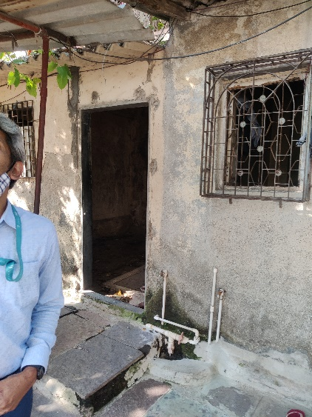
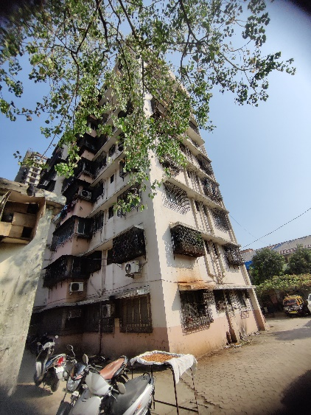
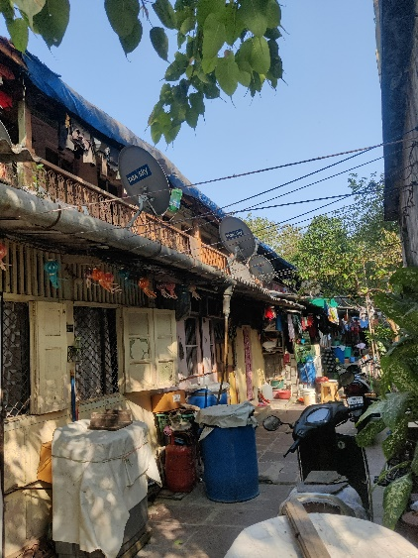
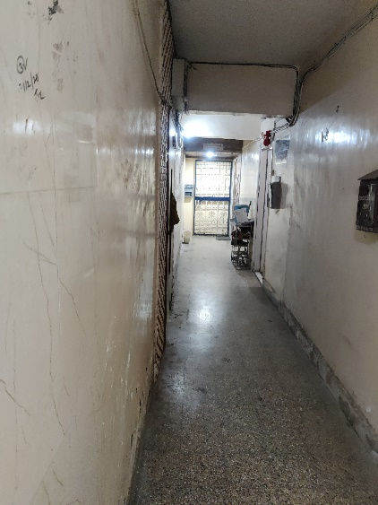
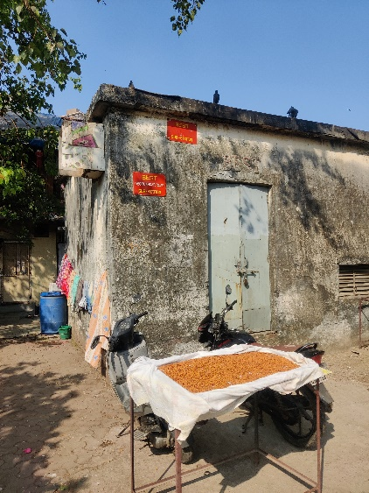
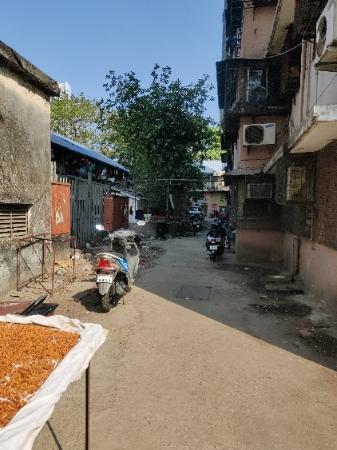
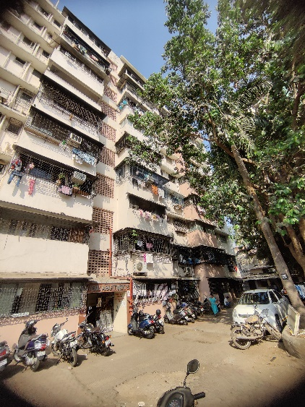
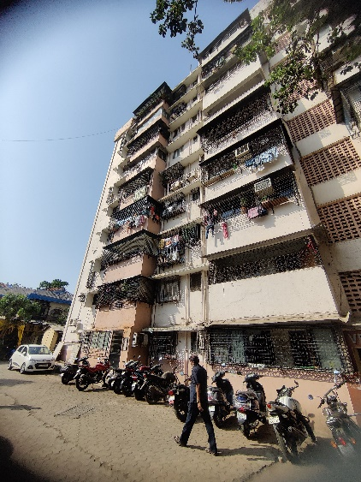
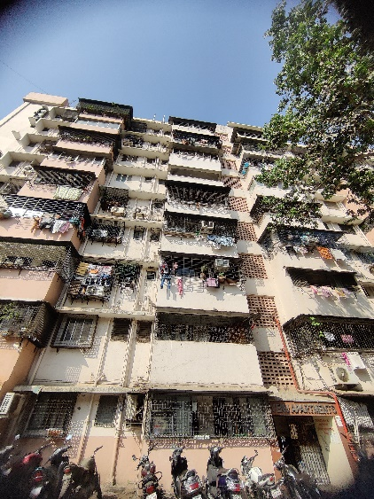
Actual Site Photographs
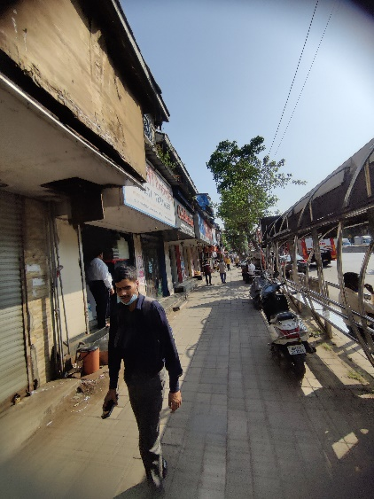
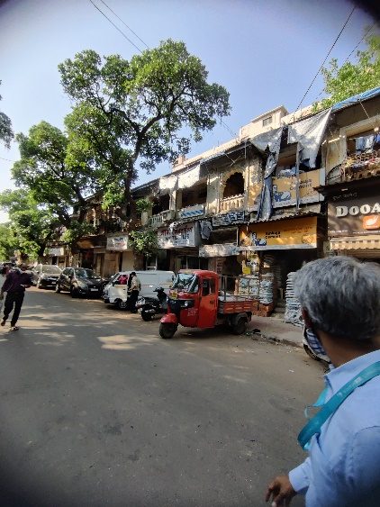
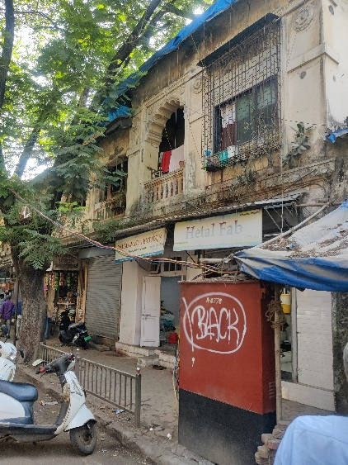
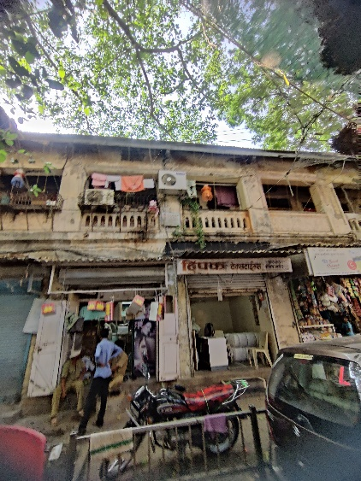
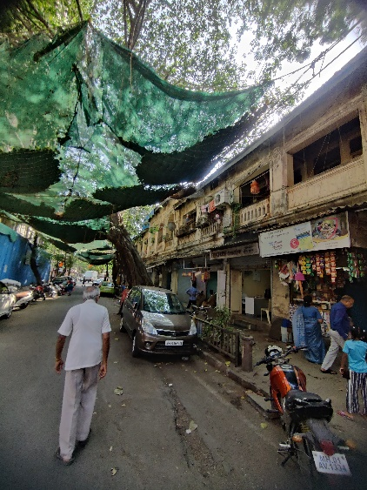
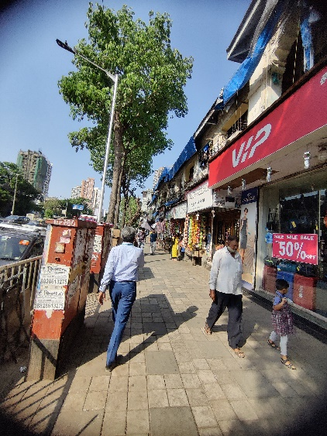
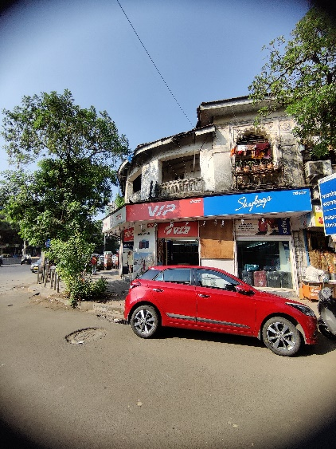
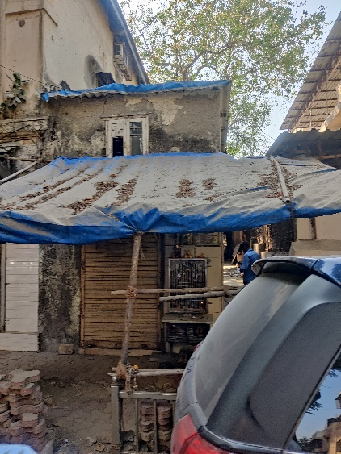
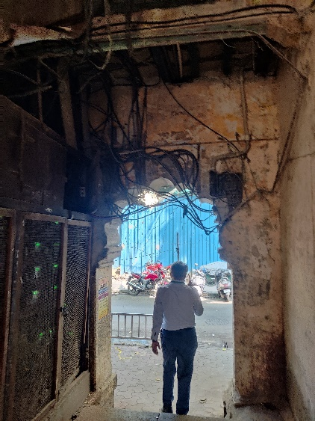
Actual Site Photographs
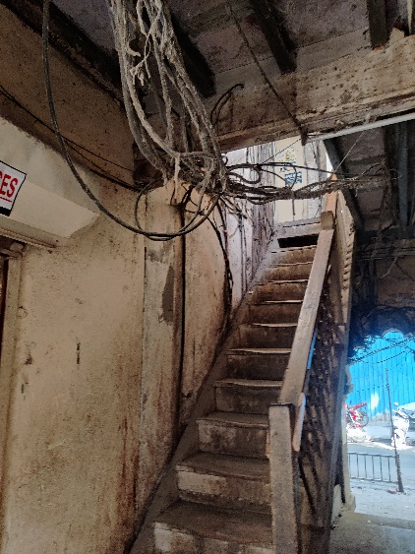
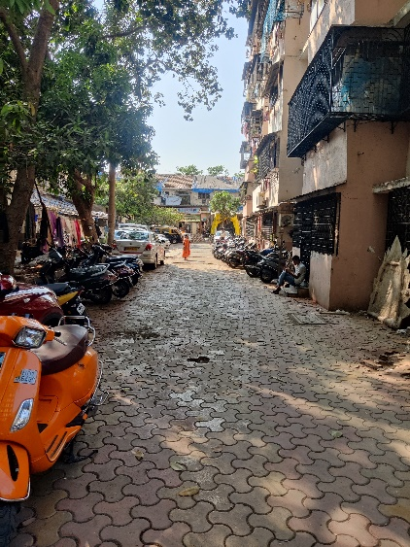
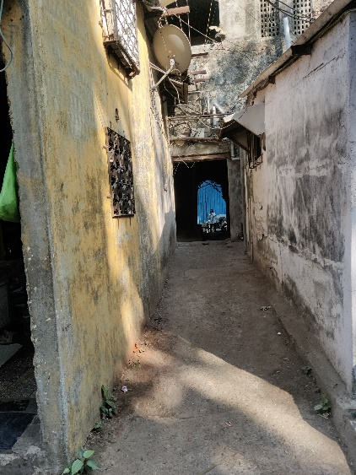
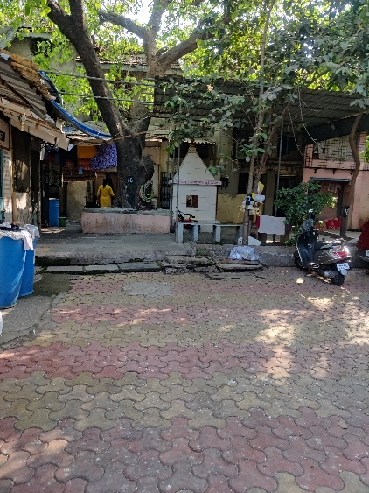
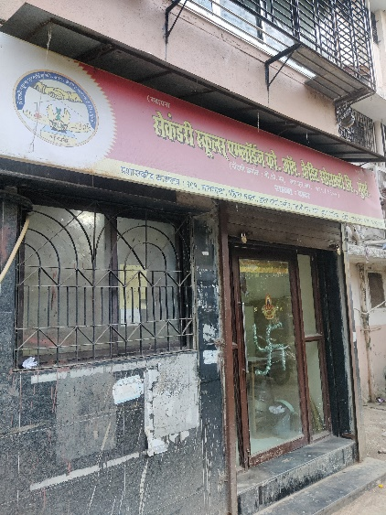
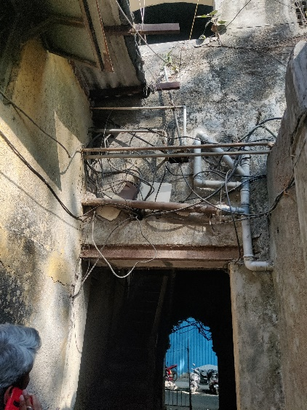
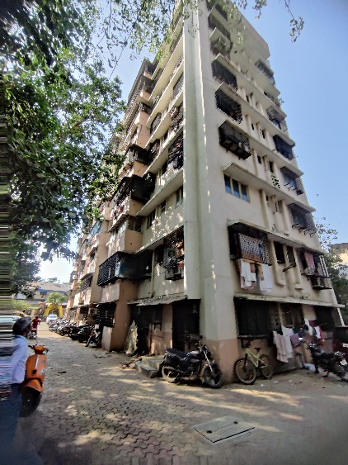
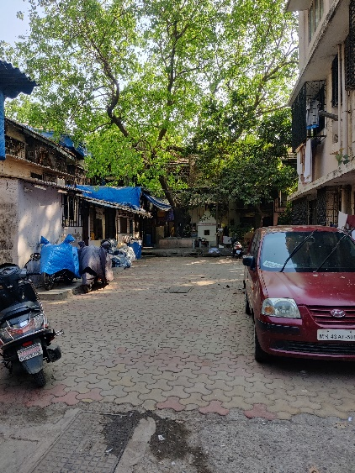
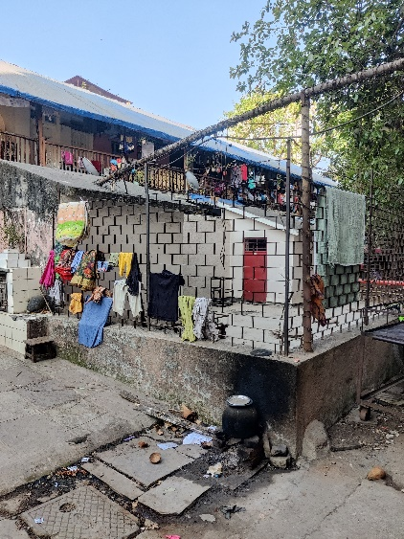
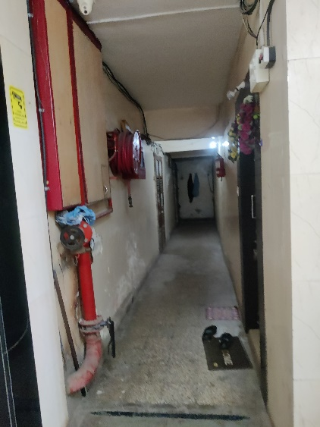
Actual Site Photographs
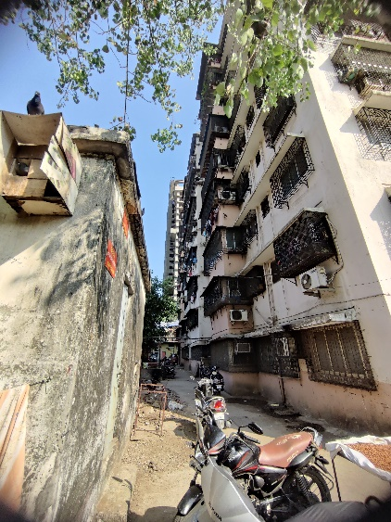
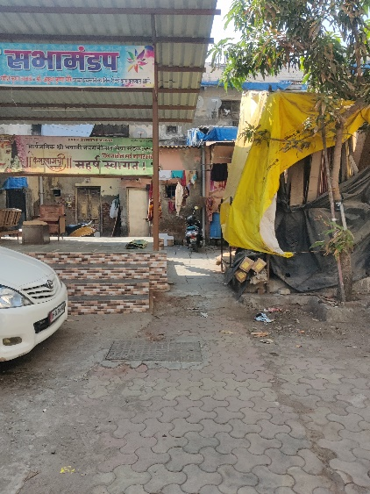
6.5
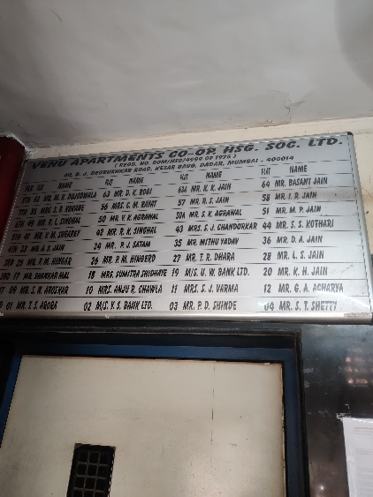
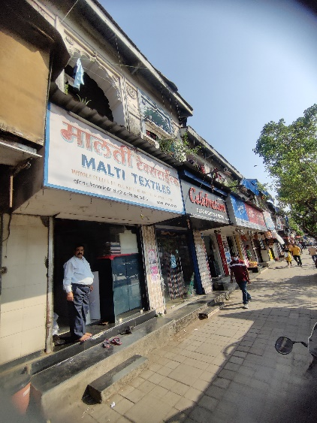
0

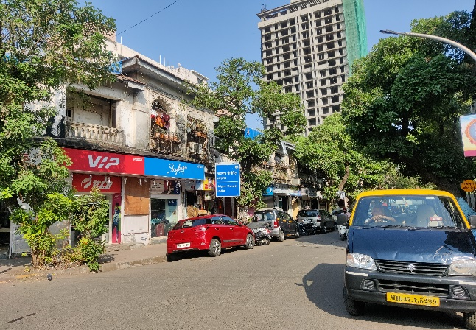
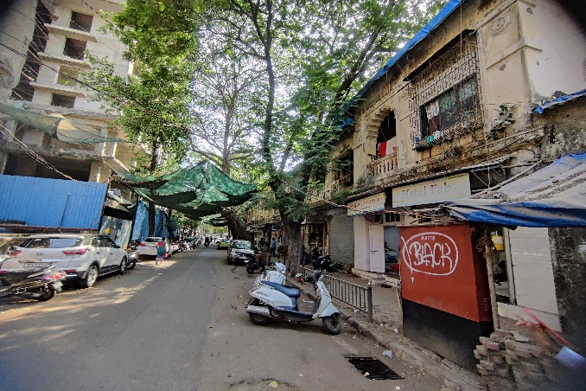

Route Map of the property
Site u/r
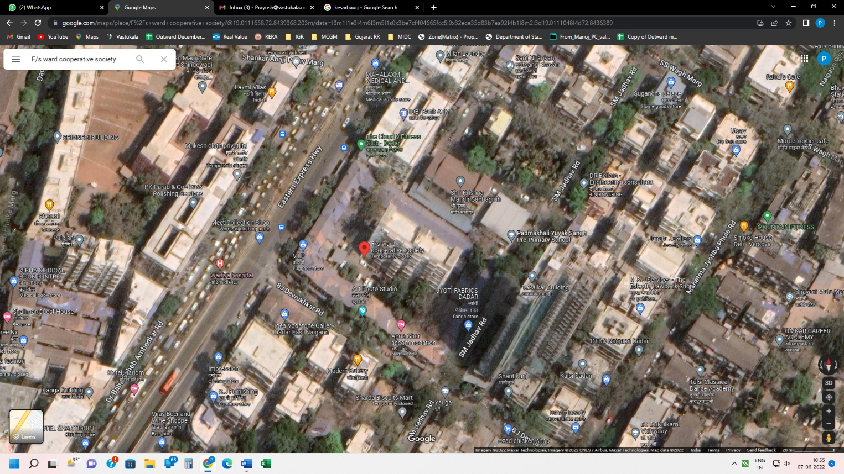

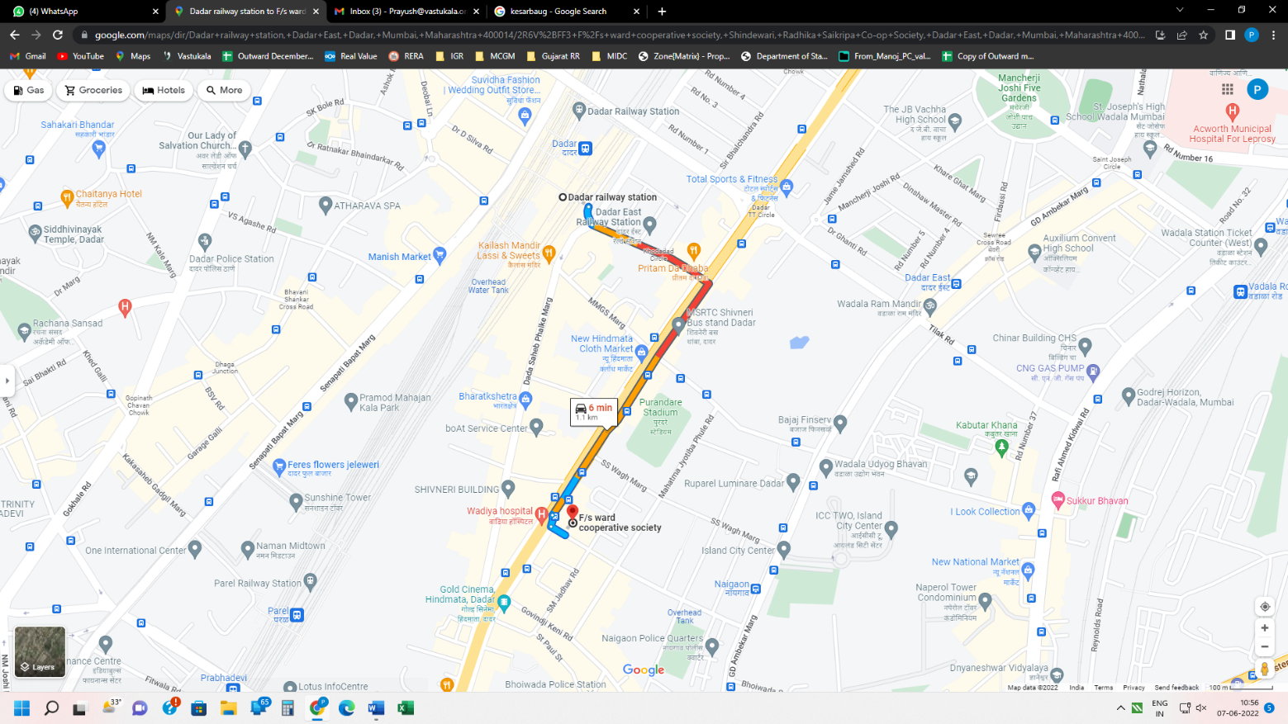

Latitude Longitude: 19°00'40.4"N 72°50'37.9"E
Note: The Blue line shows the route to site from nearest Railway station (Dadar – 1.10 Km.)

Ready Reckoner 2021 – 22

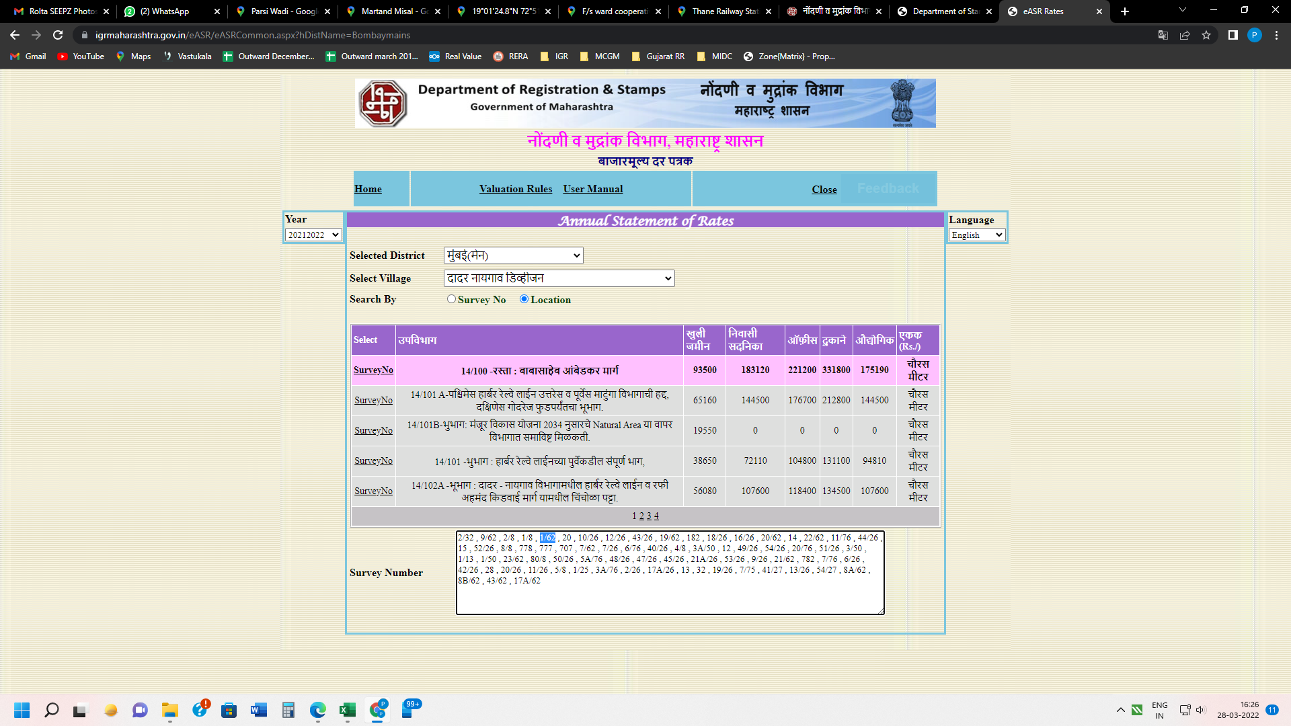

Details of assets:

Particulars
Year of Construction / Age of Building
Area of Land | 5,574.46
Basic FSI | 1.33
Permissible F.S.I. | 4.00
Total Allowable Area of Plot | 27,712.93
Net Built Up Area | 27,712.93
Total Built up area occupied by the eligible Tenants | 8,521.74
Total area occupied by the Owners (inclusive of area under non eligible tenants) | -
Total Monthly Rent from the Tenants | 12,193.00

Structure Area As per Concession Drawing Plan: -
Sr. No. | Particulars | Carpet Area in Sq. M. | Built Up Area in Sq. M.
1 | Ground Floor Structure of Chawl No. 1 | 1,645.30 | 1,974.36
2 | First Floor Structure of Chawl No. 1 | 1,331.45 | 1,597.74
3 | Ground Floor Structure of Chawl No. 2 | 471.14 | 565.37
4 | First Floor Structure of Chawl No. 2 | 454.58 | 545.50
5 | Venu Apartment | 3,198.98 | 3,838.78
TOTAL |  | 7,101.45 | 8,521.74

Guideline for valuation
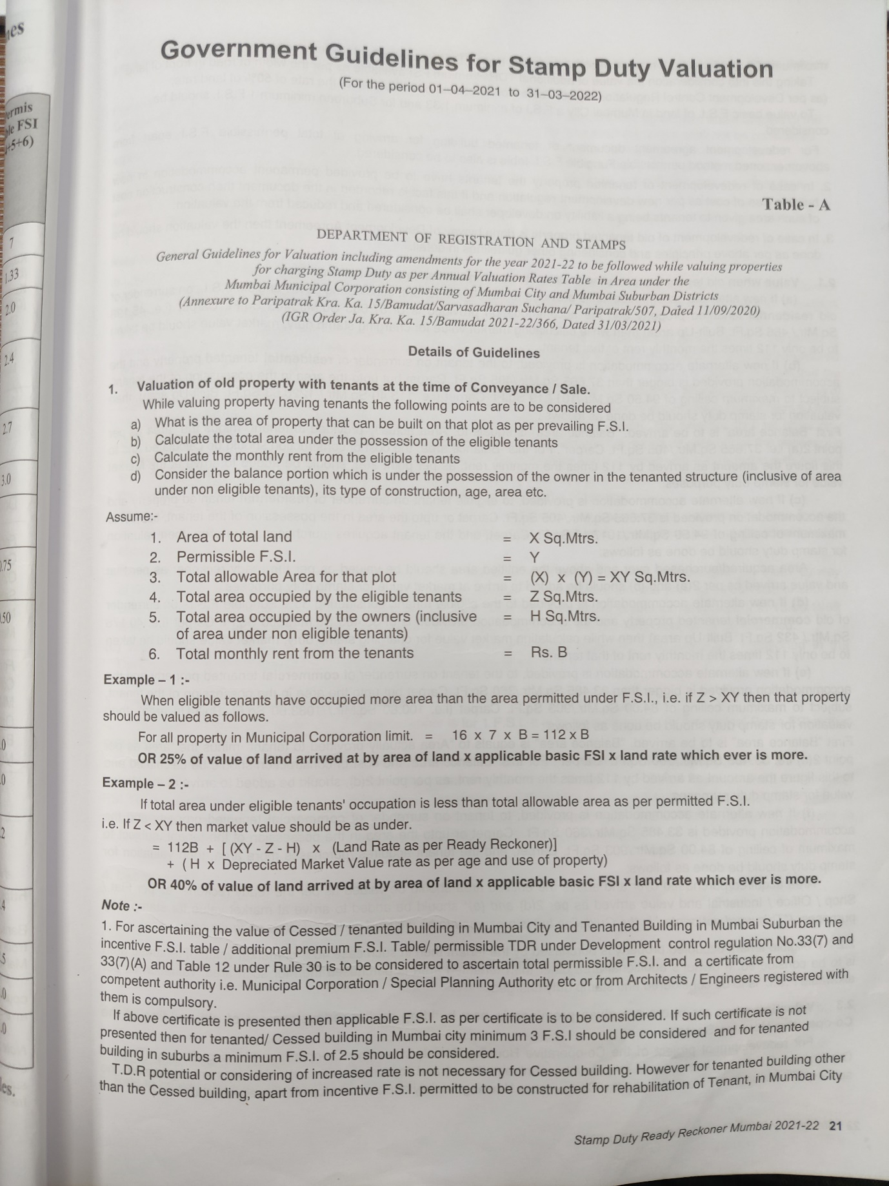

As per guideline for the period 01.04.2021 to 31.03.2022 example 1 is not considered for the calculation because permissible prevailing FSI is more than existing tenant built up area, hence we have considered example 2 for the valuation purpose.

Particulars
Year of Construction / Age of Building | -
Area of Land (Sq. M.) (X) | 5,574.46
Basic FSI | 1.33
Permissible F.S.I. (Y) | 4.00
Total Allowable Area of Plot (Sq. M.) (XY) | 27,712.93
Net Built Up Area (Sq. M.) | 27,712.93
Total area occupied by the eligible Tenants (Sq. M.) (Z) | 8,521.74
Total area occupied by the Owners (inclusive of area under non eligible tenants) (H) | -
Total Monthly Rent from the Tenants (B) | ` 12,193.00
Land Ready Reckoner Rate for 2022 – 2023 | ` 93,500.00
Rate for Construction | ` 30,250.00
Value As on 31.03.2022 | ` 179,57,41,881.00
Value As on 31.03.2022 in Cr. | ` 179.57

Land Valuation with Structure:

Land & Structure Details

Land Value: -

Method 1:
Total area under eligible tenants’ occupation is less than total allowable as per permitted FSI i.e., IF Z < XY then market value should be as under.
Value = 112(Monthly Rent from the tenants) + ((Total Allowable Area of plot - Total area occupied by the eligible Tenants - Total area occupied by the Owners) X (Land Ready Reckoner Rate)) + (Total area occupied by the Owners X Depreciated Market Value as per age and use of the property)
Value = 112(12,193.00) + ((27,712.93 - 8,521.74 – 0) X 93,500) + (0 X 0)
Value = 13,65,616 + 1,79,43,76,265
Value = 179,57,41,881.00

Method 2:
40% of Value of land arrived at by area of land X applicable basic FSI X land rate
Value = 40% X 5,574.46 X 1.33 X 93,500.00
Value = 27,72,84,789.00

Hence, from method 1 value of the property is coming on higher than method 2. Hence, we have considered value from method 1 which is ` 179,57,41,881.00
` 179,57,41,881.00; Say (Rupee One Hundred Seventy-Nine Crore Fifty-Seven Lakh Forty-One Thousand & Eight Hundred Eighty-One Only).

Summary of Valuation:

The value adopted or assessed or assessable by any authority of the Government for the purpose of payment of stamp duty in respect of the immovable property shall be ` 179,57,41,881.00; Say (Rupee One Hundred Seventy-Nine Crore Fifty-Seven Lakh Forty-One Thousand & Eight Hundred Eighty-One Only).

Conclusion

Name of Client | M/s. Nandivardhan Group (Builders & Developers)
Asset being Valued | Proposed Residential Project
Intended Users | M/s. Nandivardhan Group (Builders & Developers)
Valuation Currency | Indian Rupees (INR) / `
Purpose of Valuation | Stamp Duty Value
Valuation Standards Referred | Income Tax – Rule 11UA
Basis of Value | Stamp Duty Value
Premises for value | Highest and Best Use (HABU)
Valuation Date | 31.03.2022
Valuation Approach | As per Guideline Standard of Year 2021 - 2022
Valuation Methodology | Market value (Stamp duty)
Value of Assets | ` 179,57,41,881/-

Sharadkumar B. Chalikwar
Govt. Reg. Valuer
Chartered Engineer (India)
Reg. No. (N) CCIT/1-14/52/2008-09

