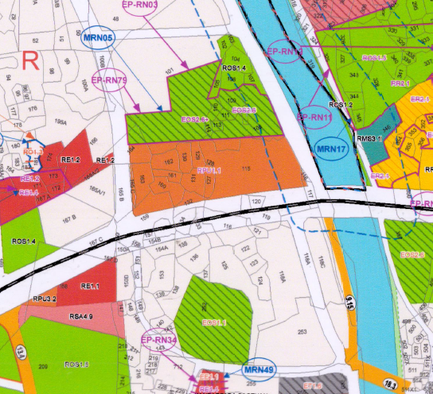
CTS No. 106, 111, 120, 122, 132, 139, 148, 161

