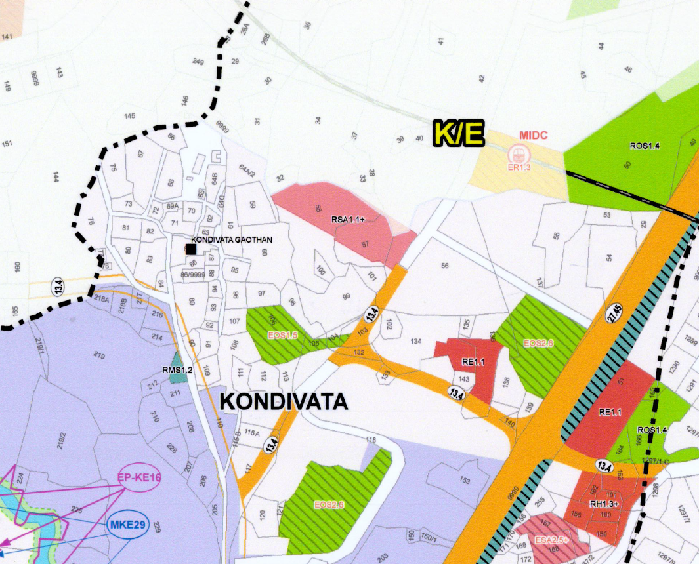
CTS No. 86, 86/1 to 8, CTS No. 88 - Total Plot Area : 1244.80 sq.mt

