Vastu/Nashik/03/2023833/30490/46262
22/24-455-RPV
Date: 06.03.2024

To, `
The Branch Manager,
State Bank of India
Maharashtra Eng. Research institute Branch
Dindori Road, MERI, Nashik, Maharashtra, Nashik - 422004,
State - Maharashtra, Country - lndia.

Sub: Vetting of Extra Amenities

Sir,

With reference to above subject, we have evaluated the Extra Amenities for Residential Row Bungalow on Plot No. 85/ C, Ground + First Floor “Shree Ganga Bungalows”, Survey No. 299/ 1/ Plot/ Number/ 85/ C/, Near Amrutvan Garden , Village – Makhmalabad-2,Taluka & District – Nashik, PIN – 422 004, State – Maharashtra, Country – India belongs to Name of Shri. Jinesh Ashanand Thakkar. Name of Proposed Purchaser: Shri. Chandrakant Dhanraj Zirwal & Chaitali Chandrakant Zirwal (Alies) Chaitali Uttam Bharsat.

We have verified the rates quoted as per current market rates. Details of work and Extra Amenities considered as per copy of Extra Amenities issued by Shri. Chandrakant Dhanraj Zirwal & Chaitali Chandrakant Zirwal (Alies) Chaitali Uttam Bharsat (First Party) and Tushar Sundarji Thakkar (Second Party) received on dated 04.03.2024. The Extra Amenities amount is Rs.5,00,000/- ( Rupees Five Lakh Only. )

The said Cost Vetting Certificate is valid upto next 6 months Only.

Thanking you

Sincerely yours

Manoj B. Chalikwar
Registered Valuer
Chartered Engineer (India)
Reg. No. CAT-I-F-1763
Reg. No. IBBI/RV/07/2018/10366
BOB Empanelment No.: ZO:MZ:ADV:46:941
Encl: Valuation report.

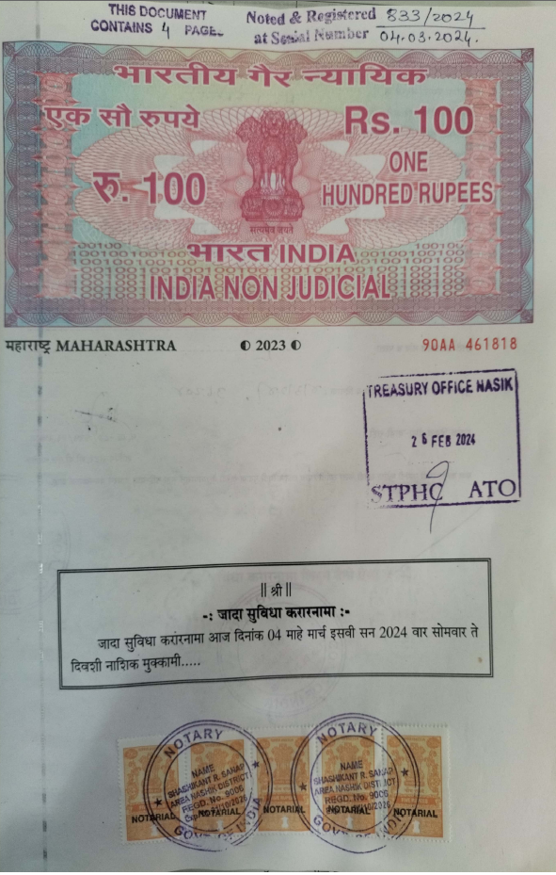
Agreement for Extra Amenities
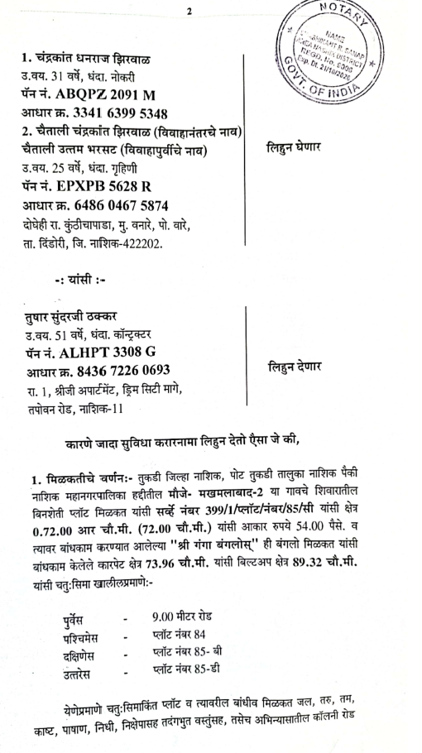

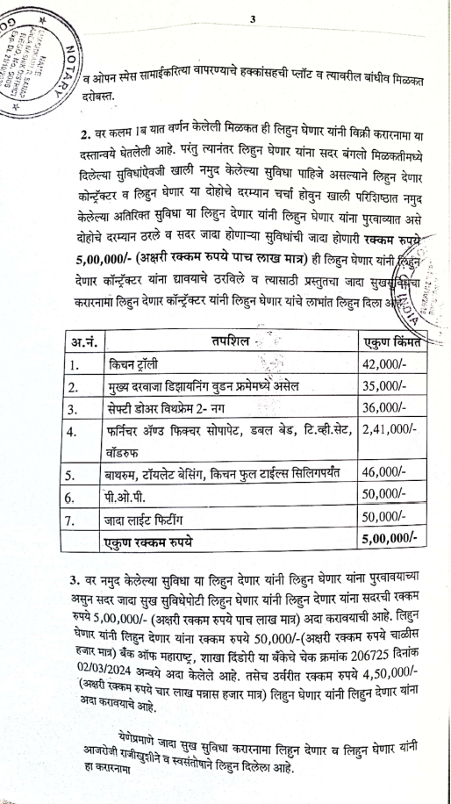
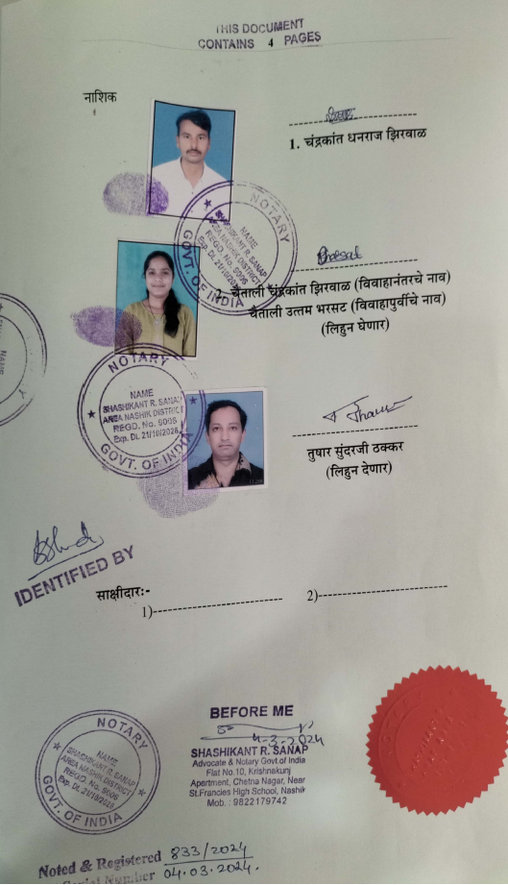

The Extra Amenities amount is Rs.5,00,000/- ( Rupees Five Lakh Only. )

