` ```Asset Verification Report Prepared for: SFSPL / M/s. Zenith Quality Assessors Private Limited. (7456/2305334)

Vastu/Thane/03/2024/7456/2305334
05/13-82 APU
Date: 05.03.2024

Asset Verification Report

1 General Information
Agreement Number: | A10127554
Label Number: | L1714B
Customer: | M/s. Zenith Quality Assessors Private Limited
Address of Asset Location: | M/s. Astute Labs Pvt. Ltd. Bajirao Dhawade Patil Industrial Estate, Dangat Patil Nagar, NDA Road, Shivane, District Pune - 411023, Maharashtra, India.
Asset/s financed as per Agreement | Sl.no | Asset Description | Model | Supplier | Quantity
 | 1 | Preekem Microwave Digestion system | M3 | Toshvin Analytical Pvt. Ltd. | 1 Set
Name Plate | ☑ Available ◻ Not Available |  | ☑Visible ◻ Not Visible
Serial number (On Asset) | ☑Available ◻ Not available If Available – Refer Photos
Serial number (in Invoice): (If available) | Not Available
Type of Foundation for Asset (wherever applicable) | ◻ Steel supporting structure |  | ◻ Concrete floor ☑ Other
Level of Bondage | ☑ Asset easy to remove |  | ◻ Asset fixed permanently
Description of the premises : | ◻ Manufacturing Facility ◻ Hospital ◻ Warehouse ◻ Office Premises  ☑ Diagnostic ◻ Others (Please specify): _________________________________
Asset influencing circumstances ( i.e Chemical Zone, Corrosive atmosphere, Highly Polluted location etc.,) : | ◻Yes  If yes, please specify: |  | ☑ No

2 Asset Condition
Optical impression of physical condition of Asset: | ◻ Excellent ☑ Good ◻ Fair ◻ Poor ◻ Very Poor
Was the asset in operation at the time of Inspection | ☑ Yes ◻ No If No Please specify reasons
Age of the Asset at the time of inspection | ~ 9 Months
Asset condition at the time of purchase | ☑New ◻Used
Any Breakdown in the machine | ◻ Yes ◻ No ☑ Not Known
Photos: | ☑ Yes | ◻ No

3 Information About Onsite Visit
Date of Onsite Visit: | 02/03/2024
Latitude & Longitude | 18°28'11.3"N 73°47'22.8"E
Customer Personnel met at site: | Mr. Kunal (Technician)
Report created at | Mumbai

For Vastukala Consultants (I) Pvt. Ltd.

Umang Ashwin Patel
Regd. Valuer
Chartered Engineer (India)
Reg. No. IBBI/RV/04/2019/10803

Photographs

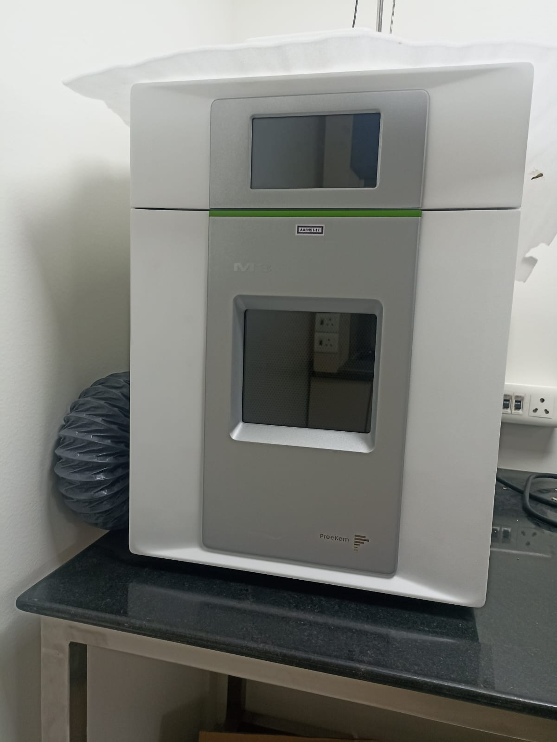 | 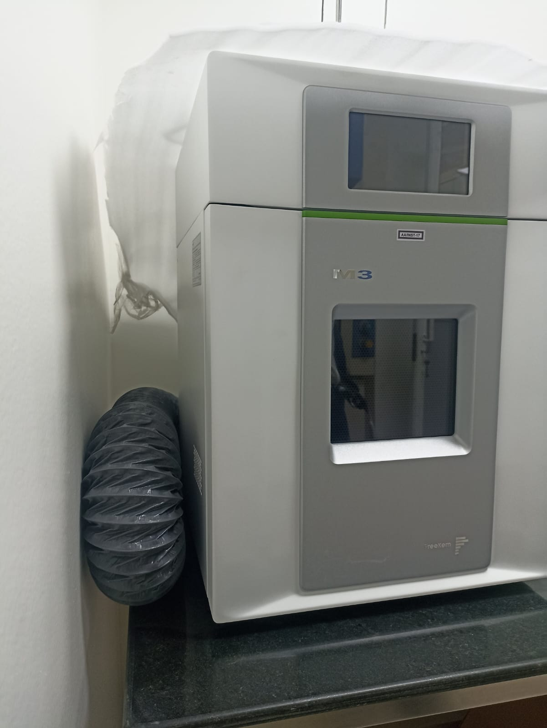
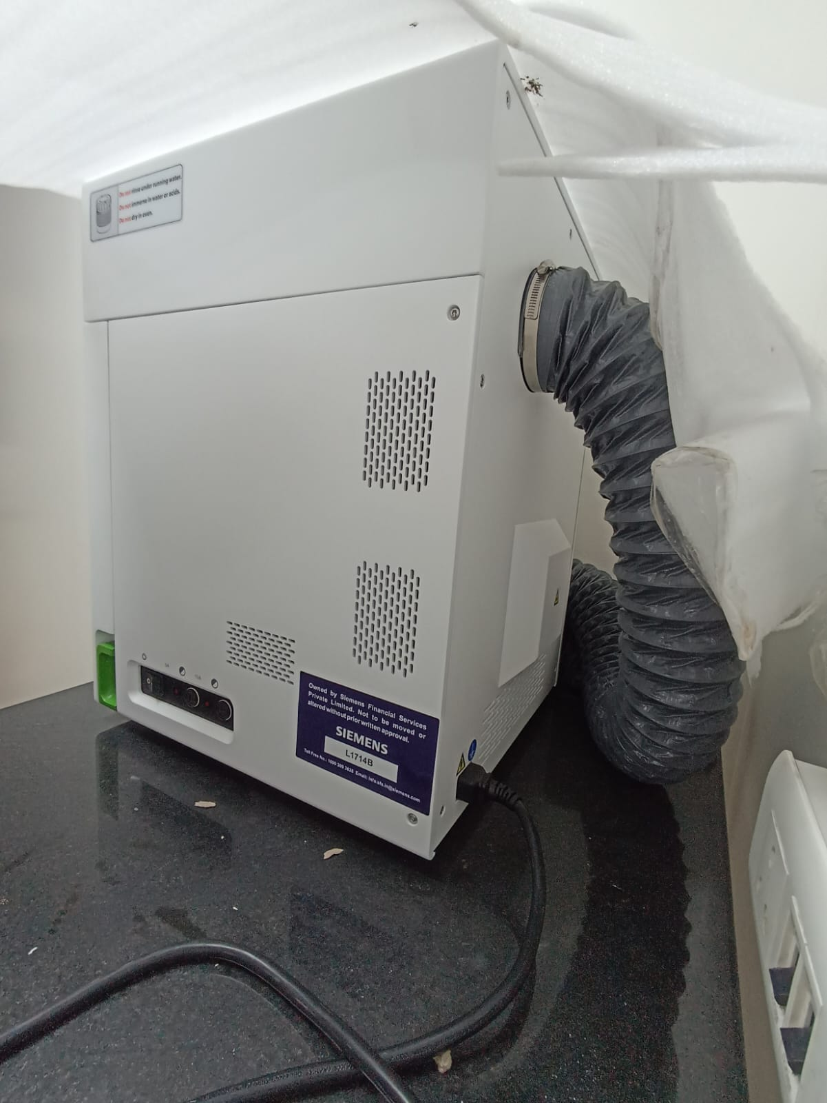 | 