Asset Verification Report Prepared for: SFSPL / M/s. G Nam Valves and Fittings. (7450/2305093)

Vastu/Thane/03/2024/7450/2305093
22/6-315 APU
Date: 05.03.2024

Asset Verification Report

1 General Information
Agreement Number: | A10195382
Label Number: | L1715B
Customer: | M/s. G Nam Valves and Fittings
Address of Asset Location: | Unit No. 412, 1st floor, Parmar Industrial Complex, Hazi Abdul Kadir Ansari Marg, Kalbhor Nagar, MIDC, S. No. 142/1, Akurdi, Chinchwad East, District Pune - 411019, Maharashtra, India.
Asset/s financed as per Agreement | Sl.no | Asset Description | Model | Supplier | Quantity
 | 1 | Smarturn CNC Lathe - Fanuc | Smarturn | Laxmi Machine Works Limited | 1 Set
Name Plate | ☑ Available ◻ Not Available |  | ☑Visible ◻ Not Visible
Serial number (On Asset) | ☑Available ◻ Not available If Available – Refer Photos
Serial number (in Invoice): (If available) | Serial No. 55-08108
Type of Foundation for Asset (wherever applicable) | ☑ Steel supporting structure |  | ◻ Concrete floor ◻ Other
Level of Bondage | ☑ Asset easy to remove |  | ◻ Asset fixed permanently
Description of the premises : | ☑ Manufacturing Facility ◻ Hospital ◻ Warehouse ◻ Office Premises  ◻Diagnostic ◻ Others (Please specify): _________________________________
Asset influencing circumstances ( i.e Chemical Zone, Corrosive atmosphere, Highly Polluted location etc.,) : | ◻Yes  If yes, please specify: |  | ☑ No

2 Asset Condition
Optical impression of physical condition of Asset: | ◻ Excellent ☑ Good ◻ Fair ◻ Poor ◻ Very Poor
Was the asset in operation at the time of Inspection | ☑ Yes ◻ No If No Please specify reasons
Age of the Asset at the time of inspection | ~ 6 Months
Asset condition at the time of purchase | ☑New ◻Used
Any Breakdown in the machine | ◻ Yes ◻ No ☑ Not Known
Photos: | ☑ Yes | ◻ No

3 Information About Onsite Visit
Date of Onsite Visit: | 02/03/2024
Latitude & Longitude | 18°39'02.0"N 73°47'35.2"E
Customer Personnel met at site: | Mr. Indrajit (Operator)
Report created at | Mumbai

For Vastukala Consultants (I) Pvt. Ltd.

Umang Ashwin Patel
Regd. Valuer
Chartered Engineer (India)
Reg. No. IBBI/RV/04/2019/10803

Photographs

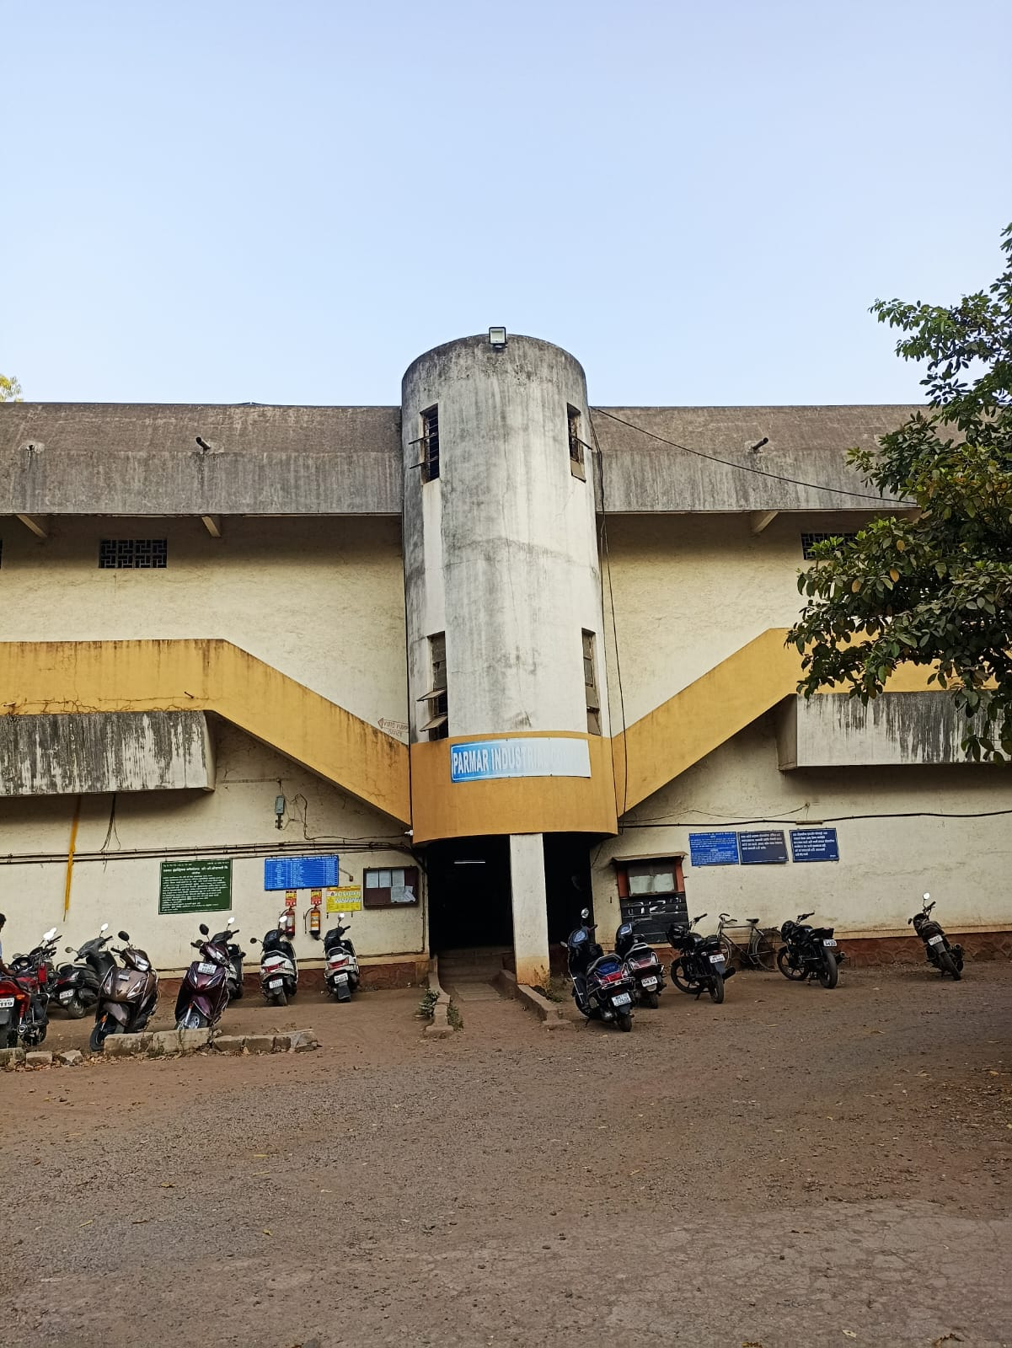 | 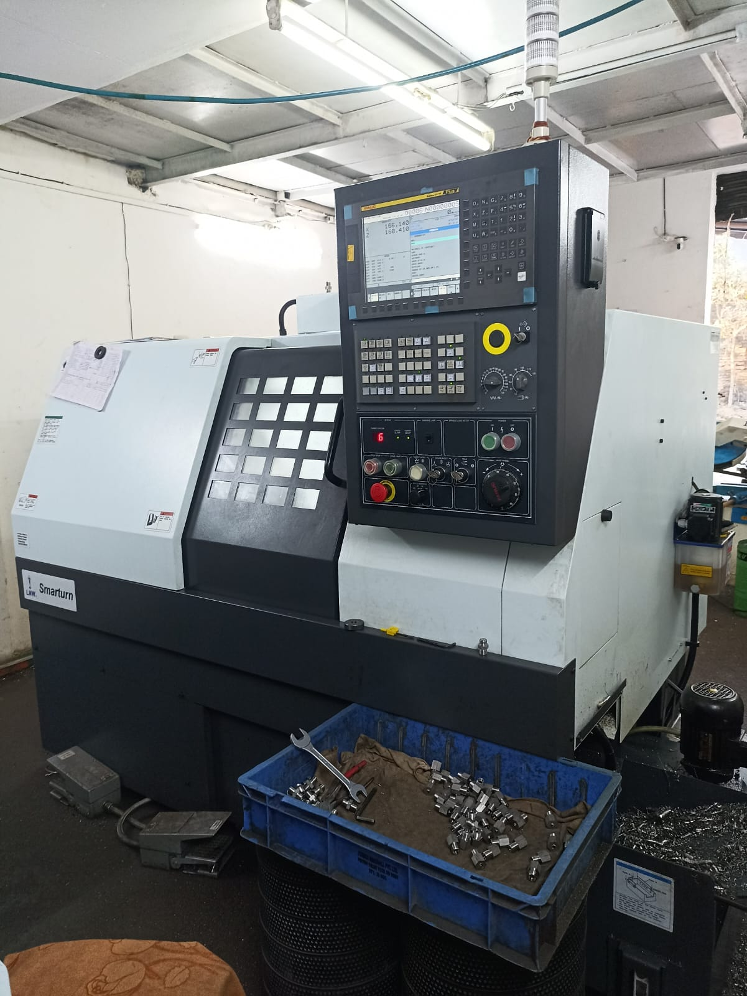
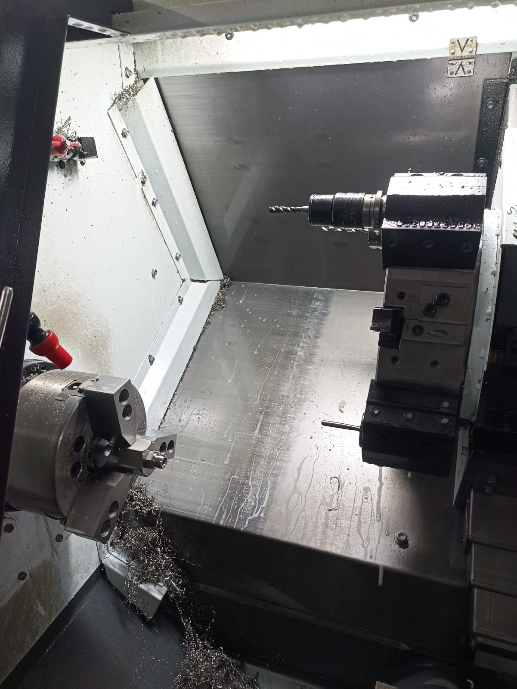 | 