**Glass Wall Systems (I) Private Limited (GWSIPL)** is India’s leading facade fabricator. They provide turnkey architectural facade solutions.

They are headquartered in Mumbai, with a strong presence in Bangalore, Delhi, NCR, Kolkata, Ahmedabad, Hyderabad and Pune. They have also expanded their operations and expertise to Sri Lanka, where they offer a full range of glazing systems and custom-designed architectural metal works.

### Corporate Information

|  |  |
| --- | --- |
| **CIN** | U74999MH2010PTC207187 |
| **Company / LLP Name** | Glass Wall Systems (India) Private Limited |
| **ROC Code** | RoC-Mumbai |
| **Registration Number** | 207187 |
| **Company Category** | Company limited by Shares |
| **Company Sub-Category** | Non-govt company |
| **Class of Company** | Private |
| **Authorised Capital (INR)** | 26,00,00,000 |
| **Paid up Capital (INR)** | 19,43,82,350 |
| **Number of Members (Applicable in case of company without Share Capital)** | 0 |
| **Date of Incorporation** | 27/08/2010 |
| **Registered Address** | 503/504, 5th floor, A wing, Marathon Futurex, Mafatlal Mills Compound, N. M. Joshi Marg, Lower Parel (W), Mumbai 400 013. |
| **Email Id** | [cs@glasswallsystem.com](mailto:cs@glasswallsystem.com) |
| **Whether Listed or not** | Unlisted |
| **Date of last AGM** | November 30, 2021 |
| **Date of Balance Sheet** | March 31, 2021 |
| **Company Status(for efiling)** | Active |

### Details of the Directors

|  |  |  |  |  |
| --- | --- | --- | --- | --- |
| **Sr. No.** | **DIN** | **Director Name** | **Begin Date** | **End Date** |
| 1 | 00740482 | Jawahar Hariram Hemrajani | 27/08/2010 | - |
| 2 | 00740645 | Kamlesh Arjunlal Choudhari | 27/08/2010 | - |
| 3 | 02987268 | Sunita Kamlesh Choudhari | 26/09/2014 | - |
| 4 | 02987292 | Eshan Jawahar Hemrajani | 26/09/2014 | - |
| 5 | 03043874 | Prakash Bagla | 26/09/2014 | - |
| 6 | BEFPC5870N | Rajeshree Maruti Chougule | 15/02/2022 | - |
| 7 | AUWPS9748R | Sanjay Suresh Sawant | 27/02/2020 | - |

*\*information culled out from* [*http://www.mca.gov.in/mcafoportal/viewCompanyMasterData.do*](http://www.mca.gov.in/mcafoportal/viewCompanyMasterData.do)

# Immovable Assets at Mangaon

### Location

The subject property is a leasehold Industrial Plot No. D-120, MIDC, Vile Bhagad Industrial Growth Centre, Village Warchiwadi, Taluka Mangaon, District Raigad, Maharashtra, India. The geographical location of the subject property is as mentioned below:

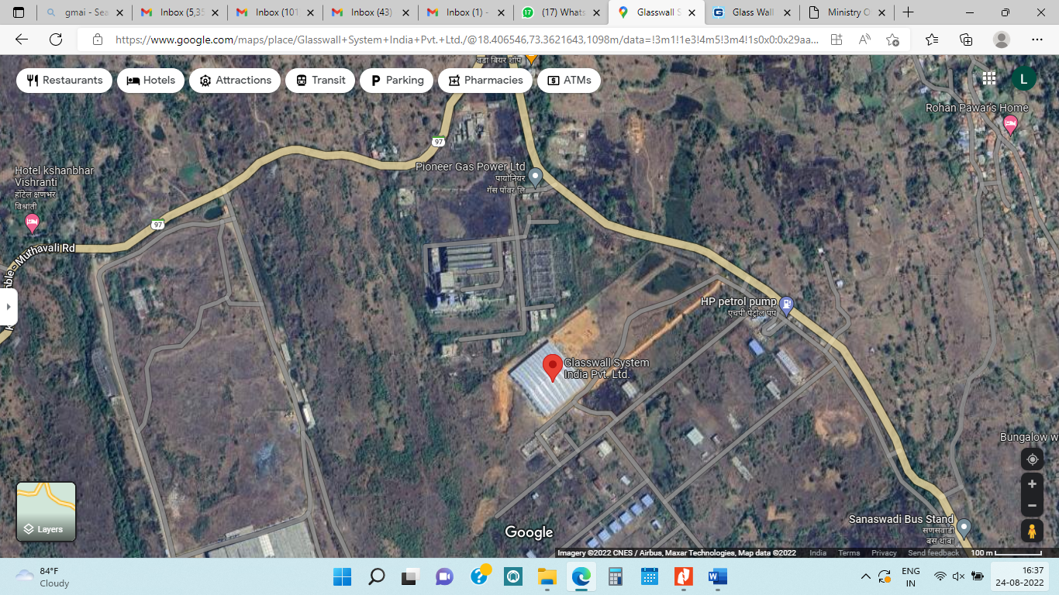

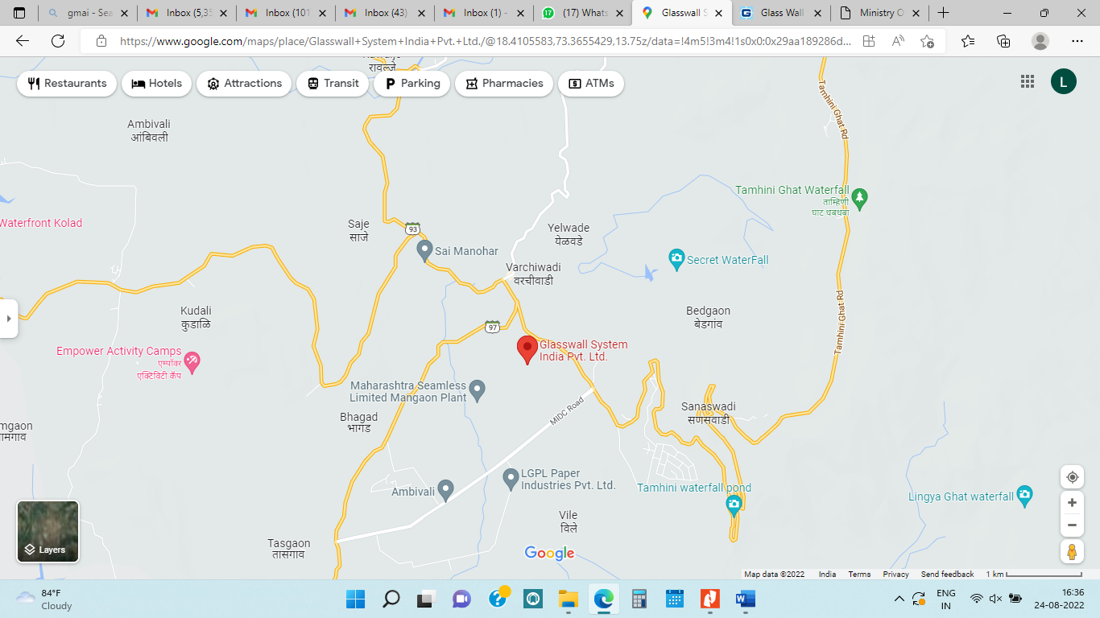

**Google Co-ordinates – 18°24'18.4"North 73°21'45.4" East.**

**The boundaries of the said property are as below –**

|  |  |
| --- | --- |
| **North** | Open Space |
| **South** | Open Space |
| **East** | Internal Road and Adjoining Main Road |
| **West** | Open Space |

**The locational advantages of the said property are as below –**

|  |  |  |
| --- | --- | --- |
| **Nearest Railway Station** |  | Mangaon Railway Station **(23.9 km.)** |
| **Nearest Bus Stop** |  | Mangaon Bus Stop **(23 km.)** |
| **Nearest Airport** |  | Pune International Airport **(102 km.)** |
| **Nearest National Highway** |  | Khadsamble Muthavali Road **(500 mtr.)** |

### K&A Observation

* The subject property under valuation is a leasehold Industrial land with building structure thereon.
* During our site inspection, the said factory was in operation.
* The said building structure comprises of ground floor only.
* The said factory / land does not have any demarcation.
* The levelling of land is done only where the shed is constructed, levelling for the rest of land is yet to be done.
* The said factory is paved with Cement Concrete.
* The said building structure is in good condition.
* We were not permitted to enter the said factory building.

### Valuation of Land

The said property is a leasehold Industrial Plot No. D-120, MIDC, Vile Bhagad Industrial Growth Centre, Village Warchiwadi, Taluka Mangaon, District Raigad, Maharashtra, India. Usually, Market Approach to Valuation is adopted for estimating the Market Value of the said Land. In this approach, the Sales Comparison Method of Valuation is adopted in which due weightages have been given to factors such as:

* The Right to Sell / Transfer / Lease the Land
* Demand and Prospective buyers for such type of Industrial plots
* Shape, Size, Prominence and Location of Land
* The Marketability, Utility, Demand and Supply of Industrial land in the surrounding area. The land rates as evident from the Sell Instances of comparable land found upon market enquiry.
* Legal and Physical Encumbrance on Land
* Freehold or Leasehold nature of Land, etc.

**Guideline MIDC Rate 2022-2023:**

The Guideline MIDC Rate for the village under our consideration is as tabulated below:

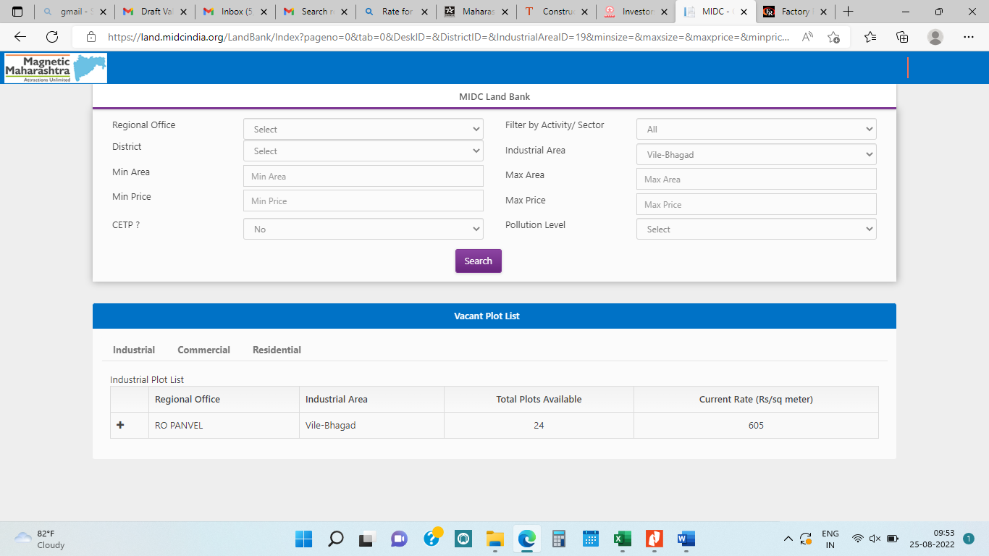

As per the above attached evidence the **MIDC Industrial Land Rate for the** **year 2022-2023** given by **Maharashtra Industrial Development Corporation (MIDC)** at Village Warchiwadi is **INR 605 per sq. mtr.** Thus, the **Guideline Value** of the said land parcel is as tabulated below:

|  |  |  |  |  |
| --- | --- | --- | --- | --- |
| **Sr. No.** | **Plot No.** | **Area in sq. mtr.** | **Guideline Land Rate in INR/sq. mtr.** | **Guideline Land Value**  **in INR Lakh** |
| 1 | D-120 | 1,01,299 | 605 | 612.86 |
|  | **Total:** |  |  | **612.86** |

The **Guideline Value** of the said leasehold Industrial Land bearing Plot No. D-120, MIDC, Vile Bhagad Industrial Growth Centre, Village Warchiwadi, Taluka Mangaon, District Raigad, Maharashtra, Indiais **INR 6.13 Crore.**

**Market Rate 2021-2022**

**Benchmark -1**

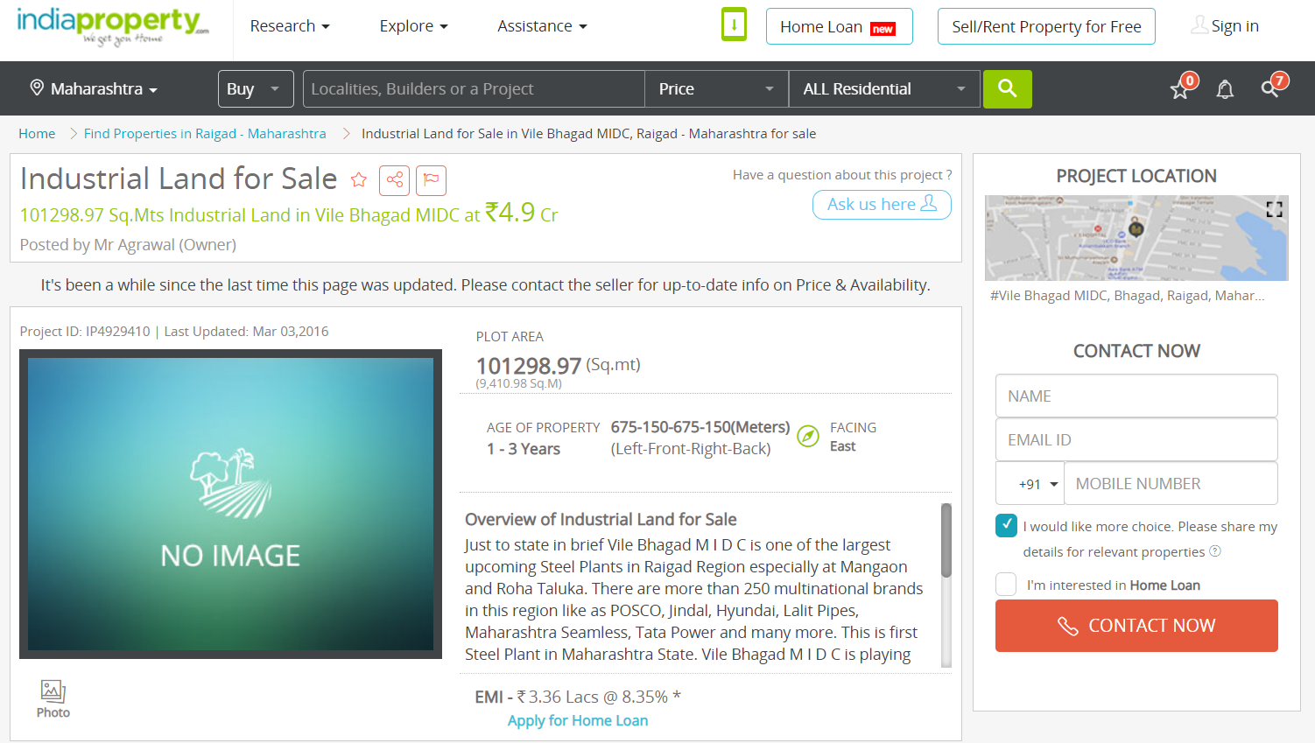

**Benchmark -2**

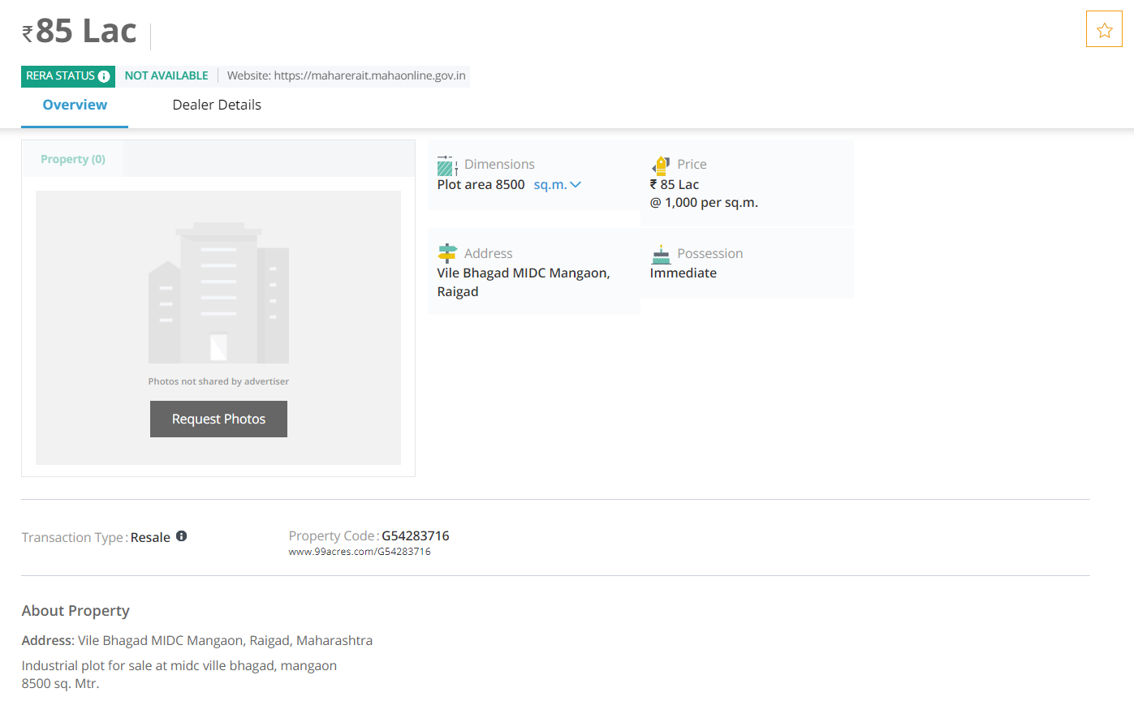

**Rate Matrix**

|  |  |  |  |
| --- | --- | --- | --- |
| **Particulars** | **Benchmark 1** | **Benchmark 2** | **Benchmark 2** |
| Transaction / Listing | Web Instance | Web Instance | Broker Enquiry |
| Property Location | Vile Bhagad | Vile Bhagad | Vile Bhagad |
| Property Type | MIDC Industrial Land | MIDC Industrial Land | MIDC Industrial Land |
| Property Rights | Leasehold | Leasehold | Leasehold |
| Current approved land use | Industrial | Industrial | Industrial |
| Approx. Area in sq. mtr. | 1,01,298.82 | 8,500.00 | 80,940.00 |
| Asking Rate per sq. mtr. | 483.72 | 1,000.00 | 741.29 |
| Asking Value (INR Crore) | 4,90,00,000 | 85,00,000 | 6,00,00,000 |
| **Adjustments** |  |  |  |
| Listing Discount | 0.00% | 0.00% | 0.00% |
| Discount for Land Type | 0.00% | 0.00% | 0.00% |
| Discount for Land Size | 0.00% | 0.00% | 0.00% |
| Location & Access | 0.00% | 0.00% | 0.00% |
| Market Liquidity Discount | 0.00% | 0.00% | 0.00% |
| **Total Adjustments** | 0.00% | 0.00% | 0.00% |
| **Adjusted Rate for NA Land in INR per sq. mtr.** | **483.72** | **1,000.00** | **741.29** |
| **Average rate per sq. mtr** | **741.67** |  | |
| **Say** | **750.00** |

As per our online market research, we understood that the Market Rate for the MIDC Industrial Land in the similar vicinity are been sold in the range between **INR 450 to INR 850 per sq. mtr.** Hence, we have considered the rate of **INR 750 per sq. mtr.** for the valuation purpose considering the location, size & usage of the said property.

Thus, the Market Value of the said land parcel for **GWSIPL** is as tabulated below:

|  |  |  |  |  |
| --- | --- | --- | --- | --- |
| **Sr. No.** | **Plot No.** | **Area in sq. mtr.** | **Market Rate  in INR/sq. mtr.** | **Market Value in INR Lakh** |
| 1 | D-120 | 1,01,299 | 750 | 759.74 |
|  |  |  | **Total:** | **759.74** |

The **Market Value** of the said leasehold MIDC Industrial Land bearing Plot No. D-120, MIDC, Vile Bhagad Industrial Growth Centre, Village Warchiwadi, Taluka Mangaon, District Raigad, Maharashtra, India,belonging to **GWSIPL** as on date of valuation using **Sales Comparison Method** of **Market Approach** of valuation is **INR 7.60 Crore.**

### Valuation of Building Structures

The detailed description of the building structure under valuation belonging to **GWSIPL** is as tabulated below:

|  |  |  |  |  |  |  |  |  |
| --- | --- | --- | --- | --- | --- | --- | --- | --- |
| **Sr. No** | **Particular** | **Asset Description** | **Built-up Area Sq. mtr.** | **Built-up Area Sq. mtr. as per physical measurement** | **Year of Construction** | **Age** | **Total Useful Life in years** | **Residual Life in years** |
| 1 | A-1 Building (Shed) | PCC flooring with walls and roofing of G.I. sheet having central height of 48 ft. and side height of 28 ft. | 13,530 | 13,530 | 2018 | 4 | 45 | 41 |
|  | **Total** |  | **13,530** | **13,530** |  |  |  |  |

*Our valuation report is based on the Built-up Area which is identified in Occupancy Certificate Ref. No.* *IFMS No./SPA/VBIA/D-79100 of 2018 dated November 14, 2018 issued by MIDC.*

The Market Value of the building structure for **GWSIPL** is as tabulated below:

***Values in INR Lakh***

|  |  |  |  |  |  |  |  |
| --- | --- | --- | --- | --- | --- | --- | --- |
| **Sr. No.** | **Particular** | **Built-up Area Sq. mtr.** | **Replacement Rate (INR per sq. mtr.)** | **Replacement Value** | **Depreciated Replacement Cost (DRC)** | **Discount for Obsolescence** | **Market**  **Value** |
| 1 | A-1 Building (Shed) | 13,530 | 22,500 | 3,044.25 | 2,787.18 | 111.49 | 2,675.69 |
|  | **Total** | **13,530** |  | **3,044.25** | **2,787.18** | **111.49** | **2,675.69** |

The **Market Value** of the said building structure standing on leasehold MIDC Industrial Land bearing Plot No. D-120, MIDC, Vile Bhagad Industrial Growth Centre, Village Warchiwadi, Taluka Mangaon, District Raigad, Maharashtra, India for **GWSIPL** as on date of valuation, using **Depreciated Replacement Cost Method** of **Cost Approach** of valuation, is **INR 26.76 Crore.**

# Valuation Summary

The valuation summary of Immovable Assets for **GWSIPL** is as tabulated below:

***Value in INR Crore***

|  |  |  |  |  |  |
| --- | --- | --- | --- | --- | --- |
| **Particular** | **Government Guideline Value** | **Replacement Value** | **Market Value** | **Realizable Value** | **Distress Sale Value** |
| Land | 6.13 |  | 7.60 | 6.84 | 6.08 |
| Building |  | 30.44 | 26.76 | 24.08 | 21.41 |
| **Total:** | **6.13** | **30.44** | **34.35** | **30.92** | **27.48** |

***\*\*\*Realizable Value is 90% of Market Value & Distress Sale Value is 80% of Market Value***

Thus, as on date of valuation the **Market Value** of the said Immovable Assets located at MIDC, Vile Bhagad Industrial Growth Centre, Village Warchiwadi, Taluka Mangaon, District Raigad, Maharashtra, India for **GWSIPL** using **Market & Cost Approach of valuation** is **INR 34.35 Crore**. The **Realizable Value** of the said asset is **INR 30.92 Crore** and the **Distress Sale Value** of the same is **INR 27.48 Crore**.

The **Replacement Value** of the said building is **INR 30.44 Crore.**

The **Government Guideline Value** of the said land is **INR 6.13 Crore.**

# Annexure I: Photographs

|  |  |
| --- | --- |
|  |  |
|  |  |
|  |  |
|  |  |
|  |  |
|  |  |

# Annexure II: Factory Plan

# Annexure III: Occupancy Certificate

