Valuation Report of the Immovable Property
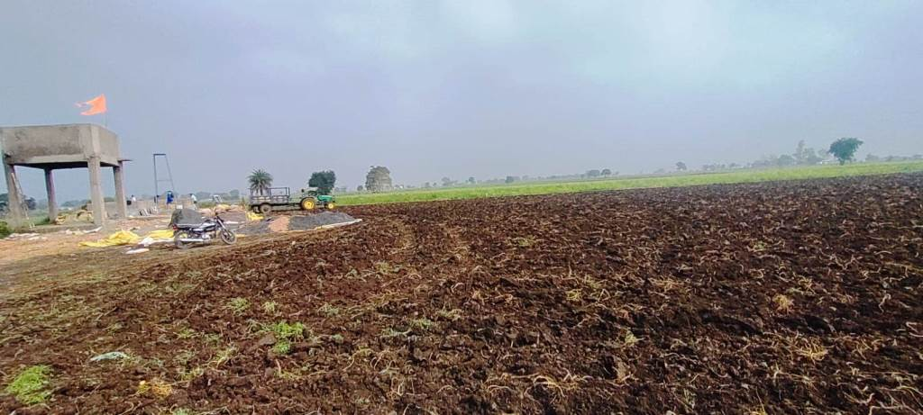

Details of the property under consideration:

Name of Owner: Harinarayan S/o Bhagirath,
Mahesh S/o Bhagirath &
Sitabai W/o Late Bhagirath

Commercial Land bearing Survey No. 779/6/1/2 & 779/6/2, Patwari Halka No. 20, Patalpani Road,
Gram - Kodariya, Tehsil - Mhow, District - Indore, PIN – 453 441
State – Madhya Pradesh, Country – India

Latitude Longitude - 22°30'30.2"N 75°45'54.1"E

Valuation Done for:

Bank of Maharashtra
Kodariya Branch
Gram Kodariya, Mhow, Indore, PIN – 453 441
State – Madhya Pradesh, Country – India

Vastu/Indore/03/2024/007412/2305310
04/14-58 -AKJA
Date: 29.02.2024

VALUATION OPINION REPORT

The property of Commercial Land bearing Survey No. 779/6/1/2 & 779/6/2, Patwari Halka No. 20, Patalpani Road, Gram - Kodariya, Tehsil - Mhow, District - Indore, PIN – 453 441, State – Madhya Pradesh, Country – India belongs to Harinarayan S/o Bhagirath, Mahesh S/o Bhagirath & Sitabai W/o Late Bhagirath.

Boundaries of the property:
Boundaries | :
North | : | Land of Manohar
South | : | Land of Sunil
East | : | Land of Santosh
West | : | Kachcha Road

Considering various parameters recorded, existing economic scenario, and the information that is available with reference to the development of neighborhood and method selected for valuation, we are of the opinion that, the property premises can be assessed and valued for banking purpose at ` 59,20,200/- (Rupees Fifty Nine Lakh Twenty Thousand Two Hundred Only).

The valuation of the property is based on the documents produced by the concern. Legal aspects have not been taken into considerations while preparing this valuation report.

Hence certified

Sharadkumar B. Chalikwar
Govt. Reg. Valuer
Chartered Engineer (India)
Reg. No. (N) CCIT/1-14/52/2008-09
Encl.: Valuation Report

VALUATION REPORT IN RESPECT OF IMMOVABLE PROPERTY

1. | Date of Inspection | : | 30.01.2024
2. | Purpose of valuation | : | As per request from Bank of Maharashtra, Kodariya Branch to assess Fair Market Value of the property under reference for Banking purpose.
3. | Name and address of the Valuer. | : | Sharadkumar B. Chalikwar  Vastukala Consultants (I) Pvt. Ltd.  106, 1st Floor, Gold Star Tower, Opp. Treasure Island Mall, M.G. Road, Indore – 452 001
4. | Copy Of Documents Handed Over to The Valuer by The Bank |  | - Copy of Rin Pustika  - Copy of Land Record Correction Order issued by Court Subdivisional Officer S.D.O. District Indore Against Application No. 22061554857 dated 06.12.2023 from client – Harinarayan Patidar. The land as per Order is diverted from agricultural to Commercial usage. The area is 500.00 Sq. M.  - Online Khasra Record of Survey No. 779/6/1/2 & 779/6/2
5. | Details of enquiries made/ visited to govt. Offices for arriving fair market value. | : | Market analysis and as per sub-registrar value.
6. | Factors for determining its market value. | : | Location, development of surrounding area, facilities provided and its prevailing market rate.
7. | Any Critical Aspects Associated with Property | : | No
8. | Present/Expected Income from the property | : | N.A., as the property is open land only
 | Property Details: | :
9. | Name(s) of the Owner and Postal address of the property under consideration. | : | Harinarayan S/o Bhagirath,  Mahesh S/o Bhagirath &  Sitabai W/o Late Bhagirath
 |  | : | Commercial Land bearing Survey No. 779/6/1/2 & 779/6/2, Patwari Halka No. 20, Patalpani Road, Gram - Kodariya, Tehsil - Mhow, District - Indore, PIN – 453 441, State – Madhya Pradesh, Country – India.  Contact Person:  Mr. Harinarayan (Co-Owner)  Contact No.: +91 7987744509
10. | If the property is under joint ownership/ co-ownership share of each such owner/ are the share is undivided. | : | Joint Ownership
11. | Brief description of the property:  The immovable property comprising of freehold commercial land only. The property is located in a developing area having basic infrastructure, well connected by road and train. It is located at 30.5 KM. travelling distance from Indore Junction railway station.  Nearest Landmark: Morvinanden Resort  As per Property Record / Diversion Order, the area of commercial land is as below and considered for the purpose of valuation.  At the time of visit, Survey No. 779/6/1/2 & 779/6/2 area merged and demarcation of the land boundaries is not present at site. Our civil engineer, Mr. Somesh Nahar visited the property as shown by Mr. Harinarayan (Co-Owner), Mobile No. 7987744509.
  Survey No. | Area in Sq. M. | Area in Sq. Ft.
  779/6/1/2 | 500.00 | 5,382.00
  779/6/2 | 500.00 | 5,382.00
  Total | 1,000.00 | 10,764.00
12. | Location of the property. (C.T.S. No., Survey No., Hissa No., Plot No., etc.). | : | Survey No. 779/6/1/2 & 779/6/2
13. | Boundaries of the property | : | As per Actual at Site |  | As per Document
13. | North | : | Land of Manohar |  | Information Not Available
13. | South | : | Land of Sunil |  | Information Not Available
13. | East | : | Land of Santosh |  | Information Not Available
13. | West | : | Kachcha Road |  | Information Not Available
14. | Route map | : | Enclosed
15. | Any specific identification marks | : | Morvinanden Resort
16. | Whether covered under Corporation/ Panchayat/ Municipality. | : | Gram Panchayat Kodariya
17. | Whether covered under any land ceiling of State/ Central Government. | : | No
18. | Is the land freehold/ leasehold? | : | Freehold
19. | Are there any restrictive covenants in regard to use of Land? If so attach a copy of the covenant. | : | Commercial
20. | Type of the property- Whether | :
 | Residential | : | No
 | Industrial | : | No
 | Commercial | : | Yes
 | Institutional | : | No
 | Government | : | No
 | Non – Government | : | No
 | Other (Specify) | : | N.A.
21. | In case of Agricultural land
 | Any conversion to House site is obtained | : | N.A.
 | Whether the land is dry or wet. | : | N.A.
 | Availability of irrigation facilities | : | N.A.
 | Type of crops grown | : | N.A.
 | Annual yield or income. | : | N.A.
22. | Year of acquisition/ purchase. | : | N.A., It is an ancestral property.
23. | Whether the property is occupied by owner or tenant. If occupied by tenant since how long he is staying, and the amount of rent being paid. | : | Open plot of land and under Owner’s possession
24. | Classification of the site. | :
 | a. Population group. | : | Semi-Urban
 | b. High/ Middle/ Poor class | : | Middle class
 | c. Residential/ nonresidential. | : | Non-residential
 | d. Development of surrounding area. | : | Undeveloped Area
 | e. Possibility of any threat to the property. (Floods, calamities etc.). | : | No
25. | Proximity of civic amenities.  (Like school, hospital, bus stop, market etc.). | : | All available nearby
26. | Level of the land (Plain, rock etc.) | : | Plain
27. | Terrain of the Land. | : | Leveled
28. | Shape of the land (Square/ rectangle etc.). | : | Irregular
29. | Type of use to which it can be put (for construction of house, factory etc.). | : | Commercial
30. | Any usage restrictions on the property. | : | Commercial
31. | Whether the plot is under town planning approved layout? | : | Yes
32. | Whether the building is intermittent or corner? | : | Intermittent
33. | Whether any road facility is available? | : | Yes
34. | Type of road available (B.T. / Cement Road etc.). | : | B.T. Road
35. | Front Width of the Road? | : | More than 20 ft.
36. | Source of water & water potentiality. | : | At present not available at site
37. | Type of Sewerage System. | : | At present not available at site
38. | Availability of power supply. | : | At present not available at site
39. | Advantages of the site. | : | Located in developing area
40. | Disadvantages of the site. | : | No
41. | Give instances of sales of immovable property in the locality on a separate sheet, indicating the name & address of the property, registration No. sale price and area of land sold. | : | As per Sub-Registrar of Assurance records
 | Valuation of the property:
42. | Dimensions of the plot | :
43. | Total area of the plot | : | 10,764.00 Sq. Ft.  (As per Khasra Records)
44. | Prevailing Market Rate/Price trend of the Property in the locality/city from property search sites viz magickbricks.com, 99acres.com, makaan.com etc. if available | : | ` 400/- to ` 600/- per Sq. Ft. for Commercial Land
45. | Government Rate obtained from the online government records of Land | : | ` 4,900/- per Sq. M.  i.e. ` 455/- per Sq. Ft.
46. | Building |  | N.A., as the property is open land only
47. | - Government Value
 | Particulars | : | Area in Sq. Ft. | Rate in ` |  | Value in `
 | Land | : | 10,764.00 | 455/- |  | 48,97,620/-
 | Structure |  | N.A., as the property is open land only
 | Total |  |  |  |  | 48,97,620/-
 | 5) Assessed/ adopted rate of valuation. |  | ` 550.00 per Sq. Ft. for Commercial Land
48. | - Fair Market Value
 | Particulars | : | Area in Sq. Ft. | Rate in ` |  | Value in `
 | A) Land |  | 10,764.00 | 550/- |  | 59,20,200/-
 | B) Building |  | N.A., as the property is open land only
 | 6) Estimated value of the land. |  | ` 59,20,200/-
 | a. Technical details of the Plot:
49. | Type of Plot (Residential/ Commercial/ Industrial). | : | N.A., as the property is open plot of land only
50. | Year of construction. | : | N.A.
51. | Future life of the property. | : | N.A.
52. | No. of floors and height of each floor including basement. | : | N.A.
53. | Plinth area of each floor | : | N.A.
54. | Type of construction.  (Load bearing/ R.C.C. / Steel framed). |  | N.A.
 | Condition of the building. | :
55. | External (excellent/ good/ normal/ poor). | : | N.A.
56. | Internal (excellent/ good/ normal/ poor). | : | N.A.
 | Remarks: | :
57. | b. Specifications of Construction:
 | Foundation. | : | N.A.
 | Basement. | : | N.A.
 | Superstructure. | : | N.A.
 | Joinery/ Doors & Windows. | : | N.A.
 | RCC work. | : | N.A.
 | Plastering. | : | N.A.
 | Flooring, Skirting. | : | N.A.
 | Kitchen Pantry Platform | : | N.A.
 | Whether any weather proof course is provided. | : | N.A.
 | Drainage | : | N.A.
 | Compound wall (Height, length and type of construction). | : | N.A.
 | Electric installation (Type of wire, Class of fittings) | : | N.A.
 | Plumbing installation (No. of water closets & wash basins etc.) | : | N.A.
 | Bore well. | : | N.A.
 | Wardrobes, if any. | : | N.A.
 | Development of open area | : | N.A.
 | Summary of Valuation
 | Total Value of the Property | : | ` 59,20,200/-
 | Realizable Value | : | ` 53,28,180/-
 | Forced/ Distress Sale value. | : | ` 47,36,160/-
 | Insurable value of the property | : | N.A. as the property is an open land only.
 | Remarks | :
 | At the time of visit, Survey No. 779/6/1/2 & 779/6/2 area merged and demarcation of the land boundaries is not present at site. Our civil engineer, Mr. Somesh Nahar visited the property as shown by Mr. Harinarayan (Co-Owner), Mobile No. 7987744509.

1,

Justification for price /rate

The Market Value of the property is based on facts of markets discovered by us during our enquiries, however the government rate value in this case is less than the market value arrived by us. We are of the opinion that the value arrive by us will prove to be correct if an Auction of the subject property is carried out. As far as Value as per Government Rate is concerned, it is not possible to comment on same, may be government rates are fixed by sampling during same point of time in part and whereas, Market values change every month.
In most of the cases the actual deal amount or Transaction value is not reflected in property documents because of various Market practices. As Valuer, we always try to give a value which is correct reflection of actual transaction value irrespective of any factors in market.

Actual site photographs
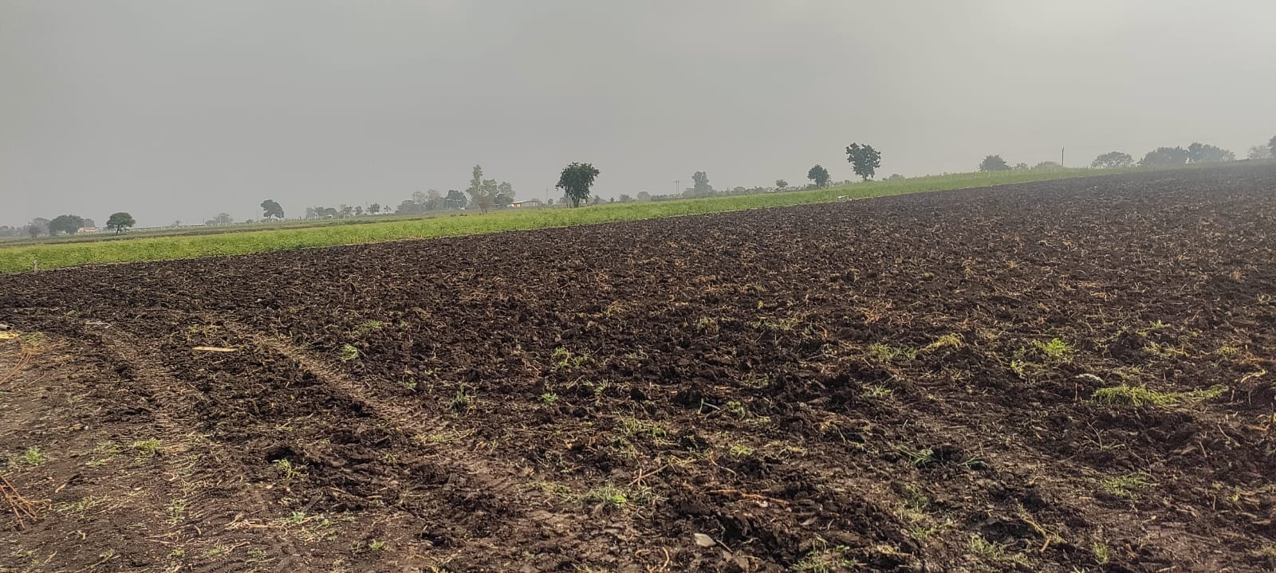
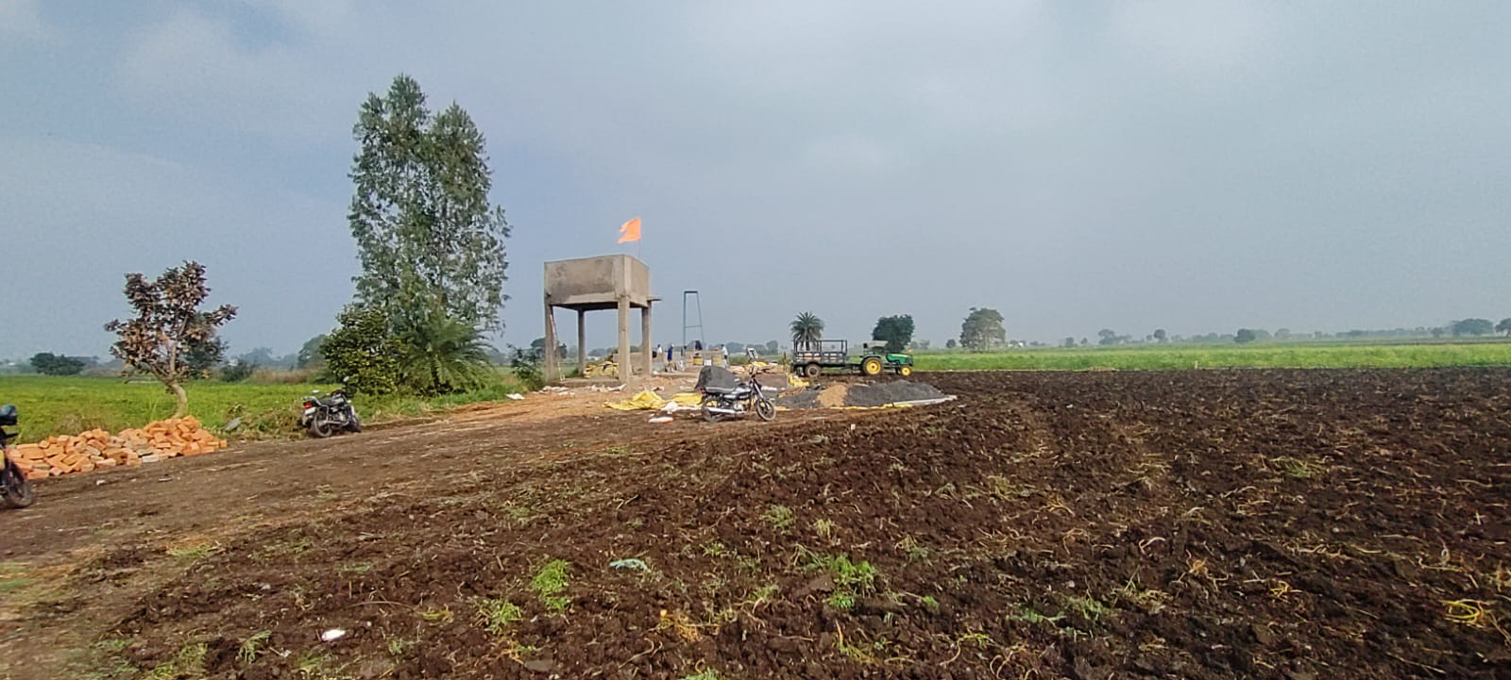

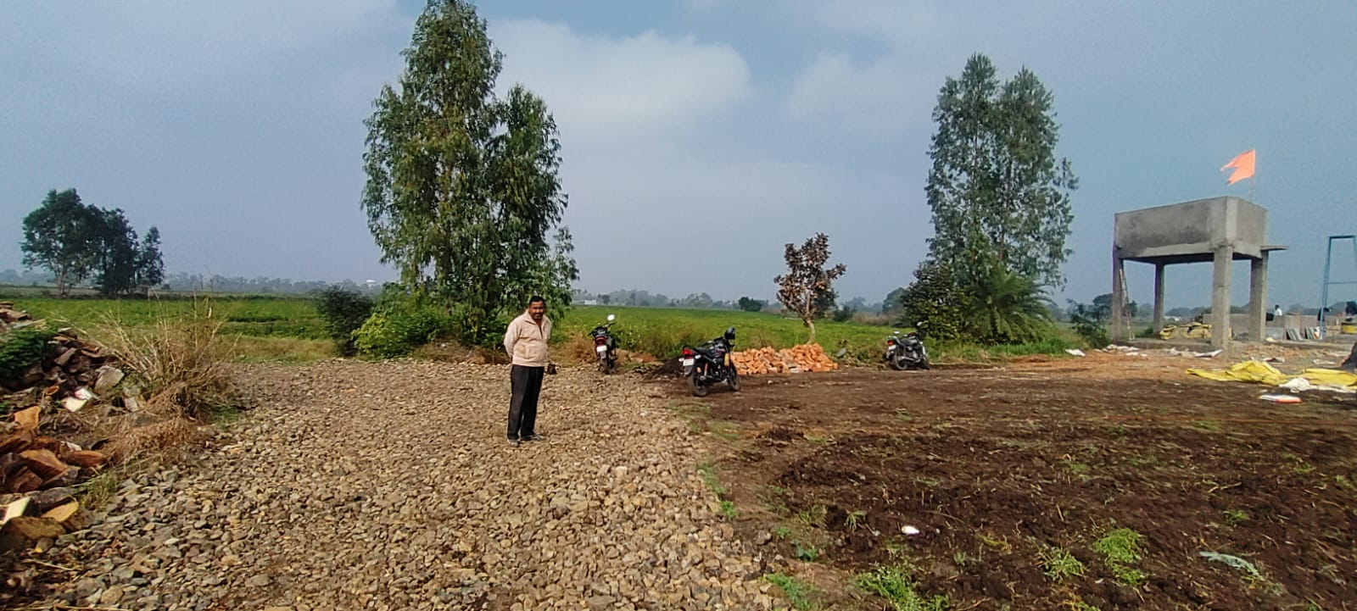
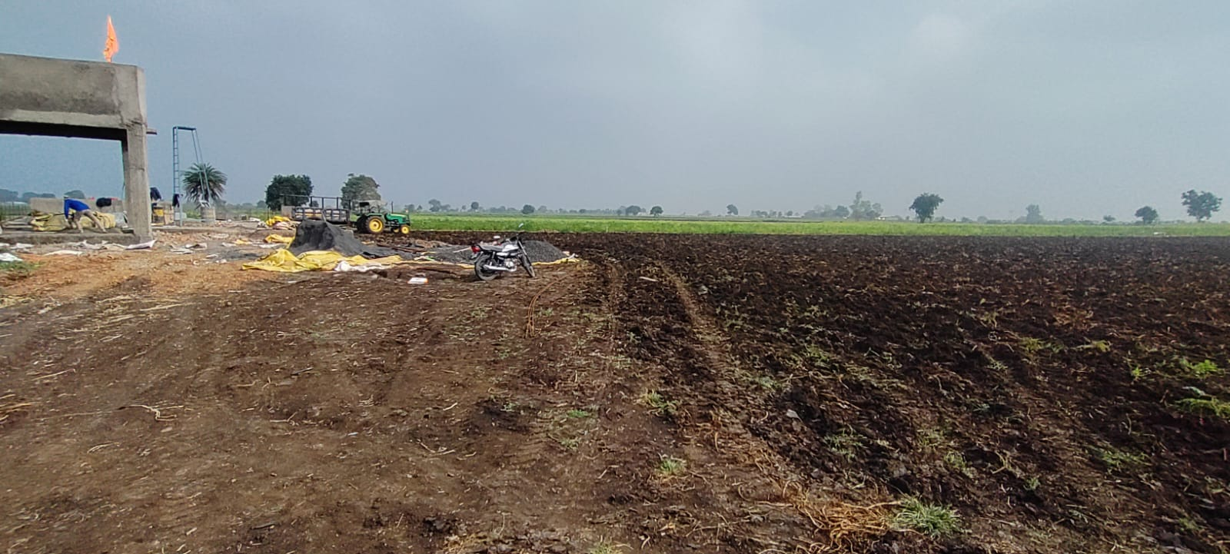


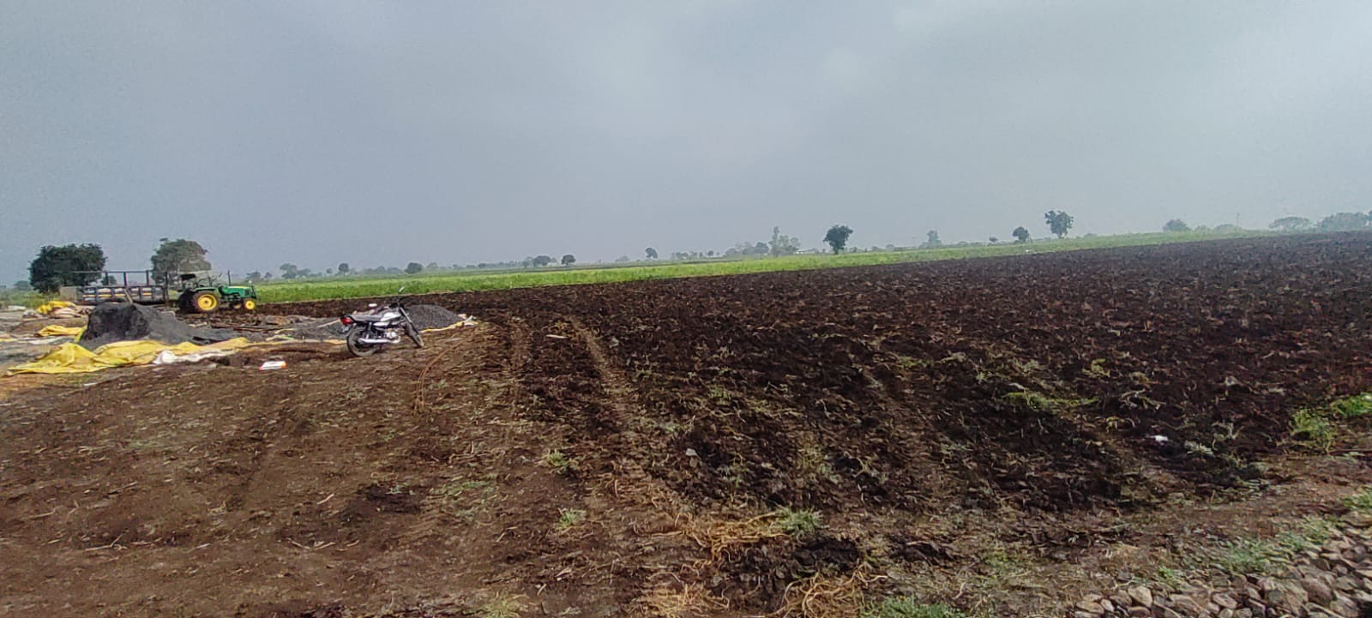

Route Map of the property
Site u/r
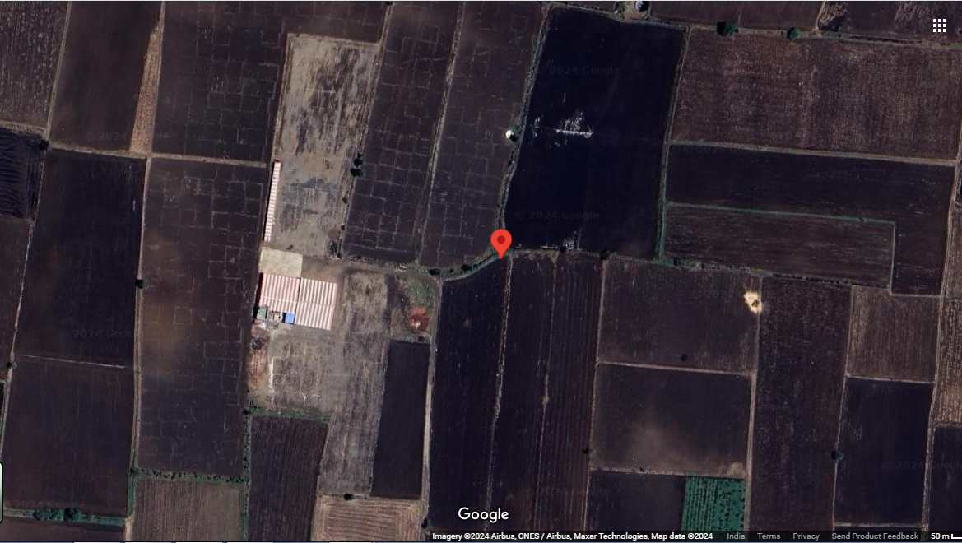

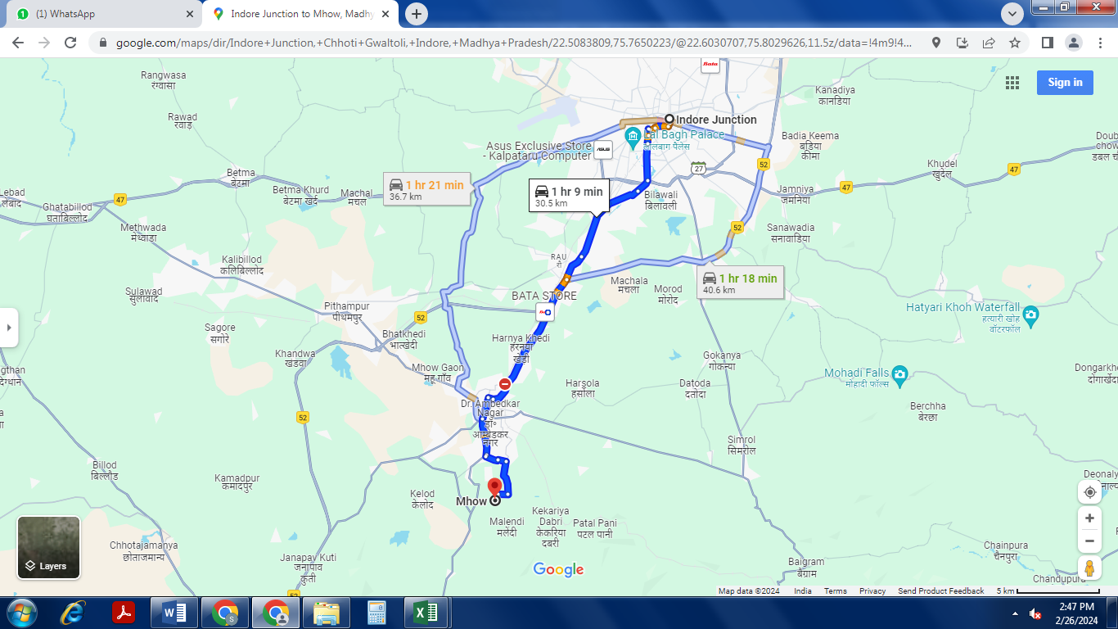

Latitude Longitude - 22°30’30.2”N 75°45’54.1”E
Note: The Blue line shows the route to site from nearest railway station (Indore Junction – 30.5 KM.)

Government Guideline Rate
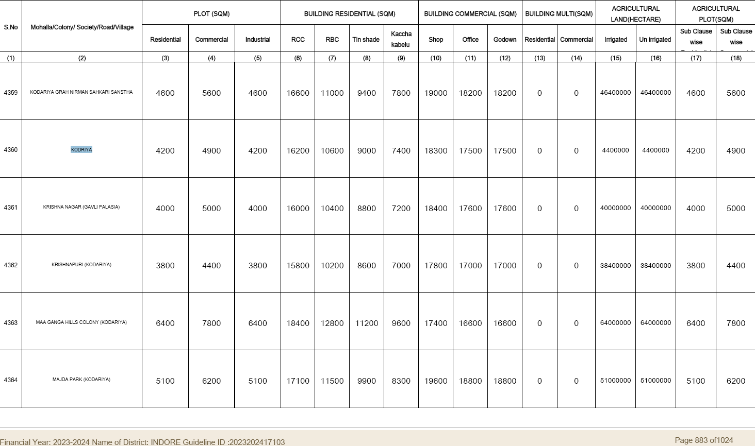

PRICE INDICATOR
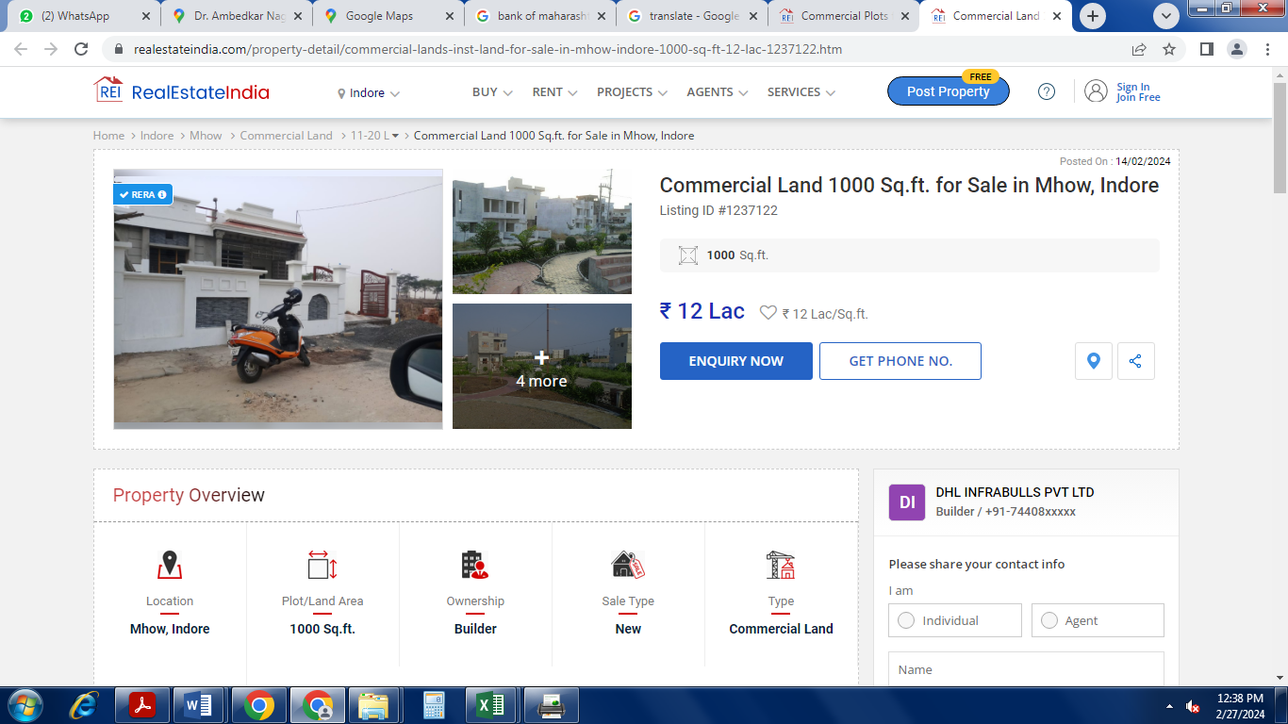

DEFINITION OF VALUE FOR THIS SPECIFIC PURPOSE

This exercise is to assess Fair Market Value of the property under reference for purpose as on 29th February 2023.

The term Fair Market Value is defined as

"The most probable price, as of a specified date, in cash, terms equivalent to cash, or in other precisely revealed terms for which the specified property rights would sell after reasonable exposure in a competitive market under all conditions requisite to a fair sale, with the buyer and seller each acting prudently knowledgeably and for self-interest assuming that neither is under undue duress"

Fundamental assumptions and conditions presumed in this definition are:

- Buyer and seller are motivated by self-interest.

- Buyer and seller are well informed and are acting prudently.

- The property is exposed for a reasonable time on the open market.

- Payment is made in cash or equivalent or in specified financing terms.

ASSUMPTIONS, CAVEATS, LIMITATION AND DISCLAIMERS
- We assume no responsibility for matters of legal nature affecting the property appraised or the title thereto, nor do we render our opinion as to the title, which is assumed to be good and marketable.
- The property is valued as though under responsible ownership.
- It is assumed that there are no hidden or unapparent conditions of the subsoil or structure that would render it more or less valuable. No responsibility is assumed for such conditions or for engineering that might be required to discover such factors.
- There is no direct/ indirect interest in the property valued.
- The rates for valuation of the property are in accordance with the Govt. approved rates and prevailing market rates.

Sharadkumar B. Chalikwar
Govt. Reg. Valuer
Chartered Engineer (India)
Reg. No. (N) CCIT/1-14/52/2008-09

