**13th LENDER’S INDEPENDENT ENGINEER REPORT**

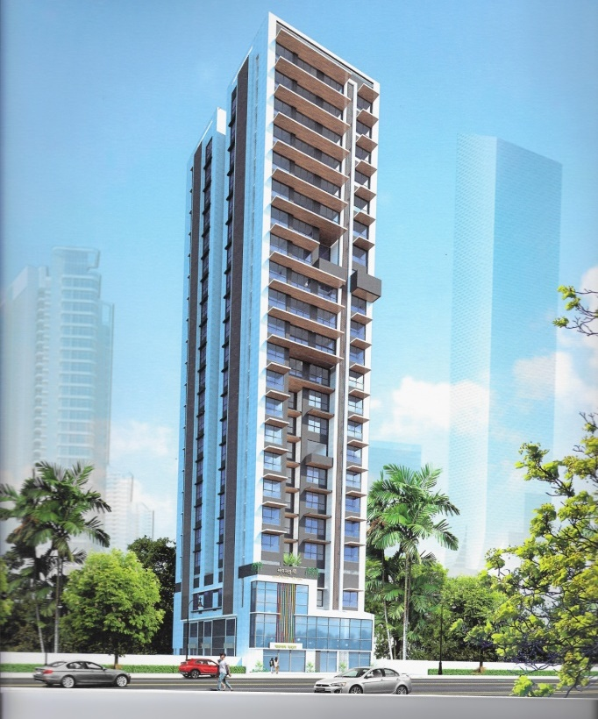

**Details of the property under consideration:**

**Name of Project: Sai Aradhya**

“Sai Aradhya”, Proposed Redevelopment of Building Bearing F.P. No. 188 & 195, C. S. No. 1654 & 1/1654,

TPS IV of Mahim Division at D. L. Vaidya Road, Dadar (West), Mumbai, Pin Code - 400 028,

State - Maharashtra, Country – India

**Latitude Longitude: 19°01'24.5"N 72°50'24.4"E**

Valuation Prepared for:

State Bank of India

SME Chembur Branch

Unit No. 11, Building No. 11, Ground Floor, Corporate Park, Sion Trombay Road,

Chembur, Mumbai, Pin Code – 400 071, State - Maharashtra, Country – India

Vastu/SBI/Mumbai/03/2024/7359/2303562

21/05-258-PY

Date: - 02.03.2024

THIRTEENTH LENDER’S INDEPENDENT ENGINEER REPORT

**To,**

**State Bank of India**

SME Chembur Branch

Unit No. 11, Building No. 11, Ground Floor,

Corporate Park, Sion Trombay Road, Chembur,

Mumbai, Pin Code – 400 071,

State - Maharashtra, Country – India.

Subject: Construction of Residential Building “Sai Aradhya”, Proposed Redevelopment of Building Bearing F.P. No. 188 & 195, C. S. No. 1654 & 1/1654, TPS IV of Mahim Division at D. L. Vaidya Road, Dadar (West), Mumbai, Pin Code - 400 028, State - Maharashtra, Country - India.

**Ref:** Your Request for Lender’s Independent Engineer Report of under Construction Building.

**Dear Sir,**

**The Construction work as per approved plan was in progress during the site visit on 04th January 2024. Total expenditure occurred as on 31/12/2023 on this project by M/s. Mangal Murti Developers is ` 47.32 Cr. & as per CA Certificate actual total expenditure occurred as on 31/12/2023 is ` 47.33 Cr. Hence, release of Balance Amount as requested by M/s. Mangal Murti Developers is hereby recommended.**

**DECLARATION**

1. The information furnished in the report is based on our 13th site visit Dated 04.01.2024 & Document Provided by Client.
2. Vastukala 12th LIE Report of the project dated 21.11.2023.
3. I have no direct and indirect interest in the property examined for report.
4. I have not been found guilty of misconduct in my professional capacity.

**Sharadkumar B. Chalikwar**

Govt. Reg. Valuer

Chartered Engineer (India)

Reg. No. (N) CCIT/1-14/52/2008-09

Encl.: LIE report

# Purpose & Methodology

• State Bank of India Banks and financial institutions require monitoring & an independent review of the progress of the sanctioned projects

**VCIPL** undertakes such study to independently review the progress of the project and put forward a comprehensive analysis.

# Advantages:

* Assurance on present practices
* Identification of risk
* Analyzing the performance of third parties
* Recommendations

# The Methodology

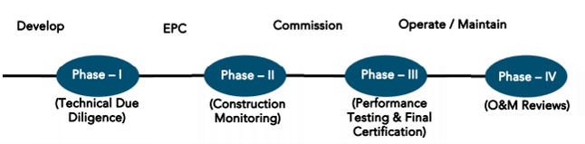

**THIRTEENTH LENDERS INDEPENDENT ENGINEER REPORT**

**OF**

**"Sai Aradhya"**

**“Sai Aradhya”, Proposed Redevelopment of Building Bearing F.P. No. 188 & 195, C. S. No. 1654 & 1/1654, TPS IV of Mahim Division at D. L. Vaidya Road, Dadar (West), Mumbai, Pin Code - 400 028,**

**State - Maharashtra, Country - India**

**Latitude Longitude: 19°01'24.5"N 72°50'24.4"E**

**NAME OF DEVELOPER: M/s. Mangal Murti Developers**

|  |
| --- |
| Pursuant to instructions from State of India, SME Chembur Branch, Mumbai we have duly visited, inspected, surveyed & assessed the above said property on **04th January 2024** to determine the fair & reasonable market value of the said property/project as on Quarter ending **31st December 2023** for LIE purpose.  **1. Location Details:**  The property is situated at Plot Bearing F.P. No. 188 & 195, C. S. No. 1654 & 1/1654, TPS IV of Mahim Division at D. L. Vaidya Road, Dadar (West), Mumbai, Pin Code - 400 028. It is about 1.90 Km. distance from Dadar railway station of Western railway line. Surface transport to the property is by buses, Auto, taxis & private vehicles. The property is in developed locality. All the amenities like shops, banks, hotels, markets, schools, hospitals, etc. are all available in the nearby locality. The locality is higher middle class & developed. |

1. **Developer Details:**

|  |  |
| --- | --- |
| **Name of builder** | **M/s. Mangal Murti Developers** |
| **Project Rera Registration Number** | **P51900023477** |
| **Registered office address** | Office No. 3, Ground Floor, Girdhari Sadan, Near Shiv Sena Bhavan Path, Dadar (W), Mumbai, Pin Code - 400 028, State - Maharashtra, Country - India. |
| **Contact details** | **Contact Person:**  **Mr. Shivaji Mane (Mob No. 9322505784 / 9619002021)** |
| **Email ID and website** | [info@mangalmurtidevelopers.com](mailto:info@mangalmurtidevelopers.com) |

**3. Boundaries of the Property:**

|  |  |
| --- | --- |
| **Direction** | **Particulars** |
| **On or towards North** | Shree Ram Krupa Building |
| **On or towards South** | Vision Eternity Building |
| **On or towards East** | 15.00 M wide D. L. Vaidya Road |
| **On or towards West** | 6.00 M wide SBVN Path Road |

# Introduction

**As per Information on site M/s. Mangal Murti Developers** has acquired land by conveyance agreement Dt.31.08.2009 & Dt.29.11.2010 admeasuring **258.27 Sq. M. and 332.03 Sq. M. respectively totally admeasuring area is 590.30 Sq. M.** bearing **F.P. No. 188 & 195, C. S. No. 1654 & 1/1654, TPS IV of Mahim Division at D. L. Vaidya Road, Dadar (West), Mumbai, Pin Code - 400 028.** For the Redevelopment of residential Building.

# Area Statement:

# Land:

|  |  |  |
| --- | --- | --- |
| **Date** | **Particular** | **Area in Sq. M.** |
| 31.08.2009 | F. P. No. 188, C.S. 1/1654 | 258.27 |
| 29.11.2010 | F. P. No. 195, C.S. 1654 | 332.03 |
|  | **Total Plot Area** | **590.30** |

1. Copy of Deed of Conveyance dated 31.07.2009 b/w M/s. Mahasukhbhai Lallubhai & 4 others (Vendor) And M/s. Mangal Murti Developers (The Purchaser) (C. S. No. 1/1654) (Purchase Amount ` 75,00,000.00).
2. Copy of Deed of Conveyance dated 29.10.2010 b/w M/s. Amit Ramkrishna Achrekar (Vendor) And M/s. Mangal Murti Developers (The Purchaser) (C. S. No. 1654) (Purchase Amount ` 1,05,00,000.00).

# Building Area:

| Sr. No. | Particulars | | Total in Sq. M. | |
| --- | --- | --- | --- | --- |
| 1 | Area of Plot (258.37 + 332.03) | | 590.30 | |
| 2 | Deduction for | | - | |
| a | Road Set Back Area | | - | |
| b | Proposed Area | | - | |
| c | Any Reservation (sub - plot) | | - | |
| d | % Amenity space as per DCR 56/57 | | - | |
| 3 | Other | | - | |
| 4 | Balance Area of Plot (1 - 2) | | 590.30 | |
| 5 | Deduction for 15% recreational ground / 10% Amenity Space (If Deductible for IND) | | - | |
| 6 | Net Area of Plot (3 -4) | | - | |
|  | Addition for Floor Space Index | | - | |
| a | 100% for D.P. Road | | - | |
| b | 100% for Setback | | - | |
| 7 | Total Area (5 + 6) | | 590.30 | |
| 8 | Floor Space Index Permissible | | Incentive | |
| 9 | Floor Space Index Credit available by development right (restricted ____% of the balance area vide 3 Above) | | - | |
|  | Addition for Floor Space Index | | - | |
| 10 | Permissible Floor Area as per DCR 33(7) | | 3,062.84 | |
| 11 | Existing Floor Area | | - | |
| 12 | Proposed Built Up Area | | - | |
| 13 | Excess Balcony Area taken in FSI | | - | |
| 14A | Purely Residential Built-Up Area | | 2,638.17 | |
| 14B | Remaining Non - Residential Built-Up Area | | 424.67 | |
| 14 | TOTAL BUILT UP PROPOSED (11 + 12 + 13)  (As per Old Approved Plan Dt. Prior to 16.01.2012) | | 3,062.84 | |
| 15 | FSI Consumed on Net Holding = 14/3 | |  | |
| B. | DETAILS OF FSI AVAILED AS PER DCPR 31(3) | | Permissible | Proposed |
| 1 | Fungible Built up area component permissible/proposed vide DCR 31(3) for Purely Residential = OR 14A X 0.35 | REHAB | 521.36 | 459.64 |
| Sale | 401.99 | 397.27 |
| 2 | Fungible Built up area component permissible/proposed vide DCR 31(3) for Non-Residential = OR 14B X 0.36 | REHAB | 148.63 | 88.02 |
| Sale |  |  |
| 3 | TOTAL Fungible Built Up Vide DCR 31(3) = B.1 + B.2 | | 1,071.98 | 994.93 |
| 4 | TOTAL Gross Built Up Area Proposed (14 + B.3) | | 4,134.82 |  |
|  | Less Deficit Area | | 122.33 |  |
|  | Net Permissible | | 4,012.49 | 4,007.77 |
| C. | TENANT STATEMENT | |  |  |
| 1 | Proposed Area | |  |  |
| 2 | Less Deduction of Non-Residential Area | |  |  |
| 3 | Area available for tenants | |  |  |
| 4 | Tenements Permissible | |  |  |
| 5 | Tenements Existing | |  |  |
| D. | PARKING STATEMENT | |  |  |
| 1 | Parking required by regulations for Car, Scooter, Motorcycle, Outsiders | |  |  |
| 2 | Covered Garage Permissible | |  |  |
| 3 | Covered Garage Proposed Car, Scooter, Motorcycle, Outsiders | |  |  |
| E. | TRANSPORT VEHICLES PARKING | |  |  |
| 1 | Spaces for Transport Vehicles Parking required by regulations | |  |  |
| 2 | Total No. of Transport Vehicles Parking spaces provided | |  |  |

# List of Approvals:

1. Copy of Proposed Redevelopment Plan No. CHE/CTY/4236/G/N/337(NEW) dated 23.05.2019 issued by M/s. Municipal Corporation of Greater Mumbai.
2. Copy of IOD No. CHE/CTY/4236/G/N/337 dated 23.05.2019 issued by Mumbai Corporation of Greater Mumbai.
3. Copy of Revised Approved Plan No. CHE/CTY/4236/G/N/337(NEW) dated 21.03.2023 issued by M/s. Municipal Corporation of Greater Mumbai.
4. Copy of First Commencement Certificate no. CHE/CTY/4236/G/N/337/(NEW)/CC/1/NEW dated 12.12.2019., this C.C. is granted up to plinth level as per approved amended plan dated 23.05.2019, it is valid up to 11.12.2020 by Mumbai Corporation of Greater Mumbai.
5. Copy of Second Commencement Certificate no. CHE/CTY/4236/G/N/337/(NEW)/OTHER/2/NEW dated 21.01.2021., this C.C. is granted up to plinth level as per approved amended plan dated 23.05.2019, it is revalidated up to 11.12.2021 by Mumbai Corporation of Greater Mumbai.
6. Copy of Third Commencement Certificate no. CHE/CTY/4236/G/N/337/(NEW)/FCC/1/New dated 25.10.2021., this C.C. is granted up to 19th floor level as per approved IOD plan dated 23.05.2019, it is revalidated up to 11.12.2021 by Mumbai Corporation of Greater Mumbai.
7. Copy of Fourth Commencement Certificate no. CHE/CTY/4236/G/N/337/(NEW)/FCC/1/New dated 12.01.2022., this C.C. is granted up to 19th floor level as per approved IOD plan dated 23.05.2019, it is revalidated up to 11.12.2022 by Mumbai Corporation of Greater Mumbai.
8. Copy of Fifth Commencement Certificate no. CHE/CTY/4236/G/N/337/(NEW)/FCC/2/Amend dated 02.05.2023., this C.C. is granted up to 21st floor i.e., full C. C. including LMR & OHT as per approved amended plan dated 21.03.2023, it is revalidated up to 11.12.2023 by Mumbai Corporation of Greater Mumbai.

# LEVEL OF COMPLETION:

# Rehab cum Sales Building

| Sr. No. | Floor | Construction area as per plan (Sq. ft.) | Completed area (Sq. ft.) | Work Completion as 12th LIE Report | Work Completion as on 04.01.2024 |
| --- | --- | --- | --- | --- | --- |
| 1 | Ground / Stilt Floor | 3,291.03 | 3,291.03 | Slab work is completed, blockwork, plasterwork & shop no. 1 (Sales Offices) gypsum works, flooring, internal painting, rolling shutter, electrical work and sanitary works were completed. Restaurant final finishing is completed and possession given to restaurant | Slab work is completed, blockwork, plasterwork & shop no. 1 (Sales Offices) gypsum works, flooring, internal painting, rolling shutter, electrical work and sanitary works were completed. Restaurant final finishing is completed and possession given to tenant & it has start functioning. |
| 2 | 1st Floor | 3,560.45 | 3,560.45 | Slab work is completed, blockwork, plasterwork & unit no. 1 (Office) gypsum works, flooring, internal painting, firefighting, electrical work, and sanitary works were completed. Restaurant final finishing is completed and possession given to restaurant | Slab work is completed, blockwork, plasterwork & unit no. 1 (Office) gypsum works, flooring, internal painting, firefighting, electrical work, and sanitary works were completed. Restaurant final finishing is completed and possession given to tenant & it has start functioning. |
| 3 | 2nd Floor | 3,560.45 | 3,560.45 | Slab work is completed, blockwork, plasterwork & flat no. 1 (Sample flat) gypsum works, flooring, internal painting, rolling shutter, electrical work and sanitary works, flooring work, firefighting, were completed. Restaurant final finishing is completed and possession given to restaurant | Slab work is completed, blockwork, plasterwork & flat no. 1 (Sample flat) gypsum works, flooring, internal painting, rolling shutter, electrical work and sanitary works, flooring work, firefighting, were completed. Restaurant final finishing is completed and possession given to tenant & it has start functioning. |
| 4 | 3rd Floor | 2,940.55 | 2,940.55 | Slab work, Block work, Door & Window frames & plasterwork, firefighting and Toilet tiling work is completed | Slab work, Block work, Door & Window frames & plasterwork, firefighting and Toilet tiling work is completed |
| 5 | 4th Floor | 2,965.31 | 2,965.31 | Slab work, Block work, Door & Window frames, firefighting, plasterwork and Toilet tiling work is completed | Slab work, Block work, Door & Window frames, firefighting, plasterwork and Toilet tiling work is completed |
| 6 | 5th Floor | 2,999.00 | 2,999.00 | Slab work, Block work, Door & Window frames, firefighting, plasterwork and Toilet tiling work is completed | Slab work, Block work, Door & Window frames, firefighting, plasterwork and Toilet tiling work is completed |
| 7 | 6th Floor | 3,081.13 | 3,081.13 | Slab work, Block work, Plaster work, Door & Window frames work, Toilet Tiling work, firefighting, Kitchen Platform and 1 flat flooring works are completed | Slab work, Block work, plaster work, water proofing, door & window frame, kitchen platform, toilet dadoing work and 2 flat flooring work is completed |
| 8 | 7th Floor | 3,147.00 | 3,147.00 | Slab work, Block work, Plaster work, Door & Window frames work, Toilet Tiling work, firefighting, Kitchen Platform and 1 flat flooring works are completed | Slab work, Block work, plaster work, water proofing, door & window frame, kitchen platform, toilet dadoing work and 2 flat flooring work is completed |
| 9 | 8th Floor | 3,101.47 | 3,101.47 | Slab work, Block work, Plaster work, Door & Window frames work, Toilet Tiling work, firefighting, Kitchen Platform and 1 flat flooring works are completed | Slab work, Block work, plaster work, water proofing, door & window frame, kitchen platform, toilet dadoing work and 2 flat flooring work is completed |
| 10 | 9th Floor | 3,081.13 | 3,081.13 | Slab work, Block work, Plaster work, Door & Window frames work, Toilet Tiling work, firefighting, Kitchen Platform and 1 flat flooring works are completed | Slab work, Block work, plaster work, water proofing, door & window frame, kitchen platform, toilet dadoing work and 2 flat flooring work is completed |
| 11 | 10th Floor | 3,127.31 | 3,127.31 | Slab work, Block work, Plaster work, Door & Window frames work, Toilet Tiling work, firefighting, Kitchen Platform and 1 flat flooring works are completed | Slab work, Block work, plaster work, water proofing, door & window frame, kitchen platform, toilet dadoing work and 2 flat flooring work is completed |
| 12 | 11th Floor | 3,211.59 | 3,211.59 | Slab work, Block work, Plaster work, Door & Window frames work, Toilet Tiling work, Kitchen Platform and 1 flat flooring works are completed | Slab work, Block work, plaster work, water proofing, door & window frame, kitchen platform, toilet dadoing work and 2 flat flooring work is completed |
| 13 | 12th Floor | 3,225.26 | 3,225.26 | Slab work, Block work, Plaster work, Door & Window frames work, Toilet Tiling work, Kitchen Platform and 1 flat flooring works are completed | Slab work, Block work, plaster work, water proofing, door & window frame, kitchen platform, toilet dadoing work and 2 flat flooring work is completed |
| 14 | 13th Floor | 3,885.41 | 3,885.41 | Slab work, Block work, Plaster work, Door & Window frames work, Toilet Tiling work, Kitchen Platform and 1 flat flooring works are completed | Slab work, Block work, plaster work, water proofing, door & window frame, kitchen platform, toilet dadoing work and 2 flat flooring work is completed |
| 15 | 14th Floor | 3,346.89 | 3,346.89 | Slab work, Block work, Plaster work, Door & Window frames work, Toilet Tiling work, Kitchen Platform and 1 flat flooring works are completed | Slab work, Block work, plaster work, water proofing, door & window frame, kitchen platform, toilet dadoing work and 1 flat flooring work is completed |
| 16 | 15th Floor | 3,173.05 | 3,173.05 | Slab work, Block work, Plaster work, Door & Window frames work, Toilet Tiling work, Kitchen Platform and 1 flat flooring works are completed | Slab work, Block work, plaster work, water proofing, door & window frame, kitchen platform, toilet dadoing work and society office flooring work is completed |
| 17 | 16th Floor | 3,237.53 | 3,237.53 | Slab work, Block work, Plaster work, Door & Window frames work, Toilet Tiling work, Kitchen Platform and 1 flat flooring works are completed | Slab work, Block work, plaster work, water proofing, door & window frame, kitchen platform & toilet dadoing work is completed |
| 18 | 17th Floor | 3,237.53 | 3,237.53 | Slab work, Block work, Plaster work, Door & Window frames work and waterproofing works are completed, Toilet Tiling work is in progress. | Slab work, Block work, plaster work, water proofing, door & window frame, kitchen platform & toilet dadoing work is completed |
| 19 | 18th Floor | 3,237.53 | 3,237.53 | Slab work, Block work is completed and plaster work is in progress | Slab work, Block work, plaster work, water proofing, door & window frame, kitchen platform & toilet dadoing work is completed |
| 20 | 19th Floor | 3,191.59 | 3,191.59 | Slab work is completed | Slab work, Block work, plaster work, water proofing, door & window frame, kitchen platform work is completed |
| 21 | 20th Floor | 3,187.91 | 3,187.91 | Slab work, Block work and 50% plaster work is completed and remaining plaster work is in progress | Slab work, Block work, plaster work, water proofing, door & window frame, kitchen platform & toilet dadoing work is completed |
| 22 | 21st Floor | 3,197.92 | 3,197.92 | Slab work is completed | Slab work, 75% Blockwork is completed |
| 23 | Terrace Area | 497.08 | 497.08 | Slab work is completed | Slab work, Blockwork & Plaster work is completed |
| 24 | LMR | 304.30 | 304.30 |  | Slab work, Blockwork & Plaster work is completed |
| 25 | OHT | 328.84 | 328.84 |  | Slab work, Blockwork & Plaster work is completed |
| TOTAL AREA in Sq. ft. | | 72,117.00 | 72,117.00 |  |  |
| As per 11th LIE Report | | 69,456.99 | 59,112.00 |  |  |
| Difference | | 2,660.00 | 13,005.00 |  |  |

Note: - As per amended approved plan construction area is increase by 2,660.00 Sq. Ft. and total construction area considered in this LIE report is 72,117.00 Sq. Ft.

# Details of the Project as Financed By SBI:

# Project Cost: (as per C.A. Certificate)

|  |  |  |  |  |
| --- | --- | --- | --- | --- |
| **Particulars** | **Revised Estimated Cost (in Cr.)** | **Incurred Cost**  **(In Cr.) till**  **31-12-2023 by M/s. Agarwal Iyer & Associates LLP** | **Incurred Cost**  **(In Cr.) till**  **30-09-2023 by M/s. Agarwal Iyer & Associates LLP** | **Net** |
| Land Cost | 1.80 | 1.80 | 1.80 | - |
| Land clearance, temporary transit accommodation & overhead cost | 12.28 | 11.67 | 11.04 | 0.63 |
| Construction cost of Building | 21.64 | 18.86 | 17.29 | 1.57 |
| Premium Cost & BMC / FSI/ GOM Charges/ fees/ security Deposits | 8.42 | 8.42 | 8.42 | - |
| On- site expenditure for development / Professional / Marketing / Advance for Project/ Administrative Cost / Fixed Assets | 2.75 | 3.01 | 2.46 | 0.55 |
| Interest Cost | 3.94 | 3.57 | 3.17 | 0.40 |
| **Total** | **50.83** | **47.33** | **44.19** | **3.14** |

* **The Builder has incurred about 11.67 Cr. for rent to tenants, 18.86 Cr. For cost of construction, 3.01 Cr. for on – site expenditure & 3.57 Cr. For Interest Cost in last quarter as per C.A. certificate issued by M/s. Agarwal Iyer & Associates LLP dated 09.01.2024.**

# Project Cost: (as per Bills):

|  |  |  |  |
| --- | --- | --- | --- |
| **Particulars** | **Incurred Cost (in Cr.)** | |  |
| **31-12-2023 as per Bill (Inclusive GST)** | **30-09-2023 as per Bill (Inclusive GST)** | **Net** |
| Land Cost | 1.80 | 1.80 | - |
| Land clearance, temporary transit accommodation & overhead cost | 10.74 | 10.12 | 0.62 |
| Construction cost of Building | 17.66 | 16.14 | 1.52 |
| Premium Cost & BMC / FSI/ GOM Charges/ fees/ security Deposits | 9.10 | 9.10 | - |
| On- site expenditure for development / Professional / Marketing / Advance for Project/ Administrative Cost / Fixed Assets | 4.99 | 4.40 | 0.60 |
| Interest Cost | 3.04 | 2.64 | 0.40 |
| **Total** | **47.32** | **44.19** | **3.14** |

# Land Cost:

|  |  |  |  |
| --- | --- | --- | --- |
| **Land Cost as per Agreement** | | | |
| **Sr. No.** | **Date** | **C.T.S No.** | **Amount** |
| **1** | 31.08.2009 | 1/1654 | 75,00,000.00 |
| **2** | 29.11.2010 | 1654 | 1,05,00,000.00 |
| **TOTAL** | | | **1,80,00,000.00** |
| **TOTAL in Cr.** | | | **1.80** |

As per conveyance deed.

There is no cost incurred in land component in last Quarter.

|  |  |  |  |  |  |  |
| --- | --- | --- | --- | --- | --- | --- |
| **Summary of Bills** | | | | | | |
| **Sr. No.** | **Particulars** | **Amount in ` (01.07.2019 to 31.12.2023)** | **Amount in `**  **(In Cr.)** | **Amount in ` (01.07.2019 to 30.09.2022)** | **Amount in `**  **(In Cr.)** | **Net in `**  **(In Cr.)** |
| **1** | Land clearance, temporary transit accommodation & overhead cost | 10,73,77,172.00 | 10.74 | 10,11,59,678.00 | 10.12 | 0.62 |
| **2** | Construction Cost | 17,66,16,229.00 | 17.66 | 16,13,77,363.00 | 16.14 | 1.52 |
| **3** | Premium Cost & BMC / FSI/ GOM Charges/ fees/ security Deposits | 9,09,63,977.00 | 9.10 | 9,09,63,977.00 | 9.10 | - |
| **4** | Professional Cost | 1,50,28,169.00 | 1.50 | 1,58,08,388.00 | 1.58 | -0.08 |
| **5** | Administrative Cost | 3,10,74,930.00 | 3.11 | 2,47,20,765.00 | 2.47 | 0.64 |
| **6** | Marketing Cost | 38,06,030.00 | 0.38 | 34,26,097.00 | 0.34 | 0.04 |
| **TOTAL** | | **42,48,66,507.00** | **42.49** | **37,14,72,791.00** | **37.15** | **2.74** |

Note: Bills were provided by the client up to 31.12.2023

The Major Cost incurred is 0.62 Cr. for Tenant Rent Cost, 1.52 Cr. for Construction Cost, 0.64 Cr. for Admin Cost & 0.04 Cr. Marketing cost in last Quarter. The total construction cost, rent cost, professional cost, & admin cost incurred till 31st December 2023 is 10.74 Cr., 17.66 Cr., 3.11 Cr. & 0.38 Cr. respectively.

# Interest Cost:

|  |  |  |  |  |  |
| --- | --- | --- | --- | --- | --- |
| **Sr. No** | **Particulars** | **Revised Amount in `** | **Incurred Amount in** **`** **till 31-12-2023** | **Incurred Amount in** **`** **till 30-09-2023** | **Net** |
| **1** | Interest Cost | 3,94,00,000.00 | 3,03,51,780.00 | 2,63,98,552.00 | 39,53,228.00 |
| **TOTAL** | | **3,94,00,000.00** | **3,03,51,780.00** | **2,63,98,552.00** | **39,53,228.00** |

Interest Cost is based on discussion with the bank officer.

# Cost of Construction as on 04th January 2024:

|  |  |  |  |  |  |  |  |
| --- | --- | --- | --- | --- | --- | --- | --- |
| **Plinth Area Calculation** | | | | | | | |
| **Sr. No.** | **Floor** | **Construction area as per plan (Sq. ft.)** | **Completed area**  **(Sq. ft.)** | **Rate per Sq. ft.** | **Full Value after completion** | **Percentage of work completed** | **Actual Expenditure till date in `** |
| 1 | Excavation & Plinth Level | As per Bills | | | | | 2,79,60,607.00 |
| 2 | Ground / Stilt Floor | 3,291.03 | 3,291.03 | 3,000.00 | 98,73,077.00 | 75% | 74,04,807.75 |
| 3 | 1st Floor | 3,560.45 | 3,560.45 | 3,000.00 | 1,06,81,346.00 | 85% | 90,79,144.10 |
| 4 | 2nd Floor | 3,560.45 | 3,560.45 | 3,000.00 | 1,06,81,346.00 | 85% | 90,79,144.10 |
| 5 | 3rd Floor | 2,940.55 | 2,940.55 | 3,000.00 | 88,21,649.00 | 70% | 61,75,154.30 |
| 6 | 4th Floor | 2,965.31 | 2,965.31 | 3,000.00 | 88,95,921.00 | 70% | 62,27,144.70 |
| 7 | 5th Floor | 2,999.00 | 2,999.00 | 3,000.00 | 89,96,995.00 | 70% | 62,97,896.50 |
| 8 | 6th Floor | 3,081.13 | 3,081.13 | 3,000.00 | 92,43,383.00 | 72% | 66,55,235.76 |
| 9 | 7th Floor | 3,147.00 | 3,147.00 | 3,000.00 | 94,41,010.00 | 72% | 67,97,527.20 |
| 10 | 8th Floor | 3,101.47 | 3,101.47 | 3,000.00 | 93,04,415.00 | 72% | 66,99,178.80 |
| 11 | 9th Floor | 3,081.13 | 3,081.13 | 3,000.00 | 92,43,383.00 | 72% | 66,55,235.76 |
| 12 | 10th Floor | 3,127.31 | 3,127.31 | 3,000.00 | 93,81,916.00 | 72% | 67,54,979.52 |
| 13 | 11th Floor | 3,211.59 | 3,211.59 | 3,000.00 | 96,34,762.00 | 72% | 69,37,028.64 |
| 14 | 12th Floor | 3,225.26 | 3,225.26 | 3,000.00 | 96,75,773.00 | 72% | 69,66,556.56 |
| 15 | 13th Floor | 3,885.41 | 3,885.41 | 3,000.00 | 1,16,56,241.00 | 72% | 83,92,493.52 |
| 16 | 14th Floor | 3,346.89 | 3,346.89 | 3,000.00 | 1,00,40,672.00 | 70% | 70,28,470.40 |
| 17 | 15th Floor | 3,173.05 | 3,173.05 | 3,000.00 | 95,19,157.00 | 70% | 66,63,409.90 |
| 18 | 16th Floor | 3,237.53 | 3,237.53 | 3,000.00 | 97,12,586.00 | 70% | 67,98,810.20 |
| 19 | 17th Floor | 3,237.53 | 3,237.53 | 3,000.00 | 97,12,586.00 | 70% | 67,98,810.20 |
| 20 | 18th Floor | 3,237.53 | 3,237.53 | 3,000.00 | 97,12,586.00 | 70% | 67,98,810.20 |
| 21 | 19th Floor | 3,191.59 | 3,191.59 | 3,000.00 | 95,74,763.00 | 70% | 67,02,334.10 |
| 22 | 20th Floor | 3,187.91 | 3,187.91 | 3,000.00 | 95,63,720.00 | 70% | 66,94,604.00 |
| 23 | 21st Floor | 3,197.92 | 3,197.92 | 3,000.00 | 95,93,751.00 | 58% | 55,16,406.83 |
| 24 | Terrace | 497.08 | 497.08 | 3,000.00 | 14,91,245.00 | 50% | 7,45,622.50 |
| 25 | LMR | 304.30 | 304.30 | 3,000.00 | 9,12,895.00 | 50% | 4,56,447.50 |
| 26 | OHT | 328.84 | 328.84 | 3,000.00 | 9,86,521.00 | 50% | 4,93,260.50 |
| **Total** | | **72,117.00** | **72,117.00** |  | **21,63,51,669.00** | **84%** | **18,27,79,121.00** |
| **Total As per 11th LIE Report** | | **69,457.00** | **59,112.00** |  | **20,83,70,979.00** | **81%** | **17,54,83,426.00** |
| **Difference** | | **2,660.00** | **13,005.00** | **-** | **79,80,720.00** | **3%** | **72,95,695.00** |

##### Note: Details of work completed is as per site visit dated 04.01.2024 but report is prepared for 31st December quarter 2023.

|  |  |  |  |  |  |
| --- | --- | --- | --- | --- | --- |
| **Particulars** | **Revised Estimated Cost (In Cr.)** | **Incurred Cost (in Cr.)** | | | **Net after previous report** |
| **As per CA Certificate up to 30-09-2023** | **As per Bills up to 31-12-2023** | **12th LIE Report Bills up to**  **30-09-2023** |
| Land Cost | 1.80 | 1.80 | 1.80 | 1.80 | - |
| Land clearance, temporary transit accommodation & overhead cost | 12.28 | 11.67 | 10.74 | 10.12 | 0.62 |
| Construction cost of Building | 21.64 | 18.86 | 17.66 | 16.14 | 1.52 |
| Premium Cost & BMC / FSI/ GOM Charges/ fees/ security Deposits | 8.42 | 8.42 | 9.10 | 9.10 | - |
| On- site expenditure for development / Professional / Marketing / Advance for Project/ Administrative Cost / Fixed Assets | 2.75 | 3.01 | 4.99 | 4.40 | 0.60 |
| Interest Cost | 3.94 | 3.57 | 3.04 | 2.64 | 0.40 |
| **Total** | **50.83** | **47.33** | **47.32** | **44.19** | **3.14** |

Remark: Project Cost is increased by ` 5.01 Cr. and hence, total revised project cost is ` 50.83 Cr.

We have considered bank processing fees, stamp duty & insurance cost in on-site expenditure cost header but CA has considered them in interest cost header.

We have considered stamp duty and other government cost in approval cost header, but CA has considered them in Rent cost header.

As per plinth area, calculation the work completed is up to 84% of total work, which comes to ` 18.28 Cr. However, company has incurred cost of ` 17.66 Cr. till 30.12.2023 as per bill.

# Comparison of Cost incurred on dated 31-12-2023 & 30-09-2023.

|  |  |  |  |  |
| --- | --- | --- | --- | --- |
| **Particulars** | **31-12-2023 as per Bills** | **As 12th LIE Report Bills up to 30-09-2023** | **Net** | **% Of net amount** |
|
| Land Cost | 1.80 | 1.80 | - | 0.00% |
| Land clearance, temporary transit accommodation & overhead cost | 10.74 | 10.12 | 0.62 | 19.82% |
| Construction cost of Building | 17.66 | 16.14 | 1.52 | 48.59% |
| Premium Cost & BMC / FSI/ GOM Charges/ fees/ security Deposits | 9.10 | 9.10 | - | 0.00% |
| On- site expenditure for development / Professional / Marketing / Advance for Project/ Administrative Cost/ Fixed Assets | 4.99 | 4.40 | 0.60 | 18.98% |
| Interest Cost | 3.04 | 2.64 | 0.40 | 12.60% |
| **Total** | 47.32 | 44.19 | 3.14 | 100.00% |

# % Of Fund Utilised till 31st December 2023

|  |  |  |  |  |
| --- | --- | --- | --- | --- |
| **Particulars** | **Revised Estimated Project Cost**  **(In Cr.)** | **Incurred cost as on**  **31-12-2023** | **% Of Incurred Cost** | **% Of Estimated Project Cost** |
| Land Cost | 1.80 | 1.80 | 100.00% | 3.54% |
| Land clearance, temporary transit accommodation & overhead cost | *12.28* | 10.74 | 87.44% | 21.12% |
| Construction cost of Building | *21.64* | 17.66 | 81.62% | 34.75% |
| Premium Cost & BMC / FSI/ GOM Charges/ fees/ security Deposits | *8.42* | 9.10 | 108.03% | 17.90% |
| On- site expenditure for development / Professional / Marketing / Advance for Project/ Administrative Cost / Fixed Assets | *2.75* | 4.99 | 181.49% | 9.82% |
| Interest Cost | *3.94* | 3.04 | 77.03% | 5.97% |
| **Total** | 50.83 | 47.32 | 93.10% | 93.10% |

Based on above Calculation it is found that Project incurred Cost is Completed upto 93.10% of the Total Project Cost.

# Means of Finance:

|  |  |  |
| --- | --- | --- |
| **Sr. No.** | **Particulars** | **Exp. Cumulative (Cr.)** |
|  | Partner’s Capital | 11.95 |
|  | Unsecured Loans | 0.45 |
|  | Secured Loans from Bank | 10.95 |
|  | Advance from Customer | 21.24 |
|  | Payable to Creditors | 5.41 |
|  | Balance in the Account | -2.67 |
|  | **Total** | **47.33** |

The Details of the Means of Finance are provided by Client as on 31.12.2023.

# Mandatory Arrangements:

|  |  |  |
| --- | --- | --- |
| **Sr. No.** | **Particulars** | **Status** |
|  | Rainwater Harvesting | To be executed after RCC Structure |
|  | Firefighting System | To be executed after RCC Structure |
|  | Solid Waste Management | To be executed after RCC Structure |

# Quality of Construction:

|  |  |  |
| --- | --- | --- |
| **Sr. No.** | **Particulars** | **Status** |
|  | Soundness of Structures | Executing as per approved Structural Design |
|  | Look of Structures | Good |
|  | Quality of Material Used | Good |
|  | Safety Measures for Construction / labour | Taken Care by Contractor |

# Schedule V/s. Actual Progress:

| Activity | Date of Implementation | Initial Date of Completion | Revised Date of Completion | Status |
| --- | --- | --- | --- | --- |
| Land |  |  |  | Completed |
| Development of Land |  |  |  | Completed |
| Foundation Work | October 2020 | March 2021 | Sept. 2021 | Completed and delay by 5 Months. |
| Ground Floor Slab | April 2021 | June 2021 | 06.10.2021 | Completed and delay by 7 Months. |
| 1st Floor Slab | 04.12.2021 | Completed and delay by 7 Months. |
| 2nd Floor Slab | 28.12.2021 | Completed and delay by 7 Months. |
| 3rd Floor Slab | July 2021 | September 2021 | 15.02.2022 | Completed and delay by 6 Months |
| 4th Floor Slab | 06.03.2022 | Completed and delay by 6 Months |
| 5th Floor Slab | 06.04.2022 | Completed and delay by 6 Months |
| 6th Floor Slab | October 2021 | December 2021 | 25.04.2022 | Completed and delay by 5 Months |
| 7th Floor Slab | 20.05.2022 | Completed and delay by 6 Months |
| 8th Floor Slab | 29.06.2022 | Completed and delay by 7 Months |
| 9th Floor Slab | 15.07.2022 | Completed and delay by 7 Months |
| 10th Floor Slab | 31.07.2022 | Completed and delay by 7 Months |
| 11th Floor Slab | January 2022 | March 2022 | 14.08.2022 | Completed and delay by 5 Months |
| 12th Floor Slab | 27.08.2022 | Completed and delay by 5 Months |
| 13th Floor Slab | April 2022 | June 2022 | 14.09.2022 | Completed and delay by 3 Months |
| 14th Floor Slab | 30.09.2022 | Completed and delay by 3 Months |
| 15th Floor Slab | 22.10.2022 | Completed and delay by 3 Months |
| 16th Floor Slab | 22.11.2022 | Completed and delay by 3 Months |
| 17th Floor Slab | July 2022 | September 2022 | 8.12.2022 | Completed and delay by 3 Months |
| 18th Floor Slab | 25.12.2022 | Completed and delay by 3 Months |
| 19th Floor Slab |  | Completed and delay by 6 Months |
| 20th Floor Slab |  | Completed and delay by 6 Months |
| 21st Floor Slab | October 2022 | December 2022 |  | Completed and delay by 6 Months |
| Block work /Internal Plaster work | January 2022 | March 2022 |  | Ground to 18th floors and 20th floor work is completed |
| Terrace Parapet wall / Overhead water tank / Lift Machine room / compound wall / External Plaster work | April 2023 | June 2023 |  | Slab work is completed |
| Electric Work | January 2022 | March 2023 |  | Work is in progress |
| Water Proofing |  | Ground to 20th floor work is completed |
| Plumbing Work |  | Work is in progress |
| Tiling / Marble Flooring |  | Work is in progress |
| Door Frames |  | Ground to 21st floor work is completed |
| Window Installation |  | Work is in progress |
| Staircase Flooring | April 2023 | June 2023 |  |  |
| Staircase Railing |  |  |
| Refuge Area Flooring | January 2022 | March 2023 |  |  |
| Internal Painting | April 2023 | June 2023 |  |  |
| External Painting |  |  |
| Lift Work |  | Work is in progress |
| Fire Fighting Installation |  | Work is in progress |
| Stack Parking |  | Slab work is completed |
| CP Fitting & Sanitary Work | January 2022 | March 2023 |  | Work is in progress |
| Final Finishing & Fitting | July 2023 | September 2023 |  |  |

# Action initiated to complete the project in time:

**For Rehab & Sales Building:** Terrace slab, OHT & LMR work is completed. Hence, Project is delay by 6 months.

**The developers have Major work on themselves only hence (all Manpower (Labour Contractor) and material resources) shall be enhanced by the Developer to meet the TimeLine. Detailed periodic progress report needs to be checked for timely completion of project.**

**Multiple activists to be done for achieving the timely progress & detailed periodic bar chart, is to be submitted for the further next quarter.**

# Comments related to cost overrun if any:

The cost of Rehab cum Sales Building is ` 50.83 Cr.

* The project has some modification due to which revised project cost work out to ` 50.83 Cr. as against sanction project cost of ` 45.82 Cr. hence project is overrun.

# Balance investment required for completion of project:

We opinion that amount of **` 3.51 Cr.** will be required to complete the Project.

# Mandatory Approval Status:

| **Sr. No.** | **Particulars** | **Name of Department** | **Status** | **Order Details** |
| --- | --- | --- | --- | --- |
| **1** | IOD of Rehab Building No. 1 | Municipal Corporation of Greater Mumbai | Obtained and available at site | CHE/CTY/4236/G/N/337 dated 23.05.2019 |
| **1A** | Revised Approved Plan | Municipal Corporation of Greater Mumbai | Obtained and available at site | CHE/CTY/4236/G/N/337(NEW) dated 21.03.2023 |
| **2A** | First C.C. | Municipal Corporation of Greater Mumbai | Obtained and available at site | CHE/CTY/4236/G/N/337/(NEW)/CC/1/NEW dated 12.12.2019., this C.C. is granted up to plinth level as per approved amended plan dated 23.05.2019, it is valid up to 11.12.2020 |
| **2B** | Second C.C. | Municipal Corporation of Greater Mumbai | Obtained and available at site | CHE/CTY/4236/G/N/337/(NEW)/OTHER/2/NEW dated 21.01.2021., this C.C. is granted up to plinth level as per approved amended plan dated 23.05.2019, it is revalidated up to 11.12.2021 |
| **2C** | Third C.C. | Municipal Corporation of Greater Mumbai | Obtained and available at site | CHE/CTY/4236/G/N/337/(NEW)/FCC/1/New dated 25.10.2021., this C.C. is granted up to 19th floor level as per approved IOD plan dated 23.05.2019, it is revalidated up to 11.12.2021 |
| **2D** | Fourth C.C. | Municipal Corporation of Greater Mumbai | Obtained and available at site | CHE/CTY/4236/G/N/337/(NEW)/FCC/1/New dated 12.01.2022., this C.C. is granted up to 19th floor level as per approved IOD plan dated 23.05.2019, it is revalidated up to 11.12.2022 |
| **2E** | Fifth C.C. | Municipal Corporation of Greater Mumbai | Obtained and available at site | CHE/CTY/4236/G/N/337/(NEW)/FCC/2/Amend dated 02.05.2023., this C.C. is granted up to 21st floor i.e., full C. C. including LMR & OHT as per approved amended plan dated 21.03.2023, it is revalidated up to 11.12.2023 |
| **3B** | Occupancy | Municipal Corporation of Greater Mumbai | Pending (Project is not completed) |  |

# Status Insurance Coverage:

|  |  |  |  |
| --- | --- | --- | --- |
| **Particulars** | **Descriptions** | **Particulars** | **Descriptions** |
| **Policy No.** | 0000000038573750 | **Policy Issued Date** | 11.02.2021 |
| **Period of Insurance** | From 05.02.2021 to 30.09.2023 | **Total Sum Insured** | ` 21,00,00,000.00 |
| **Insurance Policy Name** | Contractors All Risk Policy | **Issued By** | SBI General Insurance |
| **Type of Cover / Benefit** | 1. Material Damage / Contract Price  2. Third Party Liabilities/ All accidents during policy period | | |

# Assumptions & Remarks:

* The adequacy of Engineering / Structural design is beyond the scope of our assignment.
* Estimated project completion dated is 30/03/2024 for Rehab & Sales Building, respectively. The cost is certified based on the assumptions that the project will be completed within time period. Few assumptions were made regarding inflation & cost rise etc. during construction period.

**Sharadkumar B. Chalikwar**

Govt. Reg. Valuer

Chartered Engineer (India)

Reg. No. (N) CCIT/1-14/52/2008-09

**About the Project:**

|  |  |  |  |
| --- | --- | --- | --- |
| **1. Introduction** | | |  |
| a) | Project Name  (With Address & Phone Nos.) | | “Sai Aradhya”, Proposed Redevelopment of Building Bearing F.P. No. 188 & 195, C. S. No. 1654 & 1/1654, TPS IV of Mahim Division at D. L. Vaidya Road, Dadar (West), Mumbai, Pin Code - 400 028, State - Maharashtra, Country – India.  Contact Person:  Mr. Shivaji Mane (Mob No. 9322505784 / 9619002021) |
| b) | Purpose of Valuation | | As per request from State Bank of India, SIB Ghatkopar Branch to assess fair market value of the Project for LIE purpose. |
| c) | Date of Inspection of Property | | 04.01.2024 |
| d) | Date of LIE Report | | 02.03.2024 |
| e) | Name of the Developer of Property  (In case of developer-built properties) | | **M/s. Mangal Murti Developers**  Office No. 3, Ground Floor, Girdhari Sadan, Near Shiv Sena Bhavan Path, Dadar (W), Mumbai, Pin Code - 400 028, State - Maharashtra, Country - India. |
| **2. Physical Characteristics of the Property** | | | |
| a) | Location of the Property | | “Sai Aradhya”, Proposed Redevelopment of Building Bearing F.P. No. 188 & 195, C. S. No. 1654 & 1/1654, TPS IV of Mahim Division at D. L. Vaidya Road, Dadar (West), Mumbai, Pin Code - 400 028, State - Maharashtra, Country - India |
| Brief description of the property | |  |
|  | **TYPE OF THE BUILDING**   1. **Rehab cum Sales Building**  |  |  | | --- | --- | | No. of Floors | Ground / Stilt Floor + 1st to 21stupper floors | | Building type | Residential cum commercial rehab building |   Rehab & Sales Building labour contract work is given on contract basis. Developer has granted the labour contractor to do the work of construction and completion which includes Concrete work, Reinforcement work, Masonry, Internal Plaster, External Plaster, and other miscellaneous work such as repairing joints b/w concrete and masonry surface, etc. Bill must be paid on measurement of construction area. All the material required for construction are being provided by the Developer.  Lift & lift installation contract is not finalized till now.  Firefighting work contract is not finalized till now.  **PROPOSED DATE OF COMPLETION & FUTURE LIFE:**  Expected completion date as per RERA is 30th March 2024.  **Locality:**  Dadar is the first planned area of Mumbai. It is a densely populated residential and shopping neighborhood. It is also a prominent railway and bus service hub with local and national connectivity. Dadar is also a hub for the immigrant Marathi culture, which gradually replaced the native East Indian one, in Mumbai. Dadar has been growing importance in the current scenario because of its railway routes. The old chawls are giving way to new high-rise buildings, thus, changing the skyline of the place. The Khodadad circle and its surrounding buildings are a heritage site of Grade IIB.  Park Chowpatty or seashore Dadar West is widespread up to Reunion Restaurant where Mahim starts in north and up to Sayani Road Junction where Prabhadevi starts on south. Similarly, Dadar East is widespread up to Five Gardens where Matunga starts in North and up to Premier Theatre in South where Parel starts.  Dadar West market is a popular shopping destination for residents of central Mumbai, the suburbs, and distant satellite towns. Dadar vegetable market is the heart of the city. Both east and west areas in Dadar are dotted with women's and children's clothing shops.  Some Important Markets are,  1. Nakshatra Shopping Mall; 2. Swatantra veer Savarkar Market; 3. Meenatai Thackrey Flower Market; 4. Star Mall; 5. Hind Mata Market; 6. Manish Market; 7. Cotton King (Next to Plaza Cinema); 8. Cosmos Platinum Mall; 9. Dadar Vegetable Market; 10. Roop Sangam; 11. Roop Milan; 12. Pallari; 13. Lazaree; 14. Society Stores; 15. Dadar Departmental Stores; 16. Paneri; 17. Decor India, etc. | | |
|  | Nearby landmark | | Near Shiv Sena Bhavan |
| Postal Address of the Property | | **“Sai Aradhya”,** Proposed Redevelopment of Building Bearing F.P. No. 188 & 195, C. S. No. 1654 & 1/1654, TPS IV of Mahim Division at D. L. Vaidya Road, Dadar (West), Mumbai, Pin Code - 400 028, State - Maharashtra, Country - India |
|  | Area of the plot/land  (Supported by a plan) | Plot Area: 590.30 Sq. M. | |
| Type of Land: Solid, Rocky, Marsh land, reclaimed land, Water-logged, Land locked. | Solid land | |
|  | Independent access/approach to the property etc. | Yes | |
| Google Map Location of the Property with a neighborhood layout map | Provided | |
|  | Details of roads abutting the property | East Side: 15.00 M. wide B.T. Road  West Side: 6.00 M. wide B.T. Road | |
| Description of adjoining property | Located in Higher Middle-class locality | |
| Plot No. Survey No. | F.P. No. 188 & 195, C. S. No. 1654 & 1/1654, TPS IV of Mahim Division | |
| Ward/Village/Taluka | TPS IV, Mahim Division | |
| Sub-Registry/Block | Mumbai – 1 | |
| District | Mumbai | |
| b) | **Boundaries of the Plot** |  | |
|  | |  |  |  |  | | --- | --- | --- | --- | |  | **As per Sale Deed/TIR** | | **Actual** | |  | **C. S. No. 1654** | **C.S. No.1/1654** |  | | | **North** | Prem Bhuvan | Laxman Chintaman Tamhane | Shree Ram Krupa Building | | | **South** | Sadavdekar Niwas | Waman Vithoba Engineer | Vision Eternity Building | | | **East** | 40 Ft. D. L. Vaidya Road | 40 Ft. Road | 15.00 M wide D. L. Vaidya Road | | | **West** | 15 Ft. Shiv Sena Bhavan Path | 15 Ft. Passage | 6.00 M wide SBVN Path Road | | | | |

| **4. Document Details and Legal Aspects of Property:** | |
| --- | --- |
| a) | Ownership Documents (**Building Permission, Commencement Certificate & Status of Plan)** |
|  | Sale Deed, Gift Deed, Lease Deed |
| 1. Copy of Deed of Conveyance dated 31.07.2009 b/w M/s. Mahasukhbhai Lallubhai& 4 others (Vendor) And M/s. Mangal Murti Developers (The Purchaser) (C. S. No. 1/1654) |
| 1. Copy of Deed of Conveyance dated 29.10.2010 b/w M/s. Amit Ramkrishna Achrekar (Vendor) And M/s. M/s. Mangal Murti Developers. (The Purchaser) (C. S. No. 1654) |
| 1. Copy of Title Certificate dated 02.06.2018 by Mr. M.R. Phal |
| 1. Copy of Partnership Deed dated 01.04.2015. |
| 1. Copy of Register of Firms dated 22.01.2018. |
| 1. Copy of Commencement Certificate no. CHE/CTY/4236/G/N/337/(NEW)/CC/1/NEW dated 12.12.2019., this C.C. is granted up to plinth level as per approved amended plan dated 23.05.2019, it is valid up to 11.12.2020 by Mumbai Corporation of Greater Mumbai. |
| 1. Copy of C.A. Certificated dated 25.11.2019 issued by M/s. Agarwal Iyer& Associates LLP |
| 1. Copy of IOD No. CHE/CTY/4236/G/N/337 dated 23.05.2019 issued by Mumbai Corporation of Greater Mumbai. |
| 1. Copy of RERA Certificate No. 51900023477 dated 16.12.2019 |
| 1. Copy of Proposed Redevelopment Plan No. CHE/CTY/4236/G/N/337(NEW) dated 23.05.2019 issued by M/s. Municipal Corporation of Greater Mumbai. |
| 1. Copy of Remarks for Proposed Development No. MMRC/TP Unit /CBS/NOC/139/1262/2018 dated 25.04.2018 issued by Mumbai Metro Rail Corporation Limited. |
| 1. Copy of No Objection Certificate No. R/NOC/F-2575/3000/MBRRB-18 dated 23.04.2018 issued by MHADA. |
| 1. Copy of Revised No Objection Certificate No. R/NOC/F-2575/3642/M. B. R. & R. Board -19 dated 30.04.2019 issued by MHADA |
| 1. Copy of Fire Fighting NOC dated 27.08.2018 issued Mumbai Corporation of Greater Mumbai (Mumbai Fire Brigade). |
| 1. Copy of C.A. Certificated dated 21.08.2019 issued by M/s. Agarwal Iyer & Associates LLP |
| 1. Copy of C.A. Certificated dated 05.02.2021 issued by M/s. Agarwal Iyer & Associates LLP |
| 1. Copy of Architecture Certificate dated 11.06.2020 issued by M/s. Aparna Consultant. |
| 1. Copy of Commencement Certificate no. CHE/CTY/4236/G/N/337/(NEW)/OTHER/2/NEW dated 21.01.2021., this revised C.C. is granted up to plinth level as per approved amended plan dated 23.05.2019, it is revalidated up to 11.12.2021 by Mumbai Corporation of Greater Mumbai. |
| 1. Copy of Bills from 01.07.2019 to 30.06.2020 |
| 1. Copy of Revised RERA Certificate dated 23.06.2020 |
| 1. Copy of Architecture Certificate dated 31.03.2021 issued by M/s. Aparna Consultant. |
| 1. Copy of Commencement Certificate no. CHE/CTY/4236/G/N/337/(NEW)/FCC/1/New dated 25.10.2021., this C.C. is granted up to 19th floor level as per approved IOD plan dated 23.05.2019, it is revalidated up to 11.12.2021 by Mumbai Corporation of Greater Mumbai. |
| 1. Copy of CA Certificate dated 29.05.2021 issued by M/s. Bharti Thakkar & CO. |
| 1. Copy of Bills from 01.01.2021 to 31.03.2021. |
| 1. Copy of Insurance Policy No. 0000000038573750 dated 11.02.2021 issued by M/s. SBI General Insurance. |
| 1. Copy of Architecture Certificate dated 21.07.2021 issued by M/s. Aparna Consultant. |
| 1. Copy of CA Certificate dated 04.08.2021 issued by M/s. Agarwal Iyer & Associates LLP |
| 1. Copy of Bills from 01.04.2021 to 30.06.2021. |
| 1. Copy of CA Certificate dated 20.10.2021 issued by M/s. Agarwal Iyer & Associates LLP. |
| 1. Copy of Bills from 01.07.2021 to 30.09.2021. |
| 1. Copy of CA (Form 3) Certificate dated 08.01.2022 issued by M/s. Agarwal Iyer & Associates LLP |
| 1. Copy of Bills from 01.10.2021 to 31.12.2021 |
| 1. Copy of CA Certificate dated 08.01.2022 issued by M/s. Agarwal Iyer & Associates LLP |
| 1. Copy of Architecture Certificate dated 05.01.2022 issued by M/s. Aparna Consultant |
| 1. Copy of Commencement Certificate no. CHE/CTY/4236/G/N/337/(NEW)/FCC/1/New dated 12.01.2022., this C.C. is granted up to 19th floor level as per approved IOD plan dated 23.05.2019, it is revalidated up to 11.12.2021 by Mumbai Corporation of Greater Mumbai. |
| 1. Copy of Revised RERA Certificate dated 08.09.2021 valid till 30.03.2024 issued by MAHRERA. |
| 1. Copy of CA (Form 3) Certificate dated 26.04.2022 issued by M/s. Agarwal Iyer & Associates LLP |
| 1. Copy of Bills from 01.01.2022 to 31.03.2022 |
| 1. Copy of CA Certificate dated 26.04.2022 issued by M/s. Agarwal Iyer & Associates LLP |
| 1. Copy of Architecture Certificate dated 03.04.2022 issued by M/s. Aparna Consultant |
| 1. Copy of Engineer Certificate dated 05.04.2022 issued by Er. Yogesh Prabhakar Patil |
| 1. Copy of CA (Form 3) Certificate dated 12.07.2022 issued by M/s. Agarwal Iyer & Associates LLP |
| 1. Copy of Bills from 01.04.2022 to 30.06.2022 |
| 1. Copy of CA Certificate dated 12.07.2022 issued by M/s. Agarwal Iyer & Associates LLP |
| 1. Copy of Architecture Certificate dated 02.07.2022 issued by M/s. AG Consultants |
| 1. Copy of Engineer Certificate dated 15.07.2022 issued by Er. Ganesh Sugandhrao Mhamunkar |
| 1. Copy of CA (Form 3) Certificate dated 18.10.2022 issued by M/s. Agarwal Iyer & Associates LLP |
| 1. Copy of Bills from 01.07.2022 to 30.09.2022 |
| 1. Copy of Architecture Certificate dated 03.10.2022 issued by M/s. AG Consultants |
| 1. Copy of Engineer Certificate dated 03.10.2022 issued by Er. Ganesh Sugandhrao Mhamunkar |
| 1. Copy of CA (Form 3) Certificate dated 13.01.2023 issued by M/s. Agarwal Iyer & Associates LLP |
| 1. Copy of Bills from 01.10.2022 to 31.12.2022 |
| 1. Copy of Architecture Certificate dated 01.01.2023 issued by M/s. AG Consultants |
| 1. Copy of Engineer Certificate dated 03.01.2023 issued by Er. Ganesh Sugandhrao Mhamunkar |
| 1. Copy of Revised Approved Plan No. CHE/CTY/4236/G/N/337(NEW) dated 21.03.2023 issued by M/s. Municipal Corporation of Greater Mumbai. |
| 1. Copy of Fifth Commencement Certificate no. CHE/CTY/4236/G/N/337/(NEW)/FCC/2/Amend dated 02.05.2023., this C.C. is granted up to 21st floor i.e., full C. C. including LMR & OHT as per approved amended plan dated 21.03.2023, it is revalidated up to 11.12.2023 by Mumbai Corporation of Greater Mumbai. |
| 1. Copy of CA (Form 3) Certificate dated 22.06.2023 issued by M/s. Agarwal Iyer & Associates LLP |
| 1. Copy of Bills from 01.01.2023 to 31.03.2023 |
| 1. Copy of Architecture Certificate dated 05.04.2023 issued by M/s. AG Consultants |
| 1. Copy of CA (Form 3) Certificate dated 04.08.2023 issued by M/s. Agarwal Iyer & Associates LLP |
| 1. Copy of Bills from 01.04.2023 to 30.06.2023 |
| 1. Copy of Architecture Certificate dated 05.07.2023 issued by M/s. AG Consultants |
|  | 1. Copy of CA (Form 3) Certificate dated 20.10.2023 issued by M/s. Agarwal Iyer & Associates LLP |
|  | 1. Copy of Bills from 01.07.2023 to 30.09.2023 |
|  | 1. Copy of Architecture Certificate dated 05.10.2023 issued by M/s. AG Consultants |
|  | 1. Copy of CA Certificate dated 20.10.2023 issued by M/s. Agarwal Iyer & Associates LLP |

|  |  |
| --- | --- |
| b) | **Documents verified for present LIE report** |
|  | 1. Copy of CA (Form 3) Certificate dated 09.01.2024 issued by M/s. Agarwal Iyer & Associates LLP |
| 1. Copy of Bills from 01.10.2023 to 31.12.2023 |
| 1. Copy of Architecture Certificate dated 05.01.2024 issued by M/s. AG Consultants |
| 1. Copy of CA Certificate dated 09.01.2024 issued by M/s. Agarwal Iyer & Associates LLP |

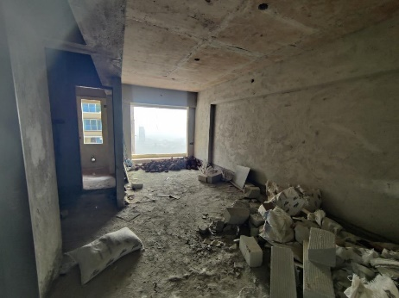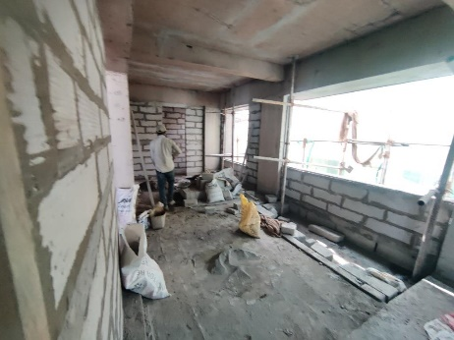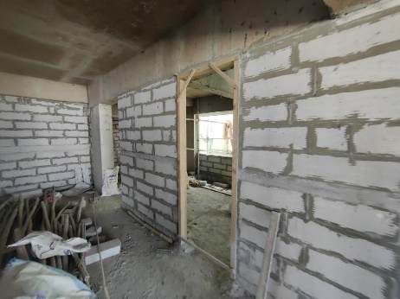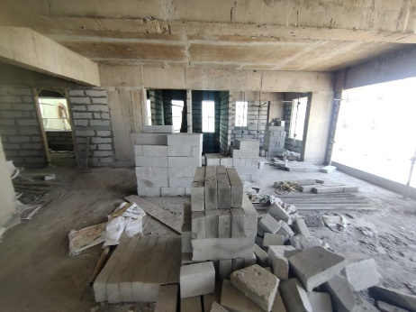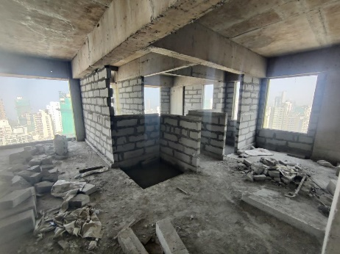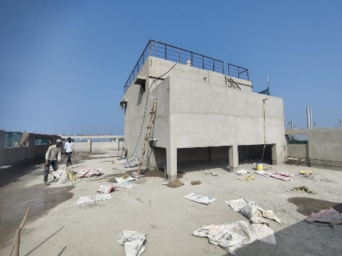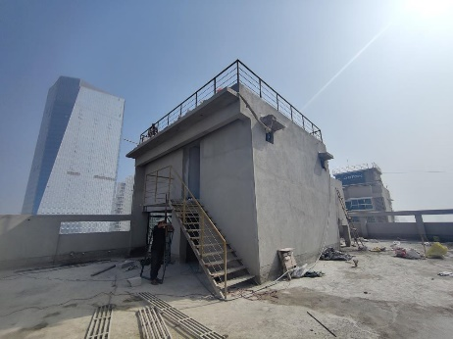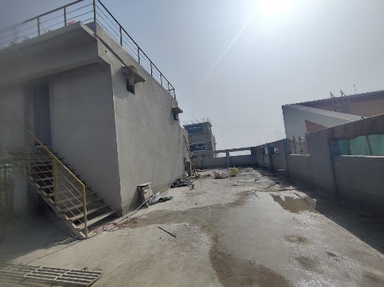**Actual Site Photographs as on 04.01.2024**

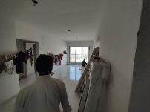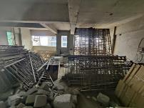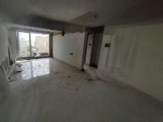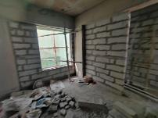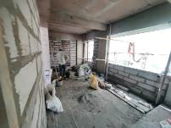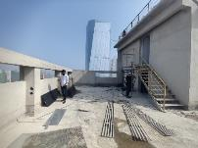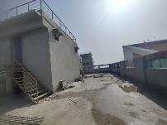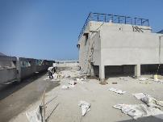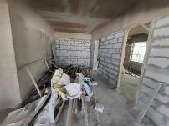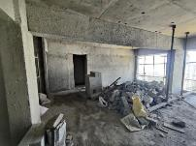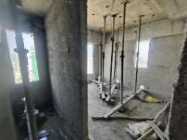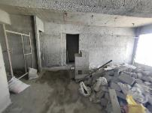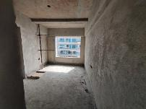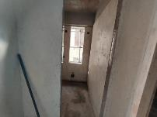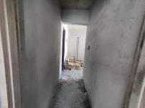

**Actual Site Photographs as on 04.01.2024**

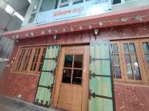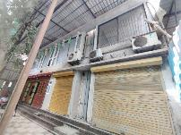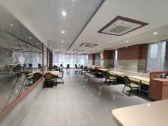

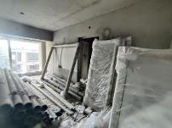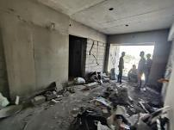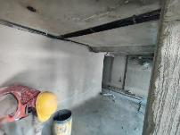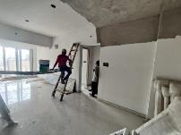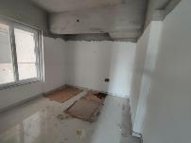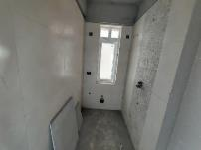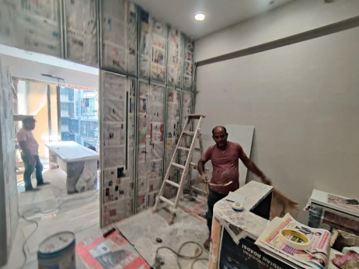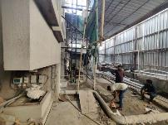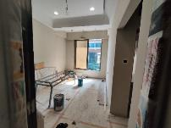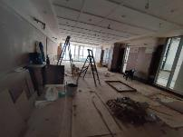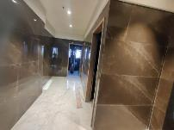

**Actual Site Photographs as on 04.01.2024**

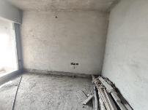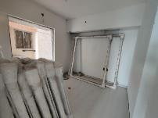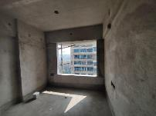

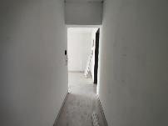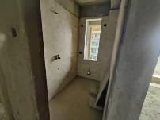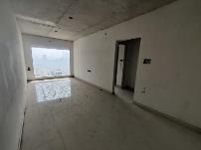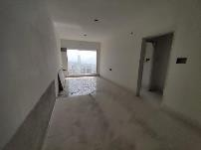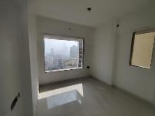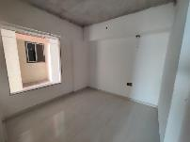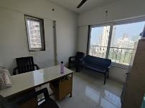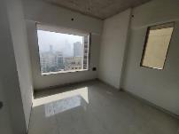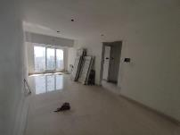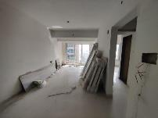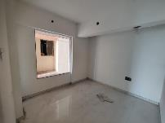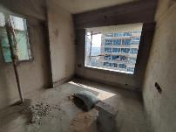

**Actual Site Photographs as on 04.01.2024**

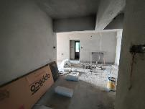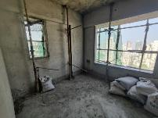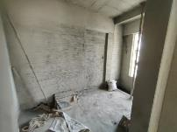

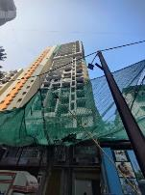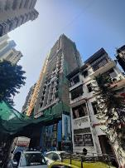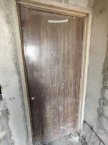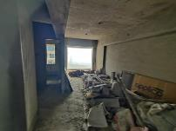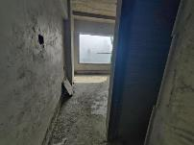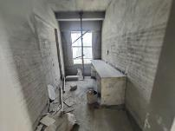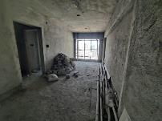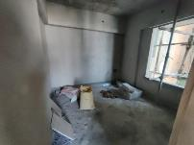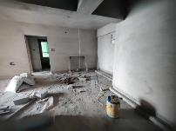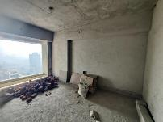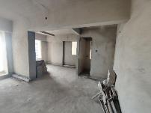

**Route Map of the property**

**Site u/r**

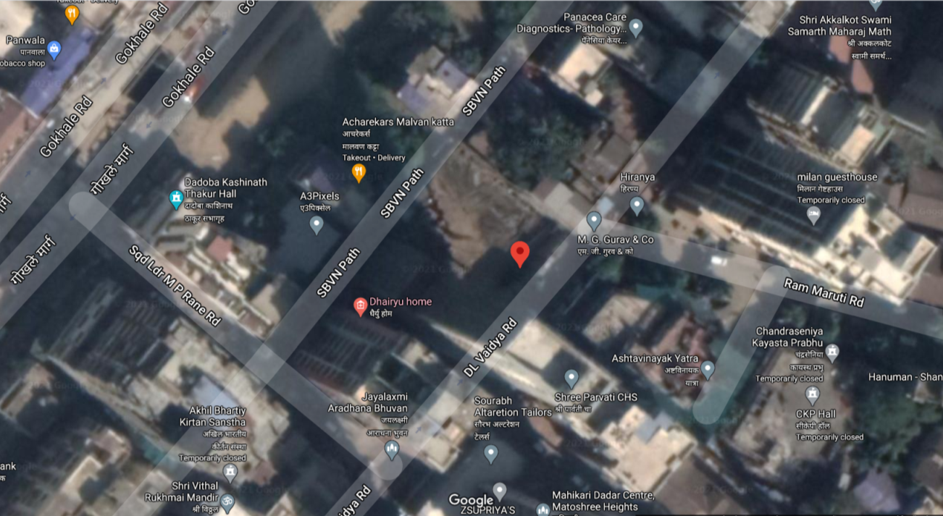

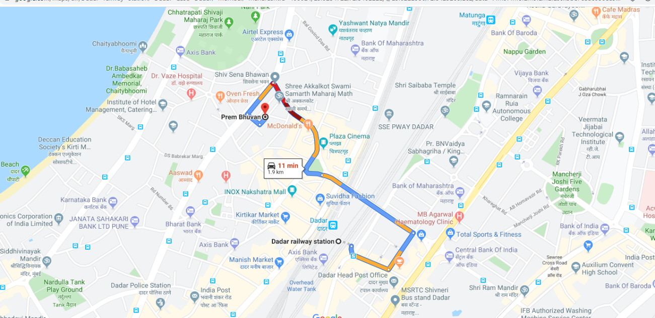

## Latitude Longitude: 19°01'24.5"N 72°50'24.4"E

Note: The Blue line shows the route to site from nearest railway station (Dadar Station –1.90 Km.)

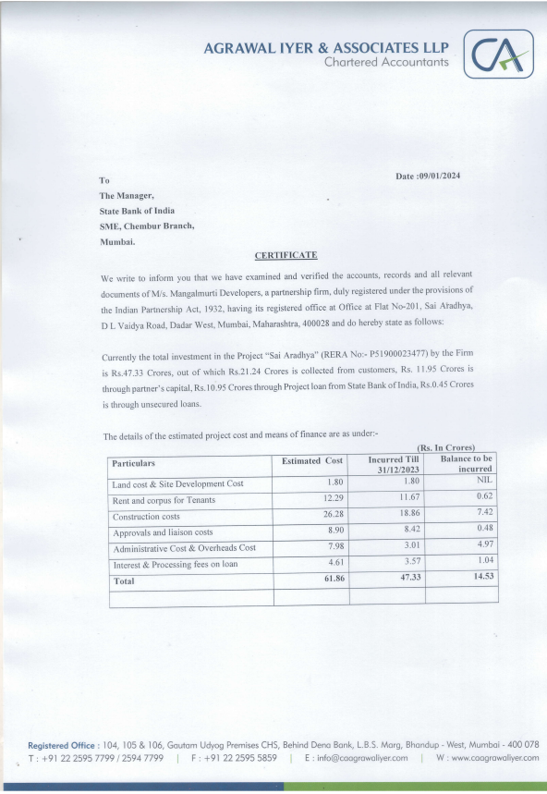**CA Certificate Dated 09.01.2024 till 31.12.2024**

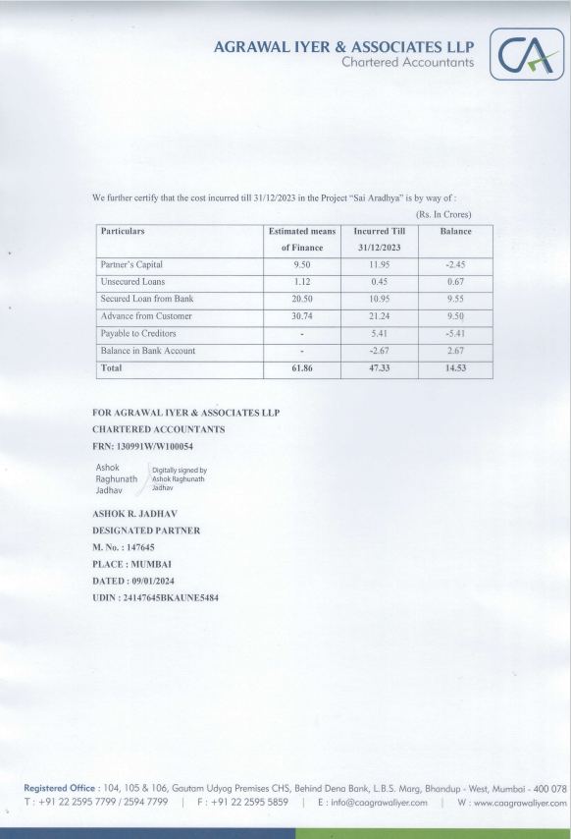**CA Certificate Dated 09.01.2024 till 31.12.2023**