7th LENDERS INDEPENDENT ENGINEER REPORT
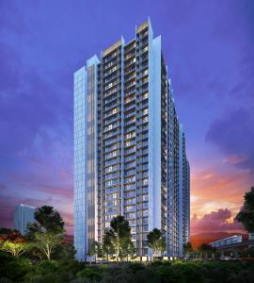

Details of the property under consideration:

Name of Project: Ambarish CHSL

"Ambarish CHSL", Proposed Redevelopment of Existing Building No. 113, along with
Plot No. 98 (R – 3) bearing on C. T. S. No. 12 (pt), S. No. 229 & 267, MHADA Colony, Nehru Nagar, Village – Kurla III, Kurla (East), Mumbai – 400 024, State - Maharashtra, Country – India

Latitude Longitude: 19°03'34.7"N 72°52'55.5"E

Valuation Prepared for:

State Bank of India
SME Chembur Branch
Unit No. 11, Building No. 11, Ground Floor, Corporate Park, Sion Trombay Road,
Chembur, Mumbai, Pin Code – 400 071, State - Maharashtra, Country – India

Vastu/SBI/Mumbai/02/2024/7358/2305268
02/01-16-PY
Date: - 02.03.2024

SEVENTH LENDERS INDEPENDENT ENGINEER REPORT

To,
State Bank of India
SME Chembur Branch
Unit No. 11, Building No. 11,
Ground Floor, Corporate Park,
Sion Trombay Road, Chembur,
Mumbai, Pin Code – 400 071,
State - Maharashtra, Country – India

Subject: Construction of Residential Building "Ambarish CHSL", Proposed Redevelopment of Existing Building No. 113, along with Plot No. 98 (R – 3) bearing on C. T. S. No. 12 (pt), S. No. 229 & 267, MHADA Colony, Nehru Nagar, Village – Kurla III, Kurla (East), Mumbai – 400 024, State - Maharashtra, Country – India.

Ref: You’re Request for Lenders Independent Engineer Report of under Construction Building.
Dear Sir,
The Construction work as per approved plan was in progress during the site visit on 06th January 2024. Total expenditure occurred as on 31/12/2023 on this project by M/s. Peerless Constructions Pvt. Ltd. is ` 50.80 Cr. & as per CA Certificate actual total expenditure occurred as on 31/12/2023 is ` 50.90 Cr. Hence, release of Balance Amount as requested by M/s. Peerless Constructions Pvt. Ltd. is hereby recommended.
DECLARATION
- The information furnished in the report is based on our 7th site visit Dated 06.01.2024 & Document Provided by Client.
- Vastukala 6th LIE Report of the project dated 22.02.2024.
- I have no direct and indirect interest in the property examined for report.
- I have not been found guilty of misconduct in my professional capacity.

Sharadkumar B. Chalikwar
Govt. Reg. Valuer
Chartered Engineer (India)
Reg. No. (N) CCIT/1-14/52/2008-09
Encl.: LIE report

Purpose & Methodology
• State Bank of India Banks and financial institutions require monitoring & an independent review of the progress of the sanctioned projects
VCIPL undertakes such study to independently review the progress of the project and put forward a comprehensive analysis

Advantages:
- Assurance on present practices
- Identification of risk
- Analyzing the performance of third parties
- Recommendations

The Methodology
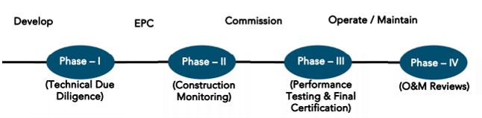
SEVENTH LENDERS INDEPENDENT ENGINEER REPORT
OF
"Ambarish CHSL"
"Ambarish CHSL", Proposed Redevelopment of Existing Building No. 113, along with Plot No. 98 (R – 3) bearing on C. T. S. No. 12 (pt), S. No. 229 & 267, MHADA Colony, Nehru Nagar, Village – Kurla III,
Kurla (East), Mumbai – 400 024, State - Maharashtra, Country – India.

Latitude Longitude: 19°03'34.7"N 72°52'55.5"E

NAME OF DEVELOPER: M/s. Peerless Constructions Pvt. Ltd.
Pursuant to instructions from State of India, SME Chembur Branch, Chembur we have duly visited, inspected, surveyed & assessed the above said property on 06th January 2024 to determine the fair & reasonable market value of the said property/project as on Quarter ending 31st December 2023 for LIE purpose.

1. Location Details:
Proposed Redevelopment of Existing Building No. 113, along with Plot No. 98 (R – 3) bearing on C. T. S. No. 12 (pt), S. No. 229 & 267, MHADA Colony, Nehru Nagar, Village – Kurla III, Kurla (East), Mumbai – 400 024. It is about 800 M. walking distance from Kurla Railway station. Surface transport to the property is by buses, Auto, taxis & private vehicles. The property is in developed locality. All the amenities like shops, banks, hotels, markets, schools, hospitals, etc. are all available in the nearby locality. The locality is higher middle class & developed.

2. Developer Details:
Name of builder | M/s. Peerless Constructions Pvt. Ltd.
Project Rera Registration Number | P51800027680
Registered office address | Office No. 2, Akshat, Ram Mandir, Babhai, Borivali (West), Mumbai – 400 091, State - Maharashtra, Country – India
Contact details | Contact Person:  Mr. Satyakishore Singh Rathore (Company Represntative)  Mobile No. 9867827090  Mrs. Mona Mehta  Mobile No. 9820950066
E – mail ID and website
3. Boundaries of the Property:
Direction | Particulars
On or towards North | Internal Road
On or towards South | Nalla
On or towards East | Nehru Nagar Police Station Road
On or towards West | Building No. 112

Introduction
As per Information on site M/s. Peerless Constructions Pvt. Ltd. has acquired land by Supplementary Development Agreement Date 19.06.2017 admeasuring area is 1,345.66 Sq. M. bearing Existing Building No. 113, along with Plot No. 98 (R – 3) bearing on C. T. S. No. 12 (pt), S. No. 229 & 267, MHADA Colony, Nehru Nagar, Village – Kurla III, Kurla (East), Mumbai – 400 024. For the Proposed Residential Building.

Area Statement:

Land:
Date | Particular | Area in Sq. M.
19.06.2017 | C. T. S. No. 12 (pt), S. No. 229 & 267 | 744.41
 | Plot No. 98 (R – 3) bearing on C. T. S. No. 12 (pt), S. No. 229 & 267 | 601.25
TOTAL LAND AREA IN Sq. M. |  | 1,345.66

- Copy of Lease Deed dated on 26.07.1989 b/w Maharashtra Housing and Area Development Authority (MHADA) (Lessor) and Ambarish CHSL (Lessee).
- Copy of Development Agreement dated 26.05.2016 b/w M/s. Ambarish CHSL (The Owners / Society) And M/s. Peerless Construction Pvt. Ltd (The Developer).
- Copy of Supplemental Development Agreement dated on 19.06.2017 b/w M/s. Ambarish CHSL (The Owners / Society) And M/s. Peerless Construction Pvt. Ltd (The Developer).
- Copy of Power of Attorney dated on 26.05.2016 b/w M/s. Ambarish CHSL (The Owners / Society) And M/s. Peerless Construction Pvt. Ltd (The Developer).

Building Area As per Approved Plan:
A | Area Statement | SQ. M.
1a | Plot Area as Per Demarcation 27.07.2017 | 1,345.66
1b | Plot Area as Per MHADA N.O.C 18.07.2017 | 1,345.66
1c | Plot Area as Per L.S/ Architect Certificate | 1,345.66
1d | Plot Area as Per Layout (733.70+617.28) | 1,350.98
1 | Least Plot Area Consider | 1,345.66
2 | Deduction For
a | Road- Set Back Area
b | Reservation of any
c | Proposed Road
d | % Amenity Space As per D.C.P.R.56/57(sub plot)
 | Total (a + b + c + d)
3 | Balance Area Plot (1-2) | 1,345.66
4 | Deductible Recreational Ground 15% | NIL
5 | Net Plot Area | 1,345.66
6 | Addition For Floor Space Index
 | 2(a) 100% (Set-Back Area) | NIL
 | 2(a) 100% (D.P. Road)
7 | Total Area (5+8) | 1,345.66
8 | Floor Space Index Permissible | 3.00
9 | Permissible Built-up Area | 4,036.98
10 | Add. Area Allotted by MHADA Under No | 1,252.40
11 | Total Permissible Built – Up Area | 5289.38
12 | Existing Floor Area | NIL
13 | Proposed Built up Area | 5282.50
14 | Purely Residential Built-up Area | 5282.50
15 | Remaining Non-Residential Built-up Area | NIL
16 | Total Built up Area Prop (12+13) | 5282.50
17 | F.S.I Consumed | 3.93
B | Details of FSI Availed as per DCR35(4)
1 | Fungible BUA Component Proposed Vide 35(4) For Purely
 | Residential = OR, (16AX0.35) (4036.56X35%) | 1,848.88
2 | Fungible BUA Component Proposed DCR 35(4) For Non | NIL
 | Residential = OR, (16AX0.20)
3 | Total Fungible BUA Vide DCR 35(4) = 1B + 2B | 1848.88
4 | Total Gross Built up Area Proposed (17+3B) | 7131.38
C | Tenant Statement
1 | Proposed Area (Item A,12 above) | 7131.38
2 | Less Deduction of Non-Res, Area | NIL
3 | Area of Tenements | 7131.38
4 | Tenements Permissible | 321.00
5 | Tenements Existing | 20.00
6 | Tenements Proposed | 94.00 Nos.
7 | Total Tenements | 114.00 Nos.
D | Parking Statement
1 | Parking Required by Regulations
 | Car | 48.00 Nos
 | Scooter Motor cycle
 | Out (Visitors) | 1.00 Nos
2 | Covered Garages Permissible | NIL
3 | Covered Garages Permissible | NIL
4 | Total parking Required | 48.00
5 | Total parking Provided | 50.00
E | Loading & Unloading Statement
1 | Loading & Unloading Provided | N. A
2 | Total Loading & Unloading Provided | N. A

List of Approvals:
- Copy of Approved Plans No. MHADA – 22/026 dated 08.01.2020 issued by Maharashtra Housing & Area Development Authority (MHADA).
Approval Upto: Ground Floor + 15 Upper Floors for built up area 5,449.36 Sq. M.
- Copy of Revised Approved Plans No. MHADA – 22/026/2022 dated 04.05.2022 issued by Maharashtra Housing & Area Development Authority (MHADA).
Approval Upto: Ground Floor + 15 Upper Floors for built up area 7,131.38 Sq. M.
- Copy of 1st Commencement Certificate No. EE/BP/Cell/GM/MHADA-22/026/2018 dated 15.06.2018 issued by Maharashtra Housing & Area Development Authority (MHADA).
(This CC is endorsed for the work upto Plinth Level)
- Copy of 2nd Commencement Certificate No. EE/BP/Cell/GM/MHADA-22/026/2018 dated 30.11.2018 issued by Maharashtra Housing & Area Development Authority (MHADA).
(This CC is endorsed for the work upto Plinth Level)
- Copy of 3rd Commencement Certificate No. EE/BP/Cell/GM/MHADA-22/026/2021 dated 22.01.2021 issued by Maharashtra Housing & Area Development Authority (MHADA).
(This CC is endorsed for the work upto Ground + 13th Upper Floors)
- Copy of 4th Commencement Certificate No. EE/BP/Cell/GM/MHADA-22/026/2022 dated 08.04.2022 issued by Maharashtra Housing & Area Development Authority (MHADA).
(This CC is endorsed for the work upto Ground + 15th Upper Floors)
- Copy of 5th Commencement Certificate No. MH/EE/BP/GM/MHADA-22/0026/2022/FCC/1/Amend dated 09.06.2022 issued by Maharashtra Housing & Area Development Authority (MHADA).
(This CC is endorsed for the work upto Ground + 15th Upper Floors for flat no. 1,2,3,6,7 & 8 and Ground + 15th Upper Floors for flat no. 4 & 5)

LEVEL OF COMPLETION:

Rehab cum Sales Building
Sr. No. | Floor No. | Construction Area in Sq. M. | Completed Area Sq. M. | Work Completion as on 6th LIE report dated 22.02.2024 | Work Completion as on 06.01.2024
1 | Ground | 611.99 | 611.99 | Slab work is completed, Under ground water tank work is in progress | Slab work is completed, Under ground water tank, Septic tank, Fire fighting tank work is in progress
2 | 1st | 611.99 | 611.99 | Slab work, Blockwork, Plasterworks, Gypsum, Door frame, window frame, Kitchen paltform, Flooring, Dazoing, waterproofing, fire fighting and lift works are completed. Windows & Doors are installed. Electrical & plumbing installation work is done & final fitting work is pending | Slab work, Blockwork, Plasterworks, Gypsum, Door frame, window frame, Kitchen paltform, Flooring, Dazoing, waterproofing, fire fighting and lift works are completed. Windows & Doors are installed. Electrical & plumbing installation work is don. Final santiary & electrical fitting work is pending & final finsihing is pending
3 | 2nd | 611.99 | 611.99 | Slab work, Blockwork, Plasterworks, Gypsum, Door frame, window frame, Kitchen paltform, Flooring, Dazoing, waterproofing, fire fighting and lift works are completed. Windows & Doors are installed. Electrical & plumbing installation work is done & final fitting work is pending | Slab work, Blockwork, Plasterworks, Gypsum, Door frame, window frame, Kitchen paltform, Flooring, Dazoing, waterproofing, fire fighting and lift works are completed. Windows & Doors are installed. Electrical & plumbing installation work is don. Final santiary & electrical fitting work is pending & final finsihing is pending
4 | 3rd | 615.39 | 615.39 | Slab work, Blockwork, Plasterworks, Gypsum, Door frame, window frame, Kitchen paltform, Flooring, Dazoing, waterproofing, fire fighting and lift works are completed. Windows & Doors are installed. Electrical & plumbing installation work is done & final fitting work is pending | Slab work, Blockwork, Plasterworks, Gypsum, Door frame, window frame, Kitchen paltform, Flooring, Dazoing, waterproofing, fire fighting and lift works are completed. Windows & Doors are installed. Electrical & plumbing installation work is don. Final santiary & electrical fitting work is pending & final finsihing is pending
5 | 4th | 615.39 | 615.39 | Slab work, Blockwork, Plasterworks, Gypsum, Door frame, window frame, Kitchen paltform, Flooring, Dazoing, waterproofing, fire fighting and lift works are completed. Windows & Doors are installed. Electrical & plumbing installation work is done & final fitting work is pending | Slab work, Blockwork, Plasterworks, Gypsum, Door frame, window frame, Kitchen paltform, Flooring, Dazoing, waterproofing, fire fighting and lift works are completed. Windows & Doors are installed. Electrical & plumbing installation work is don. Final santiary & electrical fitting work is pending & final finsihing is pending
6 | 5th | 618.91 | 618.91 | Slab work, Blockwork, Plasterworks, Gypsum, Door frame, window frame, Kitchen paltform, Flooring, Dazoing, waterproofing, fire fighting and lift works are completed. Windows & Doors are installed. Electrical & plumbing installation work is done & final fitting work is pending | Slab work, Blockwork, Plasterworks, Gypsum, Door frame, window frame, Kitchen paltform, Flooring, Dazoing, waterproofing, fire fighting and lift works are completed. Windows & Doors are installed. Electrical & plumbing installation work is don. Final santiary & electrical fitting work is pending & final finsihing is pending
7 | 6th | 618.91 | 618.91 | Slab work, Blockwork, Plasterworks, Gypsum, Door frame, window frame, Kitchen paltform, Flooring, Dazoing, waterproofing, fire fighting and lift works are completed. Windows & Doors are installed. Electrical & plumbing installation work is done & final fitting work is pending | Slab work, Blockwork, Plasterworks, Gypsum, Door frame, window frame, Kitchen paltform, Flooring, Dazoing, waterproofing, fire fighting and lift works are completed. Windows & Doors are installed. Electrical & plumbing installation work is don. Final santiary & electrical fitting work is pending & final finsihing is pending
8 | 7th | 618.91 | 618.91 | Slab work, Blockwork, Plasterworks, Gypsum, Door frame, window frame, Kitchen paltform, Flooring, Dazoing, waterproofing, fire fighting and lift works are completed. Windows & Doors are installed. Electrical & plumbing installation work is done & final fitting work is pending | Slab work, Blockwork, Plasterworks, Gypsum, Door frame, window frame, Kitchen paltform, Flooring, Dazoing, waterproofing, fire fighting and lift works are completed. Windows & Doors are installed. Electrical & plumbing installation work is don. Final santiary & electrical fitting work is pending & final finsihing is pending
9 | 8th | 621.74 | 621.74 | Slab work, Blockwork, Plasterworks, Gypsum, Door frame, window frame, Kitchen paltform, Flooring, Dazoing, waterproofing, fire fighting and lift works are completed. Windows & Doors are installed. Electrical & plumbing installation work is done & final fitting work is pending | Slab work, Blockwork, Plasterworks, Gypsum, Door frame, window frame, Kitchen paltform, Flooring, Dazoing, waterproofing, fire fighting and lift works are completed. Windows & Doors are installed. Electrical & plumbing installation work is don. Final santiary & electrical fitting work is pending & final finsihing is pending
10 | 9th | 620.81 | 620.81 | Slab work, Blockwork, Plasterworks, Gypsum, Door frame, window frame, Kitchen paltform, Flooring, Dazoing, waterproofing, fire fighting and lift works are completed. Windows & Doors are installed. Electrical & plumbing installation work is done & final fitting work is pending | Slab work, Blockwork, Plasterworks, Gypsum, Door frame, window frame, Kitchen paltform, Flooring, Dazoing, waterproofing, fire fighting and lift works are completed. Windows & Doors are installed. Electrical & plumbing installation work is don. Final santiary & electrical fitting work is pending & final finsihing is pending
11 | 10th | 634.58 | 634.58 | Slab work, Blockwork, Plasterworks, Gypsum, Door frame, window frame, Kitchen paltform, Flooring, Dazoing, waterproofing, fire fighting and lift works are completed. Windows & Doors are installed. Electrical & plumbing installation work is done & final fitting work is pending | Slab work, Blockwork, Plasterworks, Gypsum, Door frame, window frame, Kitchen paltform, Flooring, Dazoing, waterproofing, fire fighting and lift works are completed. Windows & Doors are installed. Electrical & plumbing installation work is don. Final santiary & electrical fitting work is pending & final finsihing is pending
12 | 11th | 634.62 | 634.62 | Slab work, Blockwork, Plasterworks, Gypsum, Door frame, window frame, Kitchen paltform, Flooring, Dazoing, waterproofing, fire fighting and lift works are completed. Windows & Doors are installed. Electrical & plumbing installation work is done & final fitting work is pending | Slab work, Blockwork, Plasterworks, Gypsum, Door frame, window frame, Kitchen paltform, Flooring, Dazoing, waterproofing, fire fighting and lift works are completed. Windows & Doors are installed. Electrical & plumbing installation work is don. Final santiary & electrical fitting work is pending & final finsihing is pending
13 | 12th | 620.46 | 620.46 | Slab work, Blockwork, Plasterworks, Gypsum, Door frame, window frame, Kitchen paltform, Flooring, Dazoing, waterproofing, fire fighting and lift works are completed. Windows & Doors are installed. Electrical & plumbing installation work is done & final fitting work is pending | Slab work, Blockwork, Plasterworks, Gypsum, Door frame, window frame, Kitchen paltform, Flooring, Dazoing, waterproofing, fire fighting and lift works are completed. Windows & Doors are installed. Electrical & plumbing installation work is don. Final santiary & electrical fitting work is pending & final finsihing is pending
14 | 13th | 620.46 | 620.46 | Slab work, Blockwork, Plasterworks, Gypsum, Door frame, window frame, Kitchen paltform, Flooring, Dazoing, waterproofing, fire fighting and lift works are completed. Windows & Doors are installed. Electrical & plumbing installation work is done & final fitting work is pending | Slab work, Blockwork, Plasterworks, Gypsum, Door frame, window frame, Kitchen paltform, Flooring, Dazoing, waterproofing, fire fighting and lift works are completed. Windows & Doors are installed. Electrical & plumbing installation work is don. Final santiary & electrical fitting work is pending & final finsihing is pending
15 | 14th | 620.46 | 620.46 | Slab work, Blockwork, Plasterworks, Gypsum, Door frame, window frame, Kitchen paltform, Flooring, Dazoing, waterproofing, fire fighting and lift works are completed. Windows & Doors are installed. Electrical & plumbing installation work is done & final fitting work is pending | Slab work, Blockwork, Plasterworks, Gypsum, Door frame, window frame, Kitchen paltform, Flooring, Dazoing, waterproofing, fire fighting and lift works are completed. Windows & Doors are installed. Electrical & plumbing installation work is don. Final santiary & electrical fitting work is pending & final finsihing is pending
16 | 15th | 508.90 | 508.90 | Slab work, Blockwork, Plasterworks, Gypsum, Door frame, window frame, Kitchen paltform, Flooring, Dazoing, waterproofing, fire fighting and lift works are completed. Windows & Doors are installed. Electrical & plumbing installation work is done & final fitting work is pending | Slab work, Blockwork, Plasterworks, Gypsum, Door frame, window frame, Kitchen paltform, Flooring, Dazoing, waterproofing, fire fighting and lift works are completed. Windows & Doors are installed. Electrical & plumbing installation work is don. Final santiary & electrical fitting work is pending & final finsihing is pending
17 | Terrace | 132.41 | 132.41 | Slab work, Blockwork, Parapett wall, OHT works are completed, LMR room, Painting and Waterproofing are completed. | Slab work, Blockwork, Parapett wall, OHT works are completed, LMR room, Painting and Waterproofing are completed. Firefighting, water tank & lift final checking is in progress.
Total |  | 9,937.92 | 9,937.92

Details of the Project as Financed By SBI:

Project Cost: (as per C.A. Certificate)
Particulars | Estimated Cost (in Cr.) | Incurred Cost  (In Cr.) till 30.09.2023 by  M/s. Ishwarlal & Co. dated 24.02.2024 | Incurred Cost  (In Cr.) till 30.09.2023 by  M/s. Ishwarlal & Co. dated 12.10.2023 | Net
Land Cost & Stamp Duty | 0.77 | 3.24 | 2.97 | 0.27
Rent Cost & Corpus Fund & Shifting Charges | 6.56 | 3.87 | 3.66 | 0.21
Construction Cost | 25.84 | 26.11 | 24.88 | 1.23
Approval Cost Of Fungible Cost & Development cess premium | 7.92 | 9.76 | 9.76 | -
Architect Cost, RCC & other Professional fees | 1.03 | 0.97 | 0.97 | -
Admin Cost | 0.78 | 1.77 | 1.58 | 0.19
Marketing Cost | 1.24 | 2.53 | 2.53 | -
Interest Cost | 2.57 | 2.65 | 2.20 | 0.45
Total | 46.71 | 50.90 | 48.55 | 2.35

- The Builder has incurred about 3.24 Cr. as land cost, 3.87 Cr. as Rent Cost, 26.11 Cr. as construction cost, 1.77 Cr. for admin cost & 2.65 Cr. for interest cost till 31.12.2023 as per C.A. certificate issued by M/s. Ishwarlal & Co. issued dated 24.02.2024.

Project Cost: (as per Bills):
Particulars | Incurred Cost (in Cr.) |  | Net
 | 31.12.2023 as per Bill (Inclusive GST) | 30.09.2023 as per Bill (Inclusive GST)
Land Cost & Stamp Duty | 1.31 | 1.31 | -
Rent Cost & Corpus Fund & Shifting Charges | 5.64 | 5.16 | 0.48
Construction Cost | 25.67 | 24.57 | 1.10
Approval Cost Of Fungible Cost & Development cess premium | 10.29 | 10.29 | -
Architect Cost, RCC & other Professional fees | 1.38 | 1.38 | -
Admin Cost | 1.31 | 1.26 | 0.05
Marketing Cost | 2.53 | 2.37 | 0.16
Interest Cost | 2.66 | 2.20 | 0.46
Total | 50.80 | 48.56 | 2.24

Land Cost:
Sr. No. | Date | Description | Incurred Cost
1 | 26.05.2016 | Stamp Duty | 38,64,350.00
2 |  | Reg. Fees | 30,000.00
3 |  |  | 1,440.00
4 |  |  | 100.00
5 | 19.06.2017 | Stamp Duty | 37,72,350.00
6 |  | Reg. Fees | 30,000.00
7 |  |  | 1,960.00
8 |  |  | 100.00
9 | 07.03.2018 to 30.03.2022 | Stamp Duty Reg. Fees of Tenants Flat | 54,18,650.00
Total |  |  | 77,00,300.00
As per Developer Agreement, Supplementary Developer Agreement & Register Agreement for Tenants.
There is no cost incurred for land cost in this quarter.
Summary of Bills
Sr. No. | Particulars | Amount in `  (Till 31.12.2023) | Amount in `  (In Cr.) | Amount in `  (Till 30.09.2023) | Amount in `  (In Cr.) | Net in Cr.
1 | Construction Cost | 25,67,18,229.00 | 25.67 | 24,57,37,810.00 | 24.57 | 1.10
2 | Rent Cost & Corpus Fund & Shifting Charges | 5,64,05,000.00 | 5.64 | 5,16,05,000.00 | 5.16 | 0.48
2 | Premium Cost / FSI/ GOM Charges/ fees/ security Deposits | 10,28,92,906.00 | 10.29 | 10,28,92,906.00 | 10.29 | -
3 | Professional Cost | 1,38,44,195.00 | 1.38 | 1,38,39,062.00 | 1.38 | -
4 | Administrative Cost | 1,30,71,935.00 | 1.31 | 1,26,18,692.00 | 1.26 | 0.05
5 | Marketing Cost | 2,53,42,500.00 | 2.53 | 2,36,98,500.00 | 2.37 | 0.16
TOTAL |  | 46,82,74,765.00 | 46.83 | 45,03,91,970.00 | 45.04 | 1.79
Note: Bills were provided by the client up to 31.12.2023

Interest Cost:
Sr. No | Particulars | Estimate Amount in ` | Incurred Amount in ` till 31.12.2023 | Incurred Amount in ` till 30.09.2023 | Balance Amount in `
1 | Interest Cost | 2,57,00,000.00 | 2,66,06,792.00 | 2,20,40,774.00 | 45,66,018.00
TOTAL |  | 2,57,00,000.00 | 2,66,06,792.00 | 2,20,40,774.00 | 45,66,018.00
Interest Cost is based on discussion with the client.

Cost of Construction as on 06th January 2024:
Plinth Area Calculation
Sr. | Floor No. | Construction Area in Sq. M. | Completed area in Sq. M. | Rate per Sq. M. | Full Value after completion | Percentage of work completed | Actual Expenditure till date in `
1 | Ground | 611.99 | 611.99 | 26,000.00 | 1,59,11,740.00 | 70% | 1,11,38,218.00
2 | 1st | 611.99 | 611.99 | 26,000.00 | 1,59,11,740.00 | 93% | 1,47,97,918.00
3 | 2nd | 611.99 | 611.99 | 26,000.00 | 1,59,11,740.00 | 93% | 1,47,97,918.00
4 | 3rd | 615.39 | 615.39 | 26,000.00 | 1,60,00,140.00 | 93% | 1,48,80,130.00
5 | 4th | 615.39 | 615.39 | 26,000.00 | 1,60,00,140.00 | 93% | 1,48,80,130.00
6 | 5th | 618.91 | 618.91 | 26,000.00 | 1,60,91,660.00 | 93% | 1,49,65,244.00
7 | 6th | 618.91 | 618.91 | 26,000.00 | 1,60,91,660.00 | 93% | 1,49,65,244.00
8 | 7th | 618.91 | 618.91 | 26,000.00 | 1,60,91,660.00 | 93% | 1,49,65,244.00
9 | 8th | 621.74 | 621.74 | 26,000.00 | 1,61,65,240.00 | 93% | 1,50,33,673.00
10 | 9th | 620.81 | 620.81 | 26,000.00 | 1,61,41,060.00 | 93% | 1,50,11,186.00
11 | 10th | 634.58 | 634.58 | 26,000.00 | 1,64,99,080.00 | 93% | 1,53,44,144.00
12 | 11th | 634.62 | 634.62 | 26,000.00 | 1,65,00,120.00 | 93% | 1,53,45,112.00
13 | 12th | 620.46 | 620.46 | 26,000.00 | 1,61,31,960.00 | 93% | 1,50,02,723.00
14 | 13th | 620.46 | 620.46 | 26,000.00 | 1,61,31,960.00 | 93% | 1,50,02,723.00
15 | 14th | 620.46 | 620.46 | 26,000.00 | 1,61,31,960.00 | 93% | 1,50,02,723.00
16 | 15th | 508.90 | 508.90 | 26,000.00 | 1,32,31,400.00 | 93% | 1,23,05,202.00
17 | Terrace | 132.41 | 132.41 | 26,000.00 | 34,42,660.00 | 93% | 32,01,674.00
 | Total | 9,937.92 | 9,937.92 |  | 25,83,85,920.00 | 92% | 23,66,39,206.00

Note: Details of work completed is as per site visit dated 06.01.2024 but report is prepared for 31st December quarter 2023.

Particulars | Estimated Cost  (In Cr.) | Incurred Cost (in Cr.) |  |  | Net
 |  | Issued dated 24.02.2024 as per CA till 31.12.2023 | As per Bills upto 31.12.2023 | As per 12th LIE report Bills upto 30.09.2023
Land Cost & Stamp Duty | 0.77 | 3.24 | 1.31 | 1.31 | -
Rent Cost & Corpus Fund & Shifting Charges | 6.56 | 3.87 | 5.64 | 5.16 | 0.48
Construction Cost | 25.84 | 26.11 | 25.67 | 24.57 | 1.10
Approval Cost Of Fungible Cost & Development cess premium | 7.92 | 9.76 | 10.29 | 10.29 | -
Architect Cost, RCC & other Professional fees | 1.03 | 0.97 | 1.38 | 1.38 | -
Admin Cost | 0.78 | 1.77 | 1.31 | 1.26 | 0.05
Marketing Cost | 1.24 | 2.53 | 2.53 | 2.37 | 0.16
Interest Cost | 2.57 | 2.65 | 2.66 | 2.20 | 0.46
Total | 46.71 | 50.90 | 50.80 | 48.56 | 2.24

Note:
As per plinth area, calculation the work completed is up to 92% of total work, which comes to ` 23.66 Cr. However, company has incurred cost of ` 26.11 Cr. till 31.12.2023 Which is inclusive of material on site.

Comparison of Cost incurred on dated 31.12.2023 & 30.09.2023
Particulars | 31.12.2023 as per Bill | 30.09.2023 as per Bill | Net | % of net amount
Land Cost & Stamp Duty | 1.31 | 1.31 | - | 0.00%
Rent Cost & Corpus Fund & Shifting Charges | 5.64 | 5.16 | 0.48 | 0.94%
Construction Cost | 25.67 | 24.57 | 1.10 | 2.17%
Approval Cost Of Fungible Cost & Development cess premium | 10.29 | 10.29 | - | 0.00%
Architect Cost, RCC & other Professional fees | 1.38 | 1.38 | - | 0.00%
Admin Cost | 1.31 | 1.26 | 0.05 | 0.10%
Marketing Cost | 2.53 | 2.37 | 0.16 | 0.31%
Interest Cost | 2.66 | 2.20 | 0.46 | 0.91%
Total | 50.80 | 48.56 | 2.24 | 100.00%

% of Fund Utilised till 31st December 2023
Particulars | Estimated Project Cost  (in Cr.) | Incurred cost as on 31.12.2023 | % of Incurred Cost | % of Estimated Project Cost
Land Cost & Stamp Duty | 0.77 | 1.31 | 170.38% | 2.81%
Rent Cost & Corpus Fund & Shifting Charges | 6.56 | 5.64 | 85.98% | 12.08%
Construction Cost | 25.84 | 25.67 | 99.35% | 54.96%
Approval Cost Of Fungible Cost & Development cess premium | 7.92 | 10.29 | 129.92% | 22.03%
Architect Cost, RCC & other Professional fees | 1.03 | 1.38 | 134.41% | 2.96%
Admin Cost | 0.78 | 1.31 | 167.59% | 2.80%
Marketing Cost | 1.24 | 2.53 | 204.38% | 5.43%
Interest Cost | 2.57 | 2.66 | 103.53% | 5.70%
Total | 46.71 | 50.80 | 108.76% | 108.76%
Based on above Calculation it is found that total Project cost incurred till 31.12.2023 is 108.76% of the Total Project Cost. Project cost is over running by 8.76% and in amount 4.09 Cr.

Means of Finance:
Sr. No. | Particulars | Exp. Cumulative (Cr.)
 | Equity share capital / Quassi Loan from Promoter including unsecured loan | 6.24
 | Sales (Advance from customer) | 32.69
 | Bank Laon Amount | 11.97
 | Total | 50.90
The Details of the Means of Finance are provided by Client as on 31.12.2023.

Mandatory Arrangements:
Sr. No. | Particulars | Status
 | Rainwater Harvesting | To be executed after RCC Structure
 | Firefighting System | To be executed after RCC Structure
 | Solid Waste Management | To be executed after RCC Structure

Quality of Construction:
Sr. No. | Particulars | Status
 | Soundness of Structures | Executing as per approved Structural Design
 | Look of Structures | Good
 | Quality of Material Used | Good
 | Safety Measures for Construction/labour | Taken Care by Contractor

Schedule V/s. Actual Progress:
Activity | Date of Implementation | Date of Completion | Status
Land |  |  | Completed
Development of Land |  |  | Completed
Foundation Work |  |  | Completed
Ground Floor Slab |  |  | Slab work is completed
1st Floor Slab |  |  | Slab work is completed
2nd Floor Slab |  |  | Slab work is completed
3rd Floor Slab |  |  | Slab work is completed
4th Floor Slab |  |  | Slab work is completed
5th Floor Slab |  |  | Slab work is completed
6th Floor Slab |  |  | Slab work is completed
7th Floor Slab |  |  | Slab work is completed
8th Floor Slab |  |  | Slab work is completed
9th Floor Slab |  |  | Slab work is completed
10th Floor Slab |  |  | Slab work is completed
11th Floor Slab |  |  | Slab work is completed
12th Floor Slab |  |  | Slab work is completed
13th Floor Slab |  |  | Slab work is completed
14th Floor Slab |  |  | Slab work is completed
15th Floor Slab |  |  | Slab work is completed
Block work /Internal Plaster work |  |  | Work is completed
Terrace Parapet wall / Overhead water tank / Lift Machine room / compound wall / External Plaster work |  |  | Work is completed
Electric Work |  |  | Work is in progress
Water Proofing |  |  | Work is completed
Plumbing Work |  |  | Work is completed
Tiling / Marble Flooring |  |  | Work is completed
Door Frames |  |  | Work is completed
Window Installation |  |  | Work is completed
Staircase Flooring |  |  | Work is in progress
Staircase Railing |  |  | Work is in progress
Refuge Area Flooring |  |  | Work is in progress
Internal Painting |  |  | Work is completed
External Painting |  |  | Work is in progress
Lift Work |  |  | Lift are installed
Fire Fighting Installation |  |  | Work is completed
Stack Parking
CP Fitting & Sanitary Work |  |  | Work is in progress
Final Finishing & Fitting
Work schedule is not provided by the client.

Action initiated to complete the project in time:
For Sales Building: 15th floor slab work is completed, terrace water proofing work is in completed, external painting work is in progress.

The developers have Major work on themselves only hence (all Manpower (Labour Contractor) and material resources) shall be enhanced by the Developer to meet the TimeLine. Detail periodically progress report needs to be checked for timely completion of project.

Multiple activists to be done for achieving the timely progress & detail periodically bar chart is to be submitted for the further next quarter.

Comments related to cost overrun if any:
The cost of Rehab cum Sales Building is ` 50.80 Cr. Land Cost, Approval cost, Professional charges, Admin cost, Marketing cost & Interest cost are over running, take justification from client. Project cost is over running by 8.76% and in amount ` 4.09 Cr.

Balance investment required for completion of project:
We opinion that project cost is over run by ` 4.09 Cr. Will required more amount to complete the Project.

Mandatory Approval Status:
Sr. No. | Particulars | Name of Department | Status | Order Details
1A | IOD of Building | Maharashtra Housing & Area Development Authority (MHADA). | Obtained and available at site | MHADA – 22/026 dated 08.01.2020. Approval Upto: Ground Floor + 15 Upper Floors for built up area 5,449.36 Sq. M.
1B | Revised Approved Plan | Maharashtra Housing & Area Development Authority (MHADA). | Obtained and available at site | MHADA – 22/026/2022 dated 04.05.2022 Approval Upto: Ground Floor + 15 Upper Floors for built up area 7,131.38 Sq. M.
2A | First C.C. | Maharashtra Housing & Area Development Authority (MHADA). | Obtained and available at site | EE/BP/Cell/GM/MHADA-22/026/2018 dated 15.06.2018. This CC is endorsed for the work upto Plinth Level
2B | Second C.C. | Maharashtra Housing & Area Development Authority (MHADA). | Obtained and available at site | EE/BP/Cell/GM/MHADA-22/026/2018 dated 30.11.2018. This CC is endorsed for the work upto Plinth Level
2C | Third C.C. | Maharashtra Housing & Area Development Authority (MHADA). | Obtained and available at site | EE/BP/Cell/GM/MHADA-22/026/2021 dated 22.01.2021. This CC is endorsed for the work upto Ground + 13th Upper Floors
2D | Fourth C.C. | Maharashtra Housing & Area Development Authority (MHADA). | Obtained and available at site | EE/BP/Cell/GM/MHADA-22/026/2022 dated 08.04.2022. This CC is endorsed for the work upto Ground + 15th Upper Floors
2E | Fifth C.C. | Maharashtra Housing & Area Development Authority (MHADA). | Obtained and available at site | MH/EE/BP/GM/MHADA-22/0026/2022/FCC/1/Amend dated 09.06.2022). This CC is endorsed for the work upto Ground + 15th Upper Floors for flat no. 1,2,3,6,7 & 8 and Ground + 15th Upper Floors for flat no. 4 & 5
3B | Occupancy | Maharashtra Housing & Area Development Authority (MHADA). | Pending (Project is not completed)

Status Insurance Coverage:
Information not provided

Assumptions & Remarks:
- The adequacy of Engineering / Structural design is beyond the scope of our assignment.
- Estimated project completion dated 30/06/2025 for Rehab cum Sales Building, respectively. The cost is certified based on the assumptions that the project will be completed within period. Few assumptions were made regarding inflation & cost rise etc. during construction period.

Sharadkumar B. Chalikwar
Govt. Reg. Valuer
Chartered Engineer (India)
Reg. No. (N) CCIT/1-14/52/2008

About the Project:
1. Introduction
a) | Project Name  (With Address & Phone Nos.) | "Ambarish CHSL", Proposed Redevelopment of Existing Building No. 113, along with Plot No. 98 (R – 3) bearing on C. T. S. No. 12 (pt), S. No. 229 & 267, MHADA Colony, Nehru Nagar, Village – Kurla III, Kurla (East), Mumbai – 400 024, State - Maharashtra, Country – India  Contact Person:  Mr. Satyakishore Singh Rathore (Company Represntative)  Mobile No. 9867827090  Mrs. Mona Mehta  Mobile No. 9820950066
b) | Purpose of Valuation | As per request from State Bank of India, SME Chembur Branch to assess fair market value of the Project for LIE purpose.
c) | Date of Inspection of Property | 06.01.2024
d) | Date of LIE Report | 02.03.2024
e) | Name of the Developer of Property  (in case of developer built properties) | M/s. Peerless Constructions Pvt. Ltd.  Office No. 2, Akshat, Ram Mandir, Babhai, Borivali (West), Mumbai – 400 091, State - Maharashtra, Country – India
2. Physical Characteristics of the Property
a) | Location of the Property | "Ambarish CHSL", Proposed Redevelopment of Existing Building No. 113, along with Plot No. 98 (R – 3) bearing on C. T. S. No. 12 (pt), S. No. 229 & 267, MHADA Colony, Nehru Nagar, Village – Kurla III, Kurla (East), Mumbai – 400 024, State - Maharashtra, Country – India
 | Brief description of the property
TYPE OF THE BUILDING
- Rehab cum Sales Building

No. of Floors | Ground Floor + 1st to 15th Residential Floor
Building type | Residential Rehab cum Sale building

Rehab cum Sales Building work is given on contract based for RCC contract. Developer has grant to the contractor do the work of construction and completion includes Concrete work, Reinforcement work, Masonry, Internal Plaster, External Plaster and other miscellaneous work such as repairing, joints b/w concrete and masonry surface, etc. Bill must be paid on measurement of construction area inclusive of Steel & Cement Material.
Lift & lift installation contract is not finalized till now.
Firefighting work contract is not finalized.

PROPOSED DATE OF COMPLETION & FUTURE LIFE:
Expected completion date as per RERA is 30th June 2025
 | Nearby landmark | Near MHADA Colony, Nehru Nagar
 | Postal Address of the Property | "Ambarish CHSL", Proposed Redevelopment of Existing Building No. 113, along with Plot No. 98 (R – 3) bearing on C. T. S. No. 12 (pt), S. No. 229 & 267, MHADA Colony, Nehru Nagar, Village – Kurla III, Kurla (East), Mumbai – 400 024, State - Maharashtra, Country – India.
 | Area of the plot/land  (Supported by a plan) | Plot Area: 1,345.66 Sq. M.
 | Type of Land: Solid, Rocky, Marsh land, reclaimed land, Water-logged, Land locked. | Solid land
 | Independent access/approach to the property etc. | Yes
 | Google Map Location of the Property with a neighborhood layout map | Provided
 | Details of roads abutting the property | 18.00 Mt. wide Road
 | Description of adjoining property | Located in Higher Middle-class locality
 | Plot No. Survey No. | Plot No. 98 (R – 3) bearing on C. T. S. No. 12 (pt), S. No. 229 & 267
 | Ward/Village/Taluka | Village – Kurla III, Taluka – Kurla
 | Sub-Registry/Block | Kurla – 1
 | District | District – Mumbai Suburban
b) | Boundaries of the Plot
 | As per Agreement | As per RERA Certificate | Actual
North | 12. Mtr. wide Road | 12 Mtr wide road | Internal Road
South | Existing Nalla | Nalla | Nalla
East | Building No. 114 & 15.50 Mtr. wide Road | 15 Mtr wide road | Nehru Nagar Police Station Road
West | Building No. 112 | Open | Building No. 112

4. Document Details and Legal Aspects of Property:
a) | Ownership Documents (Building Permission, Commencement Certificate & Status of Plan)
 | Sale Deed, Gift Deed, Lease Deed
 | - Copy of Development Agreement dated 26.05.2016 b/w M/s. Ambarish CHSL (The Owners / Society) And M/s. Peerless Construction Pvt. Ltd (The Developer)
 | - Copy of Supplemental Development Agreement dated on 19.06.2017 b/w M/s. Ambarish CHSL (The Owners / Society) And M/s. Peerless Construction Pvt. Ltd (The Developer)
 | - Copy of Lease Deed dated on 26.07.1989 b/w Maharashtra Housing and Area Development Authority (MHADA)(Lessor) and Ambarish CHSL (Lessee)
 | - Copy of Power of Attorney dated on 26.05.2016 b/w M/s. Ambarish CHSL (The Owners / Society) And M/s. Peerless Construction Pvt. Ltd (The Developer)
 | - Copy of General Power of Attorney dated on 19.06.2017
 | - Copy of MHADA Offer Letter No. CO/MB/REE/NOC/F-505/361/2017 dated on 20.03.2017 issued by Maharashtra Housing and Development Authority
- Copy of 1st Commencement Certificate No. EE/BP/Cell/GM/MHADA-22/026/2018 dated 15.06.2018 issued by Maharashtra Housing & Area Development Authority (MHADA).
(This CC is endorsed for the work upto Plinth Level)
- Copy of 2nd Commencement Certificate No. EE/BP/Cell/GM/MHADA-22/026/2018 dated 30.11.2018 issued by Maharashtra Housing & Area Development Authority (MHADA).
(This CC is endorsed for the work upto Plinth Level)
- Copy of Approved Plans No. MHADA – 22/026 dated 08.01.2020 issued by Maharashtra Housing & Area Development Authority
Approval Upto: Ground Floor + 15 Upper Floors for built up area 5,449.36 Sq. M.
- Copy of Concessions Drawing issued by M/s. S. B. Associates
Approval Upto: Ground Floor + 15 Upper Floors for built up area 7,133.19 Sq. M.
 | - Copy of RERA Form 3 issued by M/s. Ishwarlal & Company.
 | - Copy of CA Certificate dated 30.11.2021 issued by M/s. Ishwarlal & Company.
 | - Copy of RERA Certificate No. P51800027680 dated 08.09.2021 issued by Maharashtra Real Estate Regulatory Authority.
 | - Copy of Architect Certificate dated 16.12.2021 issued by M/s. S.B Associates.
- Copy of 3rd Commencement Certificate No. EE/BP/Cell/GM/MHADA-22/026/2021 dated 22.01.2021 issued by Maharashtra Housing & Area Development Authority (MHADA).
(This CC is endorsed for the work upto Ground + 13th Upper Floors)
- Copy of 4th Commencement Certificate No. EE/BP/Cell/GM/MHADA-22/026/2022 dated 08.04.2022 issued by Maharashtra Housing & Area Development Authority (MHADA).
(This CC is endorsed for the work upto Ground + 15th Upper Floors)
 | - Copy of Engineer Certificate dated 28.01.2022 issued by Mr. Sandeep S. Samel.
 | - Copy of CA Certificate dated 30.04.2022 issued by M/s. Ishwarlal & Company.
 | - Copy of Bill till 31.03.2022
 | - Copy of CA Certificate dated 03.11.2022 issued by M/s. Ishwarlal & Company
 | - Copy of Bills from 01.04.2022 to 30.09.2022
- Copy of Revised Approved Plans No. MHADA – 22/026/2022 dated 04.05.2022 issued by Maharashtra Housing & Area Development Authority (MHADA).
Approval Upto: Ground Floor + 15 Upper Floors for built up area 7,131.38 Sq. M.
- Copy of 5th Commencement Certificate No. MH/EE/BP/GM/MHADA-22/0026/2022/FCC/1/Amend dated 09.06.2022 issued by Maharashtra Housing & Area Development Authority (MHADA).
(This CC is endorsed for the work upto Ground + 15th Upper Floors for flat no. 1,2,3,6,7 & 8 and Ground + 15th Upper Floors for flat no. 4 & 5)
 | - Copy of CA Certificate dated 14.01.2023 issued by M/s. Ishwarlal & Company
 | - Copy of Bills from 01.10.2022 to 31.12.2022
 | - Copy of CA Certificate dated 19.06.2023 issued by M/s. Ishwarlal & Company
 | - Copy of Bills from 01.01.2023 to 31.03.2023
 | - Copy of CA Certificate dated 19.06.2023 issued by M/s. Ishwarlal & Company
 | - Copy of Bills from 01.04.2023 to 30.06.2023
 | - Copy of CA Certificate dated 12.10.2023 issued by M/s. Ishwarlal & Company
 | - Copy of Bills from 01.07.2023 to 30.09.2023

b) | Documents verified for present LIE report
 | - Copy of CA Certificate dated 24.02.2024 issued by M/s. Ishwarlal & Company
 | - Copy of Bills from 01.10.2023 to 31.12.2023
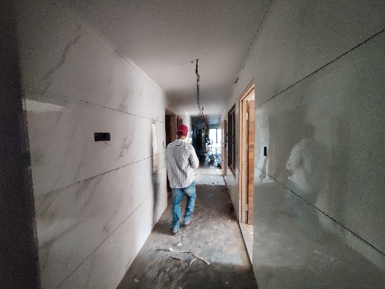
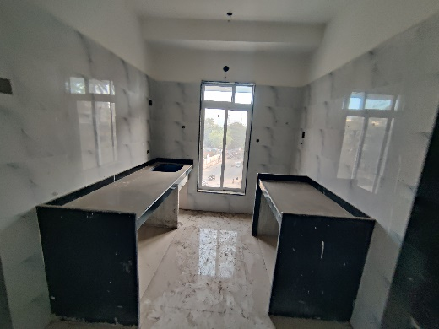
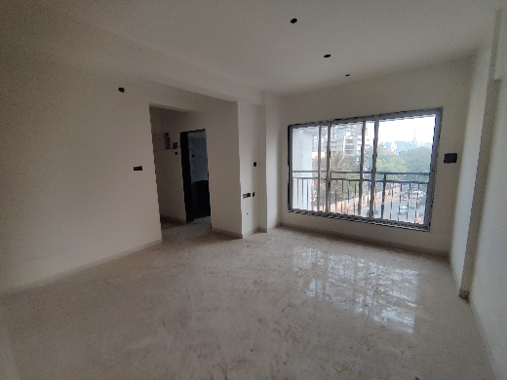
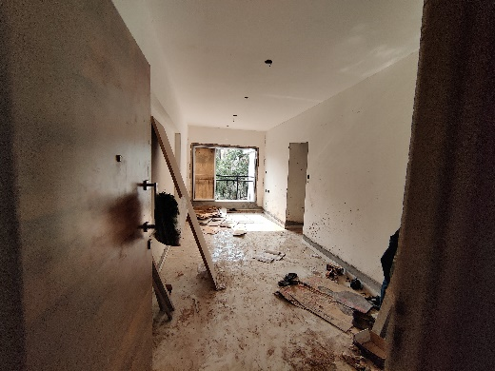
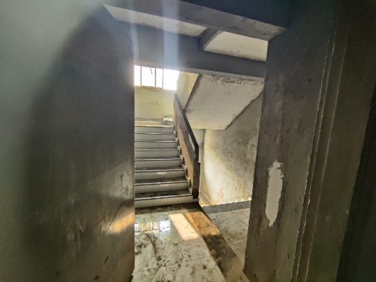
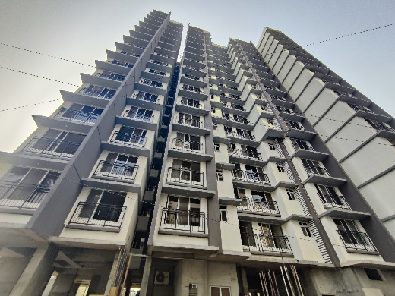
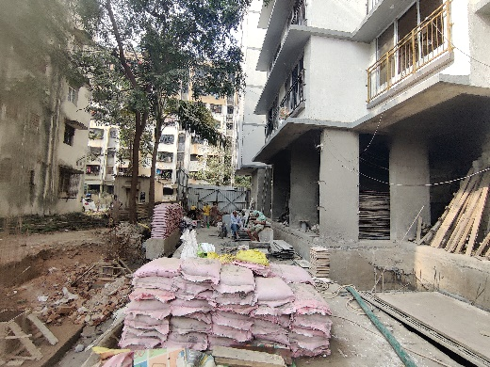
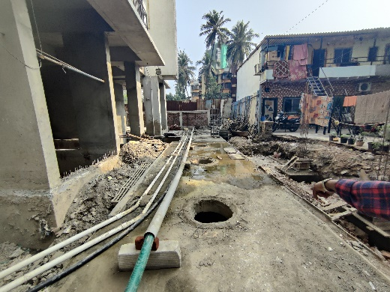
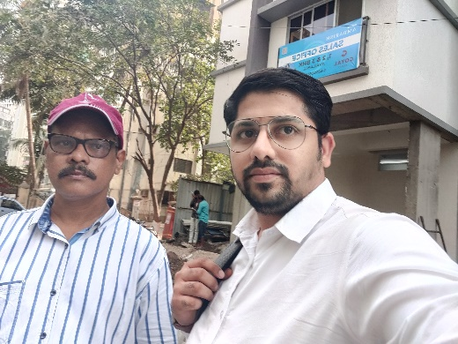
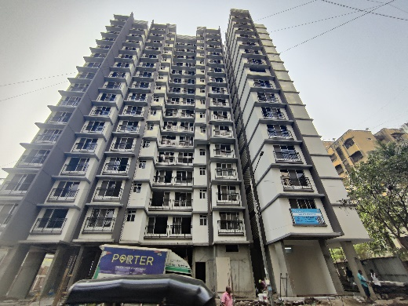
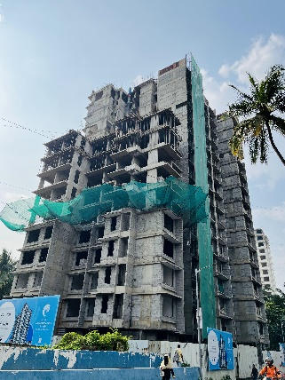
Actual Site Photographs as on 06.01.2024

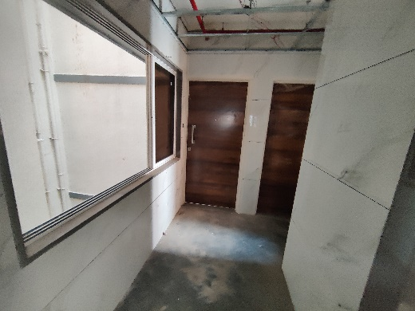
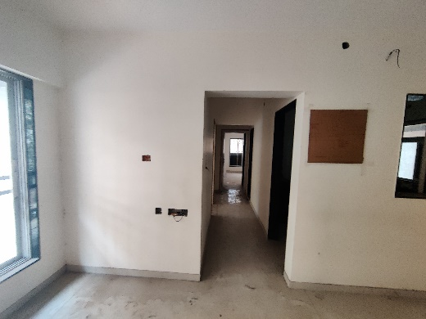
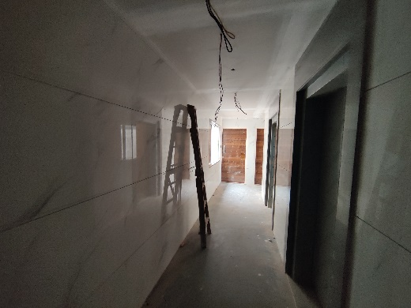
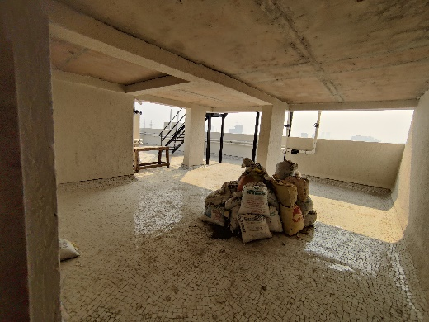
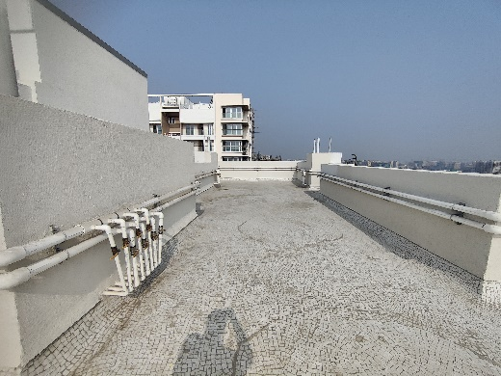
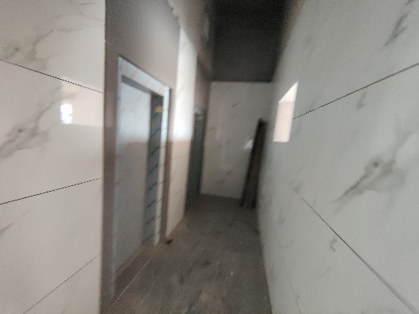
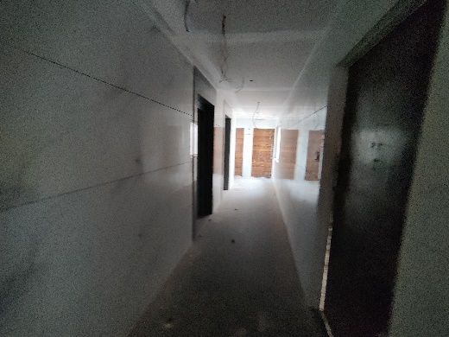
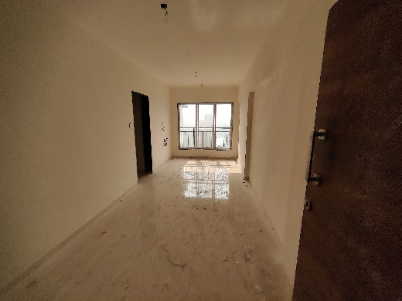
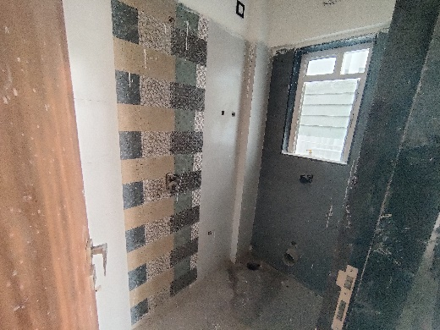
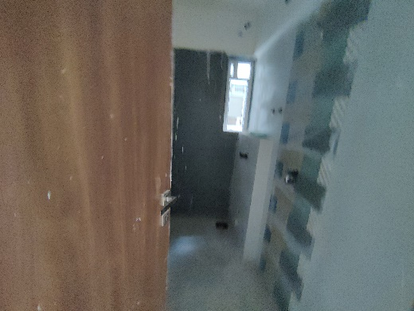
Actual Site Photographs as on 06.01.2024

Actual Site Photographs as on 06.01.2024
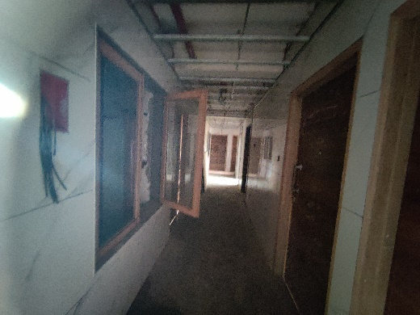
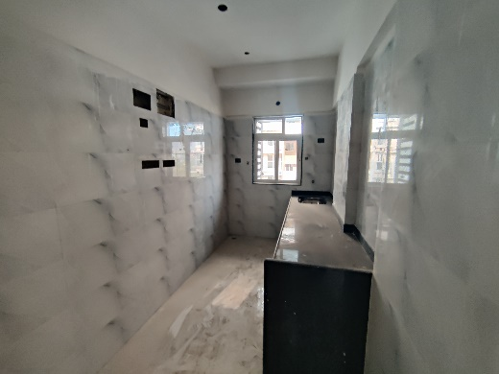
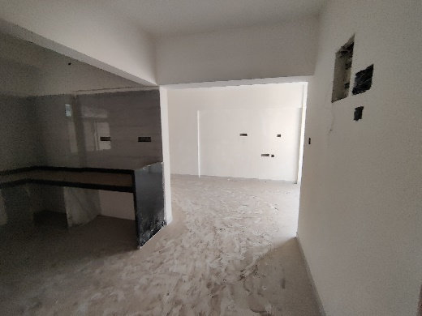
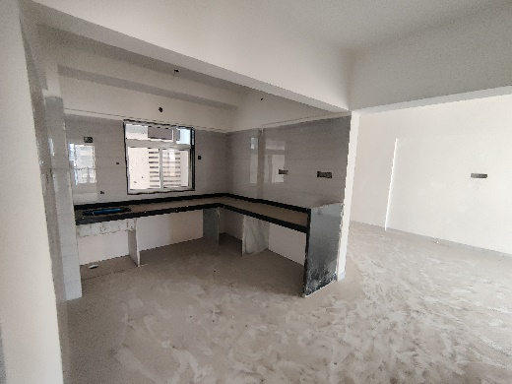
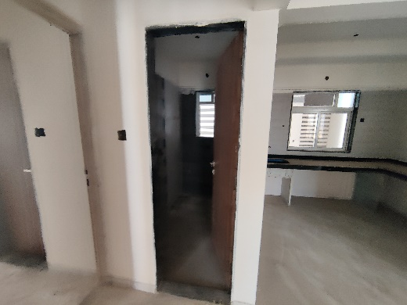
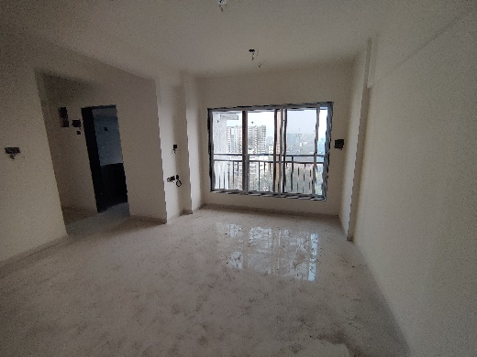
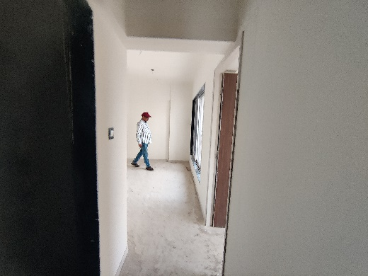
Actual Site Photographs as on 06.01.2024
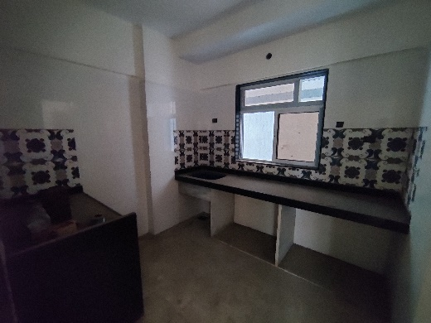
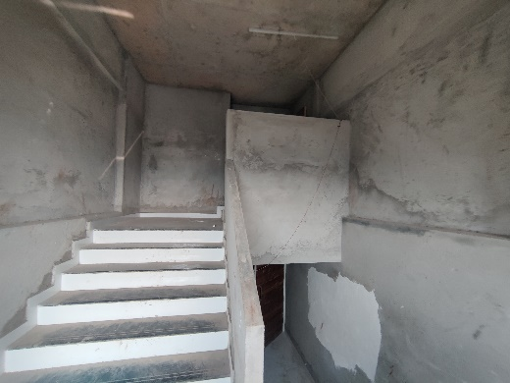
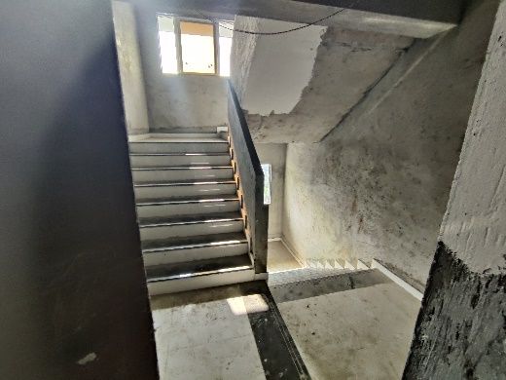
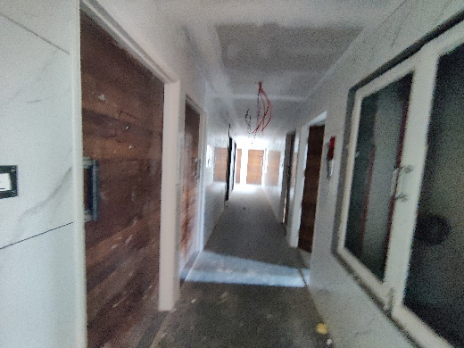
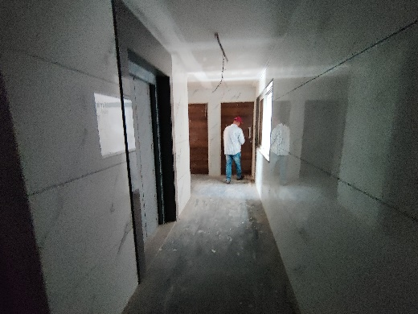
Actual Site Photographs as on 06.01.2024
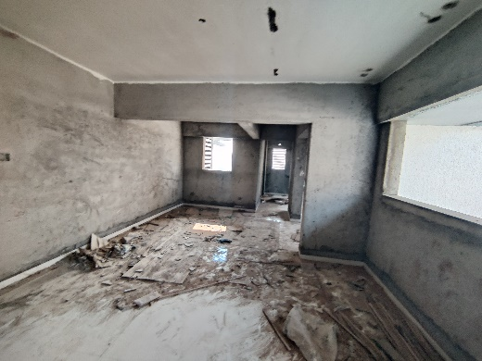
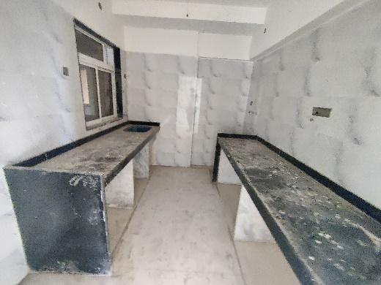
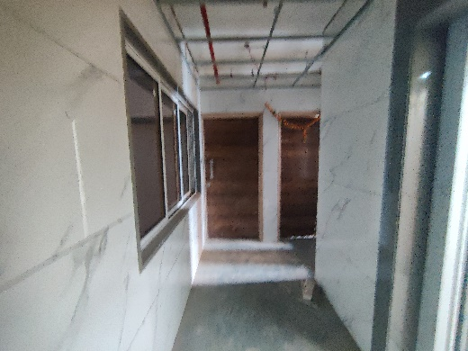
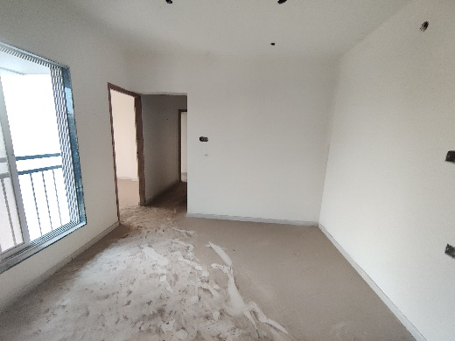
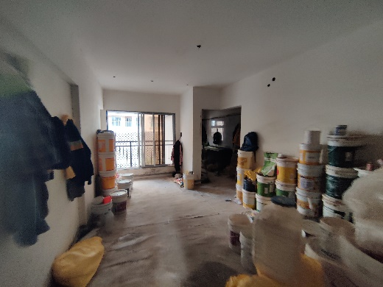
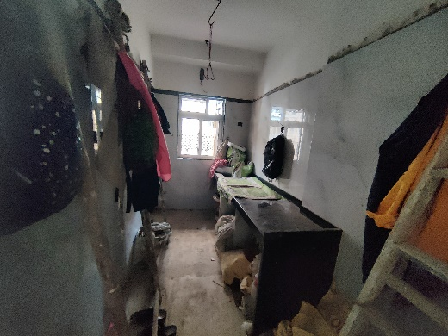
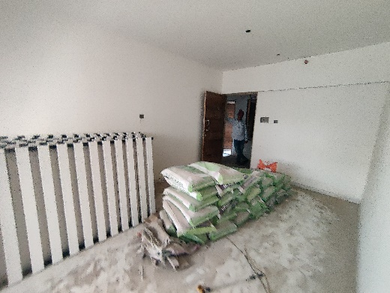
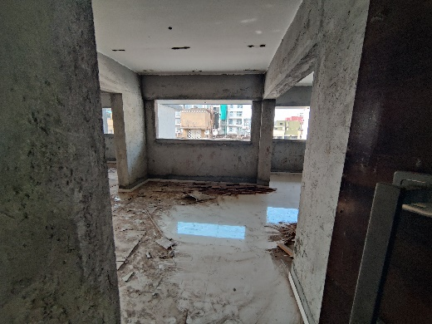
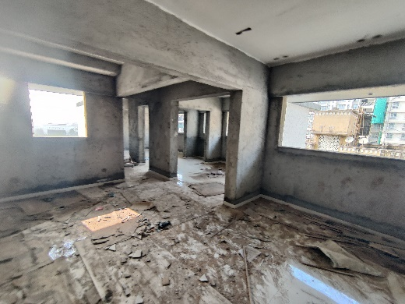
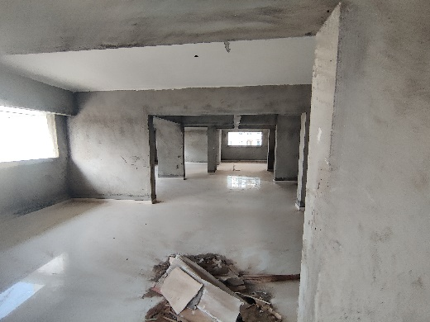
Actual Site Photographs as on 12.10.2023
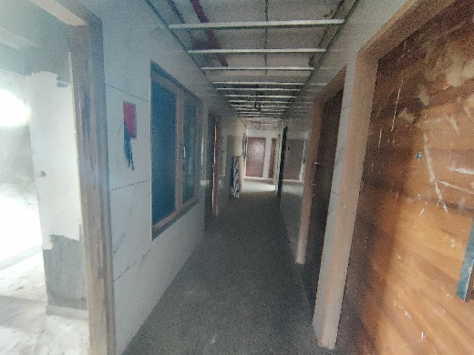
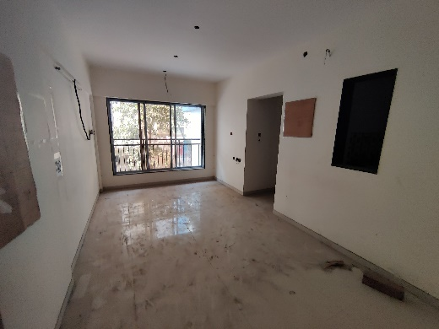
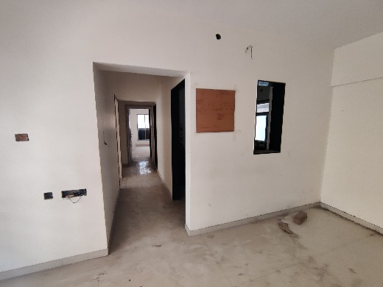
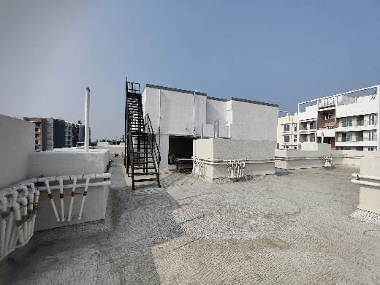
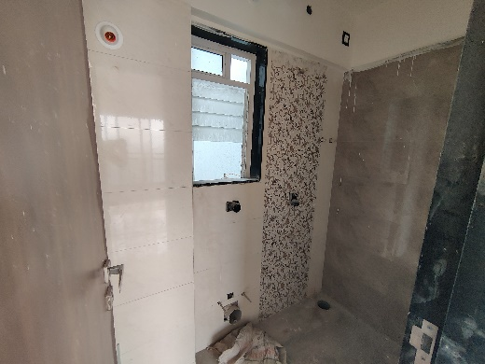

Route Map of the property
Site u/r
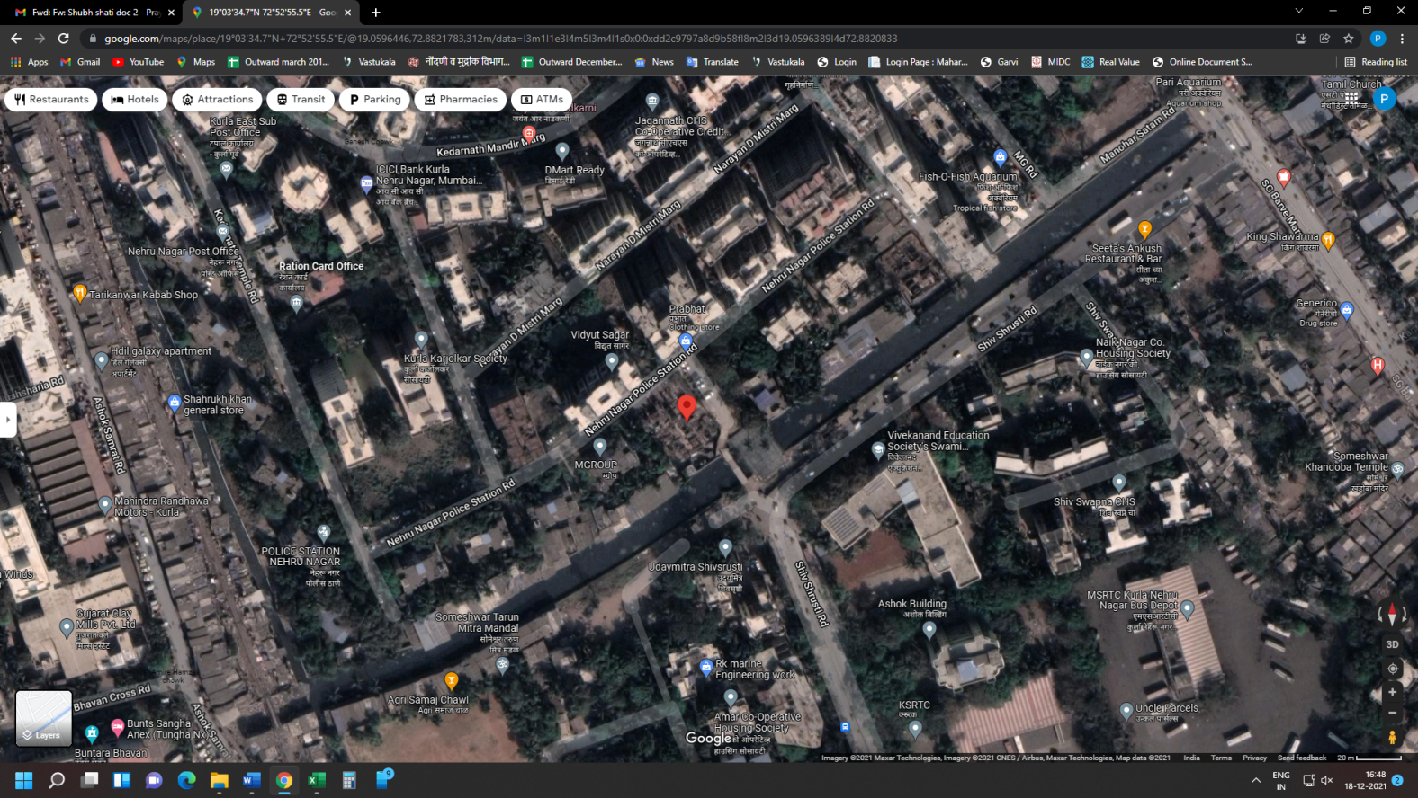

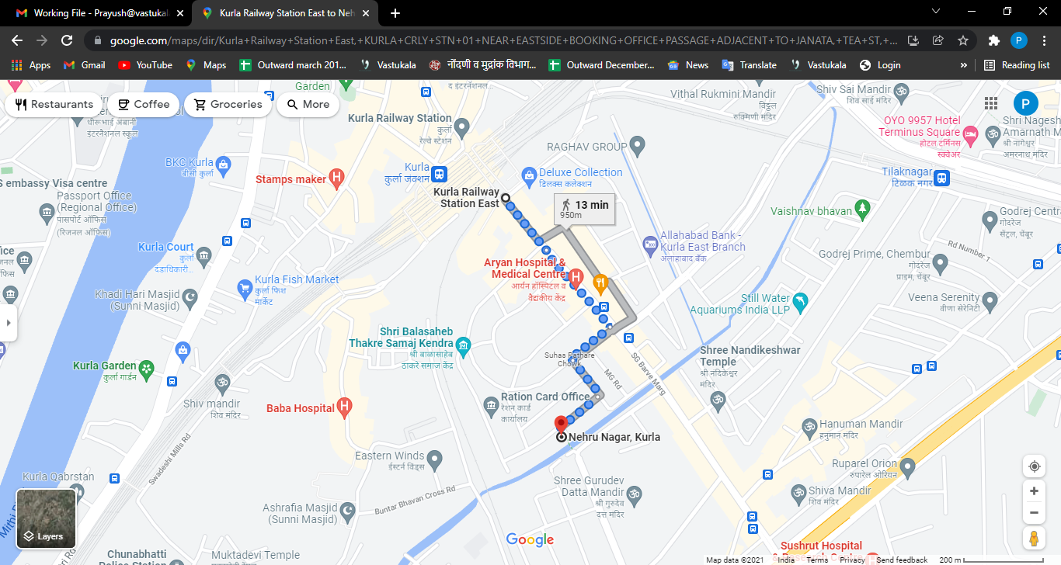

Latitude Longitude: 19°03'34.7"N 72°52'55.5"E

Note: The Blue line shows the route to site from nearest railway station (Kurla – 800 M.)

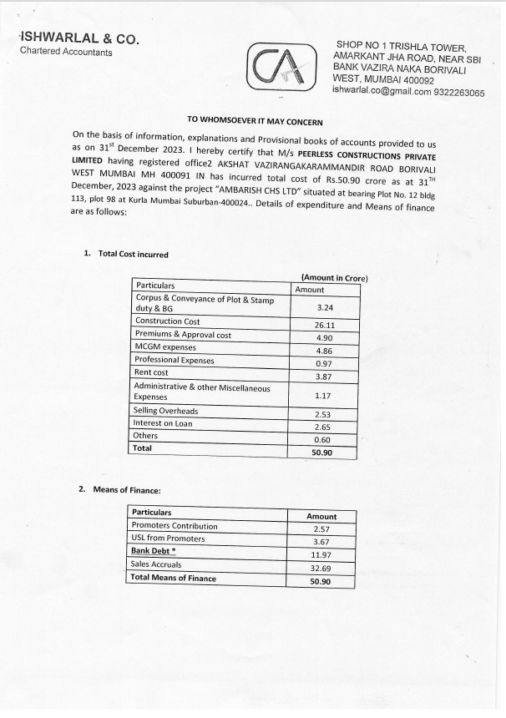
CA Certificate Till 31.12.2023 Dated 24.02.2024

CA Certificate Till 31.12.2023 Dated 24.02.2024
