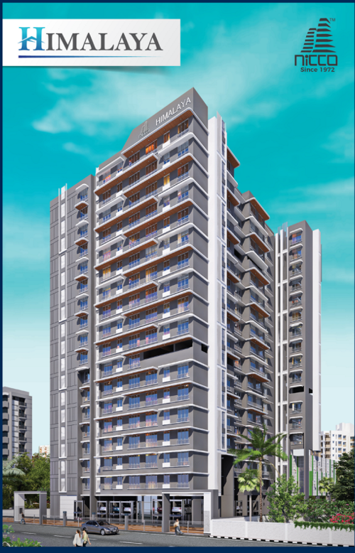2nd LENDERS INDEPENDENT ENGINEER REPORT

**Details of the property under consideration:**

**Name of Project: Himalaya**

**"Himalaya", Proposed Redevelopment of building named Andheri Himalaya CHSL on plot bearing**

**CTS 669, 669/1 to 3, Near Andheri Court, Court Lane, Village – Andheri, Andheri (East),**

**Mumbai – 400 053, State – Maharashtra, Country – India**

**Latitude Longitude: 19°07'07.7"N 72°50'56.4"E**

Valuation Prepared for:

State Bank of India

SME Chembur Branch

Unit No. 11, Building No. 11, Ground Floor, Corporate Park, Sion Trombay Road,

Chembur, Mumbai, Pin Code – 400 071, State - Maharashtra, Country – India

Vastu/SBI/Mumbai/03/2024/7356/2305360

06/10-108-PY

Date: - 06.03.2024

SECOND LENDERS INDEPENDENT ENGINEER REPORT

**To,**

**State Bank of India**

SME Chembur Branch

Unit No. 11, Building No. 11,

Ground Floor, Corporate Park,

Sion Trombay Road, Chembur,

Mumbai, Pin Code – 400 071,

State - Maharashtra, Country – India

Subject: Construction of Proposed Redevelopment of building named Andheri Himalaya CHSL on plot bearing CTS 669, 669/1 to 3, Near Andheri Court, Court Lane, Village – Andheri, Andheri (East), Mumbai – 400 053, State – Maharashtra, Country – India

**Ref:** You’re Request for Lenders Independent Engineer Report of under Construction Building.

**Dear Sir,**

**The Construction work as per approved plan was in progress during the site visit on 09th January 2024. Total expenditure occurred as on 31/12/2023 on this project by M/s. New India Construction Company is ` 77.33 Cr. & as per CA Certificate actual total expenditure occurred as on 31/12/2023 is ` 77.10 Cr. Hence, release of Balance Amount as requested by M/s. New India Construction Company is hereby recommended.**

**DECLARATION**

1. The information furnished in the report is based on our 2nd site visit Dated 09/01/2024 & Document Provided by Client.
2. Vastukala 1st LIE Report of the project dated 10/08/2023.
3. I have no direct and indirect interest in the property examined for report.
4. I have not been found guilty of misconduct in my professional capacity.

**Sharadkumar B. Chalikwar**

Govt. Reg. Valuer

Chartered Engineer (India)

Reg. No. (N) CCIT/1-14/52/2008-09

Encl.: LIE report

# Purpose & Methodology

• State Bank of India Banks and financial institutions require monitoring & an independent review of the progress of the sanctioned projects

**VCIPL** undertakes such study to independently review the progress of the project and put forward a comprehensive analysis

# Advantages:

* Assurance on present practices
* Identification of risk
* Analyzing the performance of third parties
* Recommendations

# The Methodology

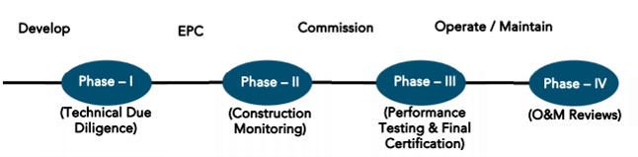

**SECOND LENDERS INDEPENDENT ENGINEER REPORT**

**OF**

**"HIMALAYA"**

**"Himalaya",** Proposed Redevelopment of building named Andheri Himalaya CHSL on plot bearing

CTS 669, 669/1 to 3, Near Andheri Court, Court Lane, Village – Andheri, Andheri (East),

Mumbai – 400 053, State – Maharashtra, Country – India

**Latitude Longitude: 19°07'07.7"N 72°50'56.4"E**

**NAME OF DEVELOPER: M/s. New India Construction Company**

|  |
| --- |
| Pursuant to instructions from State of India, SME Chembur Branch, Chembur we have duly visited, inspected, surveyed & assessed the above said property on **09th January 2024** to determine the fair & reasonable market value of the said property/project as on Quarter ending **31st December 2023** for LIE purpose.  **1. Location Details:**  Proposed Redevelopment of building named Andheri Himalaya CHSL on plot bearing CTS 669, 669/1 to 3, Near Andheri Court, Court Lane, Village – Andheri, Andheri (East), Mumbai – 400 053. It is about 400 M. walking travelling distance from Andheri Railway station. Surface transport to the property is by buses, taxis & private vehicles. The property is in developed locality. All the amenities like shops, banks, hotels, markets, schools, hospitals, etc. are all available in the surrounding locality. The area is higher middle class & developed. |

**2. Developer Details:**

|  |  |
| --- | --- |
| **Name of builder** | **M/s. New India Construction Company** |
| **Project Rera Registration Number** | **P51800047165** |
| **Registered office address** | 201/A, Vertex Vikas, Old Nagardas Road, Andheri East, Mumbai, Pin Code – 400 069, State – Maharashtra, Country – India |
| **Contact details** | **Contact Person:**  Mrs. Mona Mehta  Mobile No. 7977952834 |
| **E – mail ID and website** |  |

**3. Boundaries of the Property:**

|  |  |
| --- | --- |
| **Direction** | **Particulars** |
| **On or towards North** | Andheri Court |
| **On or towards South** | Building |
| **On or towards East** | Building |
| **On or towards West** | Court Lane |

# Introduction

**As per Information on site M/s. New India Construction Company** has acquired land by Developer Agreement dated 13.04.2021 registered vide No. BDR-18-6554-2021 dated 19.05.2021 admeasuring **area is 3,373.10 Sq. M.** bearing **CTS No. 669, 669/1 to 3.** For the Proposed Residential Building.

# Area Statement:

# Land:

|  |  |  |
| --- | --- | --- |
| **Date** | **Particular** | **Area in Sq. M.** |
| 13.04.2021 | CTS No. 669, 669/1 to 3 | 3,373.10 |
| TOTAL | | 3,373.10 |

1. Copy of Developer Agreement dated 13.04.2021 between M/s. The Andheri Himalaya Co-operative Housing Society Limited (The Society) and M/s. New India Construction Company (The Developers) registered vide No. BDR-18-6554-2021 dated 19.05.2021.

# Building Area As per Approved Plan:

| **Sr. No.** | **Particulars** | **Area in Sq. M.** |
| --- | --- | --- |
| **1** | Area of Plot | 3,373.10 |
|  | a)      Area of reservation in plot | - |
|  | b)      Area of road set back | - |
|  | c)      Area of DP Road | - |
| **2** | Deduction for |  |
| **A** | For reservation / road area to be handed over to MCGM (100%) |  |
|  | a) Road set back / widening area (Regulation No. 16) | 49.00 |
|  | b) Proposed D. P. Road area (Regulation No. 16) | - |
|  | c) Reservation area (plot) to be handed over to (Regulation No. 17) | - |
|  | Total Area Under Road / Reservation | - |
| **B** | For amenity area to be handed over to MCGM |  |
|  | a) Area of amenity plot as per dcr 14(a) | - |
|  | b) Area of amenity plot as per dcr 14(b) | - |
|  | c) Area of amenity plot as per dcr 35 | - |
|  | Total Amenity Area | - |
| **3** | Total Deduction | 49.00 |
| **4** | Balance Area of Plot | 3,324.10 |
| **5** | Plot area under development | 3,324.10 |
| **6** | Zonal (Basic) FSI (0.50 or 0.75 or 1 or 1.33) | 1.00 |
| **7** | Permissible Built-Up Area |  |
|  | a)   Permissible built-up area as per zonal (basic) FSI | 3,324.10 |
|  | b)   Permissible built-up area as per regulation 30(c) (protected development) | - |
|  | Permissible Built-up Area (7a or 7b above, whichever is more) | 3,324.10 |
| **8** | Built-up Equal to area of land handed over as per regulation 30(A) |  |
|  | a) Additional BUA for 2(A)(c)(I) & 2(B) above within the cap of “admissible TDR” as per table no. 12 on balance plot 200%for set back | - |
|  | b) Additional BUA for 2(A)(a) & 2(A)(b) above to be utilized over and above the SETBACK = 49 X 2 = 98, permissible FSI as per column no. 7 of table 12 of regulation 30(A0 and to the mentioned in table 12 a of regulation 32 (200% OR 250%) | 98.00 |
|  | c) Additional BUA in case of 2(A)(c)(ii) as per regulation 17(1) note 20(vii) & (viii) as per are policy on remaining plot. (Y% as per table no. 5 of regulation 17(1) | - |
| **9** | Additional / Incentive BUA Within the CAP of admissible TDR as per table 12 on balance plot | - |
|  | a) built up area in Lieu of setback already handover over (as per approved plan) | - |
|  | b) 50% of rehab component as per reg. 33 (7)(A) | - |
|  | C) 15% of Sr. No. 7b & 10 sq.mt per rehab tenement as per reg.33(7)(b) (15% = 0.00 sq. mt. & 10 sq. mt. x 53 Nos. of tenements = 530.00 sq.mt | 530.00 |
|  | Total Additional BUA / Incentive Area |  |
| **10** | BUA due to additional FSI on payment of premium as per table No. 12 of regulation No. 30 (A) [Sr. no. 5 x 50%] Restriction To | 1,662.05 |
| **11** | BUA due to admissible TDR as per table No. 12 of regulation No. 30 (A) & 32 [by restricting area utilized beyond zonal fsi no. 7(b), 8 (a) & 9 above | - |
|  | a) General TDR [{Sr No. 5x50% or 70% or 100%) x 50% or 80% max]  Already Claimed  RES/00006/2021 – Reservation dt 06.12.2022 - 56.36  RES/0024/2022 – Reservation dt. 06.12.2022 – 802.20 | -  469.31  861.56 |
|  | b) Slum TDR [ Sr. No. 5 x 50% or 70% or 90% or 100%) x 50%- or 20%-min DRC NO.- SRA/ /CONST. DT. | 466.00 |
|  | Total TDR | 1,796.87 |
| **12** | Permissible Built-Up Area (7+8+9+10+11) | 7,411.02 |
| **13** | Proposed Built Up Area | 7,411.02 |
| **14** | TDR Generated if any as per regulation 30(A) AND 32 for unutilized BUA on plot | - |
| **15** | Fungible Compensatory Area as per Regulation No. 31(3) |  |
|  | a. i) Permi. Fungible Compensatory area for rehab comp. w/o charging premium | - |
|  | Residential | 960.57 |
|  | Non-Residential | - |
|  | a. ii) Permi. Fungible Compensatory area for rehab comp. w/o charging premium | - |
|  | b. i) Permissible fungible compensatory area by changing premium (Residential) | - |
|  | Residential | 1632.47 |
|  | Non-Residential | - |
|  | b. ii) Fungible Compensatory area availed on payment of premium | - |
| **15a** | Total Built – up area permissible including FCA (14 + 16(b)(i)) | - |
|  | Total Built Up Area Proposed Including Area [13 + 15(a) (ii) + 15(b) (ii)] | 10,004.06 |
|  | FSI Consumed on plot [13 + 4] | 2.22 |
| **B** | **TENEMENT STATEMENT** |  |
|  | a) Proposed Area (item a 17) | 10,004.06 |
|  | b) Less Deduction of nonresidential area | - |
|  | c) Area available for tenements (a-b) | 10,004.06 |
|  | d) Tenements Permissible as per (450 + hectare) | 450 Nos. |
|  | e) Tenements Proposed | 118 Nos. |
|  | f) Tenements existing | - |
|  | Total Tenements proposed (e + f) | - |
| **C** | **PARKING ATATEMENT** |  |
|  | a) Total Parking Required | 149 Nos |
|  | b) Total Parking Proposed | 162 Nos |
| **D** | **TRANSPORT VEHICLES PARKING STATEMENT** | - |
|  | a) Transport Vehicles parking required | - |
|  | b) Transport Vehicles Parking Proposed | - |

# List of Approvals:

1. Copy of Approved Plan No. P-6954/2021/(669)/K/E Ward/Andheri dated 13.04.2022 issued by Municipal Corporation of Greater Mumbai

**Approved upto: Wing A & B: Ground Floor + 1st & 2nd (Part) Podium Floor + 1st & 2nd (Part) to 14th Upper Residential Floor**

1. Copy of 1st Amended Approved Plan No. P-6954/2021/(669)/K/E Ward/Andheri dated 13.01.2023 issued by Municipal Corporation of Greater Mumbai

**Approved upto: Wing A & B: Ground Floor + 1st & 2nd (Part) Podium Floor + 1st & 2nd (Part) to 16th Upper Residential Floor**

1. Copy of 1st Commencement Certificate No. P-6954/2021/(669)/K/E Ward/Andheri/FCC/New dated 21.10.2022 valid till 22.10.2023 issued by Municipal Corporation of Greater Mumbai.

**(This CC is endorsed for the work upto Ground for Parking + 1st to 10th Upper Floor of Wing A & B)**

1. Copy of 2nd Commencement Certificate No. P-6954/2021/(669)/K/E Ward/Andheri/FCC/1/Amend dated 09.11.2022 valid till 08.11.2023 issued by Municipal Corporation of Greater Mumbai.

**(This CC is endorsed for the work upto Ground for Parking + 1st to 10th Upper Floor of Wing A & B)**

1. Copy of 3rd Commencement Certificate No. P-6954/2021/(669)/K/E Ward/Andheri/FCC/2/Amend dated 07.02.2023 valid till 25.04.2023 issued by Municipal Corporation of Greater Mumbai.

**(This CC is endorsed for the work upto Ground for Parking + 1st to 16th Upper Floor of Wing A & B)**

# LEVEL OF COMPLETION:

# Rehab cum Sales Building (Wing A & B)

| Sr. No | Floor No. | Construction Area in Sq. M. | Completed Area in Sq. M. | Work Completion as on 1st Report dated 10.08.2023 | Work Completion as on 09.01.2024 |
| --- | --- | --- | --- | --- | --- |
| 1 | Excavation & Shore Piling | | | Work is Completed | Work is completed |
| 2 | Ground Floor | 1,263.74 | 1,263.74 | Slab Work is completed | Slab work is completed |
| 3 | 1st Floor | 1,263.74 | 1,263.74 | Slab Work & Block work is completed | Slab work, Block work, Plaster work, Door & window frame work, flooring, toilet dadoing & tiling work, fire fighting work are completed & Door & windows are installed |
| 4 | 2nd Floor | 1,287.85 | 1,287.85 | Slab Work & Block work is completed | Slab work, Block work, Plaster work, Door & window frame work, flooring, toilet dadoing & tiling work, fire fighting work are completed & Door & windows are installed |
| 5 | 3rd Floor | 874.36 | 874.36 | Slab Work, Block work, Plaster work, Kitchen Platform & waterproofing is completed | Slab work, Block work, Plaster work, Door & window frame work, flooring, toilet dadoing & tiling work, fire fighting work are completed & Door & windows are installed |
| 6 | 4th Floor | 895.27 | 895.27 | Slab Work, Block work, Plaster work, Kitchen Platform & waterproofing is completed | Slab work, Block work, Plaster work, Door & window frame work, flooring, toilet dadoing & tiling work, fire fighting work are completed & Door & windows are installed |
| 7 | 5th Floor | 907.98 | 907.98 | Slab Work, Block work, Plaster work, Kitchen Platform & waterproofing is completed | Slab work, Block work, Plaster work, Door & window frame work, flooring, toilet dadoing & tiling work, fire fighting work are completed & Door & windows are installed |
| 8 | 6th Floor | 907.98 | 907.98 | Slab Work, Block work, 70% Plaster work is completed | Slab work, Block work, Plaster work, Door & window frame work, flooring, toilet dadoing & tiling work, fire fighting work are completed & Door & windows are installed |
| 9 | 7th Floor | 910.72 | 910.72 | Slab Work, Block work, 70% Plaster work is completed | Slab work, Block work, Plaster work, Door & window frame work, flooring, toilet dadoing & tiling work, fire fighting work are completed & Door & windows are installed |
| 10 | 8th Floor | 927.32 | 927.32 | Slab Work, Block work, 70% Plaster work is completed | Slab work, Block work, Plaster work, Door & window frame work, flooring, toilet dadoing & tiling work, fire fighting work are completed & Door & windows are installed |
| 11 | 9th Floor | 927.32 | 927.32 | Slab Work, Block work, 70% Plaster work is completed | Slab work, Block work, Plaster work, Door & window frame work, flooring, toilet dadoing & tiling work, fire fighting work are completed & Door & windows are installed |
| 12 | 10th Floor | 927.32 | 927.32 | Slab Work is completed | Slab work, Block work, Plaster work, Door & window frame work, flooring, toilet dadoing & tiling work, fire fighting work are completed |
| 13 | 11th Floor | 927.32 | 927.32 | Slab Work is completed | Slab work, Block work, Plaster work, Door & window frame work, toilet dadoing & tiling work, fire fighting work are completed, Flooring work is in progress |
| 14 | 12th Floor | 927.32 | 927.32 | Slab Work is completed | Slab work, Block work, Plaster work, Door & window frame work, toilet dadoing & tiling work, fire fighting work are completed |
| 15 | 13th Floor | 927.32 | 927.32 | Slab Work is completed | Slab work, Block work, Plaster work, Door & window frame work, toilet dadoing & tiling work, fire fighting work are completed |
| 16 | 14th Floor | 928.09 | 928.09 | Shuttering work is in progress in Wing B | Slab work, Block work, Plaster work, Door & window frame work, toilet dadoing & tiling work, fire fighting work are completed |
| 17 | 15th Floor | 927.32 | 927.32 |  | Slab work, Block work, Plaster work, Door & window frame work, toilet dadoing & tiling work, fire fighting work are completed |
| 18 | 16th Floor | 937.83 | 937.83 |  | Slab work, Block work, Plaster work, Door & window frame work, toilet dadoing & tiling work, fire fighting work are completed |
| 19 | Terrace Floor | 133.34 | 133.34 |  | Slab work, Block work, OHT & LMR work is completed |
| Total | | **16,802.14** | **16,802.14** |  |  |
| Stack Parking | | **48.00** | **-** |  |  |

# Details of the Project as Financed By SBI:

# Project Cost: (as per C.A. Certificate)

|  |  |  |  |  |
| --- | --- | --- | --- | --- |
| **Particulars** | **Estimated Cost (in Cr.)** | **Incurred Cost (In Cr.) till 31.12.2023 dated 20.01.2024 by M/s. Varma & Associates** | **Incurred Cost (In Cr.) till 12.06.2023 dated 14.07.2023 by M/s. Varma & Associates** | **Net** |
| Land Cost | 1.71 | 1.71 | 1.71 | - |
| Rent Cost | 16.11 | 13.01 | 11.60 | 1.41 |
| TDR Cost | 6.45 | 7.53 | 7.53 | - |
| Construction cost of Building | 52.30 | 32.88 | 23.96 | 8.91 |
| Premium Cost / FSI / GOM Charges / fees / security Deposits | 13.42 | 14.04 | 14.02 | 0.02 |
| Architect Cost, RCC & Other Professional Cost | 2.61 | 0.05 | 0.04 | 0.01 |
| Administrative Cost | 2.09 | 6.03 | 4.23 | 1.80 |
| Marketing Cost | 2.87 |
| Interest Cost | 5.50 | 1.48 | 0.18 | 1.30 |
| Contingency Cost | 1.57 | 0.37 | 0.37 | - |
| **Total** | **104.63** | **77.10** | **63.64** | **13.46** |

* **The Builder has incurred about 13.01 Cr. Rent Cost, 32.88 Cr. as construction cost, 14.04 Cr. for approval of project, 0.05 Cr. for professional cost, 6.03 Cr. for admin cost & marketing cost & 1.48 Cr. for interest cost in last quarter till 31.12.2023 as per C.A. certificate issued by M/s. Varma & Associates dated 20.01.2024.**

# Project Cost: (as per Bills):

|  |  |  |  |
| --- | --- | --- | --- |
| **Particulars** | **Incurred Cost (in Cr.)** | | |
| **31.12.2023 as per Bill (Inclusive GST)** | **12.06.2023 as per Bill (Inclusive GST)** | **Net** |
| Land Cost | 1.71 | 1.71 | - |
| Rent Cost | 13.67 | 12.27 | 1.41 |
| TDR Cost | 7.52 | 7.52 | - |
| Construction cost of Building | 32.21 | 23.65 | 8.56 |
| Premium Cost / FSI / GOM Charges / fees / security Deposits | 14.04 | 14.02 | 0.02 |
| Architect Cost, RCC & Other Professional Cost | 0.10 | 0.06 | 0.04 |
| Administrative Cost | 1.04 | 0.76 | 0.29 |
| Marketing Cost | 5.52 | 3.23 | 2.28 |
| Interest Cost | 1.52 | 0.18 | 1.34 |
| Contingency Cost | - | - | - |
| **Total** | **77.33** | **63.39** | **13.94** |

Note: We have not considered the DSRA cost in the LIE report

# Land Cost:

|  |  |  |  |  |  |
| --- | --- | --- | --- | --- | --- |
| Sr. No. | Agreement Name | Date | Particulars | Total Cost in ` | Incurred Cost in ` |
| 1 | Development Agreement | 13-05-2021 | Stamp Duty | 1,70,28,000.00 | 1,70,28,000.00 |
| 2 | Reg. Fees | 30,000.00 | 30,000.00 |
| 3 | 7,400.00 | 7,400.00 |
| 4 | 600.00 | 600.00 |
| 5 | Special Power of Attorney | 26-09-2021 | Stamp Duty | 500.00 | 500.00 |
| 6 | Power of Attorney | 27-04-2021 | 500.00 | 500.00 |
| 7 | 22-04-2021 | 500.00 | 500.00 |
| 8 | 22-04-2021 | 300.00 | 300.00 |
| 9 | 08-05-2021 | 500.00 | 500.00 |
| 10 | 26-04-2021 | 500.00 | 500.00 |
| 11 | 26-04-2021 | 500.00 | 500.00 |
| 12 | 27-04-2021 | 500.00 | 500.00 |
| 13 | 23-04-2021 | 500.00 | 500.00 |
| 14 | 27-04-2021 | 500.00 | 500.00 |
| 15 | 21-04-2021 | 500.00 | 500.00 |
| 16 | 21-05-2021 | 500.00 | 500.00 |
|  | **TOTAL** | | | **1,70,71,800.00** | **1,70,71,800.00** |

As per developer agreement.

|  |  |  |  |  |  |  |
| --- | --- | --- | --- | --- | --- | --- |
| **Summary of Bills** | | | | | | |
| **Sr. No.** | **Particulars** | **Amount in `**  **(till 31.12.2023)** | **Amount in ` (in Cr.)** | **Amount in `**  **(till 12.06.2023)** | **Amount in ` (in Cr.)** | **Net in ` (in Cr.)** |
| **1** | TDR Cost | 7,52,30,002.00 | 7.52 | 7,52,30,002.00 | 7.52 | - |
| **2** | Construction Cost | 32,20,92,675.00 | 32.21 | 23,64,55,435.00 | 23.65 | 8.56 |
| **3** | Rent Cost | 13,67,46,298.00 | 13.67 | 12,26,64,188.00 | 12.27 | 1.41 |
| **4** | Premium Cost / FSI / GOM Charges / fees / security Deposits | 14,03,73,733.00 | 14.04 | 14,01,79,803.00 | 14.02 | 0.02 |
| **5** | Professional Cost | 9,80,465.00 | 0.10 | 5,74,040.00 | 0.06 | 0.04 |
| **6** | Administrative Cost | 1,04,14,287.00 | 1.04 | 75,57,803.00 | 0.76 | 0.29 |
| **7** | Marketing Cost | 5,51,64,670.00 | 5.52 | 3,23,24,590.00 | 3.23 | 2.28 |
| **8** | Contingency Cost | - | - | - | - | - |
| **TOTAL** | | **74,10,02,130.00** | **74.10** | **61,49,85,861.00** | **61.50** | **12.60** |

Note: Bills were provided by the client up to 31.12.2023

# Interest Cost:

|  |  |  |  |  |  |  |
| --- | --- | --- | --- | --- | --- | --- |
| **Sr. No** | **Particulars** | **Estimate Amount in `** | **Incurred Amount in ` (till 31.12.2023)** | **Incurred Amount in ` (till 12.06.2023)** | **Difference in `** | **Balance Amount in `** |
| **1** | Interest Cost | 5,50,00,000.00 | 1,52,33,649.00 | 18,24,767.00 | 1,34,08,882.00 | 3,97,66,351.00 |
| **TOTAL** | | **5,50,00,000.00** | **1,52,33,649.00** | **18,24,767.00** | **1,34,08,882.00** | **3,97,66,351.00** |

Interest Cost is based on discussion with the client.

# Cost of Construction as on 09th January 2024:

|  |  |  |  |  |  |  |  |
| --- | --- | --- | --- | --- | --- | --- | --- |
| Sr. No. | Floor | Total Construction Area in Sq. M. | Completed Area in Sq. M. | Rate per Sq. M. | Full Value after completion | Percentage of work completed | Actual Expenditure till date in ` |
| 1 | Excavation Cost |  |  |  | 4,53,65,778.00 | 100% | 4,53,65,778.00 |
| 2 | Ground | 1,263.74 | 1,263.74 | 27,000.00 | 3,41,20,980.00 | 50% | 1,70,60,490.00 |
| 3 | 1st | 1,263.74 | 1,263.74 | 27,000.00 | 3,41,20,980.00 | 80% | 2,72,96,784.00 |
| 4 | 2nd | 1,287.85 | 1,287.85 | 27,000.00 | 3,47,71,950.00 | 80% | 2,78,17,560.00 |
| 5 | 3rd | 874.36 | 874.36 | 27,000.00 | 2,36,07,720.00 | 80% | 1,88,86,176.00 |
| 6 | 4th | 895.27 | 895.27 | 27,000.00 | 2,41,72,290.00 | 80% | 1,93,37,832.00 |
| 7 | 5th | 907.98 | 907.98 | 27,000.00 | 2,45,15,460.00 | 80% | 1,96,12,368.00 |
| 8 | 6th | 907.98 | 907.98 | 27,000.00 | 2,45,15,460.00 | 80% | 1,96,12,368.00 |
| 9 | 7th | 910.72 | 910.72 | 27,000.00 | 2,45,89,440.00 | 80% | 1,96,71,552.00 |
| 10 | 8th | 927.32 | 927.32 | 27,000.00 | 2,50,37,640.00 | 80% | 2,00,30,112.00 |
| 11 | 9th | 927.32 | 927.32 | 27,000.00 | 2,50,37,640.00 | 80% | 2,00,30,112.00 |
| 12 | 10th | 927.32 | 927.32 | 27,000.00 | 2,50,37,640.00 | 75% | 1,87,78,230.00 |
| 13 | 11th | 927.32 | 927.32 | 27,000.00 | 2,50,37,640.00 | 68% | 1,70,25,595.20 |
| 14 | 12th | 927.32 | 927.32 | 27,000.00 | 2,50,37,640.00 | 68% | 1,70,25,595.20 |
| 15 | 13th | 927.32 | 927.32 | 27,000.00 | 2,50,37,640.00 | 68% | 1,70,25,595.20 |
| 16 | 14th | 928.09 | 928.09 | 27,000.00 | 2,50,58,430.00 | 68% | 1,70,39,732.40 |
| 17 | 15th | 927.32 | 927.32 | 27,000.00 | 2,50,37,640.00 | 68% | 1,70,25,595.20 |
| 18 | 16th | 937.83 | 937.83 | 27,000.00 | 2,53,21,410.00 | 68% | 1,72,18,558.80 |
| 19 | OHT / LMR | 133.34 | 133.34 | 27,000.00 | 36,00,180.00 | 60% | 21,60,108.00 |
| Sub - Total (A) | | **16,802.14** | **16,802.14** |  | **49,90,23,558.00** |  | **37,80,20,142.00** |
| STACK PARKING Nos. | | **48.00** |  | **5,00,000.00** | **2,40,00,000.00** |  | **-** |
| TOTAL COST OF CONSTRUCTION (A + B) | | | | | **52,30,23,558.00** | **72%** | **37,80,20,142.00** |

##### Note: Details of work completed is as per site visit dated 09.01.2024 but report is prepared for 31st December quarter 2023.

|  |  |  |  |  |  |
| --- | --- | --- | --- | --- | --- |
| **Particulars** | **Estimated Cost**  **(In Cr.)** | **Incurred Cost (in Cr.)** | | | **Net** |
| **Issued dated 20.01.2024 till 31.12.2023 as per CA** | **As per Bills upto 31.12.2023** | **As per Bills upto 12.06.2023** |
| Land Cost | 1.71 | 1.71 | 1.71 | 1.71 | - |
| Rent Cost | 16.11 | 13.01 | 13.67 | 12.27 | 1.41 |
| TDR Cost | 6.45 | 7.53 | 7.52 | 7.52 | - |
| Construction cost of Building | 52.30 | 32.88 | 32.21 | 23.65 | 8.56 |
| Premium Cost / FSI / GOM Charges / fees / security Deposits | 13.42 | 14.04 | 14.04 | 14.02 | 0.02 |
| Architect Cost, RCC & Other Professional Cost | 2.61 | 0.05 | 0.10 | 0.06 | 0.04 |
| Administrative Cost | 2.09 | 6.03 | 1.04 | 0.76 | 0.29 |
| Marketing Cost | 2.87 | 5.52 | 3.23 | 1.80 |
| Interest Cost | 5.50 | 1.48 | 1.52 | 0.18 | 1.34 |
| Contingency Cost | 1.57 | 0.37 | - | - | - |
| **Total** | **104.63** | **77.10** | **77.33** | **63.39** | **13.94** |

Note:

We have considered Other Expenses, Printing & Stationery, and Water Bills cost is consider in on-site expenditure cost header but CA has considered them in cost of construction header .

We have considered Stamp Duty, Registration Charges and Brokerage against of sale flat are cosnidered in marketing cost header.

We have not considered DSRA Cost but CA has considered it in Other Cost Header

As per plinth area, calculation the work completed is up to 72% of total work, which comes to ` 37.80 Cr. However, company has incurred cost of ` 32.21 Cr. till 31.12.2023 as per bill .

# Comparison of Cost incurred on dated 31.12.2023 & 12.06.2023

|  |  |  |  |  |
| --- | --- | --- | --- | --- |
| Particulars | 31.12.2023 as per Bill | 12.06.2023 as per Bill | Net | % of net amount |
| Land Cost | 1.71 | 1.71 | - | 0.00% |
| Rent Cost | 13.67 | 12.27 | 1.41 | 1.82% |
| TDR Cost | 7.52 | 7.52 | - | 0.00% |
| Construction cost of Building | 32.21 | 23.65 | 8.56 | 11.07% |
| Premium Cost / FSI / GOM Charges / fees / security Deposits | 14.04 | 14.02 | 0.02 | 0.00% |
| Architect Cost, RCC & Other Professional Cost | 0.10 | 0.06 | 0.04 | 0.03% |
| Administrative Cost | 1.04 | 0.76 | 0.29 | 0.05% |
| Marketing Cost | 5.52 | 3.23 | 1.80 | 0.38% |
| Interest Cost | 1.52 | 0.18 | 1.34 | 1.73% |
| Contingency Cost | - | - | - | 0.00% |
| Total | **77.33** | **63.39** | **13.94** | **18.03%** |

# % of Fund Utilised till 31st December 2023

|  |  |  |  |  |
| --- | --- | --- | --- | --- |
| Particulars | Estimated Project Cost  (in Cr.) | Incurred cost as on 31.12.2023 | % of Incurred Cost | % of Estimated Project Cost |
| Land Cost | 1.71 | 1.71 | 99.84% | 1.63% |
| Rent Cost | 16.11 | 13.67 | 84.88% | 13.07% |
| TDR Cost | 6.45 | 7.52 | 116.64% | 7.19% |
| Construction cost of Building | 52.30 | 32.21 | 61.59% | 30.78% |
| Premium Cost / FSI / GOM Charges / fees / security Deposits | 13.42 | 14.04 | 104.60% | 13.42% |
| Architect Cost, RCC & Other Professional Cost | 2.61 | 0.10 | 3.76% | 0.09% |
| Administrative Cost | 2.09 | 1.04 | 49.83% | 1.00% |
| Marketing Cost | 2.87 | 5.52 | 192.21% | 5.27% |
| Interest Cost | 5.50 | 1.52 | 27.70% | 1.46% |
| Contingency Cost | 1.57 | - | 0.00% | 0.00% |
| Total | **104.63** | **77.33** | **73.91%** | **73.91%** |

Based on above Calculation it is found that total Project cost incurred is 73.91% of the Total Project Cost.

# Means of Finance:

|  |  |  |
| --- | --- | --- |
| **Sr. No.** | **Particulars** | **Exp. Cumulative (Cr.)** |
|  | Equity share capital / Quassi Loan from Promoter | 3.86 |
|  | Sales (Advance from customer) | 39.06 |
|  | Bank Laon Amount | 18.06 |
|  | Unsecured Loan amount | 18.06 |
|  | **Total** | **77.10** |

The Details of the Means of Finance are provided by Client as on 31.12.2023.

# Mandatory Arrangements:

|  |  |  |
| --- | --- | --- |
| **Sr. No.** | **Particulars** | **Status** |
|  | Rainwater Harvesting | To be executed after RCC Structure |
|  | Firefighting System | To be executed after RCC Structure |
|  | Solid Waste Management | To be executed after RCC Structure |

# Quality of Construction:

|  |  |  |
| --- | --- | --- |
| **Sr. No.** | **Particulars** | **Status** |
|  | Soundness of Structures | Executing as per approved Structural Design |
|  | Look of Structures | Good |
|  | Quality of Material Used | Good |
|  | Safety Measures for Construction/labour | Taken Care by Contractor |

# Schedule V/s. Actual Progress:

| Activity | Date of Implementation | Date of Completion | Status |
| --- | --- | --- | --- |
| Land |  |  | Completed |
| Development of Land |  |  | Completed |
| Foundation Work |  |  | Completed |
| Ground Floor Slab |  |  | Slab work is Completed |
| 1st Floor Slab |  |  | Slab work is Completed |
| 2nd Floor Slab |  |  | Slab work is Completed |
| 3rd Floor Slab |  |  | Slab work is Completed |
| 4th Floor Slab |  |  | Slab work is Completed |
| 5th Floor Slab |  |  | Slab work is Completed |
| 6th Floor Slab |  |  | Slab work is Completed |
| 7th Floor Slab |  |  | Slab work is Completed |
| 8th Floor Slab |  |  | Slab work is Completed |
| 9th Floor Slab |  |  | Slab work is Completed |
| 10th Floor Slab |  |  | Slab work is Completed |
| 11th Floor Slab |  |  | Slab work is Completed |
| 12th Floor Slab |  |  | Slab work is Completed |
| 13th Floor Slab |  |  | Slab work is Completed |
| 14th Floor Slab |  |  | Slab work is Completed |
| 15th Floor Slab |  |  | Slab work is Completed |
| 16th Floor Slab |  |  | Slab work is Completed |
| Block work / Internal Plaster work |  |  | Block work & Internal plaster work is completed |
| Terrace Parapet wall / Overhead water tank / Lift Machine room / compound wall / External Plaster work |  |  | External Plaster 50% work is completed.  Terrace slab, OHT & LMR work is completed |
| Electric Work |  |  | Work is in progress |
| Water Proofing |  |  | Work is in progress |
| Plumbing Work |  |  | Work is in progress |
| Tiling / Marble Flooring |  |  | Flooring – 1st to 10th floor work is completed, 11th floor work is in progress  Tiling – 1st to 16th floor toilet dadoing & titling work is completed |
| Door Frames |  |  | Work is completed |
| Window Installation |  |  | 1st to 9th floor work is completed |
| Staircase Flooring |  |  |  |
| Staircase Railing |  |  |  |
| Refuge Area Flooring |  |  |  |
| Internal Painting |  |  |  |
| External Painting |  |  |  |
| Lift Work |  |  |  |
| Fire Fighting Installation |  |  | Work is in progress |
| Stack Parking |  |  |  |
| CP Fitting & Sanitary Work |  |  |  |
| Final Finishing & Fitting |  |  |  |

# Action initiated to complete the project in time:

**For Rehab Cum Sales Building (Wing A & B):** Slab work, Block work & Internal Plaster is completed, External plaster work 50% is completed, 1st to 10th floor flooring work is completed, 1st to 16th toilet tiling & dadoing work is completed, 1st to 9th floor door & windows are installed, 11th floor flooring work is in progress.

# Comments related to cost overrun if any:

The cost of Sales Building is ` 104.63 Cr.

# Balance investment required for completion of project:

We opinion amount of **` 27.30 Cr.** Will be required to complete the Project.

# Mandatory Approval Status:

| **Sr. No.** | **Particulars** | **Name of Department** | **Status** | **Order Details** |
| --- | --- | --- | --- | --- |
| **1** | IOD of Building | Municipal Corporation of Greater Mumbai (MCGM). | Obtained and available at site | P-6954/2021/(669)/K/E Ward/Andheri dated 11.01.2022 |
| **1A** | 1st Amended | Municipal Corporation of Greater Mumbai (MCGM). | Obtained and available at site | P-6954/2021/(669)/K/E Ward/Andheri dated 13.04.2022 |
| **1B** | 2nd Amended | Municipal Corporation of Greater Mumbai (MCGM). | Obtained and available at site | P-6954/2021/(669)/K/E Ward/Andheri dated 13.01.2023 |
| **2A** | First C.C. | Municipal Corporation of Greater Mumbai (MCGM). | Obtained and available at site | P – 6954 / 2021 / (669) / K / E Ward / Andheri / FCC / New dated 21.10.2022 valid till 22.10.2023. This CC is endorsed for the work upto Ground for Parking + 1st to 10th Upper Floor of Wing A & B |
| **2B** | Second C.C. | Municipal Corporation of Greater Mumbai (MCGM). | Obtained and available at site | P – 6954 / 2021 / (669) / K / E Ward / Andheri / FCC / 1 / Amend dated 09.11.2022 valid till 08.11.2023. This CC is endorsed for the work upto Ground for Parking + 1st to 10th Upper Floor of Wing A & B |
| **2C** | Third C.C. | Municipal Corporation of Greater Mumbai (MCGM). | Obtained and available at site | P – 6954 / 2021 / (669) / K / E Ward / Andheri / FCC / 2 /Amend dated 07.02.2023 valid till 25.04.2023. This CC is endorsed for the work upto Ground for Parking + 1st to 16th Upper Floor of Wing A & B) |
| **3B** | Occupancy | Municipal Corporation of Greater Mumbai (MCGM). | Pending (Project is not completed) |  |

# Status Insurance Coverage:

Information not provided

# Assumptions & Remarks:

* The adequacy of Engineering / Structural design is beyond the scope of our assignment.
* Estimated project completion date is 30/09/2024 for Rehab cum Sales Building respectively. The cost is certified based on the assumptions that the project will be completed within period. Few assumptions were made regarding inflation & cost rise etc. during construction period.

**Sharadkumar B. Chalikwar**

Govt. Reg. Valuer

Chartered Engineer (India)

Reg. No. (N) CCIT/1-14/52/2008

**About the Project:**

|  |  |  |
| --- | --- | --- |
| **1. Introduction** | |  |
| a) | Project Name  (With Address & Phone Nos.) | **"Himalaya",** Proposed Redevelopment of building named Andheri Himalaya CHSL on plot bearing CTS 669, 669/1 to 3, Near Andheri Court, Court Lane, Village – Andheri, Andheri (East), Mumbai – 400 053, State – Maharashtra, Country – India  Contact Person:  Mrs. Mona Mehta  Mobile No. 79779 52834 |
| b) | Purpose of Valuation | As per request from State Bank of India, SME Chembur Branch to assess fair market value of the Project for LIE purpose. |
| c) | Date of Inspection of Property | 09.01.2024 |
| d) | Date of LIE Report | 06.03.2024 |
| e) | Name of the Developer of Property  (in case of developer built properties) | M/s. New India Construction Company  201/A, Vertex Vikas, Old Nagardas Road, Andheri East, Mumbai, Pin Code – 400 069, State – Maharashtra, Country – India |
| **2. Physical Characteristics of the Property** | | |
| a) | Location of the Property | **"Himalaya",** Proposed Redevelopment of building named Andheri Himalaya CHSL on plot bearing CTS 669, 669/1 to 3, Near Andheri Court, Court Lane, Village – Andheri, Andheri (East), Mumbai – 400 053, State – Maharashtra, Country – India |
| Brief description of the property |  |
|  | **TYPE OF THE BUILDING**   1. **Rehab cum Sales Building (Wing A & B)**  |  |  | | --- | --- | | No. of Floors | Ground Floor + 1st & 2nd (Part) Podium Floor + 1st & 2nd (Part) to 16th Upper Residential Floor. | | Building type | Residential Rehab cum Sale building |   Rehab cum Sales Building work is given on contract based for RCC contract. Developer has grant to the contractor do the work of construction and completion includes Concrete work, Reinforcement work, Masonry, Internal Plaster, External Plaster and other miscellaneous work such as repairing, joints b/w concrete and masonry surface, etc. Bill must be paid on measurement of construction area exclusive of Steel, Cement & other construction material.  Lift & lift installation contract is not finalized till now.  Firefighting work contract is not finalized.  **PROPOSED DATE OF COMPLETION & FUTURE LIFE:**  Expected completion date as per RERA is 30th September 2024  **ABOUT PROJECT:**  Himalaya is a high-quality yet affordable residential project by New India Construction Company. Subscribe to a fine living with amenities such as High Ceiling, Earth quake resistant, Terrace Garden, Park, Playing Area, AC in each room, Meditation Area, Lift at Himalaya. Enjoy the luxury of living with all modern conveniences in Himalaya.  The project focuses on one sense of open space to create a perfect living space. Each home is open to let the positive vibes come in, with impressive views of lush greenery. Every convenience you need is close at hand. Opulent and Efficient, Himalaya is a place that is filled up with tranquillity and calmness. The homes have everything for your convenience and promise a luxurious yet comfortable lifestyle. Feel the essence of freshness inside the house and indulge into a peaceful gathering with your loved ones. | |
|  | Nearby landmark | Near Andheri Court |
| Postal Address of the Property | **"Himalaya",** Proposed Redevelopment of building named Andheri Himalaya CHSL on plot bearing CTS 669, 669/1 to 3, Near Andheri Court, Court Lane, Village – Andheri, Andheri (East), Mumbai – 400 053, State – Maharashtra, Country – India |
|  | Area of the plot/land  (Supported by a plan) | Plot Area: 3,324.10 Sq. M. |
| Type of Land: Solid, Rocky, Marsh land, reclaimed land, Water-logged, Land locked. | Solid land |
|  | Independent access/approach to the property etc. | Yes |
| Google Map Location of the Property with a neighborhood layout map | Provided |
|  | Details of roads abutting the property | 12 M wide road |
| Description of adjoining property | Located in Higher Middle-class locality |
| Plot No. Survey No. | CTS No. 669, 669/1 to 3 |
| Ward/Village/Taluka | Village – Andheri, Taluka – Borivali |
| Sub-Registry/Block | Mumbai Suburban |
| District | District - Mumbai Suburban |
| b) | **Boundaries of the Plot** |  |
|  | |  |  |  |  | | --- | --- | --- | --- | |  | **As per Agreement** | **As per RERA Certificate** | **Actual** | | **North** | CTS No. 665 | CTS No. 665 | Andheri Court | | **South** | CTS No. 670 | CTS no. 670 | Building | | **East** | Proposed 13.20 M. wide D. P. Road & presently bearing CTS No. 668. | CTS No. 668 | Building | | **West** | Private Road bearing CTS No. 672 leading from Sahar Road | 13.40 M. DP Road | Court Lane | | |

| **4. Document Details and Legal Aspects of Property:** | |
| --- | --- |
| a) | Ownership Documents (**Building Permission, Commencement Certificate & Status of Plan)** |
|  | Sale Deed, Gift Deed, Lease Deed |
| 1. Copy of Developer Agreement dated 13.04.2021 between M/s. The Andheri Himalaya Co-operative Housing Society Limited (The Society) and M/s. New India Construction Company (The Developers) registered vide No. BDR-18-6554-2021 dated 19.05.2021. |
| 1. Copy of Power of Attorney dated 27.04.2021 |
| 1. Copy of Power of Attorney dated 22.04.2021 |
| 1. Copy of Power of Attorney dated 08.05.2021 |
| 1. Copy of Power of Attorney dated 26.04.2021 |
| 1. Copy of Power of Attorney dated 23.04.2021 |
| 1. Copy of Power of Attorney dated 21.04.2021 |
| 1. Copy of Power of Attorney dated 21.05.2021 |
| 1. Copy of Special Power of Attorney dated 26.09.2021 |
| 1. Copy of Transfer / Utilisation of FSI (TDR) Agreement dated 04.01.2022 for TDR Area of 148.43 Sq. M. |
| 1. Copy of Transfer / Utilisation of FSI (TDR) Agreement dated 06.01.2022 for TDR Area of 379.00 Sq. M. |
| 1. Copy of Transfer / Utilisation of FSI (TDR) Agreement dated 06.01.2022 for TDR Area of 431.00 Sq. M. |
| 1. Copy of Transfer / Utilisation of FSI (TDR) Agreement dated 06.01.2022 for TDR Area of 52.00 Sq. M. |
| 1. Copy of Transfer / Utilisation of FSI (TDR) Agreement dated 14.11.2022 for TDR Area of 634.00 Sq. M. |
| 1. Copy of Approved Plan No. P-6954/2021/(669)/K/E Ward/Andheri dated 13.04.2022 issued by Municipal Corporation of Greater Mumbai   **Approved upto: Wing A & B: Ground Floor + 1st & 2nd (Part) Podium Floor + 1st & 2nd (Part) to 14th Upper Residential Floor** |
| 1. Copy of 1st Commencement Certificate No. P-6954/2021/(669)/K/E Ward/Andheri/FCC/New dated 21.10.2022 valid till 22.10.2023 issued by Municipal Corporation of Greater Mumbai.   **(This CC is endorsed for the work upto Ground for Parking + 1st to 10th Upper Floor of Wing A & B)** |
| 1. Copy of Commencement Certificate No. P-6954/2021/(669)/K/E Ward/Andheri/FCC/1/Amend dated 09.11.2022 valid till 25.04.2023 issued by Municipal Corporation of Greater Mumbai.   (**This CC is endorsed for the work upto Ground for Parking + 1st to 10th Upper Floor of Wing A & B)** |
| 1. Copy of Concession Drawing Plan No. P-6954/2021/(669)/K/E Ward/Andheri dated 09.12.2022 issued by Municipal Corporation of Greater Mumbai   **Approved upto: Wing A & B: Ground Floor + 1st & 2nd (Part) Podium Floor + 1st & 2nd (Part) to 16th Upper Residential Floor** |
| 1. Copy of CA Certificate dated 22.12.2022 issued by M/s. Varma & Associates |
|  | 1. Copy of RERA Certificate No. P51800047165 dated 10.10.2022 issued by Maharashtra Real Estate Regulatory Authority. |
|  | 1. Copy of 1st Amended Approved Plan No. P-6954/2021/(669)/K/E Ward/Andheri dated 13.01.2023 issued by Municipal Corporation of Greater Mumbai   **Approved upto: Wing A & B: Ground Floor + 1st & 2nd (Part) Podium Floor + 1st & 2nd (Part) to 16th Upper Residential Floor** |
|  | 1. Copy of 3rd Commencement Certificate No. P-6954/2021/(669)/K/E Ward/Andheri/FCC/2/Amend dated 07.02.2023 valid till 25.04.2023 issued by Municipal Corporation of Greater Mumbai.   **(This CC is endorsed for the work upto Ground for Parking + 1st to 16th Upper Floor of Wing A & B)** |
|  | 1. Copy of Bills till 12.06.2023 |
|  | 1. Copy of CA Certificate dated 14.07.2023 issued by M/s. Varma & Associates |

|  |  |
| --- | --- |
| b) | **Documents verified for present LIE report** |
|  | 1. Copy of CA Certificate dated 20.01.2024 for cost incurred till 31.12.2023 issued by M/s. Varma & Associates |
| 1. Copy of Bills From 12.07.2023 to 31.12.2023 |

**Actual Site Photographs as on 09.01.2024**

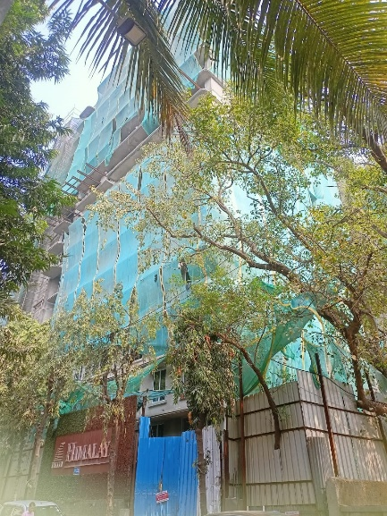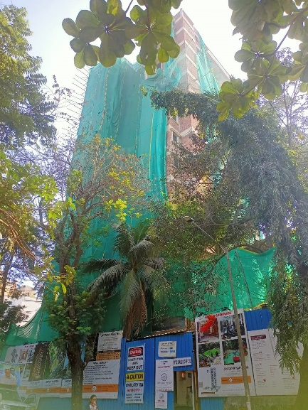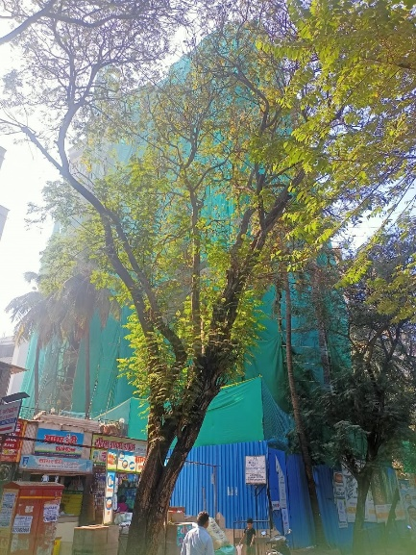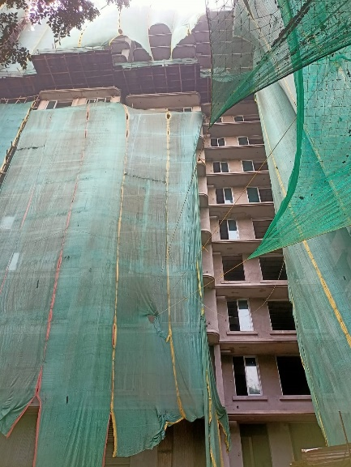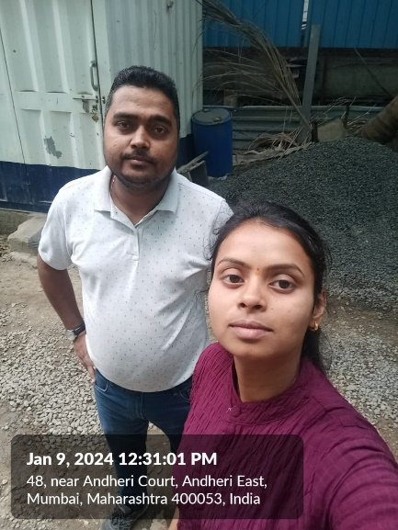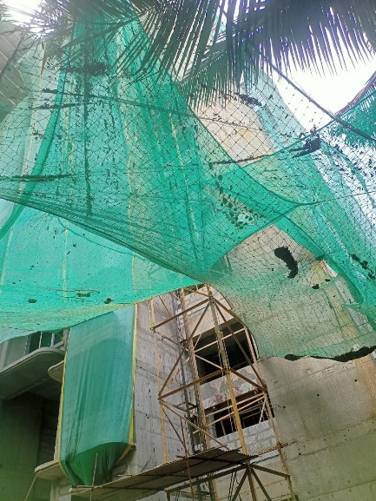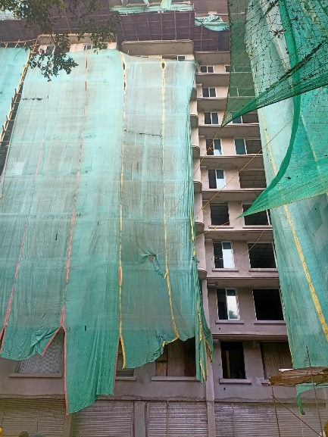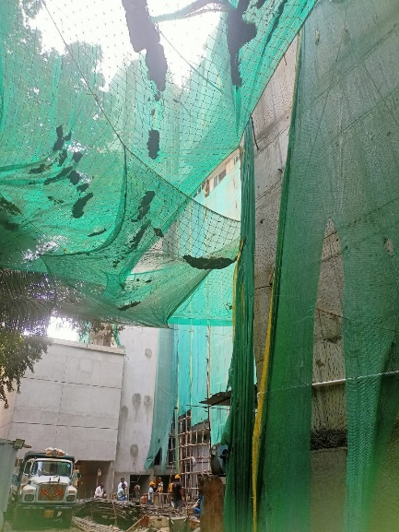

**Actual Site Photographs as on 09.01.2024**

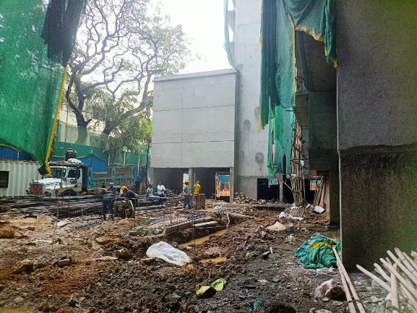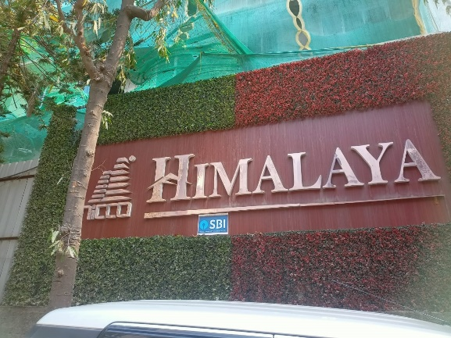

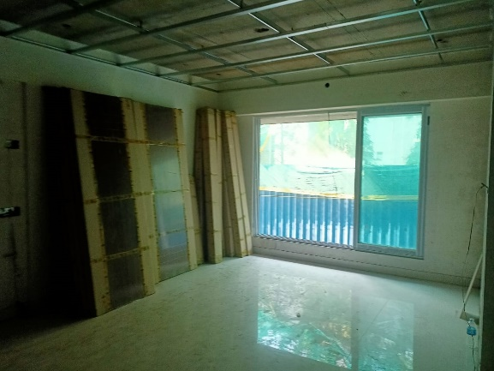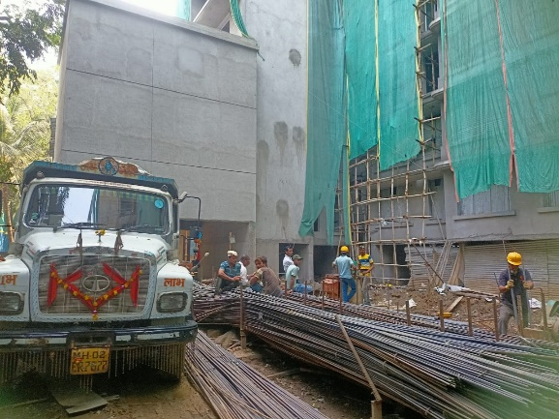

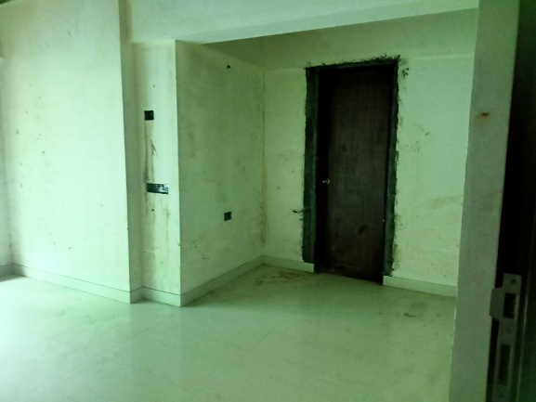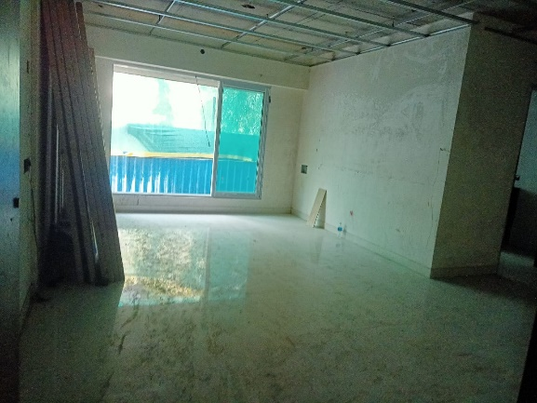

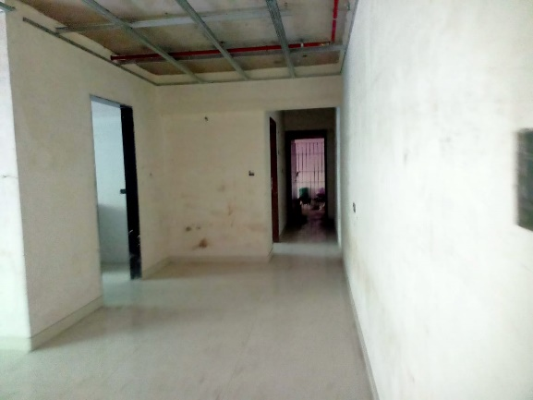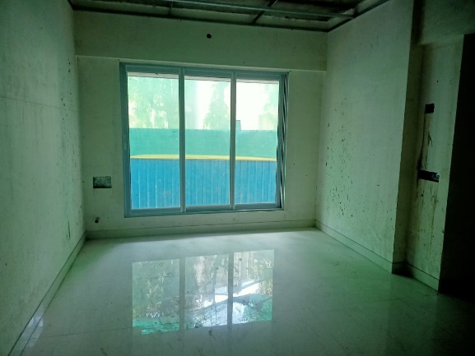

**Actual Site Photographs as on 09.01.2024**

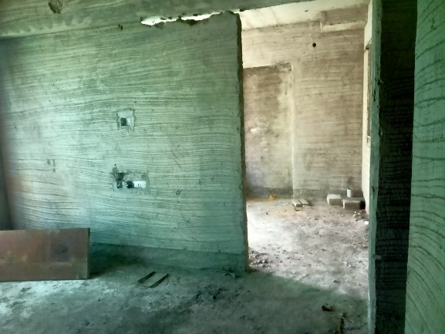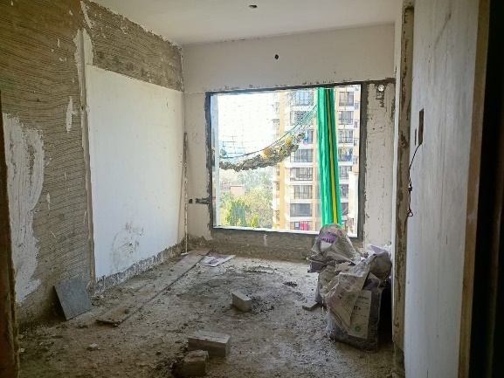

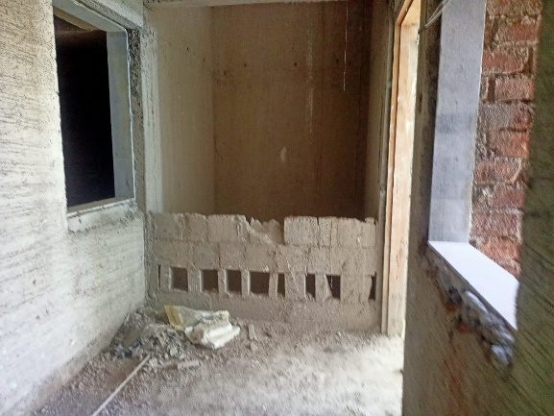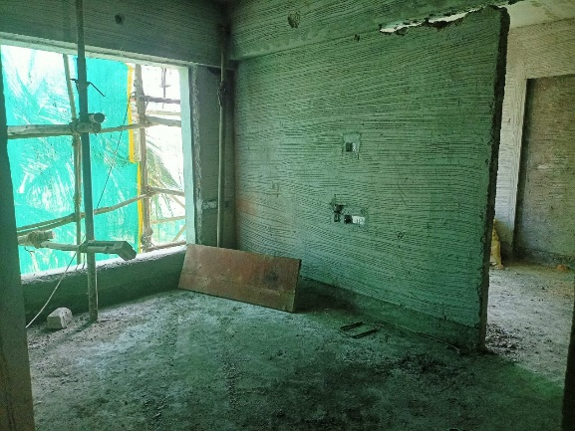

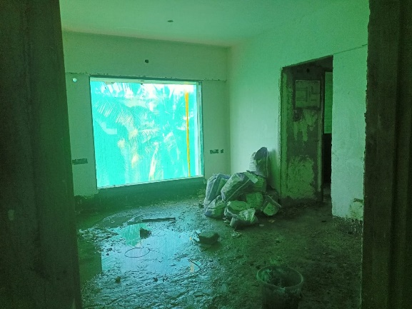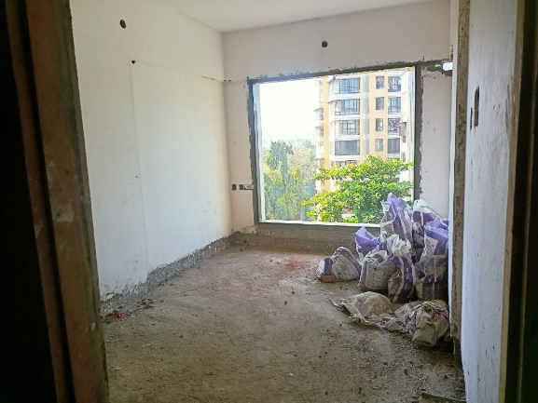

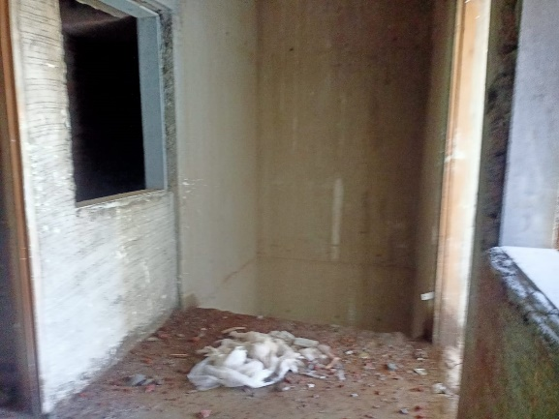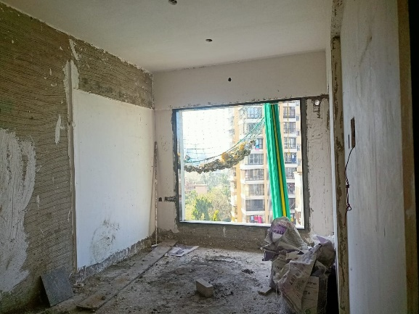

**Actual Site Photographs as on 09.01.2024**

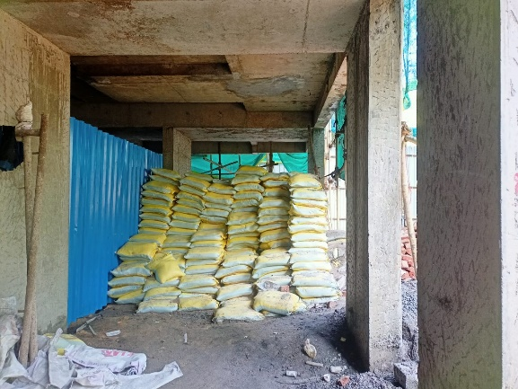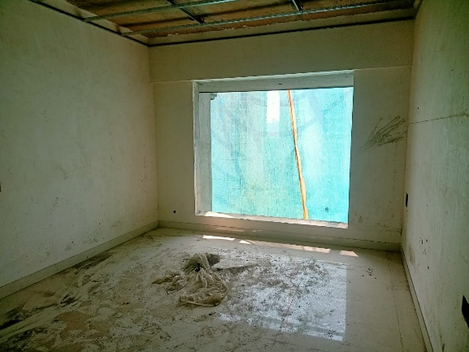

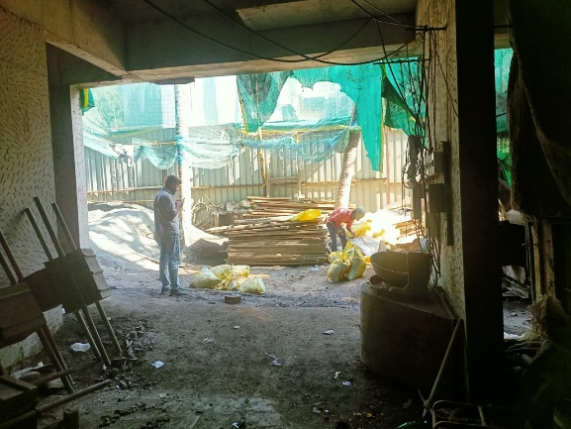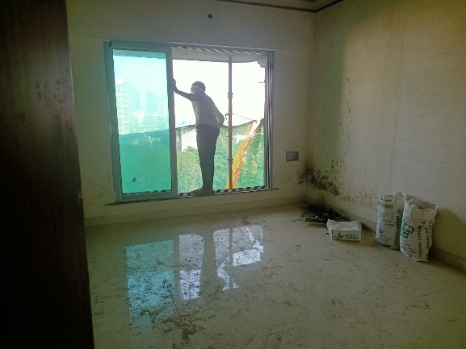

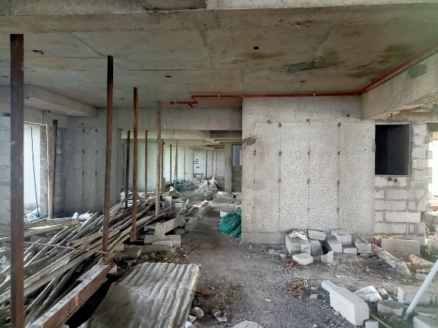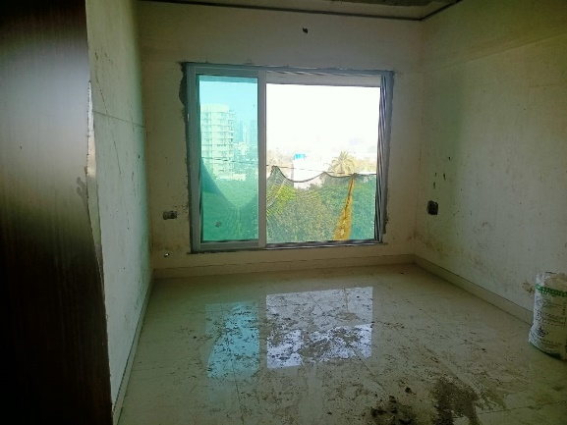

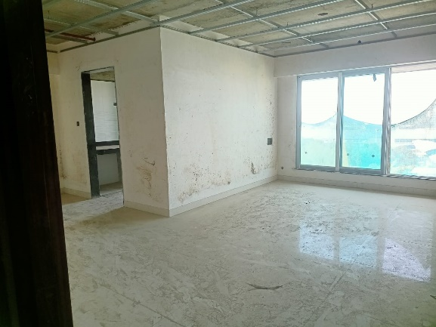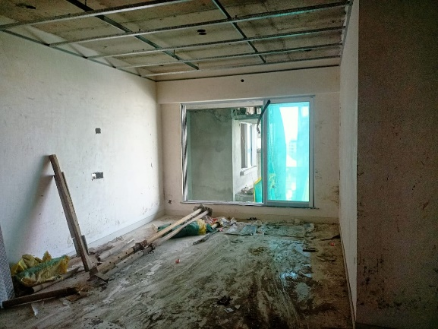

**Actual Site Photographs as on 09.01.2024**

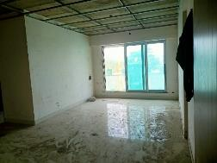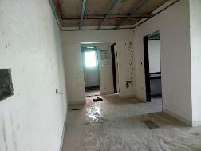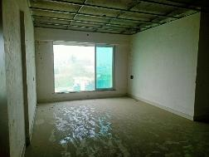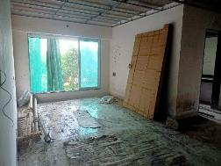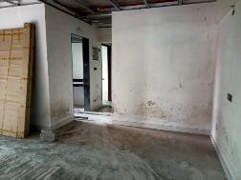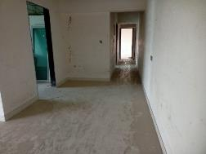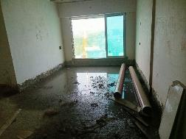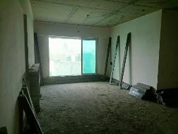

**Actual Site Photographs as on 09.01.2024**







**Route Map of the property**

**Site u/r**

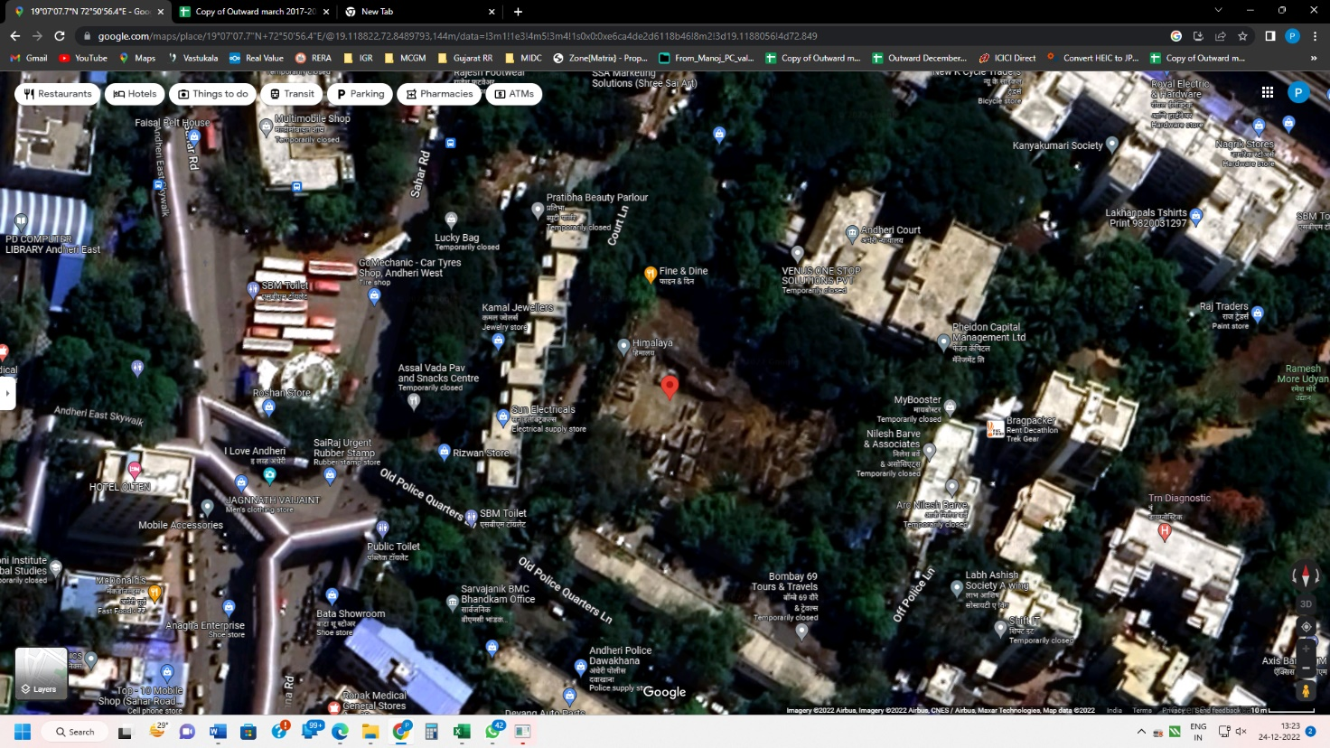

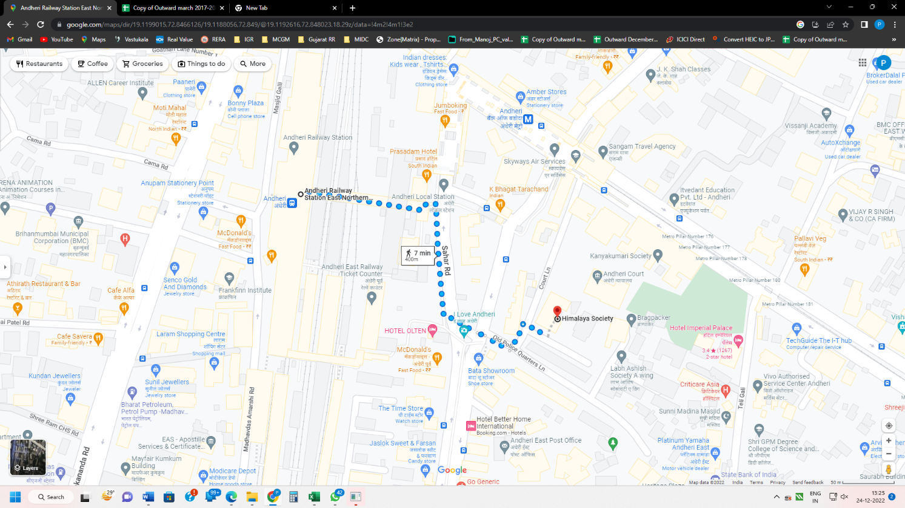

## Latitude Longitude: 19°07'07.7"N 72°50'56.4"E

Note: The Blue line shows the route to site from nearest railway station (Andheri – 400 M.)

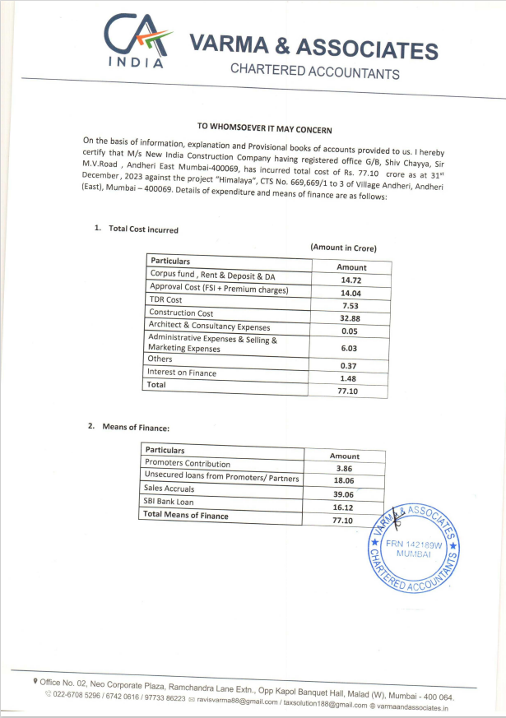**CA Certificate Dated 20.01.2024 till 31.12.2023**

**CA Certificate Dated 20.01.2024 till 31.12.2023**

