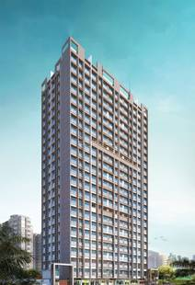
2nd LENDERS INDEPENDENT ENGINEER REPORT

Details of the property under consideration:

Name of Project: Ashtavinayak Apartments

"Ashtavinayak Apartments", Proposed S. R. Scheme Residential building on Plot bearing C.T.S. No. 68, 68/1, to 20, 69, 70, 70/1 to 26, 71, 71/1 to 38, 72, 72/1 to 26, 73, 73/1 to 14, 74 & 74/1 to 17, Village – Majas, Jogeshwari (East), Taluka – Andheri, Mumbai – 400 060, State – Maharashtra, Country – India
Latitude Longitude: 19°08'11.8"N 72°51'41.8"E

Valuation Prepared for:

State Bank of India
SME Chembur Branch
Unit No. 11, Building No. 11, Ground Floor, Corporate Park, Sion Trombay Road,
Chembur, Mumbai, Pin Code – 400 071, State - Maharashtra, Country – India

Vastu/SBI/Mumbai/03/2024/7355/2305275
02/08-23-PY
Date: - 02.03.2024

SECOND LENDERS INDEPENDENT ENGINEER REPORT
To,
State Bank of India
SME Chembur Branch
Unit No. 11, Building No. 11,
Ground Floor, Corporate Park,
Sion Trombay Road, Chembur,
Mumbai, Pin Code – 400 071,
State - Maharashtra, Country – India

Subject: Construction of Proposed S. R. Scheme Residential building on Plot bearing C.T.S. No. 68, 68/1, to 20, 69, 70, 70/1 to 26, 71, 71/1 to 38, 72, 72/1 to 26, 73, 73/1 to 14, 74 & 74/1 to 17, Village – Majas, Jogeshwari (East), Taluka – Andheri, Mumbai – 400 060, State – Maharashtra, Country – India.

Ref: You’re Request for Lenders Independent Engineer Report of under Construction Building.
Dear Sir,
The Construction work as per approved plan was in progress during the site visit on 10th January 2024.
Status of work:
For Rehab Building No. 1 (Wing C): Till 20th Floor Slab work, Door & Window Frame, till 17th floor block work, till 15th floor plaster, till 12th floor toilet dadoing and 4 flats flooring work is completed
For Sales Building No. 2 (Wing A): Till 11th Floor Slab work, Door & Window Frame, till 7th floor block work, till 4th floor internal plaster work is completed and 12th floor slab work & 8th floor block work is in progress
For Sales Building No. 2 (Wing B): Till 15th Floor Slab work, Door & Window Frame, till 10th floor block work, till 10th floor internal plaster work, till 7th floor gypsum work is completed and 16th floor slab work is in progress

Total expenditure occurred as on 31/12/2023 on this project by M/s. Shiv Shruti Developers LLP is ` 6.93 Cr. & as per CA Certificate actual total expenditure occurred as on 31/12/2023 is ` 63.51 Cr. Hence, release of Balance Amount as requested by M/s. Shiv Shruti Developers LLP is hereby recommended.
DECLARATION
- The information furnished in the report is based on our 2nd site visit Dated 10/01/2024 & Document Provided by Client.
- Vastukala 1st LIE Report of the project dated 02/11/2023.
- I have no direct and indirect interest in the property examined for report.
- I have not been found guilty of misconduct in my professional capacity.

Sharadkumar B. Chalikwar
Govt. Reg. Valuer
Chartered Engineer (India)
Reg. No. (N) CCIT/1-14/52/2008-09
Encl.: LIE report

Purpose & Methodology
• State Bank of India Banks and financial institutions require monitoring & an independent review of the progress of the sanctioned projects
VCIPL undertakes such study to independently review the progress of the project and put forward a comprehensive analysis

Advantages:
- Assurance on present practices
- Identification of risk
- Analyzing the performance of third parties
- Recommendations

The Methodology
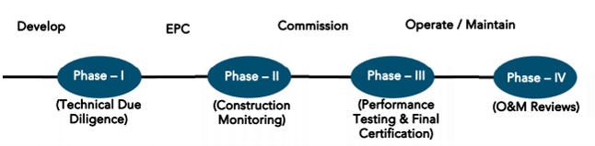
SECOND LENDERS INDEPENDENT ENGINEER REPORT
OF
"ASHTAVINAYAK APARTMENTS"

"Ashtavinayak Apartments", Proposed S. R. Scheme Residential building on Plot bearing C.T.S. No. 68,
68/1, to 20, 69, 70, 70/1 to 26, 71, 71/1 to 38, 72, 72/1 to 26, 73, 73/1 to 14, 74 & 74/1 to 17, Village – Majas,
Jogeshwari (East), Taluka – Andheri, Mumbai – 400 060, State – Maharashtra, Country – India

Latitude Longitude: 19°08'11.8"N 72°51'41.8"E

NAME OF DEVELOPER: M/s. Shiv Shruti Developers LLP
Pursuant to instructions from State of India, SME Chembur Branch, Mumbai we have duly visited, inspected, surveyed & assessed the above said property on 10th January 2024 to determine the fair & reasonable market value of the said property/project as on Quarter ending 31st December 2023 for LIE purpose.

1. Location Details:
Proposed S. R. Scheme Residential building on Plot bearing C.T.S. No. 68, 68/1, to 20, 69, 70, 70/1 to 26, 71, 71/1 to 38, 72, 72/1 to 26, 73, 73/1 to 14, 74 & 74/1 to 17, Village – Majas, Jogeshwari (East), Taluka – Andheri, Mumbai – 400 060. It is about 3.20 Km. travelling distance from Jogeshwari (East) Railway station. Surface transport to the property is by buses, taxis & private vehicles. The property is in developed locality. All the amenities like shops, banks, hotels, markets, schools, hospitals, etc. are all available in the surrounding locality. The area is higher middle class & developed.

2. Developer Details:
Name of builder | M/s. Shiv Shruti Developers LLP
Project Rera Registration Number | P51800049920
Registered office address | Office No. 201A, 2nd Floor, Wing No. A, Vikas Vertex, Behind Andheri Police Station, Andheri (East), Mumbai – 400 069, State - Maharashtra, Country – India
Contact details | Contact Person:  Mrs. Mona Mehta  Mobile No. 7977952834
E – mail ID and website
3. Boundaries of the Property:
Direction | Particulars
On or towards North | Slum Area
On or towards South | Under Construction Building
On or towards East | Road
On or towards West | Open & Slum Area

Introduction
As per Information on site M/s. Shiv Shruti Developers LLP has acquired land by Sale Agreement dated 29.12.2020 through registered agreement vide No. BDR-18-1136-2021 dated 22.01.2021 admeasuring area is 3,217.80 Sq. M. bearing C.T.S. No. 68, 68/1, to 20, 69, 70, 70/1 to 26, 71, 71/1 to 38, 72, 72/1 to 26, 73, 73/1 to 14, 74 & 74/1 to 17. For the Proposed Residential Building.

Area Statement:

Land:
Date | Particular | Area in Sq. M.
29.12.2020 | CTS No. 68, 68/1, to 20, 69, 70, 70/1 to 26, 71, 71/1 to 38, 72, 72/1 to 26, 73, 73/1 to 14, 74 & 74/1 to 17 | 3,217.80
TOTAL |  | 3,217.80

- Copy of Sale Agreement dated 29.12.2020 between M/s. Aishwarya Light Construction Company (The Vendor) and M/s. Shiv Shruti Developers LLP (The Purchasers) through registered agreement vide No. BDR-18-1136-2021 dated 22.01.2021.
- Copy of Rectification Deed dated 29.06.2021 between M/s. Aishwarya Light Construction Company (The Vendor) and M/s. Shiv Shruti Developers LLP (The Purchasers) through registered agreement vide No. BDR-18-8232-2021 dated 05.07.2021.

Building Area:

As per Approved Plan:
I | Area Statement |  |  |  | 33(10) | 30 (non-Slum) | Total Area in Sq. M.
1 | Gross area of plot |  |  |  | 3062.75 | 155.05 | 3217.8
a | Area of Road Set back / D.P Road
2 | Deductions for
(A) | For Reservation/ Road area
a | Road set-back area to be handed over (100%)
(B) | For Amenity area
a | Area of Amenity plot/plots to be handed over as per dcr 14(a)
b | Area of amenity plot/plots to be handed over as per dcr 14(b)
c | Area of amenity plot/plots to be handed over as per dcr 15
d | Area of amenity plot/plots to be handed over as per dcr 35
(C) | Deductions for existing built-up area to be retained if any
a | Land component of existing BUA as per regulation under which the development was allowed
3 | Total deductions: [2(A)+2(B) +2(C)]
4 | Balance area of plot (1 minus 3) |  |  |  | 3062.75 | 155.05 | 3217.8
4a | Addition For
A | For Reservation / Road Area
a | Road Set-Back Area to be Handed Over (100%)
 | Total
5 | Plot area under development (As per Sr. No. 4 above) |  |  |  | 3062.75 | 155.05 | 3217.8
6 | Zonal (basic) fsi (1 or 1.33) |  |  |  |  | 155.05 | 155.05
7 | Permissible built-up area as per zonal(basic) fsi (5*6) (in case of mill land permissible built-up area kept in abeyance)
8 | Built up area equal to area of land handed over as per 3(a) of regulation 30(a)
9 | Built up area in lieu of cost of construction of built-up amenity to be handed over
10 | Built up area due to "additional fsi on payment of premium" as per table no 12 of regulation no 30(a) subject to regulation no 30(a)3
11 | Built up area due to admissible "tdr" as per table no 12 of regulation no 30(a) subject to regulation no 30(a)3
12 | Permissible built-up area (7 + 8 + 9 + 10 + 11) |  |  |  |  | 155.05 | 155.05
13 | Proposed built up area
 | Bldgs. | Rehab Bua | Sale Comm. BUA | Sale Resi. BUA
 | Rehab Building No.1 | 6202.55 |  | 153.11
 | Sale Bldg. No. 2 | 534.72 | 22.57 | 11964.65
14 | Total Rehab BUA | 6737.27 |  |  | 6737.27 |  | 6737.27
15 | Total Rehab Component Area |  |  |  | 11134.29 |  | 11134.29
16 | Incentive Sale Area (15 x 1.10) |  |  |  | 12247.72 |  | 12966.28
16a | Sale Area Permissible in Non-slum |  |  |  |  | 155.05 | 155.05
17 | Total Area Permissible (14 + 16 + 16a) |  |  |  | 18984.99 | 155.05 | 19140.04
18 | Sanctioned FSI. |  |  |  | 6.2 | 1
19 | Total Sale BUA Permissible |  |  |  | 12247.72 | 155.05 | 12402.77
20 | Total Sale BUA Proposed |  | 22.57 | 12117.76 | 12140.33 |  | 12140.33
21 | Total Proposed BUA (Rehab + Sale) (14 + 20) |  |  |  | 18877.6 |  | 18877.6
22 | Fungible compensatory area as per regulation no 31(3)
a | i) Permissible Fungible Compensatory area for Rehab component without charging premium |  |  |  |  |  | 2358.04
 | ii) Fungible Compensatory area availed for Rehab component without charging premium |  |  |  |  |  | 325.64
b | i) Sale Commercial Area |  |  |  |  |  | 22.57
 | ii) Permissible Sale Commercial Fungible Compensatory area by charging premium
 | iii)Sale Commercial Fungible Compensatory area availed on payment of premium
c | i) Sale Residential Area |  |  |  |  |  | 12117.76
 | ii) Permissible Sale Residential Fungible Compensatory area by charging premium
 | iii) Sale Residential Fungible Compensatory area availed on payment of premium
23 | Total Sale Built up Area proposed including Fungible Compensatory Area [20 + 22(b)(iii) + 22(c)(iii)] |  |  |  |  |  | 12140.33
24 | FSI consumed on Net Plot [ 21/4] |  |  |  | 6.16
II | Other Requirements
A | Reservation/Designation
a | Name of Reservation
b | Area of Reservation affecting the plot
 | Area of Reservation land to be handed/ handed over as per Regulation No.17
 | Built up area of Amenity to be handed over as per Regulation No.17
 | Area/ Built up Area of Designation
 | Plot area/ Built up Amenity to be Handed Over as per Regulation No
 | i) 14(A)
 | ii) 14(B)
 | iii) 15
 | Requirement of Open Space in Layout/ Plot as per Regulation No. 27
 | Tenement Statement
 | (i) Proposed built up area (13 above) |  |  |  | Refer above statements
 | (ii) Less deduction of Non-residential area (Shop etc.)
 | (iii) Area available for tenements [(i) minus (ii).]
 | (iv) Tenements permissible (Density of tenements/hectare)
 | (v) Total number of Tenements proposed on the plot
 | Parking Statement
 | (i) Parking required by Regulations for.-
 | Scooter/Motor cycle
 | Outsider (Visitors)
 | (ii) Covered garage permissible
 | (iii) Covered garages proposed
 | Scooter/Motor cycle
 | Outsider (Visitors)
 | (iv) Total parking provided
 | Transport Vehicles Parking
 | (i)Spaces for transport vehicles parking required by Regulations
 | (ii) Total No. of transport vehicles parking spaces provided

As per Architect / Concession Drawing Plan:
I | Area Statement |  |  |  | 33(10) | 30 (non-Slum) | Total Area in Sq. M.
1 | Gross area of plot |  |  |  | 3062.75 | 155.05 | 3217.8
a | Area of Road Set back / D.P Road
2 | Deductions for
(A) | For Reservation/ Road area
a | Road set-back area to be handed over (100%)
(B) | For Amenity area
a | Area of Amenity plot/plots to be handed over as per dcr 14(a)
b | Area of amenity plot/plots to be handed over as per dcr 14(b)
c | Area of amenity plot/plots to be handed over as per dcr 15
d | Area of amenity plot/plots to be handed over as per dcr 35
(C) | Deductions for existing built-up area to be retained if any
a | Land component of existing bua as per regulation under which the development was allowed
3 | Total deductions: [2(A)+2(B) +2(C)]
4 | Balance area of plot (1 minus 3) |  |  |  | 3062.75 | 155.05 | 3217.8
4a | Addition For
A | For Reservation / Road Area
a | Road Set-Back Area to be Handed Over (100%)
 | Total
5 | Plot area under development (As per Sr. No. 4 above) |  |  |  | 3062.75 | 155.05 | 3217.8
6 | Zonal (basic) fsi (1 or 1.33) |  |  |  |  | 155.05 | 155.05
7 | Permissible built-up area as per zonal(basic) fsi (5*6) (in case of mill land permissible built up area kept in abeyance)
8 | Built up area equal to area of land handed over as per 3(a) of regulation 30(a)
9 | Built up area in lieu of cost of construction of built-up amenity to be handed over
10 | Built up area due to "additional fsi on payment of premium" as per table no 12 of regulation no 30(a) subject to regulation no 30(a)3 |  |  |  |  | 77.52 | 77.52
11 | Built up area due to admissible "tdr" as per table no 12 of regulation no 30(a) subject to regulation no 30(a)3 |  |  |  |  | 139.54 | 139.54
12 | Permissible built up area (7 + 8 + 9 + 10 + 11) |  |  |  |  | 372.11 | 372.11
13 | Proposed built up area
 | Bldgs. | Rehab Bua | Sale Comm. BUA | Sale Resi. BUA
 | Rehab Building No.1 | 6202.55 |  | 153.11
 | Sale Bldg. No. 2 | 948.42 | 16.72 | 13168.56
14 | Total Rehab BUA | 7150.97 |  |  | 7150.97 |  | 7150.97
15 | Total Rehab Component Area |  |  |  | 11787.53 |  | 11787.53
16 | Incentive Sale Area (15 x 1.10) |  |  |  | 12966.28 |  | 12966.28
16a | Sale Area Permissible in Non-slum |  |  |  |  | 372.11 | 372.11
17 | Total Area Permissible (14 + 16 + 16a) |  |  |  | 20117.25 | 372.11 | 20489.36
18 | Sanctioned FSI. |  |  |  | 6.57 | 2.4
19 | Total Sale BUA Proposed |  | 16.72 | 13321.67 | 12966.28 | 372.11 | 13338.39
20 | Total Proposed BUA (Rehab + Sale)  (14 + 19) |  |  |  | 20117.25 | 372.11 | 20489.36
21 | Fungible compensatory area as per regulation no 31(3)
22 | i) Permissible Fungible Compensatory area for Rehab component without charging premium |  |  |  |  |  | 2502.84
a | ii) Fungible Compensatory area availed for Rehab component without charging premium |  |  |  |  |  | 343.76
 | i) Sale Commercial Area |  |  |  |  |  | 16.72
b | ii) Permissible Sale Commercial Fungible Compensatory area by charging premium |  |  |  |  |  | 5.85
 | iii)Sale Commercial Fungible Compensatory area availed on payment of premium |  |  |  |  |  | 5.85
 | i) Sale Residential Area |  |  |  |  |  | 13321.67
c | ii) Permissible Sale Residential Fungible Compensatory area by charging premium |  |  |  |  |  | 4662.58
 | iii) Sale Residential Fungible Compensatory area availed on payment of premium |  |  |  |  |  | 2830.49
 | Total Sale Built up Area proposed including Fungible Compensatory Area [20 + 21(b)(iii) + 21(c)(iii)] |  |  |  |  |  | 16174.73
23 | FSI consumed on Net Plot [ 20/4 ] |  |  |  | 6.57 | 2.4
24 | Other Requirements
II | Reservation/Designation
A | Name of Reservation
a | Area of Reservation affecting the plot
b | Area of Reservation land to be handed/ handed over as per Regulation No.17
 | Built up area of Amenity to be handed over as per Regulation No.17
 | Area/ Built up Area of Designation
 | Plot area/ Built up Amenity to be Handed Over as per Regulation No
 | i) 14(A)
 | ii) 14(B)
 | iii) 15
 | Requirement of Open Space in Layout/ Plot as per Regulation No. 27
 | Tenement Statement
 | (i) Proposed built up area (13 above) |  |  |  | Refer above statements
 | (ii) Less deduction of Non-residential area (Shop etc.)
 | (iii) Area available for tenements [(i) minus (ii).]
 | (iv) Tenements permissible (Density of tenements/hectare)
 | (v) Total number of Tenements proposed on the plot
 | Parking Statement
 | (i) Parking required by Regulations for.- |  |  |  | Refer above statements
 | Scooter/Motor cycle
 | Outsider (Visitors)
 | (ii) Covered garage permissible
 | (iii) Covered garages proposed
 | Scooter/Motor cycle
 | Outsider (Visitors)
 | (iv) Total parking provided
 | Transport Vehicles Parking
 | (i)Spaces for transport vehicles parking required by Regulations
 | (ii) Total No. of transport vehicles parking spaces provided

List of Approvals:
- Copy of Letter of Intent (LOI) No. KE/PVT/0232/20180327/LOI dated 31.03.2022 issued by Slum Rehabilitation Authority (SRA).
- Copy of Rehab Building No. 1 IOA Letter No. KE/PVT/0232/20180327/AP/R – 1 dated 21.04.2022 issued by Slum Rehabilitation Authority (SRA).
- Copy of Sale Building No. 2 IOA Letter No. KE/PVT/0232/20180327/AP/S-2 dated 21.04.2022 issued by Slum Rehabilitation Authority (SRA).
- Copy of Rehab Building No. 1 Approved Plan No. KE/PVT/0232/20180327/AP/R – 1 dated 21.04.2022 issued by Slum Rehabilitation Authority (SRA).
Approved upto: Wing C: Ground Floor + 1st to 23rd Upper Residential Floor
- Copy of Sale Building No. 2 Approved Plan No. SRA/ENG/KE/PVT/0232/20180327/AP/S-2 dated 21.04.2022 issued by Slum Rehabilitation Authority (SRA).
Approved upto:
Wing A: Ground Floor + 1st to 11th Upper Residential Floor
Wing B: Ground Floor + 1st to 23rd Upper Residential Floor
- Copy of Sale Building No. 2 Concession / Architect Plan drawn by M/s. Jiyani Consultancy LLP.
Wing A: Ground Floor + 1st to 23rd Upper Residential Floor
Wing B: Ground Floor + 1st to 23rd Upper Residential Floor

- Copy of Rehab Building No. 1 (Wing C) 1st Commencement Certificate No. KE/PVT/0232/20180327/AP/R-1 dated 11.03.2022 issued by Slum Rehabilitation Authority (SRA).
(This CC is endorsed for the work for Wing C: Plinth level Work)
- Copy of Rehab Building No. 1 (Wing C) 2nd Commencement Certificate No. KE/PVT/0232/20180327/AP/R-1 dated 06.09.2022 issued by Slum Rehabilitation Authority (SRA).
(This CC is endorsed for the work for Wing C: Ground Floor + 14th Upper Floor as per approved plan dated 21.04.2022)
- Copy of Rehab Building No. 1 (Wing C) 3rd Commencement Certificate No. KE/PVT/0232/20180327/AP/R-1 dated 05.09.2023 issued by Slum Rehabilitation Authority (SRA).
(This CC is endorsed for the work for Wing C: Ground Floor + 23rd Upper Floor + LMR + OHT as per approved plan dated 21.04.2022)
- Copy of Sale Building No. 2 (Wing A & B) 1st Commencement Certificate No. KE/PVT/0232/20180327/AP/S-2 dated 11.03.2023 issued by Slum Rehabilitation Authority (SRA).
(This CC is endorsed for the work for Wing A & B : Plinth level work)
- Copy of Sale Building No. 2 (Wing A & B ) 2nd Commencement Certificate No. KE/PVT/0232/20180327/AP/S-2 dated 25.11.2022 issued by Slum Rehabilitation Authority (SRA).
(This CC is endorsed for the work for Wing A: Ground Floor + 6th Upper Floor as per approved plan 21.04.2022)
- Copy of Sale Building No. 2 (Wing A & B ) 3rd Commencement Certificate No. KE/PVT/0232/20180327/AP/S-2 dated 24.02.2023 issued by Slum Rehabilitation Authority (SRA).
(This CC is endorsed for the work for Wing A: Ground Floor + 11th Upper Floor & Wing B: Ground Floor + 12th Upper Floor as per approved plan 21.04.2022)
- Copy of Sale Building No. 2 (Wing A & B ) 4th Commencement Certificate No. KE/PVT/0232/20180327/AP/S-2 dated 09.11.2023 issued by Slum Rehabilitation Authority (SRA).
(This CC is endorsed for the work for Wing A: Ground Floor + 11th Upper Floor & Wing B: Ground Floor + 21st (part) Upper Floor as per approved plan 21.04.2022)

LEVEL OF COMPLETION:
For Rehab Building No. 1 (Wing C): Till 20th Floor Slab work, Door & Window Frame, till 17th floor block work, till 15th floor plaster, till 12th floor toilet dadoing and 4 flats flooring work is completed
For Sales Building No. 2 (Wing A): Till 11th Floor Slab work, Door & Window Frame, till 7th floor block work, till 4th floor internal plaster work is completed and 12th floor slab work & 8th floor block work is in progress
For Sales Building No. 2 (Wing B): Till 15th Floor Slab work, Door & Window Frame, till 10th floor block work, till 10th floor internal plaster work, till 7th floor gypsum work is completed and 16th floor slab work is in progress

Rehab Buidling No. 1 (Wing C)
Sr. No | Floor No. | Construction Area in Sq. M. | Completed Area in Sq. M. | Work Completion as 2nd LIE Report as on 04.10.2023 | Work Completion as on 10.01.2024
1 | Excavation & Shore Piling |  |  | Work is completed | Work is completed
2 | Ground Floor | 627.92 | 627.92 | Slab work is completed | Slab work is completed
3 | 1st Floor | 627.92 | 627.92 | Slab work, Blockwork, Plaster work, Door & Window Frames, Gypsum work, Kitchen Platform, Flooring work, Kitchen dadoing & Toilet dadoing work is completed | Slab work, Blockwork, Plaster work, Door & Window Frames, Gypsum work, Kitchen Platform, Flooring work, Kitchen dadoing & Toilet dadoing work is completed
4 | 2nd Floor | 627.92 | 627.92 | Slab work, Blockwork, Plaster work, Door & Window Frames, Gypsum work, Kitchen Platform, Flooring work, Kitchen dadoing & Toilet dadoing work is completed | Slab work, Blockwork, Plaster work, Door & Window Frames, Gypsum work, Kitchen Platform, Flooring work, Kitchen dadoing & Toilet dadoing work is completed
5 | 3rd Floor | 584.55 | 584.55 | Slab work, Blockwork, Plaster work, Door & Window Frames, Gypsum work, Kitchen Platform, Flooring work, Kitchen dadoing & Toilet dadoing work is completed | Slab work, Blockwork, Plaster work, Door & Window Frames, Gypsum work, Kitchen Platform, Flooring work, Kitchen dadoing & Toilet dadoing work is completed
6 | 4th Floor | 584.55 | 584.55 | Slab work, Blockwork, Plaster work, Door & Window Frames, Gypsum work, Kitchen Platform, Flooring work, Kitchen dadoing & Toilet dadoing work is completed | Slab work, Blockwork, Plaster work, Door & Window Frames, Gypsum work, Kitchen Platform, Flooring work, Kitchen dadoing & Toilet dadoing work is completed
7 | 5th Floor | 584.55 | 584.55 | Slab work, Blockwork, Plaster work, Door & Window Frames, Gypsum work, Kitchen Platform, Flooring work, Kitchen dadoing & Toilet dadoing work is completed | Slab work, Blockwork, Plaster work, Door & Window Frames, Gypsum work, Kitchen Platform, Flooring work, Kitchen dadoing & Toilet dadoing work is completed
8 | 6th Floor | 584.55 | 584.55 | Slab work, Blockwork, Plaster work, Door & Window Frames, Gypsum work, Kitchen Platform, Flooring work, Kitchen dadoing & Toilet dadoing work is completed | Slab work, Blockwork, Plaster work, Door & Window Frames, Gypsum work, Kitchen Platform, Flooring work, Kitchen dadoing & Toilet dadoing work is completed
9 | 7th Floor | 584.55 | 584.55 | Slab work, Blockwork, Plaster work, Door & Window Frames, Kitchen Platform, Kitchen dadoing & Toilet dadoing work is completed | Slab work, Blockwork, Plaster work, Door & Window Frames, Gypsum work, Kitchen Platform, Flooring work, Kitchen dadoing & Toilet dadoing work is completed
10 | 8th Floor | 584.66 | 584.66 | Slab work, Blockwork, Plaster work, Door & Window Frames, Kitchen Platform, Kitchen dadoing & Toilet dadoing work is completed | Slab work, Blockwork, Plaster work, Door & Window Frames, Gypsum work, Kitchen Platform, Flooring work, Kitchen dadoing & Toilet dadoing work is completed
11 | 9th Floor | 584.55 | 584.55 | Slab work, Blockwork, Plaster work, Door & Window Frames, Kitchen Platform, Kitchen dadoing & Toilet dadoing work is completed | Slab work, Blockwork, Plaster work, Door & Window Frames, Gypsum work, Kitchen Platform, Flooring work, Kitchen dadoing & Toilet dadoing work is completed
12 | 10th Floor | 584.55 | 584.55 | Slab work, Blockwork, Plaster work, Door & Window Frames, Kitchen Platform, Kitchen dadoing & Toilet dadoing work is completed | Slab work, Blockwork, Plaster work, Door & Window Frames, Gypsum work, Kitchen Platform, Flooring work, Kitchen dadoing & Toilet dadoing work is completed
13 | 11th Floor | 584.55 | 584.55 | Slab work & Blockwork is completed | Slab work, Blockwork, Plaster work, Door & Window Frames, Gypsum work, Kitchen Platform, Flooring work, Kitchen dadoing & Toilet dadoing work is completed
14 | 12th Floor | 584.55 | 584.55 | Slab work & Blockwork is completed | Slab work, Blockwork, Plaster work, Door & Window Frames, Gypsum work, Kitchen Platform, Flooring work, Kitchen dadoing & Toilet dadoing work is completed
15 | 13th Floor | 584.55 | 584.55 | Slab work is completed | Slab work, Blockwork, Plaster work, Door & Window Frames work is completed
16 | 14th Floor | 584.55 | 584.55 | Slab work is completed | Slab work, Blockwork, Plaster work, Door & Window Frames work is completed
17 | 15th Floor | 585.30 | 585.30 | Slab work is completed | Slab work, Blockwork, Plaster work, Door & Window Frames work is completed
18 | 16th Floor | 584.55 | 584.55 | Slab work is completed | Slab work, Blockwork, Door & Window Frames work is completed
19 | 17th Floor | 584.55 | 584.55 |  | Slab work, Blockwork, Door & Window Frames work is completed
20 | 18th Floor | 584.55 | 584.55 |  | Slab work is completed
21 | 19th Floor | 584.55 | 584.55 |  | Slab work is completed
22 | 20th Floor | 584.55 | 584.55 |  | Slab work is completed
23 | 21st Floor | 584.55
24 | 22nd Floor | 584.55
25 | 23rd Floor | 584.55
26 | Terrace | 264.56
Total |  | 14,424.73 | 12,406.52
No. of Puzzle Car Parking |  | 27 Nos

Sales Building No. 3 (Wing A & B)
Sr. No | Floor No. | Construction Area in Sq. M. | Completed Area in Sq. M. | Work Completion as 2nd LIE Report as on 04.10.2023 | Work Completion as on 10.01.2024
1 | Excavation & Shore Piling |  |  | Work is Completed | Work is Completed
2 | Ground Floor | 1,138.60 | 1,138.60 | Wing A & B: Slab Work is completed | Wing A & B: Slab Work is completed
3 | 1st Floor | 1,138.60 | 1,138.60 | Wing A: Slab work, Block work & Plaster work is completed  Wing B: Slab work, Blockwork, Plaster work, Gypsum work, Kitchen Platform, Kitchen dadoing, Plumbing work, Toilet tiling work, flooring, Door & Windows Frames, 2 Flats Windows Installation work are completed | Wing A: Slab work, Block work & Plaster work is completed  Wing B: Slab work, Blockwork, Plaster work, Gypsum work, Kitchen Platform, Kitchen dadoing, Plumbing work, Toilet tiling work, flooring, Door & Windows Frames, 2 Flats Windows Installation work are completed
4 | 2nd Floor | 1,138.60 | 1,138.60 | Wing A: Slab work & Block work is completed  Wing B: Slab work, Blockwork, Plaster work, are completed | Wing A: Slab work, Block work & Plaster work is completed  Wing B: Slab work, Blockwork, Plaster work, Gypsum work, are completed
5 | 3rd Floor | 1,131.03 | 1,131.03 | Wing A: Slab work & Block work is completed  Wing B: Slab work, Blockwork, Plaster work, are completed | Wing A: Slab work, Block work & Plaster work is completed  Wing B: Slab work, Blockwork, Plaster work, Gypsum work, are completed
6 | 4th Floor | 1,126.92 | 1,126.92 | Wing A: Slab work & Block work is completed  Wing B: Slab work & Blockwork are completed | Wing A: Slab work, Block work & Plaster work is completed  Wing B: Slab work, Blockwork, Plaster work, Gypsum work, are completed
7 | 5th Floor | 1,126.92 | 1,126.92 | Wing A: Slab work is completed  Wing B: Slab work & Blockwork are completed | Wing A: Slab work, Block work is completed  Wing B: Slab work, Blockwork, Plaster work, Gypsum work, are completed
8 | 6th Floor | 1,126.92 | 1,126.92 | Wing A: Slab work is completed  Wing B: Slab work are completed | Wing A: Slab work, Block work is completed  Wing B: Slab work, Blockwork, Plaster work, Gypsum work, are completed
9 | 7th Floor | 1,126.92 | 1,126.92 | Wing A: Slab work is completed  Wing B: Slab work are completed | Wing A: Slab work, Block work is completed  Wing B: Slab work, Blockwork, Plaster work, Gypsum work, are completed
10 | 8th Floor | 1,139.10 | 1,139.10 | Wing A: Slab work is completed  Wing B: Slab work are completed | Wing A: Slab work is completed & block work is in progress  Wing B: Slab work, Blockwork, Plaster work, Gypsum work, are completed
11 | 9th Floor | 1,126.92 | 1,126.92 | Wing A: Slab work is completed  Wing B: Slab work are completed | Wing A: Slab work is completed  Wing B: Slab work, Blockwork, Plaster work are completed
12 | 10th Floor | 1,126.92 | 1,126.92 | Wing A: Slab work is completed  Wing B: Slab work are completed | Wing A: Slab work is completed  Wing B: Slab work, Blockwork, Plaster work are completed
13 | 11th Floor | 1,126.92 | 563.46 | Wing A: Slab work are completed | Wing A: Slab work is completed  Wing B: Slab work is completed
14 | 12th Floor | 1,126.92 |  |  | Wing B: Slab work is completed
15 | 13th Floor | 1,126.92 |  |  | Wing B: Slab work is completed
16 | 14th Floor | 1,126.92 |  |  | Wing B: Slab work is completed
17 | 15th Floor | 1,129.81 |  |  | Wing B: Slab work is completed
18 | 16th Floor | 1,126.92 |  |  | Wing B: Slab work is completed
19 | 17th Floor | 1,126.92
20 | 18th Floor | 1,126.92
21 | 19th Floor | 1,126.92
22 | 20th Floor | 1,126.92
23 | 21st Floor | 1,126.92
24 | 22nd Floor | 1,134.51
25 | 23rd Floor | 1,134.49
26 | Terrace Floor | 302.44
Total |  | 27,417.85 | 1,877.06
No. of Puzzle Car Parking |  | 78 Nos

Details of the Project as Financed By SBI:

Project Cost: (as per C.A. Certificate)
Particulars | Estimated Cost (in Cr.) | Incurred Cost (In Cr.) till 31.12.2023 by M/s. Varma & Associates | Incurred Cost (In Cr.) till 31.08.2023 by M/s. Varma & Associates | Net
Land Cost | 0.38 | 0.44 | 0.44 | -
Rent Cost | 11.26 | 7.93 | 6.82 | 1.12
Construction Cost of Rehab Building | 30.97 | 46.55 | 35.24 | 11.31
Construction Cost of Sale Building | 85.33
Premium Cost / FSI / GOM Charges / fees / security Deposits & TDR Cost | 13.00 | 4.22 | 3.93 | 0.29
Architect Cost, RCC & Other Professional Cost | 2.33 | 1.11 | 1.07 | 0.04
Administrative Cost | 1.16 | 2.79 | 2.41 | 0.38
Marketing Cost | 5.07
Interest Cost (Bank Loan) | 4.00 | 0.46 | - | 0.46
Contingency Cost | 1.74 | - | - | -
Total | 155.24 | 63.51 | 49.91 | 13.60

- The Builder has incurred about 0.44 Cr. as land cost, 7.93 Cr. Rent Cost, 46.55 Cr. as construction cost of all buildings, 4.22 Cr. for approval of project, 1.11 Cr. for professional cost, 2.79 Cr. for admin cost & marketing cost & 0.46 for interest cost in last quarter till 31.12.2023 as per C.A. certificate issued by M/s. Varma & Associates dated 20.01.2023.

Project Cost: (as per Bills):
Particulars | Incurred Cost (in Cr.) |  | Net
 | 31.08.2023 as per Bill (Inclusive GST) | 31.08.2023 as per Bill (Inclusive GST)
Land Cost | 0.38 | 0.38 | -
Rent Cost | 7.93 | 6.83 | 1.10
Construction cost of Rehab Building | 45.73 | 35.05 | 10.68
Construction cost of Sale Building
Premium Cost / FSI / GOM Charges / fees / security Deposits & TDR Cost | 5.18 | 3.94 | 1.24
Architect Cost, RCC & Other Professional Cost | 1.09 | 1.04 | 0.05
Administrative Cost | 2.93 | 2.39 | 0.54
Marketing Cost | 0.22 | 0.21 | 0.01
Interest Cost | 0.46 | - | 0.46
Contingency Cost | - | - | -
Total | 63.93 | 49.85 | 14.08
Note:

Land Cost:
Sr. No. | Agreement Name | Date | Particulars | Total Cost in ` | Incurred Cost in `
1 | Agreement for Sale | 24.12.2020 | Stamp Duty | 31,06,500.00 | 31,06,500.00
2 |  |  | Reg. Fees | 30,000.00 | 30,000.00
3 |  |  |  | 7,700.00 | 7,700.00
4 | Rectification Deed | 05.07.2021 | Stamp Duty | 40,000.00 | 40,000.00
5 |  |  | Reg. Fees | 30,000.00 | 30,000.00
6 |  |  |  | 9,800.00 | 9,800.00
7 | Power of Attorney | 22.01.2021 | Stamp Duty | 500.00 | 500.00
8 |  |  | Reg. Fees | 100.00 | 100.00
9 |  |  |  | 800.00 | 800.00
10 | Surrender Deed | 02.01.2023 | Purchase Cost | 5,50,000.00 | 5,50,000.00
11 |  |  | Stamp Duty | 38,500.00 | 38,500.00
 | TOTAL |  |  | 38,13,900.00 | 38,13,900.00
As per conveyance agreement.
Summary of Bills
Sr. No. | Particulars | Amount in `  (till 31.08.2023) | Amount in ` (in Cr.) | Amount in `  (till 31.08.2023) | Amount in ` (in Cr.) | Net
1 | Construction Cost of Rehab Building | 45,72,92,621.00 | 45.73 | 35,05,38,277.00 | 35.05 | 10.68
2 | Construction Cost of Sale Building
3 | Rent Cost | 7,93,07,100.00 | 7.93 | 6,83,01,100.00 | 6.83 | 1.10
4 | Premium Cost / FSI / GOM Charges / fees / security Deposits & TDR Cost | 5,18,01,207.00 | 5.18 | 3,93,69,067.00 | 3.94 | 1.24
5 | Professional Cost | 1,09,03,101.00 | 1.09 | 1,04,38,401.00 | 1.04 | 0.05
6 | Administrative Cost | 2,93,04,707.00 | 2.93 | 2,38,86,437.00 | 2.39 | 0.54
7 | Marketing Cost | 46,24,142.00 | 0.46 | 21,36,145.00 | 0.21 | 0.01
TOTAL |  | 63,92,85,259.00 | 63.93 | 49,46,69,377.00 | 49.47 | 13.62
Note: Bills were provided by the client up to 31.12.2023

Interest Cost:
Sr. No | Particulars | Estimate Amount in ` | Incurred Amount in ` (till 31.08.2023) | Incurred Amount in ` (till 31.08.2023) | Difference in ` | Balance Amount in `
1 | Interest Cost | 4,00,00,000.00 | 46,24,142.00 | - | 46,24,142.00 | 3,53,75,858.00
TOTAL |  | 4,00,00,000.00 | 46,24,142.00 | - | 46,24,142.00 | 3,53,75,858.00
Interest Cost is based on discussion with the client.

Cost of Construction as on 10th January 2023:

Rehab Building No. 1 (Wing C)
Sr. No. | Floor | Total Construction Area in Sq. M. | Completed Area in Sq. M. | Rate per Sq. M. | Full Value after completion | % of work completed | Actual Expenditure till date in `
 | Excavation & Piling Work | 5% of Construction Cost of Building |  |  | 1,44,24,730.00 | 100% | 1,44,24,730.00
1 | Ground | 627.92 | 627.92 | 50% | 62,79,200.00 | 50% | 62,79,200.00
2 | 1st | 627.92 | 627.92 | 75% | 94,18,800.00 | 75% | 94,18,800.00
3 | 2nd | 627.92 | 627.92 | 75% | 94,18,800.00 | 75% | 94,18,800.00
4 | 3rd | 584.55 | 584.55 | 75% | 87,68,250.00 | 75% | 87,68,250.00
5 | 4th | 584.55 | 584.55 | 75% | 87,68,250.00 | 75% | 87,68,250.00
6 | 5th | 584.55 | 584.55 | 75% | 87,68,250.00 | 75% | 87,68,250.00
7 | 6th | 584.55 | 584.55 | 75% | 87,68,250.00 | 75% | 87,68,250.00
8 | 7th | 584.55 | 584.55 | 75% | 87,68,250.00 | 70% | 81,83,700.00
9 | 8th | 584.66 | 584.66 | 75% | 87,69,900.00 | 70% | 81,85,240.00
10 | 9th | 584.55 | 584.55 | 75% | 87,68,250.00 | 70% | 81,83,700.00
11 | 10th | 584.55 | 584.55 | 75% | 87,68,250.00 | 70% | 81,83,700.00
12 | 11th | 584.55 | 584.55 | 75% | 87,68,250.00 | 60% | 70,14,600.00
13 | 12th | 584.55 | 584.55 | 75% | 87,68,250.00 | 60% | 70,14,600.00
14 | 13th | 584.55 | 584.55 | 70% | 81,83,700.00 | 50% | 58,45,500.00
15 | 14th | 584.55 | 584.55 | 70% | 81,83,700.00 | 50% | 58,45,500.00
16 | 15th | 585.30 | 585.30 | 70% | 81,94,200.00 | 50% | 58,53,000.00
17 | 16th | 584.55 | 584.55 | 60% | 70,14,600.00 | 50% | 58,45,500.00
18 | 17th | 584.55 | 584.55 | 20,000.00 | 1,16,91,000.00 |  | -
19 | 18th | 584.55 | 584.55 | 20,000.00 | 1,16,91,000.00 |  | -
20 | 19th | 584.55 | 584.55 | 20,000.00 | 1,16,91,000.00 |  | -
21 | 20th | 584.55 | 584.55 | 20,000.00 | 1,16,91,000.00 |  | -
22 | 21st | 584.55 |  | 20,000.00 | 1,16,91,000.00 |  | -
23 | 22nd | 584.55 |  | 20,000.00 | 1,16,91,000.00 |  | -
24 | 23rd | 584.55 |  | 20,000.00 | 1,16,91,000.00 |  | -
25 | OHT / LMR | 264.56 |  | 20,000.00 | 52,91,200.00 |  | -
Total Area in Sq. M. |  | 14,424.73 | 12,406.52 |  | 30,29,19,330.00 | 61% | 18,33,52,980.00
STACK PARKING Nos. |  | 27.00 |  | 2,50,000.00 | 67,50,000.00
TOTAL COST OF CONSTRUCTION (A + B) |  |  |  |  | 30,96,69,330.00 | 59% | 18,33,52,980.00

Sales Building No. 2 (Wing A & B)
Sr. No. | Floor | Total Construction Area in Sq. M. | Completed Area in Sq. M. | Rate per Sq. M. | Full Value after completion | % of work completed | Actual Expenditure till date in `
 | Excavation & Piling Work | 10% of Construction Cost of Building |  |  | 7,40,28,200.00 | 100% | 7,40,28,200.00
1 | Ground | 1,138.60 | 1,138.60 | 27,000.00 | 3,07,42,146.00 | 50% | 1,53,71,073.00
2 | 1st | 1,138.60 | 1,138.60 | 27,000.00 | 3,07,42,146.00 | 68% | 2,09,04,659.28
3 | 2nd | 1,138.60 | 1,138.60 | 27,000.00 | 3,07,42,146.00 | 64% | 1,96,74,973.44
4 | 3rd | 1,131.03 | 1,131.03 | 27,000.00 | 3,05,37,756.00 | 64% | 1,95,44,163.84
5 | 4th | 1,126.92 | 1,126.92 | 27,000.00 | 3,04,26,786.00 | 60% | 1,82,56,071.60
6 | 5th | 1,126.92 | 1,126.92 | 27,000.00 | 3,04,26,786.00 | 55% | 1,67,34,732.30
7 | 6th | 1,126.92 | 1,126.92 | 27,000.00 | 3,04,26,786.00 | 50% | 1,52,13,393.00
8 | 7th | 1,126.92 | 1,126.92 | 27,000.00 | 3,04,26,786.00 | 50% | 1,52,13,393.00
9 | 8th | 1,139.10 | 1,139.10 | 27,000.00 | 3,07,55,646.00 | 50% | 1,53,77,823.00
10 | 9th | 1,126.92 | 1,126.92 | 27,000.00 | 3,04,26,786.00 | 50% | 1,52,13,393.00
11 | 10th | 1,126.92 | 1,126.92 | 27,000.00 | 3,04,26,786.00 | 50% | 1,52,13,393.00
12 | 11th | 1,126.92 | 1,126.92 | 27,000.00 | 3,04,26,786.00 | 50% | 1,52,13,393.00
13 | 12th | 1,126.92 | 563.46 | 27,000.00 | 3,04,26,786.00 | 25% | 76,06,696.50
14 | 13th | 1,126.92 | 563.46 | 27,000.00 | 3,04,26,786.00 | 25% | 76,06,696.50
15 | 14th | 1,126.92 | 563.46 | 27,000.00 | 3,04,26,786.00 | 25% | 76,06,696.50
16 | 15th | 1,129.81 | 563.46 | 27,000.00 | 3,05,04,816.00 | 25% | 76,26,204.00
17 | 16th | 1,126.92 |  | 27,000.00 | 3,04,26,840.00 |  | -
18 | 17th | 1,126.92 |  | 27,000.00 | 3,04,26,840.00 |  | -
19 | 18th | 1,126.92 |  | 27,000.00 | 3,04,26,840.00 |  | -
20 | 19th | 1,126.92 |  | 27,000.00 | 3,04,26,840.00 |  | -
21 | 20th | 1,126.92 |  | 27,000.00 | 3,04,26,840.00 |  | -
22 | 21st | 1,126.92 |  | 27,000.00 | 3,04,26,840.00 |  | -
23 | 22nd | 1,134.51 |  | 27,000.00 | 3,06,31,770.00 |  | -
24 | 23rd | 1,134.49 |  | 27,000.00 | 3,06,31,230.00 |  | -
25 | OHT / LMR | 302.44 |  | 27,000.00 | 81,65,880.00 |  | -
Total Area in Sq. M. |  | 27,417.90 | 15,829.63 |  | 81,43,11,500.00 | 38% | 30,64,04,954.96
STACK PARKING Nos. |  | 78.00 |  | 5,00,000.00 | 3,90,00,000.00 |  | -
TOTAL COST OF CONSTRUCTION (A + B) |  |  |  |  | 85,33,11,500.00 | 36% | 30,64,04,954.96

SUMMARY TABLE OF PLINTH AREA CALCULATION
Sr. No. | Building | Total Construction Area in Sq. M. | Full Value after completion | % of work completed | Actual Expenditure till date in `
1 | Rehab Building No. 1 | 14,424.73 | 30,29,19,330.00 | 61% | 18,33,52,980.00
2 | Sale Building | 27,417.90 | 81,43,11,500.00 | 38% | 30,64,04,954.96
 | Sub Total (A) | 41,842.63 | 111,72,30,830.00 | 44% | 48,97,57,934.96
3 | Puzzle Parking of Rehab Building in No. | 27.00 | 67,50,000.00 | 0% | -
4 | Puzzle Parking of Sale Building in No. | 78.00 | 3,90,00,000.00 | 0% | -
 | Sub Total (B) | 105.00 | 4,57,50,000.00 | 0% | -
Total Cost of Construction (A + B) |  |  | 116,29,80,830.00 | 42% | 48,97,57,934.96

Note: Details of work completed is as per site visit dated 10.01.2024 but report is prepared for 31st December quarter 2023.

Particulars | Estimated Cost  (In Cr.) | Incurred Cost (in Cr.) |  |  | Net
 |  | Issued dated 26.10.2023 till 31.08.2023 as per CA | As per Bills upto 31.12.2023 | As per Bills upto 31.08.2023
Land Cost | 0.38 | 0.44 | 0.38 | 0.38 | -
Rent Cost | 11.26 | 7.93 | 7.93 | 6.83 | 1.10
Construction cost of Rehab & Amenity Building | 30.97 | 46.55 | 45.73 | 35.05 | 10.68
Construction cost of Sale Building | 85.33
Premium Cost / FSI / GOM Charges / fees / security Deposits & TDR Cost | 13.00 | 4.22 | 5.18 | 3.94 | 1.24
Architect Cost, RCC & Other Professional Cost | 2.33 | 1.11 | 1.09 | 1.04 | 0.05
Administrative Cost | 1.16 | 2.79 | 2.93 | 2.39 | 0.54
Marketing Cost | 5.07 |  | 0.22 | 0.21 | 0.01
Interest Cost | 4.00 | 0.46 | 0.46 | - | 0.46
Contingency Cost | 1.74 | - | - | - | -
Total | 155.24 | 63.51 | 63.93 | 49.85 | 14.08
Note:
In CA Certificate , security deposits 0.06 Cr. is considered in land cost header but we have not considered same.
We have considered Other Expenses, Printing & Stationery, and Water Bills cost is consider in on-site expenditure cost header but CA has considered them in cost of construction header .
We have considered Stamp Duty, Registration Charges and Brokerage against of sale flat are cosnidered in marketing cost header.
As per plinth area, calculation the work completed is up to 59% of total work, which comes to ` 18.34 Cr. for Rehab building No. 1 and the work completed is up to 36% of total work, which comes to ` 30.64 Cr. for Sale Building No. 2. Hence total construction cost as per plinth area calculation incurred is ` 48.98 Cr. which comes upto 42% of work completion. However, company has incurred cost of ` 46.55 Cr. till 31.12.2023 as per bill inclusive material.

Comparison of Cost incurred on dated 31.08.2023 & CA Certificate
Particulars | 31.12.2023 as per Bill | 31.08.2023 as per Bill | Net | % of net amount
Land Cost | 0.38 | 0.38 | - | 0.0%
Rent Cost | 7.93 | 6.83 | 1.10 | 1.72%
Construction cost of Rehab & Amenity Building | 45.73 | 35.05 | 10.68 | 16.71%
Construction cost of Sale Building
Premium Cost / FSI / GOM Charges / fees / security Deposits & TDR Cost | 5.18 | 3.94 | 1.24 | 1.94%
Architect Cost, RCC & Other Professional Cost | 1.09 | 1.04 | 0.05 | 0.08%
Administrative Cost | 2.93 | 2.39 | 0.54 | 0.84%
Marketing Cost | 0.22 | 0.21 | 0.01 | 0.02%
Interest Cost | 0.46 | - | 0.46 | 0.72%
Contingency Cost | - | - | - | 0.00%
Total | 63.93 | 49.85 | 14.08 | 22.02%

% of Fund Utilised till 31st December 2023
Particulars | Estimated Project Cost  (in Cr.) | Incurred cost as on 31.12.2023 | % of Incurred Cost | % of Estimated Project Cost
Land Cost | 0.38 | 0.38 | 100.00% | 0.25%
Rent Cost | 11.26 | 7.93 | 70.43% | 5.11%
Construction cost of Rehab & Amenity Building | 30.97 | 45.73 | 39.32% | 29.46%
Construction cost of Sale Building | 85.33
Premium Cost / FSI / GOM Charges / fees / security Deposits | 13.00 | 5.18 | 39.85% | 3.34%
Architect Cost, RCC & Other Professional Cost | 2.33 | 1.09 | 46.79% | 0.70%
Administrative Cost | 1.16 | 2.93 | 252.63% | 1.89%
Marketing Cost | 5.07 | 0.22 | 4.42% | 0.14%
Interest Cost | 4.00 | 0.46 | 11.56% | 0.30%
Contingency Cost | 1.74 | - | 0.00% | 0.00%
Total | 155.24 | 63.93 | 41.18% | 41.18%
Based on above Calculation it is found that total Project cost incurred is 41.18% of the Total Project Cost.

Means of Finance:
Sr. No. | Particulars | Exp. Cumulative (Cr.)
 | Equity share capital / Quassi Loan from Promoter | 1.54
 | Unsecured Loan | 19.11
 | Sales (Advance from customer) | 16.52
 | Bank Laon Amount | 12.74
 | Total | 49.91
The Details of the Means of Finance are provided by Client as on 31.08.2023.

Mandatory Arrangements:
Sr. No. | Particulars | Status
 | Rainwater Harvesting | To be executed after RCC Structure
 | Firefighting System | To be executed after RCC Structure
 | Solid Waste Management | To be executed after RCC Structure

Quality of Construction:
Sr. No. | Particulars | Status
 | Soundness of Structures | Executing as per approved Structural Design
 | Look of Structures | Good
 | Quality of Material Used | Good
 | Safety Measures for Construction/labour | Taken Care by Contractor

Schedule V/s. Actual Progress:

Rehab Building No. 1
Activity | Date of Implementation | Date of Completion | Status
Land |  |  | Completed
Development of Land |  |  | Completed
Foundation Work |  |  | Completed
Ground Floor Slab |  |  | Slab work is completed
1st Floor Slab |  |  | Slab work is completed
2nd Floor Slab |  |  | Slab work is completed
3rd Floor Slab |  |  | Slab work is completed
4th Floor Slab |  |  | Slab work is completed
5th Floor Slab |  |  | Slab work is completed
6th Floor Slab |  |  | Slab work is completed
7th Floor Slab |  |  | Slab work is completed
8th Floor Slab |  |  | Slab work is completed
9th Floor Slab |  |  | Slab work is completed
10th Floor Slab |  |  | Slab work is completed
11th Floor Slab |  |  | Slab work is completed
12th Floor Slab |  |  | Slab work is completed
13th Floor Slab |  |  | Slab work is completed
14th Floor Slab |  |  | Slab work is completed
15th Floor Slab |  |  | Slab work is completed
16th Floor Slab |  |  | Slab work is completed
17th Floor Slab |  |  | Shuttering work is in progress
18th Floor Slab
19th Floor Slab
20th Floor Slab
21st Floor Slab
22nd Floor Slab
23rd Floor Slab
Block work / Internal Plaster work |  |  | Work is in progress
Terrace Parapet wall / Overhead water tank / Lift Machine room / compound wall / External Plaster work
Electric Work
Water Proofing
Plumbing Work
Tiling / Marble Flooring
Door Frames |  |  | Work is in progress
Window Installation
Staircase Flooring
Staircase Railing
Refuge Area Flooring
Internal Painting
External Painting
Lift Work
Fire Fighting Installation
Stack Parking
CP Fitting & Sanitary Work
Final Finishing & Fitting

Sale Building No. 2 (Wing A & B)
Activity | Date of Implementation | Date of Completion | Status
Land |  |  | Completed
Development of Land |  |  | Completed
Foundation Work |  |  | Completed
Ground Floor Slab |  |  | Wing A & B Slab work is Completed
1st Floor Slab |  |  | Wing A & B Slab work is Completed
2nd Floor Slab |  |  | Wing A & B Slab work is Completed
3rd Floor Slab |  |  | Wing A & B Slab work is Completed
4th Floor Slab |  |  | Wing A & B Slab work is Completed
5th Floor Slab |  |  | Wing A & B Slab work is Completed
6th Floor Slab |  |  | Wing A & B Slab work is Completed
7th Floor Slab |  |  | Wing A & B Slab work is Completed
8th Floor Slab |  |  | Wing A & B Slab work is Completed
9th Floor Slab |  |  | Wing A & B Slab work is Completed
10th Floor Slab |  |  | Wing A & B Slab work is Completed
11th Floor Slab |  |  | Wing A Slab work is Completed
12th Floor Slab
13th Floor Slab
14th Floor Slab
15th Floor Slab
16th Floor Slab
17th Floor Slab
18th Floor Slab
19th Floor Slab
20th Floor Slab
21st Floor Slab
22nd Floor Slab
23rd Floor Slab
Block work / Internal Plaster work |  |  | Work is in progress
Terrace Parapet wall / Overhead water tank / Lift Machine room / compound wall / External Plaster work
Electric Work
Water Proofing
Plumbing Work
Tiling / Marble Flooring
Door Frames
Window Installation
Staircase Flooring
Staircase Railing
Refuge Area Flooring
Internal Painting
External Painting
Lift Work
Fire Fighting Installation
Stack Parking
CP Fitting & Sanitary Work
Final Finishing & Fitting
Work progress schedule is not shared by the developer.

Action initiated to complete the project in time:
For Rehab Building No. 1 (Wing C): Till 16th Floor Slab work is completed & 17th Floor Shuttering work is in progress.
For Sales Building No. 2 (Wing A): Till 11th Floor Slab work is completed.
For Sales Building No. 2 (Wing B): Till 10th Floor Slab work is completed

Comments related to cost overrun if any:
The cost of Project is ` 155.24 Cr.

Balance investment required for completion of project:
We opinion amount of ` 105.39 Cr. Will be required to complete the Project.

Mandatory Approval Status:
Sr. No. | Particulars | Name of Department | Status | Order Details
1 | Letter of Intent (LOI) Building | Slum Rehabilitation Authority (SRA) | Obtained and available at site | KE/PVT/0232/20180327/LOI dated 31.03.2022
2A | Rehab Building No. 1 IOA | Slum Rehabilitation Authority (SRA) | Obtained and available at site | KE/PVT/0232/20180327/AP/R – 1 dated 21.04.2022
2B | Sale Building No. 2 IOA | Slum Rehabilitation Authority (SRA) | Obtained and available at site | KE/PVT/0232/20180327/AP/S-2 dated 21.04.2022
3A | Rehab Building No. 1 Approved Plan | Slum Rehabilitation Authority (SRA) | Obtained and available at site | KE/PVT/0232/20180327/AP/R – 1 dated 21.04.2022
3B | Sale Building No. 2 Approved Plan | Slum Rehabilitation Authority (SRA) | Obtained and available at site | SRA/ENG/KE/PVT/0232/20180327/AP/S-2 dated 21.04.2022
3C | Revised Sale Building No. 2 Approved Plan | Slum Rehabilitation Authority (SRA) | Pending | -
4A | First C.C. of Rehab Building No. 1 | Slum Rehabilitation Authority (SRA) | Obtained and available at site | KE/PVT/0232/20180327/AP/R-1 dated 11.03.2022. This CC is endorsed for the work for Wing C: Plinth level Work
4B | Second C.C. of Rehab Building No. 1 | Slum Rehabilitation Authority (SRA) | Obtained and available at site | KE/PVT/0232/20180327/AP/R-1 dated 06.09.2022. This CC is endorsed for the work for Wing C: Ground Floor + 14th Upper Floor as per approved plan dated 21.04.2022
4C | Third C.C. of Rehab Building No. 1 | Slum Rehabilitation Authority (SRA) | Obtained and available at site | KE/PVT/0232/20180327/AP/R-1 dated 05.09.2023. This CC is endorsed for the work for Wing C: Ground Floor + 23rd Upper Floor + LMR + OHT as per approved plan dated 21.04.2022
5A | First C.C. of Sale Building No. 2 | Slum Rehabilitation Authority (SRA) | Obtained and available at site | KE/PVT/0232/20180327/AP/S-2 dated 11.03.2023. This CC is endorsed for the work for Wing A & B: Plinth level work
5B | Second C.C. of Sale Building No. 2 | Slum Rehabilitation Authority (SRA) | Obtained and available at site | KE/PVT/0232/20180327/AP/S-2 dated 25.11.2022. This CC is endorsed for the work for Wing A: Ground Floor + 6th Upper Floor as per approved plan 21.04.2022
6A | Third C.C. of Sale Building No. 2 | Slum Rehabilitation Authority (SRA) | Obtained and available at site | KE/PVT/0232/20180327/AP/S-2 dated 24.02.2023. This CC is endorsed for the work for Wing A: Ground Floor + 11th Upper Floor & Wing B: Ground Floor + 12th Upper Floor as per approved plan 21.04.2022
6B | Fourth C.C. of Sale Building No. 2 | Slum Rehabilitation Authority (SRA) | Obtained and available at site | KE/PVT/0232/20180327/AP/S-2 dated 09.11.2023 issued by Slum Rehabilitation Authority (SRA).  (This CC is endorsed for the work for Wing A: Ground Floor + 11th Upper Floor & Wing B: Ground Floor + 21st (part) Upper Floor as per approved plan 21.04.2022)
6C | Fifth C. C. of Sale of Building No. 2 | Slum Rehabilitation Authority (SRA) | Pending | -`
7A | Occupancy of Rehab Building No. 1 | Slum Rehabilitation Authority (SRA) | Pending (Project is not completed)
7B | Occupancy of Sale Building No. 2 | Slum Rehabilitation Authority (SRA) | Pending (Project is not completed)

Status Insurance Coverage:
Information not provided

Remark:
As per General instruction from Slum Rehabilitation Authority (SRA), Further C. C. for Sale Building will be release after the completion of plinth level of Rehab Building & Completion of Amenity Building.

Assumptions & Remarks:
- The adequacy of Engineering / Structural design is beyond the scope of our assignment.
- Estimated project completion date is 31/12/2025 for Rehab & Sales Building respectively. The cost is certified based on the assumptions that the project will be completed within period. Few assumptions were made regarding inflation & cost rise etc. during construction period.

Sharadkumar B. Chalikwar
Govt. Reg. Valuer
Chartered Engineer (India)
Reg. No. (N) CCIT/1-14/52/2008

About the Project:
1. Introduction
a) | Project Name  (With Address & Phone Nos.) | "Ashtavinayak Apartments", Proposed S. R. Scheme Residential building on Plot bearing C.T.S. No. 68, 68/1, to 20, 69, 70, 70/1 to 26, 71, 71/1 to 38, 72, 72/1 to 26, 73, 73/1 to 14, 74 & 74/1 to 17, Village – Majas, Jogeshwari (East), Taluka – Andheri, Mumbai – 400 060, State – Maharashtra, Country – India  Contact Person:  Mrs. Mona Mehta  Mobile No. 79779 52834
b) | Purpose of Valuation | As per request from State Bank of India, SME Chembur Branch to assess fair market value of the Project for LIE purpose.
c) | Date of Inspection of Property | 10.01.2024
d) | Date of LIE Report | 02.03.2024
e) | Name of the Developer of Property  (in case of developer-built properties) | M/s. Shiv Shruti Developers LLP  Office No. 201A, 2nd Floor, Wing No. A, Vikas Vertex, Behind Andheri Police Station, Andheri (East), Mumbai – 400 069, State - Maharashtra, Country – India
2. Physical Characteristics of the Property
a) | Location of the Property | "Ashtavinayak Apartments", Proposed S. R. Scheme Residential building on Plot bearing C.T.S. No. 68, 68/1, to 20, 69, 70, 70/1 to 26, 71, 71/1 to 38, 72, 72/1 to 26, 73, 73/1 to 14, 74 & 74/1 to 17, Village – Majas, Jogeshwari (East), Taluka – Andheri, Mumbai – 400 060, State – Maharashtra, Country – India
 | Brief description of the property
TYPE OF THE BUILDING
- Rehab Building No. 1

No. of Floors | Ground Floor + 1st to 23rd Upper Residential Floor
Building type | Residential Rehab Building

- Sale Building No. 2 (Wing A & B)

No. of Floors | Ground Floor + 1st to 23rd Upper Residential Floor
Building type | Residential Sale building

Rehab Building No. 1 & Sale Building No. 2 work is given on contract based for RCC contract. Developer has grant to the contractor do the work of construction and completion includes Concrete work, Reinforcement work, Masonry, Internal Plaster, External Plaster and other miscellaneous work such as repairing, joints b/w concrete and masonry surface, etc. Bill must be paid on measurement of construction area exclusive of Steel, Cement & other construction material.
Lift & lift installation contract is not finalized till now.
Firefighting work contract is not finalized.

PROPOSED DATE OF COMPLETION & FUTURE LIFE:
Expected completion date as per RERA is 31st December 2025

ABOUT PROJECT:
Positioned at well-connected locality Jogeshwari East, Ashtavinayak Apartments is an aesthetically built project of Mumbai. This reasonably priced Ashtavinayak Apartments project lies in the range of Rs. 71. 0 Lac - 1. 06 Cr. This project has its expanse over an area of 1 Acre. The project features a total of 201 units that are well-ventilated.
The carefully laid out units of this Residential complex are sure to mesmerize most buyers. All the units in the property are Under Construction. Flat are the various types of units available, each of which has been created to provide total satisfaction. The property units provide a comfortable environment and range in size from 1 BHK Flat (317. 0 Sq. Ft. - 469. 0 Sq. Ft.). The design of the project is such that it is classified into 1 tower. The launch date of this beautiful project is 01 March 2022. 01 June 2025 is the date of possession.
Ashtavinayak Apartments's commencement certificate has been granted. The status of the occupancy certificate of this project not granted. Ashtavinayak Apartments has been built by reputed real estate developer Shiv Shruti Developers LLP. Ashtavinayak Apartments ensures the availability of first-class premium amenities such as Private Terrace/Garden, Earth quake resistant, Grand Entrance lobby, Lift, Meditation Area, Indoor Games Room, Kids play area, Waste Disposal, Intercom Facility, Vaastu Compliant. The site's exact address is Shyam Nagar, Off JVLR, Jogeshwari East, Mumbai. The pin code of this masterpiece project is 400060. Ashtavinayak Apartments is where fine living meets seamless connectivity to provide you comfort living.
 | Postal Address of the Property | "Ashtavinayak Apartments", Proposed S. R. Scheme Residential building on Plot bearing C.T.S. No. 68, 68/1, to 20, 69, 70, 70/1 to 26, 71, 71/1 to 38, 72, 72/1 to 26, 73, 73/1 to 14, 74 & 74/1 to 17, Village – Majas, Jogeshwari (East), Taluka – Andheri, Mumbai – 400 060, State – Maharashtra, Country – India
 | Area of the plot/land  (Supported by a plan) | Plot Area: 3,217.80 Sq. M.
 | Type of Land: Solid, Rocky, Marsh land, reclaimed land, Water-logged, Land locked. | Solid land
 | Independent access/approach to the property etc. | Yes
 | Google Map Location of the Property with a neighborhood layout map | Provided
 | Details of roads abutting the property | Proposed 30 M wide road
 | Description of adjoining property | Located in Higher Middle-class locality
 | Plot No. Survey No. | C.T.S. No. 68, 68/1, to 20, 69, 70, 70/1 to 26, 71, 71/1 to 38, 72, 72/1 to 26, 73, 73/1 to 14, 74 & 74/1 to 17
 | Ward/Village/Taluka | Village Majas Taluka – Andheri
 | Sub-Registry/Block | Mumbai Suburban
 | District | District - Mumbai Suburban
b) | Boundaries of the Plot
 | As per Agreement | As per RERA Certificate | Actual
North | CTS No. 33 | CTS NO 76 | Slum Area
South | Road | CTS NO 67 | Under Construction Building
East | CTS No. 76 | CTS NO 378 And 18 Point 30 M. Road | Road
West | CTS No. 66 & 67 | CTS NO 33 | Open & Slum Area

4. Document Details and Legal Aspects of Property:
a) | Ownership Documents (Building Permission, Commencement Certificate & Status of Plan)
 | Sale Deed, Gift Deed, Lease Deed
 | - Copy of Sale Agreement dated 29.12.2020 between M/s. Aishwarya Light Construction Company (The Vendor) and M/s. Shiv Shruti Developers LLP (The Purchasers) through registered agreement vide No. BDR-18-1136-2021 dated 22.01.2021.
 | - Copy of Rectification Deed dated 29.06.2021 between M/s. Aishwarya Light Construction Company (The Vendor) and M/s. Shiv Shruti Developers LLP (The Purchasers) through registered agreement vide No. BDR-18-8232-2021 dated 05.07.2021.
 | - Copy of Letter of Intent (LOI) No. KE/PVT/0232/20180327/LOI dated 31.03.2022 issued by Slum Rehabilitation Authority (SRA).
 | - Copy of Rehab Building No. 1 IOA Letter No. KE/PVT/0232/20180327/AP/R – 1 dated 21.04.2022 issued by Slum Rehabilitation Authority (SRA).
 | - Copy of Sale Building No. 2 IOA Letter No. KE/PVT/0232/20180327/AP/S-2 dated 21.04.2022 issued by Slum Rehabilitation Authority (SRA).
- Copy of Rehab Building No. 1 Approved Plan No. KE/PVT/0232/20180327/AP/R – 1 dated 21.04.2022 issued by Slum Rehabilitation Authority (SRA).
Approved upto: Wing C: Ground Floor + 1st to 23rd Upper Residential Floor
- Copy of Sale Building No. 2 Approved Plan No. SRA/ENG/KE/PVT/0232/20180327/AP/S-2 dated 21.04.2022 issued by Slum Rehabilitation Authority (SRA).
Approved upto:
Wing A: Ground Floor + 1st to 11th Upper Residential Floor
Wing B: Ground Floor + 1st to 23rd Upper Residential Floor
- Copy of Sale Building No. 2 Concession / Architect Plan drawn by M/s. Jiyani Consultancy LLP.
Wing A: Ground Floor + 1st to 23rd Upper Residential Floor
Wing B: Ground Floor + 1st to 23rd Upper Residential Floor
- Copy of Rehab Building No. 1 (Wing C) 1st Commencement Certificate No. KE/PVT/0232/20180327/AP/R-1 dated 11.03.2022 issued by Slum Rehabilitation Authority (SRA).
(This CC is endorsed for the work for Wing C: Plinth level Work)
- Copy of Rehab Building No. 1 (Wing C) 2nd Commencement Certificate No. KE/PVT/0232/20180327/AP/R-1 dated 06.09.2022 issued by Slum Rehabilitation Authority (SRA).
(This CC is endorsed for the work for Wing C: Ground Floor + 14th Upper Floor as per approved plan dated 21.04.2022)
- Copy of Rehab Building No. 1 (Wing C) 3rd Commencement Certificate No. KE/PVT/0232/20180327/AP/R-1 dated 05.09.2023 issued by Slum Rehabilitation Authority (SRA).
(This CC is endorsed for the work for Wing C: Ground Floor + 23rd Upper Floor + LMR + OHT as per approved plan dated 21.04.2022)
- Copy of Rehab Building No. 1 (Wing C) 3rd Commencement Certificate No. KE/PVT/0232/20180327/AP/R-1 dated 05.09.2023 issued by Slum Rehabilitation Authority (SRA).
(This CC is endorsed for the work for Wing C: Ground Floor + 23rd Upper Floor + LMR + OHT as per approved plan dated 21.04.2022)
- Copy of Sale Building No. 2 (Wing A & B) 1st Commencement Certificate No. KE/PVT/0232/20180327/AP/S-2 dated 11.03.2023 issued by Slum Rehabilitation Authority (SRA).
(This CC is endorsed for the work for Wing A & B : Plinth level work)
- Copy of Sale Building No. 2 (Wing A & B) 2nd Commencement Certificate No. KE/PVT/0232/20180327/AP/S-2 dated 25.11.2022 issued by Slum Rehabilitation Authority (SRA).
(This CC is endorsed for the work for Wing A: Ground Floor + 6th Upper Floor as per approved plan 21.04.2022)
- Copy of Sale Building No. 2 (Wing A & B) 3rd Commencement Certificate No. KE/PVT/0232/20180327/AP/S-2 dated 24.02.2023 issued by Slum Rehabilitation Authority (SRA).
(This CC is endorsed for the work for Wing A: Ground Floor + 11th Upper Floor & Wing B: Ground Floor + 12th Upper Floor as per approved plan 21.04.2022)
 | - Copy of Environmental Clearance Certificate No. SIA/MH/MIS/273404/2022 dated 13.09.2022 issued by State Environment Impact Assessment Authority (SEIAA), Maharashtra.
 | - Copy of CA Certificate dated 10.08.2023 issued by M/s. Varma & Associates
 | - Copy of RERA Certificate No. P51800049920 dated 06.03.2023 issued by Maharashtra Real Estate Regulatory Authority.
 | - Copy of Legal Title Report dated 07.02.2022 issued by M/s. Mehta & Co.
 | - Bills Upto 31.08.2023
 | - Copy of CA Certificate dated 26.10.2023 for cost incurred till 31.08.2023 issued by M/s. Varma & Associates

b) | Documents verified for present LIE report
 | - Copy of CA Certificate dated 20.01.2024 issued by M/s. M/s. Varma & Associates.
 | - Copy of Bills from 01.09.2023 to 31.12.2023
- Copy of Sale Building No. 2 (Wing A & B ) 4th Commencement Certificate No. KE/PVT/0232/20180327/AP/S-2 dated 09.11.2023 issued by Slum Rehabilitation Authority (SRA).
(This CC is endorsed for the work for Wing A: Ground Floor + 11th Upper Floor & Wing B: Ground Floor + 21st (part) Upper Floor as per approved plan 21.04.2022)

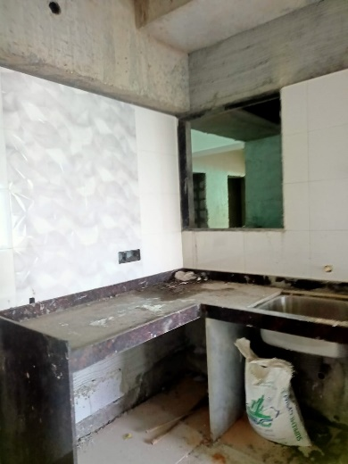
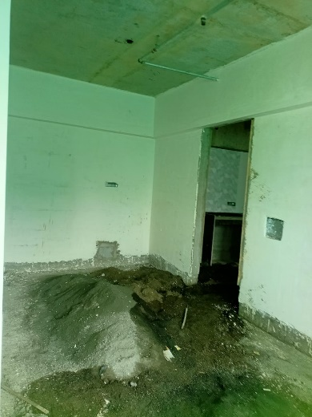
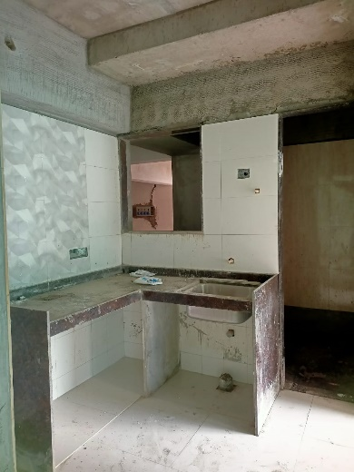
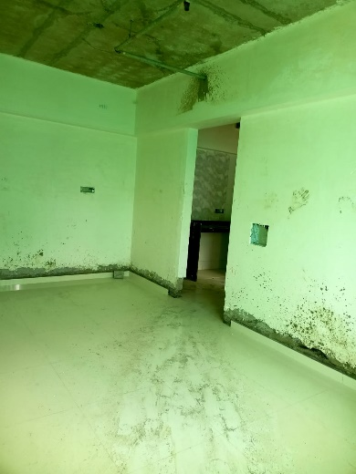
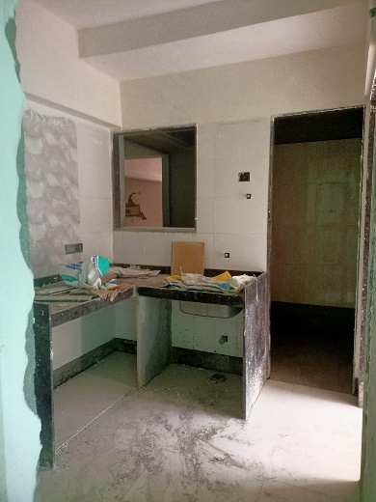
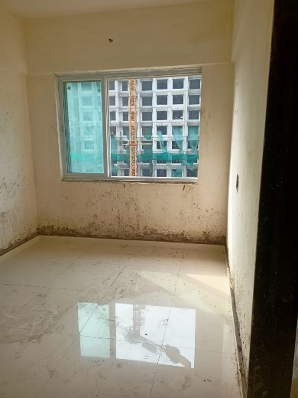
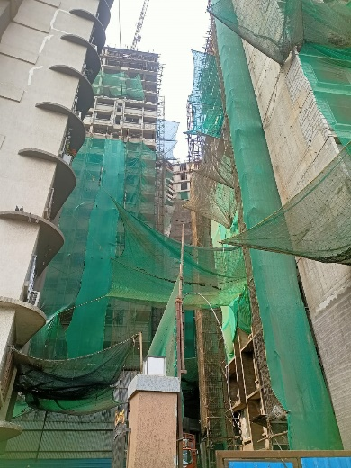
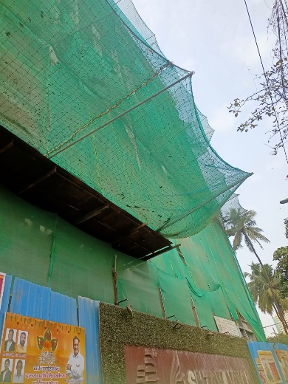
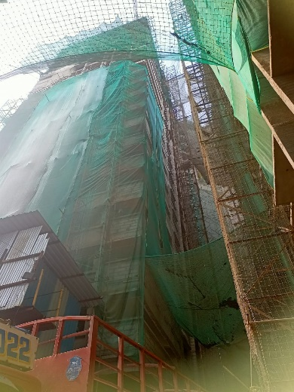
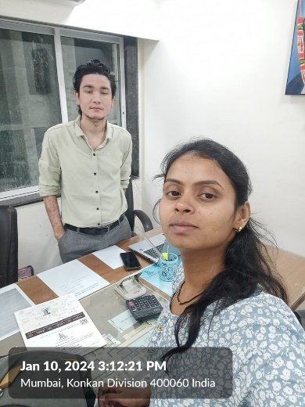
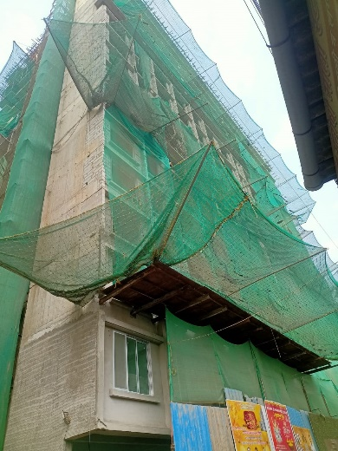
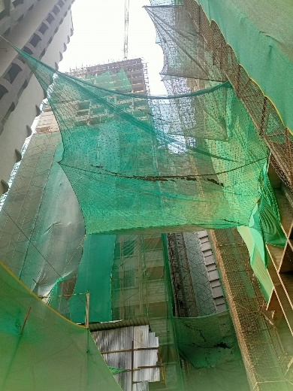
Actual Site Photographs As on 10.01.2024

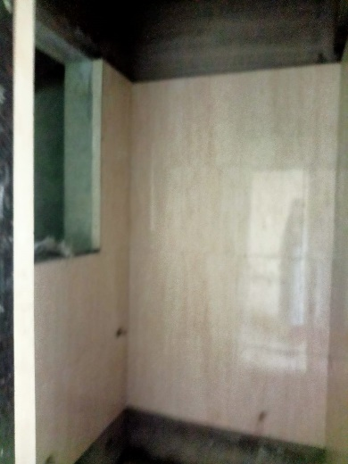
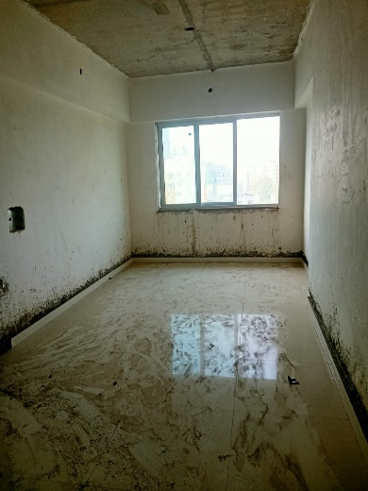
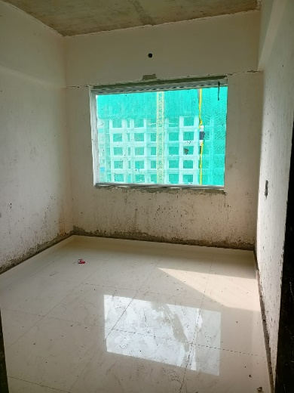
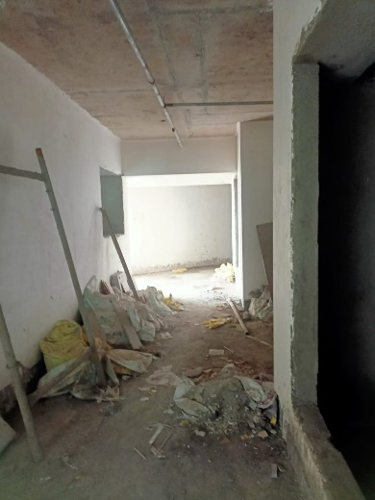
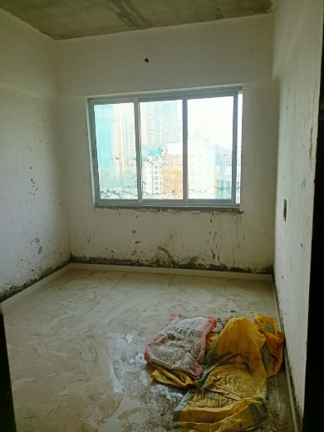
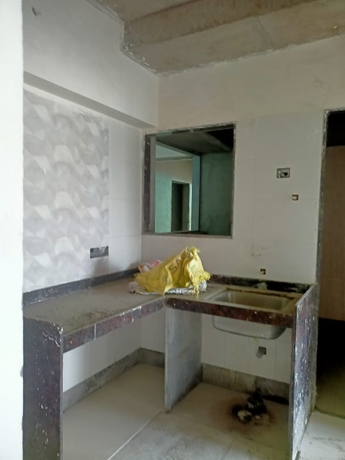
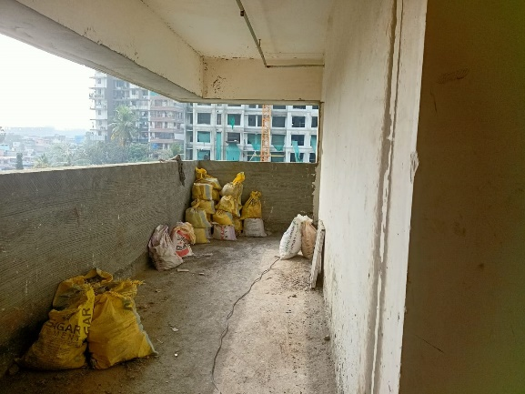
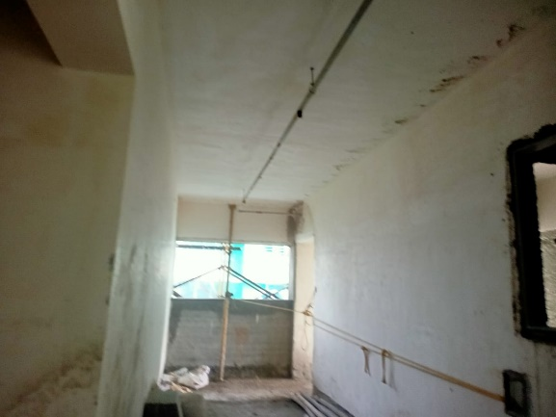
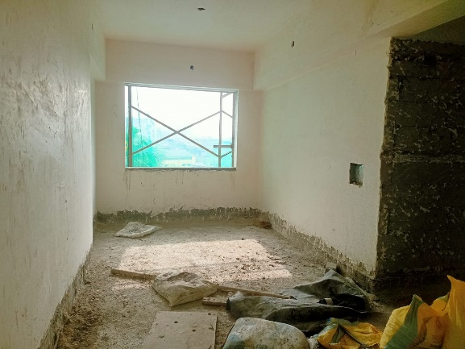
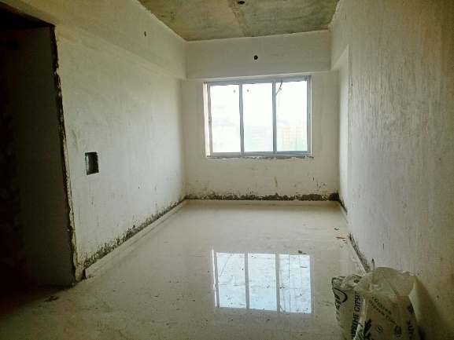
Actual Site Photographs As on 10.01.2024

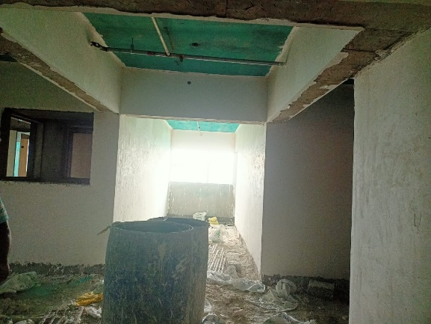
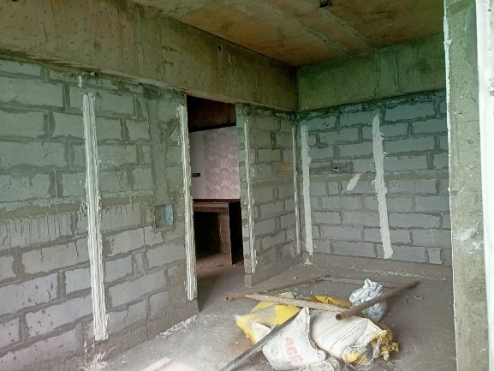
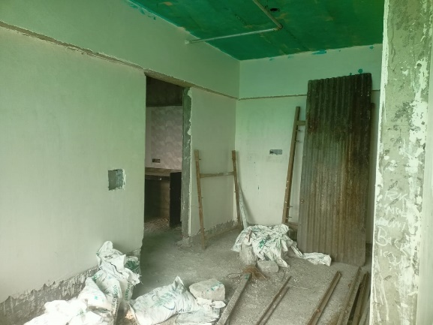
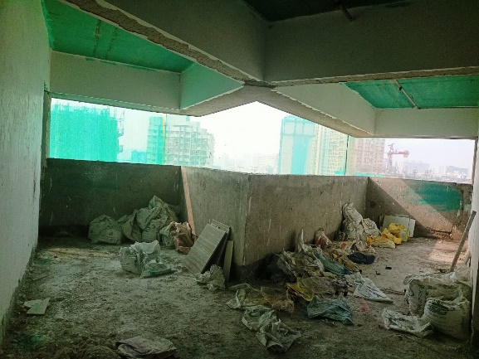
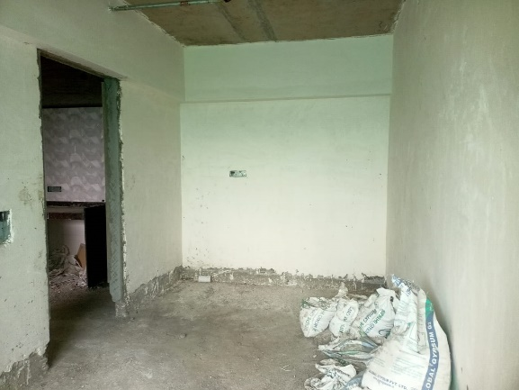
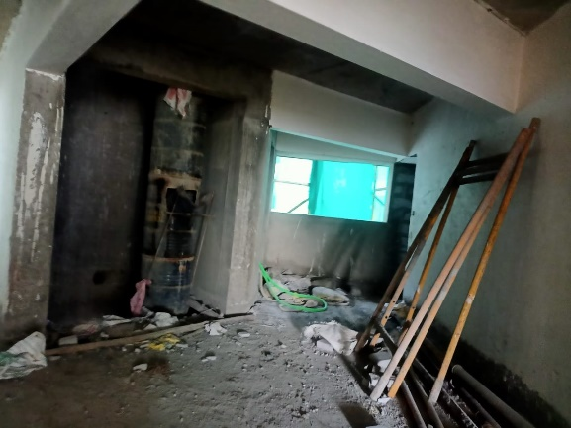
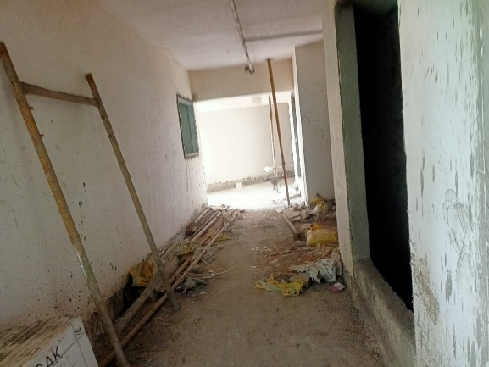
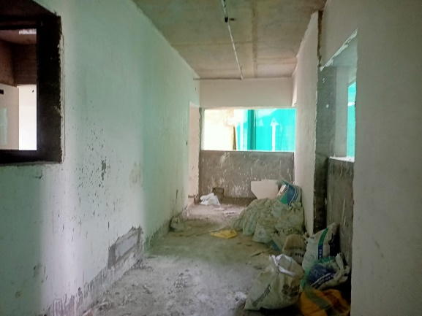
Actual Site Photographs As on 10.01.2024

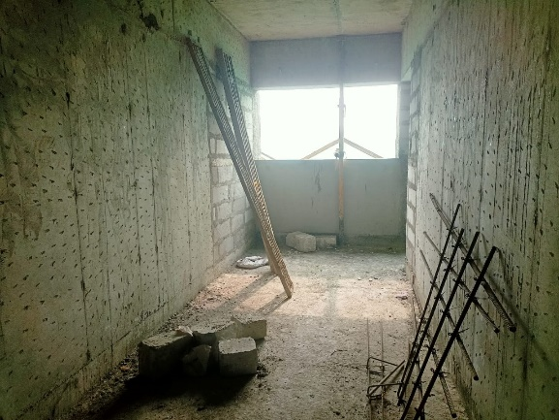
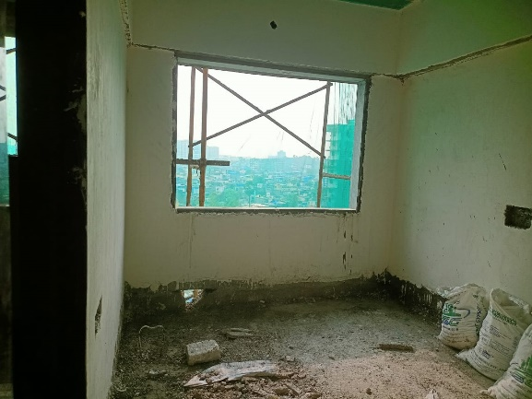
Actual Site Photographs As on 10.01.2024
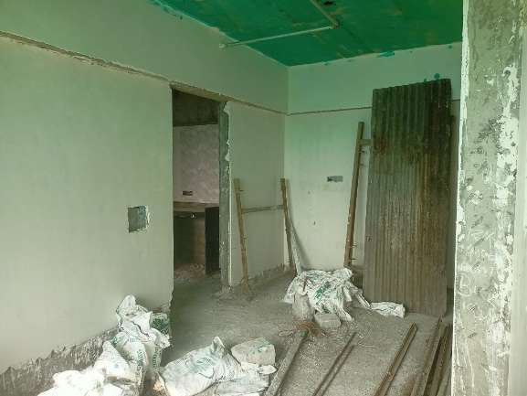
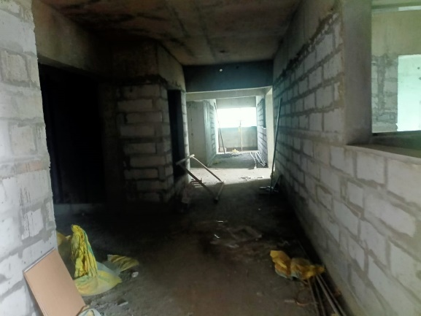
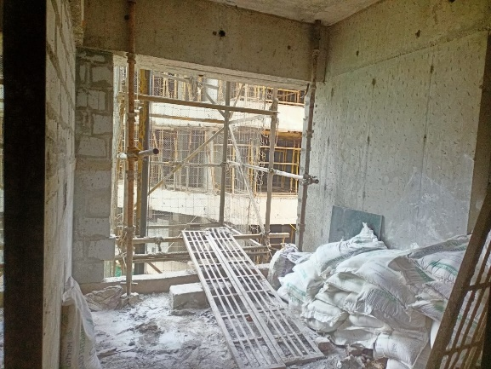
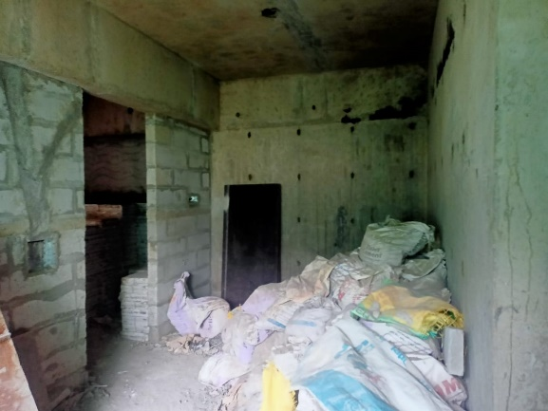
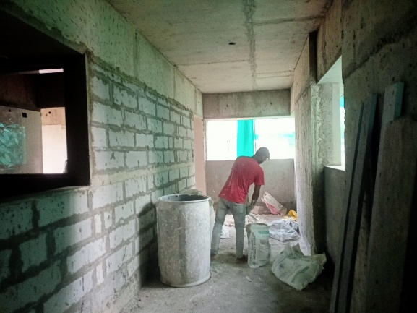
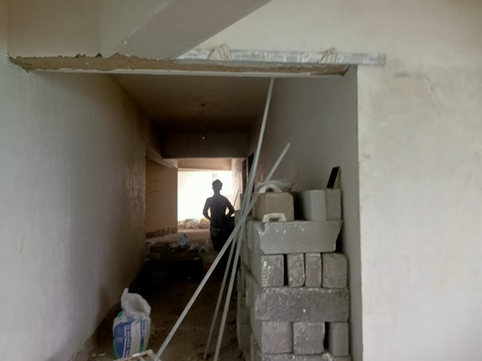
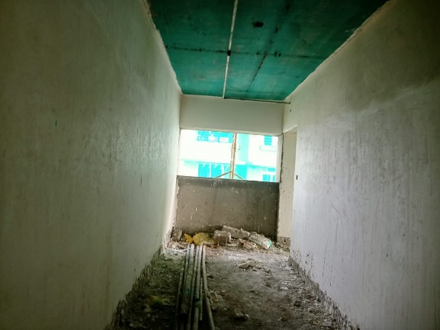
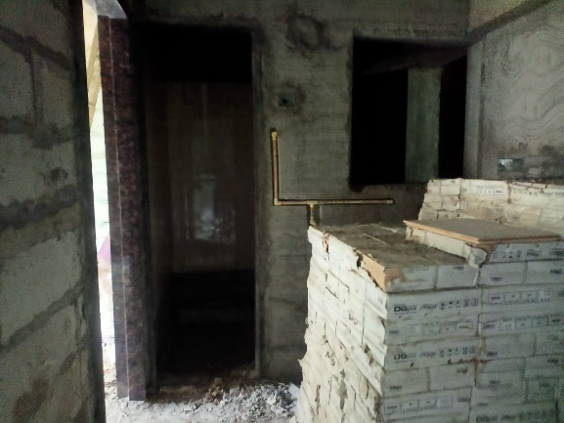
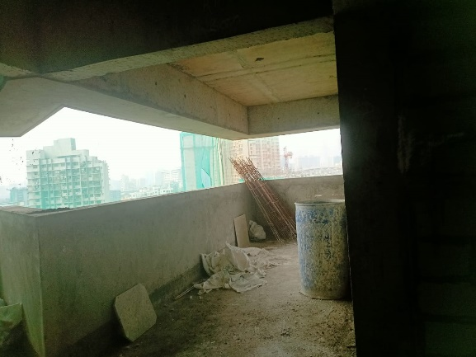
Actual Site Photographs As on 10.01.2024
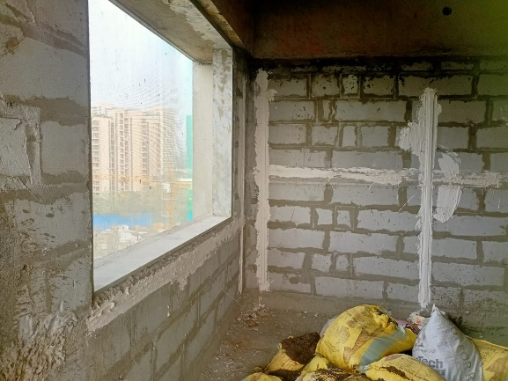
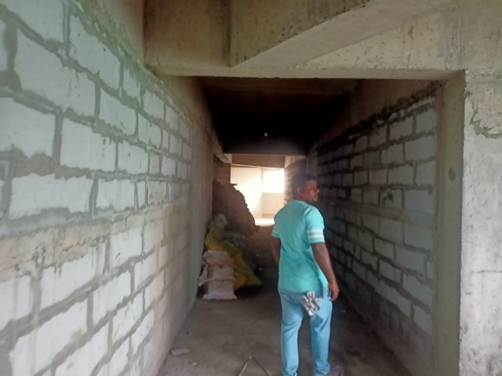
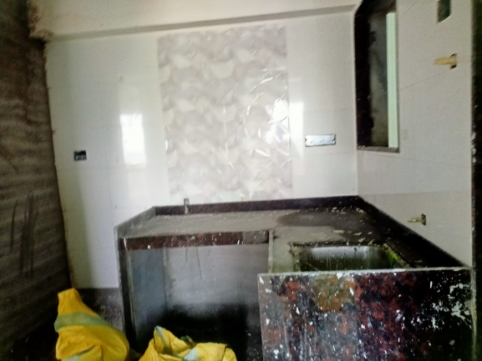
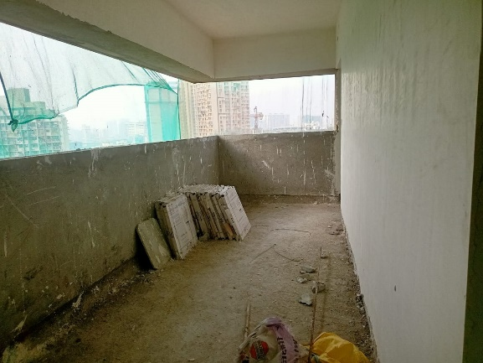
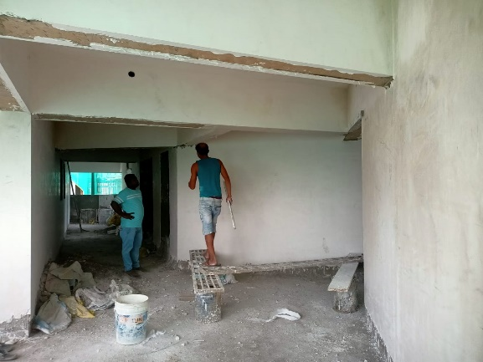
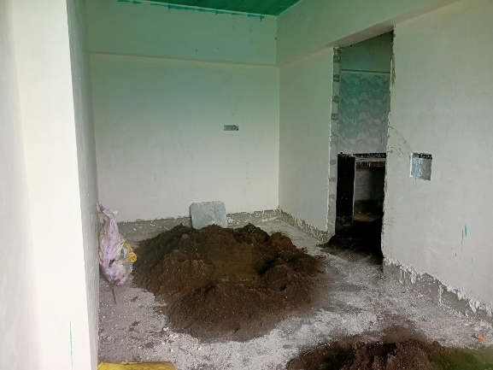
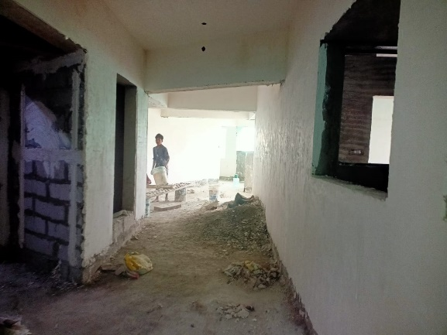
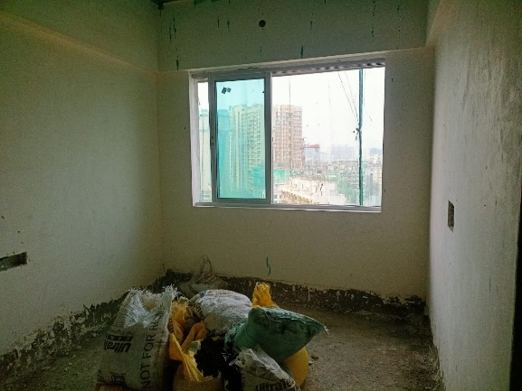
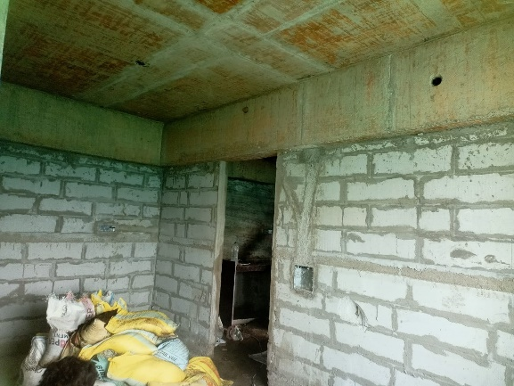
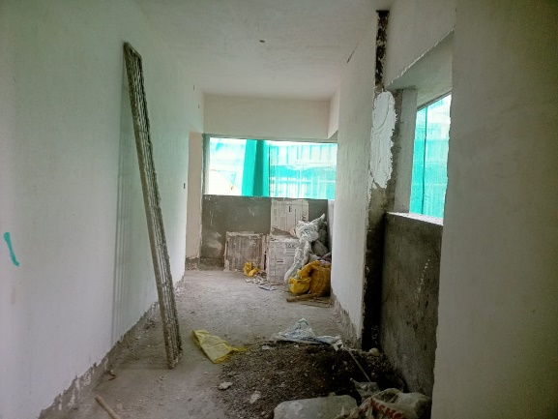
Actual Site Photographs As on 10.01.2024
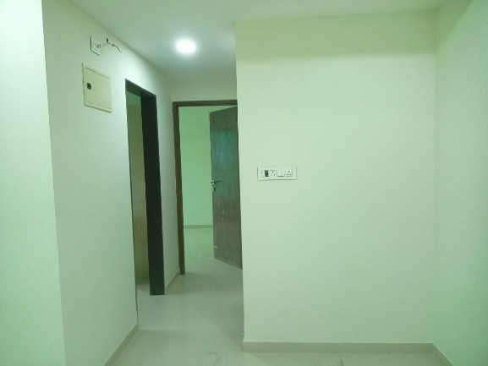
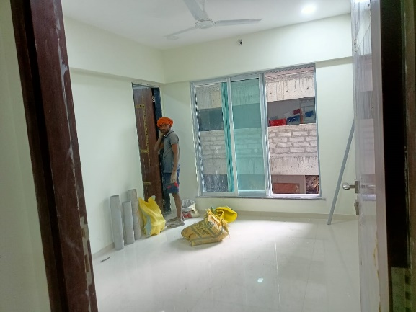
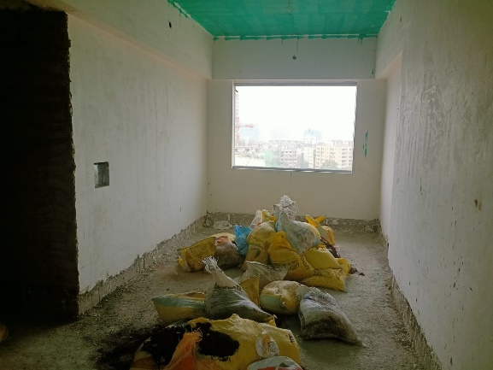
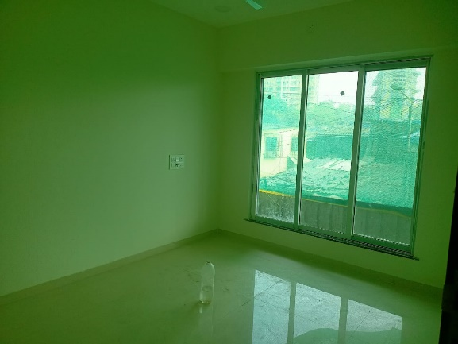
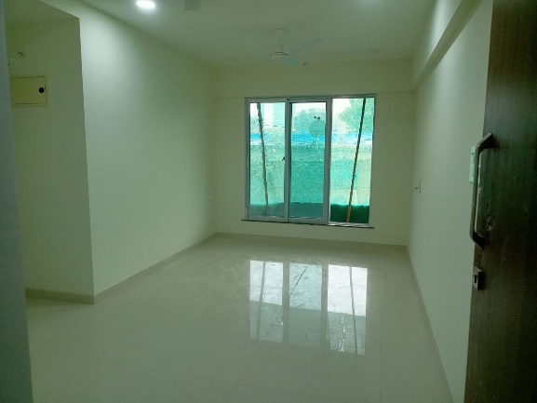
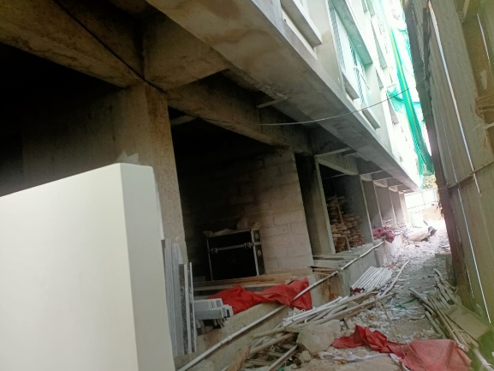
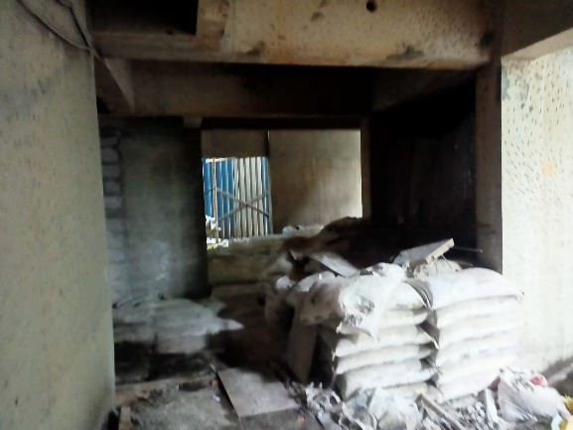
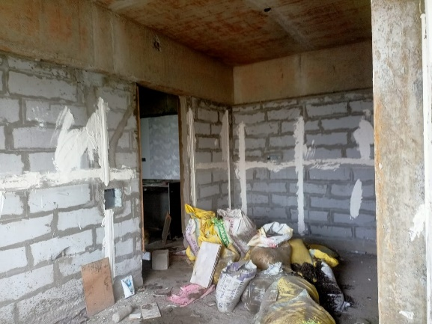
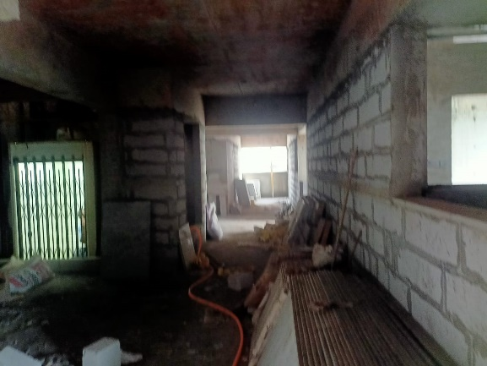
Actual Site Photographs As on 10.01.2024
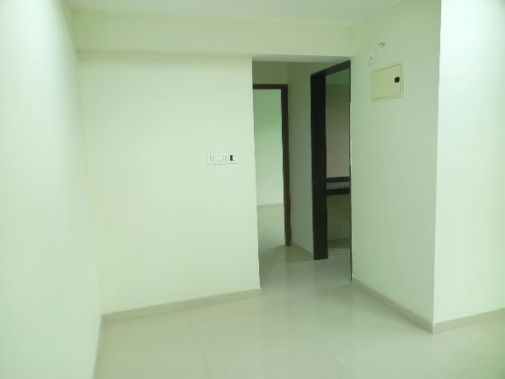
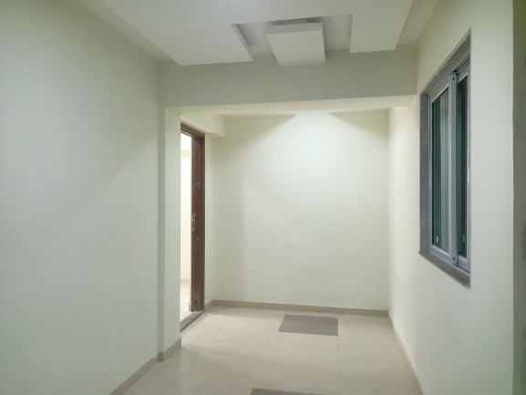
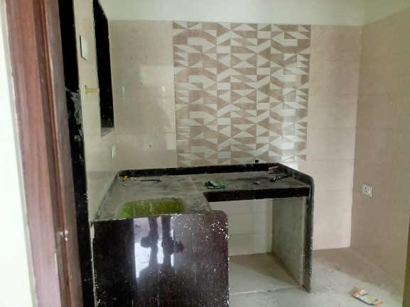
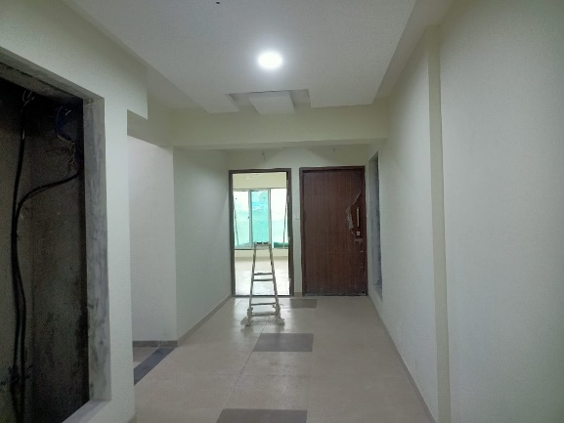
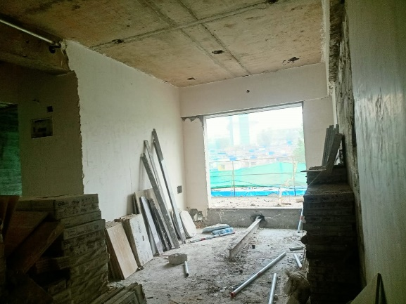
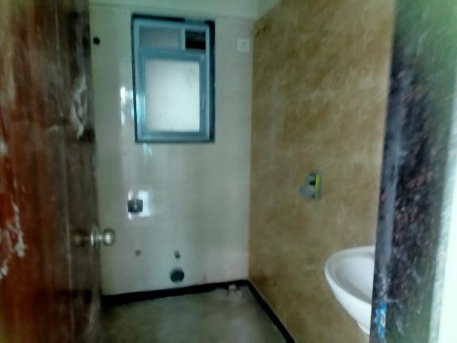
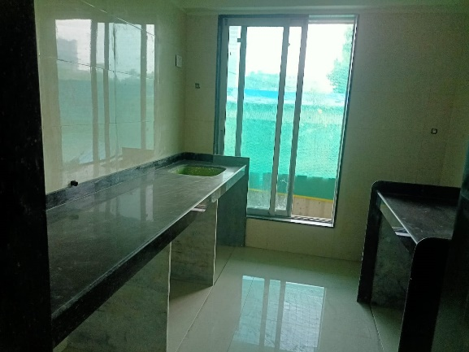
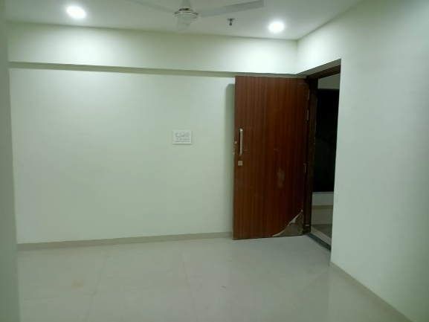
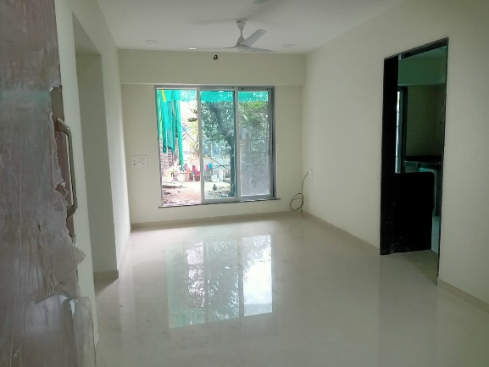
Actual Site Photographs As on 10.01.2024

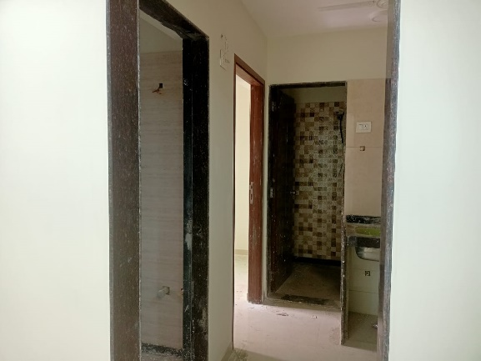
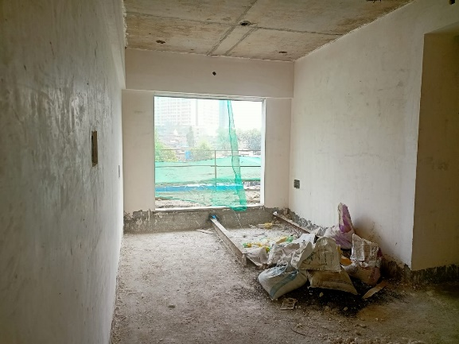
Actual Site Photographs As on 10.01.2024

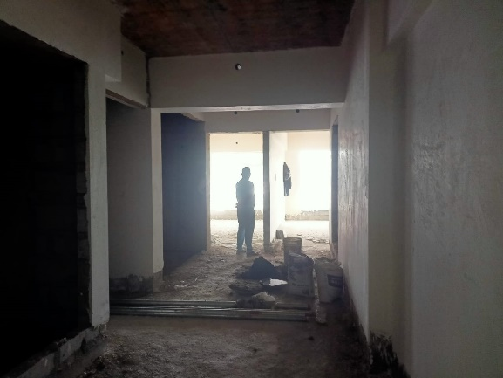
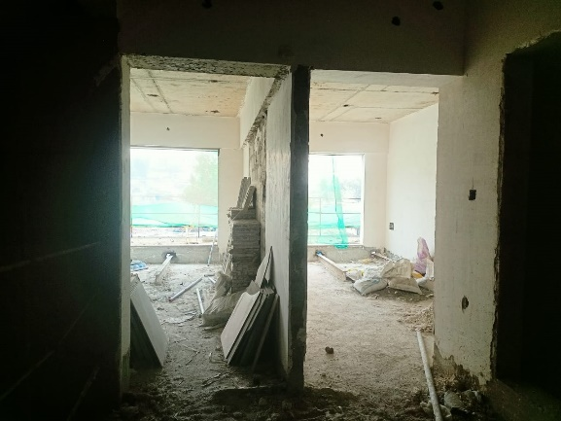
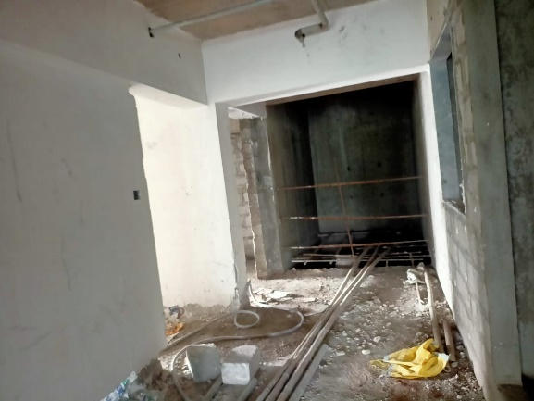
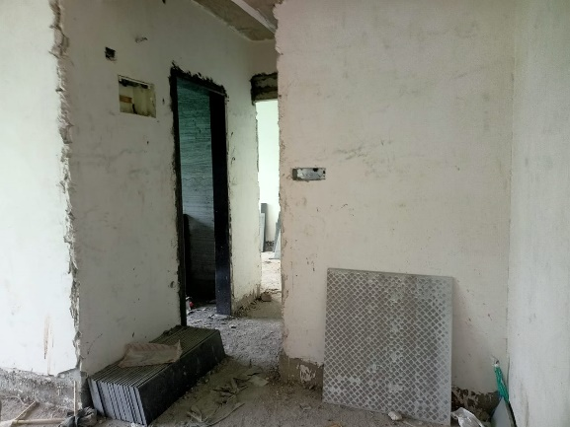
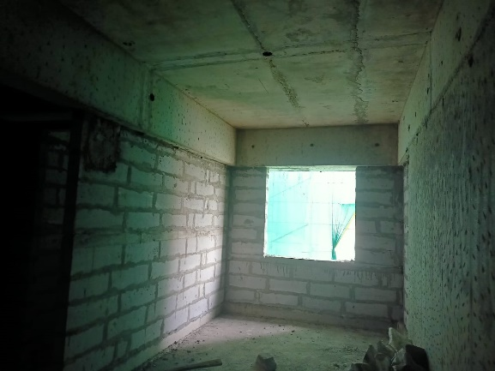
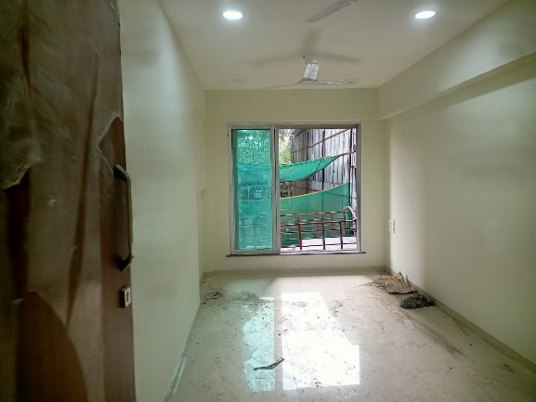
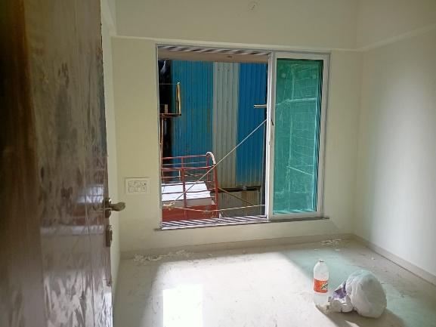
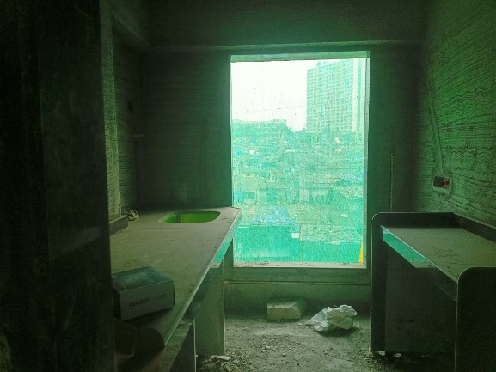
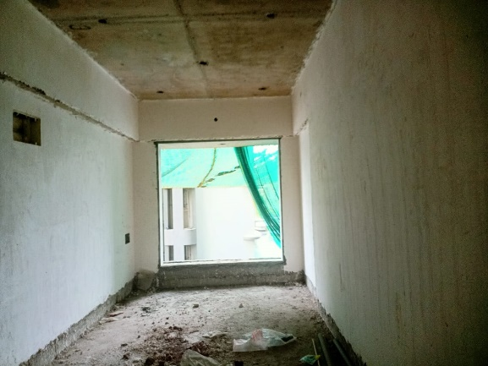
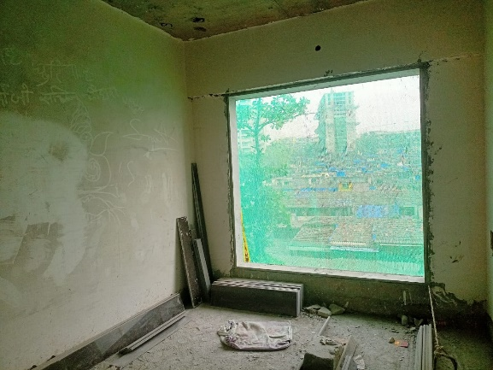
Actual Site Photographs As on 10.01.2024

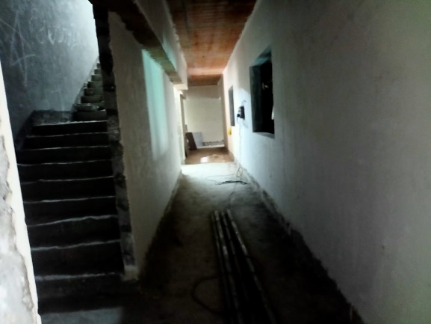
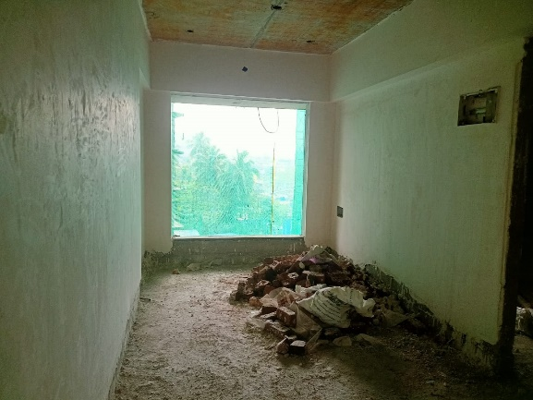
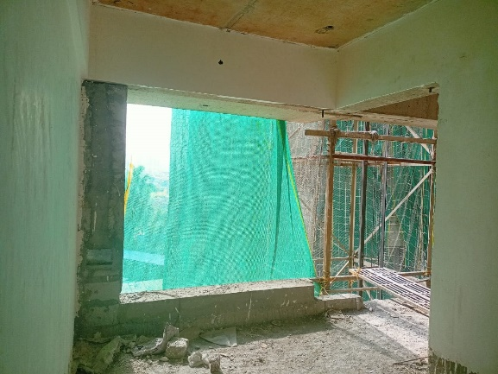
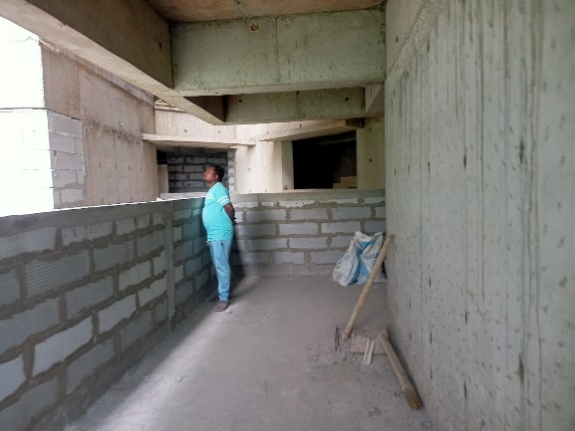
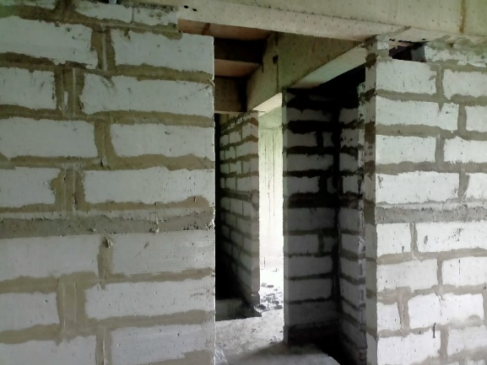
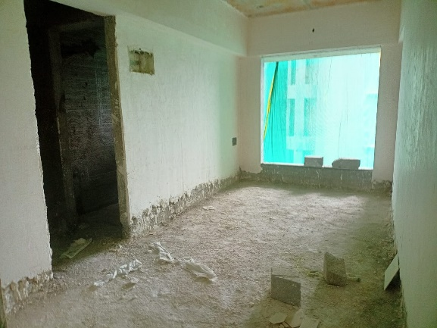
Actual Site Photographs As on 10.01.2024
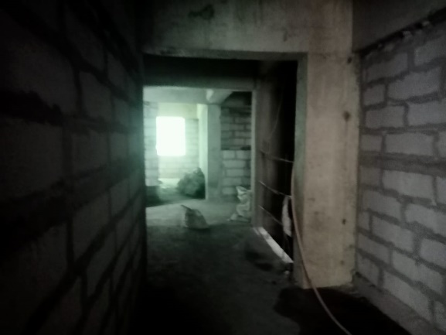
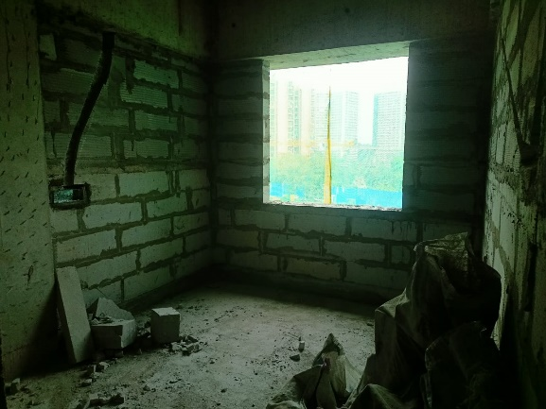
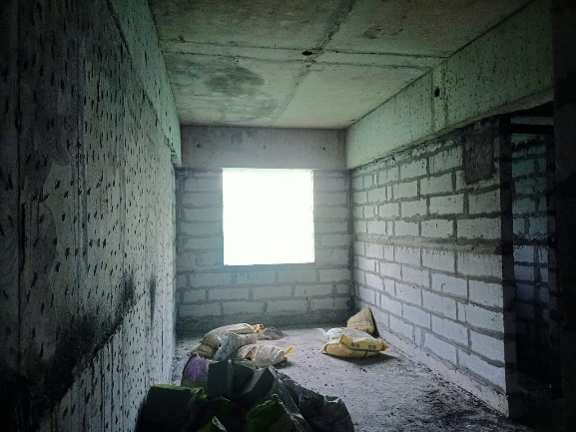
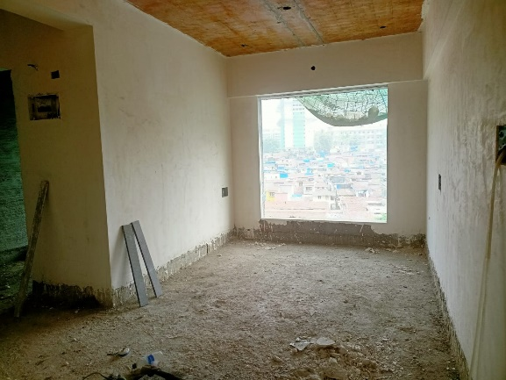
Route Map of the property
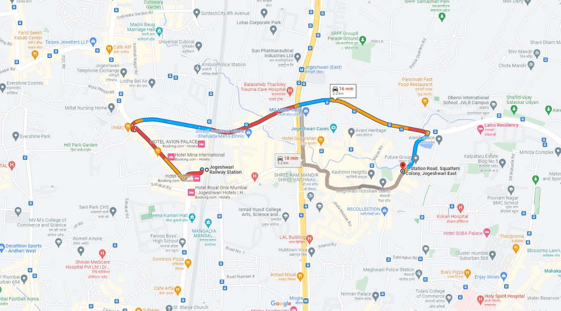
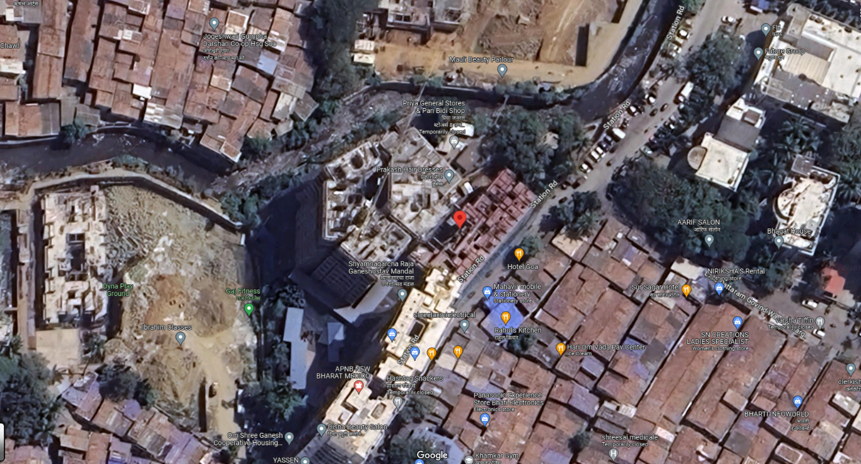
Site u/r

Latitude Longitude: 19°08'11.8"N 72°51'41.8"E

Note: The Blue line shows the route to site from nearest railway station (Jogeshwari – 3.20 Km.)
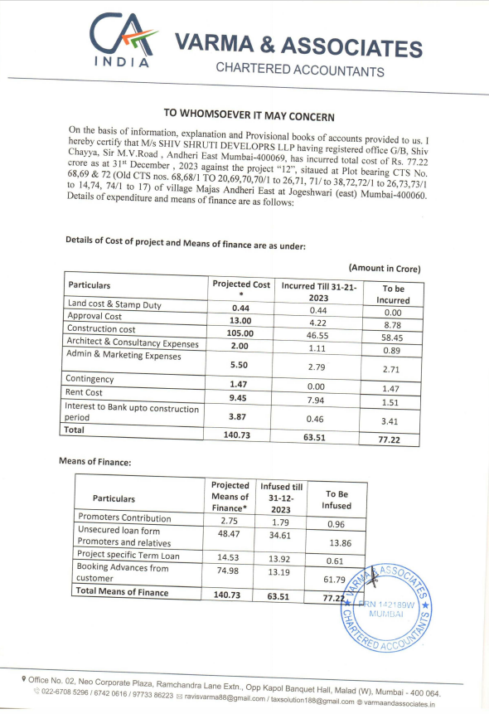
CA Certificate Dated 20.01.2024 till 31.12.2023

CA Certificate Dated 20.01.2024 till 31.12.2023
