Valuation Report of the Immovable Property
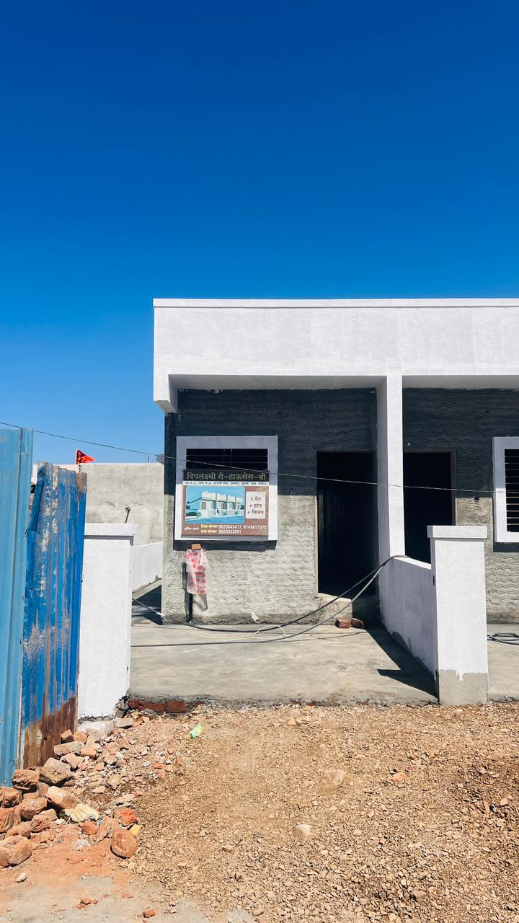

Details of the property under consideration:

Name of Proposed Purchaser: Shri.Prafulla Bharatbhushan
Prasad Kumar. &
Sau.Sugandhi Kumari

Name of Owner: Shri.Shiva Mukinda Borkar &
Shri.Sani Mukinda Borkar

Residential Land & Row House No.1, Ground Floor , " Deeplaxmi-C Row Houses " Survey No.63/2/A,
Plot No.23, Opposite Anna Bhau Sathe Play Ground , Ambedkar Nagar, Trimurti Road, Village- Chunchale ,
Tal & Dist.- Nashik, PIN Code – 422 007, State - Maharashtra, Country - India

Latitude Longitude: 19°57'19.5"N 73°43'22.6"E

Valuation Done for:

Punjab National Bank

Canada Corner Branch
Shop No.2,3,4 Prestige Point, Opp. Vasant Market, Canada Corner

Nashik – 422 005, State – Maharashtra, Country – India.

Vastu/PNB/Nashik/09/2023/3597/2302441
08/02-85-CHV
Date 28.02.2024

VALUATION OPINION REPORT

The property bearing Residential Land & Row House No.1, Ground Floor , " Deeplaxmi-C Row Houses " Survey No.63/2/A, Plot No.23, Opposite Anna Bhau Sathe Play Ground , Ambedkar Nagar, Trimurti Road, Village- Chunchale , Tal & Dist.- Nashik, PIN Code – 422 007, State - Maharashtra, Country - India belongs to Shri.Shiva Mukinda Borkar & Shri.Sani Mukinda Borkar. Name of Proposed Purchaser: Shri.Prafulla Bharatbhushan Prasad Kumar. & Sau.Sugandhi Kumari

Boundaries of the property

 | Plot | Row House
North | Plot No.26 | Marginal Space & Plot No.26
South | 30 Ft Colony Road | 9.00 Meter Colony Road
East | Plot No.24 | Row House No.2
West | Plot No.22 | Open Space

Considering various parameters recorded, existing economic scenario, and the information that is available with reference to the development of neighborhood and method selected for valuation, we are of the opinion that, the property premises can be assessed and valued for this particular purpose at ` 27,58,290/- (Rupees Twenty Seven Lakh Fifty Eight Thousand Two Hundred Ninety Only).

The valuation of the property is based on the documents produced by the concerned. Legal aspects have not been taken into consideration while preparing this valuation report.

Hence certified

Sharadkumar B. Chalikwar
Govt. Reg. Valuer
Chartered Engineer (India)
Reg. No. (N) CCIT/1-14/52/2008-09
PNB Empanelment No. ZO:SAMD:1138
Encl: Valuation report.
Vastukala Consultants (I) Pvt. Ltd.
B1-001, U/B Floor, Boomerang, Chandivali Farm Road, Powai, Andheri (East), Mumbai – 400 072

To
Branch Manager,
Punjab National Bank

Canada Corner Branch
Shop No.2,3,4 Prestige Point, Opp. Vasant Market, Canada Corner

Nashik – 422 005, State – Maharashtra, Country – India.

Valuation Report of Immovable Property

I | Introduction
1 | Name of Valuer |  |  | Vastukala Consultants (I) Pvt. Ltd.
2 | Date of Inspection |  |  | 28.02.2024
 | Date of Valuation |  |  | 28.02.2024
3 | Purpose of Valuation |  |  | As per the request from Punjab National Bank, Canada Corner Branch to assess fair market value of the property for Banking purpose
4 | Name of Property Owner/s  (Details of share of each owner  in case of joint & Co-ownership) |  |  | Name of Proposed Purchaser:  Shri.Prafulla Bharatbhushan  Prasad Kumar. &  Sau.Sugandhi Kumari  Name of Owner:  Shri.Shiva Mukinda Borkar &  Shri.Sani Mukinda Borkar  Address – Residential Land & Row House No.1, Ground Floor , " Deeplaxmi-C Row Houses " Survey No.63/2/A, Plot No.23, Opposite Anna Bhau Sathe Play Ground , Ambedkar Nagar, Trimurti Road, Village- Chunchale , Tal & Dist.- Nashik, PIN Code – 422 007, State - Maharashtra, Country - India  Contact Details  Shri.Prafulla Bharatbhushan  Prasad Kumar (Proposed Purchaser)  Contact No.+91 9599059510  (Joint Ownership)
5 | Name of Bank/FI as applicable |  |  | Punjab National Bank
6 | Name of the Developer of Property (in case of developer-built properties) |  |  | Developer
7 | Whether occupied by the owner / tenant?  If occupied by tenant, since how long? |  |  | Vacant
II | Physical Characteristics of the Asset
1 | Location of the Property |  |  | Residential Land & Row House No.1, Ground Floor , " Deeplaxmi-C Row Houses " Survey No.63/2/A, Plot No.23, Opposite Anna Bhau Sathe Play Ground , Ambedkar Nagar, Trimurti Road, Village- Chunchale , Tal & Dist.- Nashik, PIN Code – 422 007, State - Maharashtra, Country - India
1 | S No / Plot |  |  | Survey No.63/2/A, Plot No.23
1 | Door No. |  |  | Residential Land & Row House No.1
1 | C. T.S. No. / Village |  |  | Village- Chunchale
1 | Ward / Taluka |  |  | Nashik
1 | Mandal / District |  |  | Nashik
1 | Brief description of the property
1 | Property -  The property is Residential Land & Row House No.1, Ground Floor , " Deeplaxmi-C Row Houses " Survey No.63/2/A, Plot No.23, Opposite Anna Bhau Sathe Play Ground , Ambedkar Nagar, Trimurti Road, Village- Chunchale , Tal & Dist.- Nashik, PIN Code – 422 007, State - Maharashtra, Country - India. It is well connected by road and train. It is located at about 16.5 KM. travelling distance from Nashik Railway Station.  Plot Area:  As per Notarized Agreement , the land area is 84.00 Sq. M. considered for valuation.  Structures –  The composition of the Residential Row House as per site inspection is as below:  As per Notarized Agreement the Built-up area is 49.27 Sq. M. considered for valuation.
  Composition (As per site Inspection) | As per site measurement Carpet Area in Sq. M.
  Ground Floor – Living , Kitchen, W.C., Bath, Passage, Varandah | 36.50
  Floor | Area ( Sq.M )
  Ground | 49.27
  Total Built Up Area | 49.27
1 | Nearby landmark |  |  | Opposite Anna Bhau Sathe Play Ground
2. | Survey No / Plot |  |  | Survey No.63/2/A, Plot No.23
3. | Village |  |  | Village- Chunchale
 | Residential area |  |  | Yes
 | Commercial area |  |  | No
 | Industrial area |  |  | No
4. | Classification of the area
 | i) High / Middle / Poor |  |  | Middle Class
 | ii) Urban / Semi Urban / Rural |  |  | Urban
5. | Coming under Corporation limit / Village Panchayat / Municipality |  |  | Nashik Municipal Corporation
6. | Postal address of the property |  |  | Residential Land & Row House No.1, Ground Floor , " Deeplaxmi-C Row Houses " Survey No.63/2/A, Plot No.23, Opposite Anna Bhau Sathe Play Ground , Ambedkar Nagar, Trimurti Road, Village- Chunchale , Tal & Dist.- Nashik, PIN Code – 422 007, State - Maharashtra, Country - India
7. | Latitude, Longitude and Coordinates of the site |  |  | 19°02'40.2"N 72°55'01.6"E
8. | Area of the plot/land (supported by a plan) |  |  | Land Area – 84.00 Sq. M.  (As per Notarized Agreement)
9. | Layout plan of the area in which the property is located |  |  | Not Provided
10. | Development of surrounding areas |  |  | Developed
11. | Details of Roads abutting the property |  |  | Above than 20 ft. B.T. Road
12. | Whether covered under any State / Central Govt. enactments (e.g., Urban Land Ceiling Act) or notified under agency area / scheduled area / cantonment area |  |  | No
13. | In case it is an agricultural land, any conversion to house site plots is contemplated |  |  | N.A., Residential Land
14. | Boundaries of the Property Plot |  |  | As per Site |  |  |  | As per Document
14. | North |  |  | Plot No.26 |  |  |  | Plot No.26
14. | South |  |  | 30 Ft Colony Road |  |  |  | 30 Ft Colony Road
14. | East |  |  | Plot No.24 |  |  |  | Plot No.24
14. | West |  |  | Plot No.22 |  |  |  | Plot No.22
14A | Boundaries of the Property Row House
 | North |  |  | Marginal Space & Plot No.26 |  |  |  | Marginal Space & Plot No.26
 | South |  |  | 9.00 Meter Colony Road |  |  |  | 9.00 Meter Colony Road
 | East |  |  | Row House No.2 |  |  |  | Row House No.2
 | West |  |  | Open Space |  |  |  | Open Space
 | Extent of the site considered for valuation (least of 14 A & 14 B) |  |  | Land Area – 84.00 Sq. M.  (As per Notarized Agreement)  Built up area – 49.27 Sq.M  (As per Notarized Agreement)
15. | Description of Adjoining properties |  |  | Residential properties
 | North
 | South
 | East
 | West
16. | Survey no. if any |  |  | -
17 | Type of Row House (Residential/ Commercial/ Industrial) |  |  | Residential
18. | Details of the Row House/Row Houses and other improvements in terms of area, height, no. of floors, plinth area floor wise, year of construction, year of making alterations/additional constructions with details, full details of specifications to be appended along with Row House plans and elevations |  |  | Built up area – 49.27 Sq.M  (As per Notarized Agreement))  Year of Construction – 2024  (As per Full occupancy certificate)
19. | Plinth Area, and saleable are to be mentioned separately and clarified |  |  | Land Area – 84.00 Sq. M.  (As per Notarized Agreement)
20. | Any other aspect |  |  | -
III | Town Planning parameters
1. | Master plan provisions related to the property in terms of land use |  |  | Residential use
2. | Date of issue and validity of layout of approved map / plan |  |  | Copy of Digitally Singed Approved Building Plan dated 23.10.2023, issued by Executive Engineer Town Planning Nashik Municipal Corporation  Nashik Municipal Corporation
3. | Approved map / plan issuing authority
4. | Whether genuineness or authenticity of approved map / plan is verified |  |  | Yes
5. | Any other comments by our empaneled valuers on authentic of approved plan |  |  | No
6. | Planning area/zone |  |  | Residential Zone
7. | Development controls |  |  | Nashik Municipal Corporation
8. | Zoning regulations |  |  | Residential Purpose
9. | FAR/FSI permitted and consumed |  |  | As per NMC Norms
10. | Ground coverage |  |  | -
11. | Transferability of development rights if any, Row House bye- law provisions as applicable to the property viz. setbacks, height restrictions, etc. |  |  | No information provided.
12. | Comment on surrounding land uses and adjoining properties in terms of usage. |  |  | Residential
13. | Comment on unauthorized constructions if any |  |  | No
14. | Comment on demolition proceedings if any |  |  | No
15. | Comment on compounding/ regularization proceedings |  |  | No
16. | Comment on whether OC has been issued or not |  |  | Copy of Full Occupancy Certificate Building Proposal Number-217963 dated 13.02.2024 issued by Nashik Municipal Corporation
17. | Any other aspect |  |  | -
IV. | Legal Aspects
1. | Ownership Documents
 | - Copy of Notarized Agreement between Shri.Shiva Mukinda Borkar & Shri.Sani Mukinda Borkar (the Seller) and Shri.Prafulla Bharatbhushan Prasad Kumar. & Sau.Sugandhi Kumari (Proposed Purchaser)
 | - Copy of Commencement Certificate Permit No.NMCB/B/2023/APL/10247 dated 23.10.2023 issued by Nashik Municipal Corporation
 | - Copy of Digitally Singed Approved Building Plan dated 23.10.2023, issued by Executive Engineer Town Planning Nashik Municipal Corporation
 | - Copy of Full Occupancy Certificate Building Proposal Number-217963 dated 13.02.2024 issued by Nashik Municipal Corporation.
2. | TIR Verification |  |  | Not Applicable
3. | Name of the Owner/s |  |  | Name of Proposed Purchaser:  Shri.Prafulla Bharatbhushan  Prasad Kumar. &  Sau.Sugandhi Kumari  Name of Owner:  Shri.Shiva Mukinda Borkar &  Shri.Sani Mukinda Borkar
4. | Comment on dispute/issues of landlord with tenant/statutory body/any other agencies, if any regarding immovable property. |  |  | Information not available
5. | Comment on whether the IP is independently accessible? |  |  | Yes.
6. | Title verification, |  |  | Not Applicable
7. | Details of leases if any, |  |  | Not Applicable
8. | Ordinary status of freehold or leasehold including restrictions on transfer |  |  | Not Applicable
9. | Agreement of easement if any |  |  | Not Applicable
10. | Notification of acquisition if any |  |  | Not Applicable
11. | Notification of road widening if any |  |  | Not Applicable
12. | Possibility of frequent flooding / sub-merging |  |  | No
13. | Special remarks, if any, like threat of acquisition of land for public service purposes, road widening or applicability of CRZ provisions etc. (Distance from sea-coast / tidal level must be incorporated) |  |  | No
14. | Heritage restrictions if any, all legal documents, receipts related to electricity, water tax, property tax and any other Row House taxes to be verified and copies as applicable to be enclosed with the report. |  |  | No
15. | Comment on transferability of the property ownership |  |  | Not Applicable
16. | Comment on existing mortgages / charges / encumbrances on the property, if any |  |  | Not Applicable
17. | Comment on whether the owners of the property have issued any guarantee (personal or corporate) as the case may be |  |  | Not Applicable
18. | Row House plan sanction: Authority approving the plan - Name of the office of the Authority - Any violation from the approved Row House Plan |  |  | Not Applicable
 | Any other aspect |  |  | -
V. | Economic Aspects
1. | Details of ground rent payable, |  |  | N.A.
2. | Details of monthly rents being received if any, |  |  | Vacant
3. | Taxes and other outings |  |  | Details not provided
4. | Property Insurance |  |  | Details not provided
5. | Monthly maintenance charges |  |  | Self - Maintained
6. | Security charges |  |  | Details not provided
7. | Any other aspect |  |  | Nil
VI. | Socio-cultural Aspects of the Property
a) | Descriptive account of the location of the property in terms of social structure of the area, population, social stratification, regional origin, economic level, location of slums, squatter settlements nearby, etc. |  |  | Developed Residential area, Middle Class
VII. | Functional and Utilitarian Aspects of the Property
1. | Description of the functionality and utility of the property in terms of:
2. | Space allocation |  |  | Provided
3. | Storage Spaces |  |  | Provided
4. | Utility spaces provided within the Row House |  |  | Provided
5. | Any other aspect |  |  | Nil
VIII. | Infrastructure Availability
1. | Description of physical infrastructure availability in terms of
1. | Water supply |  |  | Yes
1. | Sewerage / sanitation System |  |  | Yes
1. | Storm water drainage |  |  | Yes
2. | Description of other physical infrastructure facilities viz.
 | Solid waste management |  |  | No
 | Electricity |  |  | Yes
 | Road and public transport connectivity |  |  | Connected with public transport like Auto, bus, private vehicles, etc.
 | Availability of other public utilities nearby |  |  | All available nearby
3. | Social infrastructure in terms of  - School  - Medical facilities  - Recreational facility in terms of parks and open space |  |  | All available nearby
IX. | Marketability
1. | Analysis of the property in terms of |  |  | Location, development of surrounding area, type of construction, construction specifications, age of Row House, condition of the premises & Row House, facilities provided and its prevailing market rate.
2. | Locational attributes |  |  | Residential Area
3. | Scarcity |  |  | Average
 | Demand and supply of the kind of subject property |  |  | Average
4. | Comparable sale prices in the locality |  |  | Price Indicators attached
X. | Engineering and Technology Aspects of the Property
1. | Type of construction |  |  | As per Brief Description
2. | Material & technology used |  |  | B Grade
3. | Specifications |  |  | Standard
4. | Maintenance issues |  |  | No
5. | Age of the Row House |  |  | New Construction
6. | Total life of the Row House |  |  | 60 years
7. | Extent of deterioration |  |  | 60 years Subject to proper, preventive periodic Maintenance & structural repairs.
8. | Structural safety |  |  | Good
9. | Protection against natural disaster viz. earthquakes, |  |  | Good
10. | Visible damage in the Row House |  |  | Nil
11. | System of air-conditioning |  |  | No
12. | Provision for firefighting, |  |  | Not Provided
13. | Copies of the plan and elevation of the Row House to be included |  |  | Not Provided
XI. | Environmental Factors
1. | Use of environment friendly Row House materials, Green Row House techniques if any |  |  | No
2. | Provision of rain water harvesting |  |  | Information not available
3. | Use of solar heating and lighting systems, etc. Presence of environmental pollution in the vicinity of the property in terms of industries, heavy traffic, etc. |  |  | No
XII. | Architectural and aesthetic quality of the Property
1. | Descriptive account on whether the Row House is modern, old fashioned, plain looking or decorative, heritage value, presence of landscape elements etc. |  |  | Row House is modern
XIII. | In case of valuation of industrial property
1. | Proximity to residential areas |  |  | Nearby
2. | Availability of public transport facilities |  |  | All public transport facilities are available.
XIV. | Valuation
 | Methodology of valuation – Procedures adopted for arriving at the valuation. Valuers may consider various approaches and state explicitly the reason for adopting particular approach and assumptions made, basis adopted with supporting data, comparable sales, and reconciliation of various factors on which final value judgment is arrived at. |  |  | Land and Row House Method is used for this valuation report.
 | Prevailing Market Rate/Price trend of the Property in the locality/city from property search sites viz. magickbricks.com, 99acres.com, makaan.com etc. if available |  |  | ` 15,000/- to ` 21,000/- per Sq. M. Considering the rate with attached report, current market conditions, demand and supply position, Residential land size, Row House area, location, upswing in real estate prices, sustained demand for residential land, all round development of industrial application in the locality etc. We estimate ` 17,000/- per Sq. M. for land including land development.
 | Guideline Rate |  |  | ` 3,400/- per Sq. M.
 | Land |  |  | ` 17,000/- per Sq. M.
 | Row House |  |  | As per valuation table
 | Summary of Valuation
 | - Guideline Value |  |  | Area in Sq. M. |  | Rate in ` |  |  | Value in `
 | Land |  |  | 84.00 |  | ` 3,400/- |  |  | 2,85,600/-
 | Row House |  |  | As per below chart |  |  |  |  | 13,30,290/-
 | Total |  |  |  |  |  |  |  | 16,15,890/-
 | - Fair Market Value
 | A) Land |  |  | Area in Sq. M. |  | Rate in ` |  |  | Fair Market Value in `
 |  |  |  | 84.00 |  | 17,000/- |  |  | 14,28,000/-
 | B) Row House
 | Particulars | Built up Area | Estimated  replacement rate |  | Replacement rate |  | Replacement  value |  |  | Full Value / Insurable Value
 |  | (Sq. M.) | (`) |  | (`) |  | (`) |  |  | (`)
 | Row House | 49.27 | 27,000.00 |  | 27,000.00 |  | 13,30,290/- |  |  | 13,30,290/-
 | Total |  |  |  |  |  | 13,30,290/- |  |  | 13,30,290/-
 | Total Value = A + B |  |  |  |  |  | 27,58,290.00
 | Remarks:

As a result of my appraisal and analysis, it is my considered opinion that the present market value of the above property in prevailing condition with aforesaid specifications is ` 27,58,290/- (Rupees Twenty Seven Lakh Fifty Eight Thousand Two Hundred Ninety Only).

- Date of purchase of immovable property | : | ---
- Purchase Price of immovable property | : | ` 23,00,000/-
- Book value of immovable property | : | ` 23,00,000/-
- Fair Market Value of immovable property (A + B) | : | ` 27,58,290/-
- Cost of Extra Amenities |  | ---
- Total Value |  | ` 27,58,290/-
- Realizable Value of immovable property | : | ` 26,20,376/-
- Distress Sale Value of immovable property | : | ` 22,06,632/-
- Insurable Value of immovable property | : | ` 11,30,746/-
- Guideline Value | : | ` 16,15,890/-

15. Enclosures
a) | Layout plan sketch of the area in which the property is located with latitude and longitude | Latitude and longitude provided along with satellite image of the Row House
b) | Row House Plan | Provided
c) | Floor Plan | Provided
d) | Site Photograph of the property | Site photographs of the property is provided
e) | Certified copy of the approved / sanctioned plan wherever applicable from the concerned office | Provided
f) | Google Map location of the property | Provided
g) | Price trend of the Property in the locality/city from property search sites viz Magickbricks.com, 99Acres.com, Makan.com etc. | Available and attached in annexure
h) | Any other relevant documents/ extracts | No
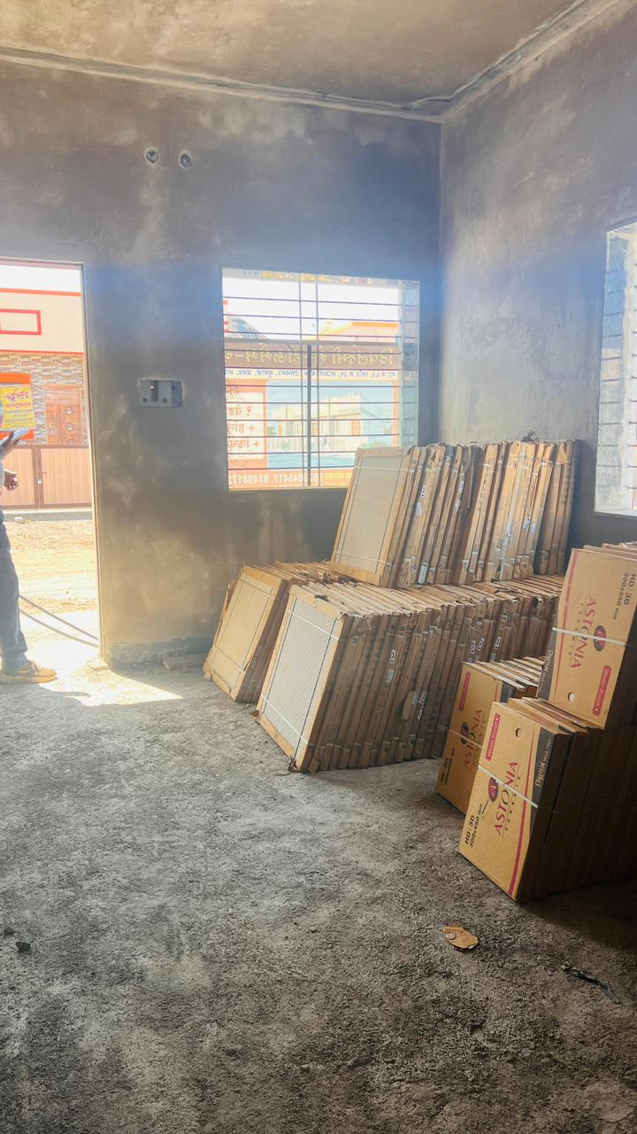
Actual Site Photographs
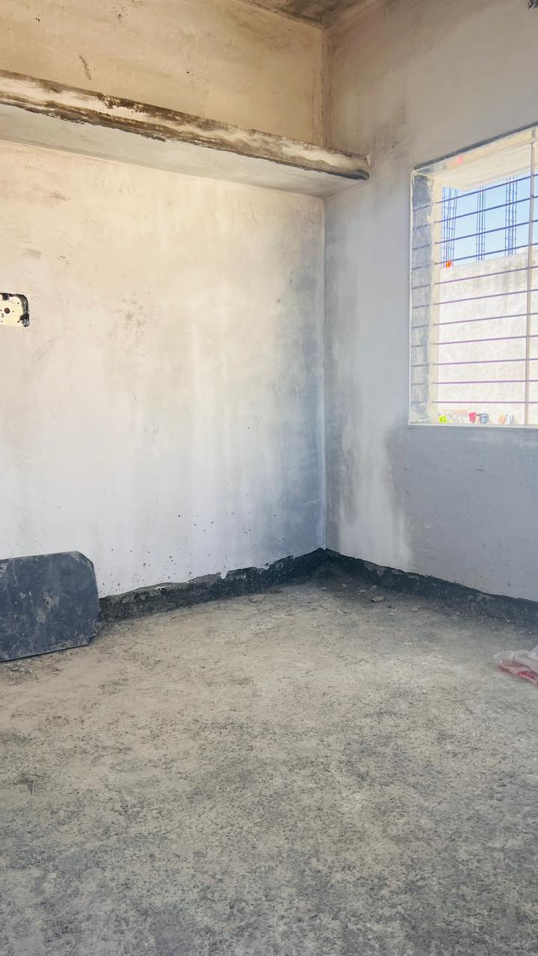
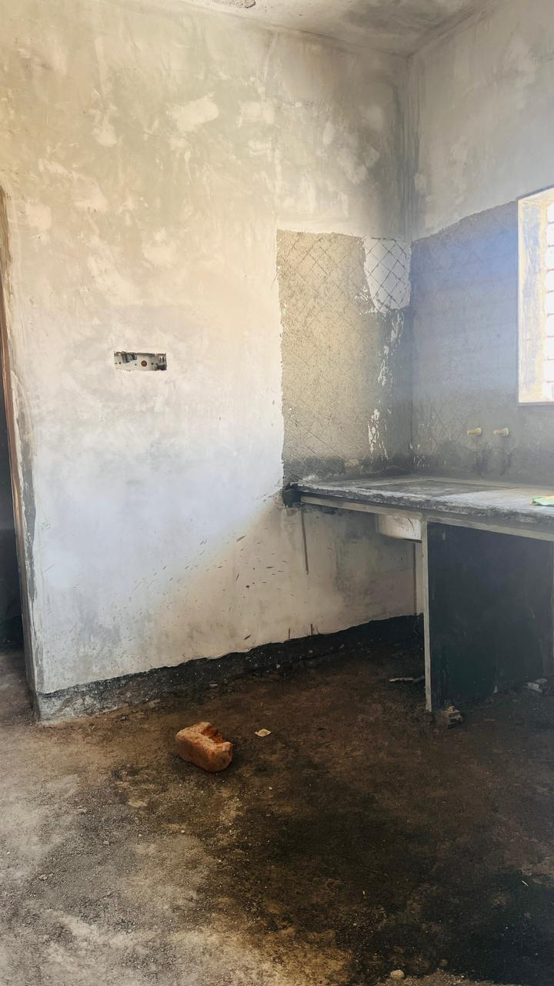

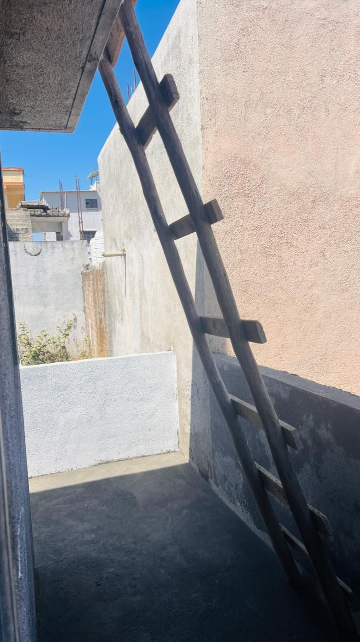
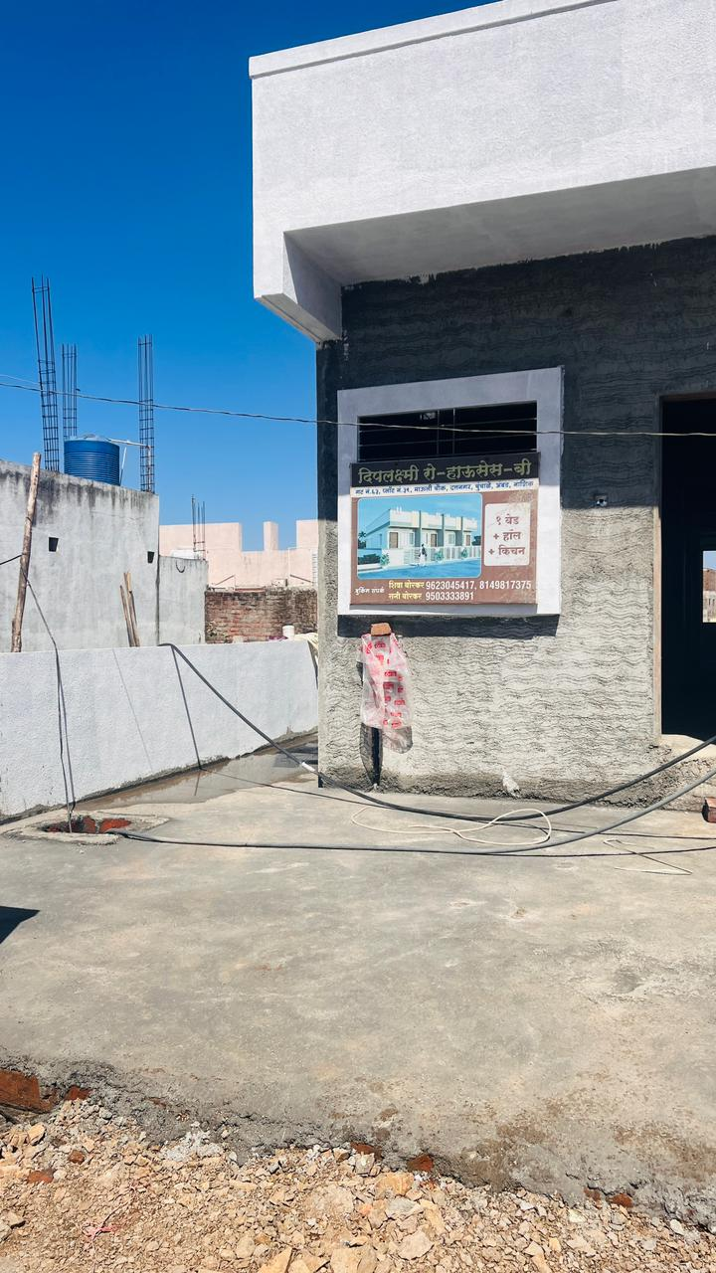
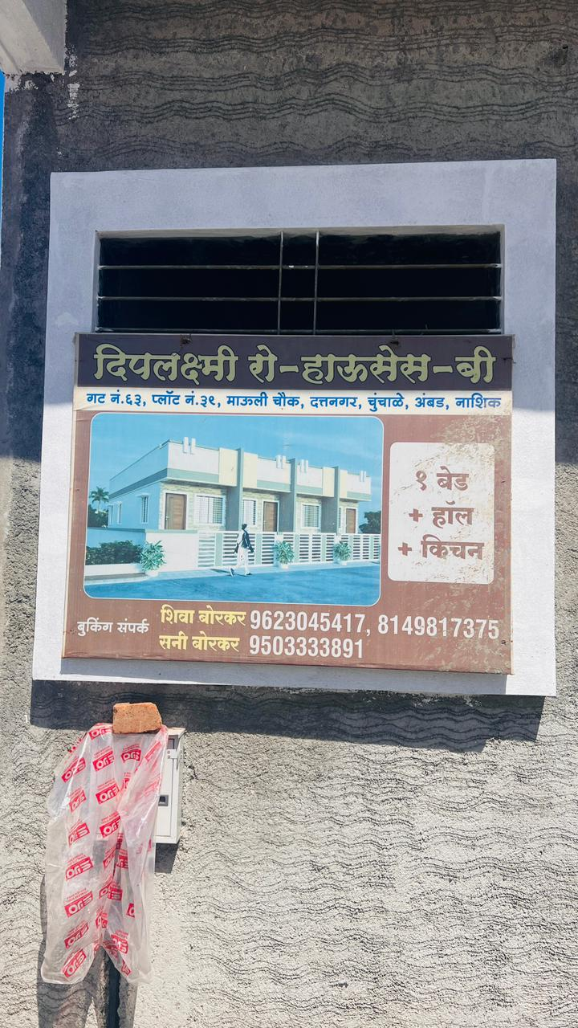

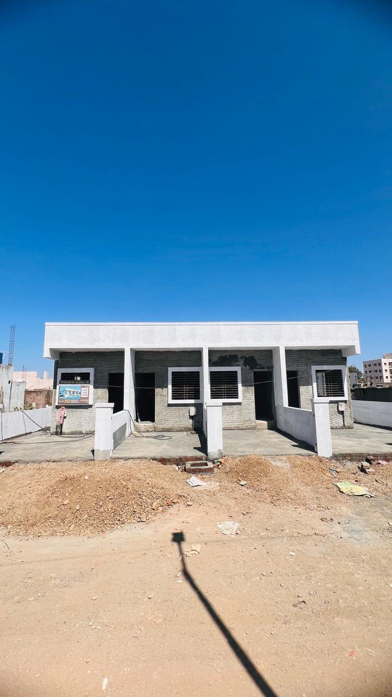


Route Map of the property
Site u/r
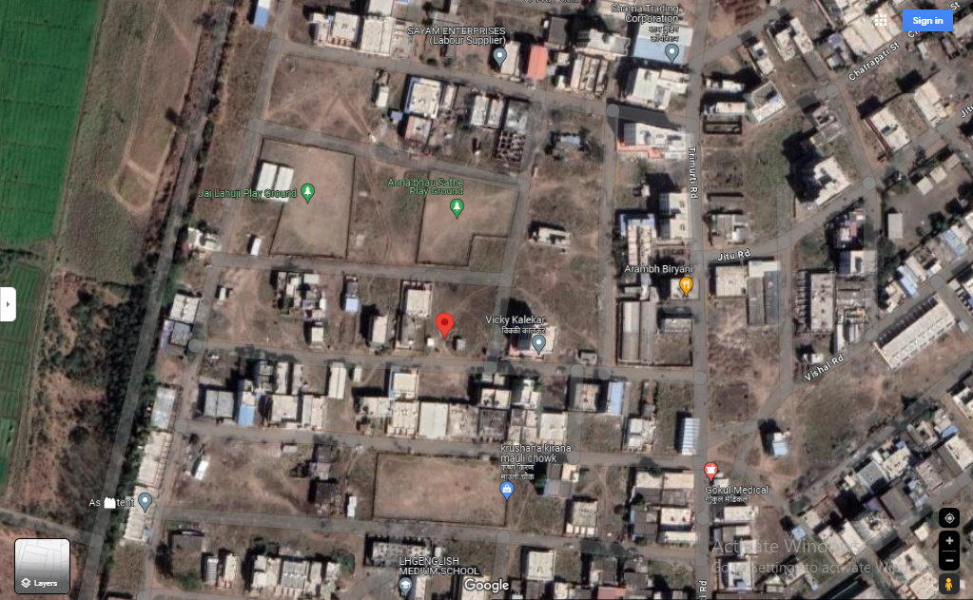

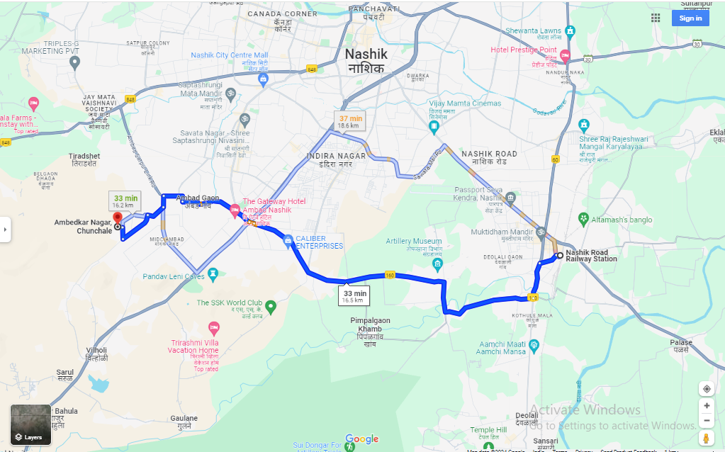

Latitude Longitude: 19°57'19.5"N 73°43'22.6"E
Note: The Blue line shows the route to site from nearest railway station ( Nashik– 16.5 KM

Ready Reckoner Rate
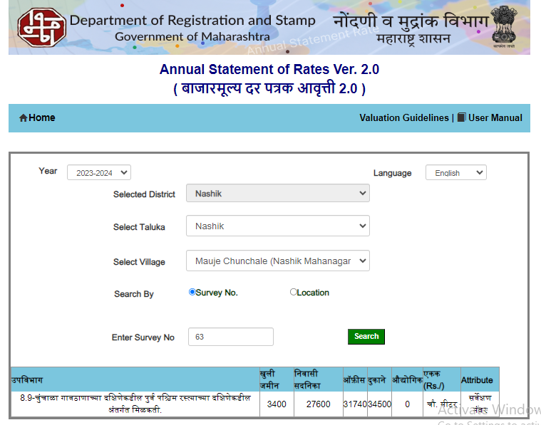

Price Indicators
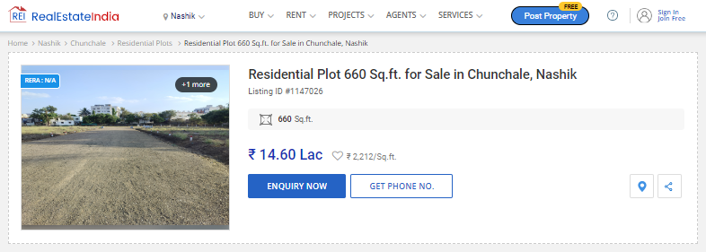

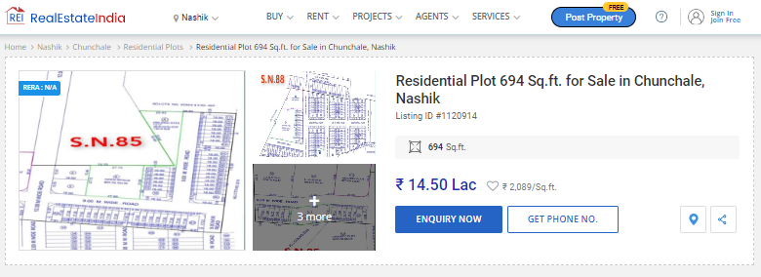

Notarized Agreement
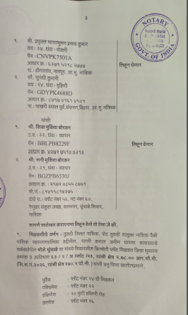
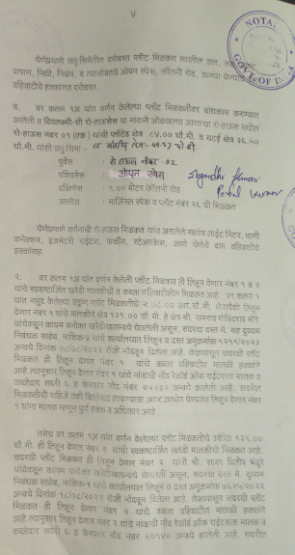

Commencement Certificate & Full Occupancy Certificate
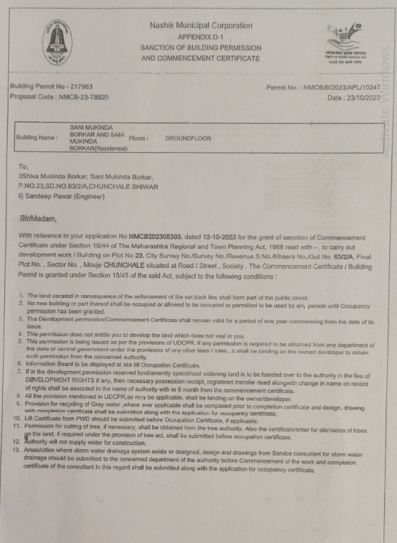
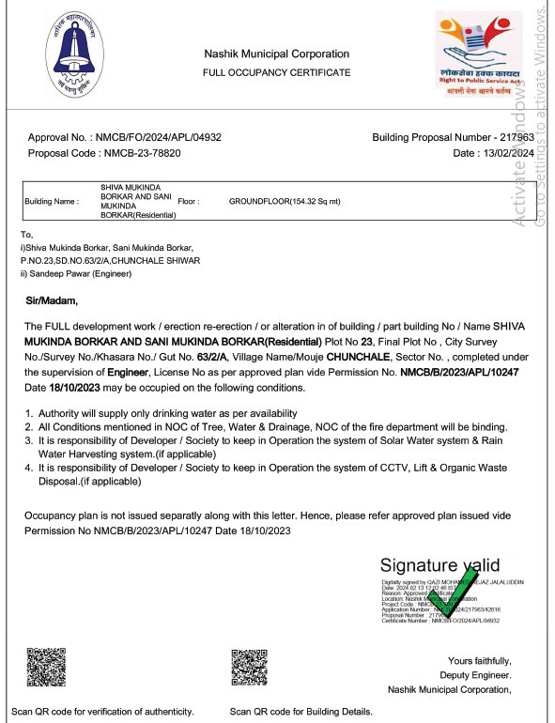

Building Plan
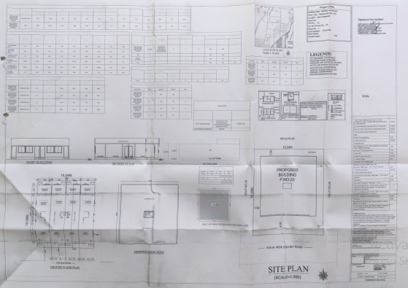

Justification for price /rate

The Market Value of the property is based on facts of markets discovered by us during our enquiries, however the government rate value in this case is less than the market value arrived by us. We are of the opinion that the value arrive by us will prove to be correct if an Auction of the subject property is carried out. As far as Market Value in Index II is concerned, it is not possible to comment on same, may be government rates are fixed by sampling during same point of time in part and whereas, Market values change every month.
In most of the cases the actual deal amount or Transaction value is not reflected in Index II because of various Market practices. As Valuer, we always try to give a value which is correct reflection of actual transaction value irrespective of any factors in market.
APPENDIX IV

DECLARATION FROM VALUERS

I hereby declare that-

- The information furnished in my valuation report dated 28.02.2024 is true and correct to the best of my knowledge and belief and I have made an impartial and true valuation of the property.

- I have no direct or indirect interest in the property valued;

- I/ my authorized representative has personally visited the property on 28.02.2024. The work is not sub- contracted to any other valuer and carried out by myself.

- I have not been convicted of any offence and sentenced to a term of Imprisonment;

- I have not been found guilty of misconduct in my professional capacity.

- I have read the Handbook on Policy, Standards and procedure for Real Estate Valuation, 2011 of the IBA and this report is in conformity to the "Standards" as enshrined for valuation in the Part - B of the above handbook to the best of my ability.

- I have read the International Valuation Standards (IVS) and the report submitted to the Bank for the respective asset class is in conformity to the "Standards" as enshrined for valuation in the IVS in "General Standards" and "Asset Standards" as applicable. The valuation report is submitted in the prescribed format of the bank.

- I abide by the Model Code of Conduct for empanelment of valuer in the Bank. (Annexure III - A signed copy of same to be taken and kept along with this declaration)

- I am registered under Section 34 AB of the Wealth Tax Act, 1957.

- I am the proprietor / partner / authorized official of the firm / company, who is competent to sign this valuation report.

- Further, I hereby provide the following information.

Sr. No. | Particulars | Valuer comment
 | Background information of the asset being valued; | The property under consideration is purchased by Shri.Prafulla Bharatbhushan Prasad Kumar. &Sau.Sugandhi Kumari from Shri.Shiva Mukinda Borkar & Shri.Sani Mukinda Borkar as per Vide Notarized Agreement
 | Purpose of valuation and appointing authority | As per the request from Punjab National Bank, Canada Corner Branch, to assess fair market value of the property for Banking purpose
 | Identity of the valuer and any other experts involved in the valuation; | Sharad B. Chalikwar – Regd. Valuer  Sanjay Phadol- Regional Technical Manager  Swapnil Wagh- Site Engineer  Binu Surendran – Technical Manager  Chintamani Chaudhari – Technical Officer
 | Disclosure of valuer interest or conflict, if any; | We have no interest, either direct or indirect, in the property valued. Further to state that we do not have relation or any connection with property owner / applicant directly or indirectly. Further to state that we are an independent Valuer and in no way related to property owner / applicant
 | Date of appointment, valuation date and date of report; | Date of Appointment – 28.02.2024  Valuation Date – 28.02.2024  Date of Report – 28.02.2024
 | Inspections and/or investigations undertaken; | Physical Inspection done on date 28.02.2024
 | Nature and sources of the information used or relied upon; | - Market Survey at the time of site visit  - Ready Reckoner rates / Circle rates  - Online search for Registered Transactions  - Online Price Indicators on real estate portals  - Enquiries with Real estate consultants  - Existing data of Valuation assignments carried out by us
 | Procedures adopted in carrying out the valuation and valuation standards followed; | Cost Approach (For Row House construction)  Comparative Sales Method / Market Approach (For Land component)
 | Restrictions on use of the report, if any; | This valuation is for the use of the party to whom it is addressed and for no other purpose. No responsibility is accepted to any third party who may use or rely on the whole or any part of this valuation. The valuer has no pecuniary interest that would conflict with the proper valuation of the property.
 | Major factors that were taken into account during the valuation; | current market conditions, demand and supply position, Residential land and Row House size, location, upswing in real estate prices, sustained demand for Residential land and Row House, all round development of residential application in the locality etc.
 | Caveats, limitations and disclaimers to the extent they explain or elucidate the limitations faced by valuer, which shall not be for the purpose of limiting his responsibility for the valuation report. | Attached

APPENDIX V

MODEL CODE OF CONDUCT FOR VALUERS

{Adopted in line with Companies (Registered Valuers and Valuation Rules, 2017)}
All valuers empanelled with bank shall strictly adhere to the following code of conduct:

Integrity and Fairness
- A valuer shall, in the conduct of his/its business, follow high standards of integrity and fairness in all his/its dealings with his/its clients and other valuers.
- A valuer shall maintain integrity by being honest, straightforward, and forthright in all professional relationships.
- A valuer shall endeavour to ensure that he/it provides true and adequate information and shall not misrepresent any facts or situations.
- A valuer shall refrain from being involved in any action that would bring disrepute to the profession.
- A valuer shall keep public interest foremost while delivering his services.
Professional Competence and Due Care
- A valuer shall render at all times high standards of service, exercise due diligence, ensure proper care and exercise independent professional judgment.
- A valuer shall carry out professional services in accordance with the relevant technical and professional standards that may be specified from time to time.
- A valuer shall continuously maintain professional knowledge and skill to provide competent professional service based on up-to-date developments in practice, prevailing regulations / guidelines and techniques.
- In the preparation of a valuation report, the valuer shall not disclaim liability for his/its expertise or deny his/its duty of care, except to the extent that the assumptions are based on statements of fact provided by the company or its auditors or consultants or information available in public domain and not generated by the valuer.
- A valuer shall not carry out any instruction of the client insofar as they are in compatible with the requirements of integrity, objectivity and independence.
- A valuer shall clearly state to his client the services that he would be competent to provide and the services for which he would be relying on other valuers or professionals or for which the client can have a separate arrangement with other valuers.
Independence and Disclosure of Interest
- A valuer shall act with objectivity in his/its professional dealings by ensuring that his/its decisions are made without the presence of any bias, conflict of interest, coercion, or undue influence of any party, whether directly connected to the valuation assignment or not.
- A valuer shall not take up an assignment if he/it or any of his/its relatives or associates is not independent in terms of association to the company.
- A valuer shall maintain complete independence in his/its professional relationships and shall conduct the valuation independent of external influences.
- A valuer shall wherever necessary disclose to the clients, possible sources of conflicts of duties and interests, while providing unbiased services.
- A valuer shall not deal in securities of any subject company after any time when he/it first becomes aware of the possibility of his / its association with the valuation, and in accordance with the Securities and Exchange Board of India (Prohibition of Insider Trading)Regulations,2015 or till the time the valuation report becomes public, whichever is earlier.
- A valuer shall not indulge in "mandate snatching" or offering "convenience valuations" in order to cater to a company or client's needs.
- As an independent valuer, the valuer shall not charge success fee (Success fees may be defined as a compensation / incentive paid to any third party for successful closure of transaction. In this case, approval of credit proposals).
- In any fairness opinion or independent expert opinion submitted by a valuer, if there has been a prior engagement in an unconnected transaction, the valuer shall declare the association with the company during the last five years.
Confidentiality
- A valuer shall not use or divulge to other clients or any other party any confidential information about the subject company, which has come to his / its knowledge without proper and specific authority or unless there is a legal or professional right or duty to disclose.
Information Management
- A valuer shall ensure that he/ it maintains written contemporaneous records for any decision taken, the reasons for taking the decision, and the information and evidence in support of such decision. This shall be maintained so as to sufficiently enable a reasonable person to take a view on the appropriateness of his /its decisions and actions.
- A valuer shall appear, co-operate and be available for inspections and investigations carried out by the authority, any person authorised by the authority, the registered valuers organisation with which he/it is registered or any other statutory regulatory body.
- A valuer shall provide all information and records as may be required by the authority, the Tribunal, Appellate Tribunal, the registered valuers organisation with which he/it is registered, or any other statutory regulatory body.
- A valuer while respecting the confidentiality of information acquired during the course of performing professional services, shall maintain proper working papers for a period of three years or such longer period as required in its contract for a specific valuation, for production before a regulatory authority or for a peer review. In the event of a pending case before the Tribunal or Appellate Tribunal, the record shall be maintained till the disposal of the case.
Gifts and hospitality:
- A valuer or his / its relative shall not accept gifts or hospitality which undermines or affects his independence as a valuer.
Explanation, - For the purposes of this code the term 'relative' shall have the same meaning as defined in clause (77) of Section 2 of the Companies Act, 2013 (18 of 2013).
- A valuer shall not offer gifts or hospitality or a financial or any other advantage to a public servant or any other person with a view to obtain or retain work for himself / itself, or to obtain or retain an advantage in the conduct of profession for himself / itself.
Remuneration and Costs.
- A valuer shall provide services for remuneration which is charged in a transparent manner, is a reasonable reflection of the work necessarily and properly undertaken, and is not inconsistent with the applicable rules.
- A valuer shall not accept any fees or charges other than those which are disclosed in a written contract with the person to whom he would be rendering service.
Occupation, employability and restrictions.
- A valuer shall refrain from accepting too many assignments, if he/it is unlikely to be able to devote adequate time to each of his/ its assignments.
- A valuer shall not conduct business which in the opinion of the authority or the registered valuer organisation discredits the profession.

DECLARATION-CUM-UNDERTAKING

I, Sharadkumar Chalikwar son of Shri. Baburao Chalikwar do hereby solemnly affirm and state that:

- I am a citizen of India.
- I have not been removed / dismissed from service / employment earlier.
- I have not been convicted of any offence and sentenced to a term of imprisonment.
- I have not been found guilty of misconduct in my professional capacity.
- I am not an undischarged insolvent.
- I have not been convicted of an offence connected with any proceeding under the Income Tax Act 1961, Wealth Tax Act 1957 or Gift Tax Act 1958 and
- My PAN Card number as applicable is AEAPC0117Q
- I have read and understood the ‘Handbook on Policy, Standards and Procedures for real Estate Valuation by Banks and HFI in India 2010’ of the IBA and fulfil all the conditions of criteria for Empanelment as listed therein.
- I undertake to keep you informed of any events or happenings which would make me ineligible for empanelment as a valuer.
- I have not concealed or suppressed any material information, facts and record and I have made a complete and full disclosure.
- I have not been found guilty of misconduct in professional capacity. In case I am found guilty of misconduct/adoption of unethical practices/submission of under or overvalued valuation reports, in professional capacity, in Punjab National Bank OR in some other Bank/Institution and brought to the notice of Punjab National Bank, by IBA/Central Bureau of Investigation (CBI)/ Reserve Bank of India (RBI)/Any other Govt. Agency/Body, my empanelment will stand cancelled with Punjab National Bank, without referring to Grievances Redressal System of the Bank. PNB will be free to report to the IBA, Institute of Valuers etc. about the misconduct/adoption of unethical practices and may take appropriate legal action for deficiency in services.

DEFINITION OF VALUE FOR THIS SPECIFIC PURPOSE

This exercise is to assess Fair Market Value of the property under reference for Banking purpose as on dated 28th February 2024.
The term Fair Market Value is defined as
“The most probable price, as of a specified date, in cash, terms equivalent to cash, or in other precisely revealed terms for which the specified property rights would sell after reasonable exposure in a competitive market under all conditions requisite to a fair sale, with the buyer and seller each acting prudently knowledgeably and for self-interest assuming that neither is under undue duress”.
Fundamental assumptions and conditions presumed in this definition are:
1. Buyer and seller are motivated by self-interest.
2. Buyer and seller are well informed and are acting prudently.
3. The property is exposed for a reasonable time on the open market.
4. Payment is made in cash or equivalent or in specified financing terms.
DECLARATION OF PROFESSIONAL FEES CHARGED

We hereby declare that, our professional fees are not contingent upon the valuation findings. However, if the statute AND/OR clients demands that, the fees should be charged on the percentage of assessed value then, with the full knowledge of the AND/OR end user, it is being charged accordingly.

VALUATION OF THE PROPERTY PREMISES
Considering various parameters recorded herein above, existing economic scenario, and the information that is available with reference to the development of neighborhood and method selected for valuation, we are of the opinion that, the property premises can be assessed and valued for this Banking purpose at ` 27,58,290/- (Rupees Twenty Seven Lakh Fifty Eight Thousand Two Hundred Ninety Only).

Sharadkumar B. Chalikwar
Govt. Reg. Valuer
Chartered Engineer (India)
Reg. No. (N) CCIT/1-14/52/2008-09
PNB Empanelment No. ZO: SAMD:1138

