Valuation Report Of The Plant and Machinery
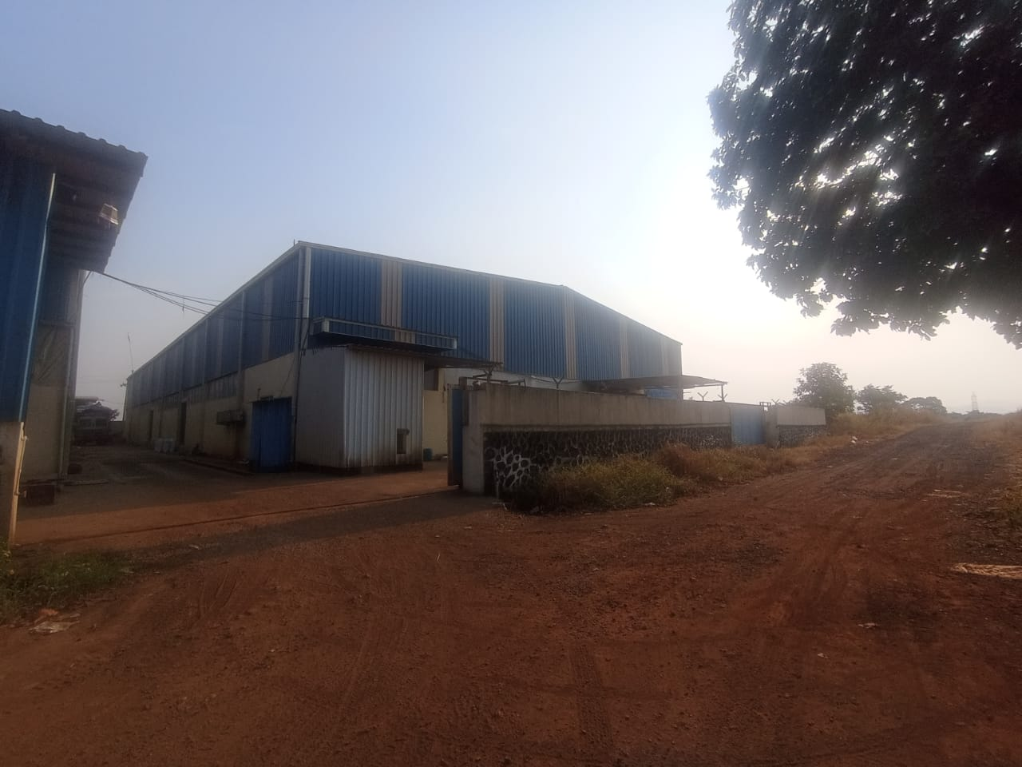

Details of the property under consideration:
Name of Owner: M/s. Shahapur Bhagar Food LLP

Plant & Machinery on Plot No. 10, 11 & 12, Survey No. 152, 153 & 157 at Village - Lahe, Taluka Shahapur, District - Thane, PIN - 421 601, State - Maharashtra, Country - India

Longitude Latitude: 19°32'14.6"N 73°21'55.7"E

Valuation Done for:
State Bank of India
Stressed Assets Recovery Branch, Churchgate
6th Floor, International 16, Maharshi Karve Road, Churchgate, Mumbai - 400020,
State - Maharashtra, Country - India

Vastukala Consultants (I) Pvt. Ltd.
Mumbai • Delhi NCR • Indore • Aurangabad • Nanded • Pune
Raipur • Jaipur • Ahmedabad • Rajkot • Thane • Nashik
INDEX
Contents Page No.
1. VALUATION OPINION REPORT 3
2. VALUATION REPORT (IN RESPECT OF PLANT AND MACHINERY) 4
3. VALUATION RATIONALE 5
4. DOCUMENTS REFERRED 9
5. DETAILS OF PLANT AND MACHINERY 10
6. DECLARATION CUM UNDERTAKING (Annexure-IV) 11
7. ACTUAL SITE PHOTOGRAPHS 14
ACTUAL SITE PHOTOGRAPHS 16
ACTUAL SITE PHOTOGRAPHS 16
8. ROUTE MAP OF THE PROPERTY 18
9. ASSUMPTIONS, CAVEATS, LIMITATION AND DISCLAIMERS 19
10. MODEL CODE OF CONDUCT FOR VALUERS (Annexure V) 21
11. DEFINITION OF VALUE FOR THIS SPECIFIC PURPOSE 24
12. VALUATION OF MOVABLE ASSETS 25

Vastu/Mumbai/12/2023/7324/2305212
28/17-434-VSU
Date: 01.01.2024

VALUATION OPINION REPORT
This is to certify that the Plant & Machinery on Plot No. 10, 11 & 12, Survey No. 152, 153 & 157 at Village - Lahe, Taluka Shahapur, District - Thane, PIN - 421 601, State - Maharashtra, Country - India belongs to M/s. Shahapur Bhagar Food LLP.
Boundaries of the property: -
North | : | Internal Road
South | : | Open Plot
East | : | Nikita Enterprises
West | : | Internal Road & Open Plot
Considering various parameters recorded, existing economic scenario, and the information that is available with reference to the development of neighborhood and method selected for valuation, we are of the opinion that, the property premises can be assessed and Fair Market value for SARFAESI Securitisation and Reconstruction of Financial Assets and Enforcement of Security Interest Act, 2002 purpose as below:
Particulars | Fair Market Value (`) | Realizable Value (`) | Distress Sale Value (`)
Plant and Machinery | 55,23,000.00 | 46,94,550.00 | 38,66,100.00
Hence certified.
For Vastukala Consultants (I) Pvt. Ltd.

Umang Ashwin Patel
Regd. Valuer
Chartered Engineer (India)
Reg. No. IBBI/RV/04/2019/10803
SBI Empanelment No.- SME/TCC/2021-22/86/4

VALUATION REPORT (IN RESPECT OF PLANT AND MACHINERY)
To,
The Branch Manager,
State Bank of India,
Stressed Assets Recovery Branch, Churchgate
6th Floor, International 16,
Maharshi Karve Road, Churchgate,
Mumbai - 400020,
State - Maharashtra, Country - India

I | General (Form- O - 7)
1. | Location of factory/ works/ premises |  | : | Plant & Machinery on Plot No. 10, 11 & 12, Survey No. 152, 153 & 157 at Village - Lahe, Taluka Shahapur, District - Thane, PIN - 421 601, State - Maharashtra, Country – India
2. | Purpose for which valuation is made |  | : | As per the request from State Bank of India, Stressed Assets Recovery Branch, Churchgate Branch to assess Realizable value of the property for SARFAESI Securitisation and Reconstruction of Financial Assets and Enforcement of Security Interest Act, 2002 purpose.
3. | a) | Date of inspection | : | 31.10.2023
 | b) | Date on which the valuation is made | : | 01.01.2024
4. | Basis of valuation / assumptions made of |  | : | As mentioned below.
 | - Indigenous Machines |  | : | The Plant & Machinery under valuation are Indigenous. For Valuation Cost Approach is used for calculation of Fair Market Value.  Basis of Valuation is as under: -  • Purchase Value  • Visual Observation  • Specifications of Machinery  • Manufacturer of Machinery  • Condition of Machinery  • Present Maintenance  • Age of Machines  • Estimated Balance Economic Life  • Depreciation calculated by straight line method  We have assessed the Fair Market Value (FMV) by applying appropriate depreciation considering the above parameters
 | - Imported Machines |  | : | NA
5. | Details of the charges created on the assets |  | : | Information Not available

VALUATION RATIONALE

3.1 Methodologies

3.1.1 Market Approach
As per Ind AS 113: Appendix A, it is defined as a valuation technique that uses prices and other relevant information generated by market transactions involving identical or comparable (i.e. similar) assets, liabilities or a group of assets and liabilities.
In order to compare the subject of the valuation with the price of the other tangible asset interests, Valuers adopt generally accepted and appropriate units of comparison that are considered by participants, dependent upon the type of asset being valued.

As per IVS 400 differences that should be considered in valuing tangible asset interests include, but are not limited to:
- The type of interest providing the price evidence and the type of interest being valued,
- The respective locations,
- The respective configuration,
- The circumstances under which the price was determined, and the basis of value required,
- The effective date of the price evidence and the valuation date, and market conditions at the time of the relevant transactions and how they differ from conditions at the valuation date.
Direct Sales Comparison Method is the most common method under the Market Approach for Plant and Machinery Valuation. The basic fundamental for this method is on the assumption that an informed purchaser would not pay more for an item than the cost of acquiring an existing one with the same utility. This method is preferred when valuing plant and machinery for which there is a known and active secondary market. In applying it under the ‘in-situ’ premise, an allowance then is made to reflect the cost of delivery, installation taxes, fees and duties known as indirect or additional costs.
Comparable Match Method is other method under market approach for plant and machinery valuation. This technique establishes values based on the analysis of similar (but not identical) assets using some measure of utility (size, capacity, year manufactured, etc.) as the basis of comparison. The main difference from direct sales comparison method is that the comparisons may not be similar in terms of model and year built, but has other similarities such as capacity, brand acceptance or same country of origin. Hence, appropriate adjustments have to be made on the comparable before the value of asset can be derived.

3.1.2 Income Approach
It is defined as valuation technique that convert future amounts (e.g., cash flows or income and expenses) to a single current (i.e., discounted) amount. The fair value measurement is determined on the basis of the value indicated by current market expectations about future amounts.
The income approach is defined in the International Glossary of Business Valuation Terms as
“A general way of determining a value indication of a business, business ownership interest, security or intangible asset using one or more methods that converts anticipated economic benefits into a present single amount.”
The development of a yield or discount rate should be influenced by the objective of the valuation. For example:
- If the objective of the valuation is to establish the value to a particular owner or potential owner based on their own investment criteria, the rate used may reflect their required rate of return or their weighted average cost of capital, and
- If the objective of the valuation is to establish the market value, the discount rate may be derived from observation of the returns implicit in the price paid for tangible asset interests traded in the market between participants or from hypothetical participant’s required rates or return. When a discount rate is based on an analysis of market transactions, Valuers should also follow the guidance contained in IVS 105 Valuation Approaches and Methods.

Two methods are typically used to value machinery and equipment using the income approach, Direct Capitalization Method and Discounted Cash Flow Method.
Direct Capitalization Method involves capitalizing a ‘normalized’ single year net income estimated by an appropriate market-based yield. It capitalizes a projected cash flow into perpetuity and the capitalization rate that is calculated has no changes.
Discounted Cash Flow Method is a multiple period model. Using this method, future cash flows from the asset are forecasted using market stated assumptions as well as future capital and operational expenditures projected by the company. This method allows for the explicit modelling of income and expense associated with the assets. These future financial benefits are then discounted to a present-day value at an appropriate discount rate taking into account return on investment and risk.

3.1.3 Cost Approach
The cost approach is commonly adopted method for plant and equipment, particularly in the case of individual assets that are specialised or special-use facilities. In cost approach appraisal, the market price for the asset is equal to the cost, less depreciation. It yields the most accurate market value when the asset is new.
Replacement Cost New is the cost of obtaining an alternative asset of equivalent utility; this can either be a modern equivalent providing the same functionality or the cost of reproducing an exact replica of the subject asset. After concluding on a replacement cost, the value should be adjusted to reflect the impact on value of physical, functional, technological and economic obsolescence on value. In any event, adjustments made to any particular replacement cost should be designed to produce the same cost as the modern equivalent asset from an output and utility point of view. In addition, other applicable direct & indirect cost applicable in the current market conditions will be factored to arrive at current RCN for the machineries.
Reproduction Cost New Method is appropriate in circumstances where the cost of a modern equivalent asset is greater than the cost of recreating a replica of the subject asset or the utility offered by the subject asset could only be provided by a replica rather than a modern equivalent.
Under Indexing Method, a ratio multiplier based on applicable index of a particular category of assets in comparison to the similar index at the time of procurement/ acquisition of asset is computed. The ratio multiplier is computed from Wholesale Price Index (WPI) published by Reserve Bank of India for various categories of assets. This multiplier is then applied to historical cost to estimate the current replacement cost of the assets. Under this scenario, capitalized values in the fixed register would typically involve all direct and indirect costs and thus, no extra costs will be factored to estimate current replacement cost.

3.2 Other terminologies used

3.2.1 Depreciated Replacement Cost
In regard to the Appraisal and Guidance Notes issued by the International Valuation Standards Council (IVSC) in which the Depreciated Replacement Cost is defined as:
“The current cost of replacing an asset with its modern equivalent asset less deductions for physical deterioration and all relevant forms of obsolescence and optimization.”
Under Cost Approach, the fair value of the Plant & Machinery component will be assessed through ‘Depreciated Replacement Cost’ (DRC) Method. In this approach, the Current Replacement Cost of the assets (given the current condition of the asset) is evaluated after giving regards to parameters such as Make, Model, Capacity, Technical specification, Types of process, construction specifications, age of the Machinery, Country of origin, etc. and the same has been depreciated based on parameters such as age, physical condition of the components, remaining useful life, technical obsolescence, etc. of individual components.

3.2.2 Total Economic/ Physical life
The total economic life of the assets has been considered on the basis of economic life prescribed for various categories under Schedule II, Part C of Indian Companies Act, 2013 and Useful life of machines catalogue published by American Society of Appraisers (ASA). Wherever the age of machineries had exceeded the prescribed total economic life, typically future/ balance physical life will be adopted on the basis of physical/ working condition of the assets. It is to be noted that estimated future physical life of the machineries is based on the visual/ physical observation of the valuer as of date of inspection and no technical evaluation regarding the durability of machineries has been undertaken.

3.2.3 Scrap & Salvage Value
Salvage value is the estimated amount that an asset is worth at the end of its useful life. It is also known as scrap value or residual value and is used while determining the depreciation of an asset.

3.2.4 In-situ & ex-situ value
Under In-situ value, the assets will remain in their existing place and location (In-Situ) following the completion of sale. In-situ value is typically assessed in the case of assessment of Fair Value on ‘going concern’ basis. In this scenario, the prospective buyer for the unit would comprehend the requirement of necessary industrial infrastructure (including other indirect costs that are typically allowed for capitalization) that is required for the operations of the industry.
Under Ex-situ value, the assets will be removed from their existing location following the completion of sale and this typically utilized in the case of assessment of Liquidation Value or Forced Sale Value. In this scenario, adjustments are required to exclude necessary costs & charges such as foundation costs, decommissioning costs, etc.

3.3 Factors affecting the value

3.3.1 General factors
The value of P&E starts with the inspection. This is done to ascertain the condition of the plant and also to determine if the information provided to them is usable and related to the subject assets being valued. The factors generally considered during inspection are:

Asset related
- The asset’s technical specification
- The remaining useful, economic or effective life, considering both preventive and predictive maintenance
- The asset’s condition including maintenance history
- Any functional, physical or technological obsolescence
- Additional costs associated with additional equipment, transport, installation and commissioning etc.

Environment related
- The location in relation to the source of raw material and market for the product
- The impact of any environmental or other legislation that either restricts utilization or imposes additional operation or decommissioning costs
- Licenses to operate machineries which produce or utilize radioactive substances or toxic wastes and that may be restricted in certain countries.

Economy related
- The actual or potential profitability of the asset based on comparison of operating costs with earnings or potential earnings
- The demand for the product manufactured by the plant with regard to both macro and micro- economic factors could impact on demand
- The potential for the asset to be put to a more valuable use than the current use (i.e. HABU)

3.3.3 Factors related to imported assets
For assessing Current Replacement Cost of imported Machineries (if any), I have adopted the current price (vide replacement cost method or index method using producer price index issued by central bank of respective country) of the machineries along with prevailing currency exchange rate, duties, freight charges, commissioning costs, etc.

3.3.4 Factors related to used assets
The methodologies and approaches specified above are equitably used in the case of transferred assets. Replacement cost of second-hand machineries/ transferred equipment is assessed after taking proper consideration to the actual year of manufacturing of the plant and machineries, country of origin, actual invoice or Historic cost, etc. It is to be noted that the details related to the same has been availed from the Client as well as based on my best effort basis.

3.4 Methodology adopted
As stated earlier, the fair value of Plant and Machinery has been estimated through Depreciated Replacement Cost Method

3.5 Valuation

3.5.1 Valuation approach
Fair Value assessed is the ‘in-situ’ and on ‘going concern’ basis that assumes that the enterprise shall continue to operate and run its business and that specified fixed asset shall continue to have economic utility. Under this assessment, I have assumed that the prospective buyer for the unit would comprehend the requirement of necessary industrial infrastructure (including other indirect costs which are typically allowed for capitalization) that is required for the operations of the industry. Fair Value of the assets has been assessed on the basis of the afore-mentioned premise.

DOCUMENTS REFERRED
Client has provided the Copy of following documents/ Information.
- List of Plant & Machinery
- OBSERVATION
- M/s. Shahapur Bhagar Food LLP is having Plant & Machinery on Plot No. 10, 11 & 12, Survey No. 152, 153 & 157 at Village - Lahe, Taluka Shahapur, District - Thane, PIN - 421 601, State - Maharashtra, Country - India.
- Company has not provided any documents.
- The residual life of major plant and machinery is considered as 15 to 20 years subjected to repairs and maintenance.
- Mr. Manish (SBI Employee - Contact No. 91 97682 38185) accompanied our Engineer and showed the Plant & Machinery under valuation.
- During the date and time of our visit, the plant was not in operation.
- Company has not provided the List of Plant & Machinery with Year of Purchase & Purchase Value and the value is based on our market research & Physical Visit.

DETAILS OF PLANT AND MACHINERY
Sr. No. | Description | Value in `
 | Air Blowing Fan | 4,000
 | Air Compressor | 88,000
 | Bag Sewing Machine Dad | 3,000
 | Belting 100 mm x 5 Ply | 9,000
 | Bhagar Konda Machinery | 53,000
 | Bhagar Mill Plant Machine | 15,84,000
 | Bhagar Polisher Machine | 21,46,000
 | ColourSorter Machin(LP-256) | 6,10,000
 | CTSD-CUP FILLER | 3,13,000
 | Digital Wieght Indicator EP305 | 63,000
 | Fan with Upper Vibrator | 8,000
 | Hindusthan Motors 1.00 HP 0.75 KW 4 POLE 1500 RPM | 3,000
 | Hindusthan Motors 1.00 HP 0.75 KW 8 POLE 960 RPM B3 | 15,000
 | Hindusthan Motors 3.00HP 2.20 KW 6 BPOLE 1000 RPM | 11,000
 | Hindusthan Motors 5.00 HP 3.70 KW BPLE 1000 RPM | 39,000
 | Hindusthan Motors7.5 HP 5.5KW 6 POLE 1000 RPM | 30,000
 | Polisher Machinery | 63,000
 | Miscellaneous | 2,08,000
 | Revo Bag Closing Machine | 1,000
 | Rubeer Rice Processer | 22,000
 | Miscellaneous - Furniture Fixture, Electrical Fitting, Etc. | 2,50,000
 | TOTAL | 55,23,000

Particulars | Fair Market Value (`) | Realizable Value (`) | Distress Sale Value (`)
Plant and Machinery | 55,23,000.00 | 46,94,550.00 | 38,66,100.00

DECLARATION CUM UNDERTAKING (Annexure-IV)
I, Umang Patel son of Shri. Ashwin Patel do hereby solemnly affirm and state that:

- I am a citizen of India.
- I will not undertake valuation of any assets in which I have a direct or indirect interest or become so interested at any time during a period of three years prior to my appointment as valuer or three years after the valuation of assets was conducted by me.
- The information furnished in my valuation report dated 01.01.2024 is true and correct to the best of my knowledge and belief and I have made an impartial and true valuation of the property.
- I/ my authorized representative has personally inspected the property on 31.10.2023. The work is not sub - contracted to any other valuer and carried out by myself.
- Valuation report is submitted in the format as prescribed by the bank.
- I have not been depanelled / delisted by any other bank and in case any such depanelment by other banks during my empanelment with you, I will inform you within 3 days of such depanelment.
- I have not been removed / dismissed from service / employment earlier.
- I have not been convicted of any offence and sentenced to a term of imprisonment
- I have not been found guilty of misconduct in my professional capacity.
- I have not been declared to be unsound mind
- I am not an undischarged bankrupt or has not applied to be adjudicated as a bankrupt.
- I am not an undischarged insolvent.
- I have not been levied a penalty under section 271J of Income-tax Act, 1961 (43 of 1961) and time limit for filing appeal before Commissioner of Income-tax (Appeals) or Income-tax Appellate Tribunal, as the case may has expired, or such penalty has been confirmed by Income-tax Appellate Tribunal, and five years have not elapsed after levy of such penalty
- I have not been convicted of an offence connected with any proceeding under the Income Tax Act 1961, Wealth Tax Act 1957 or Gift Tax Act 1958 and
- My PAN Card number as applicable is AMKPP9341F
- I undertake to keep you informed of any events or happenings which would make me ineligible for empanelment as a valuer.
- I have not concealed or suppressed any material information, facts and records and I have made a complete and full disclosure
- I have read the Handbook on Policy, Standards and procedure for Real Estate Valuation, 2011 of the IBA and this report is in conformity to the "Standards" enshrined for valuation in the Part - B of the above handbook to the best of my ability.
- I have read the International Valuation Standards (IVS) and the report submitted to the Bank for the respective asset class is in conformity to the "Standards" as enshrined for valuation in the IVS in "General Standards" and "Asset Standards" as applicable. The valuation report is submitted in the prescribed format of the bank.
- I abide by the Model Code of Conduct for empanelment of valuer in the Bank. (Annexure V - A signed copy of same to be taken and kept along with this declaration)
- I am valuer registered with Insolvency & Bankruptcy Board of India (IBBI)
- My CIBIL Score and credit worthiness is as per Bank's guidelines.
- I am Director of the company, who is competent to sign this valuation report.
- I will undertake the valuation work on receipt of Letter of Engagement generated from the system (i.e., LLMS / LOS) only.
For preparation of valuation report we have relied upon following information provided to us by the company / Bank and other various sources as well as our data bank:
- The valuation of the machinery available at the said location is worked out by ‘as is where is basis’. After considering its present replacement value, the residual life of the particular machinery.
- The maintenance up-keep and the present condition of the said machinery is considered while estimating the present realizable value for the particular machinery.
- Information available on internet on the subject matter.
- Our engineer visited the company/plant on October 31st , 2023 and has taken photographs of said Machinery which are attached to this report. Technical changes/obsolescence is not considered while preparing this report.
- Further, I hereby provide the following information.

S. No. | Particulars | Valuer comment
1 | background information of the asset being valued; | Plant & Machinery on Plot No. 10, 11 & 12, Survey No. 152, 153 & 157 at Village - Lahe, Taluka Shahapur, District - Thane, PIN - 421 601, State - Maharashtra, Country - India
2 | Purpose of valuation and appointing authority | As per the request from State Bank of India, Stressed Assets Recovery Branch, Churchgate Branch to assess Fair Market value of the property for SARFAESI Securitisation and Reconstruction of Financial Assets and Enforcement of Security Interest Act, 2002 purpose.
3 | Identity of the Valuer and any other experts involved in the valuation; | Umang Patel – Regd. Valuer  Harshad Panchal – Valuation Engineer
4 | Disclosure of Valuer interest or conflict, if any; | We have no interest, either direct or indirect, in the property valued. Further to state that we do not have relation or any connection with property owner / applicant directly or indirectly. Further to state that we are an independent Valuer and in no way related to property owner / applicant
5 | Date of appointment, valuation date and date of report; | Date of Appointment – 31.10.2023  Valuation Date – 01.01.2024  Date of Report – 01.01.2024
6 | Inspections and/or investigations undertaken; | Physical Inspection done on date 31.10.2023
7 | Nature and sources of the information used or relied upon; | - List of Plant & Machinery provided by company
8 | Procedures adopted in carrying out the valuation and valuation standards followed; | Cost Approach (Replacement cost Method)
9 | Restrictions on use of the report, if any; | This valuation is for the use of the party to whom it is addressed and for no other purpose. No responsibility is accepted to any third party who may use or rely on the whole or any part of this valuation. The valuer has no pecuniary interest that would conflict with the proper valuation of the property.
10 | Caveats, limitations, and disclaimers to the extent they explain or elucidate the limitations faced by valuer, which shall not be for the purpose of limiting his responsibility for the valuation report. | Attached

Date: 01.01.2024
Place: Mumbai
For Vastukala Consultants (I) Pvt. Ltd.

Umang Ashwin Patel
Regd. Valuer
Chartered Engineer (India)
Reg. No. IBBI/RV/04/2019/10803
SBI Empanelment No.- SME/TCC/221-22/86/4

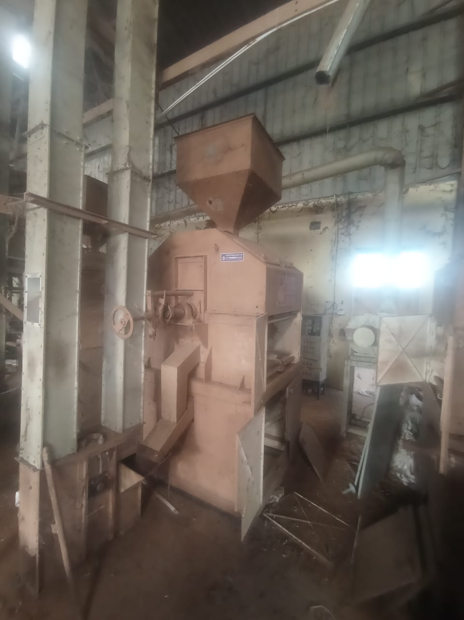
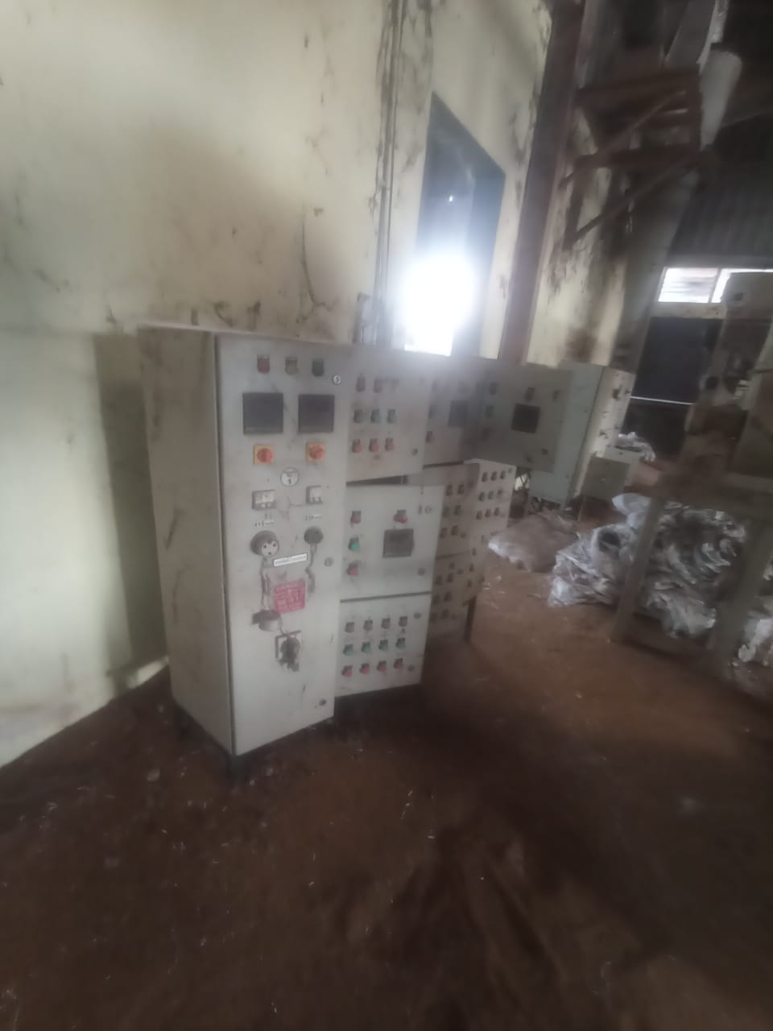
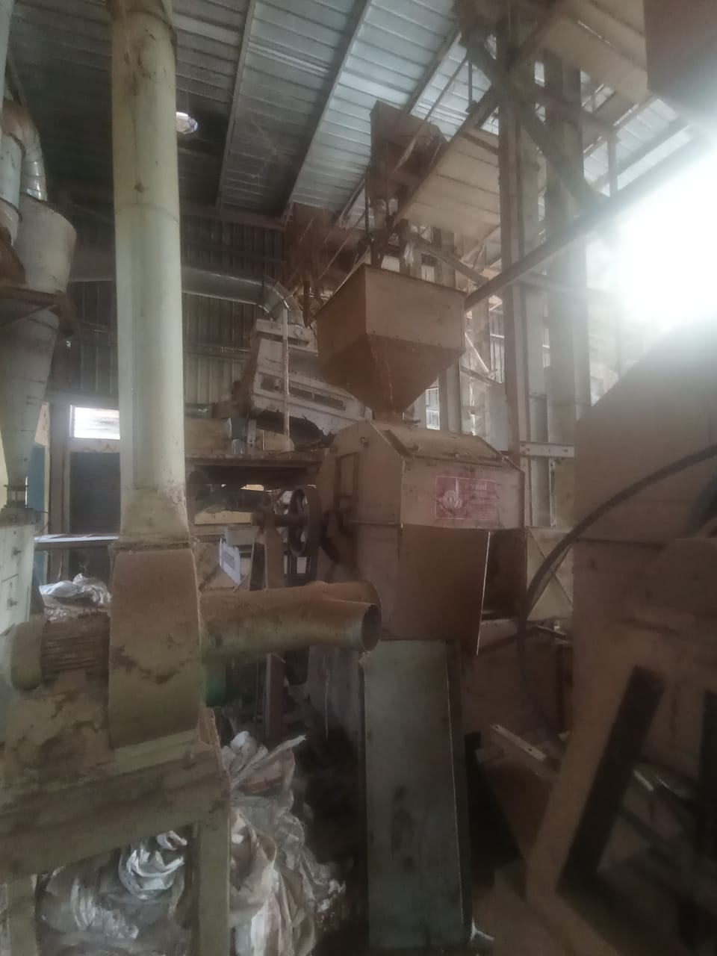
ACTUAL SITE PHOTOGRAPHS

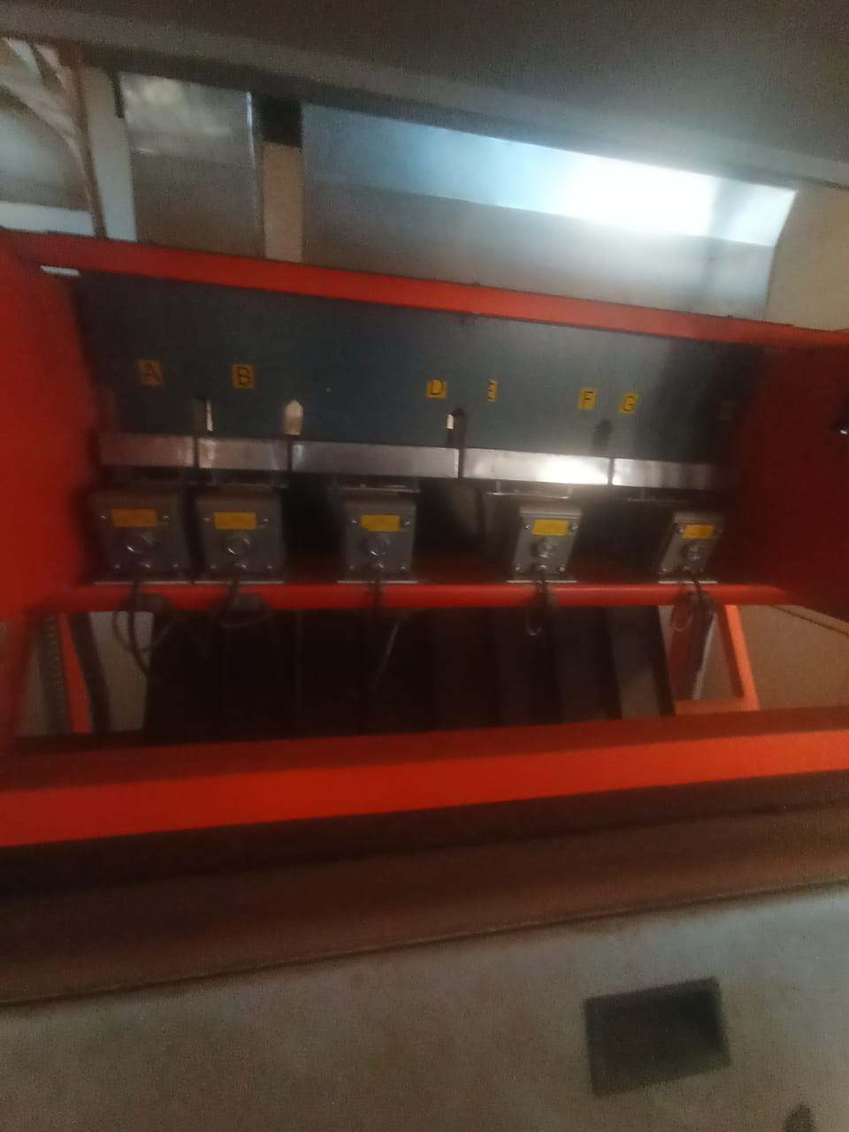
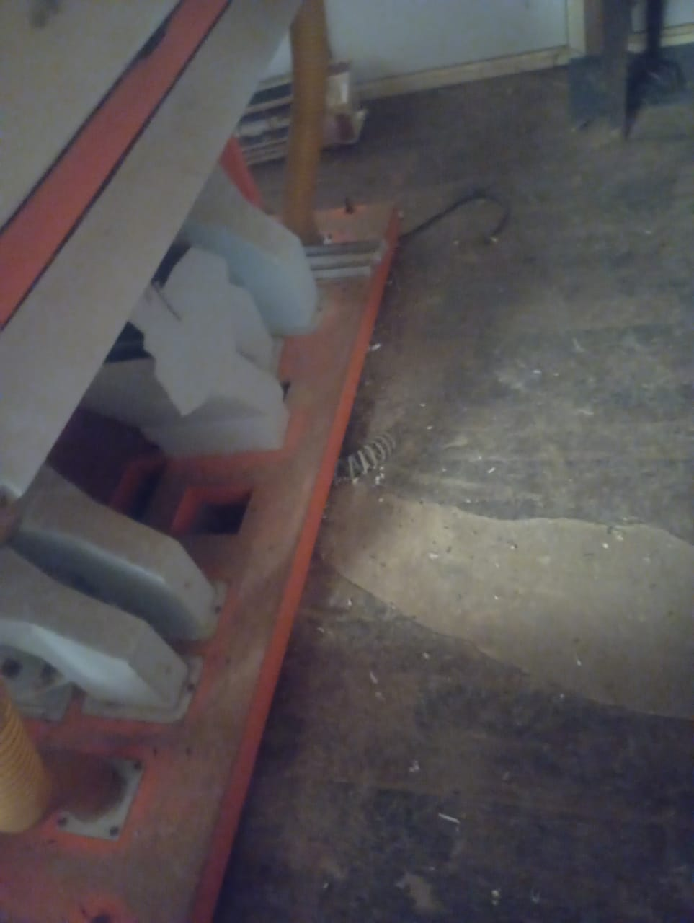
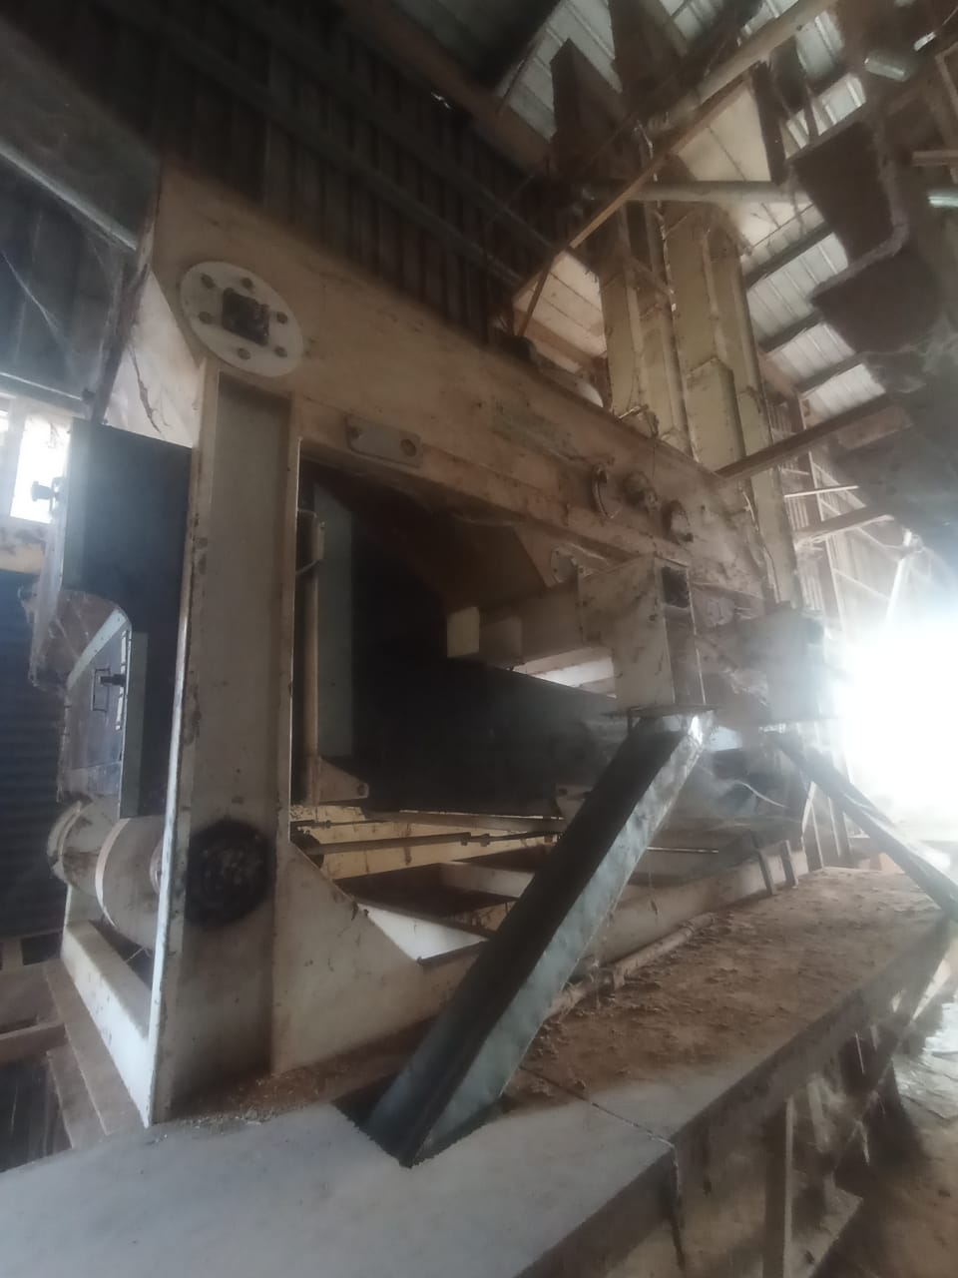
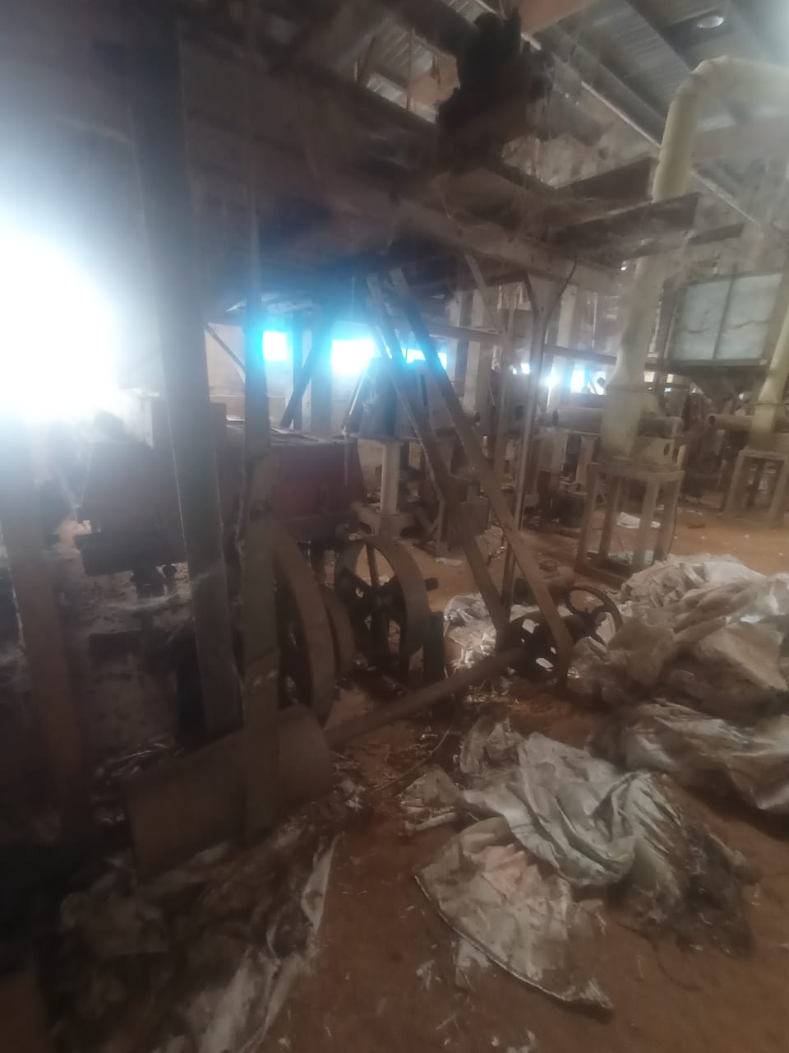
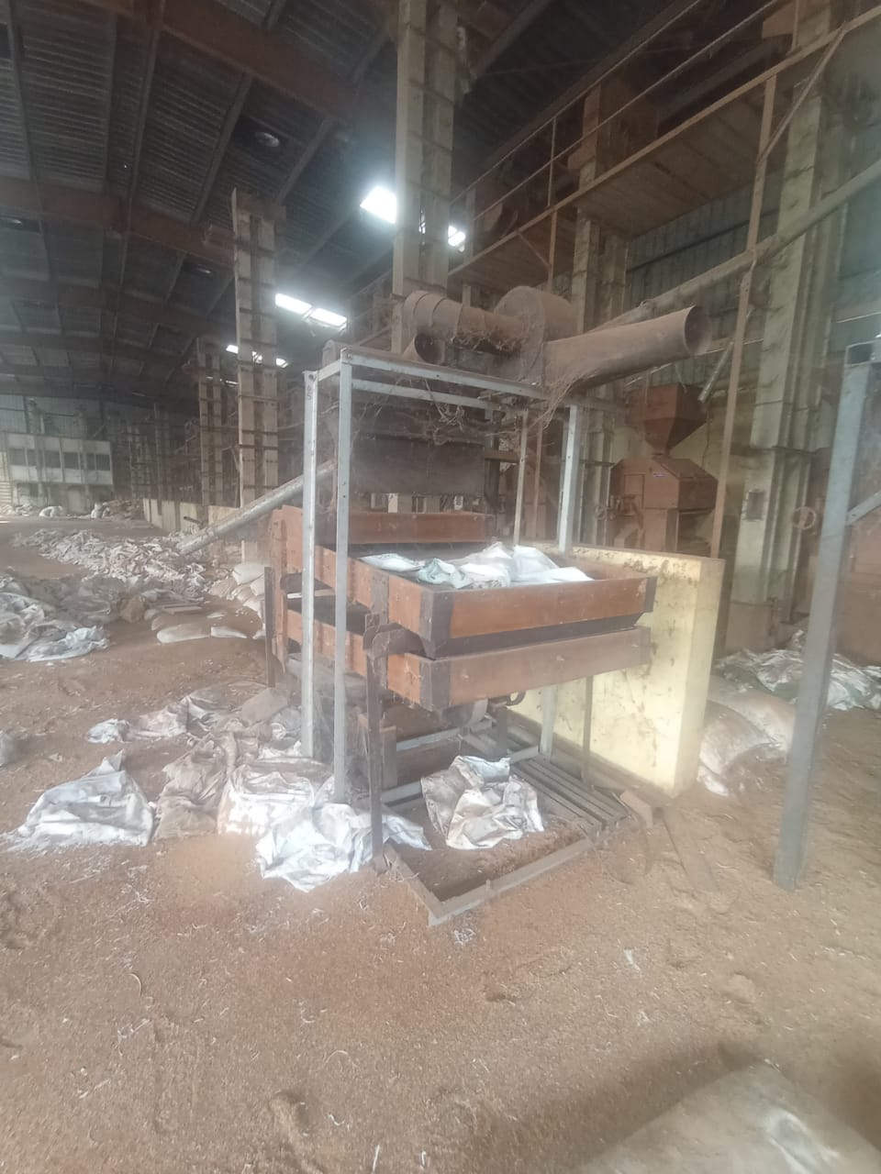
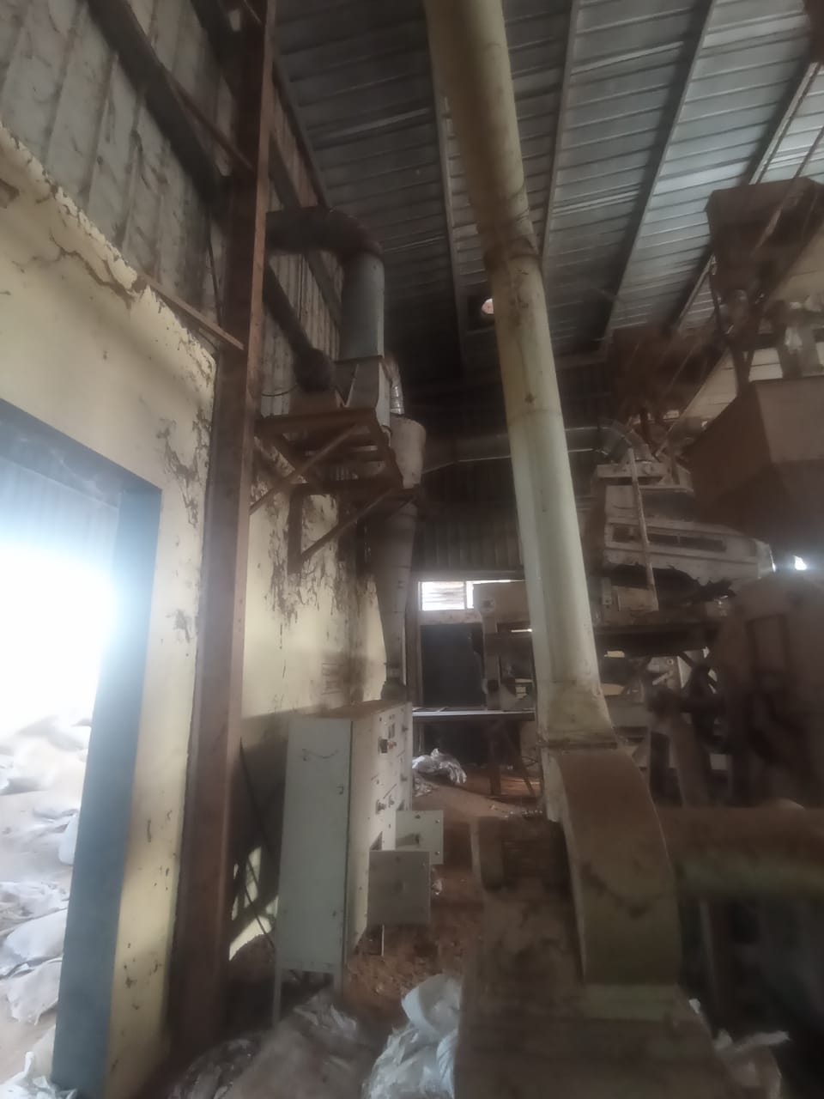
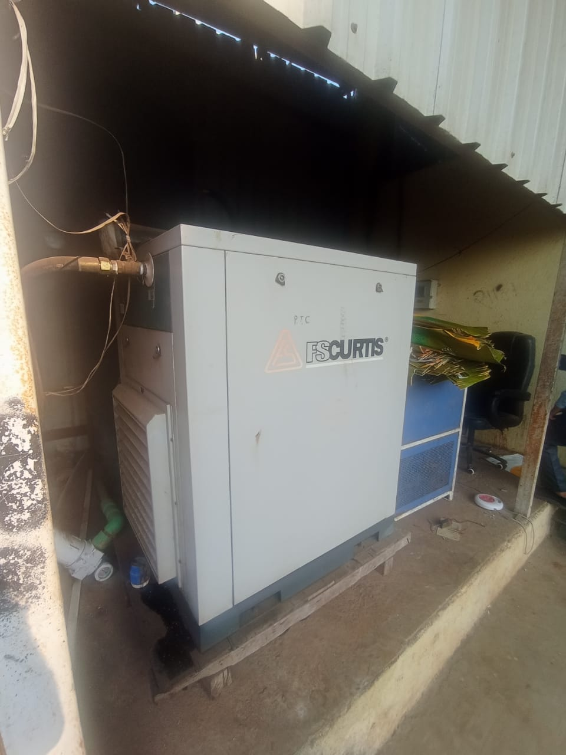
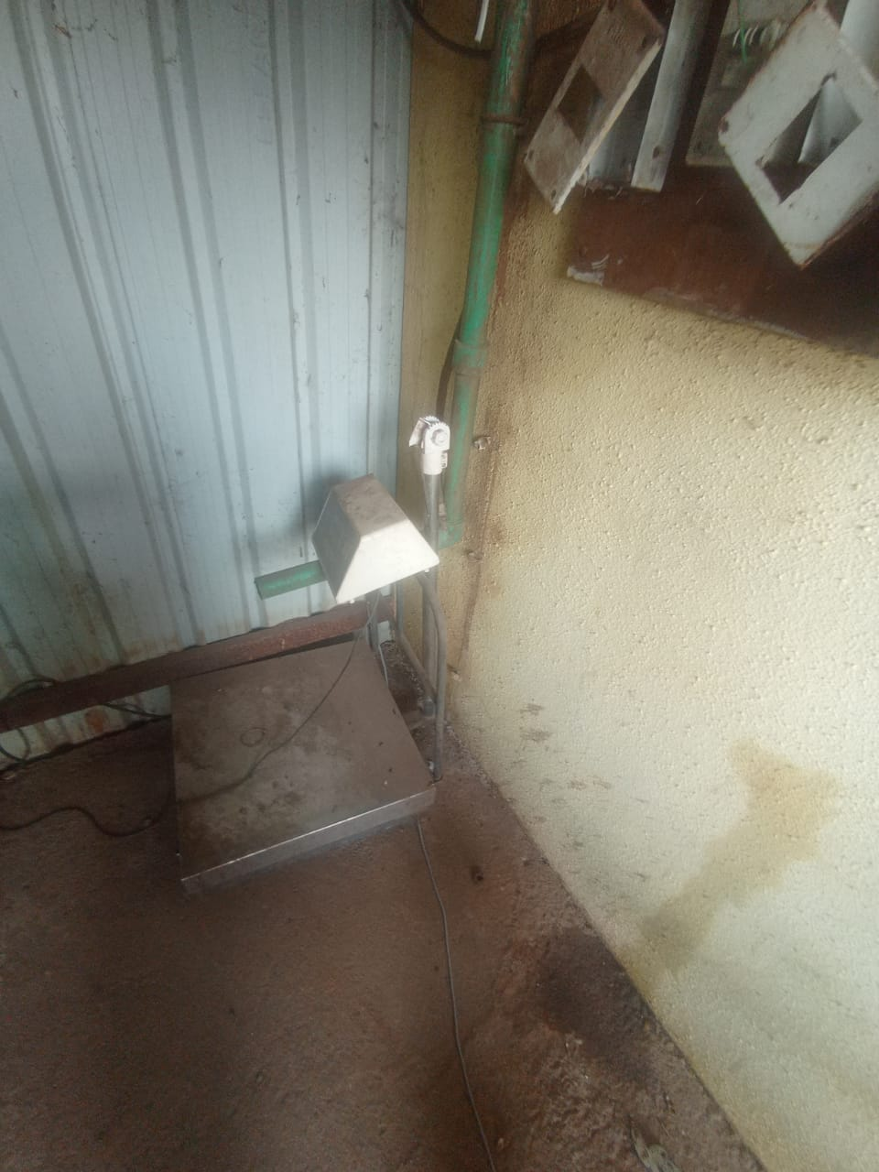
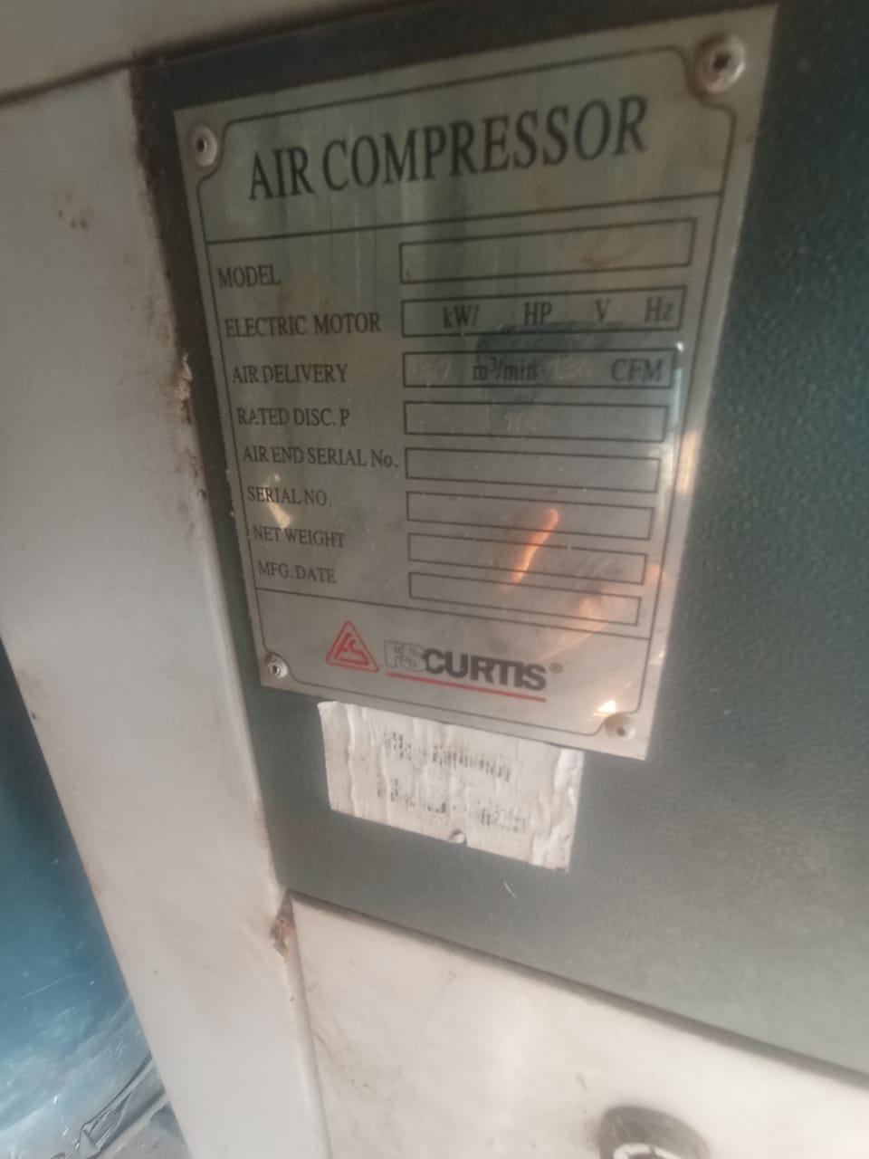
ACTUAL SITE PHOTOGRAPHS

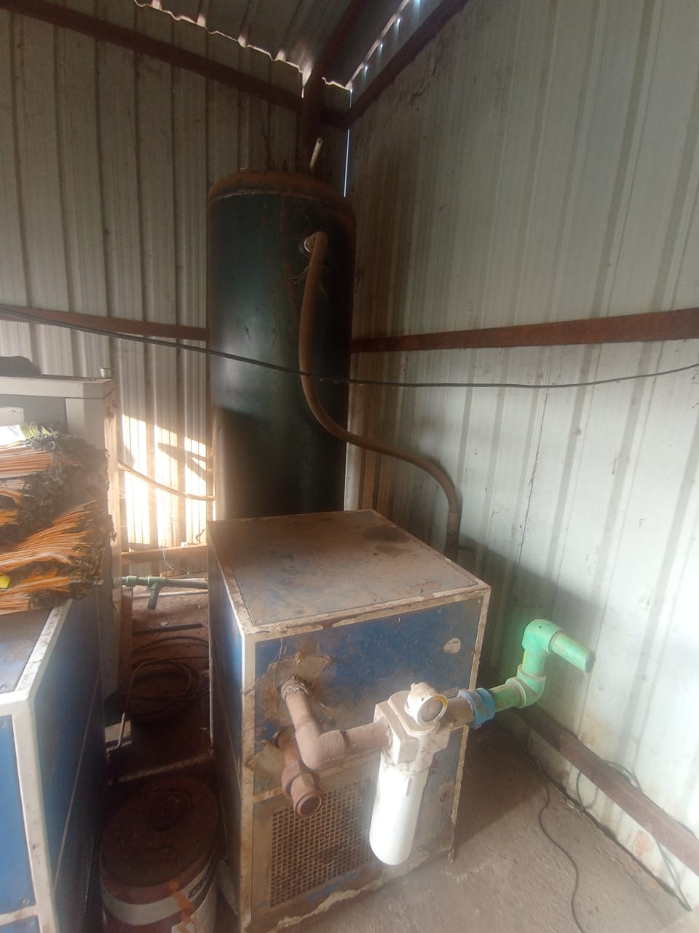
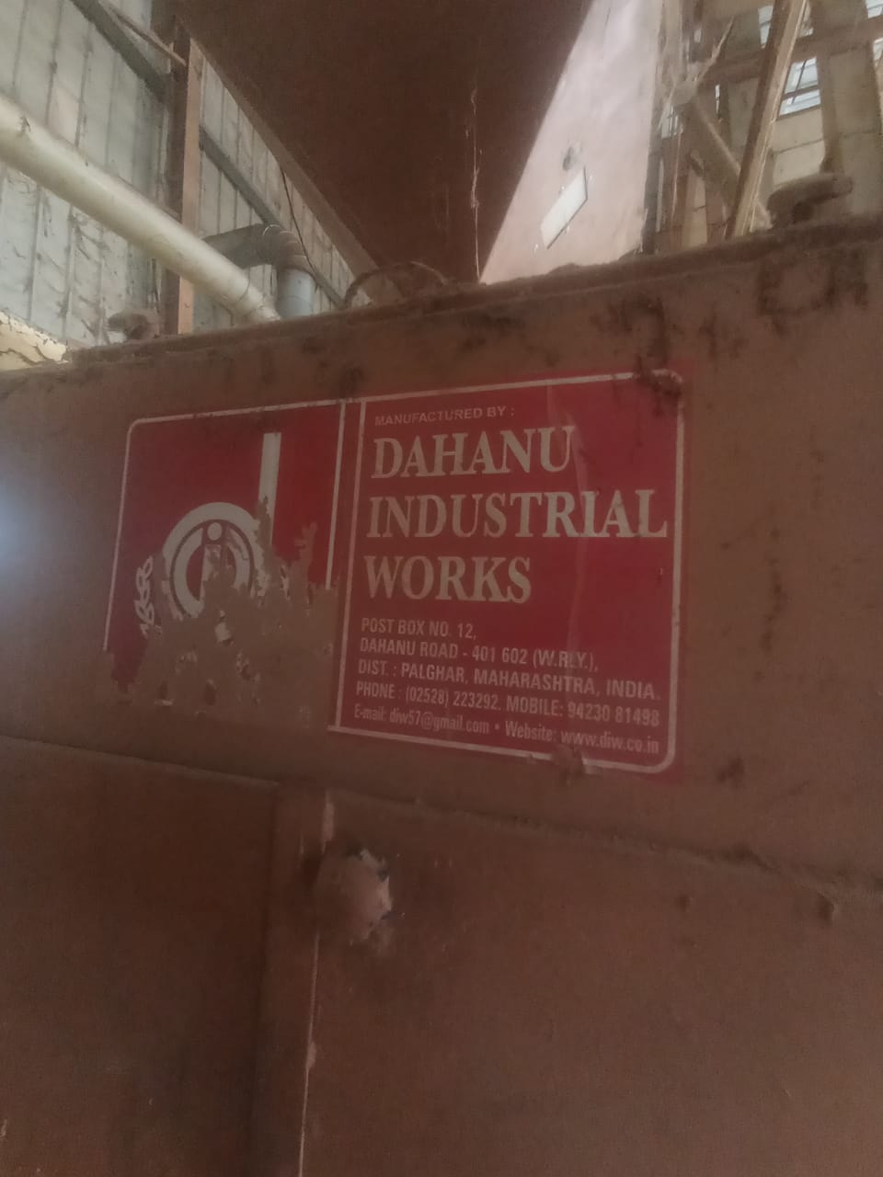
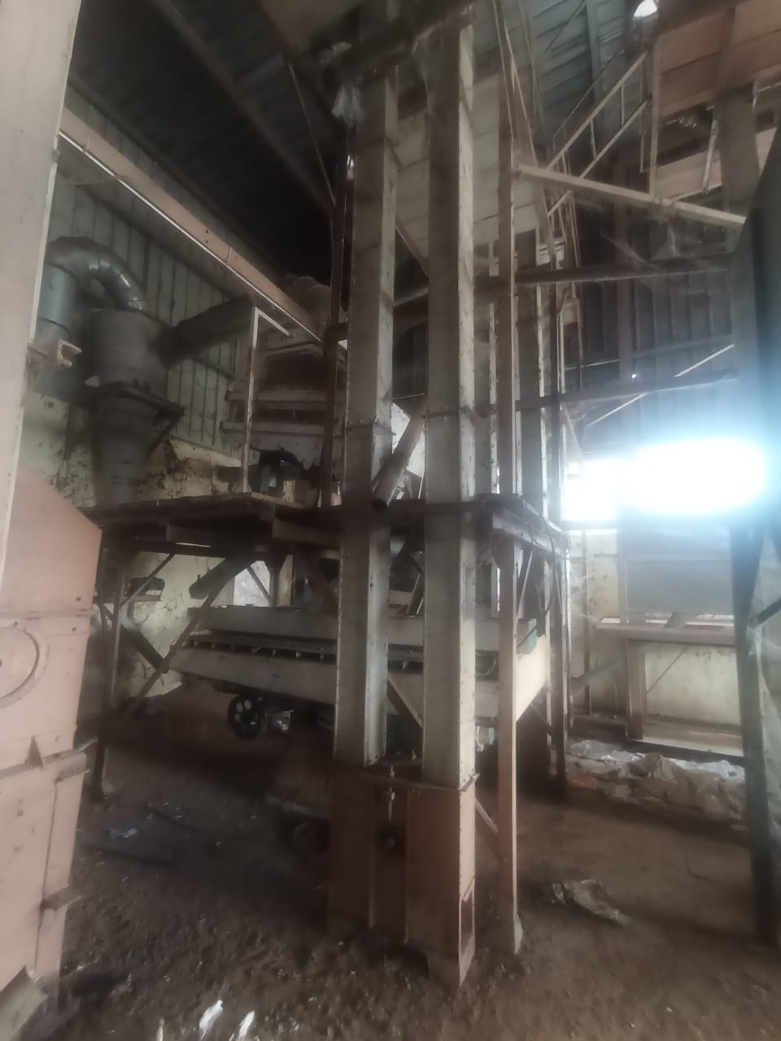
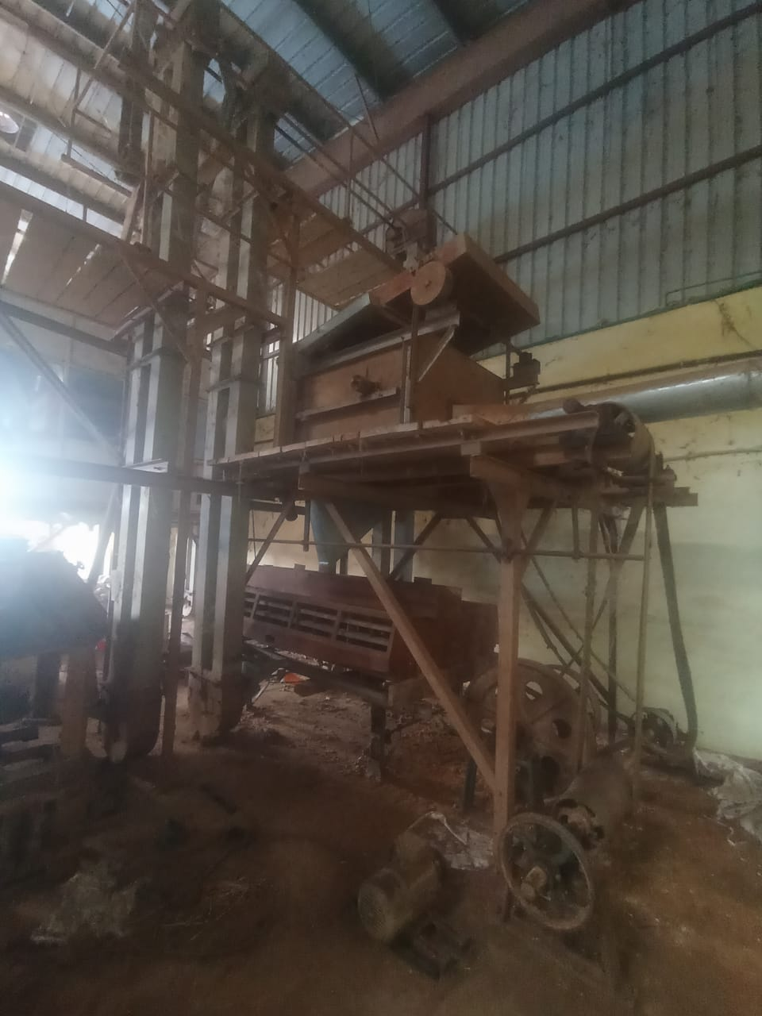
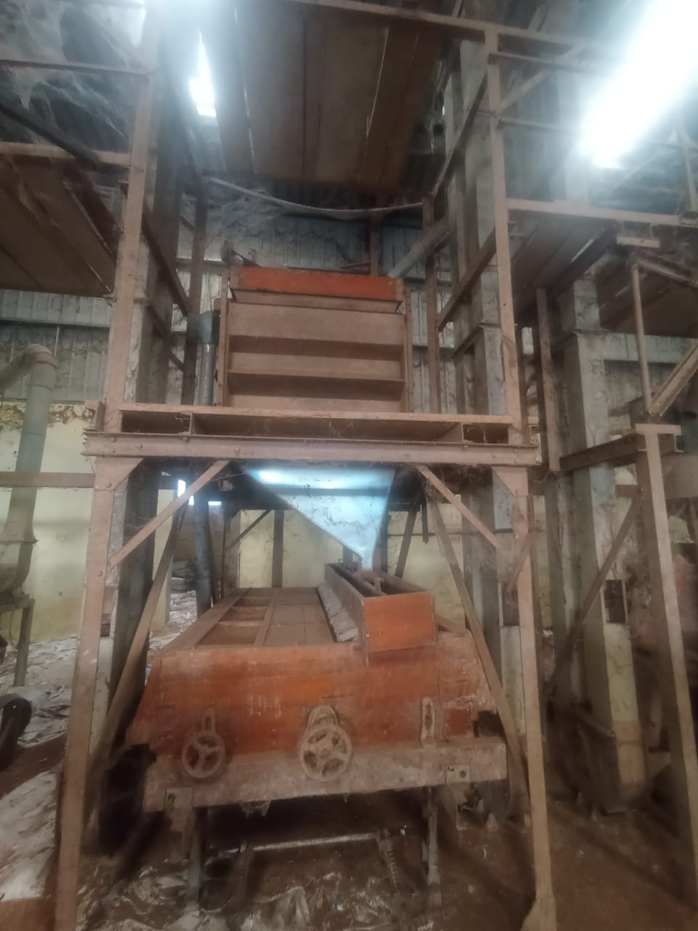
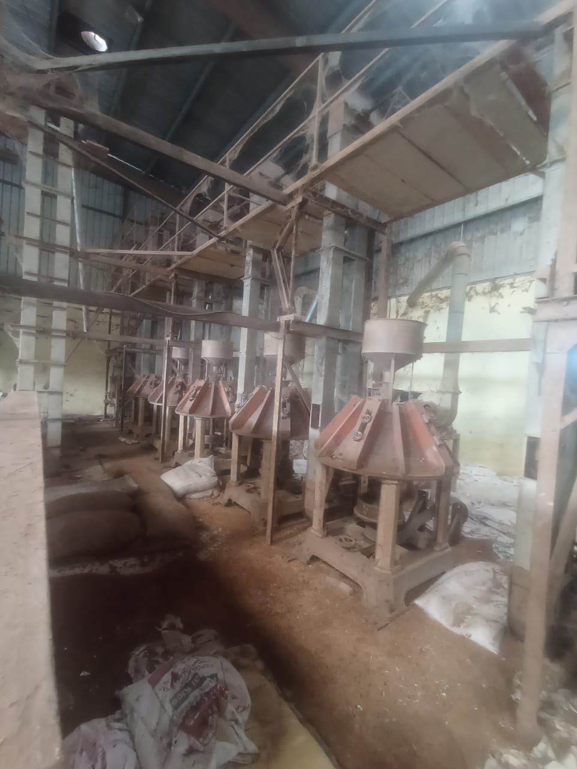

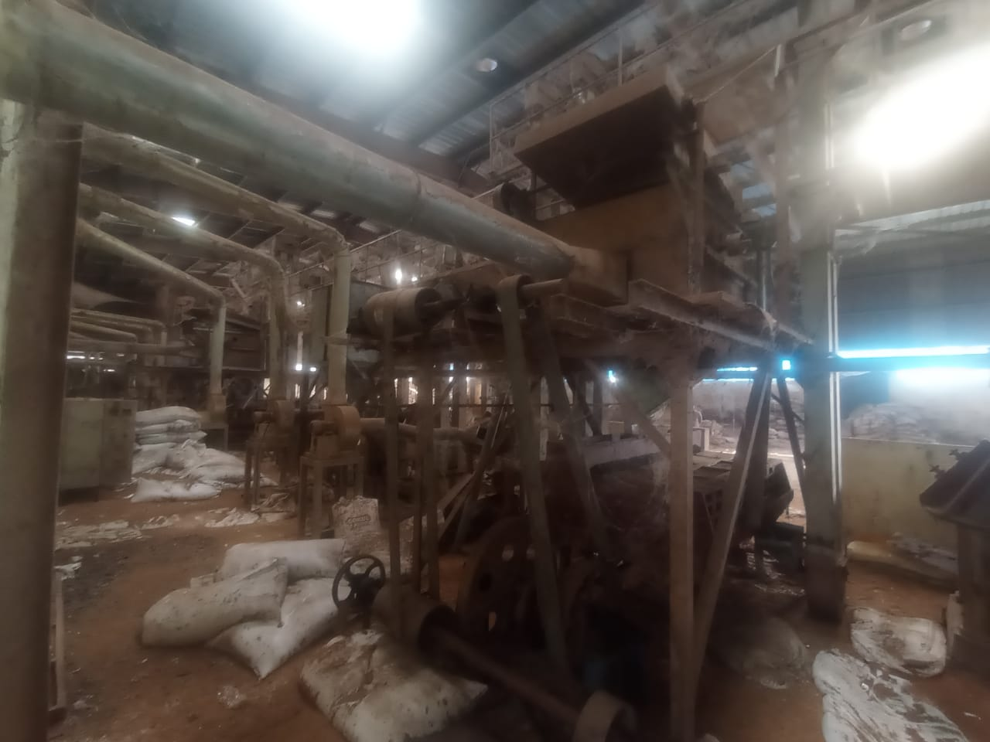
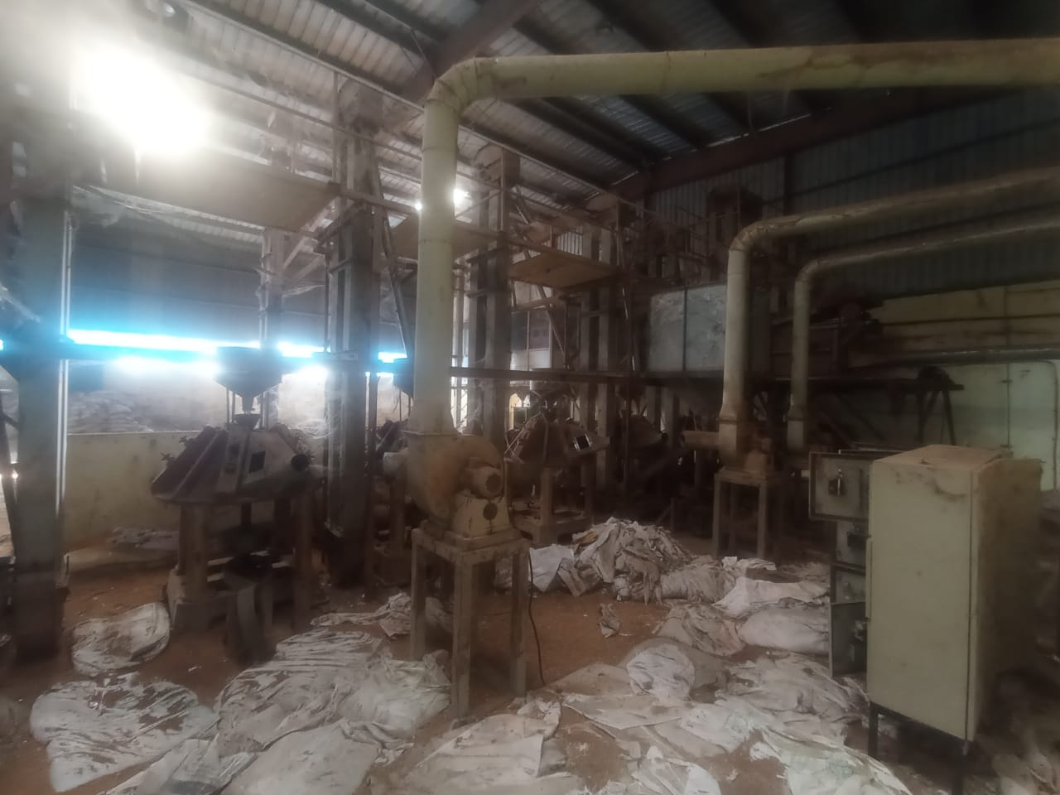
ACTUAL SITE PHOTOGRAPHS

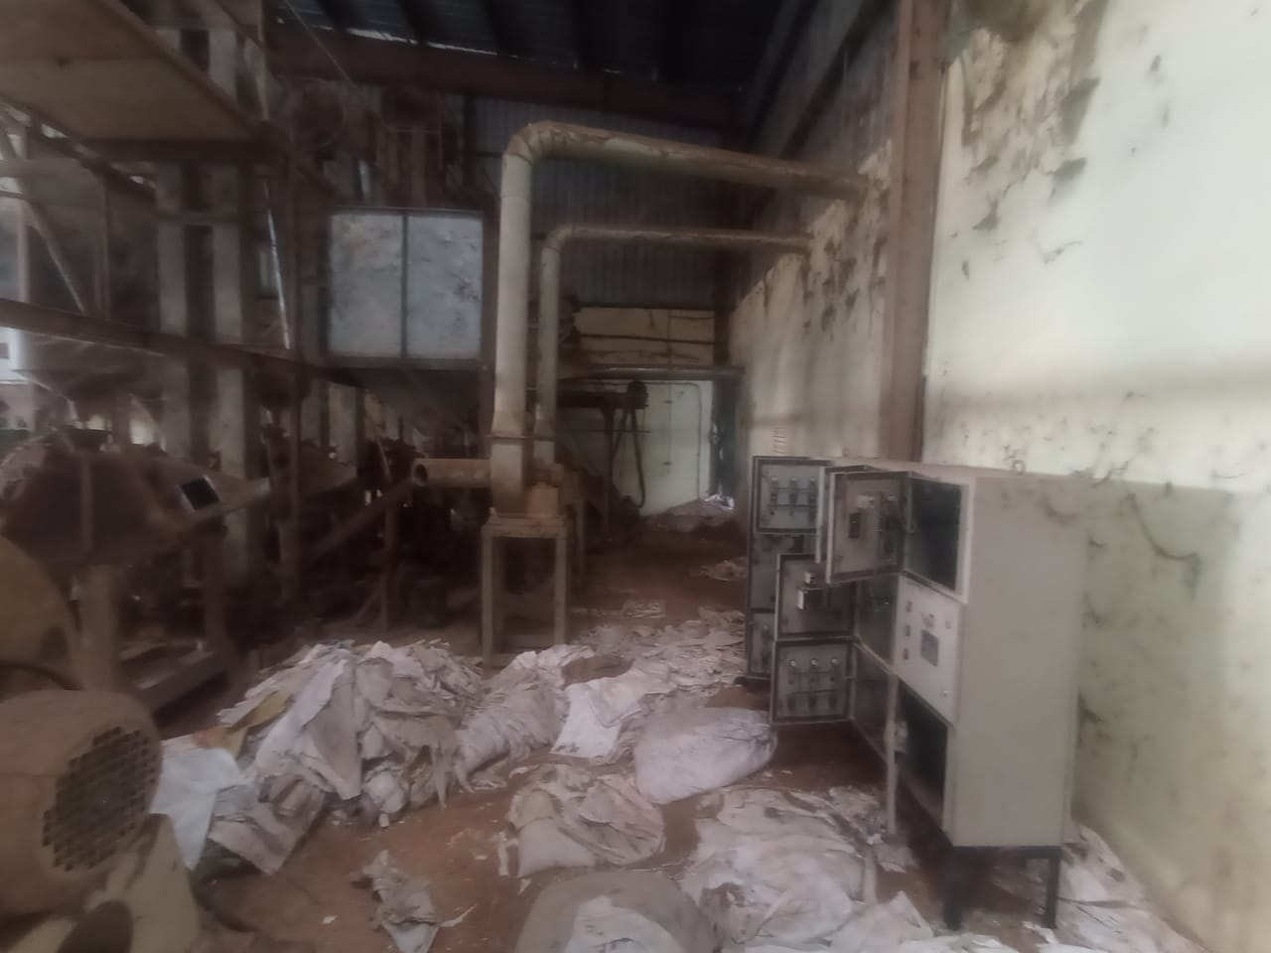
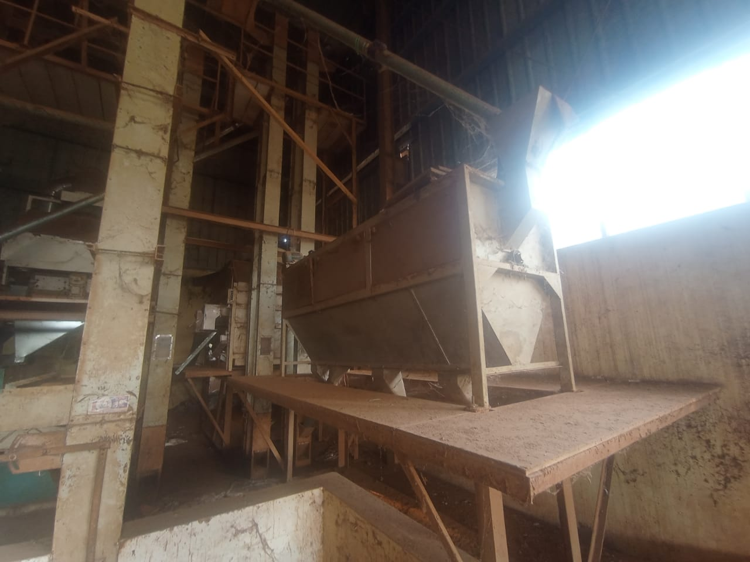
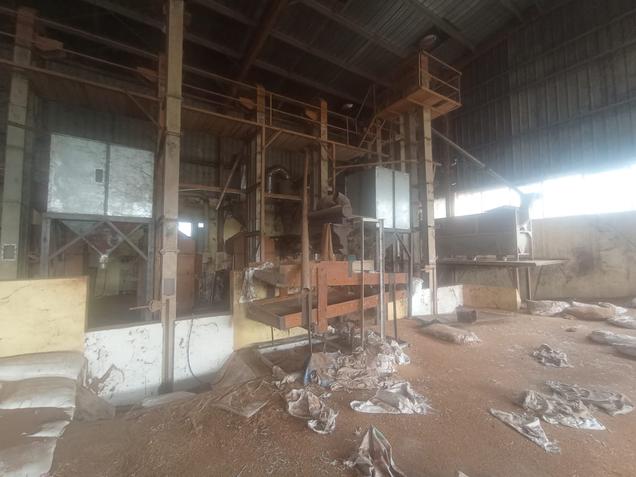
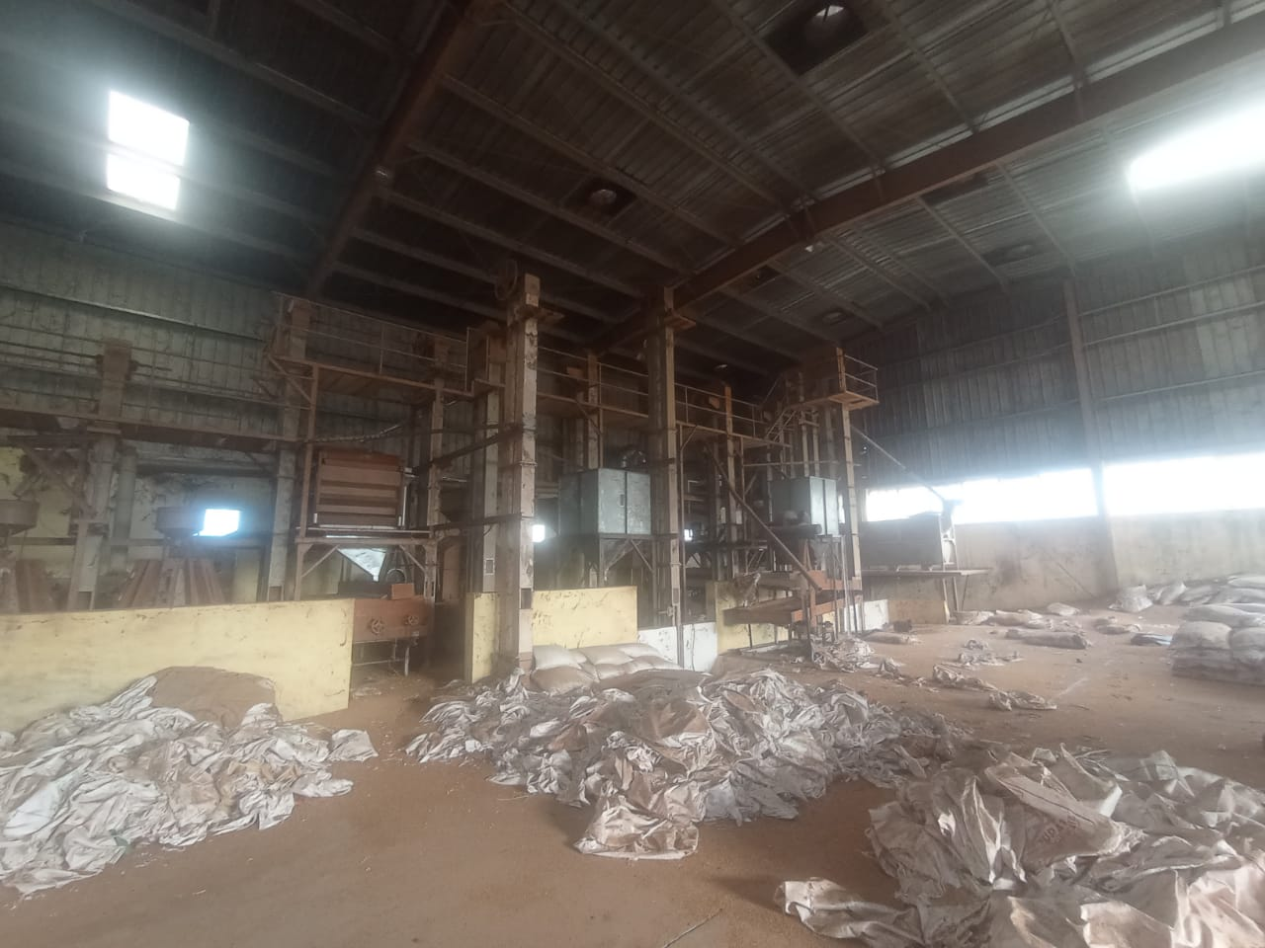

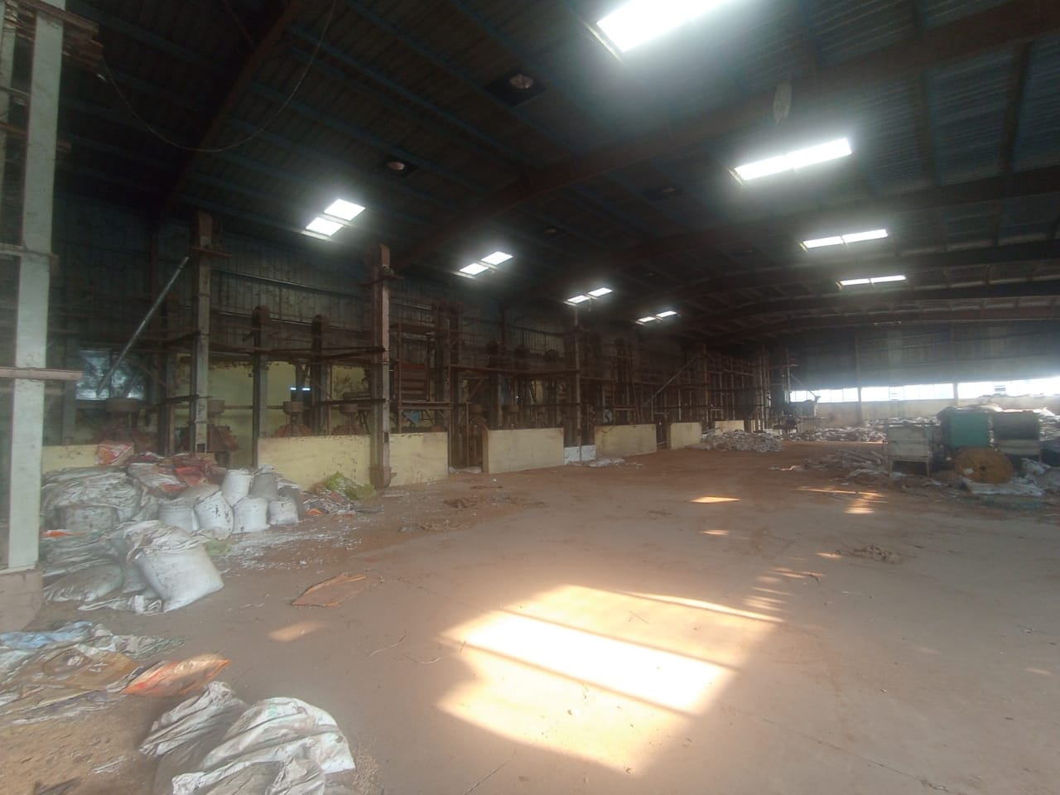
ACTUAL SITE PHOTOGRAPHS

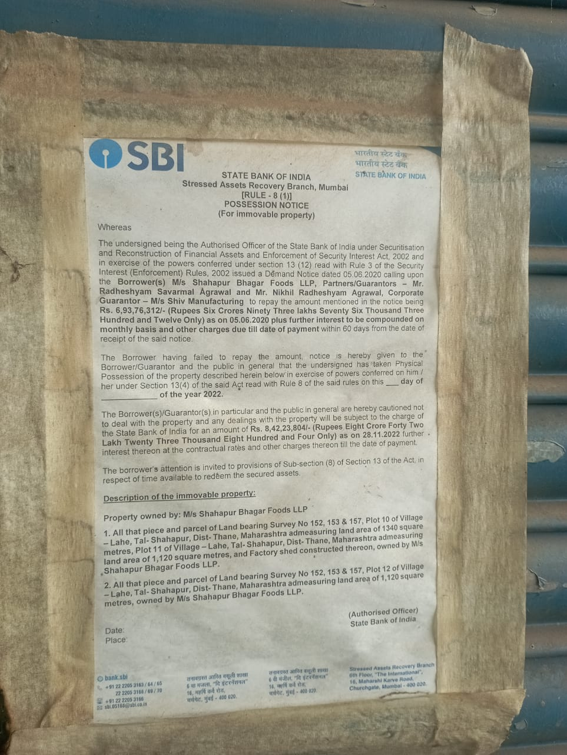
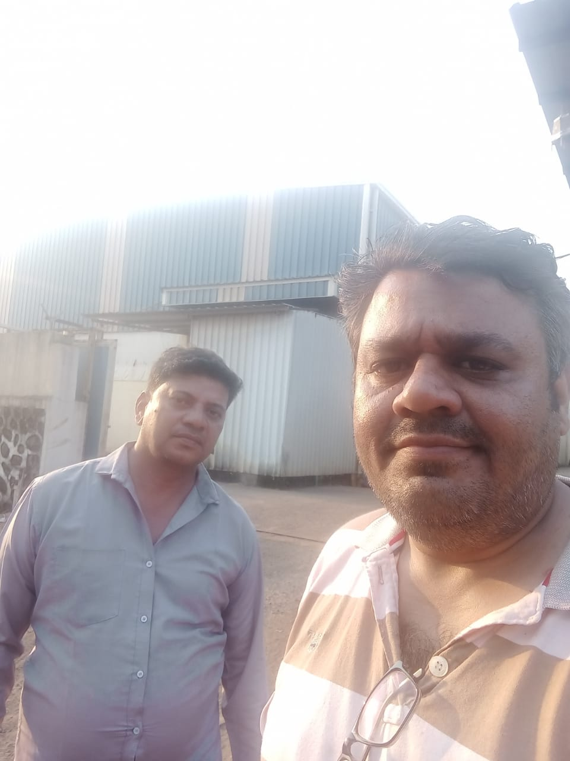


ROUTE MAP OF THE PROPERTY
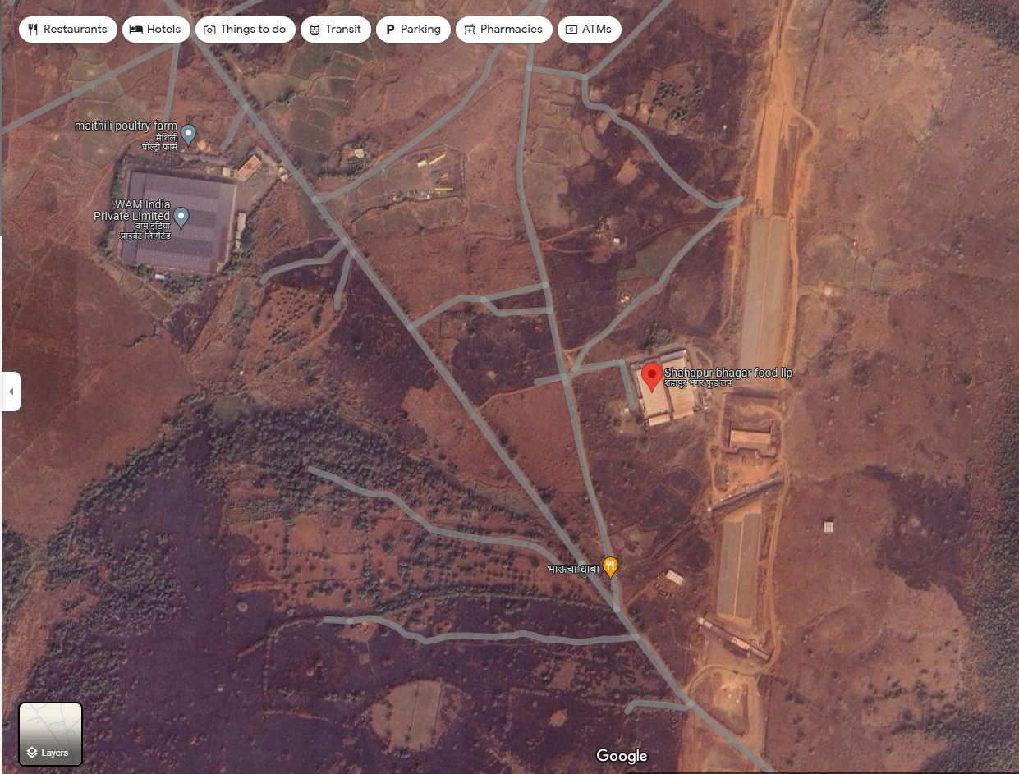
Site u/r

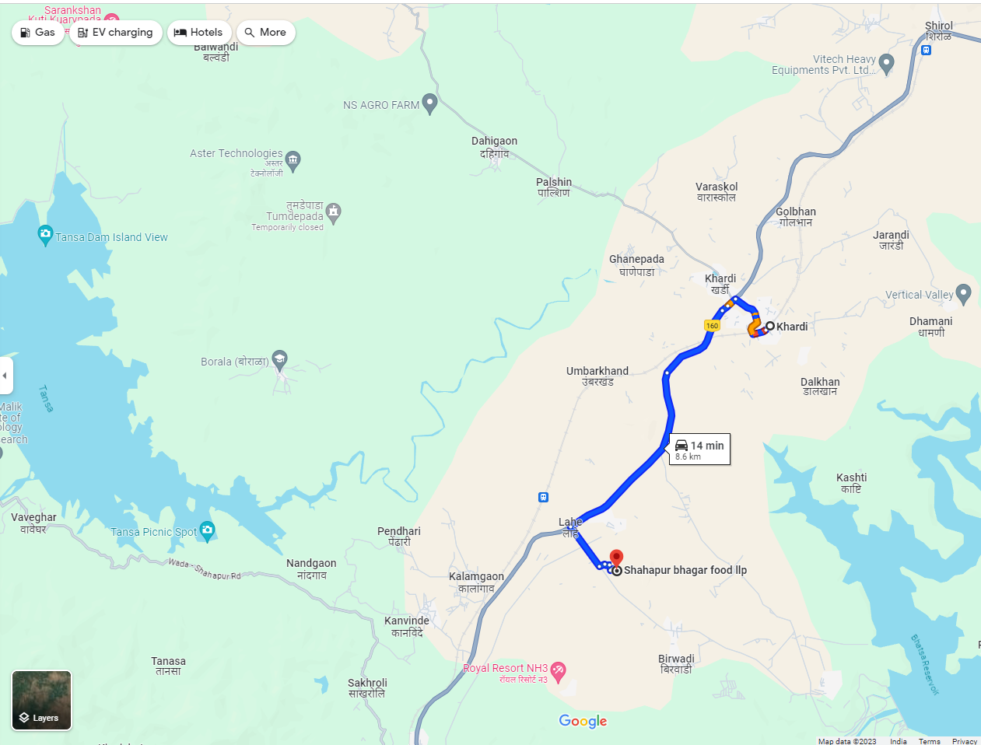

Latitude Longitude: 19°32'13.4"N 73°22'00.3"E
Note: The Blue line shows the route to site from nearest railway station (Khardi – 806 Km.)

ASSUMPTIONS, CAVEATS, LIMITATION AND DISCLAIMERS
- We assume no responsibility for matters of legal nature affecting the assets appraised or the title thereto, nor do we render our opinion as to the title, which is assumed to be good and marketable.
- The assets are valued as though under responsible ownership.
- It is assumed that the assets are free of liens and encumbrances.
- It is assumed that there are no hidden or unapparent conditions of the subsoil or structure that would render it more or less valuable. No responsibility is assumed for such conditions or for engineering that might be required to discover such factors.
- There is no direct/ indirect interest in the assets valued.
- The rates for valuation of the assets are in accordance with the Govt. Approved rates and prevailing market rates.
- The statements of fact presented in the report are correct to the best of the valuer’s knowledge.
- The “valuer/ appraiser” word implies the valuer him/herself or any authorised representative of the valuer.
- The analysis & conclusions are limited only by the reported assumptions & conditions.
- It is hereby stated that the valuer has followed the professional requirements and standards in this document.
- The valuer has no interest in the subject assets.
- The value’s fee is not contingent upon any aspect of the report.
- The valuation was performed in accordance with an ethical code and performance standards.
- The valuer has satisfied professional education requirements.
- The valuer has experience in the location and category of the assets being valued.
- Both legal description and dimension are taken from sources thought to be authoritative, however, no responsibility is assumed for either unless a survey, by a competent surveyor or engineer, is furnished to the appraiser.
- This report is valid only, subject to a legal search furnished by the Bank’s lawyer or legal advisor, ascertaining the ownership & genuineness of the document and clear & marketable title in the name of the present owner/owners.
- No responsibility is to be assumed for matters legal in nature, nor is any opinion of title rendered by this report. Good title is assumed.
- In no events shall the valuer be held responsible or liable for special, direct or consequential damages, as the assignment has been completed with best efforts, available knowledge & in good intentions following professional ethics.
- I have upon the invoices provided to us by the Client for the technical specification as well as details of manufacturer for the machineries or equipment. I have assumed that no major replacement of components in any of the machineries has been done unless otherwise specific details provided to me.
- Valuation is done on physical verification and external inspection basis. The valuer does not bear any responsibility for any error which is due to the assumptions made for working condition or internal part of machines which are not inspectable without dismantling.
- The Valuer, by reasons of this report, is not required to give testimony in court, with reference to the appraised assets unless arrangements for such contingency have been previously agreed upon.
- The analysis and additional data (like company information, micro-market data) of this report is based on Publicly available information, Industry Benchmark / Standards or my Professional Judgment where the information has not been furnished by the company.
- For the purpose of this exercise, I have assumed (where sufficient ownership data has not been provided) that the assets considered under this exercise are owned by the Company and has a clear and marketable title and is free from any legal and physical encumbrances, disputes, claims and other statutory liabilities and the requisite planning approvals from appropriate authorities has already been pursued; if any, I do not bear any responsibility for the same.
- The condition assessment and the estimation of useful life is based on industry standards as any visual observations / review of maintenance was beyond the scope of work.
- The inspection, due diligence and condition assessment of the asset was made by individuals generally familiar with valuation assessment of such assets. However, I do not opine nor am I responsible for its conformity to any health, safety, environmental or any other regulatory requirements that were not readily apparent to my team of experts during their inspection.
- This valuation is valid only for the purpose mentioned in this report; and neither intended nor valid to be used for any other purposes.
- The valuation is not a precise science and the conclusions arrived at in many cases will be subjective and dependent on the exercise of individual judgement. Hence, there is no indisputable single value. Whilst I consider my conclusions to be both reasonable and defensible based on the information available to us, others may place a different value based on the same information.
- I reserve my rights to change my conclusion at later date, if it is found that the data provided to us was not reliable, complete or accurate in any material aspect.
- For the purpose of this valuation report, the fair market value and fair value of the assets may be considered to be synonymous.
- All figures are in INR, unless mentioned otherwise. Further, round off errors (if any) arising from calculations or conversions to millions/ other units have negligible impact on the final value, therefore, can be ignored.

MODEL CODE OF CONDUCT FOR VALUERS (Annexure V)
Integrity and Fairness
- A valuer shall, in the conduct of his/its business, follow high standards of integrity and fairness in all his/its dealings with his/its clients and other valuers.
- A valuer shall maintain integrity by being honest, straightforward, and forthright in all professional relationships.
- A valuer shall endeavour to ensure that he/it provides true and adequate information and shall not misrepresent any facts or situations.
- A valuer shall refrain from being involved in any action that would bring disrepute to the profession.
- A valuer shall keep public interest foremost while delivering his services.

Professional Competence and Due Care
- A valuer shall render at all times high standards of service, exercise due diligence, ensure proper care and exercise independent professional judgment.
- A valuer shall carry out professional services in accordance with the relevant technical and professional standards that may be specified from time to time.
- A valuer shall continuously maintain professional knowledge and skill to provide competent professional service based on up-to-date developments in practice, prevailing regulations / guidelines and techniques.
- In the preparation of a valuation report, the valuer shall not disclaim liability for his/its expertise or deny his/its duty of care, except to the extent that the assumptions are based on statements of fact provided by the company or its auditors or consultants or information available in public domain and not generated by the valuer.
- A valuer shall not carry out any instruction of the client insofar as they are incompatible with the requirements of integrity, objectivity and independence.
- A valuer shall clearly state to his client the services that he would be competent to provide and the services for which he would be relying on other valuers or professionals or for which the client can have a separate arrangement with other valuers.
Independence and Disclosure of Interest
- A valuer shall act with objectivity in his/its professional dealings by ensuring that his/its decisions are made without the presence of any bias, conflict of interest, coercion, or undue influence of any party, whether directly connected to the valuation assignment or not.
- A valuer shall not take up an assignment if he/it or any of his/its relatives or associates is not independent in terms of association to the company.
- A valuer shall maintain complete independence in his/its professional relationships and shall conduct the valuation independent of external influences.
- A valuer shall wherever necessary disclose to the clients, possible sources of conflicts of duties and interests, while providing unbiased services.
- A valuer shall not deal in securities of any subject company after any time when he/it first becomes aware of the possibility of his / its association with the valuation, and in accordance with the Securities and Exchange Board of India (Prohibition of Insider Trading)Regulations,2015 or till the time the valuation report becomes public, whichever is earlier.
- A valuer shall not indulge in "mandate snatching" or offering "convenience valuations" in order to cater to a company or client's needs.
- As an independent valuer, the valuer shall not charge success fee.
- In any fairness opinion or independent expert opinion submitted by a valuer, if there has been a prior engagement in an unconnected transaction, the valuer shall declare the association with the company during the last five years.
Confidentiality
- A valuer shall not use or divulge to other clients or any other party any confidential information about the subject company, which has come to his / its knowledge without proper and specific authority or unless there is a legal or professional right or duty to disclose.
Information Management
- A valuer shall ensure that he/ it maintains written contemporaneous records for any decision taken, the reasons for taking the decision, and the information and evidence in support of such decision. This shall be maintained so as to sufficiently enable a reasonable person to take a view on the appropriateness of his /its decisions and actions.
- A valuer shall appear, co-operate and be available for inspections and investigations carried out by the authority, any person authorised by the authority, the registered valuers organisation with which he/it is registered or any other statutory regulatory body.
- A valuer shall provide all information and records as may be required by the authority, the Tribunal, Appellate Tribunal, the registered valuers organisation with which he/it is registered, or any other statutory regulatory body.
- A valuer while respecting the confidentiality of information acquired during the course of performing professional services, shall maintain proper working papers for a period of three years or such longer period as required in its contract for a specific valuation, for production before a regulatory authority or for a peer review. In the event of a pending case before the Tribunal or Appellate Tribunal, the record shall be maintained till the disposal of the case.
Gifts and hospitality:
- A valuer or his / its relative shall not accept gifts or hospitality which undermines or affects his independence as a valuer.
- Explanation: For the purposes of this code the term 'relative' shall have the same meaning as defined in clause (77) of Section 2 of the Companies Act, 2013 (18 of 2013).
- A valuer shall not offer gifts or hospitality or a financial or any other advantage to a public servant or any other person with a view to obtain or retain work for himself / itself, or to obtain or retain an advantage in the conduct of profession for himself / itself.
Remuneration and Costs.
- A valuer shall provide services for remuneration which is charged in a transparent manner, is a reasonable reflection of the work necessarily and properly undertaken, and is not inconsistent with the applicable rules.
- A valuer shall not accept any fees or charges other than those which are disclosed in a written contract with the person to whom he would be rendering service.

Occupation, employability and restrictions.
- A valuer shall refrain from accepting too many assignments, if he/it is unlikely to be able to devote adequate time to each of his/ its assignments.
- A valuer shall not conduct business which in the opinion of the authority or the registered valuer organisation discredits the profession.
Miscellaneous
- A valuer shall refrain from undertaking to review the work of another valuer of the same client except under written orders from the bank or housing finance institutions and with knowledge of the concerned valuer.
- A valuer shall follow this code as amended or revised from time to time.

DEFINITION OF VALUE FOR THIS SPECIFIC PURPOSE
This exercise is to assess Fair Market Value of the property under reference as on 01st January 2024 The term Fair Market Value is defined as
“The most probable price, as of a specified date, in cash, terms equivalent to cash, or in other precisely revealed terms for which the specified property rights would sell after reasonable exposure in a competitive market under all conditions requisite to a fair sale, with the buyer and seller each acting prudently knowledgeably and for self-interest assuming that neither is under undue duress”.
Fundamental assumptions and conditions presumed in this definition are:
- Buyer and seller are motivated by self-interest.
- Buyer and seller are well informed and are acting prudently.
- The property is exposed for a reasonable time on the open market.
- Payment is made in cash or equivalent or in specified financing terms.
DECLARATION OF PROFESSIONAL FEES CHARGED
We hereby declare that our professional fees are not contingent upon the valuation findings. However, if the statute AND/OR client demands that, the fees should be charged on the percentage of assessed value then, with the full knowledge of the AND/OR end user, it is being charged accordingly.

VALUATION OF MOVABLE ASSETS
Considering various parameters recorded, existing economic scenario, and the information that is available with reference to the industrial development and method selected for valuation, we are of the opinion that, the assets can be assessed and valued for particular purpose at:
Particulars | Fair Market Value (`) | Realizable Value (`) | Distress Sale Value (`)
Plant and Machinery | 55,23,000.00 | 46,94,550.00 | 38,66,100.00

Place: Mumbai
Date: 01.01.2024
For Vastukala Consultants (I) Pvt. Ltd.

Umang Ashwin Patel
Regd. Valuer
Chartered Engineer (India)
Reg. No. IBBI/RV/04/2019/10803
SBI Empanelment No.- SME/TCC/2021-22/86/4

