VALUATION REPORT OF THE MOVABLE PROPERTY

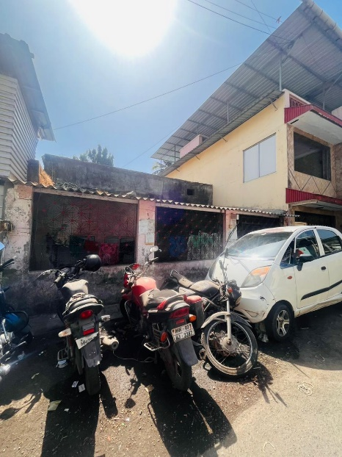

**Details of the property under consideration:**

**Name of Client: Mr. Tejindersingh Sewasingh Kumar**

**Guarantor of M/s. Nagesh Textile (Prop. Mr. Nagesh Mallesham Upalla)**

Movable Assets Available at Row House No. 109/42, Malabar Hill Road, Mulund Colony, Mulund (West),

Mumbai – 400 082, State – Maharashtra, Country – India.

# **Latitude Longitude: 19°10'45.0"N 72°56'16.8"E**

**Intended User:**

**Cosmos Bank**

**Recovery W-Off Wing, MRO, Dadar (West)**

36-A, Maru Niketan, D. L. Vaidya Road, Dadar (West), Mumbai - 400028, State - Maharashtra, Country - India

|  |  |  |  |  |  |  |  |  |  |  |  |  |  |  |  |  |  |  |  |  |  |  |  |  |  |  |  |  |  |  |  |  |  |  |  |  |  |  |  |  |  |  |  |  |  |  |  |  |  |  |  |  |  |  |  |  |  |  |  |  |  |  |  |  |  |  |  |  |  |  |  |  |  |  |  |  |  |  |  |  |  |  |  |  |  |  |  |  |  |  |  |  |  |  |  |  |  |  |  |  |  |  |  |  |  |  |  |  |  |  |  |  |  |  |  |  |  |  |  |  |  |  |  |  |  |  |  |  |  |  |  |  |  |  |  |  |  |  |  |  |  |  |  |  |  |  |  |  |  |  |  |  |  |  |  |  |  |  |  |  |  |  |  |  |  |  |  |  |  |  |  |  |  |  |  |  |  |  |  |  |  |  |  |  |  |  |  |  |  |  |  |  |  |  |  |  |  |  |  |  |  |  |  |  |  |  |  |  |  |  |  |  |  |  |  |  |  |  |  |  |  |  |  |  |  |  |  |  |  |  |  |  |  |  |  |  |  |  |  |  |  |  |  |  |  |  |  |  |  |  |  |  |  |  |  |  |  |  |
| --- | --- | --- | --- | --- | --- | --- | --- | --- | --- | --- | --- | --- | --- | --- | --- | --- | --- | --- | --- | --- | --- | --- | --- | --- | --- | --- | --- | --- | --- | --- | --- | --- | --- | --- | --- | --- | --- | --- | --- | --- | --- | --- | --- | --- | --- | --- | --- | --- | --- | --- | --- | --- | --- | --- | --- | --- | --- | --- | --- | --- | --- | --- | --- | --- | --- | --- | --- | --- | --- | --- | --- | --- | --- | --- | --- | --- | --- | --- | --- | --- | --- | --- | --- | --- | --- | --- | --- | --- | --- | --- | --- | --- | --- | --- | --- | --- | --- | --- | --- | --- | --- | --- | --- | --- | --- | --- | --- | --- | --- | --- | --- | --- | --- | --- | --- | --- | --- | --- | --- | --- | --- | --- | --- | --- | --- | --- | --- | --- | --- | --- | --- | --- | --- | --- | --- | --- | --- | --- | --- | --- | --- | --- | --- | --- | --- | --- | --- | --- | --- | --- | --- | --- | --- | --- | --- | --- | --- | --- | --- | --- | --- | --- | --- | --- | --- | --- | --- | --- | --- | --- | --- | --- | --- | --- | --- | --- | --- | --- | --- | --- | --- | --- | --- | --- | --- | --- | --- | --- | --- | --- | --- | --- | --- | --- | --- | --- | --- | --- | --- | --- | --- | --- | --- | --- | --- | --- | --- | --- | --- | --- | --- | --- | --- | --- | --- | --- | --- | --- | --- | --- | --- | --- | --- | --- | --- | --- | --- | --- | --- | --- | --- | --- | --- | --- | --- | --- | --- | --- | --- | --- | --- | --- | --- | --- | --- | --- | --- | --- | --- | --- | --- | --- | --- | --- | --- | --- | --- | --- |
| Vastu/Cosmos/ Mumbai/03/2024/7297/2305486 13/16-234-VSU  Date: 13.03.2024  To,  **The Branch Manager,**  **Cosmos Bank**  **Recovery W-Off Wing, MRO, Dadar (West)**  36-A, Maru Niketan, D. L. Vaidya Road,  Dadar (West), Mumbai - 400028,  State - Maharashtra, Country - India  **Sub:** Valuation of "**Movable Property**" at Row House No. 109/42, Malabar Hill Road, Mulund Colony, Mulund (West), Mumbai – 400 082, State – Maharashtra, Country – India.  Dear Sir,  This is to certify that the Movable Assets available at Row House No. 109/42, Malabar Hill Road, Mulund Colony, Mulund (West), Mumbai – 400 082, State – Maharashtra, Country – India belongs to Mr. Tejindersingh Sewasingh Kumar Guarantor of M/s. Nagesh Textile (Prop. Mr. Nagesh Mallesham Upalla) Considering various parameters recorded, existing economic scenario, and the information that is available with reference to the development of neighborhood and method selected for valuation, we are of the opinion that, the asset can be assessed for this particular purpose is not more than **` 25,000.00 (Rupees Twenty Five Thousand Only).**  The valuation of the property is based on the documents produced by the concern. Legal aspects have not been taken into considerations while preparing this valuation report.  Hence certified  **Sharadkumar B. Chalikwar**  Govt. Reg. Valuer  Chartered Engineer (India)  Reg. No. (N) CCIT/1-14/52/2008-09  Encl: Valuation Report  **Movable Property considered for the Valuation as per site visit dated 29.02.2024 and Inventory List dated 28.04.2022 provided by the bank.**   |  |  |  | | --- | --- | --- | | **Location** | **Inventory List** | **Nos.** | | Hall | Wall Watch | 1 | | Hall | Tube Light | 4 | | Hall | Wooden Chair | 4 | | Hall | Stool | 1 | | Hall | Suit Case | 1 | | Hall | Book Rack | 1 | | Hall | Sealing Fan | 1 | | Hall | Tabla | 4 | | Hall | Harmonium | 2 | | Hall | Fan | 1 | | Hall | Table Light | 1 | | Hall | Bed | 1 | | Bedroom - 1 | Cushion Chair | 2 | | Bedroom - 1 | Dinning Table with 5 chairs | 2 | | Bedroom - 1 | Bed | 1 | | Bedroom - 1 | Teapoy | 1 | | Bedroom - 1 | Computer Table | 1 | | Bedroom - 1 | Gas Stove | 1 | | Bedroom - 1 | Cushion Sofa | 1 | | Bedroom - 1 | ceiling fan | 1 | | Kitchen | Kitchen with Trolley with Utensil | 1 | | Kitchen | Gas Cylinder | 2 | | Kitchen | Gas Stove | 1 | | Kitchen | Fridge | 1 | | Kitchen | Oven | 1 | | Kitchen | Wooden Cupboard | 1 | | Kitchen | Wooden Cupboard with Kitchen Set | 1 | | Kitchen | Fan | 1 | | Kitchen | Tube Light | 2 | | Kitchen | Chair | 1 | | Kitchen | Alumimiun Pot | 1 | | Kitchen | Ghamela | 1 | | Rear side of bedroom | Cupboard | 3 | | Rear side of bedroom | Fan | 1 | | Rear side of bedroom | Iron | 1 | | Rear side of bedroom | Wooden cupboard | 1 | | Rear side of bedroom | Mobile | 2 | | Rear side of bedroom | Tare steel | 2 | | Rear side of bedroom | Vessel | 2 | | Rear side of bedroom | Dressing table (Small + Glass door) Showcase | 1 | | Rear side of bedroom | Bed with cushion | 1 | | Rear side of bedroom | Metal chair | 1 | | Rear side of bedroom | Tub | 1 | | Rear side of bedroom | Wooden chair | 2 | | Rear side of bedroom | MS grill door at back side | 1 | | Rear side of bedroom | Fan | 1 | | Rear side of bedroom | Watch | 1 | | Bathroom near kitchen | Washing machine | 1 | | Bathroom near kitchen | Bucket | 1 | | Bathroom near kitchen | Mug | 1 | | Bathroom near kitchen | Geyser | 1 | | Bathroom near kitchen | Commode | 1 | | Bathroom near kitchen | Wash basin | 1 | | **Location** | **Inventory List** | **Nos.** | | Bathroom near kitchen | Dustbin | 1 | | Bedroom - 2 | MS cupboard | 2 | | Bedroom - 2 | Bed | 1 | | Bedroom - 2 | Small Stool | 1 | | Bedroom - 2 | Table fan | 1 | | Bedroom - 2 | Geyser | 1 | | Bedroom - 2 | Commode | 1 | | Bedroom - 2 | Wash basin | 1 | | Bedroom - 2 | Plastic buckets | 2 | | Bedroom - 2 | Watch | 1 | | Bedroom - 2 | Tube light | 2 | | Bedroom - 2 | Dressing table | 1 | | Bedroom - 2 | Bag | 2 | | Bedroom - 2 | Ceiling Fan | 1 | | Bedroom - 2 | New Fan in the cupboard | 1 | | Bedroom - 2 | Scanner Printer | 1 | | Bedroom - 2 | Hooper | 1 | | Bedroom - 2 | Sound Machine | 1 | | Bedroom - 2 | Tube light | 3 | | Bedroom - 2 | Wooden bed | 1 | | Bedroom - 2 | plastic bucket | 1 | | Space Main Gate | Sofa | 1 | | Space Main Gate | Wooden table | 1 | | Space Main Gate | Wooden chair | 1 | | Space Main Gate | Ceiling fan | 1 | | Space Main Gate | Tube Light | 2 | | Space Main Gate | Wooden table | 1 | | Space Main Gate | Plastic bucket | 2 | | Space Main Gate | Water Motor with connection | 1 | | Space Main Gate | Ply | 1 | | Space Main Gate | Plastic bucket | 1 | |

**The inventory was locked in the flat since last 10 years. Most of the articles are unusable and in scrap condition, which may require costing of discarding the material. Hence in our opinion scrap value shall not be more than ` 25,000.00 (Rupees Twenty Five Thousand Only) of the inventory as on date.**

**Actual Site Photographs**

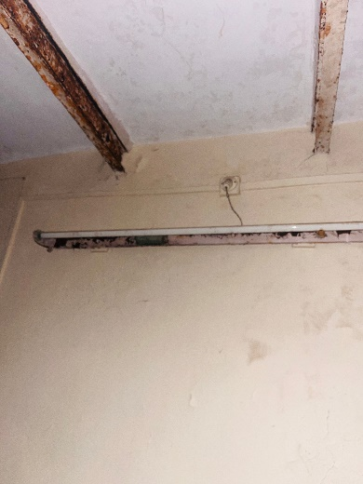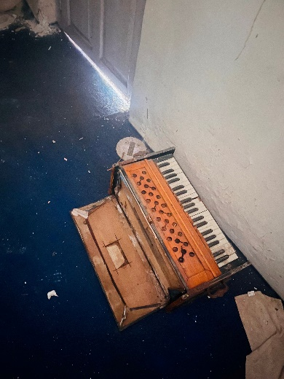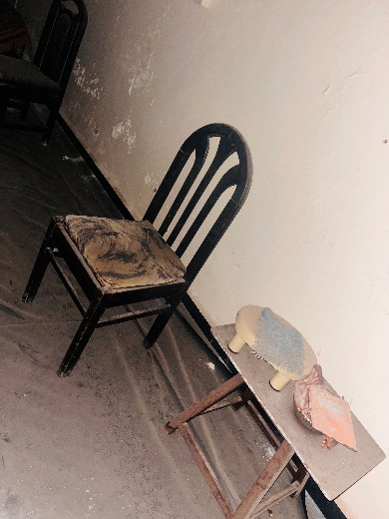

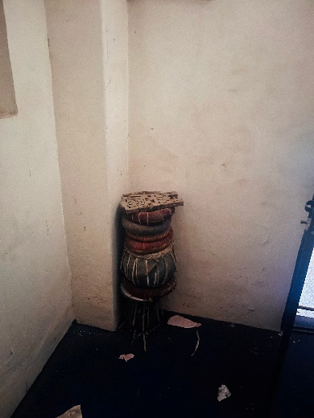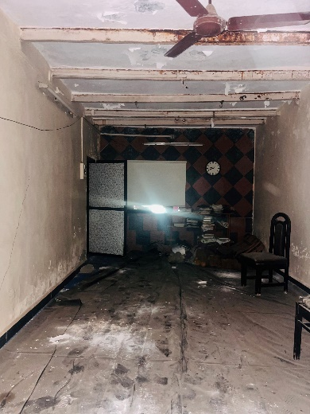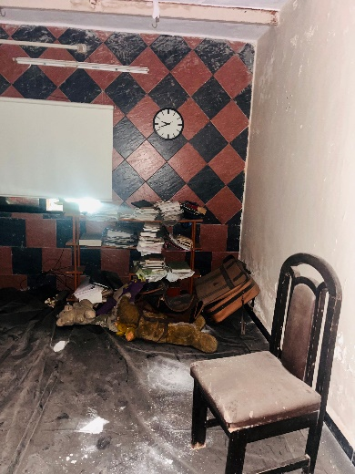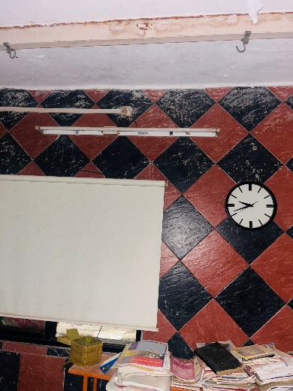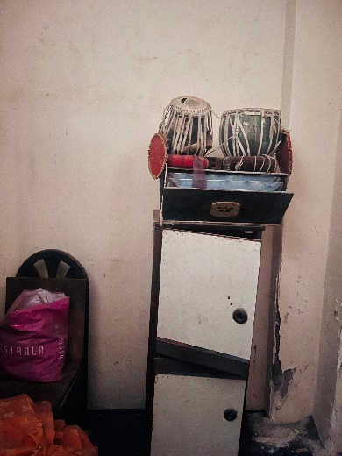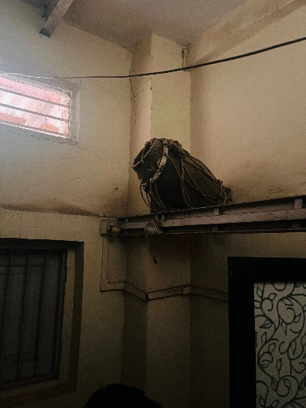**Actual Site Photographs**

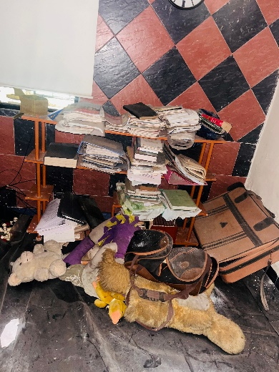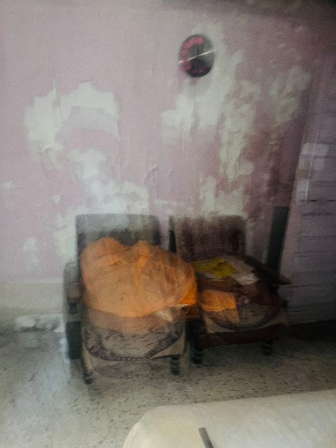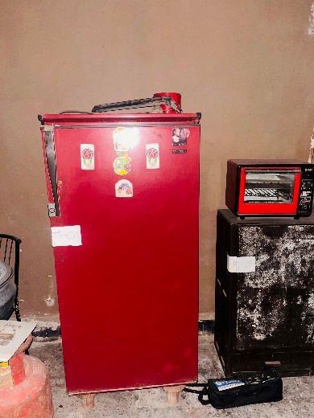

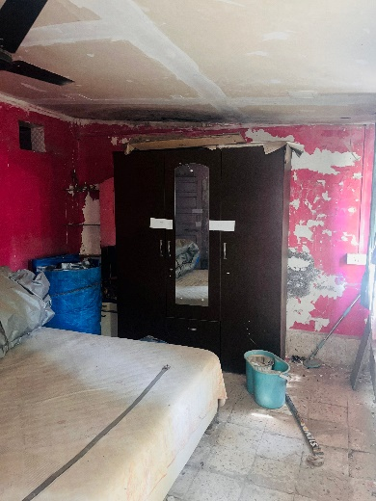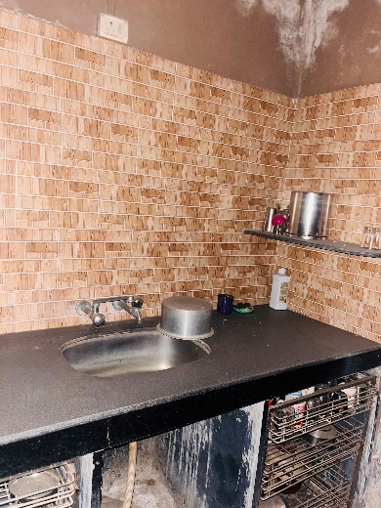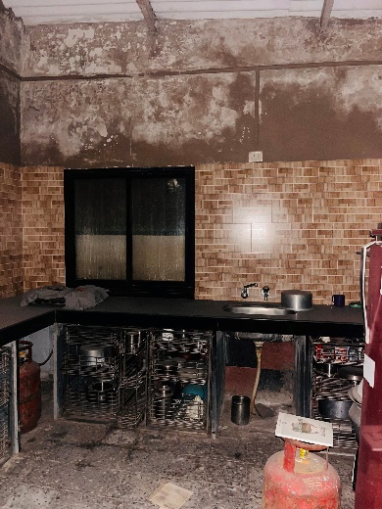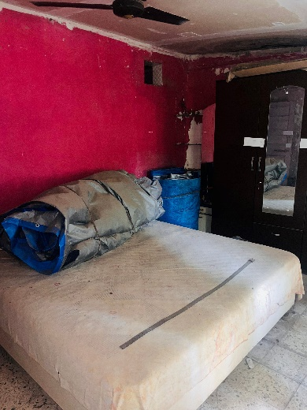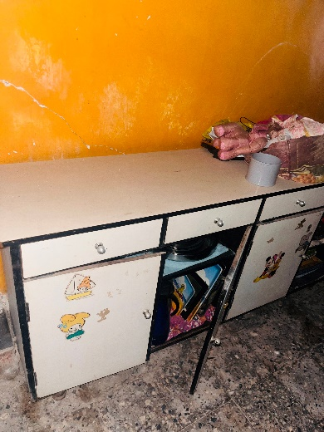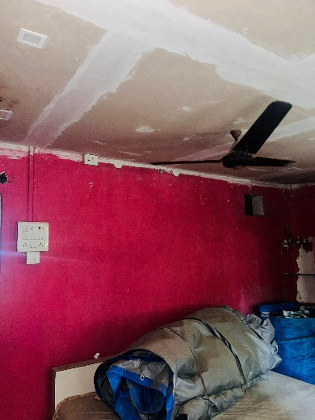

**Actual Site Photographs**

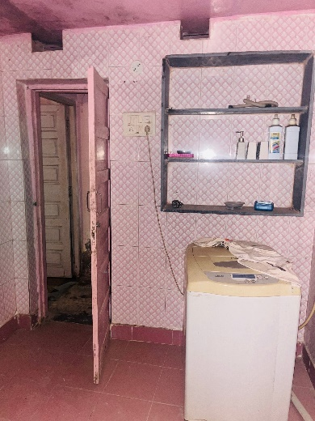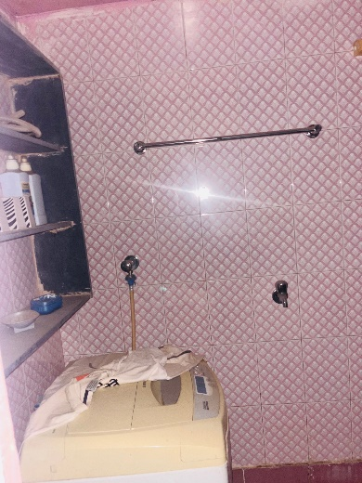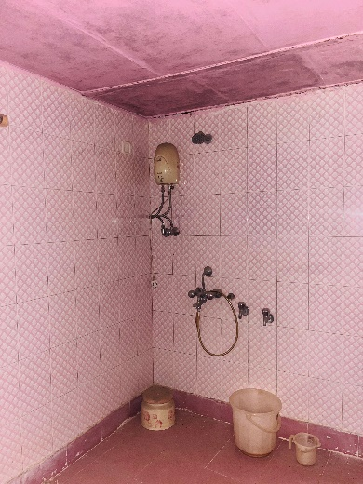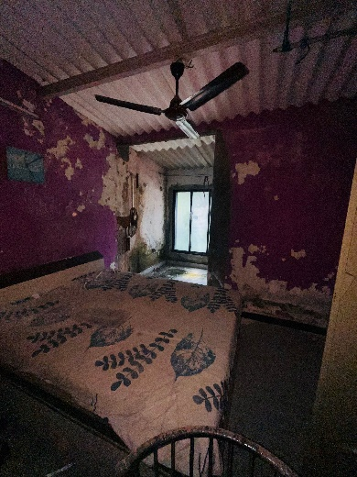

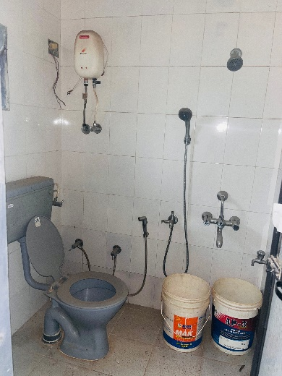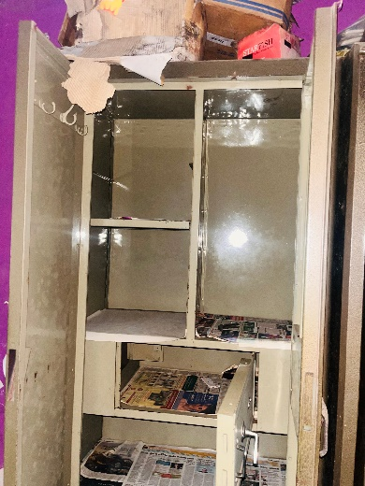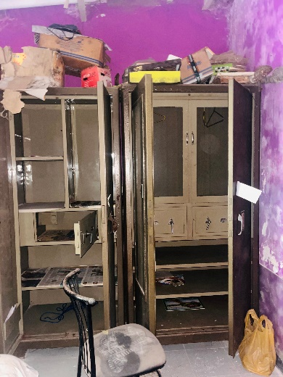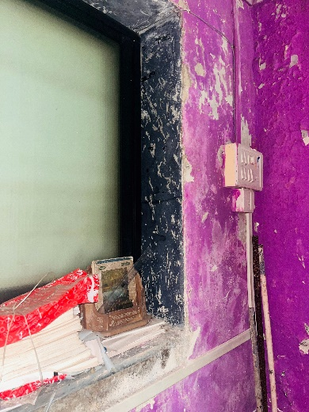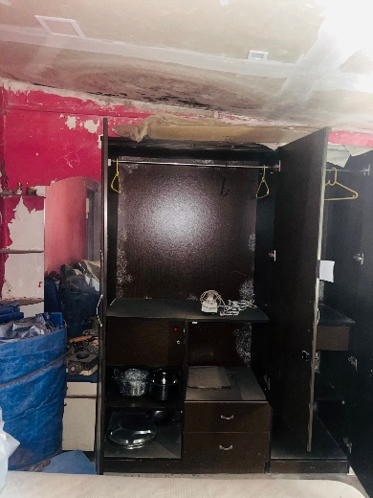

**Actual Site Photographs**

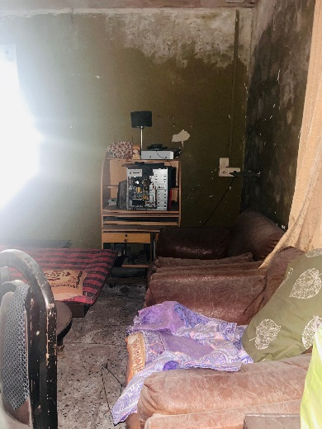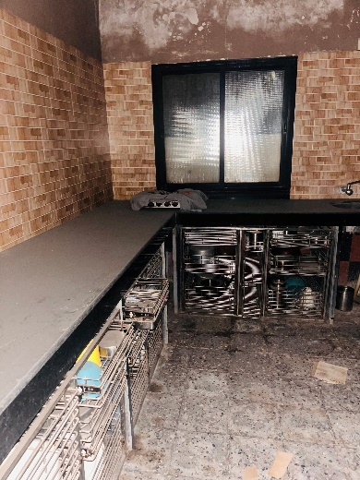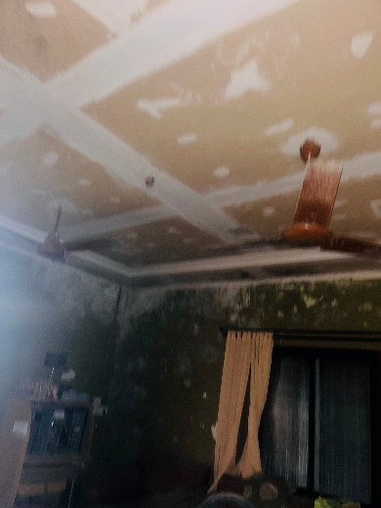

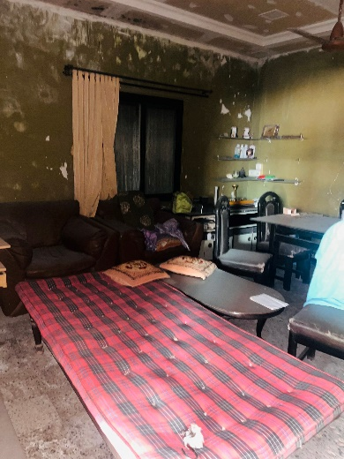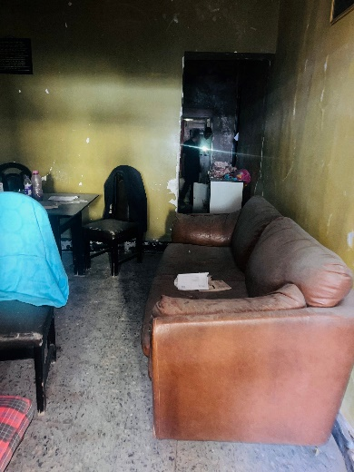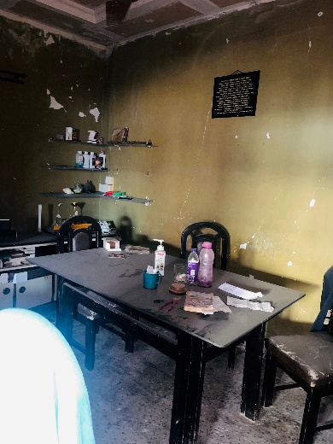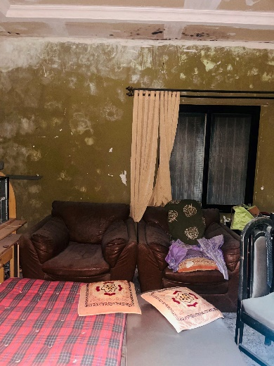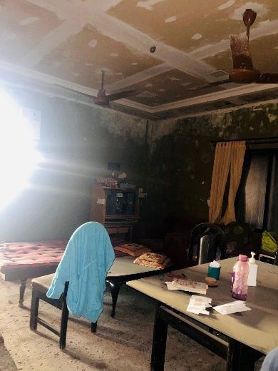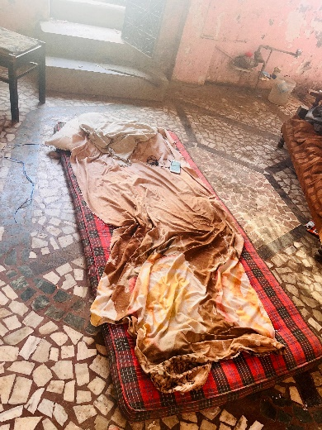

**Actual Site Photographs**

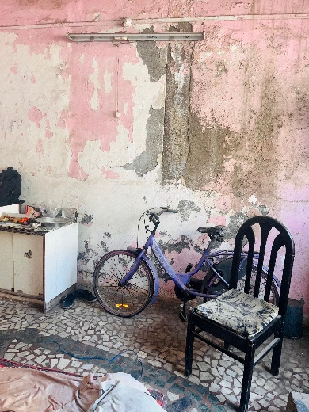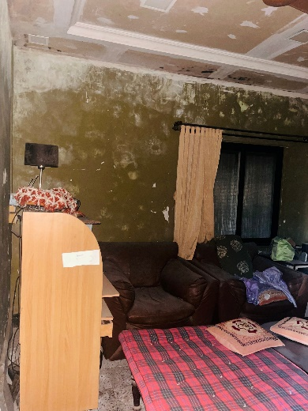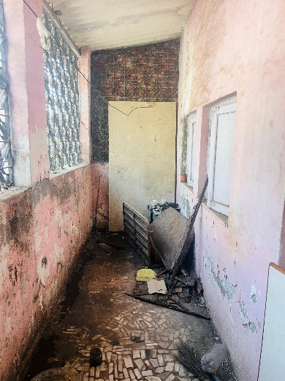

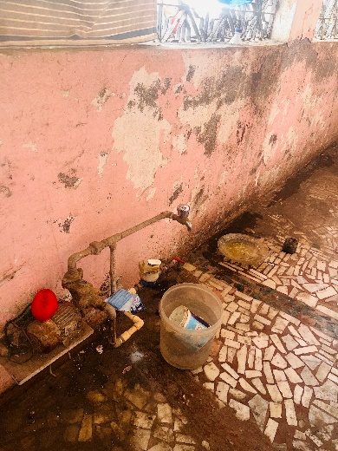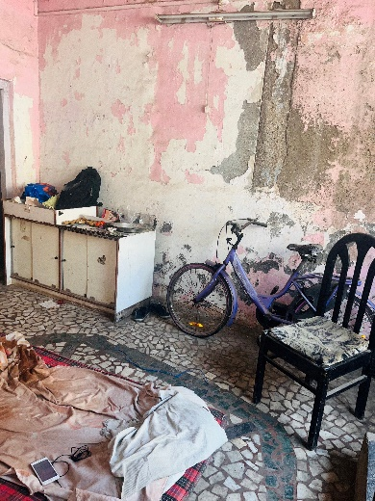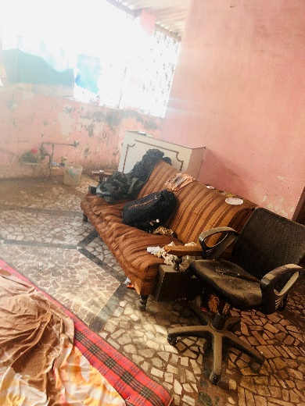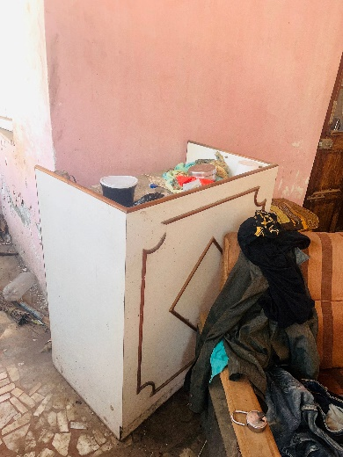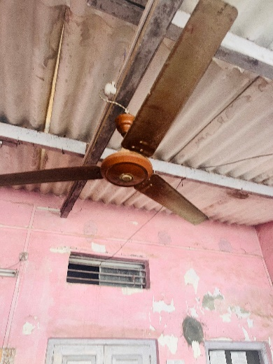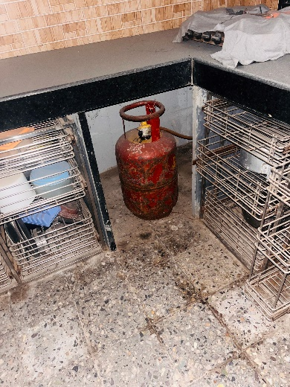

**Actual Site Photographs**

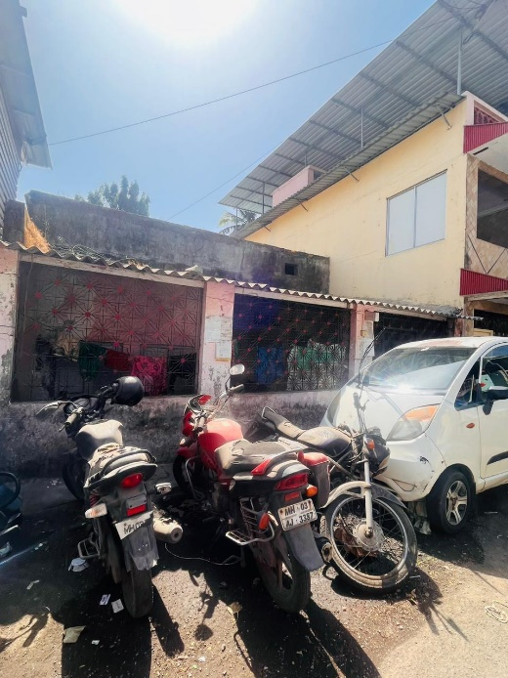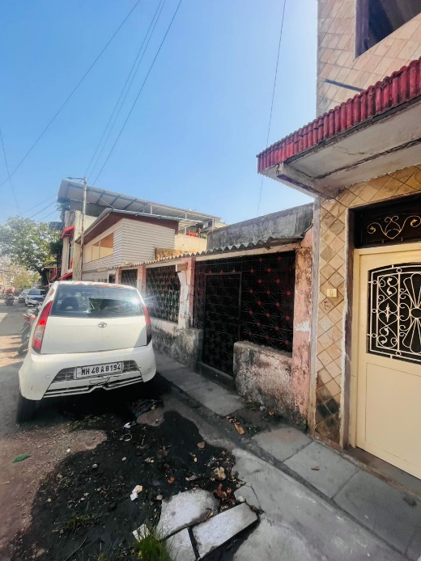

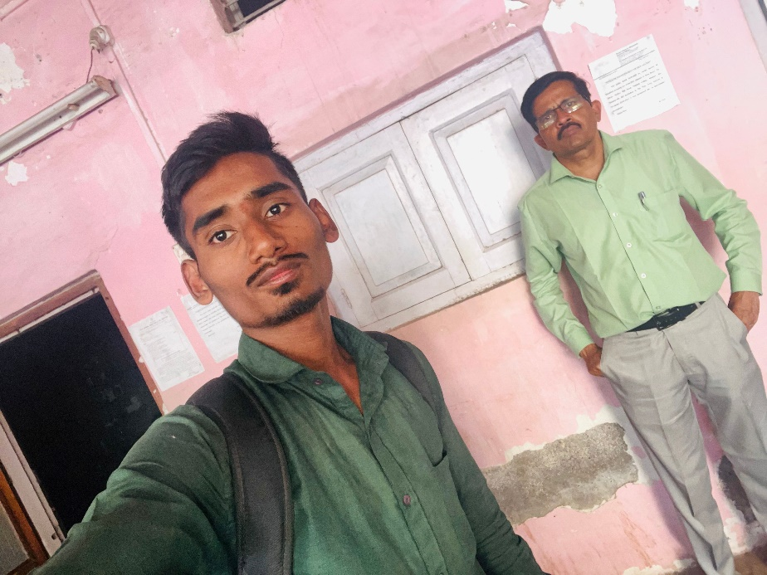

**Route Map of the property**

**Site u/r**

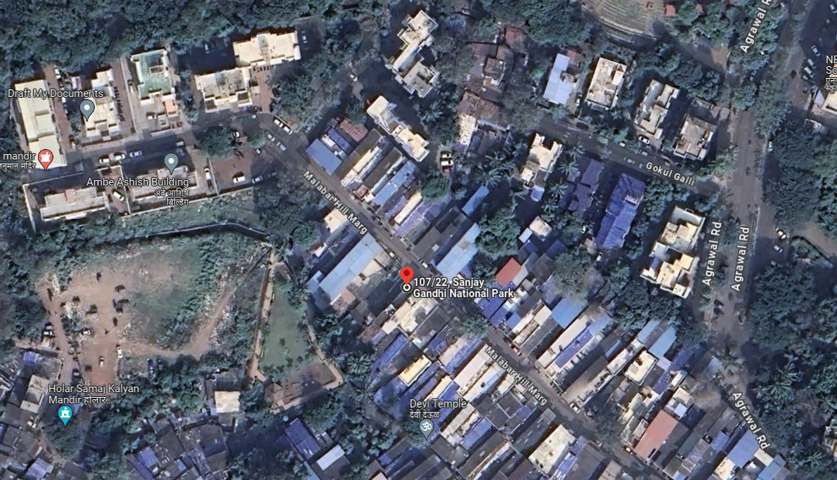

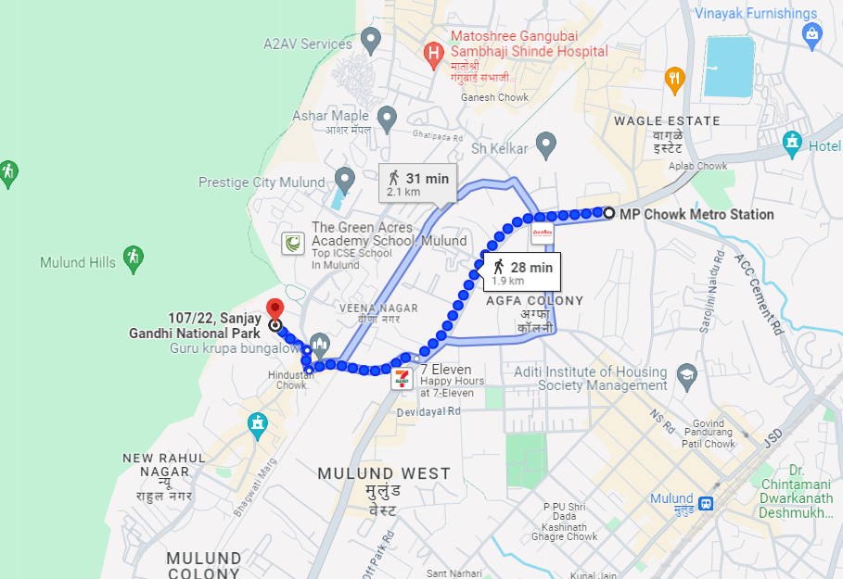

# **Latitude Longitude: 19°10'45.0"N 72°56'16.8"E**

# **Note:** The Blue line shows the route to site from nearest Metro station (Mulund – 1.9 Km.)