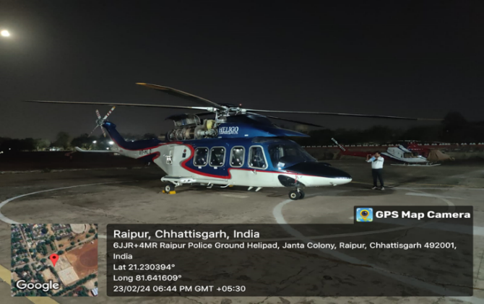 Chapter 1 the assignment 3

Report Prepared for : **Union Bank of India**

capital market cell M.S. Marg, Fort, Mumbai

Report Prepared By : **Vastukala Consultants (I) Pvt. Ltd., Mumbai**

B1-001, UB, Boomerang Near Chandivali Studio, Andheri,

Mumbai - 400072, State - Maharashtra, Country - India

Valuation of Helicopter (AW-139)

Owned by Heligo Charters Private Limited (VT-HLD)

Chapter 2 Purpose of valuation and appointing authority; 3

Chapter 3 Identity of the valuer and any other experts involved in the valuation 4

Disclosure of Valuer's Interest 4

Assumptions 5

Chapter 4 Background of valuer company 6

Chapter 5 About the owner: Heligo Charters Pvt. Ltd. 9

Chapter 6 Date of appointment, valuation date and date of report; 10

Chapter 7 Assets to be Valued: 10

Details considered for valuation: 10

Chapter 8 Summary of Valuation: 11

Market Approach Value: 11

Cost Approach Value: 11

Income Approach Value: 11

Chapter 9 Background Information of the asset being valued 13

Helicopter Background: 13

Base value: 13

Types of appraisals: 14

Market value: 15

Distress value: 16

Securitized value: 16

Appraiser's report: 17

Chapter 10 Bases of Value; 18

Chapter 11 Premise of Value as per ivs - international valuation standards 20

Premise of Value – Highest and Best Use 21

Premise of Value – Current Use/Existing Use 22

Premise of Value – Orderly Liquidation 22

Premise of Value – Forced Sale 22

Chapter 12 Inspections and /or investigations undertaken; 25

Airframe-VT-HLD - 31281 25

Insurance 26

Chapter 13 Nature and sources of information; 28

Chapter 14 Significant Assumptions, if any; 29

Airframe-AW139 29

VT-HLD Valuation Working 32

Chapter 15 Procedures adopted in carrying out the valuation and valuation standards followed; 33

Chapter 16 Restrictions on use of report, if any; 33

Chapter 17 Major factors that were taken into account during valuation; 33

Airframe hours and age 33

ENGINE HOURS 33

Installed equipment 33

Records and Airworthiness Directives 34

Damage history 34

Paint 34

Interior 34

Chapter 18 Actual Photograph 35

Actual Photo of Airframe- VT-HLD 35

1. Cabin interior 35

2. Head and engine 36

3. Data Plate 36

4. Tail assembly 37

5. external Photo 38

Vastu/Mumbai/12-2020/18723/34111

Date: 28.12.2020

# the assignment

Determination of fair market value of Helicopter VT-HLD hypothecated to Union Bank of India

# Purpose of valuation and appointing authority;

Mr. Ankush Jaiswal Senior Manager Union Bank of India, capital market cell M.S. Marg, Union Bank Of India Building , Ground Floor, 66/80, Mumbai Samachar Marg, Fort, Mumbai-400023, Has appointed M/s Vastukala Consultants (I) Pvt. Ltd. – Mr. Umang Ashwin Patel - Registered Valuer –Movable Property to provide an opinion on Determination of fair market value Helicopter VT-HLD hypothecated to Union Bank of India.

|  |  |
| --- | --- |
| **Valuer** | **Details** |
| Name of the Valuer | **Umang Ashwin Patel** |
| Registration number | Reg. No. IBBI/RV/04/2019/10803 |
| E-mail | [umang@vastukala.org](mailto:manoj@vastukala.org)  mumbai@vastukala.org |
| Address | **Vastukala Consultants (I) Pvt. Ltd.**  B1-001, UB, Boomerang Near Chandivali Studio, Andheri, Mumbai - 400072, State - Maharashtra, Country - India |

|  |  |
| --- | --- |
| **Bank** | **Details** |
| Name of the Bank | **Union Bank of India** |
| Bank Officer | Mr. Ankush Jaiswal, Senior Manager |
| E-mail | [ankushjaiswal@unionbankofindia.bank](mailto:ankushjaiswal@unionbankofindia.bank) |
| Address | Union Bank Of India capital market cell M.S. Marg,  Union Bank Of India Building , Ground Floor, 66/80, Mumbai Samachar Marg, Fort, Mumbai-400023Mumbai - 400 001, Maharashtra State, India |

# Identity of the valuer and any other experts involved in the valuation

**Mr. Umang A. Patel** - Register Valuer

Mr. Manoj B. Chalikwar - Registered Valuer

Mr. Rituraj Shrivastava, Aviation Engineer & Subject Expert.

Having experience in the field of General Engineering and Helicopter Maintenance since last 30 years. Have done numerous machine inspections, assessments and repairs in all these years.

## Disclosure of Valuer's Interest

***I, Umang Ashwin Patel*** *hereby declare that - I have no interest, either direct or indirect, in subject asset. Further to state that I do not have relation or any connection with Promoters or Directors or any officer of the client company, directly or indirectly. Further to state that I am independent and in no way related to any officials of Company.*

*This report is prepared on the request of Bank of India as Lenders and this report only to be used in its entirety, and for the purpose stated in the report. No third parties should refer or rely on the information or data contained in this report. This report should not be used for any other purpose than stated above - Valuer does not takeany responsibily for unauthorised usage of the report.*

*We have acknowledged that we have no present or contemplated financial interest in the Company or assets valued. Our fees for this valuation is based upon our normal billing rates, and not contingent upon the results or the value or any other manner. We have no responsibility to modify this report for events and circumstances occurring subsequent to the date of this report.*

*We haveused conceptually sound and generally accepted methods, principles and procedures of International valuation standarsd determining the value estimate included in this report.*

## Assumptions

*The Opinion of Value given in this report is based on information provided by Heligo Charters Private Limited. officials and Management team and other sources as listed in the report. This information is assumed to be accurate and complete.*

*We have relied upon the representation contained in the public domain and other documents in my possession concerning the value and useful condition of the assets, and any other assets or liabilities except as specifically stated to contrary in this report.*

*We have not attempted to confirm whether or not all assets have good title. We have been informed by the management that there are no environmental or Infringement of brand, trade or patent or any significant lawsuits, orany other undisclosed Contingent liabilities which may potentially affect the Value, except as explicitly stated in this report.*

# Background of valuer company





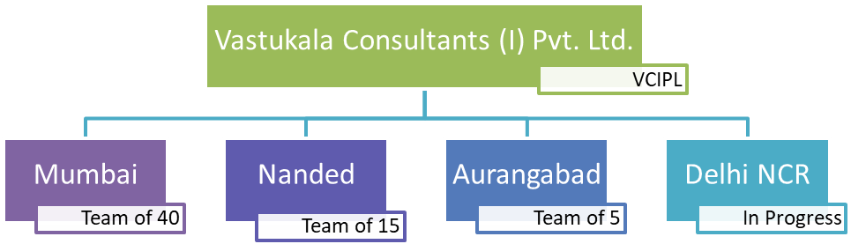

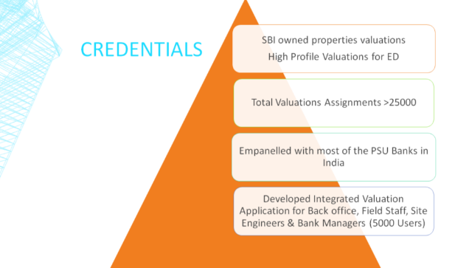

# About the owner: Heligo Charters Pvt. Ltd.

Heligo Charters Pvt. Ltd ( HCPL ) is in the business of providing Onshore Helicopter support to Corporates, VIPs and offshore helicopter services to the Oil & Gas industry in India. Formed & operated by a team of highly experienced aviation professionals in Onshore and Off Shore Helicopter Services, the Company is a part of the Globe straddling J V Gokal Group (JVG).

HCPL has the distinction of launching the "state of the art" AW 139 Helicopter in India, which is now recognized as the ideal air logistics machine for servicing the needs of deep water blocks under exploration in India. The induction of the AW 139 Helicopter in the country's offshore is in line with the company's aspiration to be a force multiplier for the Oil Industry, as India goes further and deeper into the seas in its Exploration & Production endeavour. HCPL is the only Helicopter company in India , operating FOUR different types of Medium Twin Engine Helicopters Viz AW 139, BELL 412, AS365N3 and Airbus H145. We firmly believe that the foundation for success in aviation is built upon the corner stones of safety and operational reliability, HCPL is committed to maintaining best - in - industry standards in Helicopter Operations at all times; it is the 'K' constant of our business.

**HCPL CORPORATE VISION**

HCPL Corporate Vision - "Becoming the ultimate Onshore and Offshore Air Logistics company through the pursuit of holistic excellence"; is borne out of our philosophy of total commitment to the customer.

**COMPANY MANAGEMENT & EXPERIENCE**

HCPL management constitutes of personnel who are highly qualified, experienced and extremely conversant in running helicopter charter services for VIPs, corporates & the offshore Oil & Gas Exploration & Production sector.

**ACCOUNTABLE MANAGER**

Air Cmde Dayasagar

Air Cmde Dayasagar, commissioned as a helicopter pilot in the Indian Air Force in Dec 1985, boasts a 37-year aviation career with over 5300 flight hours on diverse military and civil helicopters. Notably, he served as the Commanding Officer of a Frontline Combat Helicopter Unit in central India, overseeing national tasks such as aid to civil power, VVIP flying, and disaster relief operations. His exceptional contributions extend to two prestigious UN missions in Sierra Leone ('Op Kukri') and Sudan, where he led a crucial Aviation Contingent during pivotal political stages.

Within the IAF, Air Cmde Dayasagar held a significant role in the Directorate of Operations (Helicopters) at Air HQ, managing the helicopter fleet and providing operational support to defense services and aid to civil power. His initiative led to the establishment of the UN Cell in IAF HQ, New Delhi. Following a premature separation from the IAF, he joined the top management of Pawan Hans Ltd, a Mini Ratna CPSE, serving as Executive Director (Ops & Tech), (BD & Marketing), and the Accountable Manager for over six years.

**CHIEF FINANCIAL OFFICER**

Ashish Yadav

Ashish Yadav is a rank holder Chartered Accountant and a Cost Accountant with 23 years of experience. Also, he has a Diploma in Management Accounting from CIMA UK and is SAP FICO certified. He has an extensive knowledge in areas of reconciliation, finalization, evaluation and development of accounting systems, auditing and MIS.

**CHIEF COMMERCIAL OFFICER**

Nikesh Goswami

Nikesh Goswami has completed his MBA from Mumbai University and has gained experience of almost 20 years in helicopter sales and marketing for onshore and offshore activities. He is the dedicated chief commercial officer at Heligo since Sep 2021.

**DIRECTOR OPERATIONS**

Capt Sanjay Mishra

Has 30 years of aviation experience and over 13,500 hours of accident/incident free flying experience on both fixed and rotary wing Helicopter. He has been a Check Pilot and Examiner on Bell 412 as well as AW 139 helicopters.

# Date of appointment, valuation date and date of report;

|  |  |
| --- | --- |
| **Appointment Date** | 07.02.2024 |
| **Date of Visit** | 23.02.2024 |
| **Date of Valuation** | 06.03.2024 |
| **Date (last set of Data received)** | 05.03.2020 |
| **Date of Report** | 06.03.2020 |

# Assets to be Valued:

|  |  |  |  |  |  |  |
| --- | --- | --- | --- | --- | --- | --- |
| Sr. | Helicopter | Serial No. | Make | Engine no. | Date of delivery | Value in USD |
| 1 | Helicopter  VT-HLD | 31281 | AW-139 | PCE- KB0556 &  PCE- KB0647 | 13.10.2010 | 51,00,000.00 |

## Details considered for valuation:

Market value of the Helicopter will be based on one of these two approaches:

(1) Upon an assumed average physical condition and mid-life maintenance time status, depending on the nature of the appraisal assignment, or

(2) based on actual or given physical condition and/or maintenance time status.

* The maintenance performed on an Helicopter has an impact on its value.
* Maintenance records as well as visual evaluations to determine value.
* The availability of maintenance records and their completeness related to the accomplishment of the maintenance program
* Life-limited parts
* Damage history also has a bearing on the appraised value of an Helicopter.

The primary objective of an Helicopter value appraisal is the determination of a numerical result, either as a range or most probable dollar amount of a value now, or at some specific point in the past or future.

The objective of this Value appraisal is to assess Present Fair Market Value for Bank lending purpose.

# Summary of Valuation:

Based on the methodologies applied and the market analysis conducted, the following valuation results have been determined:

## Market Approach Value:

The market value of a 2010 AW139 helicopter varies based on recent sales data and market trends. As of this time, a 2010 AW139 in good condition with average flight hours has a market value ranging from approximately $6 million to $8 million USD.

## Cost Approach Value:

The cost approach involves estimating the cost to replace or reproduce the helicopter. Considering the current cost of purchasing a new AW139 helicopter and adjusting for depreciation, a rough estimate for the replacement cost of a 2010 model is in the range of $10 million to $11 million USD

## Income Approach Value:

The income approach relies on estimating the income generated by the helicopter over its remaining useful life. This helicopter is currently used for commercial purposes such as chartering or leasing, with projected revenues and expenses taken into account, the present value of its income stream result in a valuation ranging from $5 million to $7 million USD

|  |  |  |  |
| --- | --- | --- | --- |
| Sr. | *frame/Engine* | *Value in USD* | *Value in INR* |
| *1A* | frame - VT-HLD | **5,100,000** | **42,33,00,000** |
| *1B* | Engine no. PCE-KB0556 |
| *1C* | Engine No. PCE-KBO647 |
|  | ***Fair Value*** | **5,100,000** | **42,33,00,000** |
|  | ***Realizable Value*** | **4,590,000** | **38,09,70,000** |
|  | ***Distress Value*** | **4,080,000** | **33,86,40,000** |

***Note: As on 28.12.2020 Conversion Factor for USD to INR (1USD = 83 INR)***

The Market value as per comprehensive appraisalin respect of the movable Asset (2 Helicopters with Engines) shall be **`42,33,00,000/- Say (Rupee Fourty Two Crore Thirty Three Lac Only**)

|  |  |
| --- | --- |
| Manoj B. Chalikwar | Umang A. Patel |
| Registered Valuer  Reg. No. IBBI/RV/07/2018/10366 | Registered Valuer  Reg. No. IBBI/RV/04/2019/10803 |

# Background Information of the asset being valued

## Helicopter Background:

The **AgustaWestland AW139**, now known as the **Leonardo AW139**, is a 15-seat medium-sized twin-engined [helicopter](https://en.wikipedia.org/wiki/Helicopter) developed and produced by the Anglo-Italian helicopter manufacturer [AgustaWestland](https://en.wikipedia.org/wiki/AgustaWestland), now part of [Leonardo](https://en.wikipedia.org/wiki/Leonardo_S.p.A.). It is marketed at several different roles, including VIP/corporate transport, military use, offshore transport, firefighting, law enforcement, search and rescue, emergency medical service, disaster relief, and maritime patrol.[[2]](https://en.wikipedia.org/wiki/AgustaWestland_AW139#cite_note-agusta_corp_201-2)

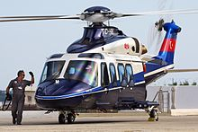The AW139 was designed jointly by the Italian helicopter manufacturer Agusta and the American company [Bell Helicopters](https://en.wikipedia.org/wiki/Bell_Helicopter_Textron). It was marketed as the **Agusta-Bell AB139**, but was redesignated as the AW139 after Bell withdrew from the project. In addition to AgustaWestland's manufacturing facilities in Italy and the United States, other companies are involved in the programme, such as the Polish manufacturer [PZL-Świdnik](https://en.wikipedia.org/wiki/PZL-%C5%9Awidnik), which has produced hundreds of AW139 airframes, and HeliVert, a joint venture between AgustaWestland and [Russian Helicopters](https://en.wikipedia.org/wiki/Russian_Helicopters), which has established a production line inside Russia for the type. Having performed its [maiden flight](https://en.wikipedia.org/wiki/Maiden_flight) on 3 February 2001, the AW139 entered revenue service in 2003 and quickly proved itself to be a commercial success.

Many AW139 customers have been in the civilian sector. Large fleets have been obtained by operators such as [CHC Helicopter](https://en.wikipedia.org/wiki/CHC_Helicopter), [Gulf Helicopters](https://en.wikipedia.org/wiki/Gulf_Helicopters), and [Weststar Aviation](https://en.wikipedia.org/wiki/Weststar_Aviation). Its performance has enabled it to become popular amongst operators supporting the offshore oil and gas industry. A dedicated militarised model, the *AW139M*, was developed by AgustaWestland. It was first procured by the [Italian Air Force](https://en.wikipedia.org/wiki/Italian_Air_Force). Other military operators include the [United States Air Force](https://en.wikipedia.org/wiki/United_States_Air_Force), which operates the *MH-139 Grey Wolf* model. The Japanese business [Mitsui Bussan Aerospace](https://en.wikipedia.org/wiki/Mitsui_%26_Co) has obtained an exclusive distribution agreement for the AW139 in Japan. Over 1,100 rotorcraft had been sold by January 2021.[[1]](https://en.wikipedia.org/wiki/AgustaWestland_AW139#cite_note-jan2021_sales-1) The AW139 has been developed into the [AW149](https://en.wikipedia.org/wiki/AgustaWestland_AW149), an enlarged medium-lift military orientated rotorcraft.[[3]](https://en.wikipedia.org/wiki/AgustaWestland_AW139#cite_note-Lake-3)

## Base value:

Base value is the appraiser's opinion of the underlying economic value of an Helicopter in an open, unrestricted, stable market environment with a reasonable balance of supply and demand. It assumes full consideration of its "highest and best use." An Helicopter's base value is found in the historical trend of values and in the projection of value trends and presumes an arm's-length, cash transaction between willing, able, and knowledgeable parties, acting prudently with an absence of duress, and with a reasonable period of time available for marketing. In most cases the base value of an Helicopter assumes its physical condition is average for an Helicopter of its type and age, and its maintenance time status is at mid-life, mid-time (or benefiting from an above-average maintenance status if it is new or nearly new).

Base value pertains to a somewhat idealized Helicopter and market combination. It may not necessarily reflect the actual value of the Helicopter being appraised. Rather it may serve as a starting value to which adjustments may be applied to determine the actual value. Base value is related to long-term market trends thus it is often applied in terms of projections of residual values and historical values. There are times when the value of an Helicopter is not reflected in long-term market trends, when projected future profits or discounted rental streams may give a better value.

## Types of appraisals:

There are essentially five types of appraisals. A desktop appraisal does not include any inspection of the Helicopter or review of its maintenance records. It is based upon assumed Helicopter condition and maintenance status, information provided to the appraiser, or from the appraiser's own database.

**The *extended* *desktop appraisal***includes consideration of the maintenance status information provided to the appraiser from the client, Helicopter operator, or another appraiser's report but not any on-site inspection of the Helicopter or its maintenance records.

A full appraisal includes an inspection of the Helicopter and its maintenance records. This inspection determines the overall condition of the Helicopter and records to support the appraiser's opinion of the value. The full appraisal normally does not require that inspection panels be opened or that any record archives be reviewed in detail.

A comprehensive appraisal includes a detailed inspection of the Helicopter and records. Sufficient detail is required to ensure that the records are complete and in good order to allow for the re-registration of the Helicopter in a different country.

A financial appraisal determines the value of an Helicopter to an investor upon the income earning potential from its lease and residual value. It may be done in conjunction with either desktop or full appraisals.

## Market value:

Market value or current market value (value at the time of the analysis) is the appraiser's opinion of the most likely trading price that may be generated under the market conditions and circumstances that are perceived to exist at a particular time. Market value assumes that the Helicopter is valued for its highest and best use, that the parties to the sale are willing, able, prudent, knowledgeable, and under no pressure for a prompt sale. The transaction is negotiated in an open, unrestricted market at arm's-length for cash or an equivalent consideration with an adequate amount of time for effective exposure to any prospective buyers.

If the market is stable, market value often tends to be consistent with base value. When equilibrium between supply and demand does not exist then there may be a variance between the two. The Helicopter's maintenance status and configuration can influence the value so the appraiser's report needs to clearly state any assumptions. Market value of the Helicopter will be based on one of these two approaches:

(1) Upon an assumed average physical condition and mid-life maintenance time status, depending on the nature of the appraisal assignment, or

(2) based on actual or given physical condition and/or maintenance time status.

## Distress value:

Distress value is the appraiser's opinion of the price that an Helicopter could be sold under abnormal conditions. These conditions may include an auction, liquidation, any commercial restrictions, legal complications, or an artificially limited marketing time period. If there is a perception that the seller is under duress to sell or there are other factors that reduce the bargaining leverage of the seller, thus giving the buyer a significant advantage, there may be a discounted selling price. It is assumed that the market is not balanced because of the seller's motivation. Otherwise both parties are willing, able, knowledgeable, and prudent, having negotiated at arm's-length under the market conditions that existed during the negotiations. There are also situations when buyers are under time pressures or other business situations where they are willing to pay a premium price thus changing the perceived value.

## Securitized value:

The securitized value or lease-encumbered value is an appraiser's opinion of current market value. It takes into account the rent and terms of a specific lease payment plan and considers the future residual value at lease termination. Also considered is an appropriate discount rate. The appraiser may not be fully aware of all the credit risks attributed to the parties involved or the time-value to all parties. Furthermore, information may not be known such as lease provisions pertaining to security deposits, term extensions, purchase options with associate dates, sub-lease provisions, repossession rights, reserve payments, and return conditions.

You will find these values used in appraisal reports. Look for a statement of the appraisal's objective. The report could determine a fair market value of the Helicopter, determine a future residual value, or determine or forecast a fair market lease rate for an Helicopter. Other objectives could be to determine: The value of the Helicopter for lease or sale; present and future Helicopter value for loan collateral; future value for establishing residual insurance premiums; values for basis of state and local taxes; fleet values to support equity stock offerings, values in mergers or bankruptcies; and values acceptable to the IRS for contributions to museums or charity.

## Appraiser's report:

Look in the appraiser's report for the specific kind of value described with its accompanying explanation. It is important to determine when (by date) the value estimate or forecasted value applied. Good appraisal practice requires the inclusion of certain explanations, descriptions, and statements. A detailed description of property is necessary; this would include the Helicopter, engine, spare parts, or other property. Identification must be made by specific model number and serial number for the Helicopter, engines, or equipment as well as stating the date of manufacture. The physical condition must be described as well as major points about its value. Any legal rights that are not obvious must be shown along with any restrictions implicit in the ownership.

Look for statements, information, and/or data, which were obtained by the appraiser, summarized, or stated in full in the report. The sources of the data should be identified so that users can verify the data. The person who makes the appraisal or the person who has the appraisal conducted under his supervision should sign the report. In many instances the validity of the appraiser's conclusions as to the value of the Helicopter is contingent upon the validity of statements, information, and/or data that he has relied upon, for example, Helicopter logbooks and maintenance records. The appraiser can rely upon and use these records as long as the source of the information is stated. Good appraisal practice requires that the appraiser state any other contingent or limiting conditions that affect the appraisal, such as a value contingent upon the completion of certain repairs, overhauls, modifications or restoration.

# Bases of Value;

As per International Valuation Standards (IVS), 2020, bases of value (sometimes called standards of value) describe the fundamental premises on which the reported values will be based. It is critical that the basis (or bases) of value be appropriate to the terms and purpose of the valuation assignment, as a basis of value may influence or dictate a valuer’s selection of methods, inputs and assumptions, and the ultimate opinion of value.

**Market Value** is the estimated amount for which an asset or liability should exchange on the valuation date between a willing buyer and a willing seller in an arm’s length transaction, after proper marketing and where the parties had each acted knowledgeably, prudently and without compulsion. The definition of Market Value must be applied in accordance with the following conceptual framework:

(a) “The estimated amount” refers to a price expressed in terms of money payable for the asset in an arm’s length market transaction. Market Value is the most probable price reasonably obtainable in the market on the valuation date in keeping with the market value definition. It is the best price reasonably obtainable by the seller and the most advantageous price reasonably obtainable by the buyer. Thisestimate specifically excludes an estimated price inflated or deflated by special terms or circumstances such as atypical financing, sale and leaseback arrangements, special considerations or concessions granted by anyone associated with the sale, or any element of value available only to a specific owner or purchaser,

(b) “an asset or liability should exchange” refers to the fact that the value of an asset or liability is an estimated amount rather than a predeterminedamount or actual sale price. It is the price in a transaction that meets all the elements of the Market Value definition at the valuation date,

(c) “on the valuation date” requires that the value is time-specific as of a given date. Because markets and market conditions may change, the estimated value may be incorrect or inappropriate at another time. The valuation amount will reflect the market state and circumstances as at the valuation date, not those at any other date.

(d) “between a willing buyer” refers to one who is motivated, but not compelled to buy. This buyer is neither over eager nor determined to buy at any price. This buyer is also one who purchases in accordance with the realities of the current market and with current market expectations, rather than in relation to an imaginary or hypothetical market that cannot be demonstrated or anticipated to exist. The assumed buyer would not pay a higher price than the market requires. The present owner is included among those who constitute “the market”,

(e) “and a willing seller” is neither an overeager nor a forced seller prepared to sell at any price, nor one prepared to hold out for a price not considered reasonable in the current market. The willing seller is motivated to sell the asset at market terms for the best price attainable in the open market after proper marketing, whatever that price may be. The factual circumstances of the actual owner are not a part of this consideration because the willing seller is a hypothetical owner,

(f) “in an arm’s length transaction” is one between parties who do not have a particular or special relationship, eg, parent and subsidiary companies or landlord and tenant, that may make the price level uncharacteristic of the market or inflated because of an element of special value. The Market Value transaction is presumed to be between unrelated parties, each acting independently,

(g) “after proper marketing” means that the asset would be exposed to the market in the most appropriate manner to effect its disposal at the best price reasonably obtainable in accordance with the market value definition. The method of sale is deemed to be that most appropriate to obtain the best price in the market to which the seller has access. The length of exposure time is not a fixed period but will vary according to the type of asset and market conditions. The only criterion is that there must have been sufficient time to allow the asset to be brought to the attention of an adequate number of market participants. The exposure period occurs prior to the valuation date,

(h) “where the parties had each acted knowledgeably, prudently” presumes that both the willing buyer and the willing seller are reasonably informed about the nature and characteristics of the asset, its actual and potential uses, and the state of the market as of the valuation date. Each is further presumed to use that knowledge prudently to seek the price that is most favourable for their respective positions in the transaction. Prudence is assessed by referring to the state of the market at the valuation date, not with the benefit of hindsight at some later date. For example, it is not necessarily imprudent for a seller to sell assets in a market with falling prices at a price that is lower than previous market levels. In such cases, as is true for other exchanges in markets with changing prices, the prudent buyer or seller will act in accordance with the best market information available at the time, and

(i) “and without compulsion” establishes that each party is motivated to undertake the transaction, but neither is forced or unduly coerced to complete it.

30.3. The Market Value of an asset will reflect its highest and best use. The highest and best use is the use of an asset that maximises its potential and that is possible, legally permissible and financially feasible. The highest and best use may be for continuation of an asset’s existing use or for some alternative use. This is determined by the use that a market participant would have in mind for the asset when formulating the price that it would be willing to bid.

30.4. Market Value does not reflect attributes of an asset that are of value to a specific owner or purchaser that are not available to other buyers in the market. Such advantages may relate to the physical, geographic, economic or legal characteristics of an asset. Market Value requires the disregard of any such element of value because at any given date it is only assumed that there is a willing buyer, not a particular willing buyer.

# Premise of Value as per ivs - international valuation standards

140.1 A premise of value or assumed use describes the circumstances of how an asset or liability is used. Different bases of value may require a particular premise of value or allow the consideration of multiple premises of value. Some common premises of value are:

(a) Highest and Best Use (HABU)

(b) Current Use/Existing Use,

(c) Orderly Liquidation, and

(d) Forced Sale.

## Premise of Value – Highest and Best Use

150.1 Highest and best use is the use that would produce the highest value for an asset, liability or a group of assets and/or liabilities, regardless of the actual current use.

150.2 The highest and best use must be physically possible, financially feasible, legally allowed and result in the highest value. If different from the current use, the costs to convert an asset to its highest and best use would impact the value. For example, a piece of property used as a manufacturing facility may be worth $100 million in its current use but it would be worth $120 million if converted to mixed commercial/residential use. The highest and best use of the property would be mixed commercial/residential use only if the cost to convert the property is less than $20 million.

150.3 The highest and best use for an asset may be its current or existing use when it is being used optimally. However, highest and best use may differ from current use or even be an orderly liquidation. For example, the highest and best use for assets employed in a loss-making business may be an orderly liquidation of the assets.

150.4 The highest and best use of an asset valued on a standalone basis may be different from its highest and best use as part of a group, when its contribution to the overall value of the group must be considered.

150.5 The determination of the highest and best use involves consideration of the following:

(a) to establish whether a use is possible, regard will be had to what would be considered reasonable by market participants,

(b) to reflect the requirement to be legally permissible, any legal restrictions on the use of the asset, e.g. zoning designations, need to be taken into account as well as the likelihood that these restrictions will change, and

(c) the requirement that the use be financially feasible takes into account whether an alternative use that is physically possible and legally permissible will generate sufficient return to a typical market participant, after taking into account the costs of conversion to that use, over and above the return on the existing use.

150.6 It is generally assumed that knowledgeable buyers and sellers would be aware of the highest and best use and transact at prices reflecting that use. As such, bases of value that assume a market transaction between reasonably knowledgeable market participants generally require the consideration of highest and best use.These bases of value include Market Value (as discussed in paras 30.1 to 30.4) and Fair Value (as discussed in paras 100.1 and 100.2).

## Premise of Value – Current Use/Existing Use

160.1 Current use/existing use is the current way an asset, liability, or group of assets and/or liabilities is used. The current use may be, but is not necessarily, also the highest and best use.

This premise (Current use/existing use) is considered for this valuation assignment.

## Premise of Value – Orderly Liquidation

170.1 An orderly liquidation describes the value of a group of assets that could be realised in a liquidation sale, given a reasonable period of time to find a purchaser (or purchasers), with the seller being compelled to sell on an as-is, where-is basis.

170.2 The reasonable period of time to find a purchaser (or purchasers) may vary by asset type. For example, the reasonable period of time to liquidate a portfolio of securities and financial instruments may differ from the reasonable period of time to liquidate a portfolio of real estate.

## Premise of Value – Forced Sale

180.1 The term “forced sale” is often used in circumstances where a seller is under compulsion to sell and that, as consequence, a proper marketing period is not possible. The price that could be obtained in these circumstances will depend upon the nature of the pressure on the seller and the reasons why proper marketing cannot be undertaken. It may also reflect the consequences for the seller of failing to sell within the period available. Unless the nature of and the reason for the constraints on the seller are known, the price obtainable in a forced sale cannot be realistically estimated. The price that a seller will accept in a forced sale will reflect its particular circumstances rather than those of the hypothetical willing seller in the Market Value definition. The price obtainable in a forced sale has only a coincidental relationship to Market Value or any of the other bases defined in this standard. A “forced sale” is a description of the situation under which the exchange takes place, not a distinct basis of value.

180.2 If an indication of the price obtainable under forced sale circumstances is required, it will be necessary to clearly identify the reasons for the constraint on the seller including the consequences of failing to sell in the specified period by setting out appropriate assumptions. If these circumstances do not exist at the valuation date, these must be clearly identified as special assumptions.

180.3 A forced sale typically reflects the most probable price that a specified property is likely to bring under all of the following conditions:

(a) consummation of a sale within a short time period,

(b) the asset is subjected to market conditions prevailing as of the date of valuation or assumed timescale within which the transaction is to be completed,

(c) both the buyer and the seller are acting prudently and knowledgeably,

(d) the seller is under extreme compulsion to sell,

(e) the buyer is typically motivated,

(f) both parties are acting in what they consider their best interests,

(g) a normal marketing effort is not possible due to the brief exposure time,

(h) payment will be made in cash,

(i) the price represents the normal consideration for the property sold, unaffected by special or creative financing concessions granted by anyone associated with the sale.

180.4 Sales in an inactive or falling market are not automatically “forced sales” simply because a seller might hope for a better price if conditions improved. Unless the seller is compelled to sell by a deadline that prevents proper marketing, the seller will be a willing seller within the definition of market value (see paras 30.1 to 30.4).

180.5 While confirmed “forced sale” transactions would generally be excluded from consideration in a valuation, it can be difficult to verify that an arm’s length transaction in a market was a forced sale.

# Inspections and /or investigations undertaken;

| **Sr.** | ***Airframe/Engine*** | ***Date of Visit*** | ***Location of Visit*** | ***Persons Present for Visit*** | ***Remark of Observation*** |
| --- | --- | --- | --- | --- | --- |
| ***1*** | VT-HLD | 23.02.2024 | Raipur | Mr. Umang A. Patel (Valuer Vastukala)  Mr. Anil Sunder Thakur (Helicopter Engineer)  Mr. Kamal Deep (AME)  Heligo charters Pvt. Ltd. (8433294651) | VT-HLD with  Engine LHPCE-KB0556 TSN. 8287:32,TSO:3313:11  Engine RHPCE-KBO647 TSN. 8239:14,TSO:3242:42  Owner: Heligo Charters Pvt. Ltd.  TSN: 44894:01  CSN: 15447 |

## Airframe-VT-HLD - 31281

* Certificate of Airworthiness
* Certificate of Registration
* Airworthiness Review Certificate – valid upto 27.09.2024
* Certificate of Aeromobile station license valid upto 31.12.2025
* Aircraft Status Report
* Weight Schedule for 7,8 & 10 seater
* Rotor Track & Balacne Reprot as on 26.12.2023
* Defect Report as on 27.02.2024
* Certificate of Insurance from ICICI Lombard 25.05.2023

**Visit dated: 23.02.2024**

**Location: Raipur**

**The Flight Record as on visit has TSN: 8944.11 & CSN: 17063**

**Airframe Total Time Detail of Calculation:**

Total flight time and cycles is based on the time and cycles recorded in the Helicopter Journey log book by the pilot after each flight. Air time and cycles are then transposed to the Airframe, Engine and Propeller electronic record keeping system.

The time shown above was taken from the last entry in the Journey Log Book kept in the Helicopter.

**Airframe Condition:** Very Good to fair

**Comments on Visual Inspection:**

The airframe condition is good to fair – consistent with a 13 year old charterd airliner and appears to be corrosion and damage free.

Physical:

External Appearance:

|  |  |  |  |  |  |
| --- | --- | --- | --- | --- | --- |
| Area | Rating | | | | |
|  | Excellent | Good | Average | Fair | Poor |
| Fuselage |  |  | √ |  |  |
| Tailboom |  |  | √ |  |  |
| Windows |  |  | √ |  |  |
| Doors |  |  | √ |  |  |
| Panels/Cowls |  |  | √ |  |  |

Internal Appearance :

|  |  |  |  |  |  |
| --- | --- | --- | --- | --- | --- |
| Area | Rating | | | | |
|  | **Excellent** | **Good** | **Average** | **Fair** | **Poor** |
| Cabin |  |  | √ |  |  |
| Engine |  |  | **√** |  |  |
| cockpit |  |  | √ |  |  |

The ratings are not a comparison of the machine's condition against a new aircraft’s condition.  It is a rating comparing it with similar models of the same age group doing comparable work.

## Insurance

The Company has taken Insurance From ICICI Lombard vide Certificate of Insurance Number C23/HEGO/00003 for the Period of 25 May 2023 to 24 May 2024.

Geographical Limits:

operations in connection with their fleet of aircraft, including all new and acquired aircraft from the moment they become the insurance responsibility of the Insured, excluding Algeria, Burundi, Far North Region of Cameroon, Central African Republic, Democratic Republic of Congo, Ethiopia, Kenya, Mali, Mauritania, Nigeria, Somalia, The Republic of Sudan, South Sudan, Colombia, Peru, Afghanistan, North Korea, Pakistan, Abkhazia, Ukraine (including Donetsk, Lugansk and Crimea regions of), Nagorno-Karabakh, North Caucasian Federal District, South Ossetia, Belarus, Russia, Iran, Iraq, Lenanon, Libya, North Sinai Province of Egypt (including Taba International Airport), Syria, Yemen and any country where the operation of the insured Aircraft is in breach of United Nations sanctions. However, coverage is granted for the over flight of any excluded country where the flight is within an internationally recognised air corridor and is performed in accordance with International Civil Aviation Organisation recommendations), however excluding overflying of Ukraine (including Donetsk, Lugansk and Crimea regions of), Belarus and Russia)

but in respect of Hull & spares War and Allied Perils subject to the following:

|  |  |  |  |  |
| --- | --- | --- | --- | --- |
| Sr. | Helicopter Type | Registration | Helicopter Agreed Value | Maximum Permissible Weight Each Helicopter |
| 11 | AW139 | VT-HLD | USD 7,112,558 | 79,015 Kgs |

# Nature and sources of information;

We have relied on following information, data and documents to form our opinion in report:

* Engine Logbook for Engine No 894445, 895486, 894621, 894620
* Airframe Logbook for Flight AXP & AXQ
* SDB Chart for Flight AXP & AXQ
* Incident Chart for Flight AXP & AXQ
* List of Open [Airworthiness Directive for AXP & AXQ Engines](https://en.wikipedia.org/wiki/Airworthiness_Directive" \l ":~:text=An%20Airworthiness%20Directive%20(commonly%20abbreviated,exists%20and%20must%20be%20corrected.)
* List of Open Airworthiness Directive& Mdantory SB List Pending for Compliance for Flight AXP & AXQ
* Certificate of Airworthiness for VT-AXP(36328) having sr. no. 2906
* Certificate of Registration for VT-AXP (36328) having Certificate No 3497/4 Category A dated 14/11/2018
* Certificate of Registration for VT-AXP (36328) having Certificate No 3497/5 Category A dated 17/07/2020 (Hypothecated to Bank Of India Mumbai Large Corporate Branch)
* Helicopter Receipt for VT-AXP (36328)
* Certificate of Airworthiness for VT-AXQ (36329) having sr. no. 2938
* Certificate of Registration for VT-AXQ (36329) having Sr. No. 3529/4 Category: A dated 12/02/2019
* Certificate of Registration for VT-AXQ (36329) having Certificate No 3497/5 Category A dated 17/07/2020 (Hypothecated to Bank Of India Mumbai Large Corporate Branch)
* Helicopter Receipt for VT-AXQ (36329)
* Explanation and other details provided by Air India Representative.

# Significant Assumptions, if any;

## Airframe-AW139

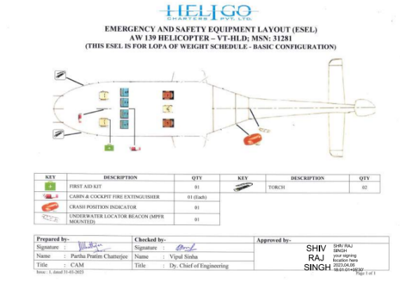

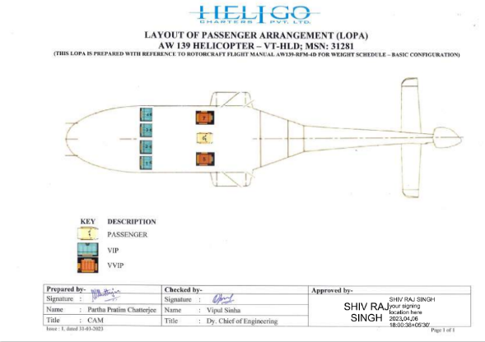

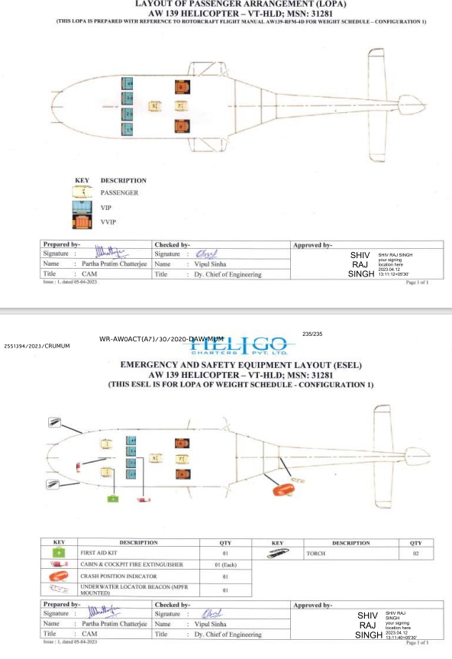 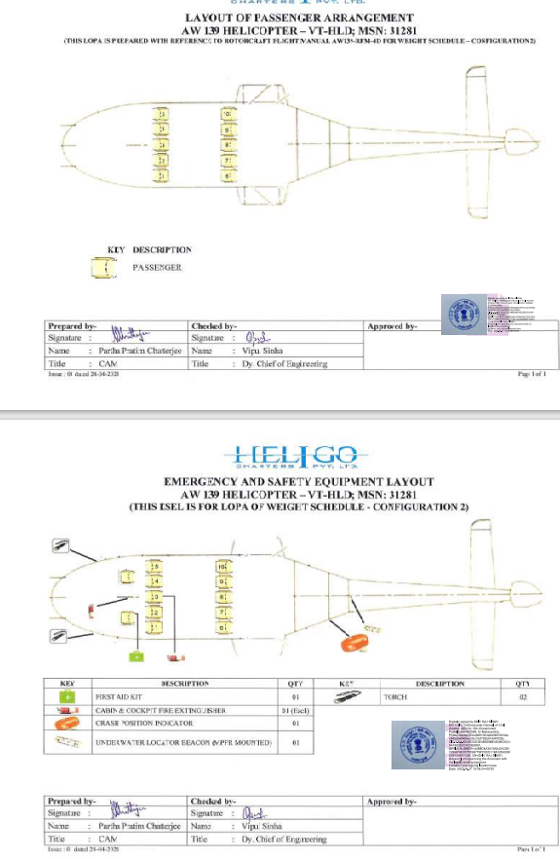

## VT-HLD Valuation Working

|  |  |
| --- | --- |
| Helicopter Registration | VT-HLD |
| Helicopter Type | AW139 long nose |
| Helicopter Sl No | 31281 |
| Date of Manufacture | 2010 |
| Engine LH | PCE-KB0556  TSN. 8287:32,TSO:3313:11 |
| Engine RH | PCE-KBO647  TSN. 8239:14,TSO:3242:42 |
| All Up Wt | 6800 KGS. |
| Hrs Flown so Far | 8947:26 A/F. HRS  DTD 27/02/2024 |
| Landings | 17070 |
| Airworthiness Review Certificate | VALID TILL 27/09/2024 |
| Aeromobile License | VALID TILL 31/12/2025 |
| Configuration | Offshore/Onshore |
| Avionics | HONEYWELL PRIMUS EPIC  (phase 5 software) |
| PBH/HMP | Not availed |

**Final Valuation of VT-HLD**

Based on CMV for AW139 and adjusting for airplane and engine utilization at approximately 25% more than half life at close to 14 years with average utilization of 685 hours per year, and adjusting for airframe/engine condition and future maintenance costs in the upcoming 5 years, the value of the Helicopter VT-HLD is arrived at 5.1 Million US Dollar.

# Procedures adopted in carrying out the valuation and valuation standards followed;

* *This movable Asset Valuation Report is carried out in the following sequence:*
* *List of assets to be valued:*

|  |  |  |  |  |  |
| --- | --- | --- | --- | --- | --- |
| **Sr.** | **Helicopter** | **Serial No.** | **Make** | **Engine no.** | **Date of delivery** |
| **1** | Helicopter VT-HLD | 31281 | AW139 | PCE-KB0556 & PCE-KBO647 | 13.10.2010 |

* *Verification of the documents provided by Client*
* *Identification of missing information and requesting for the revised list of documents*
* *Overall Site inspection for Airframe & Engines.*
* *We have followed International valuation Standards for Aviation Industries (IATA)*

# Restrictions on use of report, if any;

The report is prepared in the Request of Union Bank of India and it only to be used only by Union Bank of India

# Major factors that were taken into account during valuation;

Several factors determine the selling price of a pre-owned airplane

## Airframe hours and age

An Helicopter loses a certain amount from its value for every hour it flies over the fleet’s average. That per-hour reduction changes depending on the model and grows smaller as the Helicopter ages. Though flying under the fleet average is good for other reasons, the market does not offer a similar advantage to Helicopter values when the total number of hours flown is below the fleet’s average. Consequently, early in an Helicopter’s lifecycle, total airframe hours have greater impact on an Helicopter’s value. Years later, the age of the Helicopter affects resale value more.

## ENGINE HOURS

The closer an engine is to its recommended time between overhaul, the less its value. Equally important is a record of consistent use coupled with a good maintenance program.

## Installed equipment

The technology inside the Helicopter can have a noticeable impact on values, good and bad. Some owners double the value of their older models by installing new avionics. Conversely, dated technology, including old air conditioning and aging de-icing gear can bring down resale value because those systems are generally more expensive to maintain.

## Records and Airworthiness Directives

Complete records that show prompt responses to Airworthiness Directives and other maintenance needs increase an Helicopter’s value. Buyers should review the Helicopter’s airworthiness certificate, engine and airframe logbooks, Helicopter equipment list, weight and balance data, placards and FAA-approved Helicopter flight manual or owner's handbook. Missing documents, pages or entries from Helicopter logbooks may cause significant problems for the buyer and reduce the value of the Helicopter.

## Damage history

A damage history will decrease the value of an Helicopter. Buyers should consider the type of accident, nature of the damage, who repaired the damage and the degree to which the issue affected major components. Pre-purchase inspectors should closely scrutinize damage history to make sure it is properly repaired in accordance with applicable FAA regulations and recommended practices.

## Paint

New paint jobs can increase the value of an Helicopter, but buyers should be careful. The work could hide corrosion under the surface, which can negatively affect value.

## Interior

Interiors that are in good condition and properly fit also enhance the value of the Helicopter. Even so, some owners still choose to update their Helicopter’s interiors before they sell so that colors and patterns more closely match the latest trends. Choosing to do so can lessen the time the Helicopter are on the market.

# Actual Photograph

## Actual Photo of Airframe- VT-HLD

### Cabin interior

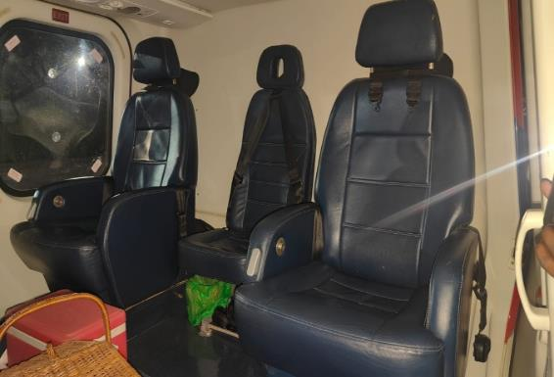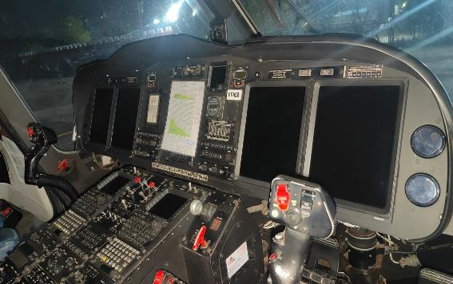

### Head and engine

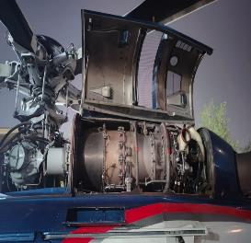 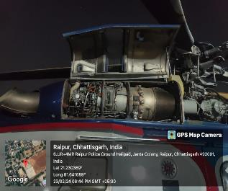

### Data Plate

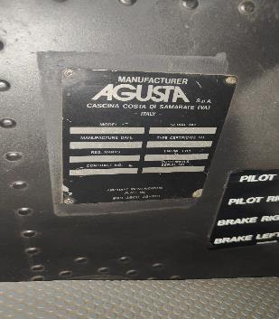

### Tail assembly

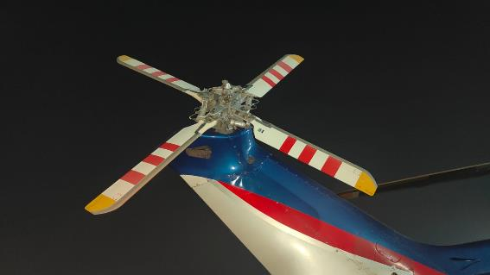

### external Photo

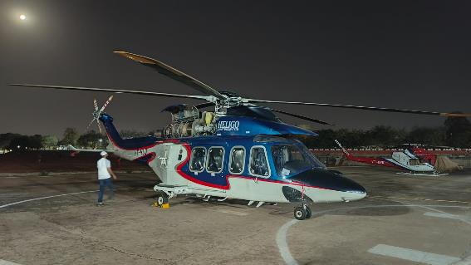

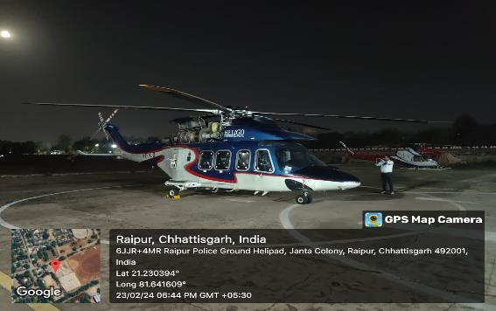

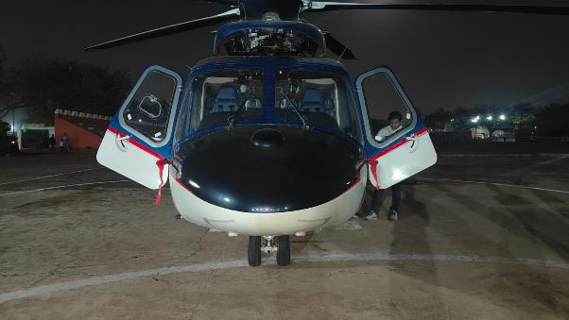

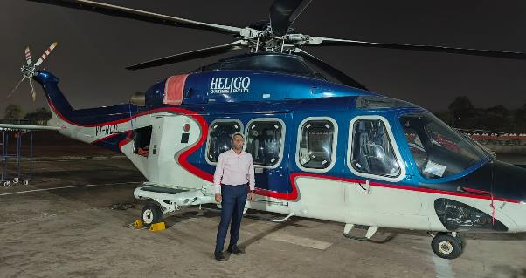

|  |  |
| --- | --- |
| Manoj B. Chalikwar | Umang A. Patel |
| Registered Valuer  Reg. No. IBBI/RV/07/2018/10366 | Registered Valuer  Reg. No. IBBI/RV/04/2019/10803 |