Asset Verification Report Prepared for: SFSPL / M/s. Remsons Industries Ltd. (7283/2305187)
Vastu/Thane/02/2024/7283/2305187
27/18-409 APU
Date: 27.02.2024

Asset Verification Report

1. General Information
Agreement Number: | A10124728
Label Number: | L1731B
Customer: | M/s. Remsons Industries Ltd.
Address of Asset Location: | Gat No. 268, 269, 270, Kharabwadi, Remsons Road, Taluka Khed, District Pune – 410501, Maharashtra, India.
Asset/s financed as per Agreement | Sl.no | Asset Description | Model | Supplier | Quantity
 | 1 | HCV Cable Line | N.A. | Simple Integral Private Limited | 1 Set
Name Plate | ◻Available ☑ Not Available |  | ◻ Visible ☑ Not Visible
Serial number (On Asset) | ◻ Available ☑ Not Available If Available – Refer Photos
Serial number (in Invoice): (If available) | Not Available
Type of Foundation for Asset (wherever applicable) | ☑ Steel supporting structure |  | ◻ Concrete floor ◻ Other
Level of Bondage | ☑ Asset easy to remove |  | ◻ Asset fixed permanently
Description of the premises: | ☑ Manufacturing Facility ◻ Hospital ◻ Warehouse ◻ Office Premises  ◻Diagnostic ◻ Others (Please specify): _________________________________
Asset influencing circumstances ( i.e Chemical Zone, Corrosive atmosphere, Highly Polluted location etc.,) : | ◻Yes  If yes, please specify: |  | ☑ No

2 Asset Condition
Optical impression of physical condition of Asset: | ◻ Excellent ☑ Good ◻ Fair ◻ Poor ◻ Very Poor
Was the asset in operation at the time of Inspection | ☑ Yes ◻ No If No Please specify reasons
Age of the Asset at the time of inspection | ~ 6 Months
Asset condition at the time of purchase | ☑New ◻Used
Any Breakdown in the machine | ◻ Yes ◻ No ☑ Not Known
Photos: | ☑ Yes | ◻ No
3 Information About Onsite Visit
Date of Onsite Visit: | 10/02/2024
Latitude & Longitude | 18°45'54.1"N 73°50'08.3"E
Customer Personnel met at site: | Mr. Jaisingh Shelar – 9821080397.
Report created at | Mumbai

For Vastukala Consultants (I) Pvt. Ltd.

Umang Ashwin Patel
Regd. Valuer
Chartered Engineer (India)
Reg. No. IBBI/RV/04/2019/10803

Photographs

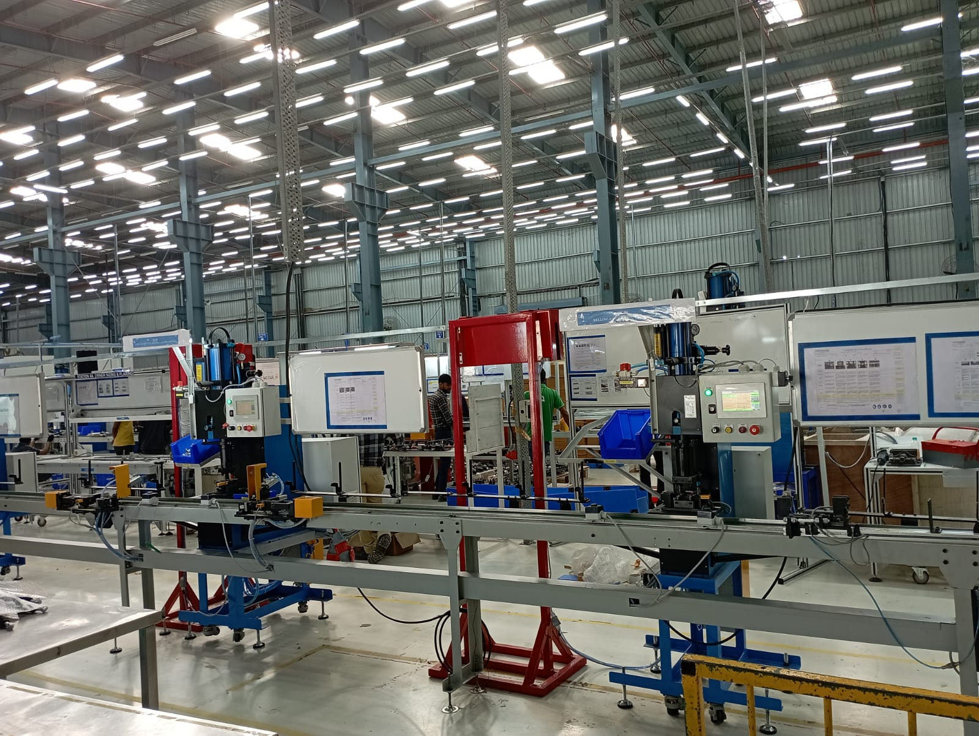 | 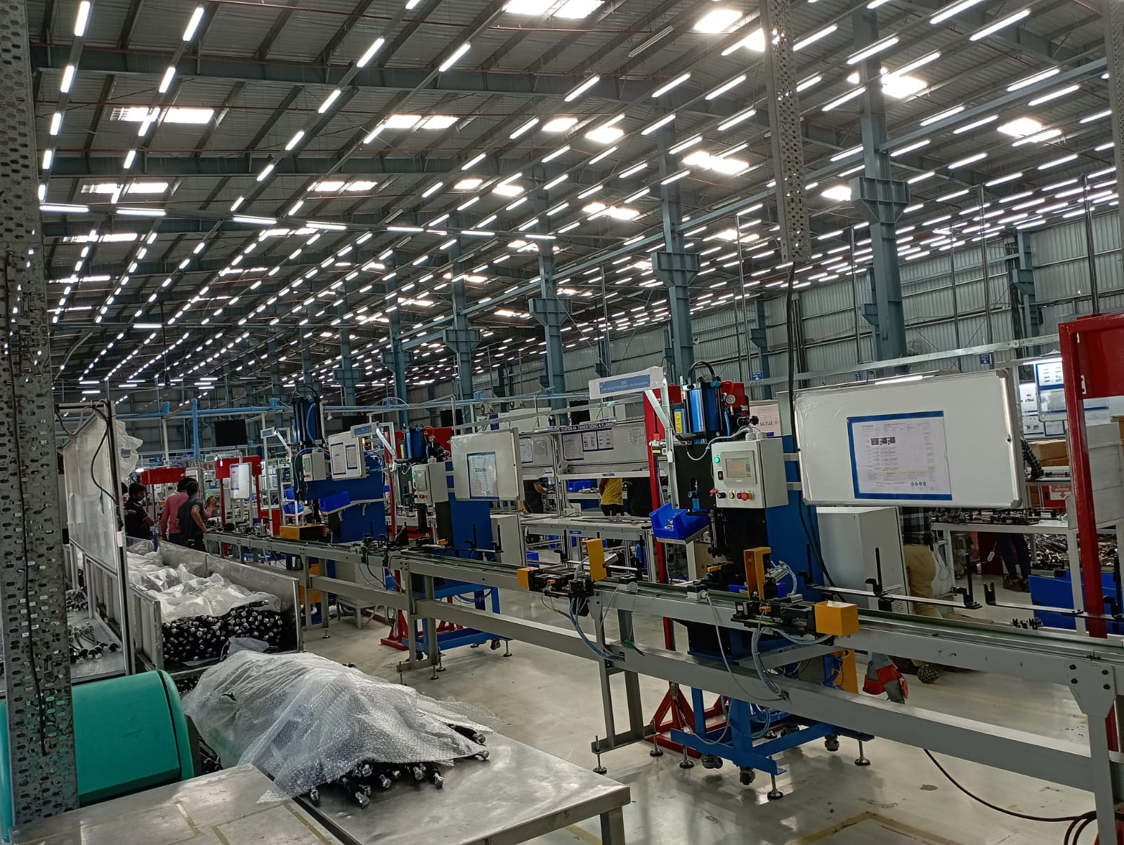
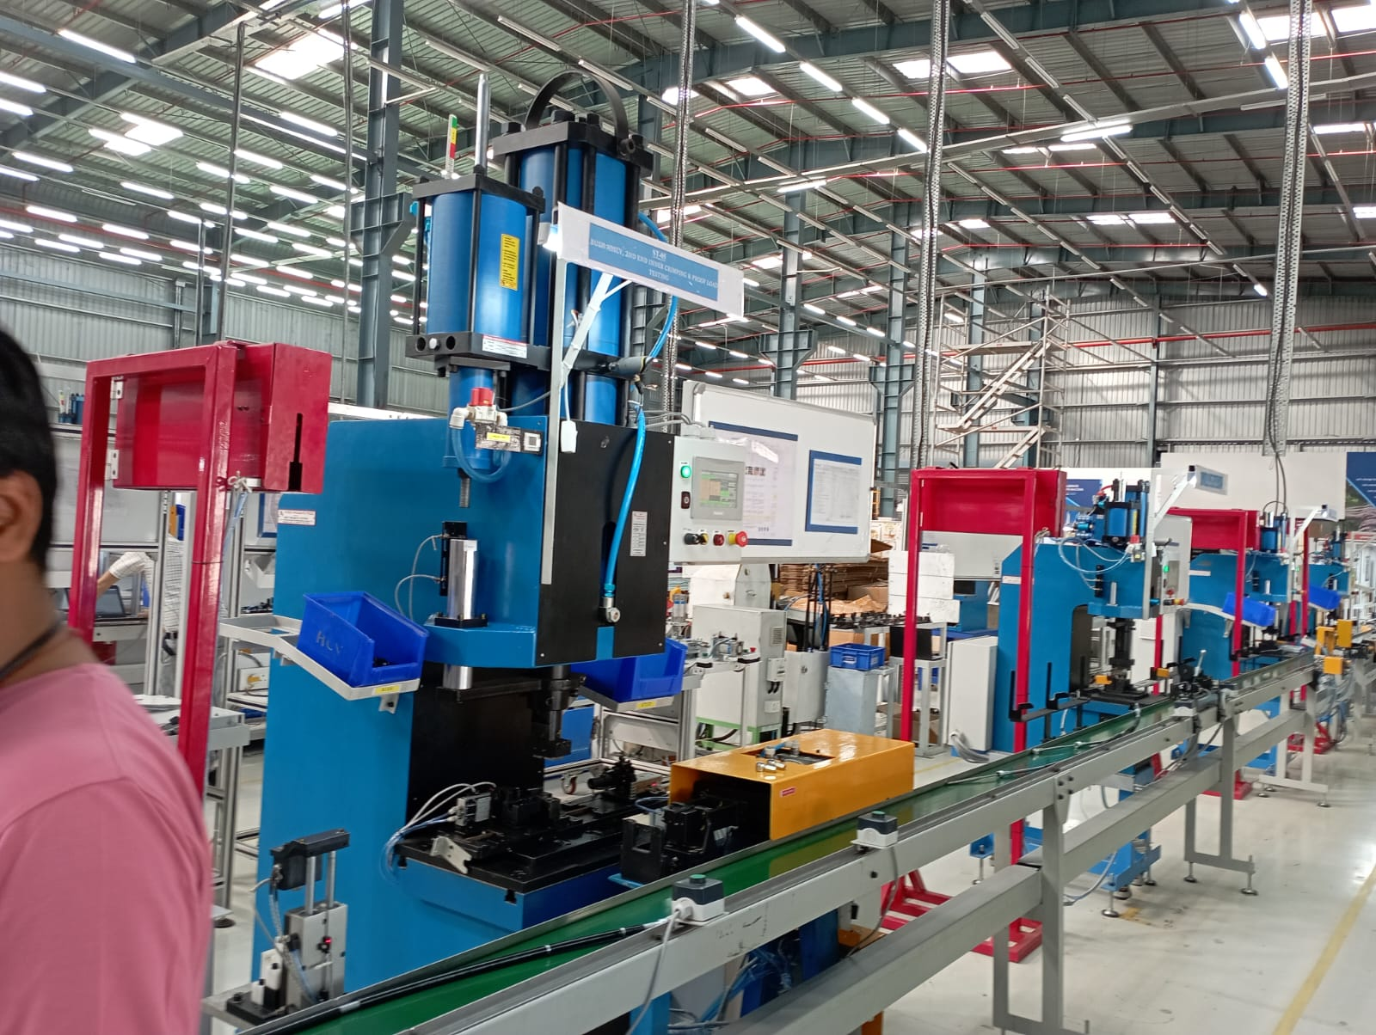 | 