Asset Verification Report Prepared for: SFSPL / M/s. Mudra Engg. Solutions Pvt. Ltd. (7269/2305185)
Vastu/Thane/02/2024/7269/2305185
27/16-407 APU
Date: 27.02.2024

Asset Verification Report

1 General Information
Agreement Number: | A10194878
Label Number: | L1712B
Customer: | M/s. Mudra Engg. Solutions Pvt. Ltd.
Address of Asset Location: | J 65/1, J Block, MIDC Bhosari, Near Lande Patil Transport,Pimpri - Chinchwad Bhosari, District Pune – 411026, Maharashtra ,India.
Asset/s financed as per Agreement | Sl.no | Asset Description | Model | Supplier | Quantity
 | 1 | CNC Vertical Machining Centre | Model BMV 80 | Bharat Pritz Werner Limited | 1 No.
Name Plate | ☑ Available ◻ Not Available |  | ☑Visible ◻ Not Visible
Serial number (On Asset) | ☑Available ◻ Not available If Available – Refer Photos
Serial number (in Invoice): (If available) | Serial No. 6140
Type of Foundation for Asset (wherever applicable) | ☑ Steel supporting structure |  | ◻ Concrete floor ◻ Other
Level of Bondage | ☑ Asset easy to remove |  | ◻ Asset fixed permanently
Description of the premises : | ☑ Manufacturing Facility ◻ Hospital ◻ Warehouse ◻ Office Premises  ◻Diagnostic ◻ Others (Please specify): _________________________________
Asset influencing circumstances ( i.e Chemical Zone, Corrosive atmosphere, Highly Polluted location etc.,) : | ◻Yes  If yes, please specify: |  | ☑ No

2 Asset Condition
Optical impression of physical condition of Asset: | ◻ Excellent ☑ Good ◻ Fair ◻ Poor ◻ Very Poor
Was the asset in operation at the time of Inspection | ☑ Yes ◻ No If No Please specify reasons
Age of the Asset at the time of inspection | ~ 5 Months
Asset condition at the time of purchase | ☑ New ◻Used
Any Breakdown in the machine | ◻ Yes ◻ No ☑ Not Known
Photos: | ☑ Yes | ◻ No

3 Information About Onsite Visit
Date of Onsite Visit: | 10/02/2024
Latitude & Longitude | 18°37'58.8"N 73°50'04.7"E
Customer Personnel met at site: | Debranjan Das - 9158766269
Report created at | Mumbai

For Vastukala Consultants (I) Pvt. Ltd.

Umang Ashwin Patel
Regd. Valuer
Chartered Engineer (India)
Reg. No. IBBI/RV/04/2019/10803

Photographs

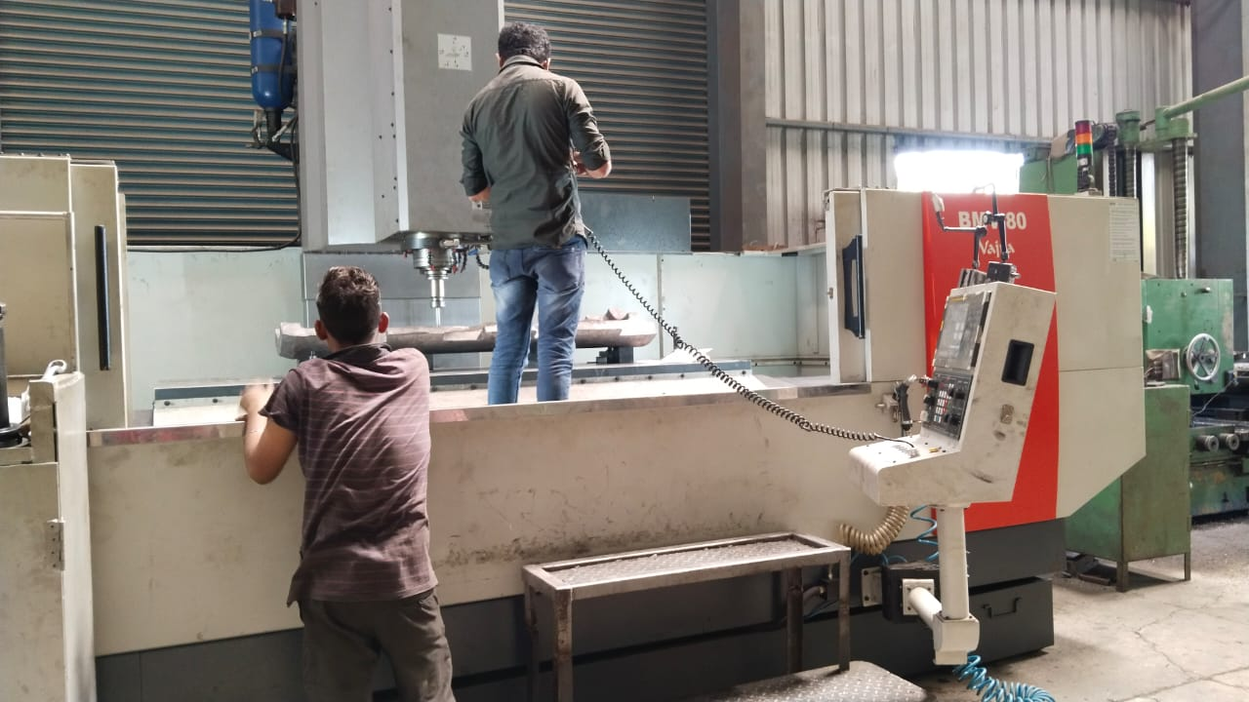 | 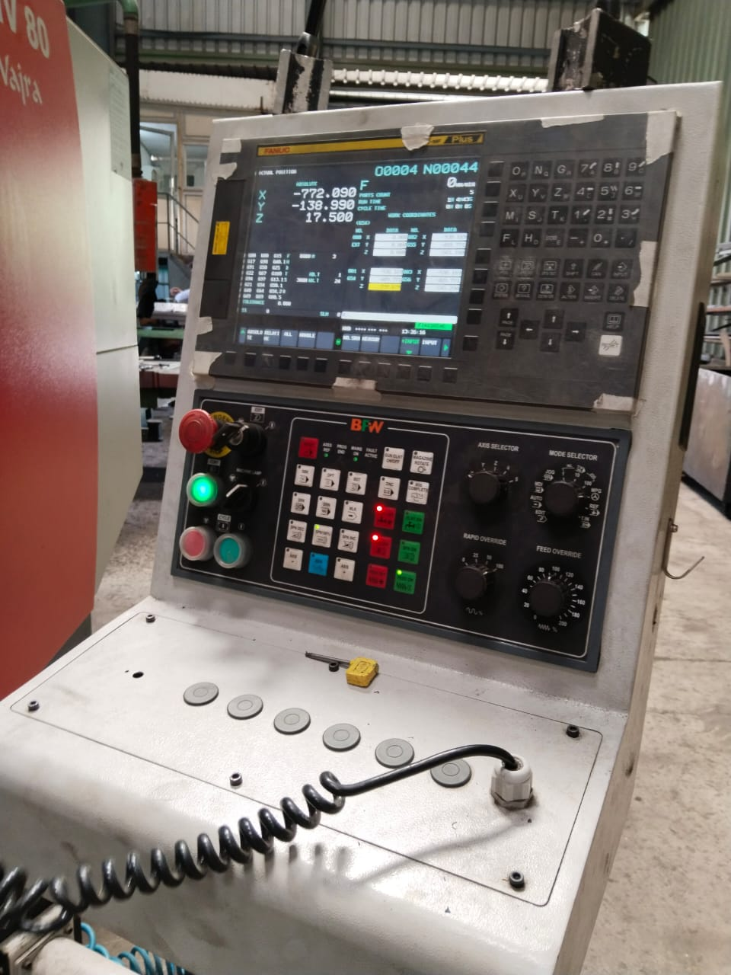
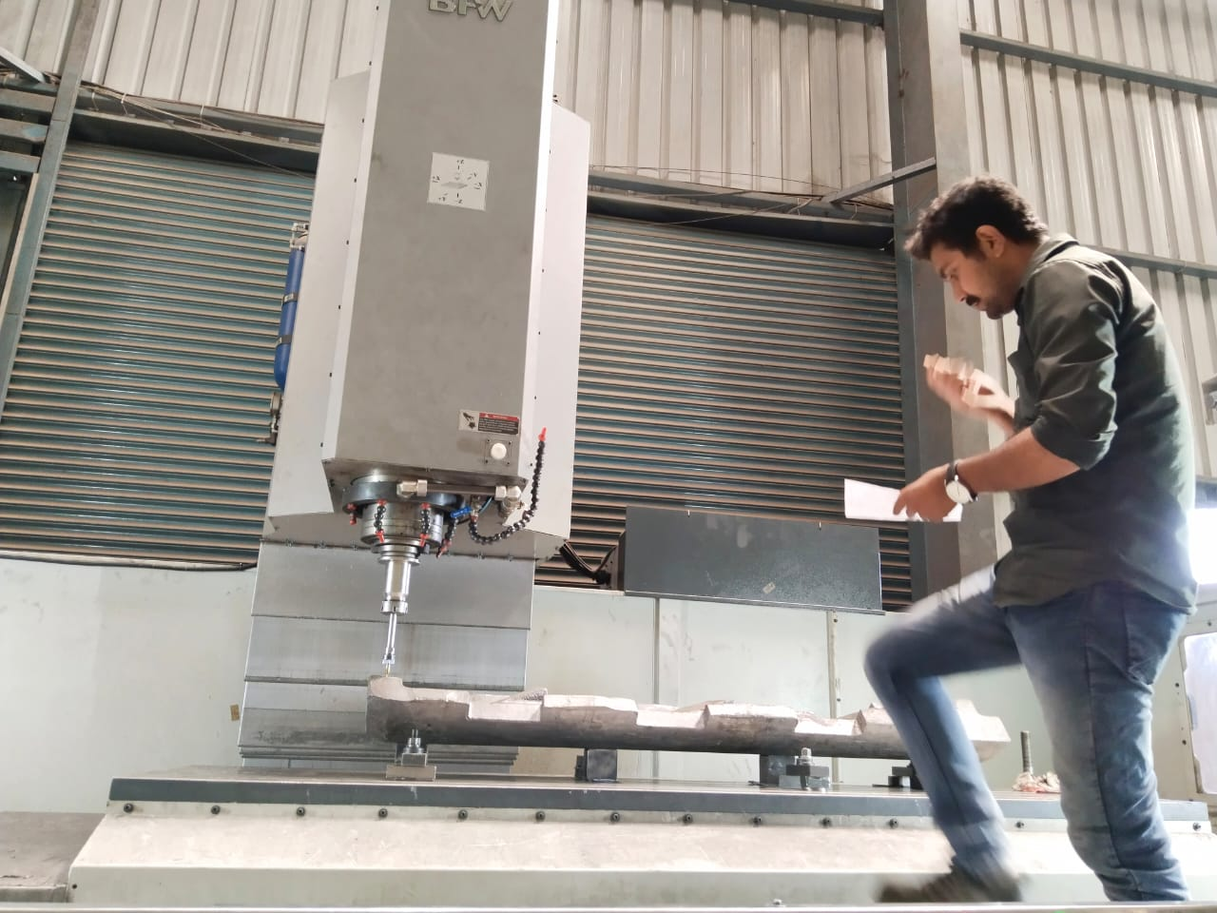 | 