Vastu/Nashik/06/32014/2301224
22/20-325-RYBS
Date: 26.02.2024

To,
The Branch Manager,
State Bank of India
Shinde Palse (Shinde Br 61457)
Nivrutti Complex, Gat No. 82, Nashik Pune Road, At Post Shinde Taluka and
Dist. Nashik, Pin 422102, State – Maharashtra, Country – India.

Sub: Vetting of Extra Work

Sir,

With reference to above subject, we have evaluated the Extra Work for Residential Flat No. A - 701, Seventh Floor, A - Wing, “ DB`S Empyrean ”, Survey No. 33/ 1A/ 1/ 1A, Plot No. 8+9+10+11, Next To Reliance Petrol Pump, Behind Ford/ Jeep Service Centre, Gulmohar Colony, Pipeline Road, Village – Anandwalli, Taluka & District – Nashik, Nashik - 422 007, State – Maharashtra, Country – India belongs to Name of Proposed Purchaser : Mr. Ashish Bharamanna Talikot & Mrs. Bhakti Ashish Talikot. Name of Owner: M/s. Shree Dream Builders.

We have verified the rates quoted as per current market rates. Details of Extra Work considered as per copy of Extra Work Agreement between Mr. Ashish Bharamanna Talikot & Mrs. Bhakti Ashish Talikot (First Party). Mr. Paresh Arun Bhavsar (Second Party) received on dated 22.02.2024. The Extra Work amount is Rs. 9,00,000/- (Rupees Nine Lakh Only)

The said Cost Vetting Certificate is valid upto next 6 months Only.

Thanking you

Sincerely yours

Manoj B. Chalikwar
Registered Valuer
Chartered Engineer (India)
Reg. No. CAT-I-F-1763
SBI Empanelment No.: SME/TCC/2021-22/86/3
Encl. Valuation Report

Agreement for Extra Work
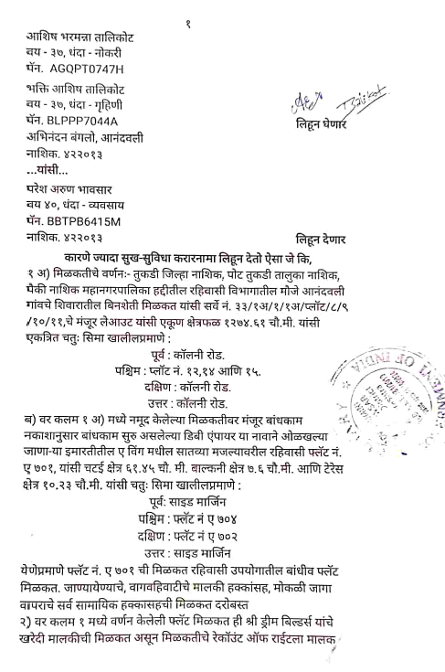
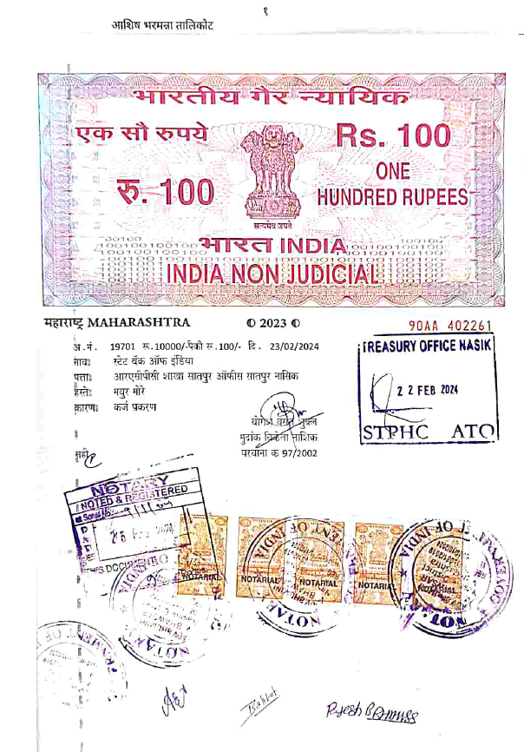

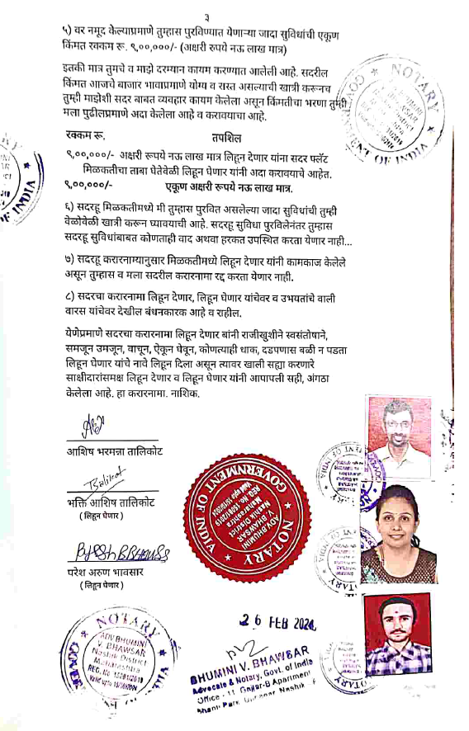
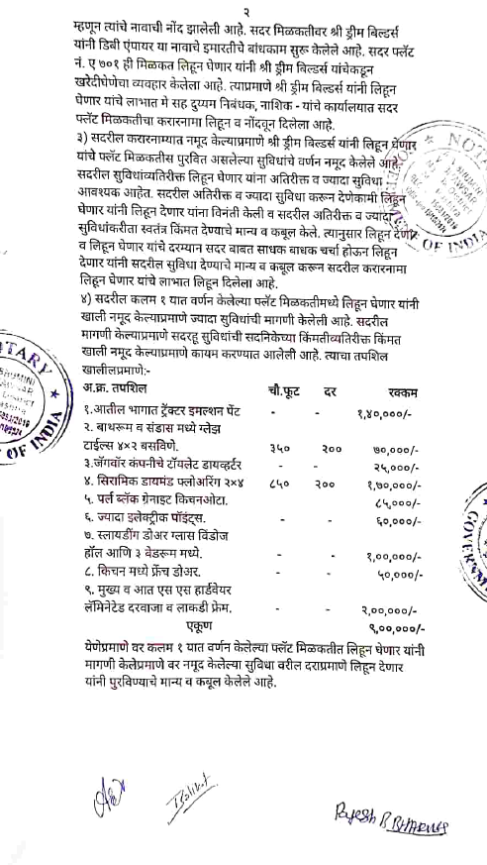

The Extra Work amount is Rs. 9,00,000/- (Rupees Nine Lakh Only)

