Valuation Report of the Immovable Property
(For Capital Gain Purpose)

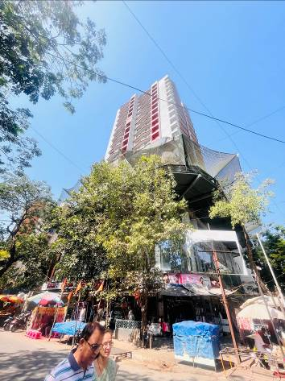

Details of the property under consideration:

Name of Client: Mr. Jayesh Ramesh Chothani

Commercial Shop No. 04, Ground Floor, “Marathon Zaver Arcade”, Zaver Road, Mulund (West), Mumbai – 400080, State – Maharashtra, Country - India

Latitude Longitude: 19°10'20.0"N 72°57'12.1"E

Table of Contents
1. VALUATION OPINION REPORT 3
2. Part-1 Form 0-1 5
2.1. GENERAL: 5
2.2. LAND 5
2.3. IMPROVEMENTS 6
2.4. RENTS 6
2.5. SALES 7
2.6. COST OF CONSTRUCTION 8
3. PART II- VALUATION 8
3.1. General: 8
3.2. Location: 8
3.3. History: 8
3.4. Valuation as on 01.04.2001 of the Commercial Shop: 9
3.4.1. Indexed Cost of Acquisition 9
3.5. NOTES 10
4. ANNEXURE TO FORM 0-1 10
5. PART III- DECLARATION 11
5.1. DECLARATION OF PROFESSIONAL FEES CHARGED 11
5.2. DEFINITION OF VALUE FOR THIS SPECIFIC PURPOSE 12
5.3. UNDER LYING ASSUMPTIONS 12
6. Actual site photographs 13
7. Actual site photographs 14
8. Route Map of the property 15
9. Ready Reckoner Rate for Year 2001 16
9.1. Rate for Property 16
9.2. Construction Rate 16
10. VALUATION OF THE PROPERTY PREMISES 17

Vastu/Mumbai/02/2024/7221/2305226
29/05-448-VS
Date: 29.02.2024

VALUATION OPINION REPORT

This is to certify that the property bearing Commercial Shop No. 04, Ground Floor, “Marathon Zaver Arcade”, Zaver Road, Mulund (West), Mumbai – 400080, State – Maharashtra, Country - India belongs to Mr. Jayesh Ramesh Chothani as per Agreement For Permanent Alternate Accommodation dated 26.10.2020.

Boundaries of the property.

North | : | Zaver Road
South | : | Laxmi Mahadev Niwas & Sevaram Lalwani Road
East | : | Sevaram Lalwani Road
West | : | Vasupujya Darshan

- The purpose of this report is to ascertain the Indexed Cost of Acquisition ( F. Y. 2023 - 24) of the property as detailed above.
- The property premises can be assessed and valued for calculation of Capital Gain Tax purpose as on 01.04.2001 at ` 15,07,147.00 (Rupees Fifteen Lakh Seven Thousand One Hundred Forty Seven Only).
- The Indexed Cost of Acquisition of Property under consideration as on 2023 – 24 is ` 52,44,872.00 (Rupees Fifty Two Lakh Forty Four Thousand Eight Hundred Seventy Two Only) without any major Renovation & improvement after 2001.
- The following documents were perused :
- Copy of Agreement dated 17.05.1997 between M/s. United Builders (Promoters) & Mr. Jayesh Ramesh Chothani (Purchaser).
- Copy of Commencement Certificate vide No. CE / 2558 / BPES / A / 5 dated 23.06.1980. Full Commencement Certificate issued on 17.02.1993 issued by Municipal Corporation Of Greater Mumbai.
- Copy of Agreement for Permanent Alternate Accommodation dated 26.10.2020 between United Builders (Developer) and Mr. Jayesh Ramesh Chothani (Allotee).
- Copy of Electricity bill for the month of February in the name of Mr. Jayesh Ramesh Chothani.

This assignment is undertaken based on the request from our client Mr. Jayesh Ramesh Chothani

The valuation of the property is based on the documents produced by the concern. Legal aspects have not been taken into considerations while preparing this valuation report.

Hence certified.

For Vastukala Architects & Engineers

Sharadkumar B. Chalikwar
Govt. Reg. Valuer
Chartered Engineer (India)
Reg. No. (N) CCIT/1-14/52/2008-09
Valuation Report of Commercial Shop No. 04, Ground Floor, “Marathon Zaver Arcade”, Zaver Road, Mulund (West), Mumbai – 400080, State – Maharashtra, Country – India

Part-1 Form 0-1
(See Rule 8 D)
REPORT OF VALUATION OF IMMOVABLE PROPERTY (OTHER THAN AGRICULTURAL LANDS, PLANTATIONS, FORESTS, MINES AND QUARRIES)

GENERAL:

1 | Purpose for which the valuation is made | To assess the Fair Market Value as on 01.04.2001 for computation of Capital Gains Tax.
2 | Date of Report | 29.02.2024
3 | Name of the Owner | Mr. Jayesh Ramesh Chothani as per Agreement For Permanent Alternate Accommodation dated 26.10.2020
4 | If the property is under joint ownership, Ownership / co-ownership, share of each such owner. Are the shares undivided? | Sole Ownership
5 | Brief description of the property | Commercial Shop No. 04, Ground Floor, “Marathon Zaver Arcade”, Zaver Road, Mulund (West), Mumbai – 400080, State – Maharashtra, Country – India
6 | Location, street, ward no | Zaver Road, Mulund (West)
7 | Survey/ Plot no. of land | Plot No. 69 (part), S, No. 1000 (Part), C.T.S. Nos. 1224, 1224/1 to 14, Village Mulund (West), Taluka Kurla
8 | Is the property situated in Residential / commercial/ mixed area/ industrial area? | Residential cum commercial
9 | Classification of locality-high class/ middle class/poor class | Middle Class
10 | Proximity to civic amenities like schools, Hospitals, Offices, market, cinemas etc. | All the amenities are available in the vicinity.
11 | Means and proximity to surface communication by which the locality is served | Served by BEST Buses, Taxies, Private Vehicles

LAND

12 | Area of land supported by documentary proof. Shape, dimension and physical features | Carpet Area = 287.00 Sq. Ft.  (Area as per Agreement)  Built up area = 344.00 Sq. Ft.  (Carpet Area + 20%)
13 | Roads, Streets or lanes on which the land is abutting | Zaver Road
14 | If freehold or leasehold land | Freehold
15 | If leasehold, the name of Lessor/lessee, nature of lease, date of commencement and termination of lease and terms of renewal of lease.  (i) Initial premium  (ii) Ground rent payable per annum  (iii) Unearned increase payable to the Lessor in the event of sale or transfer | Not applicable
16 | Is there any restriction covenant in regard to use of land? If so attach a copy of the covenant. | As per documents
17 | Are there any agreements of easements? If so attach a copy of the covenant | Information not available
18 | Does the land fall in an area included in any Town Planning Scheme or any Development Plan of Government or any statutory body? If so give Particulars. | Municipal Corporation of Greater Mumbai
19 | Has any contribution been made towards development or is any demand for such contribution still outstanding. | Information not available
20 | Has the whole or part of the land been notified for acquisition by government or any statutory body? Give date of the notification. | No
21 | Attach a dimensioned site plan | Attached

IMPROVEMENTS

22 | Attach plans and elevations of all structures standing on the land and a lay-out plan. | N.A.
23 | Furnish technical details of the building on a separate sheet (The Annexure to this form may be used) | Attached
24 | Is the building owner occupied/ tenanted/ both? | Tenant occupied – The Beauty Hub
 | If the property owner occupied, specify portion and extent of area under owner-occupation | Fully occupied by tenant
25 | What is the Floor Space Index permissible and Percentage actually utilized? | - Floor Space Index Permissible – As per Development Control of Regulation of Municipal Corporation of Greater Mumbai  - FSI percentage actually utilized - Information not available

RENTS

26 | (i) | Names of tenants/ lessees/ licensees, etc | Tenant occupied – The Beauty Hub
 | (ii) | Portions in their occupation | Full
 | (iii) | Monthly or annual rent /compensation/license fee, etc. paid by each | Information not available
 | (iv) | Gross amount received for the whole property | Information not available
27 | Are any of the occupants related to, or close to business associates of the owner? |  | Information not available
28 | Is separate amount being recovered for the use of fixtures, like fans, geysers, refrigerators, cooking ranges, built-in wardrobes, etc. or for services charges? If so, give details |  | Information not available
29 | Give details of the water and electricity charges, If any, to be borne by the owner |  | Copy of Electricity Bill for the month of February 2024 in the name of Mr. Jayesh Ramesh Chothani
30 | Has the tenant to bear the whole or part of the cost repairs and maintenance? Give particulars |  | Not applicable
31 | If a lift is installed, who is to bear the cost of maintenance and operation- owner or tenant? |  | Information not available
32 | If a pump is installed, who is to bear the cost of maintenance and operation- owner or tenant? |  | Information not available
33 | Who has to bear the cost of electricity charges for lighting of common space like entrance hall, stairs, passage, compound, etc. owner or tenant? |  | Information not available
34 | What is the amount of property tax? Who is to bear it? Give details with documentary proof |  | Information not available
35 | Is the building insured? If so, give the policy no., amount for which it is insured and the annual premium |  | Information not available
36 | Is any dispute between landlord and tenant regarding rent pending in a court of rent? |  | Not applicable
37 | Has any standard rent been fixed for the premises under any law relating to the control of rent? |  | Not applicable

SALES

38 | Give instances of sales of immovable property in the locality on a separate sheet, indicating the Name and address of the property, registration No., sale price and area of land sold. | As per sub registrar assurance records
39 | Land rate adopted in this valuation | N. A. as the property is valued by composite rate method
40 | If sale instances are not available or not relied up on, the basis of arriving at the land rate | Copy of Stamp Duty Ready Reckoner for the year 2001

COST OF CONSTRUCTION

41 | Year of commencement of construction and year of completion | Year of Completion – 1993 (As per Commencement Certificate)
42 | What was the method of construction, by contract/By employing Labour directly/ both? | Information not available
43 | For items of work done on contract, produce copies of agreements | Not applicable
44 | For items of work done by engaging Labour directly, give basic rates of materials and Labour supported by documentary proof. | Not applicable

PART II- VALUATION

General:

Under the instructions of Mr. Jayesh Ramesh Chothani, we have valued the Commercial Shop No. 04, Ground Floor, “Marathon Zaver Arcade”, Zaver Road, Mulund (West), Mumbai – 400080, State – Maharashtra, Country - India to ascertain the market value of said property, as on 01.04.2001 for computation of Capital Gains Tax.

We are in receipt of the following documents:
- Copy of Agreement dated 17.05.1997 between M/s. United Builders (Promoters) & Mr. Jayesh Ramesh Chothani (Purchaser).
- Copy of Commencement Certificate vide No. CE / 2558 / BPES / A / 5 dated 23.06.1980. Full Commencement Certificate issued on 17.02.1993 issued by Municipal Corporation Of Greater Mumbai.
- Copy of Agreement for Permanent Alternate Accommodation dated 26.10.2020 between United Builders (Developer) and Mr. Jayesh Ramesh Chothani (Allotee).
- Copy of Electricity bill for the month of February in the name of Mr. Jayesh Ramesh Chothani.

Location:
The said building is located at Plot No. 69 (part), S, No. 1000 (Part), C.T.S. Nos. 1224, 1224/1 to 14, village Mulund (West), Taluka Kurla in Municipal Corporation of Greater Mumbai. The property falls in Residential Zone. It is at 600 M. travel distance from Mulund railway station.

History:

The old shop bearing No. 04 on ground floor was located in the building known as “Zaver Arcade”. The said building gone for redevelopment and possession of new Shop bearing No. 04 on ground floor in building known as “Marathon Zaver Arcade” given on 01.11.2022 as per Possession Letter issued by Builder. The new building is consisting of 2 wings and comprising of Basement, Ground Floor, 1st Floor, 2nd to 4th Podium Floor, 5th Stilt Floor and upto 8th floor (Sanctioned) and proposed upto 19th Habitable Floors as per Agreement.

Valuation as on 01.04.2001 of the Commercial Shop:

The Built up area of the Property in Sq. Ft. | : | 344.00
The Built up area of the Property in Sq. M. | : | 31.96
Depreciation Calculation:
Year of Construction of the building | : | 1993 (As per Commencement Certificate)
Expected total life of building | : | 70 years
Age of the building as on 01.04.2001 | : | 8 years
Cost of Construction | : | 31.96 x ` 5,500.00  = ` 1,75,780.00
Depreciation | : | 10.29%
Amount of depreciation | : | ` 18,088.00
Rate as on 01-04-2001 for Residential Property Premises (As per Ready Reckoner 2001) | : | ` 43,050.00 per Sq. M.
Rate considered for valuation Value of Property as on 2001. | : | 31.96 Sq. M. x ` 43,050.00  = ` 13,75,878.00
Depreciated Fair Value of the property as on 01-04-2001 | : | ` 13,75,878.00 (-) ` 18,088.00  = ` 13,57,790.00
Add for Stamp Duty charges ( B ) | : | ` 1,35,779.00
Add for Registration charges ( C ) | : | ` 13,578.00
Total Cost of Acquisition (A + B + C) | : | ` 15,07,147.00

Indexed Cost of Acquisition
- Cost Inflation Index for 01.04.2001 : 100
(Considering the transaction shall be made
after 01.04.2017)
- Cost Inflation Index for 2023 - 24 : 348
- Indexed Cost of Acquisition : ` 52,44,872.00
(` 15,07,147.00 x 348 / 100)

Taking into consideration above said facts, we can evaluate the value of Commercial Shop No. 04, Ground Floor, “Marathon Zaver Arcade”, Zaver Road, Mulund (West), Mumbai – 400080, State – Maharashtra, Country - India for this particular purpose at ` 15,07,147.00 (Rupees Fifteen Lakh Seven Thousand One Hundred Forty Seven Only) as on 01.04.2001.

NOTES

- I, Sharadkumar B. Chalikwar with my experience and ability to judgment I am of the considered opinion that the fair market value of the property as on 01.04.2001 is ` 15,07,147.00 (Rupees Fifteen Lakh Seven Thousand One Hundred Forty Seven Only) Value varies with time and purpose and hence this value should not be referred for any purpose other than mentioned in this report.

- This valuation is done on the basis of information, which the valuer has obtained by information provided by the client about the premises and location of the surrounding area and also prevailing rates in the surrounding area, and further subject to document as mentioned in valuation report.

- This valuer should not be held responsible for authentication of documents, clear title and other such related matters. For that purpose Latest Legal Opinion should be sought.

ANNEXURE TO FORM 0-1

1. | No. of floors and height of each floor | Not applicable as old structure gone for redevelopment
2. | Plinth area floor wise as per IS 3361-1966 | -
3 | Year of construction | -
4 | Estimated future life as on year 2001 | -
5 | Type of construction- load bearing walls/RCC frame/ steel frame | -
6 | Type of foundations | -
7 | Walls | -
8 | Partitions | -
9 | Doors and Windows | -
10 | Flooring | -
11 | Finishing | -
12 | Roofing and terracing | -
13 | Special architectural or decorative features, if any | -
14 |  | -
  (i) | Internal wiring – surface or conduit
  (ii) | Class of fittings: Superior / Ordinary / Poor.
15 | Sanitary installations  Class of fittings: Superior colored / superior white/ordinary. | -
  (i) | No. of water closets
  (ii) | No. of lavatory basins
  (iii) | No. of urinals
  (iv) | No. of sinks
16 | Compound wall  Height and length  Type of construction | -
17 | No. of lifts and capacity | -
18 | Underground sump – capacity and type of construction | -
19 | Over-head tank  Location, capacity  Type of construction | -
20 | Pumps- no. and their horse power | -
21 | Roads and paving within the compound approximate area and type of paving | Not found
22 | Sewage disposal – whereas connected to public sewers, if septic tanks provided, no. and capacity | Connected to Municipal Sewers

PART III- DECLARATION
I hereby declare that
    - The information furnished in part I is true and correct to the best of my knowledge and belief;
    - I have no direct or indirect interest in the property valued:

DECLARATION OF PROFESSIONAL FEES CHARGED

We hereby declare that, our professional fees are not contingent upon the valuation findings. However, if the statute AND/OR clients demands that, the fees should be charged on the percentage of assessed value then, with the full knowledge of the AND/OR end user, it is being charged accordingly.

DEFINITION OF VALUE FOR THIS SPECIFIC PURPOSE

This exercise is to assess Fair Market Value of the property under reference as on 01.04.2001 for calculation of Capital Gains Tax.

The term Fair Market Value is defined as

“The most probable price, as of a specified date, in cash, terms equivalent to cash, or in other precisely revealed terms for which the specified property rights would sell after reasonable exposure in a competitive market under all conditions requisite to a fair sale, with the buyer and seller each acting prudently knowledgeably and for self-interest assuming that neither is under undue duress”.
Fundamental assumptions and conditions presumed in this definition are:

1. Buyer and seller are motivated by self-interest.

2. Buyer and seller are well informed and are acting prudently.

3. The property is exposed for a reasonable time on the open market.

- Payment is made in cash or equivalent or in specified financing terms.

UNDER LYING ASSUMPTIONS
1. We assume no responsibility for matters of legal nature affecting the property appraised or the title thereto, nor do we render our opinion as to the title, which is assumed to be good and marketable.
2. The property is valued as though under responsible ownership.
3. It is assumed that the property is free of liens and encumbrances.
4. It is assumed that there are no hidden or unapparent conditions of the subsoil or structure that would render it more or less valuable. No responsibility is assumed for such conditions or for engineering that might be required to discover such factors.

Actual site photographs
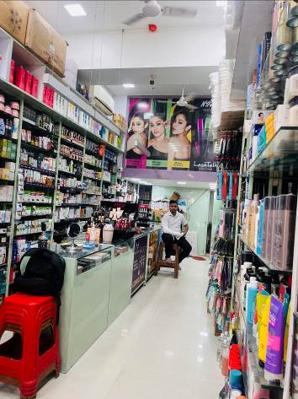
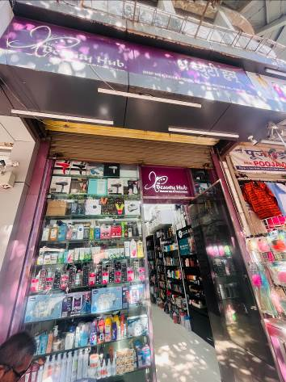
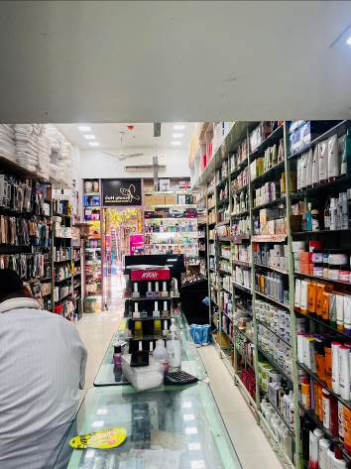

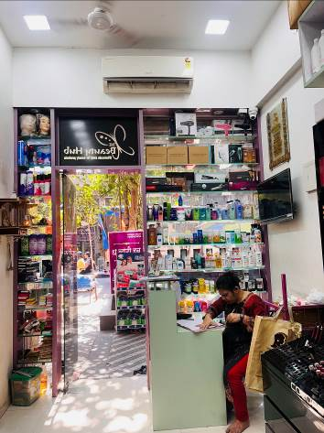
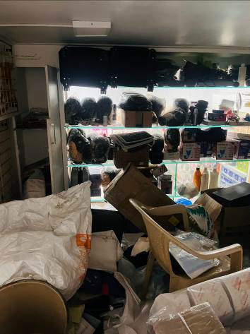
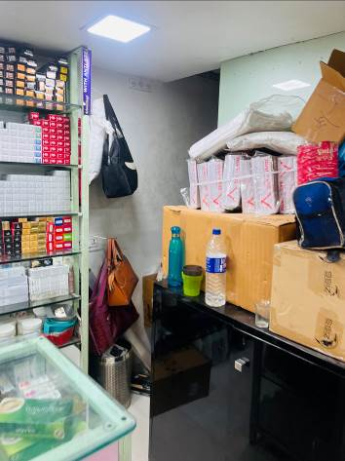

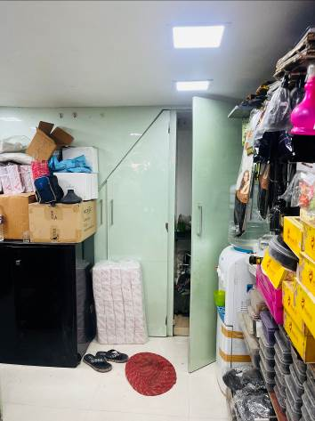
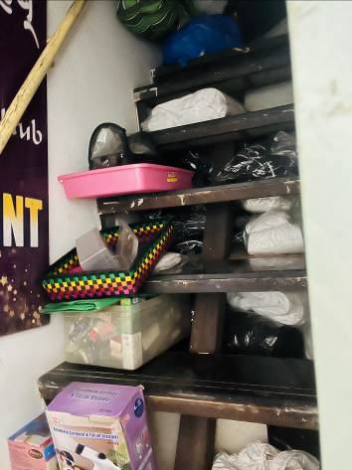
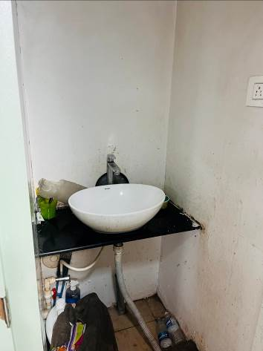

Actual site photographs
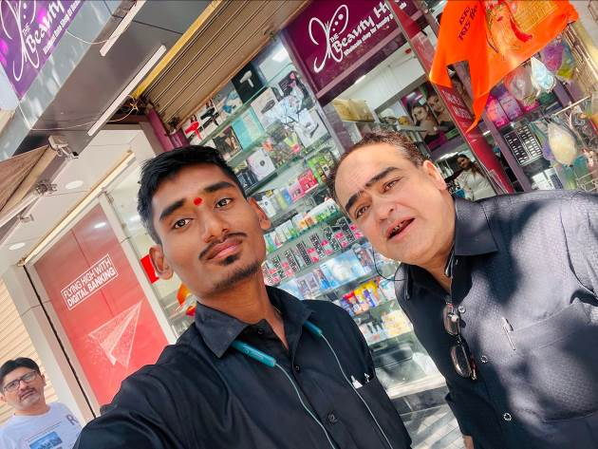

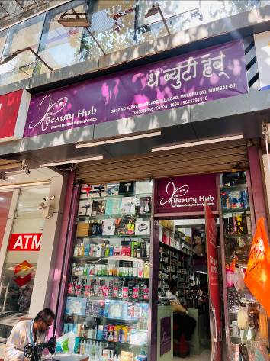
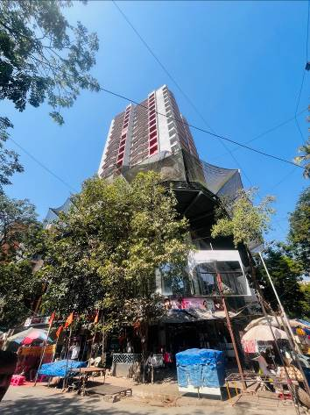

Route Map of the property
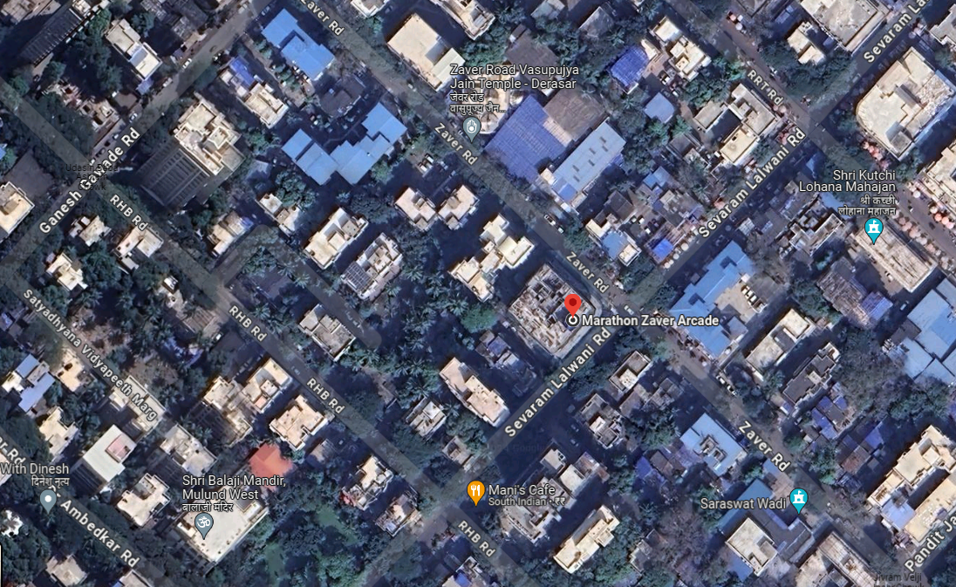
Site U/R

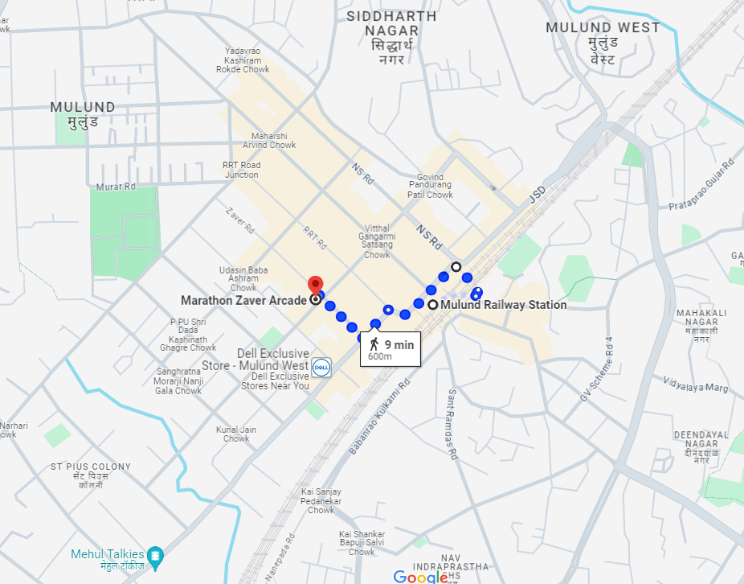

Latitude Longitude: 19°10'14.8"N 72°57'18.0"E

Note: The Blue line shows the route to site from nearest Railway station (Mulund – 600 M.)

Ready Reckoner Rate for Year 2001

Rate for Property
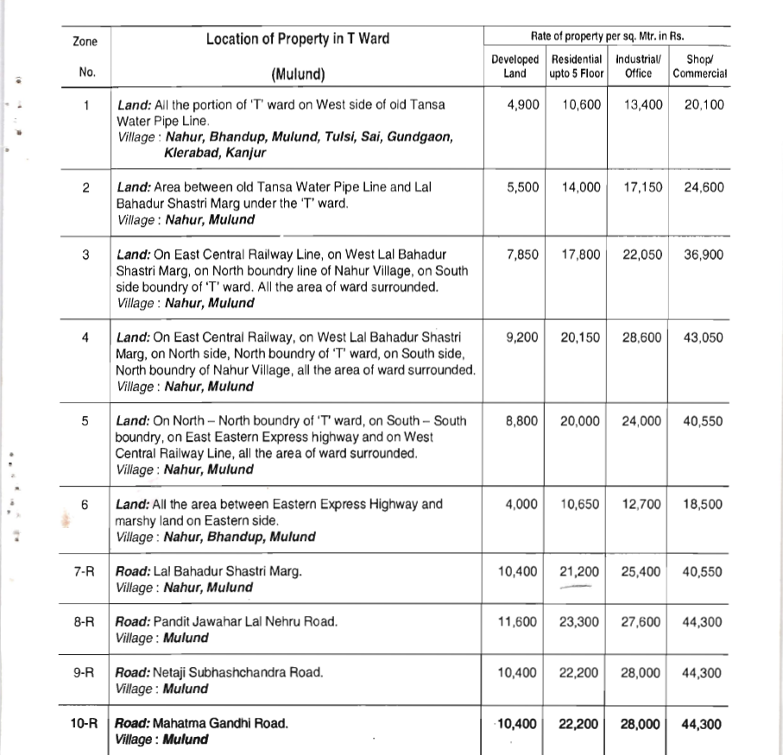

Construction Rate
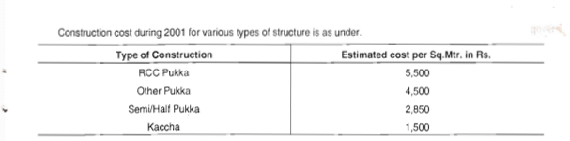

VALUATION OF THE PROPERTY PREMISES

Considering various parameters recorded herein above, existing economic scenario, and the information that is available with reference to the development of neighbourhood and method selected for valuation, we are of the opinion that, the property premises can be assessed and valued for calculation of Capital Gain Tax for ` 15,07,147.00 (Rupees Fifteen Lakh Seven Thousand One Hundred Forty Seven Only).
For Vastukala Architects & Engineers

Sharadkumar B. Chalikwar
Govt. Reg. Valuer
Chartered Engineer (India)
Reg. No. (N) CCIT/1-14/52/2008-09

