COST VETTING REPORT
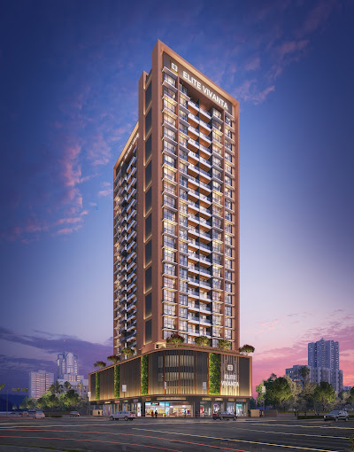

Details of the property under consideration:

Name of Project: "Elite Vivanta"

"Elite Vivanta", Proposed Residential cum Commercial building on Plot bearing Plot No. 38C, Sector No. 15, Near Millennium Empire, D – Mart Road, Village – Kharghar, Navi Mumbai, Taluka – Panvel, District – Raigad, Pin Code – 410 210, State – Maharashtra, Country – India

Latitude Longitude: 19°02'34.0"N 73°04'41.6"E

Valuation Done for:
State Bank of India
SME - Vashi Turbhe Branch
Sector 19, Ground Floor, Central Facility Building, Phase – II, Vashi,
Navi Mumbai – 400 705, State - Maharashtra, Country – India

Vastu/SBI/Mumbai/02/2024/7214/2305242
29/21-464-PY
Date: 22.02.2024

To,
The Branch Manager,
State Bank of India
SME - Vashi Turbhe Branch
Sector 19, Ground Floor,
Central Facility Building, Phase – II,
Vashi, Navi Mumbai – 400 705,
State - Maharashtra, Country – India

Sub: Cost Vetting Report for "Elite Vivanta" at Kharghar, Navi Mumbai, Pin Code – 410 210.

Dear Sir,
In accordance with your letter of engagement as stated above, we enclose our Report on Cost Vetting for "Elite Vivanta", Proposed Residential cum Commercial building on Plot bearing Plot No. 38C, Sector No. 15, Near Millennium Empire, D – Mart Road, Village – Kharghar, Navi Mumbai, Taluka – Panvel, District – Raigad, Pin Code – 410 210, State – Maharashtra, Country – India.
M/s. Nathdwara Developers Pvt. Ltd., is a private limited company. The firm is in operation for over the last 20 years, M/s Nathdwara Developers Pvt. Ltd., a Builders & Developers has created a history of success by building a robust portfolio for itself by delivering dream homes to affordable homes in and around Navi Mumbai area.
M/s. Nathdwara Developers Pvt. Ltd., is developing a Residential cum Commercial building on Plot bearing Plot bearing Plot No. 38C, Sector No. 15, Near Millennium Empire, D – Mart Road, Village – Kharghar, Navi Mumbai, Taluka – Panvel, District – Raigad, Pin Code – 410 210, State – Maharashtra, Country – India. Project is comprising of Residential Building.
Residential Building is proposed of Ground Floor + 1st to 3rd Podium Floors + 4th to 24th Upper Residential Floors with total RERA carpet area of 79,282.60 Sq. Ft. which consists 2 BHK, 3 BHK and Shops units with 81 nos. of Sell flats and 14 nos. of Sell Shops providing with Fitness Centre, Society Office, & Other Amenities.
In this regard, SBI, SME - Vashi Turbhe Branch, Sector 19, Ground Floor, Central Facility Building, Phase – II, Vashi, Navi Mumbai – 400 705, has approached Vastukala Consultants (I) Pvt. Ltd. (VCIPL) to conduct a Cost Vetting of the said project.

Our analysis of the cost vetting is enclosed in this report. This Report forms an integral whole and cannot be split in parts. The outcome of the report/ study can only lead to proper conclusions if the Report as a whole is taken into account.
The information used by Vastukala Consultants (I) Pvt. Ltd. (VCIPL) in preparing this report has been obtained from a variety of sources and other relevant documents provided by the client & bank. As agreed, we have performed our cost vetting exercise with the data available related to the business, considering the market prospects and projections. Our results are dependent on documents provided by client & bank, the underlying assumptions, which has been analyzed at a broader level by VCIPL while assessing their reasonableness.
Total Project Cost for the completion of Project will be ` 87.98 Cr.

For Vastukala Consultants (I) Pvt. Ltd.

Manoj B. Chalikwar
Registered Valuer
Chartered Engineer (India)
Reg. No. IBBI / RV / 07/2018/10366
Reg. No. CAT-I-F-1763
SBI Empanelment No.: SME/TCC/2021-22/86/3
About the Project:
Proposed Residential cum Commercial building on Plot bearing Plot No. 38C, Sector No. 15, Near Millennium Empire, D – Mart Road, Village – Kharghar, Navi Mumbai, Taluka – Panvel, District – Raigad, Pin Code – 410 210. It is about 1.30 Km. travelling distance from Kharghar Village Metro Station & 2.90 Km. travelling distance from Kharghar Railway station.

Construction Area as per Approved Plan for Building

Sr. No. | Floor | Built Up Area in Sq. M. | Other Area in Sq. M. | Total Construction Area in Sq. M.
1 | Ground Floor | 612.86 | 612.10 | 1,224.97
2 | 1st Floor | - | 1,232.77 | 1,232.77
3 | 2nd Floor | - | 1,232.77 | 1,232.77
4 | 3rd Floor | - | 1,232.77 | 1,232.77
5 | 4th Floor | 442.90 | 35.76 | 478.66
6 | 5th Floor | 441.55 | 35.76 | 477.31
7 | 6th Floor | 441.55 | 35.76 | 477.31
8 | 7th Floor | 441.55 | 35.76 | 477.31
9 | 8th Floor | 441.55 | 35.76 | 477.31
10 | 9th Floor | 441.55 | 35.76 | 477.31
11 | 10th Floor | 441.55 | 35.76 | 477.31
12 | 11th Floor | 441.55 | 35.76 | 477.31
13 | 12th Floor | 441.55 | 35.76 | 477.31
14 | 13th Floor | 441.55 | 35.76 | 477.31
15 | 14th Floor | 441.55 | 35.76 | 477.31
16 | 15th Floor | 441.55 | 35.76 | 477.31
17 | 16th Floor | 441.55 | 35.76 | 477.31
18 | 17th Floor | 441.55 | 35.76 | 477.31
19 | 18th Floor | 441.55 | 35.76 | 477.31
20 | 19th Floor | 441.55 | 35.76 | 477.31
21 | 20th Floor | 441.55 | 35.76 | 477.31
22 | 21st Floor | 441.55 | 35.76 | 477.31
23 | 22nd Floor | 441.55 | 35.76 | 477.31
24 | 23rd Floor | 441.55 | 35.76 | 477.31
25 | 24th Floor | 441.55 | 35.76 | 477.31
26 | OHT / LMR | - | 35.76 | 35.76
Total Area in Sq. M. |  | 9,886.83 | 5,097.12 | 14,983.94

Project Cost
Sr. No. | Particulars | Total Estimated Amount in ` | Total Estimated Amount  in ` Cr.
1 | Land Cost
 | Acquisition Cost of Land or Development Rights, and Legal Cost. | 27,34,89,550.00 | 27.35
 | Rent to Tenants, Lease premium, Lease Rent, interest cost incurred or payable on Land Cost | - | -
 | Amount of Premium payable to obtain development rights, FSI, additional FSI, fungible area, and any other incentive under DCR from Local Authority or State Government or any Statutory Authority. | 7,77,99,525.00 | 7.78
 | Acquisition cost of TDR (if any) | - | -
2 | Cost of Construction
 | Estimated construction cost of sale building including site development and infrastructure for the same. | 37,45,98,575.00 | 37.46
 | On site expenditure for development of entire project excluding cost of construction as per(i) above,
a. | Architect Fees & Consultant fees | 1,87,29,929.00 | 1.87
b. | Admin Cost includes salaries, site overheads, development works, cost of services (including water, electricity, sewerage, drainage, layout roads etc.), cost of machineries and equipment including its hire and maintenance cost, consumables etc. All costs directly incurred to complete the construction of the entire phase of the project registered. | 2,24,75,915.00 | 2.25
c. | Marketing Cost | 3,06,29,736.00 | 3.06
3 | Interest during the Project | 7,08,00,000.00 | 7.08
4. | Contingency Charges | 1,12,37,957.00 | 1.12
 | GRAND TOTAL: | 87,97,61,187.00 | 87.98

Manoj B. Chalikwar
Registered Valuer
Chartered Engineer (India)
Reg. No. IBBI / RV / 07/2018/10366
Reg. No. CAT-I-F-1763
SBI Empanelment No.: SME/TCC/2021-22/86/3

Comments on each element of Cost of Project: -
- Land Cost:
As per Present Ready Reckoner rate the Project Land Value is ` 8.69 Cr. considering Land Rate @ ` 42,400.00 per Sq. M. & Net Plot Area of 2,050.70 Sq. M.
As per document purchase cost of land & stamp duty cost is ` 27,34,89,550.00 i.e., ` 27.35 Cr. which is 31.09% of Total Project Cost.
Sr. | Agreement Name | Date | Particulars | Total Cost in ` | Incurred Cost in `
1 | Lease Agreement | 11.07.2019 | Purchase | 26,04,36,850.00 | 26,04,36,850.00
2 | Lease Agreement | 11.07.2019 | Stamp Duty | 1,30,22,000.00 | 1,30,22,000.00
3 | Lease Agreement | 11.07.2019 | Reg. Fees | 30,000.00 | 30,000.00
4 | Lease Agreement | 11.07.2019 | Reg. Fees | 700.00 | 700.00
TOTAL |  |  |  | 27,34,89,550.00 | 27,34,89,550.00

- Building Cost of Construction for Building:
Construction Area of Building = 14,983.94 Sq. M. i.e., 1,61,287.16 Sq. Ft.
Total estimated cost for construction of Building (includes cost of RCC work, manpower, lift, material, painting, finishing work, site development, etc.) is ` 37,45,98,575.00 i.e., ` 37.46 Cr. which comes ` 25,000.00 per Sq. M. on construction area for building.
The total construction area is 14,983.94 Sq. M., projected cost of ` 37.46 Cr is 42.58% of total project cost
VCIPL opinion the construction cost of 25,000/- Per Sq. M. which is in line with Market-Trend.
Particulars | Rate per Sq. M.
Excavation Work | 1,500.00
RCC Work | 15,000.00
Final Finishing Work | 5,000.00
Other Work | 3,500.00
Cost of Construction | 25,000.00

- Approval Charges:
The Total Approval Cost (Fungible Cost & Development Cess Premium & TDR Cost) as per architect letter will be ` 7,77,99,525.00 i.e., ` 7.78Cr. which is 8.84% of Total Project Cost. Builder has paid ` 7.78 Cr.
Sr. No. | Particulars | Total Cost in ` | Incurred Cost in `
1 | Development Charges | 6,15,63,719.00 | 6,15,63,719.00
2 | Labour Cess | 1,62,35,806.00 | 1,62,35,806.00
Total |  | 7,77,99,525.00 | 7,77,99,525.00
As per information provided by developer.

- Architect Cost, RCC & Other Professional Charges:
The total Architect charges of ` 1,87,29,929.00 i.e., ` 1.87 Cr. is 5% of construction cost of building & it is line up with Market trend.
The professional charge consists of Architect & Legal which in market is in the range of 2% - 5% of Total Construction cost of the project.

- Administrative Expenses:
Salaries, site overheads, development works, cost of services (including water, electricity, sewerage, drainage, layout roads etc.), cost of machineries and equipment including its hire and maintenance cost, consumables etc. All costs directly incurred to complete the construction of the entire phase of the project registered is estimated 6% of construction cost of building which comes to ` 2,24,75,915.00 i.e., ` 2.25 Cr.
The admin charges which in market is in the range of 4% - 6% of Total Construction cost of the project.

- Marketing Expenses:
Marketing costs directly incurred to complete the construction of the entire phase of the project registered is estimated at 2% of total Sale income from the project which comes to ` 3,06,29,736.00 i.e., ` 3.06 Cr.
The marketing charge consists of brokerage & commission which in market is in the range of 1% - 3% of Total Sale income of the property.

- Interest Costs:
The Interest cost for the term loan is ` 7,08,00,000.00 i.e., ` 7.08 Cr., which is 8.05% of total project cost.
As per information provided by the client.

- Contingency Costs:
The contingency charges estimated at 3% construction cost of building which comes to ` 1,12,37,957.00 i.e., ` 1.12 Cr.

Observation and Construction: -
Total estimated cost of project i.e., ` 87,97,61,187.00 (Rupees Eighty – Seven Crore Ninety – Seven Lakh Sixty – One Thousand One Hundred Eighty – Four Only) i.e., ` 87.98 Cr. is fair & reasonable.
The project cost is including land premium payable to concern authorities, Fungible FSI Premium, Cost of Construction of Sale Building, on site expenses including admin & marketing expenses, premiums / charges to be paid to competent authority and Bank interest, etc. we have not independently verified interest cost hence not consider in cost vetting.
As per present sanctioned building plan, permissible built-up area on the said plot is 9,886.83 Sq. M. The sale building is presently approved for Ground Floor + 1st to 3rd Podium Floors + 4th to 24th Upper Residential Floors only. Estimated cost of entire project of 24th upper floors is considered.
Total estimated cost of construction of Sales building is ` 37,45,98,575.00 i.e., ` 37.46 Cr. which comes ` 25,000.00 per Sq. M. on construction area for building, which is fair & reasonable considering the present status of project, type & quality of construction & specification of the building materials to be used, height of the structure, amenities to be provided in proposed building.

Assumptions & Remarks-
- The adequacy of Engineering / Structural design is beyond the scope of our assignment.
- Estimated project completion date is 31/12/2027. The cost is certified based on the assumptions that the project will be completed within time frame. Few assumptions are made regarding inflation & cost rise etc. during construction period.

Photo copy of following document is provided to us & this report should be read along with it:
- Copy of Agreement to Lease dated 11.07.2019 between M/s. City and Industrial Development Corporation of Maharashtra Limited (CIDCO (The Corporation) and M/s. Nathdwara Developers Pvt. Ltd. (The Licensee) through registered agreement vide No. PVL-2/8821/2019 dated 11.07.2019.
- Copy of Allotment of Residential + Commercial Plot Letter Reference No. 1960/1000082/221 dated 10.10.2018 issued by City and Industrial Development Corporation of Maharashtra Limited (CIDCO).
- Copy of Approved Plan No. CIDCO/BP-17102/TPO (NM & K)/2019/10852 dated 06.06.2023 issued by City and Industrial Development Corporation of Maharashtra Limited (CIDCO).
Approved upto: Ground Floor + 1st to 3rd Podium Floors + 4th to 24th Upper Residential Floors
- Copy of Commencement Certificate No. CIDCO/BP-17102/TPO (NM & K)/2019/10852 dated 06.06.2023 issued by City and Industrial Development Corporation of Maharashtra Ltd. (CIDCO).
(This CC is endorsed for the work for Ground Floor + 1st to 3rd Podium Floors + 4th to 24th Upper Residential Floors remain valid for period of 1 years commencing from the date of its issue)
- Copy of Fire NOC Certificate No. CIDCO/FIRE/HQ/2023/E-208345 dated 10.05.2023 issued by City and Industrial Development Corporation of Maharashtra Limited (CIDCO).
- Copy of No Objection Certificate for Height Clearance NOC ID No. NAVI/WEST/B/072419/418097 dated 20.08.2019 valid upto 19.08.2027 issued by Airports Authority of India.
- Copy of Grant of NOC for avail additional FSI Certificate No. CIDCO/MTS-III/UDCPR/800197105/2023/2311 dated 27.03.2023 issued by City and Industrial Development Corporation of Maharashtra Limited (CIDCO).
- Copy of RERA Certificate RERA No. P5200054784 dated 12.02.2024 issued by Maharashtra Real Estate Regulatory Authority (MAHRERA).
- Copy of CA Certificate (Form 3) dated 27.11.2023 issued by M/s. H. M. Shah & Associates.
- Copy of Architect Certificate dated 01.09.2023 issued by M/s. Soyuz Talib Architects Ltd.

Actual Site Photographs
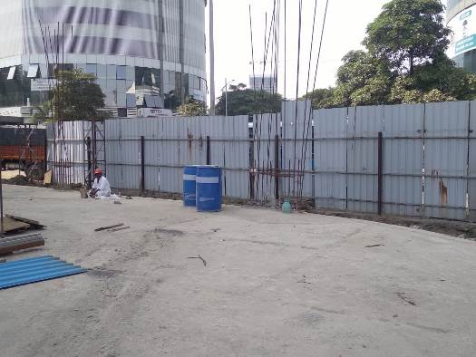
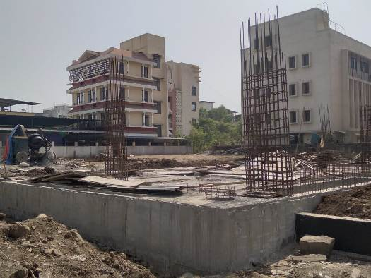
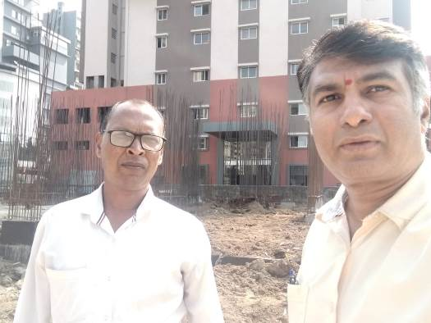
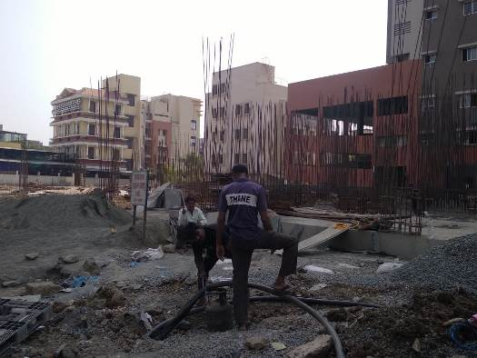
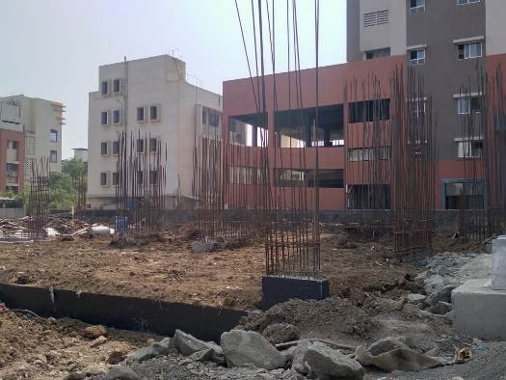
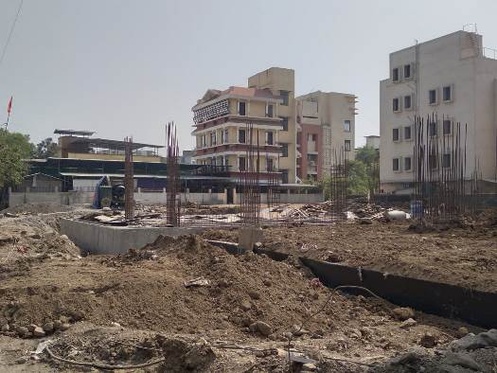
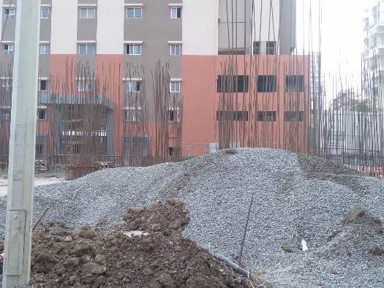
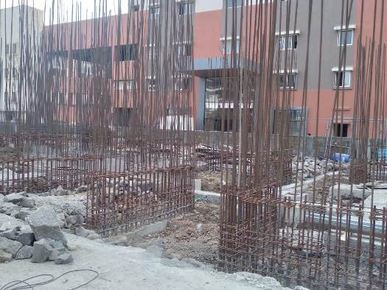
Route Map of the property
Site u/r
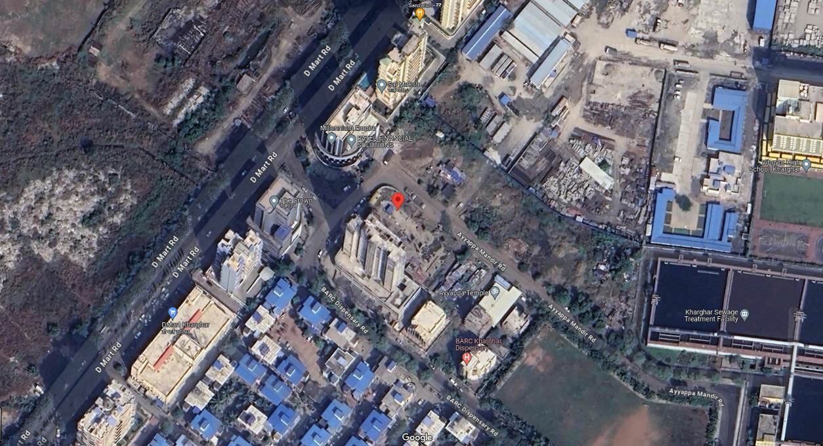

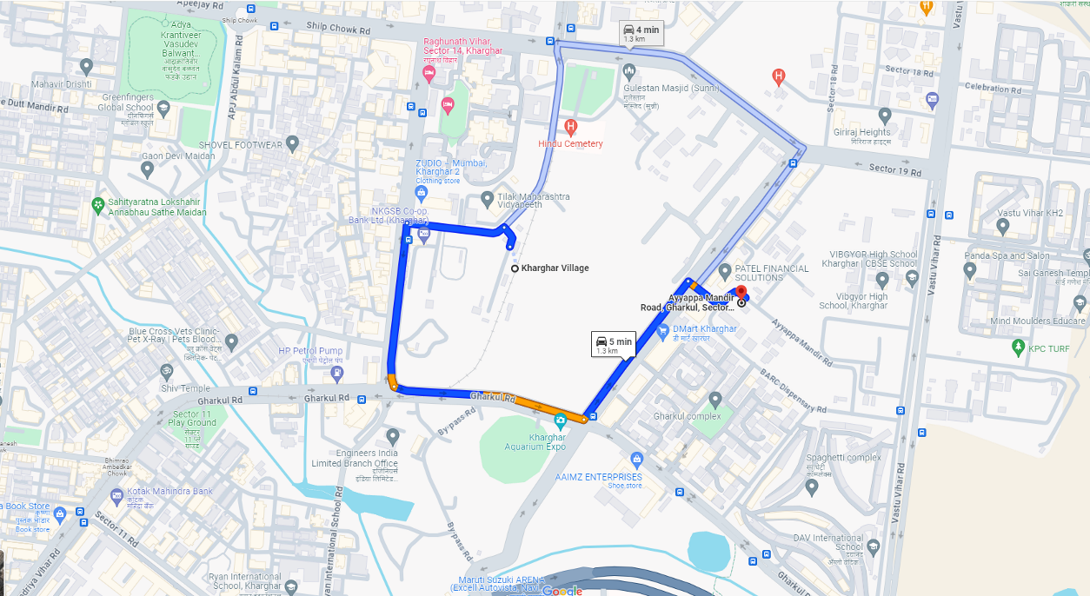

Latitude Longitude: 19°02'34.0"N 73°04'41.6"E
Note: The Blue line shows the route to site from nearest metro station (Kharghar Village – 1.30 Km.)

