PROJECT VALUATION REPORT
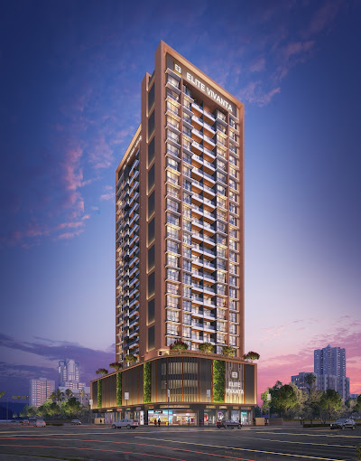

Details of the property under consideration:

Name of Project: "Elite Vivanta"

"Elite Vivanta", Proposed Residential cum Commercial building on Plot bearing Plot No. 38C, Sector No. 15, Near Millennium Empire, D – Mart Road, Village – Kharghar, Navi Mumbai, Taluka – Panvel, District – Raigad, Pin Code – 410 210, State – Maharashtra, Country – India

Latitude Longitude: 19°02'34.0"N 73°04'41.6"E

Valuation Done for:
State Bank of India
SME - Vashi Turbhe Branch
Sector 19, Ground Floor, Central Facility Building, Phase – II, Vashi,
Navi Mumbai – 400 705, State - Maharashtra, Country – India

Vastu/SBI/Mumbai/02/2024/7213/2305241
29/20-463-PY
Date: 22.02.2024

To,
The Branch Manager,
State Bank of India
SME - Vashi Turbhe Branch
Sector 19, Ground Floor,
Central Facility Building, Phase – II,
Vashi, Navi Mumbai – 400 705,
State - Maharashtra, Country – India

Sub: Project Valuation for "Elite Vivanta" at Kharghar, Navi Mumbai, Pin Code – 410 210.

Dear Sir,
In accordance with your letter of engagement as stated above, we enclose our Report on Project Valuation for "Elite Vivanta", Proposed Residential cum Commercial building on Plot bearing Plot No. 38C, Sector No. 15, Near Millennium Empire, D – Mart Road, Village – Kharghar, Navi Mumbai, Taluka – Panvel, District – Raigad, Pin Code – 410 210, State – Maharashtra, Country – India.
M/s. Nathdwara Developers Pvt. Ltd., is a private limited company. The firm is in operation for over the last 20 years, M/s Nathdwara Developers Pvt. Ltd., a Builders & Developers has created a history of success by building a robust portfolio for itself by delivering dream homes to affordable homes in and around Navi Mumbai area.
M/s. Nathdwara Developers Pvt. Ltd., is developing a Residential cum Commercial building on Plot bearing Plot bearing Plot No. 38C, Sector No. 15, Near Millennium Empire, D – Mart Road, Village – Kharghar, Navi Mumbai, Taluka – Panvel, District – Raigad, Pin Code – 410 210, State – Maharashtra, Country – India. Project is comprising of Residential Building.
Residential Building is proposed of Ground Floor + 1st to 3rd Podium Floors + 4th to 24th Upper Residential Floors with total RERA carpet area of 79,282.60 Sq. Ft. which consists 2 BHK, 3 BHK and Shops units with 81 nos. of Sell flats and 14 nos. of Sell Shops providing with Fitness Centre, Society Office, & Other Amenities.
In this regard, SBI, SME - Vashi Turbhe Branch, Sector 19, Ground Floor, Central Facility Building, Phase – II, Vashi, Navi Mumbai – 400 705, has approached Vastukala Consultants (I) Pvt. Ltd. (VCIPL) to conduct a Project Valuation of the said project.
Our analysis of the project valuation is enclosed in this report. This Report forms an integral whole and cannot be split in parts. The outcome of the report/ study can only lead to proper conclusions if the Report as a whole is taken into account.
The information used by Vastukala Consultants (I) Pvt. Ltd. (VCIPL) in preparing this report has been obtained from a variety of sources and other relevant documents provided by the client & bank. As agreed, we have performed our project valuation exercise with the data available related to the business, considering the market prospects and projections. Our results are dependent on documents provided by client & bank, the underlying assumptions, which has been analyzed at a broader level by VCIPL while assessing their reasonableness.
Sale Realisation from the Project is ` 153.15 Cr. and Net Present Value of the project as on date is ` 71.15 Cr.

For Vastukala Consultants (I) Pvt. Ltd.

Manoj B. Chalikwar
Registered Valuer
Chartered Engineer (India)
Reg. No. IBBI / RV / 07/2018/10366
Reg. No. CAT-I-F-1763
SBI Empanelment No.: SME/TCC/2021-22/86/3
PROJECT VALUATION REPORT
OF
"Elite Vivanta"

"Elite Vivanta", Proposed Residential cum Commercial building on Plot bearing Plot No. 38C,
Sector No. 15, Near Millennium Empire, D – Mart Road, Village – Kharghar, Navi Mumbai,
Taluka – Panvel, District – Raigad, Pin Code – 410 210, State – Maharashtra, Country – India

Latitude Longitude: 19°02'34.0"N 73°04'41.6"E

NAME OF DEVELOPER: M/s. Nathdwara Developers Pvt. Ltd.
Pursuant to instructions from State Bank of India, SME – Vashi Turbhe Branch, we have duly visited, inspected, surveyed & assessed the above said property to determine the fair & reasonable market value of the said property as on 31st December 2024 for approval of project finance purpose.

- Location Details:
Proposed Residential cum Commercial building on Plot bearing Plot No. 38C, Sector No. 15, Near Millennium Empire, D – Mart Road, Village – Kharghar, Navi Mumbai, Taluka – Panvel, District – Raigad, Pin Code – 410 210. It is about 1.30 Km. travelling distance from Kharghar Village Metro Station & 2.90 Km. travelling distance from Kharghar Railway station. Surface transport to the property is by buses, taxis & private vehicles. The property is in developed locality. All the amenities like shops, banks, hotels, markets, schools, hospitals, etc. are all available in the surrounding locality. The area is higher middle class & developed.

2. Developer Details:
Name of builder | M/s. Nathdwara Developers Pvt. Ltd.
Project Registration Number | P52000054784
Register office address | M/s. Nathdwara Developers Pvt. Ltd.  309, Arenja Corner, Sector – 17, Vashi, Navi Mumbai, Taluka & District – Thane, Pin Code – 400 703, State – Maharashtra, Country – India.
Contact Numbers | Contact Person:  Mr. Vijesh Jain (Consultant)  Mobile No. 9929977362  Mr. Ramchandra Chauhan (Site Engineer)  Mobile No. 9321256337
E – mail ID and Website

3. Boundaries of the Property:
Direction | Sale Building
On or towards North | Ayyappa Mandir Road & Millennium Empire
On or towards South | Under Construction Building
On or towards East | Ayyappa Mandir Road
On or towards West | Tricity Eros Building

Vastukala Consultants (I) Pvt. Ltd.
B1-001, U/B Floor, Boomerang, Chandivali Farm Road, Powai, Andheri (East), Mumbai – 400 072

To,
The Branch Manager,
State Bank of India
SME - Vashi Turbhe Branch
Sector 19, Ground Floor,
Central Facility Building, Phase – II,
Vashi, Navi Mumbai – 400 705,
State - Maharashtra, Country – India

VALUATION REPORT (IN RESPECT OF PROJECT FINANCE)
I | General
1. | Purpose for which the valuation is made |  |  |  |  | : | As per request from State Bank of India, SME – Vashi Turbhe Branch, to assess Fair Market value of the Project for bank loan purpose.
2. | a) |  | Date of inspection |  |  | : | 31.01.2024
 | b) |  | Date on which the valuation is made |  |  | : | 22.02.2024
3. | List of documents produced for perusal
 | - Copy of Agreement to Lease dated 11.07.2019 between M/s. City and Industrial Development Corporation of Maharashtra Limited (CIDCO (The Corporation) and M/s. Nathdwara Developers Pvt. Ltd. (The Licensee) through registered agreement vide No. PVL-2/8821/2019 dated 11.07.2019.
 | - Copy of Allotment of Residential + Commercial Plot Letter Reference No. 1960/1000082/221 dated 10.10.2018 issued by City and Industrial Development Corporation of Maharashtra Limited (CIDCO).
- Copy of Approved Plan No. CIDCO/BP-17102/TPO (NM & K)/2019/10852 dated 06.06.2023 issued by City and Industrial Development Corporation of Maharashtra Limited (CIDCO).
Approved upto: Ground Floor + 1st to 3rd Podium Floors + 4th to 24th Upper Residential Floors
- Copy of Commencement Certificate No. CIDCO/BP-17102/TPO (NM & K)/2019/10852 dated 06.06.2023 issued by City and Industrial Development Corporation of Maharashtra Ltd. (CIDCO).
(This CC is endorsed for the work for Ground Floor + 1st to 3rd Podium Floors + 4th to 24th Upper Residential Floors remain valid for period of 1 years commencing from the date of its issue)
 | - Copy of Fire NOC Certificate No. CIDCO/FIRE/HQ/2023/E-208345 dated 10.05.2023 issued by City and Industrial Development Corporation of Maharashtra Limited (CIDCO).
 | - Copy of No Objection Certificate for Height Clearance NOC ID No. NAVI/WEST/B/072419/418097 dated 20.08.2019 valid upto 19.08.2027 issued by Airports Authority of India.
 | - Copy of Grant of NOC for avail additional FSI Certificate No. CIDCO/MTS-III/UDCPR/800197105/2023/2311 dated 27.03.2023 issued by City and Industrial Development Corporation of Maharashtra Limited (CIDCO).
 | - Copy of RERA Certificate RERA No. P5200054784 dated 12.02.2024 issued by Maharashtra Real Estate Regulatory Authority (MAHRERA).
 | - Copy of CA Certificate (Form 3) dated 27.11.2023 issued by M/s. H. M. Shah & Associates.
 | - Copy of Architect Certificate dated 01.09.2023 issued by M/s. Soyuz Talib Architects Ltd.
 | Project Name  (with address & phone nos.) |  |  |  |  | : | "Elite Vivanta", Proposed Residential cum Commercial building on Plot bearing Plot No. 38C, Sector No. 15, Near Millennium Empire, D – Mart Road, Village – Kharghar, Navi Mumbai, Taluka – Panvel, District – Raigad, Pin Code – 410 210, State – Maharashtra, Country – India
4. | Name of the owner(s) and his / their address (es) with Phone no. (details of share of each owner in case of joint ownership) |  |  |  |  | : | M/s. Nathdwara Developers Pvt. Ltd.  309, Arenja Corner, Sector – 17, Vashi, Navi Mumbai, Taluka & District – Thane, Pin Code – 400 703, State – Maharashtra, Country – India.  Contact Person:  Mr. Vijesh Jain (Consultant)  Mobile No. 9929977362  Mr. Ramchandra Chauhan (Site Engineer)  Mobile No. 9321256337
5. | Brief description of the property (Including Leasehold / freehold etc.): Leasehold land
TYPE OF THE BUILDING:
Building | Number of Floors
"Elite Vivanta” | Proposed Residential Building of Ground Floor + 1st to 3rd Podium Floors + 4th to 24th Upper Residential Floors as per approved plan and information from developer.

LEVEL OF COMPLETEION:
Building | Present stage of Construction | Percentage of work completion | % of construction cost incurred certificate dated 27.11.2023
Elite Vivanta | Plinth Work is in completed; Column work is in progress | 10.00% | 5.00%

PROPOSED DATE OF COMPLETION & FUTURE LIFE:
Expected completion date as informed by builder is 31.12.2027 (As per RERA Certificate)
Future estimated life of the Structure is 60 years (after completion) Subject to proper, preventive periodic maintenance & Structural repairs.

PROPOSED PROJECT AMENITIES:
Vitrified flooring tiles in all rooms
Granite Kitchen platform with Stainless Steel Sink
Powder coated aluminum sliding windows with M.S. Grills
Laminated wooden flush doors with Safety door
Concealed wiring
Concealed plumbing
Fire Fighting System
Car Parking
Fitness Center

6. | Location of property |  |  |  |  | :
 | a) | Plot No. / Survey No. |  |  |  | : | Plot No. 38C, Sector No. 15
 | b) | Door No. |  |  |  | : | Not applicable
 | c) | C. T.S. No. / Village |  |  |  | : | Village – Kharghar
 | d) | Ward / Taluka |  |  |  | : | Taluka – Panvel
 | e) | Mandal / District |  |  |  | : | District – Raigad
7. | Postal address of the property |  |  |  |  | : | "Elite Vivanta", Proposed Residential cum Commercial building on Plot bearing Plot No. 38C, Sector No. 15, Near Millennium Empire, D – Mart Road, Village – Kharghar, Navi Mumbai, Taluka – Panvel, District – Raigad, Pin Code – 410 210, State – Maharashtra, Country – India
8. | City / Town |  |  |  |  | : | Kharghar, Navi Mumbai
 | Residential area |  |  |  |  | : | Yes
 | Commercial area |  |  |  |  | : | Yes
 | Industrial area |  |  |  |  | : | No
9. | Classification of the area |  |  |  |  | :
 | i) High / Middle / Poor |  |  |  |  | : | Higher Middle Class
 | ii) Urban / Semi Urban / Rural |  |  |  |  | : | Urban
10. | Coming under Corporation limit / Village Panchayat / Municipality |  |  |  |  | : | Kharghar, Navi Mumbai  City and Industrial Development Corporation of Maharashtra Limited (CIDCO)
11. | Whether covered under any State / Central Govt. enactments (e.g., Urban Land Ceiling Act) or notified under agency area/ scheduled area / cantonment area |  |  |  |  | : | No
12. | In Case it is Agricultural land, any conversion to house site plots is contemplated |  |  |  |  | : | N.A.
13. | Boundaries of the property |  |  | As per Agreement | As per RERA Certificate |  |  | As per Site
 | North |  |  | 15 Meters Wide Road | 15 Meters Wide Road |  |  | Ayyappa Mandir Road & Millennium Empire
 | South |  |  | Plot No - 38 | Plot No - 38 |  |  | Under Construction Building
 | East |  |  | Plot No – 38A | Plot No – 38A |  |  | Ayyappa Mandir Road
 | West |  |  | 15 Meters Wide Road | 15 Meters Wide Road |  |  | Tricity Eros Building
14.1 | Dimensions of the site |  |  |  |  |  | N. A. as the land is irregular in shape
 |  |  |  |  |  |  | A (As per the Deed) |  | B (Actuals)
 | North |  |  |  |  | : | - |  | -
 | South |  |  |  |  | : | - |  | -
 | East |  |  |  |  | : | - |  | -
 | West |  |  |  |  | : | - |  | -
14.2 | Latitude, Longitude & Co-ordinates of property |  |  |  |  | : | 19°02'34.0"N 73°04'41.6"E
14. | Extent of the site |  |  |  |  | : | Net Plot area = 2,050.70 Sq. M.  Structure - As per table attached to the report
15. | Extent of the site considered for Valuation (least of 14A& 14B) |  |  |  |  | : | Net Plot area = 2,050.70 Sq. M.
16 | Whether occupied by the owner / tenant? If occupied by tenant since how long? Rent received per month. |  |  |  |  | : | N.A. Building Construction work is in progress
II | CHARACTERSTICS OF THE SITE
 | Classification of locality |  |  |  |  | : | Higher Middle class
 | Development of surrounding areas |  |  |  |  | : | Very Good
 | Possibility of frequent flooding/ sub-merging |  |  |  |  | : | No
 | Feasibility to the Civic amenities like School, Hospital, Bus Stop, Market etc. |  |  |  |  | : | All available near by
 | Level of land with topographical conditions |  |  |  |  | : | Plain
 | Shape of land |  |  |  |  | : | Irregular
 | Type of use to which it can be put |  |  |  |  | : | For residential cum commercial purpose
 | Any usage restriction |  |  |  |  | : | Residential cim Commercial
 | Is plot in town planning approved layout? |  |  |  |  | : | - Copy of Approved Plan No. CIDCO/BP-17102/TPO (NM & K)/2019/10852 dated 06.06.2023 issued by City and Industrial Development Corporation of Maharashtra Limited (CIDCO).  Approved upto: Ground Floor + 1st to 3rd Podium Floors + 4th to 24th Upper Residential Floors  - Copy of Commencement Certificate No. CIDCO/BP-17102/TPO (NM & K)/2019/10852 dated 06.06.2023 issued by City and Industrial Development Corporation of Maharashtra Ltd. (CIDCO).  (This CC is endorsed for the work for Ground Floor + 1st to 3rd Podium Floors + 4th to 24th Upper Residential Floors remain valid for period of 1 years commencing from the date of its issue)
 | Corner plot or intermittent plot? |  |  |  |  | : | Corner Plot
 | Road facilities |  |  |  |  | : | Yes
 | Type of road available at present |  |  |  |  | : | Bituminous Road
 | Width of road – is it below 20 ft. or more than 20 ft. |  |  |  |  | : | 15 M wide road
 | Is it a Land – Locked land? |  |  |  |  | : | No
 | Water potentiality |  |  |  |  | : | Municipal Water supply
 | Underground sewerage system |  |  |  |  | : | Connected to Municipal sewer
 | Is Power supply is available in the site |  |  |  |  | : | Yes
 | Advantages of the site |  |  |  |  | : | Located in developed area
 | Special remarks, if any like threat of acquisition of land for publics service purposes, road widening or applicability of CRZ provisions etc. (Distance from sea-cost / tidal level must be incorporated) |  |  |  |  | : | No
Part – A (Valuation of land)
1 | Size of plot |  |  |  |  | : | Net Plot area = 2,050.70 Sq. M.
 | North & South |  |  |  |  | : | -
 | East & West |  |  |  |  | : | -
2 | Total extent of the plot |  |  |  |  | : | As per table attached to the report
3 | Prevailing market rate (Along With details / reference of at least two latest deals / transactions with respect to adjacent properties in the areas) |  |  |  |  | : | As per table attached to the report  Details of recent transactions/online listings are attached with the report.
4 | Guideline rate obtained from the Register’s Office (evidence thereof to be enclosed) |  |  |  |  | : | ` 42,400.00 per Sq. M. for Land  ` 86,800.00 per Sq. M. for Residential Flat  ` 1,27,600.00 per Sq. M. for Commercial Office
5 | Assessed / adopted rate of valuation |  |  |  |  | : | As per table attached to the report
6 | Estimated value of land |  |  |  |  | : | As per table attached to the report
Part – B (Valuation of Building)
1 | Technical details of the building |  |  |  |  | :
 | - Type of Building (Residential / Commercial / Industrial) |  |  |  |  | : | Residential
 | - Type of construction (Load bearing / RCC / Steel Framed) |  |  |  |  | : | R.C.C. Framed structure
 | - Year of construction |  |  |  |  | : | Building Construction work is in progress
 | - Number of floors and height of each floor including basement, if any |  |  |  |  | :
Building | Number of Floors
"Elite Vivanta” | Proposed Residential Building of Ground Floor + 1st to 3rd Podium Floors + 4th to 24th Upper Residential Floors as per approved plan and information from developer.

 | - Plinth area floor-wise |  |  |  |  | : | As per table attached to the report
 | - Condition of the building |  |  |  |  | :
 | - Exterior – Excellent, Good, Normal, Poor |  |  |  |  | : | N.A. Building Construction work is in progress
 | - Interior – Excellent, Good, Normal, Poor |  |  |  |  | : | N.A. Building Construction work is in progress
 | - Date of issue and validity of layout of approved map |  |  |  |  | : | - Copy of Approved Plan No. CIDCO/BP-17102/TPO (NM & K)/2019/10852 dated 06.06.2023 issued by City and Industrial Development Corporation of Maharashtra Limited (CIDCO).  Approved upto: Ground Floor + 1st to 3rd Podium Floors + 4th to 24th Upper Residential Floors  - Copy of Commencement Certificate No. CIDCO/BP-17102/TPO (NM & K)/2019/10852 dated 06.06.2023 issued by City and Industrial Development Corporation of Maharashtra Ltd. (CIDCO).  (This CC is endorsed for the work for Ground Floor + 1st to 3rd Podium Floors + 4th to 24th Upper Residential Floors remain valid for period of 1 years commencing from the date of its issue)
 | - Approved map / plan issuing authority |  |  |  |  | : | City and Industrial Development Corporation of Maharashtra Limited (CIDCO)
 | - Whether genuineness or authenticity of approved map / plan is verified |  |  |  |  | : | Verified
 | - Any other comments by our empanelled valuers on authentic of approved plan |  |  |  |  | : | N.A.

Specifications of construction (floor-wise) in respect of
Sr. No. | Description
 | Foundation | : | Proposed R.C.C. Footing
 | Basement | : | N. A.
 | Superstructure | : | Proposed as per IS Code requirements
 | Joinery / Doors & Windows (Please furnish details about size of frames, shutters, glazing, fitting etc. and specify the species of timber | : | Proposed
 | RCC Works | : | N.A. Building Construction work is in progress
 | Plastering | : | N.A. Building Construction work is in progress
 | Flooring, Skirting, dado | : | N.A. Building Construction work is in progress
 | Special finish as marble, granite, wooden paneling, grills etc. | : | N.A. Building Construction work is in progress
 | Roofing including weather proof course | : | N.A. Building Construction work is in progress
 | Drainage | : | Proposed
2. | Compound Wall | :
 | Height | : | N.A. Building Construction work is in progress
 | Length | : | N.A. Building Construction work is in progress
 | Type of construction | : | N.A. Building Construction work is in progress
3. | Electrical installation | : | N.A. Building Construction work is in progress
 | Type of wiring | : | N.A. Building Construction work is in progress
 | Class of fittings (superior / ordinary / poor) | : | N.A. Building Construction work is in progress
 | Number of light points | : | N.A. Building Construction work is in progress
 | Fan points | : | N.A. Building Construction work is in progress
 | Spare plug points | : | N.A. Building Construction work is in progress
 | Any other item | : | -
4. | Plumbing installation
 | - No. of water closets and their type | : | N.A. Building Construction work is in progress
 | - No. of wash basins | : | N.A. Building Construction work is in progress
 | - No. of urinals | : | N.A. Building Construction work is in progress
 | - No. of bath tubs | : | N.A. Building Construction work is in progress
 | - Water meters, taps etc. | : | N.A. Building Construction work is in progress
 | - Any other fixtures | : | N.A. Building Construction work is in progress
Remarks:

Part – C (Extra Items) |  | : | Amount in `
 | Portico | : | N.A. Building Construction work is in progress
 | Ornamental front door | : | N.A. Building Construction work is in progress
 | Sit out / Verandah with steel grills | : | N.A. Building Construction work is in progress
 | Overhead water tank | : | N.A. Building Construction work is in progress
 | Extra steel / collapsible gates | : | N.A. Building Construction work is in progress
 | Total
Part – D (Amenities) |  | : | Amount in `
 | Wardrobes | : | N.A. Building Construction work is in progress
 | Glazed tiles | : | N.A. Building Construction work is in progress
 | Extra sinks and bath tub | : | N.A. Building Construction work is in progress
 | Marble / ceramic tiles flooring | : | N.A. Building Construction work is in progress
 | Interior decorations | : | N.A. Building Construction work is in progress
 | Architectural elevation works |  | N.A. Building Construction work is in progress
 | Paneling works |  | N.A. Building Construction work is in progress
 | Aluminum works |  | N.A. Building Construction work is in progress
 | Aluminum hand rails |  | N.A. Building Construction work is in progress
 | False ceiling |  | N.A. Building Construction work is in progress
 | Total
Part – E (Miscellaneous) |  | : | Amount in `
 | Separate toilet room | : | N.A. Building Construction work is in progress
 | Separate lumber room | : | N.A. Building Construction work is in progress
 | Separate water tank / sump | : | N.A. Building Construction work is in progress
 | Trees, gardening | : | N.A. Building Construction work is in progress
 | Total
Part – F (Services) |  | : | Amount in `
 | Water supply arrangements | : | N.A. Building Construction work is in progress
 | Drainage arrangements | : | N.A. Building Construction work is in progress
 | Compound wall | : | N.A. Building Construction work is in progress
 | C.B. deposits, fittings etc. | : | N.A. Building Construction work is in progress
 | Pavement |  | N.A. Building Construction work is in progress
 | Total

Total abstract of the entire property

Part – A | Land | : | As per below table attached in the report
Part – B | Building | : | As per below table attached in the report
 | Land development | : | As per below table attached in the report
Part – C | Compound wall | : | As per below table attached in the report
Part - D | Amenities | : | As per below table attached in the report
Part – E | Pavement | : | As per below table attached in the report
Part – F | Services | : | As per below table attached in the report
CA Certificate dated 27.11.2023 by M/s. H. M. Shah & Associates
Sr. No. | Particulars | Amounts in `
Sr. No. | Particulars | Estimated | Incurred
1 | Land Cost
a | Value of Land as ascertained from Annual Statements of Rates (ASR) | 28,36,84,917.00 | 28,36,84,917.00
b | Amount of Premium payable to obtain development rights, FSI, additional FSI, fungible area, and any other incentive under DCR from Local Authority or State Government or any Statutory Authority | 6,15,63,719.00 | 6,15,63,719.00
c | Acquisition cost of TDR (if any) | - | -
d | Amounts payable to State Government or competent authority or any other statutory authority of the State or Central Government, towards stamp duty, transfer charges, registration fees etc. (Stamp Duty Paid on account of Development agreement and Municipal Charges paid) | 1,30,51,900.00 | 1,30,51,900.00
e | Land Premium payable as per annual statement of rates (ASR) for redevelopment of land owned by public authorities. | - | -
f | Under Rehabilitation Scheme
g | Estimated construction cost of rehab building including site development and infrastructure IBR the same as certified by Engineer | - | -
h | Actual Cost of construction of rehab building incurred as per the books of accounts as verified by the CA Note: (for total cost of construction incurred, Minimum of (i) or (ii) is to be considered). | - | -
i | Cost towards clearance of land of all or any encumbrances including cost of removal of legal/illegal occupants, cost for providing temporary transit accommodation or rent in lieu of Transit Accommodation, overhead cost | - | -
j | Cost of ASR linked premium, fees, charges and security deposits or maintenance deposit, or any amount whatsoever payable to any authorities towards and in project of rehabilitation | - | -
2 | Development Cost / Cost of Construction
a | Estimated Cost of Construction as certified by Engineer | 35,30,00,000.00 | 97,54,317.00
b | Actual Cost of construction incurred as per the books of accounts as verified by the CA | - | 1,37,55,000.00
c | Onsite expenditure for development of entire project excluding cost (iii) of construction as per (i) or (ii) above, i.e., salaries, consultants’ fees, site overheads, development works, cost of services (including water, electricity, sewerage, drainage, layout roads etc.), cost of machineries and equipment including its hire and maintenance costs, consumables etc. All costs directly incurred to complete the construction of the entire phase of the project registered | 4,50,00,000.00 | 45,08,968.00
i | Payment of Taxes, cess, fees, charges, premiums, interest etc. to any statutory Authority Including all Charges paid to Municipality | 4,50,00,000.00 | 1,62,35,806.00
ii | Principal sum and interest payable to financial institutions, scheduled banks, non-banking financial institution (NBFC) or money lenders on construction funding or money borrowed for construction | - | -
TOTAL |  | 80,13,00,536.00 | 39,93,49,626.00
Construction Area as per Approved Plan
Sr. No. | Floor | Built Up Area in Sq. M. | Other Area in Sq. M. | Total Construction Area in Sq. M.
1 | Ground Floor | 612.86 | 612.10 | 1,224.97
2 | 1st Floor | - | 1,232.77 | 1,232.77
3 | 2nd Floor | - | 1,232.77 | 1,232.77
4 | 3rd Floor | - | 1,232.77 | 1,232.77
5 | 4th Floor | 442.90 | 35.76 | 478.66
6 | 5th Floor | 441.55 | 35.76 | 477.31
7 | 6th Floor | 441.55 | 35.76 | 477.31
8 | 7th Floor | 441.55 | 35.76 | 477.31
9 | 8th Floor | 441.55 | 35.76 | 477.31
10 | 9th Floor | 441.55 | 35.76 | 477.31
11 | 10th Floor | 441.55 | 35.76 | 477.31
12 | 11th Floor | 441.55 | 35.76 | 477.31
13 | 12th Floor | 441.55 | 35.76 | 477.31
14 | 13th Floor | 441.55 | 35.76 | 477.31
15 | 14th Floor | 441.55 | 35.76 | 477.31
16 | 15th Floor | 441.55 | 35.76 | 477.31
17 | 16th Floor | 441.55 | 35.76 | 477.31
18 | 17th Floor | 441.55 | 35.76 | 477.31
19 | 18th Floor | 441.55 | 35.76 | 477.31
20 | 19th Floor | 441.55 | 35.76 | 477.31
21 | 20th Floor | 441.55 | 35.76 | 477.31
22 | 21st Floor | 441.55 | 35.76 | 477.31
23 | 22nd Floor | 441.55 | 35.76 | 477.31
24 | 23rd Floor | 441.55 | 35.76 | 477.31
25 | 24th Floor | 441.55 | 35.76 | 477.31
26 | OHT / LMR | - | 35.76 | 35.76
Total Area in Sq. M. |  | 9,886.83 | 5,097.12 | 14,983.94

The floor wise Area Statement of the Project is as table below:

S. No. | Floor No. | Shop No / Flat No. | Comp. | RERA Carpet Area in Sq. M. | RERA Carpet Area in Sq. Ft. | Balcony Area in Sq. M. | Balcony Area in Sq. Ft. | Total Carpet Area in Sq. Ft. | Built Up Area in Sq. Ft. | Sold / Unsold Inventory
1 | Ground Floor | 1 | Shop | 58.18 | 626.00 | - | - | 626.00 | 689.00 | Unsold
2 | Ground Floor | 2 | Shop | 39.21 | 422.00 | - | - | 422.00 | 464.00 | Unsold
3 | Ground Floor | 3 | Shop | 44.59 | 480.00 | - | - | 480.00 | 528.00 | Unsold
4 | Ground Floor | 4 | Shop | 43.16 | 465.00 | - | - | 465.00 | 512.00 | Unsold
5 | Ground Floor | 5 | Shop | 91.90 | 989.00 | - | - | 989.00 | 1,088.00 | Unsold
6 | Ground Floor | 6 | Shop | 20.34 | 219.00 | - | - | 219.00 | 241.00 | Unsold
7 | Ground Floor | 7 | Shop | 30.31 | 326.00 | - | - | 326.00 | 359.00 | Unsold
8 | Ground Floor | 8 | Shop | 34.87 | 375.00 | - | - | 375.00 | 413.00 | Unsold
9 | Ground Floor | 9 | Shop | 25.05 | 270.00 | - | - | 270.00 | 297.00 | Unsold
10 | Ground Floor | 10 | Shop | 29.96 | 322.00 | - | - | 322.00 | 354.00 | Unsold
11 | Ground Floor | 11 | Shop | 29.96 | 322.00 | - | - | 322.00 | 354.00 | Unsold
12 | Ground Floor | 12 | Shop | 25.05 | 270.00 | - | - | 270.00 | 297.00 | Unsold
13 | Ground Floor | 13 | Shop | 32.91 | 354.00 | - | - | 354.00 | 389.00 | Unsold
14 | Ground Floor | 14 | Shop | 33.40 | 360.00 | - | - | 360.00 | 396.00 | Unsold
15 | 1st Floor |  | Podium | - | - | - | - | - | - | Podium
16 | 2nd Floor |  | Podium | - | - | - | - | - | - | Podium
17 | 3rd Floor |  | Podium | - | - | - | - | - | - | Podium
18 | 4th Floor | 401 | 3 BHK | 93.88 | 1,010.52 | - | - | 1,010.52 | 1,112.00 | Unsold
19 | 4th Floor | 402 | 3 BHK | 95.05 | 1,023.12 | - | - | 1,023.12 | 1,125.00 | Unsold
20 | 4th Floor | 403 | Society Office | - | - | - | - | - | - | Society Office
21 | 4th Floor | 404 | Fitness Center | - | - | - | - | - | - | Fitness Center
22 | 5th Floor | 501 | 3 BHK | 86.99 | 936.36 | 7.50 | 81.00 | 1,017.36 | 1,119.00 | Unsold
23 | 5th Floor | 502 | 3 BHK | 88.15 | 948.85 | 6.60 | 71.00 | 1,019.85 | 1,122.00 | Unsold
24 | 5th Floor | 503 | 2 BHK | 64.92 | 698.80 | 6.01 | 65.00 | 763.80 | 840.00 | Unsold
25 | 5th Floor | 504 | 2 BHK | 65.61 | 706.23 | 6.01 | 65.00 | 771.23 | 848.00 | Unsold
26 | 6th Floor | 601 | 3 BHK | 86.99 | 936.36 | 7.50 | 81.00 | 1,017.36 | 1,119.00 | Unsold
27 | 6th Floor | 602 | 3 BHK | 88.15 | 948.85 | 6.60 | 71.00 | 1,019.85 | 1,122.00 | Unsold
28 | 6th Floor | 603 | 2 BHK | 64.92 | 698.80 | 6.01 | 65.00 | 763.80 | 840.00 | Unsold
29 | 6th Floor | 604 | 2 BHK | 65.61 | 706.23 | 6.01 | 65.00 | 771.23 | 848.00 | Unsold
30 | 7th Floor | 701 | 3 BHK | 86.99 | 936.36 | 7.50 | 81.00 | 1,017.36 | 1,119.00 | Unsold
31 | 7th Floor | 702 | 3 BHK | 88.15 | 948.85 | 6.60 | 71.00 | 1,019.85 | 1,122.00 | Unsold
32 | 7th Floor | 703 | 2 BHK | 64.92 | 698.80 | 6.01 | 65.00 | 763.80 | 840.00 | Unsold
33 | 7th Floor | 704 | 2 BHK | 65.61 | 706.23 | 6.01 | 65.00 | 771.23 | 848.00 | Unsold
34 | 8th Floor | 801 | 3 BHK | 86.99 | 936.36 | 7.50 | 81.00 | 1,017.36 | 1,119.00 | Unsold
35 | 8th Floor | 802 | 3 BHK | 88.15 | 948.85 | 6.60 | 71.00 | 1,019.85 | 1,122.00 | Unsold
36 | 8th Floor | 803 | 2 BHK | 64.92 | 698.80 | 6.01 | 65.00 | 763.80 | 840.00 | Unsold
37 | 8th Floor | 804 | 2 BHK | 65.61 | 706.23 | 6.01 | 65.00 | 771.23 | 848.00 | Unsold
38 | 9th Floor | 901 | 3 BHK | 86.99 | 936.36 | 7.50 | 81.00 | 1,017.36 | 1,119.00 | Unsold
39 | 9th Floor | 902 | 3 BHK | 88.15 | 948.85 | 6.60 | 71.00 | 1,019.85 | 1,122.00 | Unsold
40 | 9th Floor | 903 | 2 BHK | 64.92 | 698.80 | 6.01 | 65.00 | 763.80 | 840.00 | Unsold
41 | 9th Floor | 904 | 2 BHK | 65.61 | 706.23 | 6.01 | 65.00 | 771.23 | 848.00 | Unsold
42 | 10th Floor | 1001 | 3 BHK | 86.99 | 936.36 | 7.50 | 81.00 | 1,017.36 | 1,119.00 | Unsold
43 | 10th Floor | 1002 | 3 BHK | 88.15 | 948.85 | 6.60 | 71.00 | 1,019.85 | 1,122.00 | Unsold
44 | 10th Floor | 1003 | 2 BHK | 64.92 | 698.80 | 6.01 | 65.00 | 763.80 | 840.00 | Unsold
45 | 10th Floor | 1004 | 2 BHK | 65.61 | 706.23 | 6.01 | 65.00 | 771.23 | 848.00 | Unsold
46 | 11th Floor | 1101 | 3 BHK | 86.99 | 936.36 | 7.50 | 81.00 | 1,017.36 | 1,119.00 | Unsold
47 | 11th Floor | 1102 | 3 BHK | 88.15 | 948.85 | 6.60 | 71.00 | 1,019.85 | 1,122.00 | Unsold
48 | 11th Floor | 1103 | 2 BHK | 64.92 | 698.80 | 6.01 | 65.00 | 763.80 | 840.00 | Unsold
49 | 11th Floor | 1104 | 2 BHK | 65.61 | 706.23 | 6.01 | 65.00 | 771.23 | 848.00 | Unsold
50 | 12th Floor | 1201 | 3 BHK | 86.99 | 936.36 | 7.50 | 81.00 | 1,017.36 | 1,119.00 | Unsold
51 | 12th Floor | 1202 | 3 BHK | 88.15 | 948.85 | 6.60 | 71.00 | 1,019.85 | 1,122.00 | Unsold
52 | 12th Floor | 1203 | 2 BHK | 64.92 | 698.80 | 6.01 | 65.00 | 763.80 | 840.00 | Unsold
53 | 12th Floor | 1204 | 2 BHK | 65.61 | 706.23 | 6.01 | 65.00 | 771.23 | 848.00 | Unsold
54 | 13th Floor | 1301 | 3 BHK | 86.99 | 936.36 | 7.50 | 81.00 | 1,017.36 | 1,119.00 | Unsold
55 | 13th Floor | 1302 | 3 BHK | 88.15 | 948.85 | 6.60 | 71.00 | 1,019.85 | 1,122.00 | Unsold
56 | 13th Floor | 1303 | 2 BHK | 64.92 | 698.80 | 6.01 | 65.00 | 763.80 | 840.00 | Unsold
57 | 13th Floor | 1304 | 2 BHK | 65.61 | 706.23 | 6.01 | 65.00 | 771.23 | 848.00 | Unsold
58 | 14th Floor | 1401 | 3 BHK | 86.99 | 936.36 | 7.50 | 81.00 | 1,017.36 | 1,119.00 | Unsold
59 | 14th Floor | 1402 | 3 BHK | 88.15 | 948.85 | 6.60 | 71.00 | 1,019.85 | 1,122.00 | Unsold
60 | 14th Floor | 1403 | 2 BHK | 64.92 | 698.80 | 6.01 | 65.00 | 763.80 | 840.00 | Unsold
61 | 14th Floor | 1404 | 2 BHK | 65.61 | 706.23 | 6.01 | 65.00 | 771.23 | 848.00 | Unsold
62 | 15th Floor | 1501 | 3 BHK | 86.99 | 936.36 | 7.50 | 81.00 | 1,017.36 | 1,119.00 | Unsold
63 | 15th Floor | 1502 | 3 BHK | 88.15 | 948.85 | 6.60 | 71.00 | 1,019.85 | 1,122.00 | Unsold
64 | 15th Floor | 1503 | 2 BHK | 64.92 | 698.80 | 6.01 | 65.00 | 763.80 | 840.00 | Unsold
65 | 15th Floor | 1504 | 2 BHK | 65.61 | 706.23 | 6.01 | 65.00 | 771.23 | 848.00 | Unsold
66 | 16th Floor | 1601 | 3 BHK | 86.99 | 936.36 | 7.50 | 81.00 | 1,017.36 | 1,119.00 | Unsold
67 | 16th Floor | 1602 | 3 BHK | 88.15 | 948.85 | 6.60 | 71.00 | 1,019.85 | 1,122.00 | Unsold
68 | 16th Floor | 1603 | 2 BHK | 64.92 | 698.80 | 6.01 | 65.00 | 763.80 | 840.00 | Unsold
69 | 16th Floor | 1604 | 2 BHK | 65.61 | 706.23 | 6.01 | 65.00 | 771.23 | 848.00 | Unsold
70 | 17th Floor | 1701 | 3 BHK | 86.99 | 936.36 | 7.50 | 81.00 | 1,017.36 | 1,119.00 | Unsold
71 | 17th Floor | 1702 | 3 BHK | 88.15 | 948.85 | 6.60 | 71.00 | 1,019.85 | 1,122.00 | Unsold
72 | 17th Floor | 1703 | 2 BHK | 64.92 | 698.80 | 6.01 | 65.00 | 763.80 | 840.00 | Unsold
73 | 17th Floor | 1704 | 2 BHK | 65.61 | 706.23 | 6.01 | 65.00 | 771.23 | 848.00 | Unsold
74 | 18th Floor | 1801 | 3 BHK | 86.99 | 936.36 | 7.50 | 81.00 | 1,017.36 | 1,119.00 | Unsold
75 | 18th Floor | 1802 | 3 BHK | 88.15 | 948.85 | 6.60 | 71.00 | 1,019.85 | 1,122.00 | Unsold
76 | 18th Floor | 1803 | 2 BHK | 64.92 | 698.80 | 6.01 | 65.00 | 763.80 | 840.00 | Unsold
77 | 18th Floor | 1804 | 2 BHK | 65.61 | 706.23 | 6.01 | 65.00 | 771.23 | 848.00 | Unsold
78 | 19th Floor | 1901 | 3 BHK | 86.99 | 936.36 | 7.50 | 81.00 | 1,017.36 | 1,119.00 | Unsold
79 | 19th Floor | 1902 | 3 BHK | 88.15 | 948.85 | 6.60 | 71.00 | 1,019.85 | 1,122.00 | Unsold
80 | 19th Floor | 1903 | 2 BHK | 64.92 | 698.80 | 6.01 | 65.00 | 763.80 | 840.00 | Unsold
81 | 19th Floor | 1904 | 2 BHK | 65.61 | 706.23 | 6.01 | 65.00 | 771.23 | 848.00 | Unsold
82 | 20th Floor | 2001 | 3 BHK | 86.99 | 936.36 | 7.50 | 81.00 | 1,017.36 | 1,119.00 | Unsold
83 | 20th Floor | 2002 | 3 BHK | 88.15 | 948.85 | 6.60 | 71.00 | 1,019.85 | 1,122.00 | Unsold
84 | 20th Floor | 2003 | 2 BHK | 64.92 | 698.80 | 6.01 | 65.00 | 763.80 | 840.00 | Unsold
85 | 20th Floor | 2004 | 2 BHK | 65.61 | 706.23 | 6.01 | 65.00 | 771.23 | 848.00 | Unsold
86 | 21st Floor | 2101 | 3 BHK | 86.99 | 936.36 | 7.50 | 81.00 | 1,017.36 | 1,119.00 | Unsold
87 | 21st Floor | 2102 | 3 BHK | 88.15 | 948.85 | 6.60 | 71.00 | 1,019.85 | 1,122.00 | Unsold
88 | 21st Floor | 2103 | 2 BHK | 64.92 | 698.80 | 6.01 | 65.00 | 763.80 | 840.00 | Unsold
89 | 21st Floor | 2104 | 2 BHK | 65.61 | 706.23 | 6.01 | 65.00 | 771.23 | 848.00 | Unsold
90 | 22nd Floor | 2201 | 3 BHK | 86.99 | 936.36 | 7.50 | 81.00 | 1,017.36 | 1,119.00 | Unsold
91 | 22nd Floor | 2202 | 3 BHK | 88.15 | 948.85 | 6.60 | 71.00 | 1,019.85 | 1,122.00 | Unsold
92 | 22nd Floor | 2203 | 2 BHK | 64.92 | 698.80 | 6.01 | 65.00 | 763.80 | 840.00 | Unsold
93 | 22nd Floor | 2204 | 2 BHK | 65.61 | 706.23 | 6.01 | 65.00 | 771.23 | 848.00 | Unsold
94 | 23rd Floor | 2301 | 3 BHK | 86.99 | 936.36 | 7.50 | 81.00 | 1,017.36 | 1,119.00 | Unsold
95 | 23rd Floor | 2302 | 3 BHK | 88.15 | 948.85 | 6.60 | 71.00 | 1,019.85 | 1,122.00 | Unsold
96 | 23rd Floor | 2303 | 2 BHK | 64.92 | 698.80 | 6.01 | 65.00 | 763.80 | 840.00 | Unsold
97 | 23rd Floor | 2304 | 2 BHK | 65.61 | 706.23 | 6.01 | 65.00 | 771.23 | 848.00 | Unsold
98 | 24th Floor | 2401 | 3 BHK | 86.99 | 936.36 | 7.50 | 81.00 | 1,017.36 | 1,119.00 | Unsold
99 | 24th Floor | 2402 | 3 BHK | 88.15 | 948.85 | 6.60 | 71.00 | 1,019.85 | 1,122.00 | Unsold
100 | 24th Floor | 2403 | 4 BHK | 131.01 | 1,410.19 | 12.03 | 129.00 | 1,539.19 | 1,693.00 | Unsold
Total |  |  |  | 6,841.70 | 73,643.60 | 522.41 | 5,639.00 | 79,282.60 | 87,203.00

Unsold Flats Inventory
S. No. | Floor | Flat No. | Comp. | RERA Carpet Area in Sq. Ft. | Balcony Area in Sq. Ft. | Total Carpet Area in Sq. Ft. | Built Up Area in Sq. Ft. | Rate per Sq. Ft. on Carpet Area | Value in `
1 | 4th Floor | 401 | 3 BHK | 1,010.52 | - | 1,010.52 | 1,112.00 | 18,000.00 | 1,81,89,360.00
2 | 4th Floor | 402 | 3 BHK | 1,023.12 | - | 1,023.12 | 1,125.00 | 18,000.00 | 1,84,16,160.00
3 | 5th Floor | 501 | 3 BHK | 936.36 | 81.00 | 1,017.36 | 1,119.00 | 18,000.00 | 1,83,12,480.00
4 | 5th Floor | 502 | 3 BHK | 948.85 | 71.00 | 1,019.85 | 1,122.00 | 18,000.00 | 1,83,57,300.00
5 | 5th Floor | 503 | 2 BHK | 698.80 | 65.00 | 763.80 | 840.00 | 18,000.00 | 1,37,48,400.00
6 | 5th Floor | 504 | 2 BHK | 706.23 | 65.00 | 771.23 | 848.00 | 18,000.00 | 1,38,82,140.00
7 | 6th Floor | 601 | 3 BHK | 936.36 | 81.00 | 1,017.36 | 1,119.00 | 18,000.00 | 1,83,12,480.00
8 | 6th Floor | 602 | 3 BHK | 948.85 | 71.00 | 1,019.85 | 1,122.00 | 18,000.00 | 1,83,57,300.00
9 | 6th Floor | 603 | 2 BHK | 698.80 | 65.00 | 763.80 | 840.00 | 18,000.00 | 1,37,48,400.00
10 | 6th Floor | 604 | 2 BHK | 706.23 | 65.00 | 771.23 | 848.00 | 18,000.00 | 1,38,82,140.00
11 | 7th Floor | 701 | 3 BHK | 936.36 | 81.00 | 1,017.36 | 1,119.00 | 18,000.00 | 1,83,12,480.00
12 | 7th Floor | 702 | 3 BHK | 948.85 | 71.00 | 1,019.85 | 1,122.00 | 18,000.00 | 1,83,57,300.00
13 | 7th Floor | 703 | 2 BHK | 698.80 | 65.00 | 763.80 | 840.00 | 18,000.00 | 1,37,48,400.00
14 | 7th Floor | 704 | 2 BHK | 706.23 | 65.00 | 771.23 | 848.00 | 18,000.00 | 1,38,82,140.00
15 | 8th Floor | 801 | 3 BHK | 936.36 | 81.00 | 1,017.36 | 1,119.00 | 18,000.00 | 1,83,12,480.00
16 | 8th Floor | 802 | 3 BHK | 948.85 | 71.00 | 1,019.85 | 1,122.00 | 18,000.00 | 1,83,57,300.00
17 | 8th Floor | 803 | 2 BHK | 698.80 | 65.00 | 763.80 | 840.00 | 18,000.00 | 1,37,48,400.00
18 | 8th Floor | 804 | 2 BHK | 706.23 | 65.00 | 771.23 | 848.00 | 18,000.00 | 1,38,82,140.00
19 | 9th Floor | 901 | 3 BHK | 936.36 | 81.00 | 1,017.36 | 1,119.00 | 18,000.00 | 1,83,12,480.00
20 | 9th Floor | 902 | 3 BHK | 948.85 | 71.00 | 1,019.85 | 1,122.00 | 18,000.00 | 1,83,57,300.00
21 | 9th Floor | 903 | 2 BHK | 698.80 | 65.00 | 763.80 | 840.00 | 18,000.00 | 1,37,48,400.00
22 | 9th Floor | 904 | 2 BHK | 706.23 | 65.00 | 771.23 | 848.00 | 18,000.00 | 1,38,82,140.00
23 | 10th Floor | 1001 | 3 BHK | 936.36 | 81.00 | 1,017.36 | 1,119.00 | 18,000.00 | 1,83,12,480.00
24 | 10th Floor | 1002 | 3 BHK | 948.85 | 71.00 | 1,019.85 | 1,122.00 | 18,000.00 | 1,83,57,300.00
25 | 10th Floor | 1003 | 2 BHK | 698.80 | 65.00 | 763.80 | 840.00 | 18,000.00 | 1,37,48,400.00
26 | 10th Floor | 1004 | 2 BHK | 706.23 | 65.00 | 771.23 | 848.00 | 18,000.00 | 1,38,82,140.00
27 | 11th Floor | 1101 | 3 BHK | 936.36 | 81.00 | 1,017.36 | 1,119.00 | 18,000.00 | 1,83,12,480.00
28 | 11th Floor | 1102 | 3 BHK | 948.85 | 71.00 | 1,019.85 | 1,122.00 | 18,000.00 | 1,83,57,300.00
29 | 11th Floor | 1103 | 2 BHK | 698.80 | 65.00 | 763.80 | 840.00 | 18,000.00 | 1,37,48,400.00
30 | 11th Floor | 1104 | 2 BHK | 706.23 | 65.00 | 771.23 | 848.00 | 18,000.00 | 1,38,82,140.00
31 | 12th Floor | 1201 | 3 BHK | 936.36 | 81.00 | 1,017.36 | 1,119.00 | 18,000.00 | 1,83,12,480.00
32 | 12th Floor | 1202 | 3 BHK | 948.85 | 71.00 | 1,019.85 | 1,122.00 | 18,000.00 | 1,83,57,300.00
33 | 12th Floor | 1203 | 2 BHK | 698.80 | 65.00 | 763.80 | 840.00 | 18,000.00 | 1,37,48,400.00
34 | 12th Floor | 1204 | 2 BHK | 706.23 | 65.00 | 771.23 | 848.00 | 18,000.00 | 1,38,82,140.00
35 | 13th Floor | 1301 | 3 BHK | 936.36 | 81.00 | 1,017.36 | 1,119.00 | 18,000.00 | 1,83,12,480.00
36 | 13th Floor | 1302 | 3 BHK | 948.85 | 71.00 | 1,019.85 | 1,122.00 | 18,000.00 | 1,83,57,300.00
37 | 13th Floor | 1303 | 2 BHK | 698.80 | 65.00 | 763.80 | 840.00 | 18,000.00 | 1,37,48,400.00
38 | 13th Floor | 1304 | 2 BHK | 706.23 | 65.00 | 771.23 | 848.00 | 18,000.00 | 1,38,82,140.00
39 | 14th Floor | 1401 | 3 BHK | 936.36 | 81.00 | 1,017.36 | 1,119.00 | 18,000.00 | 1,83,12,480.00
40 | 14th Floor | 1402 | 3 BHK | 948.85 | 71.00 | 1,019.85 | 1,122.00 | 18,000.00 | 1,83,57,300.00
41 | 14th Floor | 1403 | 2 BHK | 698.80 | 65.00 | 763.80 | 840.00 | 18,000.00 | 1,37,48,400.00
42 | 14th Floor | 1404 | 2 BHK | 706.23 | 65.00 | 771.23 | 848.00 | 18,000.00 | 1,38,82,140.00
43 | 15th Floor | 1501 | 3 BHK | 936.36 | 81.00 | 1,017.36 | 1,119.00 | 18,000.00 | 1,83,12,480.00
44 | 15th Floor | 1502 | 3 BHK | 948.85 | 71.00 | 1,019.85 | 1,122.00 | 18,000.00 | 1,83,57,300.00
45 | 15th Floor | 1503 | 2 BHK | 698.80 | 65.00 | 763.80 | 840.00 | 18,000.00 | 1,37,48,400.00
46 | 15th Floor | 1504 | 2 BHK | 706.23 | 65.00 | 771.23 | 848.00 | 18,000.00 | 1,38,82,140.00
47 | 16th Floor | 1601 | 3 BHK | 936.36 | 81.00 | 1,017.36 | 1,119.00 | 18,000.00 | 1,83,12,480.00
48 | 16th Floor | 1602 | 3 BHK | 948.85 | 71.00 | 1,019.85 | 1,122.00 | 18,000.00 | 1,83,57,300.00
49 | 16th Floor | 1603 | 2 BHK | 698.80 | 65.00 | 763.80 | 840.00 | 18,000.00 | 1,37,48,400.00
50 | 16th Floor | 1604 | 2 BHK | 706.23 | 65.00 | 771.23 | 848.00 | 18,000.00 | 1,38,82,140.00
51 | 17th Floor | 1701 | 3 BHK | 936.36 | 81.00 | 1,017.36 | 1,119.00 | 18,000.00 | 1,83,12,480.00
52 | 17th Floor | 1702 | 3 BHK | 948.85 | 71.00 | 1,019.85 | 1,122.00 | 18,000.00 | 1,83,57,300.00
53 | 17th Floor | 1703 | 2 BHK | 698.80 | 65.00 | 763.80 | 840.00 | 18,000.00 | 1,37,48,400.00
54 | 17th Floor | 1704 | 2 BHK | 706.23 | 65.00 | 771.23 | 848.00 | 18,000.00 | 1,38,82,140.00
55 | 18th Floor | 1801 | 3 BHK | 936.36 | 81.00 | 1,017.36 | 1,119.00 | 18,000.00 | 1,83,12,480.00
56 | 18th Floor | 1802 | 3 BHK | 948.85 | 71.00 | 1,019.85 | 1,122.00 | 18,000.00 | 1,83,57,300.00
57 | 18th Floor | 1803 | 2 BHK | 698.80 | 65.00 | 763.80 | 840.00 | 18,000.00 | 1,37,48,400.00
58 | 18th Floor | 1804 | 2 BHK | 706.23 | 65.00 | 771.23 | 848.00 | 18,000.00 | 1,38,82,140.00
59 | 19th Floor | 1901 | 3 BHK | 936.36 | 81.00 | 1,017.36 | 1,119.00 | 18,000.00 | 1,83,12,480.00
60 | 19th Floor | 1902 | 3 BHK | 948.85 | 71.00 | 1,019.85 | 1,122.00 | 18,000.00 | 1,83,57,300.00
61 | 19th Floor | 1903 | 2 BHK | 698.80 | 65.00 | 763.80 | 840.00 | 18,000.00 | 1,37,48,400.00
62 | 19th Floor | 1904 | 2 BHK | 706.23 | 65.00 | 771.23 | 848.00 | 18,000.00 | 1,38,82,140.00
63 | 20th Floor | 2001 | 3 BHK | 936.36 | 81.00 | 1,017.36 | 1,119.00 | 18,000.00 | 1,83,12,480.00
64 | 20th Floor | 2002 | 3 BHK | 948.85 | 71.00 | 1,019.85 | 1,122.00 | 18,000.00 | 1,83,57,300.00
65 | 20th Floor | 2003 | 2 BHK | 698.80 | 65.00 | 763.80 | 840.00 | 18,000.00 | 1,37,48,400.00
66 | 20th Floor | 2004 | 2 BHK | 706.23 | 65.00 | 771.23 | 848.00 | 18,000.00 | 1,38,82,140.00
67 | 21st Floor | 2101 | 3 BHK | 936.36 | 81.00 | 1,017.36 | 1,119.00 | 18,000.00 | 1,83,12,480.00
68 | 21st Floor | 2102 | 3 BHK | 948.85 | 71.00 | 1,019.85 | 1,122.00 | 18,000.00 | 1,83,57,300.00
69 | 21st Floor | 2103 | 2 BHK | 698.80 | 65.00 | 763.80 | 840.00 | 18,000.00 | 1,37,48,400.00
70 | 21st Floor | 2104 | 2 BHK | 706.23 | 65.00 | 771.23 | 848.00 | 18,000.00 | 1,38,82,140.00
71 | 22nd Floor | 2201 | 3 BHK | 936.36 | 81.00 | 1,017.36 | 1,119.00 | 18,000.00 | 1,83,12,480.00
72 | 22nd Floor | 2202 | 3 BHK | 948.85 | 71.00 | 1,019.85 | 1,122.00 | 18,000.00 | 1,83,57,300.00
73 | 22nd Floor | 2203 | 2 BHK | 698.80 | 65.00 | 763.80 | 840.00 | 18,000.00 | 1,37,48,400.00
74 | 22nd Floor | 2204 | 2 BHK | 706.23 | 65.00 | 771.23 | 848.00 | 18,000.00 | 1,38,82,140.00
75 | 23rd Floor | 2301 | 3 BHK | 936.36 | 81.00 | 1,017.36 | 1,119.00 | 18,000.00 | 1,83,12,480.00
76 | 23rd Floor | 2302 | 3 BHK | 948.85 | 71.00 | 1,019.85 | 1,122.00 | 18,000.00 | 1,83,57,300.00
77 | 23rd Floor | 2303 | 2 BHK | 698.80 | 65.00 | 763.80 | 840.00 | 18,000.00 | 1,37,48,400.00
78 | 23rd Floor | 2304 | 2 BHK | 706.23 | 65.00 | 771.23 | 848.00 | 18,000.00 | 1,38,82,140.00
79 | 24th Floor | 2401 | 3 BHK | 936.36 | 81.00 | 1,017.36 | 1,119.00 | 18,000.00 | 1,83,12,480.00
80 | 24th Floor | 2402 | 3 BHK | 948.85 | 71.00 | 1,019.85 | 1,122.00 | 18,000.00 | 1,83,57,300.00
81 | 24th Floor | 2403 | 4 BHK | 1,410.19 | 129.00 | 1,539.19 | 1,693.00 | 18,000.00 | 2,77,05,420.00
Total |  |  |  | 67,843.60 | 5,639.00 | 73,482.60 | 80,822.00 |  | 1,32,26,86,800.00

Unsold Flats Inventory
S. No. | Floor | Shop No. | Comp. | RERA Carpet Area in Sq. Ft. | Built UP Area in Sq. Ft. | Rate per Sq. Ft. on Carpet Area | Value in `
1 | Ground Floor | 1 | Shop | 626.00 | 689.00 | 36,000.00 | 2,25,36,000.00
2 | Ground Floor | 2 | Shop | 422.00 | 464.00 | 36,000.00 | 1,51,92,000.00
3 | Ground Floor | 3 | Shop | 480.00 | 528.00 | 36,000.00 | 1,72,80,000.00
4 | Ground Floor | 4 | Shop | 465.00 | 512.00 | 36,000.00 | 1,67,40,000.00
5 | Ground Floor | 5 | Shop | 989.00 | 1,088.00 | 36,000.00 | 3,56,04,000.00
6 | Ground Floor | 6 | Shop | 219.00 | 241.00 | 36,000.00 | 78,84,000.00
7 | Ground Floor | 7 | Shop | 326.00 | 359.00 | 36,000.00 | 1,17,36,000.00
8 | Ground Floor | 8 | Shop | 375.00 | 413.00 | 36,000.00 | 1,35,00,000.00
9 | Ground Floor | 9 | Shop | 270.00 | 297.00 | 36,000.00 | 97,20,000.00
10 | Ground Floor | 10 | Shop | 322.00 | 354.00 | 36,000.00 | 1,15,92,000.00
11 | Ground Floor | 11 | Shop | 322.00 | 354.00 | 36,000.00 | 1,15,92,000.00
12 | Ground Floor | 12 | Shop | 270.00 | 297.00 | 36,000.00 | 97,20,000.00
13 | Ground Floor | 13 | Shop | 354.00 | 389.00 | 36,000.00 | 1,27,44,000.00
14 | Ground Floor | 14 | Shop | 360.00 | 396.00 | 36,000.00 | 1,29,60,000.00
Total |  |  |  | 5,800.00 | 6,381.00 |  | 20,88,00,000.00

TOTAL SUMMARY
Particulars | No. of Units | Total Carpet Area in Sq. Ft. | Rate in ` | Market Value in `
Unsold Flats | 81.00 | 73,482.60 | 18,000.00 | 132,26,86,800.00
Unsold Shops | 14.00 | 5,800.00 | 36,000.00 | 20,88,00,000.00
Total | 95.00 | 79,282.60 |  | 153,14,86,800.00
Total Income from Sale in Cr. |  |  |  | 153.15

COST OF PROJECT
Project expenses | Incurred Cost in ` Cr. | To be Incurred Cost in ` Cr. | Total  (` in Cr.)
Land & Stamp Duty Cost | 27.35 | - | 27.35
Construction Cost of Building | 2.04 | 35.42 | 37.46
Approval Cost of Fungible Cost & Development charges | 7.78 | - | 7.78
Architect Cost, RCC & other Professional fees | 0.45 | 6.73 | 1.87
Administrative Expenses | 0.45 | 6.73 | 2.25
Marketing Expenses | 0.45 | 6.73 | 3.06
Interest Cost | - | 7.08 | 7.08
Contiguous Cost | - | 1.12 | 1.12
TOTAL COST | 37.62 | 50.36 | 87.98

- Land Cost:
As per Present Ready Reckoner rate the Project Land Value is ` 8.69 Cr. considering Land Rate @ ` 42,400.00 per Sq. M. & Net Plot Area of 2,050.70 Sq. M.
As per document purchase cost of land & stamp duty cost is ` 27,34,89,550.00 i.e., ` 27.35 Cr. which is 31.09% of Total Project Cost.
Sr. | Agreement Name | Date | Particulars | Total Cost in ` | Incurred Cost in `
1 | Lease Agreement | 11.07.2019 | Purchase | 26,04,36,850.00 | 26,04,36,850.00
2 | Lease Agreement | 11.07.2019 | Stamp Duty | 1,30,22,000.00 | 1,30,22,000.00
3 | Lease Agreement | 11.07.2019 | Reg. Fees | 30,000.00 | 30,000.00
4 | Lease Agreement | 11.07.2019 | Reg. Fees | 700.00 | 700.00
TOTAL |  |  |  | 27,34,89,550.00 | 27,34,89,550.00

- Building Cost of Construction for Building:
Construction Area of Building = 14,983.94 Sq. M. i.e., 1,61,287.16 Sq. Ft.
Total estimated cost for construction of Building (includes cost of RCC work, manpower, lift, material, painting, finishing work, site development, etc.) is ` 37,45,98,575.00 i.e., ` 37.46 Cr. which comes ` 25,000.00 per Sq. M. on construction area for building.
The total construction area is 14,983.94 Sq. M., projected cost of ` 37.46 Cr is 42.58% of total project cost
VCIPL opinion the construction cost of 25,000/- Per Sq. M. which is in line with Market-Trend.
Particulars | Rate per Sq. M.
Excavation Work | 1,500.00
RCC Work | 15,000.00
Final Finishing Work | 5,000.00
Other Work | 3,500.00
Cost of Construction | 25,000.00

- Approval Charges:
The Total Approval Cost (Fungible Cost & Development Cess Premium & TDR Cost) as per architect letter will be ` 7,77,99,525.00 i.e., ` 7.78Cr. which is 8.84% of Total Project Cost. Builder has paid ` 7.78 Cr.
Sr. No. | Particulars | Total Cost in ` | Incurred Cost in `
1 | Development Charges | 6,15,63,719.00 | 6,15,63,719.00
2 | Labour Cess | 1,62,35,806.00 | 1,62,35,806.00
Total |  | 7,77,99,525.00 | 7,77,99,525.00
As per information provided by developer.

- Architect Cost, RCC & Other Professional Charges:
The total Architect charges of ` 1,87,29,929.00 i.e., ` 1.87 Cr. is 5% of construction cost of building & it is line up with Market trend.
The professional charge consists of Architect & Legal which in market is in the range of 2% - 5% of Total Construction cost of the project.

- Administrative Expenses:
Salaries, site overheads, development works, cost of services (including water, electricity, sewerage, drainage, layout roads etc.), cost of machineries and equipment including its hire and maintenance cost, consumables etc. All costs directly incurred to complete the construction of the entire phase of the project registered is estimated 6% of construction cost of building which comes to ` 2,24,75,915.00 i.e., ` 2.25 Cr.
The admin charges which in market is in the range of 4% - 6% of Total Construction cost of the project.

- Marketing Expenses:
Marketing costs directly incurred to complete the construction of the entire phase of the project registered is estimated at 2% of total Sale income from the project which comes to ` 3,06,29,736.00 i.e., ` 3.06 Cr.
The marketing charge consists of brokerage & commission which in market is in the range of 1% - 3% of Total Sale income of the property.

- Interest Costs:
The Interest cost for the term loan is ` 7,08,00,000.00 i.e., ` 7.08 Cr., which is 8.05% of total project cost.
As per information provided by the client.

- Contingency Costs:
The contingency charges estimated at 3% construction cost of building which comes to ` 1,12,37,957.00 i.e., ` 1.12 Cr.

PROFIT FROM THE PROJECT:
Particulars | Amount (` in Cr.)
Gross Estimated Revenue | 153.15
Less: Total projected Expenses | 87.98
Estimated Surplus | 65.17
Project Cost and Developer Profit
Developer Profit @ 30% of estimated surplus | 19.55
Net Surplus (3-4) | 45.62
PV (discounted @ 8% for 2 years) | Rs. 33.53
Add:
Expenses already incurred as on date | 37.62
(As per the certified Trial Balance Sheet of the project)
Less: | -
Present Value of the project potential/ Land Value as on Date | Rs. 71.15
The realizable value of the property | Rs. 64.04
Distress value of the property | Rs. 56.92
Actual Site Photographs
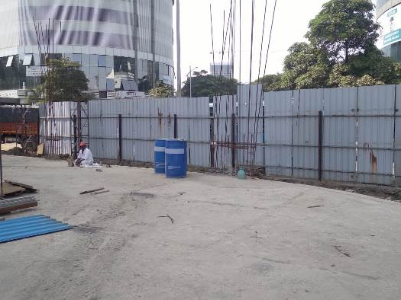
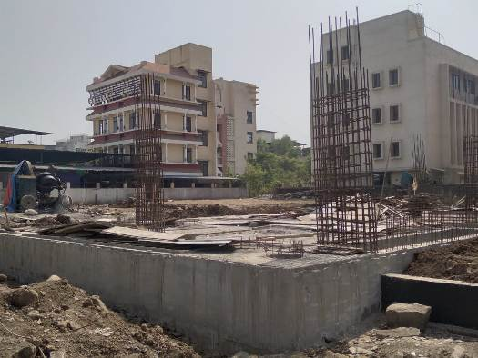
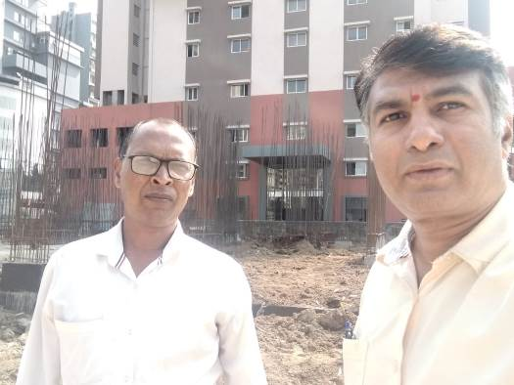
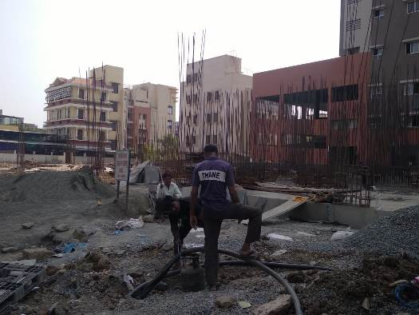
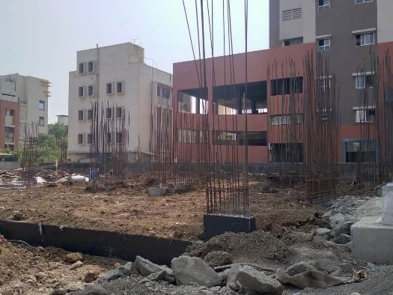
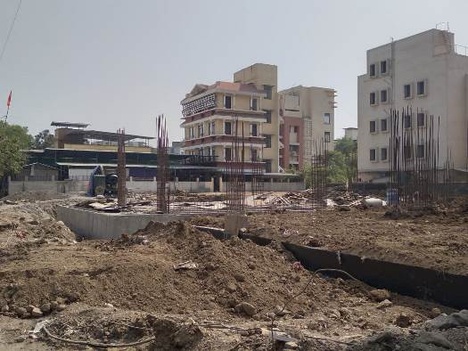
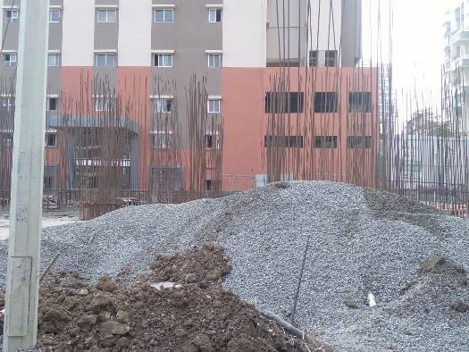
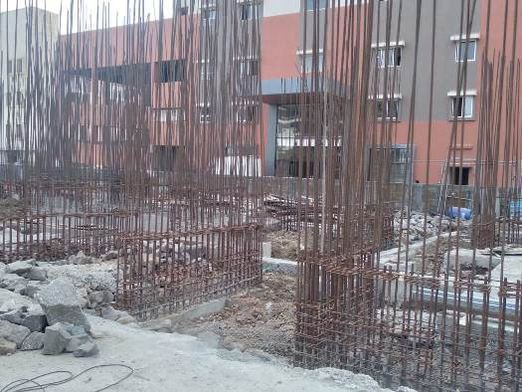
Route Map of the property
Site u/r
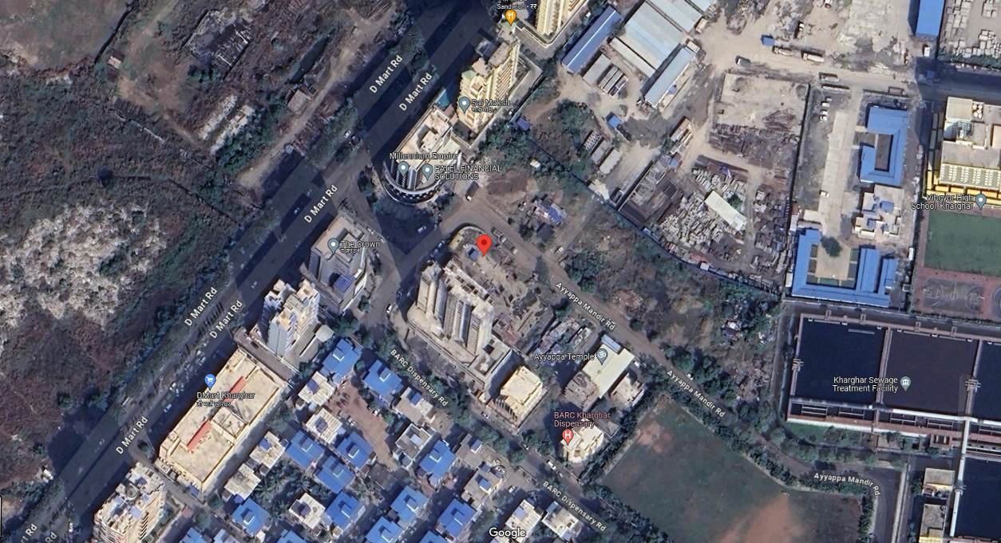

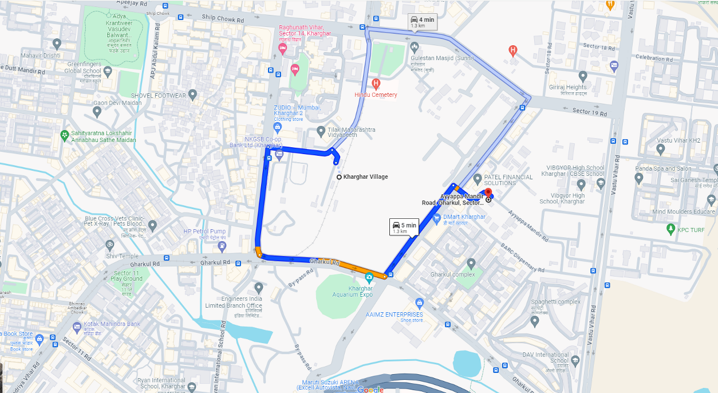

Latitude Longitude: 19°02'34.0"N 73°04'41.6"E
Note: The Blue line shows the route to site from nearest metro station (Kharghar Village – 1.30 Km.)

Ready Reckoner 2023 – 2024
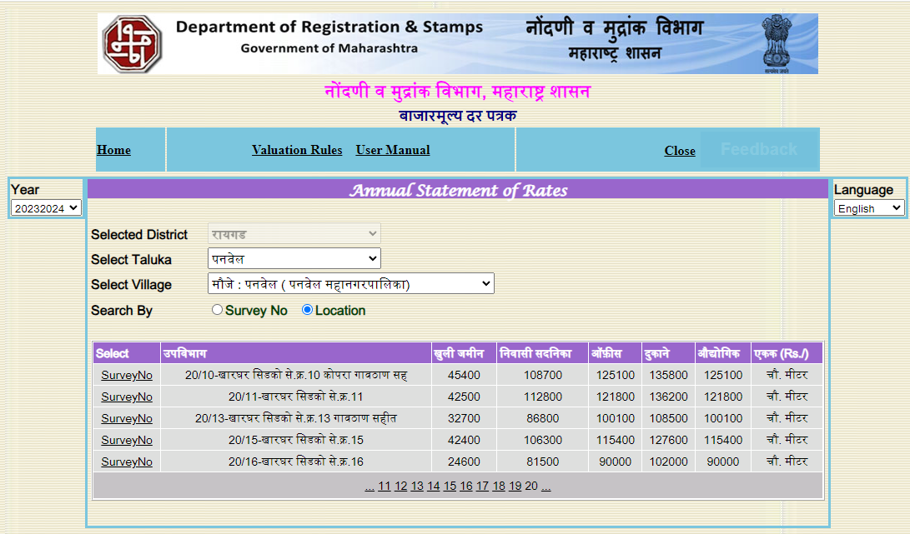

Registered Sales Instances
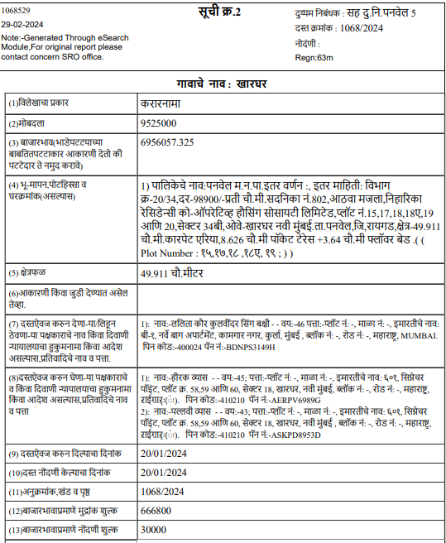

Registered Sales Instances
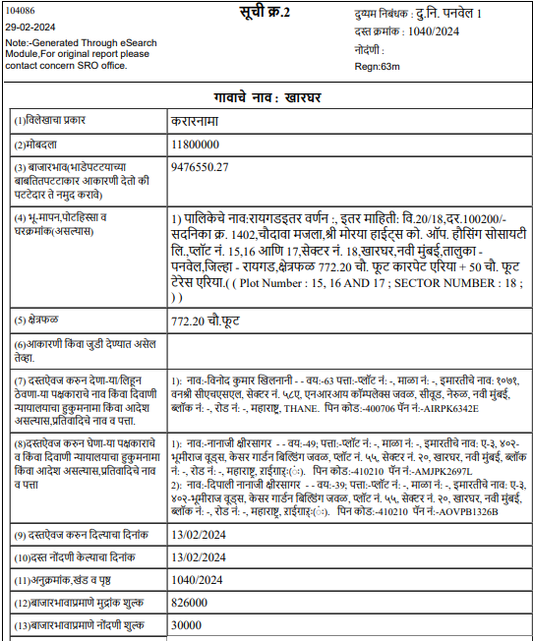

Price Indicators for Flats
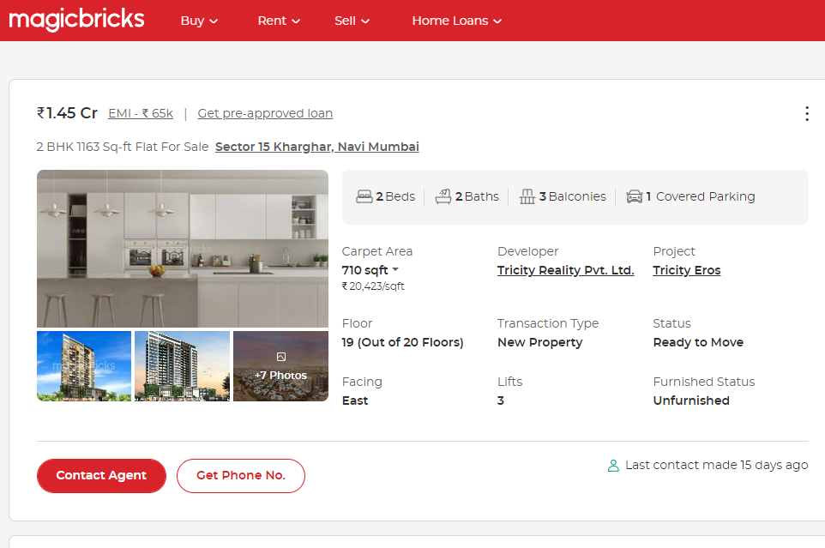

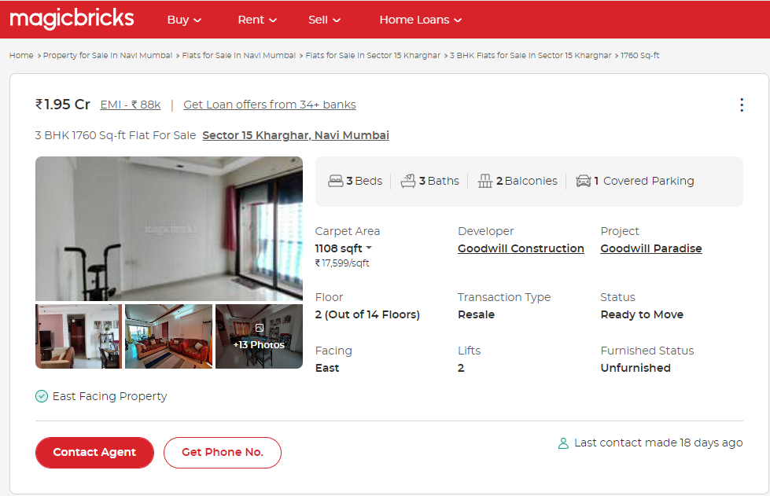

Price Indicators for Flats
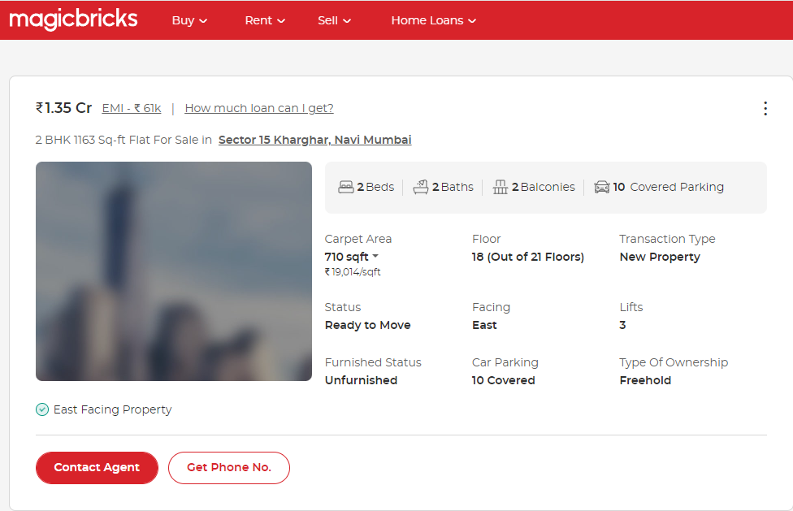
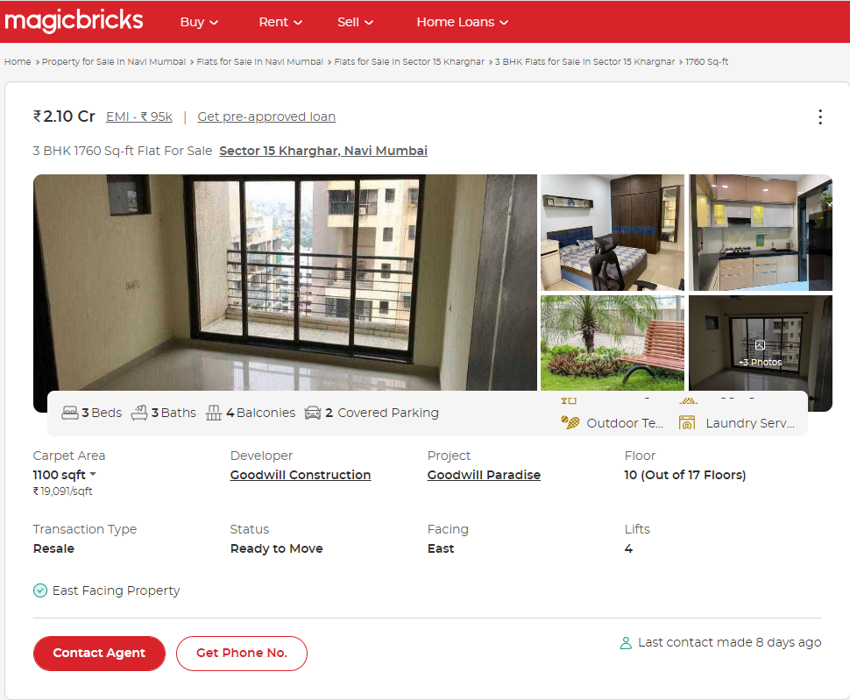
Justification for price /rate

The Market Value of the property is based on facts of markets discovered by us during our enquiries, however the government rate value in this case is less than the market value arrived by us. We are of the opinion that the value arrive by us will prove to be correct if an Auction of the subject property is carried out. As far as Market Value in Index II is concerned, it is not possible to comment on same, may be government rates are fixed by sampling during same point of time in part and whereas, Market values change every month.

In most of the cases the actual deal amount or Transaction value is not reflected in Index II because of various Market practices. As Valuer, we always try to give a value which is correct reflection of actual transaction value irrespective of any factors in market.

We hope this will satisfy your requirements.
As a result of my appraisal and analysis, it is my considered opinion that the realizable Value of the above property in the prevailing condition with aforesaid specification is (As per table attached to the report)

Place: Mumbai
Date: 22.02.2024

Manoj B. Chalikwar
Registered Valuer
Chartered Engineer (India)
Reg. No. IBBI / RV / 07/2018/10366
Reg. No. CAT-I-F-1763
SBI Empanelment No.: SME/TCC/2021-22/86/3

Enclosures
 | Declaration-cum-undertaking from the valuer (Annexure- I) | Attached
 | Model code of conduct for valuer - (Annexure - II) | Attached
(Annexure-I)

DECLARATION-CUM-UNDERTAKING

I, Manoj Chalikwar son of Shri. Baburao Chalikwar do hereby solemnly affirm and state that:

- I am a citizen of India.

- I will not undertake valuation of any assets in which I have a direct or indirect interest or become so interested at any time during a period of three years prior to my appointment as valuer or three years after the valuation of assets was conducted by me.

- The information furnished in my valuation report dated 22.02.2024 is true and correct to the best of my knowledge and belief and I have made an impartial and true valuation of the property.

- I/ my authorized representative have personally inspected the property on 31.01.2024. The work is not sub - contracted to any other valuer and carried out by myself.

- Valuation report is submitted in the format as prescribed by the bank.

- I have not been depanelled / delisted by any other bank and in case any such depanelment by other banks during my empanelment with you, I will inform you within 3 days of such depanelment.

- I have not been removed / dismissed from service / employment earlier.

- I have not been convicted of any offence and sentenced to a term of imprisonment

- I have not been found guilty of misconduct in my professional capacity.

- I have not been declared to be unsound mind

- I am not an undischarged bankrupt, or has not applied to be adjudicated as a bankrupt;

- I am not an undischarged insolvent.

- I have not been levied a penalty under section 271J of Income-tax Act, 1961 (43 of 1961) and time limit for filing appeal before Commissioner of Income-tax (Appeals) or Income-tax Appellate Tribunal, as the case may be has expired, or such penalty has been confirmed by Income-tax Appellate Tribunal, and five years have not elapsed after levy of such penalty

- I have not been convicted of an offence connected with any proceeding under the Income Tax Act 1961, Wealth Tax Act 1957 or Gift Tax Act 1958 and

- My PAN Card number as applicable is AERPC9086P

- I undertake to keep you informed of any events or happenings which would make me ineligible for empanelment as a valuer

- I have not concealed or suppressed any material information, facts and records and I have made a complete and full disclosure

- I have read the Handbook on Policy, Standards and procedure for Real Estate Valuation, 2011 of the IBA and this report is in conformity to the "Standards" enshrined for valuation in the Part - B of the above handbook to the best of my ability.

- I have read the International Valuation Standards (IVS) and the report submitted to the Bank for the respective asset class is in conformity to the "Standards" as enshrined for valuation in the IVS in "General Standards" and "Asset Standards" as applicable. The valuation report is submitted in the prescribed format of the bank.

- I abide by the Model Code of Conduct for empanelment of valuer in the Bank. (Annexure V - A signed copy of same to be taken and kept along with this declaration)

- I am valuer registered with Insolvency & Bankruptcy Board of India (IBBI)

- My CIBIL Score and credit worthiness is as per Bank's guidelines.

- I am Chairman & Managing Director of the company, who is competent to sign this valuation report.

- I will undertake the valuation work on receipt of Letter of Engagement generated from the system (i.e., LLMS / LOS) only.

- Further, I hereby provide the following information.

 | Particulars | Valuer comment
 | Background information of the asset being valued; | The property under consideration is developed by M/s. Nathdwara Developers Pvt. Ltd..
 | Purpose of valuation and appointing authority | As per request from State Bank of India, SME – Vashi Turbhe Branch to assess Fair Market value of the Project for bank loan purpose.
 | Identity of the Valuer and any other experts involved in the valuation; | Manoj B. Chalikwar – Regd. Valuer  Umang Ashwin Patel – Regd. Valuer  Prayush P. Parekh – Senior Valuation Engineer  Vaibhav Bhagat – Valuation Engineer
 | Disclosure of Valuer interest or conflict, if any; | We have no interest, either direct or indirect, in the property valued. Further to state that we do not have relation or any connection with property owner / applicant directly or indirectly. Further to state that we are an independent Valuer and in no way related to property owner / applicant
 | Date of appointment, valuation date and date of report; | Date of Appointment – 30.01.2024  Valuation Date – 22.02.2024  Date of Report – 22.02.2024
 | Inspections and/or investigations undertaken; | Physical Inspection done on date 31.01.2024
 | Nature and sources of the information used or relied upon; | - Market Survey at the time of site visit  - Ready Reckoner rates / Circle rates  - Online search for Registered Transactions  - Online Price Indicators on real estate portals  - Enquiries with Real estate consultants  - Existing data of Valuation assignments carried out by us
 | Procedures adopted in carrying out the valuation and valuation standards followed; | Sales Comparative Method
 | Restrictions on use of the report, if any; | This valuation is for the use of the party to whom it is addressed and for no other purpose. No responsibility is accepted to any third party who may use or rely on the whole or any part of this valuation. The valuer has no pecuniary interest that would conflict with the proper valuation of the property.
- . | Major factors that were taken into account during the valuation; | Current market conditions, demand and supply position, residential land size, location, sustained demand for residential land, all round development of commercial and residential application in the locality etc.
 | Caveats, limitations and disclaimers to the extent they explain or elucidate the limitations faced by valuer, which shall not be for the purpose of limiting his responsibility for the valuation report. | Attached

Assumptions, Disclaimers, Limitations & Qualifications
Value Subject to Change
The subject appraisal exercise is based on prevailing market dynamics as on 22nd February 2024 and does not take into account any unforeseeable developments which could impact the same in the future.
Our Investigations
We are not engaged to carry out all possible investigations in relation to the subject property. Where in our report we identify certain limitations to our investigations, this is to enable the reliant party to instruct further investigations where considered appropriate or where we recommend as necessary prior to reliance. Vastukala Consultants India Pvt. Ltd. (VCIPL) is not liable for any loss occasioned by a decision not to conduct further investigations
Assumptions
Assumptions are a necessary part of undertaking valuations. VCIPL adopts assumptions for the purpose of providing valuation advise because some matters are not capable of accurate calculations or fall outside the scope of our expertise, or out instructions. The reliant party accepts that the valuation contains certain specific assumptions and acknowledge and accept the risk of that if any of the assumptions adopted in the valuation are incorrect, then this may have an effect on the valuation.
Information Supplied by Others
The appraisal is based on the information provided by the client. The same has been assumed to be correct and has been used for appraisal exercise. Where it is stated in the report that another party has supplied information to VCIPL, this information is believed to be reliable but VCIPL can accept no responsibility if this should prove not to be so.
Future Matters
To the extent that the valuation includes any statement as to a future matter, that statement is provided as an estimate and/or opinion based on the information known to VCIPL at the date of this document. VCIPL does not warrant that such statements are accurate or correct.
Map and Plans
Any sketch, plan or map in this report is included to assist the reader while visualising the property and assume no responsibility in connection with such matters.
Site Details
Based on documents / information received from Client's representative and site visit conducted, we understand that the subject property is currently a Building Under Construction work is in progress contiguous and non-agricultural land parcel admeasuring as per table attached to the report and in the name of M/s. Nathdwara Developers Pvt. Ltd. Further, VCIPL has assumed that the subject property is free from any encroachment and is available as on the date of the appraisal.
Property Title
Based on our discussion with the Client, we understand that the subject property is owned by M/s. Nathdwara Developers Pvt. Ltd. For the purpose of this appraisal exercise, we have assumed that the subject property has a clear title and is free from any encumbrances, disputes and claims. VCIPL has made no further enquiries with the relevant local authorities in this regard and does not certify the property as having a clear and marketable title. Further, no legal advice regarding the title and ownership of the subject property has been obtained for the purpose of this appraisal exercise. It has been assumed that the title deeds are clear and marketable.
Environmental Conditions
We have assumed that the subject property is not contaminated and is not adversely affected by any existing or proposed environmental law and any processes which are carried out on the property are regulated by environmental legislation and are properly licensed by the appropriate authorities.
Town Planning
The permissible land use, zoning, achievable FSI, area statement adopted for purpose of this valuation is based on the documents / information provided by the Client's representative and the same has been adopted for this valuation purpose. VCIPL has assumed the same to be correct and permissible. VCIPL has not validated the same from any authority.
Area
Based on the document provided by the Client's representative, we understand that the subject property is a Building Under Construction work is in progress, contiguous and non-agricultural land parcel admeasuring as per table attached to the report.
Condition & Repair
In the absence of any information to the contrary, we have assumed that there are no abnormal ground conditions, nor archaeological remains present which might adversely affect the current or future occupation, development or value of the property. The property is free from rat, infestation, structural or latent defect. No currently known deleterious or hazardous materials or suspect techniques will be used in the construction of or subsequent alteration or additions to the property and comments made in the property details do not purport to express an opinion about, or advise upon, the condition of uninspected parts and should not be taken as making an implied representation or statement about such parts
Valuation Methodology
For the purpose of this valuation exercise, the valuation methodology used is Direct Comparison Approach Method and proposed Highest and Best Use model is used for analysing development potential.
The Direct Comparison Approach involves a comparison of the property being valued to similar properties that have actually been sold in arms - length transactions or are offered for sale. This approach demonstrates what buyers have historically been willing to pay (and sellers willing to accept) for similar properties in an open and competitive market and is particularly useful in estimating the value of the land and properties that are typically traded on a unit basis.
In case of inadequate recent transaction activity in the subject micro-market, the appraiser would collate details of older transactions. Subsequently, the appraiser would analyse rental / capital value trends in the subject micro-market in order to calculate the percentage increase / decrease in values since the date of the identified transactions. This percentage would then be adopted to project the current value of the same.
Where reliance has been placed upon external sources of information in applying the valuation methodologies, unless otherwise specifically instructed by Client and/or stated in the valuation, VCIPL has not independently verified that information and VCIPL does not advise nor accept it as reliable. The person or entity to whom the report is addressed acknowledges and accepts the risk that if any of the unverified information in the valuation is incorrect, then this may have an effect on the valuation.
Not a Structural Survey
We state that this is a valuation report and not a structural survey
Other
All measurements, areas and ages quoted in our report are approximate
Legal
We have not made any allowances with respect to any existing or proposed local legislation relating to taxation on realization of the sale value of the subject property. VCIPL is not required to give testimony or to appear in court by reason of this appraisal report, with reference to the property in question, unless arrangement has been made thereof. Further, no legal advice on any aspects has been obtained for the purpose of this appraisal exercise
Property specific assumptions
Based on inputs received from the client and site visit conducted, we understand that the subject property is currently Building Under Construction work is in progress, contiguous and non-agricultural land parcel admeasuring area as per table attached to the report.

ASSUMPTIONS, CAVEATS, LIMITATION AND DISCLAIMERS
- We assume no responsibility for matters of legal nature affecting the property appraised or the title thereto, nor do we render our opinion as to the title, which is assumed to be good and marketable.
- The property is valued as though under responsible ownership.
- It is assumed that the property is free of liens and encumbrances.
- It is assumed that there are no hidden or unapparent conditions of the subsoil or structure that would render it more or less valuable. No responsibility is assumed for such conditions or for engineering that might be required to discover such factors.
- There is no direct/ indirect interest in the property valued.
- The rates for valuation of the property are in accordance with the Govt. approved rates and prevailing market rates.
(Annexure - II)
MODEL CODE OF CONDUCT FOR VALUERS
Integrity and Fairness
- A valuer shall, in the conduct of his/its business, follow high standards of integrity and fairness in all his/its dealings with his/its clients and other valuers.
- A valuer shall maintain integrity by being honest, straightforward, and forthright in all professional relationships.
- A valuer shall endeavour to ensure that he/it provides true and adequate information and shall not misrepresent any facts or situations.
- A valuer shall refrain from being involved in any action that would bring disrepute to the profession.
- A valuer shall keep public interest foremost while delivering his services.
Professional Competence and Due Care
- A valuer shall render at all times high standards of service, exercise due diligence, ensure proper care and exercise independent professional judgment.
- A valuer shall carry out professional services in accordance with the relevant technical and professional standards that may be specified from time to time.
- A valuer shall continuously maintain professional knowledge and skill to provide competent professional service based on up-to-date developments in practice, prevailing regulations / guidelines and techniques.
- In the preparation of a valuation report, the valuer shall not disclaim liability for his/its expertise or deny his/its duty of care, except to the extent that the assumptions are based on statements of fact provided by the company or its auditors or consultants or information available in public domain and not generated by the valuer.
- A valuer shall not carry out any instruction of the client insofar as they are incompatible with the requirements of integrity, objectivity and independence.
- A valuer shall clearly state to his client the services that he would be competent to provide and the services for which he would be relying on other valuers or professionals or for which the client can have a separate arrangement with other valuers.
Independence and Disclosure of Interest
- A valuer shall act with objectivity in his/its professional dealings by ensuring that his/its decisions are made without the presence of any bias, conflict of interest, coercion, or undue influence of any party, whether directly connected to the valuation assignment or not.
- A valuer shall not take up an assignment if he/it or any of his/its relatives or associates is not independent in terms of association to the company.
- A valuer shall maintain complete independence in his/its professional relationships and shall conduct the valuation independent of external influences.
- A valuer shall wherever necessary disclose to the clients, possible sources of conflicts of duties and interests, while providing unbiased services.
- A valuer shall not deal in securities of any subject company after any time when he/it first becomes aware of the possibility of his / its association with the valuation, and in accordance with the Securities and Exchange Board of India (Prohibition of Insider Trading)Regulations,2015 or till the time the valuation report becomes public, whichever is earlier.
- A valuer shall not indulge in "mandate snatching" or offering "convenience valuations" in order to cater to a company or client's needs.
- As an independent valuer, the valuer shall not charge success fee.
- In any fairness opinion or independent expert opinion submitted by a valuer, if there has been a prior engagement in an unconnected transaction, the valuer shall declare the association with the company during the last five years.
Confidentiality
- A valuer shall not use or divulge to other clients or any other party any confidential information about the subject company, which has come to his / its knowledge without proper and specific authority or unless there is a legal or professional right or duty to disclose.
Information Management
- A valuer shall ensure that he/ it maintains written contemporaneous records for any decision taken, the reasons for taking the decision, and the information and evidence in support of such decision. This shall be maintained so as to sufficiently enable a reasonable person to take a view on the appropriateness of his /its decisions and actions.
- A valuer shall appear, co-operate and be available for inspections and investigations carried out by the authority, any person authorised by the authority, the registered valuers organisation with which he/it is registered or any other statutory regulatory body.
- A valuer shall provide all information and records as may be required by the authority, the Tribunal, Appellate Tribunal, the registered valuers organisation with which he/it is registered, or any other statutory regulatory body.
- A valuer while respecting the confidentiality of information acquired during the course of performing professional services, shall maintain proper working papers for a period of three years or such longer period as required in its contract for a specific valuation, for production before a regulatory authority or for a peer review. In the event of a pending case before the Tribunal or Appellate Tribunal, the record shall be maintained till the disposal of the case.
Gifts and hospitality:
- A valuer or his / its relative shall not accept gifts or hospitality which undermines or affects his independence as a valuer.
- Explanation: For the purposes of this code the term 'relative' shall have the same meaning as defined in clause (77) of Section 2 of the Companies Act, 2013 (18 of 2013).
- A valuer shall not offer gifts or hospitality or a financial or any other advantage to a public servant or any other person with a view to obtain or retain work for himself / itself, or to obtain or retain an advantage in the conduct of profession for himself / itself.
Remuneration and Costs.
- A valuer shall provide services for remuneration which is charged in a transparent manner, is a reasonable reflection of the work necessarily and properly undertaken, and is not inconsistent with the applicable rules.
- A valuer shall not accept any fees or charges other than those which are disclosed in a written contract with the person to whom he would be rendering service.
Occupation, employability and restrictions.
- A valuer shall refrain from accepting too many assignments, if he/it is unlikely to be able to devote adequate time to each of his/ its assignments.
- A valuer shall not conduct business which in the opinion of the authority or the registered valuer organisation discredits the profession.
Miscellaneous
- A valuer shall refrain from undertaking to review the work of another valuer of the same client except under written orders from the bank or housing finance institutions and with knowledge of the concerned valuer.
- A valuer shall follow this code as amended or revised from time to time.
DEFINITION OF VALUE FOR THIS SPECIFIC PURPOSE

This exercise is to assess Master Valuation of the property under reference as on 22nd February 2024.

The term Fair Market Value is defined as

“The most probable price, as of a specified date, in cash, terms equivalent to cash, or in other precisely revealed terms for which the specified property rights would sell after reasonable exposure in a competitive market under all conditions requisite to a fair sale, with the buyer and seller each acting prudently knowledgeably and for self-interest assuming that neither is under undue duress”.

Fundamental assumptions and conditions presumed in this definition are:

1. Buyer and seller are motivated by self-interest.
2. Buyer and seller are well informed and are acting prudently.
3. The property is exposed for a reasonable time on the open market.
4. Payment is made in cash or equivalent or in specified financing terms.
DECLARATION OF PROFESSIONAL FEES CHARGED

We hereby declare that, our professional fees are not contingent upon the valuation findings. However, if the statute AND/OR clients demands that, the fees should be charged on the percentage of assessed value then, with the full knowledge of the AND/OR end user, it is being charged accordingly.

VALUATION OF THE PROPERTY PREMISES

Considering various parameters recorded herein above, existing economic scenario, and the information that is available with reference to the development of neighborhood and method selected for valuation, we are of the opinion that, the property premises can be assessed and valued for this particular purpose as per the details provided.

Manoj B. Chalikwar
Registered Valuer
Chartered Engineer (India)
Reg. No. IBBI / RV / 07/2018/10366
Reg. No. CAT-I-F-1763
SBI Empanelment No.: SME/TCC/2021-22/86/3

