Vastu/Nashik/01/2024/006225/2304419
09/7-121 -CCBS
Date: 23.02.2024

To,
The Assistant General Manager,
State Bank of India
RACC Nashik Branch
RBO.2, The Wave Building, 1st Floor, Opposite Shell Petrol Pump,
Pathardi Road, Nashik – 422 010,State – Maharashtra, Country – India.

Sub: Vetting of Estimate

Sir,

With reference to above subject, we have evaluated the Estimate for Residential Bungalow on CTS No.850, Ground + First Floor, Near Borse Classes,Kapse Galli , At – Niphad , Taluka – Niphad,District - Nashik,PIN Code - 422 303, State - Maharashtra, Country - India belongs Mr.Vijay Babulal Chordiya.

We have verified the rates quoted as per current market rates. Details of Estimate considered as per copy of Estimate Provided by Ar. Haardik C.Bedmutha received on dated 23.02.2024. The Estimate amount is Rs.98,50,000/- (Rupees Ninety Eight Lakh Fifty Thousand Only.)

Note:1) The said Cost Vetting Certificate is valid upto next 6 months Only.

Thanking you

Sincerely yours

Manoj B. Chalikwar
Registered Valuer
Chartered Engineer (India)
Reg. No. CAT-I-F-1763
SBI Empanelment No.: SME/TCC/2021-22/86/3
Encl: Valuation report

Estimate
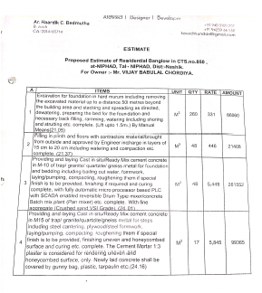
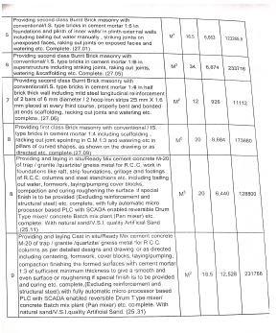

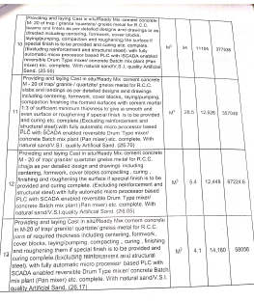
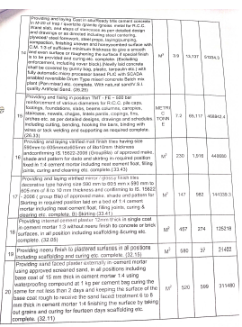

Estimate
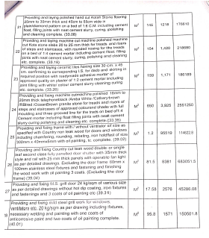
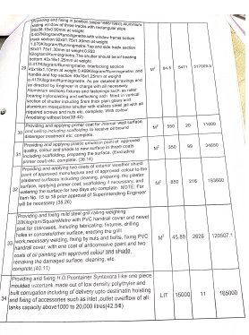

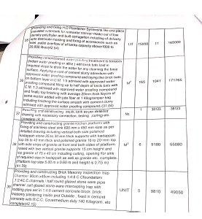
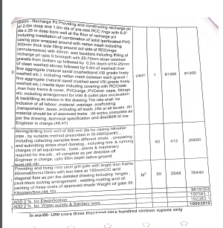

The Estimate amount is Rs.98,50,000/- (Rupees Ninety Eight Lakh Fifty Thousand Only.)

