MASTER VALUATION REPORT
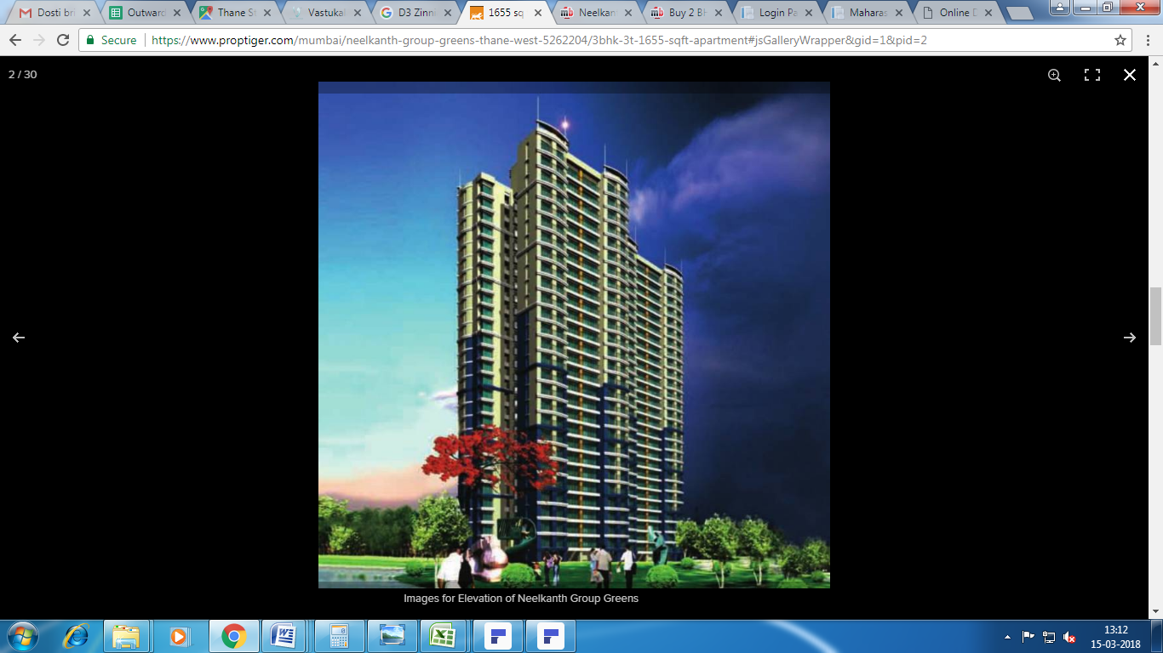

Details of the property under consideration:

Name of Project: D3 - Zinnia

“D3 - Zinnia", Survey No. 312/1A, 316 (part), 318/1D, 319/1A, 319/1B/1 of Village – Majiwade,
Neelkanth Greens Road Gate No. 1, Thane (West), Taluka & Dist. Thane – 400 607

Longitude Latitude - 19°14'38.0"N 72°58'16.1"E

Valuation Done for:

State Bank of India
HLST Ground Floor, Synergy Building, C – 6, G Block
Bandra Kurla Complex, Bandra (East),
Mumbai – 400 051

Vastukala Consultants (I) Pvt. Ltd.
Mumbai • Nanded • Navi Mumbai • Aurangabad

Vastu/SBI/Mumbai/03/2018/27006
15/13-210-V
Date: 15.03.2018

MASTER VALUATION REPORT
OF
“D3 - Zinnia”
“D3 - Zinnia", Survey No. 312/1A, 316 (part), 318/1D, 319/1A, 319/1B/1 of Village – Majiwade,
Neelkanth Greens Road Gate No. 1, Thane (West), Taluka & Dist. Thane – 400 607

Longitude Latitude - 19°14'38.0"N 72°58'16.1"E

NAME OF DEVELOPER: M/s. Neelkanth Mansions & Infrastructure Pvt. Ltd.
Pursuant to instructions from State Bank of India, Home Loan Sales Team, BKC, Mumbai, Mumbai, we have duly visited, inspected, surveyed & assessed the above said property to determine the fair & reasonable market value of the said property as on 13th March 2018 for approval of Advance Processing Facility.

- Location Details:

The property is situated at Village Majiwade, Neelkanth Greens Road Gate No. 1, Thane (West). It is about 20 - 25 minutes travel distance from Thane station of Central Railway line. Surface transport to the property is by buses, taxis & private vehicles. The property is in developed locality. All the amenities like shops, banks, hotels, markets, schools, hospitals, etc. are all available in the surrounding locality. The area is middle class & developed.

2. Developer Details:

Name of builder | M/s. Neelkanth Mansions & Infrastructure Pvt. Ltd.
Project Rera Registration Number | P51700013969
Register office address | Fine House, 5th Floor, Anandji Lane, Next Bhaveshwar Market, M. G. Road, Ghatkopar (East), Mumbai - 400 077
Contact Numbers | Contact Person :  Mr. Jugal Patel - 9819154254  Kiran Patel - 022-25841328/022-21021080
Email Id and Website | jugalpatel@neelkanthgroup.com  www.neelkanthgroup.com

3. Boundaries of the Property:

Direction | Particulars
On or towards North | Road & Open Plot
On or towards South | Podium Garden
On or towards East | Road
On or towards West | Juniper Building & Neelkanth Greens Road Gate No. 1

Project Valuation Report

1. Introduction
a) |  |  | Project Name  (with address & phone nos.) |  |  | “D3 - Zinnia", Survey No. 312/1A, 316 (part), 318/1D, 319/1A, 319/1B/1 of Village – Majiwade, Neelkanth Greens Road Gate No. 1, Thane (West), Taluka & Dist. Thane – 400 607  Contact Person :  Mr. Jugal Patel - 9819154254  Kiran Patel - 022-25841328/022-21021080
b) |  |  | Purpose of Valuation |  |  | As per request from State Bank of India, HLST Branch to assess fair market value of the property for bank loan purpose.
c) |  |  | Date of Inspection of Property |  |  | 13.03.2018
d) |  |  | Date of Valuation Report |  |  | 15.03.2018
e) |  |  | Name of the Developer of Property  (in case of developer built properties) |  |  | M/s. Neelkanth Mansions & Infrastructure Pvt. Ltd.  Fine House, 5th Floor, Anandji Lane, Next Bhaveshwar Market, M. G. Road, Ghatkopar (East), Mumbai - 400 077
2. Physical Characteristics of the Property
a) |  |  | Location of the Property |  |  | “D3 - Zinnia", Survey No. 312/1A, 316 (part), 318/1D, 319/1A, 319/1B/1 of Village – Majiwade, Neelkanth Greens Road Gate No. 1, Thane (West), Taluka & Dist. Thane – 400 607
 |  |  | Brief description of the property
TYPE OF THE BUILDING
Building Type | Number of Floors
D3 | Proposed Lower Stilt + Upper Stilt + 27th upper floors.

LEVEL OF COMPLETEION:
Building Type | Present stage of Construction | Percentage of work completion
D3 | RCC work is completed. Brick work upto 26th floor is completed | 62%

PROPOSED DATE OF COMPLETION & FUTURE LIFE:
Expected completion date as informed by builder is October – 2020
Future estimated life of the Structure is 60 years (after completion) Subject to proper, preventive periodic maintenance & Structural repairs.

PROPOSED PROJECT AMENITIES:
Vitrified tiles flooring in all rooms
Granite kitchen platform with Stainless Steel Sink
Powder coated sliding windows with M.S. Grills
Laminated wooden flush doors with safety door
Concealed wiring
Concealed plumbing
Badminton Court
Swimming Pool
Joggers Track
Landscaped Garden
Basketball
Spa Area
Gazebo
Club House
Library
Squash Court

 |  |  | Nearby landmark |  |  | Near Neelkanth Woods
 |  |  | Postal Address of the Property |  |  | “D3 - Zinnia", Survey No. 312/1A, 316 (part), 318/1D, 319/1A, 319/1B/1 of Village – Majiwade, Neelkanth Greens Road Gate No. 1, Thane (West), Taluka & Dist. Thane – 400 607
 |  |  | Area of the plot/land (supported by a plan) |  |  | Total Plot Area: 56654.00 Sq. M.
 |  |  | Type of Land: Solid, Rocky, Marsh land, reclaimed land, Water-logged, Land locked. |  |  | Solid land
 |  |  | Independent access/approach to the property etc. |  |  | Yes
 |  |  | Google Map Location of the Property with a neighborhood layout map |  |  | Provided
 |  |  | Details of roads abutting the property |  |  | 09.00 M. wide B.T. Road
 |  |  | Description of adjoining property |  |  | Located in middle class locality
 |  |  | Plot No. Survey No. |  |  | Survey No. 312/1A, 316 (part), 318/1D, 319/1A, 319/1B/1
 |  |  | Ward/Village/Taluka |  |  | Village – Majiwade, Taluka – Thane
 |  |  | Sub-Registry/Block |  |  | Thane
 |  |  | District |  |  | Thane
 | Any other aspect |  |  |  |  | -
b) | Plinth Area, Built up Area, and Saleable are to be mentioned separately and clarified |  |  |  |  | As per table attached to the report
c) | Boundaries of the Plot |  |  |  |  | As per Sale Deed/TIR | Actual
c) | North |  |  |  |  | Details not available | Road & Open Plot
c) | South |  |  |  |  | Details not available | Podium Garden
c) | East |  |  |  |  | Details not available | Road
c) | West |  |  |  |  | Details not available | Juniper Building & Neelkanth Greens Road Gate No. 1
3. Town Planning parameters
a) |  |  |  |  | Master Plan provisions related to property in terms of land use | Residential Building
 |  |  |  |  | FAR- Floor Area Rise/FSI- Floor Space Index permitted & consumed | FSI permitted: 1.00  FSI Consumed: 0.99
 |  |  |  |  | Ground coverage | As per Approved Plans
 |  |  |  |  | Comment on whether OC- Occupancy Certificate has been issued or not | N.A. Building Construction work is in progress
 |  |  |  |  | Comment on unauthorized constructions if any | N.A. Building Construction work is in progress
 |  |  |  |  | Transferability of developmental rights if any, Building by-laws provision as applicable to the property viz. setbacks, height restriction etc. | Nil
 |  |  |  |  | Planning area/zone | Residential
 |  |  |  |  | Developmental controls | Copy of Approved Plan V. P. No. S04 / 0069 / 14 / TMC / TD-DP / TPS / 1720 / 16 dated 15.03.2016 issued by Thane Municipal Corporation (Number of Copies –Eight - Sheet No. 1/8 & 8/8)
 |  |  |  |  | Zoning regulations | Residential
 |  |  |  |  | Comment on the surrounding land uses and adjoining properties in terms of uses | Land used for Residential use.
 |  |  |  |  | Comment on demolition proceedings if any | No
 |  |  |  |  | Comment on compounding / regularization proceedings | Information not available
 |  |  |  |  | Any other Aspect | -
 |  |  | 4. Document Details and Legal Aspects of Property
a) |  |  |  |  | Ownership Documents (Building Permission, Commencement Certificate & Status of Plan)
 |  |  |  |  | Sale Deed, Gift Deed, Lease Deed
 |  |  |  |  | - Copy of Affidavit Cum Declaration dated 15.06.2017 of M/s. Neelkanth Mansions & Infrastructure Pvt. Ltd.
 |  |  |  |  | - Copy of Rera Certificate No. P51700013969
 |  |  |  |  | - Copy of Index No. II dated 05.04.2017 between J M. Financial Products Pvt. Ltd. (the Purchaser) AND M/s. Neelkanth Mansions & Infrastructure Pvt. Ltd. (the Vendors)
 |  |  |  |  | - Copy of Agreement for Development Registered with Sub Registrar No. TNN - 2 / 1948 / 2006 dated 13.03.2006 between Bahar Housing & Developers (the Owners) AND M/s. Neelkanth Mansions & Infrastructure Pvt. Ltd. (the Developers)
 |  |  |  |  | - Copy of Title Certificate from Adv. Purnanand & Co. dated 07.10.2006
 |  |  |  | - Copy of Commencement Certificate V. P. No. S04 / 0069 / 14 / TMC / TD-DP / TPS / 1720 / 16 dated 15.03.2016 issued by Thane Municipal Corporation (Building Type - A2 & B2)
 |  |  |  | - Copy of Approved Plan V. P. No. S04 / 0069 / 14 / TMC / TD-DP / TPS / 1720 / 16 dated 15.03.2016 issued by Thane Municipal Corporation (Number of Copies –Eight - Sheet No. 1/8 & 8/8)
 |  |  |  | TIR of the Property |  | Yes
b) |  |  |  | Name of the Owner/s |  | M/s. Neelkanth Mansions & Infrastructure Pvt. Ltd.
c) |  |  |  | Ordinary status of freehold or leasehold including restrictions on transfer |  | Freehold
d) |  |  |  | Agreement of easement if any |  | As per TIR
e) |  |  |  | Notification of acquisition if any |  | As per TIR
f) |  |  |  | Notification of road widening if any |  | As per approved plan
g) |  |  |  | Heritage restriction, if any |  | No
h) |  |  |  | Comment on transferability of the property ownership |  | As per TIR

i) |  | Comment on existing mortgages/charges/encumbrances on the property, if any | As per TIR
j) |  | Comment on whether the owners of the property have issued any guarantee (personal or corporate) as the case may be | Information not available
k) |  | Building plan sanction: Authority approving the plan - Name of the office of the Authority - Any violation from the approved Building Plan | Copy of Approved Plan V. P. No. S04 / 0069 / 14 / TMC / TD-DP / TPS / 1720 / 16 dated 15.03.2016 issued by Thane Municipal Corporation (Number of Copies –Eight - Sheet No. 1/8 & 8/8)
l) |  | Whether Property is Agricultural Land if yes, any conversion is contemplated | No
m) |  | Whether the property is SARFAESI compliant | As per TIR
n) |  | a. All legal documents, receipts related to electricity, Water tax, Municipal tax and other building taxes to be verified and copies as applicable to be enclosed with the report. b. Observation on Dispute or Dues if any in payment of bills/taxes to be reported. | All the provided documents are enclosed with the valuation report.
o) |  | Whether entire piece of land on which the unit is set up / property is situated has been mortgaged or to be mortgaged. | Take Legal Opinion
p) |  | Qualification in TIR/mitigation suggested if any. | As per TIR
q) |  | Any other aspect | -
 | 5. Economic Aspects of the Property
a) |  | Reasonable letting value | As per table attached to the report
a) |  | If property is occupied by tenant | N.A. Building Construction work is in progress
 |  | Number of tenants | N. A.
 |  | Since how long (tenant- wise) | N. A.
 |  | Status of tenancy right | Information not available
 |  | Rent received per month (tenant-wise) with a comparison of existing market rent | Information not available
 |  | Taxes and other outings | Information not available
 |  | Property Insurance | Information not available
 |  | Monthly maintenance charges | Information not available
 |  | Security charges | Information not available
 |  | Any other aspect | -

 | 6. Socio-cultural Aspects of the Property
a) |  |  |  | Descriptive account of the location of the property in terms of social structure of the area, population, social stratification, regional origin, economic level, location of slums, squatter settlements nearby, etc. | Strategic Location
b) |  |  |  | Whether property belongs to social infrastructure like hospital, school, old age homes etc. | No
 | 7. Functional and Utilitarian Aspects of the Property
a) |  |  |  | Description of the functionality and utility of the property in terms of:
 |  |  |  | Space allocation | Provided
 |  |  |  | Storage Spaces | Provided
 |  |  |  | Utility spaces provided within the building | Provided
 |  |  |  | Car Parking facility | Provided
 |  |  |  | Balconies, etc. | Yes
b) |  |  |  | Any other aspect | -
 | 8. Infrastructure Availability
a) |  |  |  | Description of aqua infrastructure availability in terms of i.e.
 |  |  |  | Water supply | Municipal Corporation
 |  |  |  | Sewerage/sanitation System Underground or Open | Underground Sewerage connected to municipal Corporation line
 |  |  |  | Storm water drainage | Yes
b) |  |  |  | Description of other physical infrastructure facilities viz.
 |  |  |  | Solid waste management | Yes
 |  |  |  | Electricity | N.A. Building Construction work is in progress
 |  |  |  | Road and public transport connectivity | All well connected with public transport like Auto, taxi, bus, private vehicles etc.
 |  |  |  | Availability of other public utilities nearby | All available near by
c) |  |  |  | Social infrastructure in terms of  - School  - Medical facilities  - Recreational facility in terms of parks and open space | All available near by
 | 9. Marketability of the Property
a) |  |  |  | Marketability of the property in terms of | Location, development of surrounding area, type of construction, construction specifications, age of building, condition of the premises & building, facilities provided and its prevailing market rate
 |  |  |  | Locational attributes | Developed Area
 |  |  |  | Scarcity | Excellent
 |  |  |  | Demand and supply of the kind of subject property | Excellent
 |  |  |  | Comparable sale prices in the locality | Price Indicators from online property portals attached.
b) |  |  |  | Any other aspect which has relevance on the value or marketability of the property | No
 | 10. Engineering and Technology Aspects of the Property
a) |  |  | Type of construction |  | R.C.C. framed structures
b) |  |  | Material & technology used |  | A Grade
c) |  |  | Specifications, |  | Standard
d) |  |  | Maintenance issues |  | N. A. Building Construction work is in progress
e) |  |  | Age of the building |  | N. A. Building Construction work is in progress
f) |  |  | Total life of the building |  | Building Construction work is in progress
g) |  |  | Extent of deterioration |  | 60 years (after completion) Subject to proper, preventive periodic Maintenance & structural repairs.
h) |  |  | Structural safety |  | As per requirement
i) |  |  | Protection against natural disaster viz. earthquakes, |  | Proposed
j) |  |  | Visible damage in the building |  | N. A. Building Construction work is in progress
k) |  | System of air-conditioning |  |  | N. A. Building Construction work is in progress
l) |  | Provision of firefighting |  |  | Provided in building premises
m) |  | Copies of the plan and elevation of the building to be included |  |  | Provided
11. Environmental Factors
a) |  | Use of environment friendly building materials, Green Building techniques if any |  |  | Yes
b) |  | Provision of rain water harvesting |  |  | Yes
c) |  | Use of solar heating and lightening systems, etc., |  |  | Information not available
d) |  | Presence of environmental pollution in the vicinity of the property in terms of industry, heavy traffic etc. |  |  | Normal
12. Architectural and aesthetic quality of the Property
a) |  | Descriptive account on whether the building is modern, old fashioned, plain looking or decorative, heritage value, presence of landscape elements etc. |  |  | Modern Looking
13. Valuation
a) |  | Methodology of valuation – Procedures adopted for arriving at the valuation. Valuers may consider various approaches and state explicitly the reason for adopting particular approach and assumptions made, basis adopted with supporting data, comparable sales, and reconciliation of various factors on which final value judgment is arrived at. |  |  | Composite Method is used for this valuation report.
b) |  | Prevailing Market Rate/Price trend of the Property in the locality/city from property search sites viz magickbricks.com, 99acres.com, makaan.com etc. if available |  |  | As per table attached to the report

d) | Summary of Valuation
d) | - Fair Market Value | As per table attached
 | CONFIGURATION OF PROJECT AS PER DEVELOPER’S INFORMATION:

- Building Type - D3, Zinnia:
Sr. No. | Flat No. | Floor No. | Comp. | Carpet Area in  Sq. ft. | Built up Area in  Sq. ft. | Rate per  Sq. ft. on Carpet area  in ` | Cost of flat  in ` | Expected Rent per month in `
1 | 101 | 1 | 2.5 BHK | 788 | 867 | 20000 | 1,57,60,000.00 | 33000
2 | 102 | 1 | 3 BHK | 978 | 1076 | 20000 | 1,95,60,000.00 | 41000
3 | 103 | 1 | 3 BHK | 987 | 1086 | 20000 | 1,97,40,000.00 | 41000
4 | 104 | 1 | 2.5 BHK | 796 | 876 | 20000 | 1,59,20,000.00 | 33000
5 | 201 | 2 | 2.5 BHK | 788 | 867 | 20100 | 1,58,38,800.00 | 33000
6 | 202 | 2 | 3 BHK | 978 | 1076 | 20100 | 1,96,57,800.00 | 41000
7 | 203 | 2 | 3 BHK | 987 | 1086 | 20100 | 1,98,38,700.00 | 41500
8 | 204 | 2 | 2.5 BHK | 796 | 876 | 20100 | 1,59,99,600.00 | 33500
9 | 301 | 3 | 2.5 BHK | 788 | 867 | 20200 | 1,59,17,600.00 | 33000
10 | 302 | 3 | 3 BHK | 978 | 1076 | 20200 | 1,97,55,600.00 | 41000
11 | 303 | 3 | 3 BHK | 987 | 1086 | 20200 | 1,99,37,400.00 | 41500
12 | 304 | 3 | 2.5 BHK | 796 | 876 | 20200 | 1,60,79,200.00 | 33500
13 | 401 | 4 | 2.5 BHK | 788 | 867 | 20300 | 1,59,96,400.00 | 33500
14 | 402 | 4 | 3 BHK | 978 | 1076 | 20300 | 1,98,53,400.00 | 41500
15 | 403 | 4 | 3 BHK | 987 | 1086 | 20300 | 2,00,36,100.00 | 41500
16 | 404 | 4 | 2.5 BHK | 796 | 876 | 20300 | 1,61,58,800.00 | 33500
17 | 501 | 5 | 2.5 BHK | 788 | 867 | 20400 | 1,60,75,200.00 | 33500
18 | 502 | 5 | 3 BHK | 978 | 1076 | 20400 | 1,99,51,200.00 | 41500
19 | 503 | 5 | 3 BHK | 987 | 1086 | 20400 | 2,01,34,800.00 | 42000
20 | 504 | 5 | 2.5 BHK | 796 | 876 | 20400 | 1,62,38,400.00 | 34000
21 | 601 | 6 | 2.5 BHK | 788 | 867 | 20500 | 1,61,54,000.00 | 33500
22 | 602 | 6 | 3 BHK | 978 | 1076 | 20500 | 2,00,49,000.00 | 42000
23 | 603 | 6 | 3 BHK | 987 | 1086 | 20500 | 2,02,33,500.00 | 42000
24 | 604 | 6 | 2.5 BHK | 796 | 876 | 20500 | 1,63,18,000.00 | 34000
25 | 701 | 7 | 2.5 BHK | 788 | 867 | 20600 | 1,62,32,800.00 | 34000
26 | 702 | 7 | 3 BHK | 978 | 1076 | 20600 | 2,01,46,800.00 | 42000
27 | 703 | 7 | 3 BHK | 987 | 1086 | 20600 | 2,03,32,200.00 | 42500
28 | 704 | 7 | 2.5 BHK | 796 | 876 | 20600 | 1,63,97,600.00 | 34000
29 | 801 | 8 | 2.5 BHK | 788 | 867 | 20700 | 1,63,11,600.00 | 34000
30 | 802 | 8 | 3 BHK | 978 | 1076 | 20700 | 2,02,44,600.00 | 42000
31 | 803 | 8 | 3 BHK | 987 | 1086 | 20700 | 2,04,30,900.00 | 42500
32 | 804 | 8 | Refuge Area
33 | 901 | 9 | 2.5 BHK | 788 | 867 | 20800 | 1,63,90,400.00 | 34000
34 | 902 | 9 | 3 BHK | 978 | 1076 | 20800 | 2,03,42,400.00 | 42500
35 | 903 | 9 | 3 BHK | 987 | 1086 | 20800 | 2,05,29,600.00 | 43000
36 | 904 | 9 | 2.5 BHK | 796 | 876 | 20800 | 1,65,56,800.00 | 34500
37 | 1001 | 10 | 2.5 BHK | 788 | 867 | 20900 | 1,64,69,200.00 | 34500
38 | 1002 | 10 | 3 BHK | 978 | 1076 | 20900 | 2,04,40,200.00 | 42500
39 | 1003 | 10 | 3 BHK | 987 | 1086 | 20900 | 2,06,28,300.00 | 43000
40 | 1004 | 10 | 2.5 BHK | 796 | 876 | 20900 | 1,66,36,400.00 | 34500
41 | 1101 | 11 | 2.5 BHK | 788 | 867 | 21000 | 1,65,48,000.00 | 34500
42 | 1102 | 11 | 3 BHK | 978 | 1076 | 21000 | 2,05,38,000.00 | 43000
43 | 1103 | 11 | 3 BHK | 987 | 1086 | 21000 | 2,07,27,000.00 | 43000
44 | 1104 | 11 | 2.5 BHK | 796 | 876 | 21000 | 1,67,16,000.00 | 35000
45 | 1201 | 12 | 2.5 BHK | 788 | 867 | 21100 | 1,66,26,800.00 | 34500
46 | 1202 | 12 | 3 BHK | 978 | 1076 | 21100 | 2,06,35,800.00 | 43000
47 | 1203 | 12 | 3 BHK | 987 | 1086 | 21100 | 2,08,25,700.00 | 43500
48 | 1204 | 12 | 2.5 BHK | 796 | 876 | 21100 | 1,67,95,600.00 | 35000
49 | 1301 | 13 | 2.5 BHK | 788 | 867 | 21200 | 1,67,05,600.00 | 35000
50 | 1302 | 13 | 3 BHK | 978 | 1076 | 21200 | 2,07,33,600.00 | 43000
51 | 1303 | 13 | 3 BHK | 987 | 1086 | 21200 | 2,09,24,400.00 | 43500
52 | 1304 | 13 | Refuge Area
53 | 1401 | 14 | 2.5 BHK | 788 | 867 | 21300 | 1,67,84,400.00 | 35000
54 | 1402 | 14 | 3 BHK | 978 | 1076 | 21300 | 2,08,31,400.00 | 43500
55 | 1403 | 14 | 3 BHK | 987 | 1086 | 21300 | 2,10,23,100.00 | 44000
56 | 1404 | 14 | 2.5 BHK | 796 | 876 | 21300 | 1,69,54,800.00 | 35500
57 | 1501 | 15 | 2.5 BHK | 788 | 867 | 21400 | 1,68,63,200.00 | 35000
58 | 1502 | 15 | 3 BHK | 978 | 1076 | 21400 | 2,09,29,200.00 | 43500
59 | 1503 | 15 | 3 BHK | 987 | 1086 | 21400 | 2,11,21,800.00 | 44000
60 | 1504 | 15 | 2.5 BHK | 796 | 876 | 21400 | 1,70,34,400.00 | 35500
61 | 1601 | 16 | 2.5 BHK | 788 | 867 | 21500 | 1,69,42,000.00 | 35500
62 | 1602 | 16 | 3 BHK | 978 | 1076 | 21500 | 2,10,27,000.00 | 44000
63 | 1603 | 16 | 3 BHK | 987 | 1086 | 21500 | 2,12,20,500.00 | 44000
64 | 1604 | 16 | 2.5 BHK | 796 | 876 | 21500 | 1,71,14,000.00 | 35500
65 | 1701 | 17 | 2.5 BHK | 788 | 867 | 21600 | 1,70,20,800.00 | 35500
66 | 1702 | 17 | 3 BHK | 978 | 1076 | 21600 | 2,11,24,800.00 | 44000
67 | 1703 | 17 | 3 BHK | 987 | 1086 | 21600 | 2,13,19,200.00 | 44500
68 | 1704 | 17 | 2.5 BHK | 796 | 876 | 21600 | 1,71,93,600.00 | 36000
69 | 1801 | 18 | 2.5 BHK | 788 | 867 | 21700 | 1,70,99,600.00 | 35500
70 | 1802 | 18 | 3 BHK | 978 | 1076 | 21700 | 2,12,22,600.00 | 44000
71 | 1803 | 18 | 3 BHK | 987 | 1086 | 21700 | 2,14,17,900.00 | 44500
72 | 1804 | 18 | Refuge Area
73 | 1901 | 19 | 2.5 BHK | 788 | 867 | 21800 | 1,71,78,400.00 | 36000
74 | 1902 | 19 | 3 BHK | 978 | 1076 | 21800 | 2,13,20,400.00 | 44500
75 | 1903 | 19 | 3 BHK | 987 | 1086 | 21800 | 2,15,16,600.00 | 45000
76 | 1904 | 19 | 2.5 BHK | 796 | 876 | 21800 | 1,73,52,800.00 | 36000
77 | 2001 | 20 | 2.5 BHK | 788 | 867 | 21900 | 1,72,57,200.00 | 36000
78 | 2002 | 20 | 3 BHK | 978 | 1076 | 21900 | 2,14,18,200.00 | 44500
79 | 2003 | 20 | 3 BHK | 987 | 1086 | 21900 | 2,16,15,300.00 | 45000
80 | 2004 | 20 | 2.5 BHK | 796 | 876 | 21900 | 1,74,32,400.00 | 36500
81 | 2101 | 21 | 2.5 BHK | 788 | 867 | 22000 | 1,73,36,000.00 | 36000
82 | 2102 | 21 | 3 BHK | 978 | 1076 | 22000 | 2,15,16,000.00 | 45000
83 | 2103 | 21 | 3 BHK | 987 | 1086 | 22000 | 2,17,14,000.00 | 45000
84 | 2104 | 21 | 2.5 BHK | 796 | 876 | 22000 | 1,75,12,000.00 | 36500
85 | 2201 | 22 | 2.5 BHK | 788 | 867 | 22100 | 1,74,14,800.00 | 36500
86 | 2202 | 22 | 3 BHK | 978 | 1076 | 22100 | 2,16,13,800.00 | 45000
87 | 2203 | 22 | 3 BHK | 987 | 1086 | 22100 | 2,18,12,700.00 | 45500
88 | 2204 | 22 | 2.5 BHK | 796 | 876 | 22100 | 1,75,91,600.00 | 36500
89 | 2301 | 23 | 2.5 BHK | 788 | 867 | 22200 | 1,74,93,600.00 | 36500
90 | 2302 | 23 | 3 BHK | 978 | 1076 | 22200 | 2,17,11,600.00 | 45000
91 | 2303 | 23 | 3 BHK | 987 | 1086 | 22200 | 2,19,11,400.00 | 45500
92 | 2304 | 23 | Refuge Area
93 | 2401 | 24 | 2.5 BHK | 788 | 867 | 22300 | 1,75,72,400.00 | 36500
94 | 2402 | 24 | 3 BHK | 978 | 1076 | 22300 | 2,18,09,400.00 | 45500
95 | 2403 | 24 | 3 BHK | 987 | 1086 | 22300 | 2,20,10,100.00 | 46000
96 | 2404 | 24 | 2.5 BHK | 796 | 876 | 22300 | 1,77,50,800.00 | 37000
97 | 2501 | 25 | 2.5 BHK | 788 | 867 | 22400 | 1,76,51,200.00 | 37000
98 | 2502 | 25 | 3 BHK | 978 | 1076 | 22400 | 2,19,07,200.00 | 45500
99 | 2503 | 25 | 3 BHK | 987 | 1086 | 22400 | 2,21,08,800.00 | 46000
100 | 2504 | 25 | 2.5 BHK | 796 | 876 | 22400 | 1,78,30,400.00 | 37000
101 | 2601 | 26 | 2.5 BHK | 788 | 867 | 22500 | 1,77,30,000.00 | 37000
102 | 2602 | 26 | 3 BHK | 978 | 1076 | 22500 | 2,20,05,000.00 | 46000
103 | 2603 | 26 | 3 BHK | 987 | 1086 | 22500 | 2,22,07,500.00 | 46500
104 | 2604 | 26 | 2.5 BHK | 796 | 876 | 22500 | 1,79,10,000.00 | 37500
105 | 2701 | 27 | 2.5 BHK | 788 | 867 | 22600 | 1,78,08,800.00 | 37000
106 | 2702 | 27 | 3 BHK | 978 | 1076 | 22600 | 2,21,02,800.00 | 46000
107 | 2703 | 27 | 3 BHK | 987 | 1086 | 22600 | 2,23,06,200.00 | 46500
108 | 2704 | 27 | 2.5 BHK | 796 | 876 | 22600 | 1,79,89,600.00 | 37500
Total |  |  |  | 92639 | 101903 |  | 1,97,27,33,100.00

Building Type | Carpet area in  Sq. Ft. | Built up area  in Sq. Ft | Market Value (`)
1. | 2. | 3. | 4.
D3 | 92639 | 101903 | 1,97,27,33,100.00

Particulars | Market Value (`)
Full Value after completion | 1,97,27,33,100.00
Cost of Construction  (Total Built up area x Rate)  101903 Sq. Ft. x ` 2500 | 25,47,57,250.00

Building Type  1. | Percentage of work done as on date  2. | Built up area in Sq. Ft.  3. | Total Cost Of Construction  4. | Cost of construction as of today  5.
D3 | 62 | 101903 | 25,47,57,250.00 | 15,79,49,495.00

Sharad B. Chalikwar
Chartered Engineer (India)
Govt. Reg. Valuer
Reg. No. (N) CCIT/1-14/52/2008-09

e) | In case of variation of 20% or more in the valuation proposed by the valuer and the Guideline value provided in the State Govt. notification or Income Tax Gazette justification on variation has to be given. | Price Indicators Attached
e) | Details of last two transactions in the locality/area to be provided, if available. | Not available
 | Remarks
14. Declaration
I hereby declare that:
- The information provided is true and correct to the best of my knowledge and belief.
- The analysis and conclusions are limited by the reported assumptions and conditions.
- I have read the Handbook on Policy, Standard and Procedures for Real Estate Valuation by Banks and HFIs in India, 2011, issued by IBA and NHB, fully understood the provisions of the same and followed the provisions of the same to the best of my ability and this report is in conformity to the Standards of Reporting enshrined in the above Handbook.
- I have no direct or indirect interest in the above property valued.
- I/ my authorized me / our representative, has inspected the subject property on 14.03.2018
- I am a registered Valuer under Section 34AB of Wealth Tax Act, 1957, Category-I for valuing property up to no limit
- I am an approved Valuer under SARFAESI ACT-2002 and am approved by the Bank.
- I have not been depanelled or removed from any Bank/Financial Institution/Government Organization at any point of time in the past.
- I have submitted the Valuation Report (s) directly to the Bank.

S. B. Chalikwar
Govt. Reg. Valuer
Chartered Engineer (India)
Wealth Tax Reg. No.: (N) CCIT/1-14/52/2008-09

Address:
Vastukala Consultants (I) Pvt. Ltd.
Office No. 121, 1st Floor, Ackruti Star,
Central Road, MIDC, Andheri (East),
Mumbai - 400 093

Name of Valuer association of which I am a bonafide member in good standing: Institution of Valuers & Practicing Valuers Association of India.
Date 15.03.2018
Tel No. - +91 22 28371324 /25
Mobile No. - +91 98195 97579
Email Id – mumbai@vastukala.org

15. Enclosures
a) | Layout plan sketch of the area in which the property is located with latitude and longitude | Latitude and longitude provided along with satellite image of the building
b) | Building Plan | Provided
c) | Floor Plan | Provided
d) | Site Photograph of the property | Site photographs of the property is provided
e) | Certified copy of the approved / sanctioned plan wherever applicable from the concerned office | Provided
f) | Google Map location of the property | Provided
g) | Price trend of the Property in the locality/city from property search sites viz Magickbricks.com,99Acres.com, Makan.com etc. | Provided
h) | Any other relevant documents/ extracts | No

Actual Site Photographs
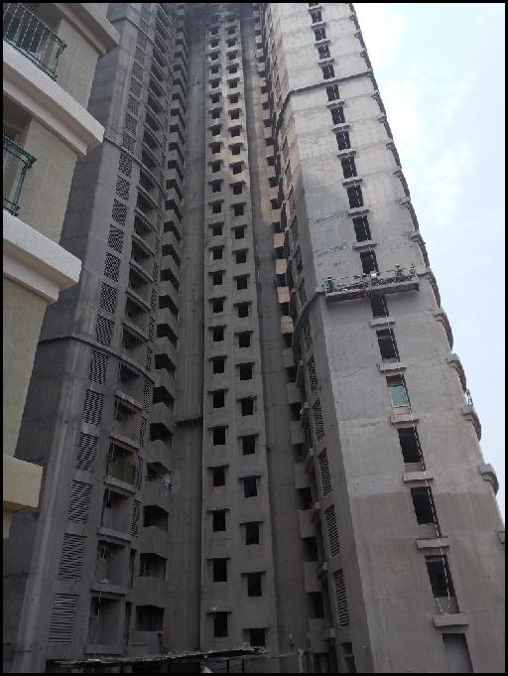
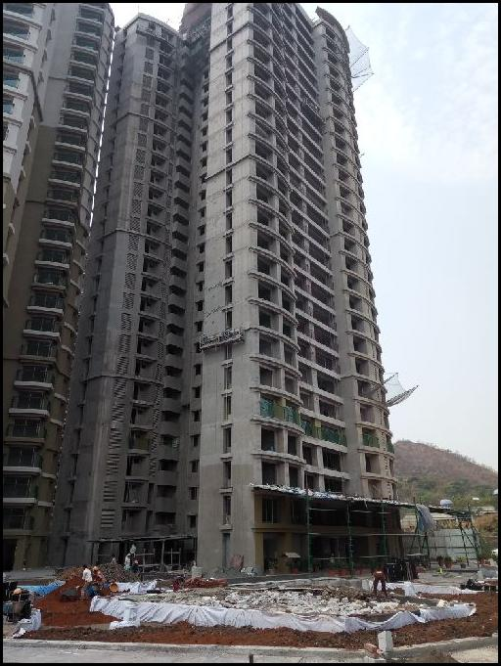

Route Map of the property
Site u/r
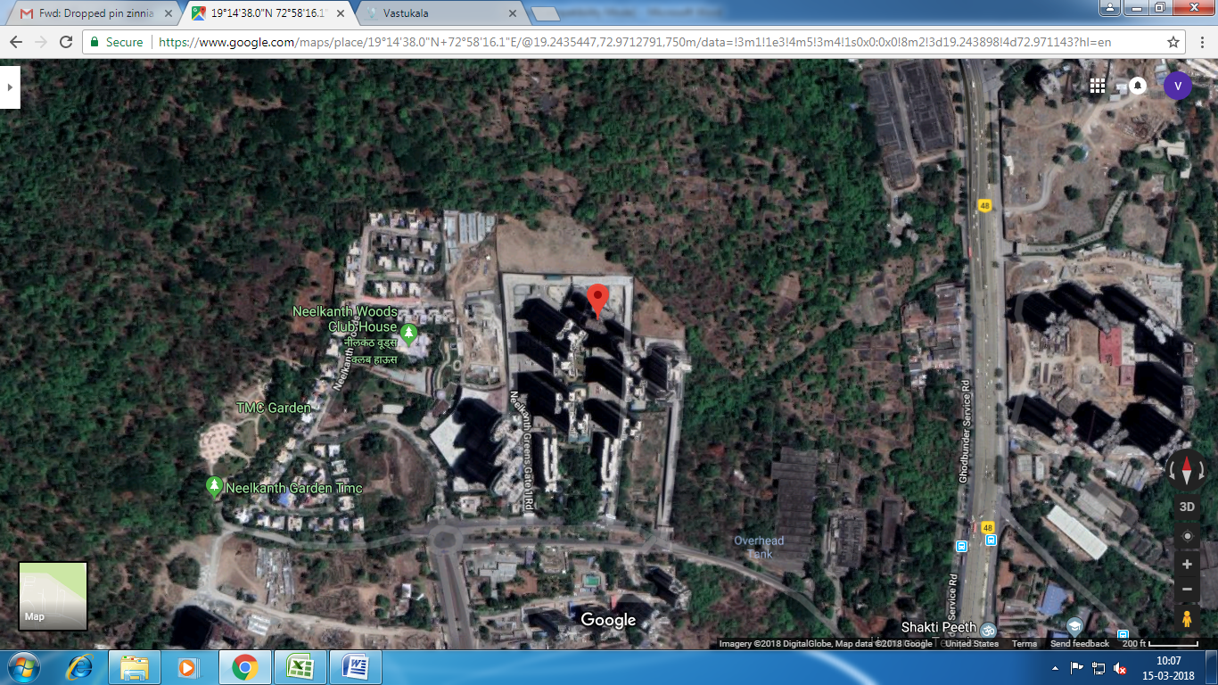

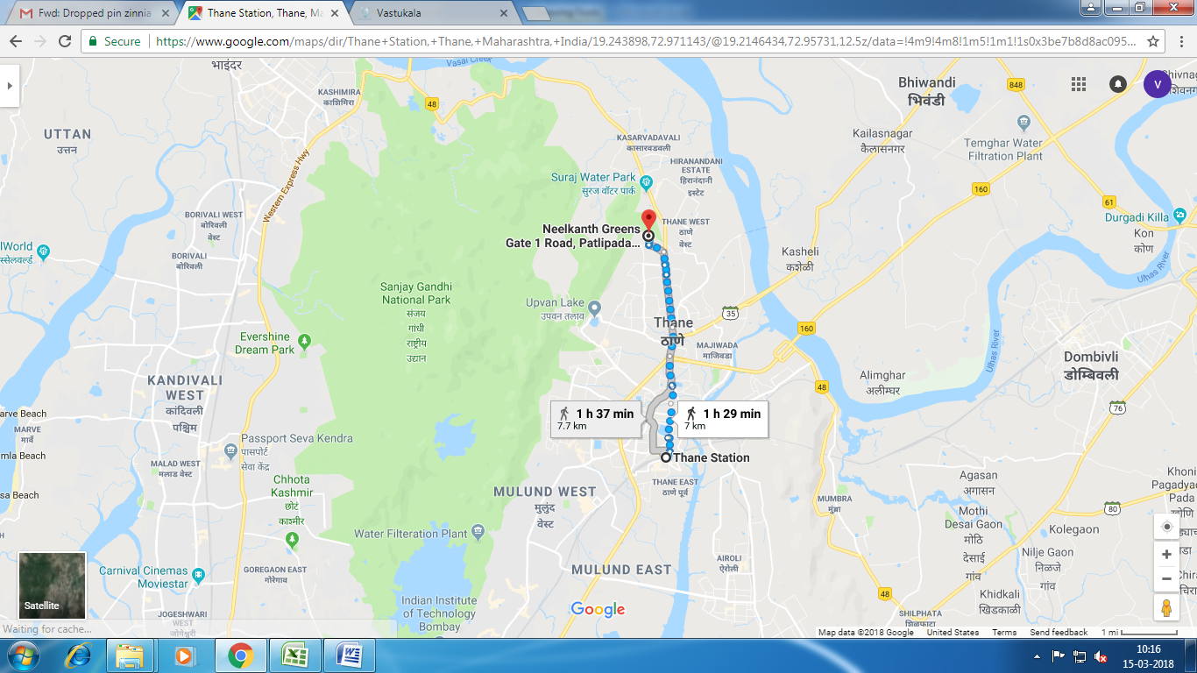

Longitude Latitude - 19°14'38.0"N 72°58'16.1"E

Note: The Blue line shows the route to site from nearest metro station (Thane – 7.7 Km.)

Price Indicators
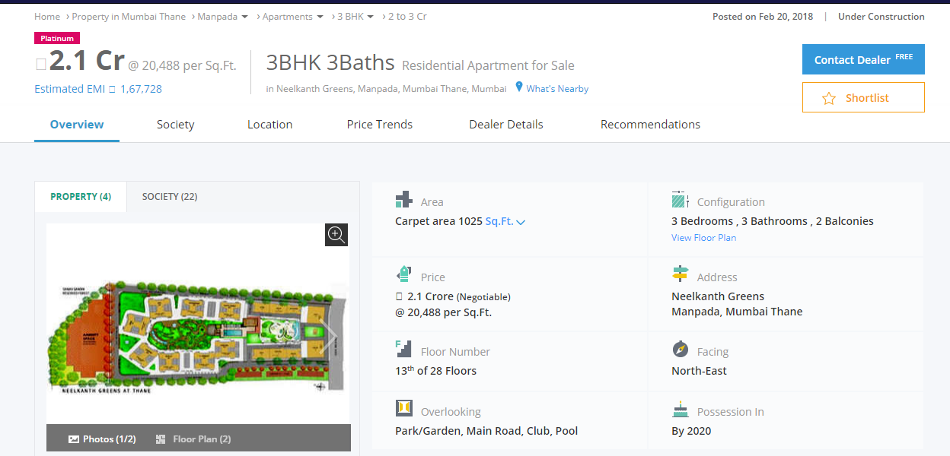

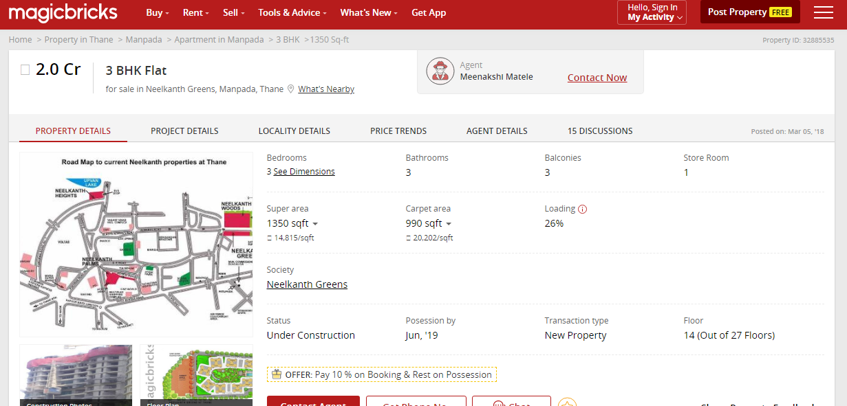

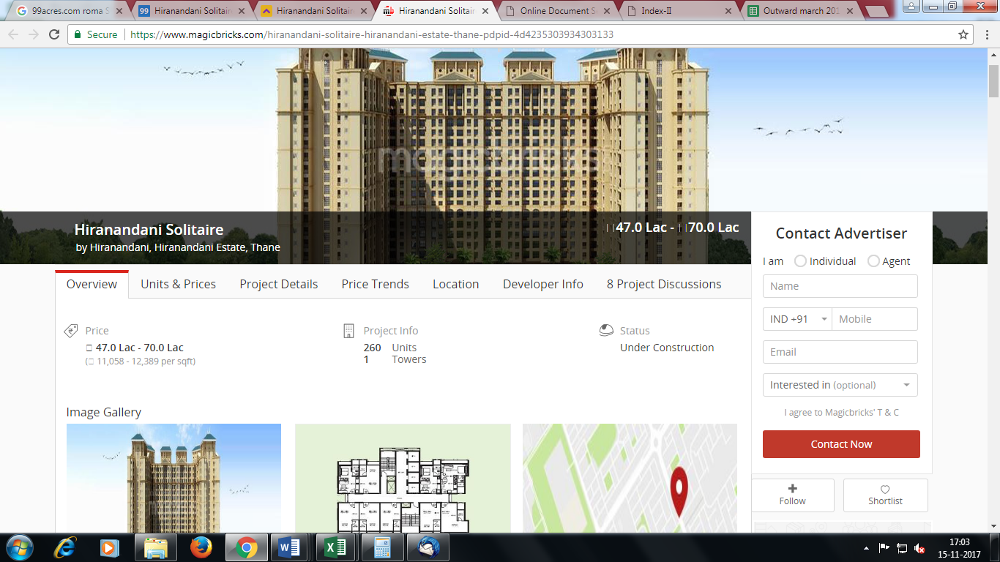

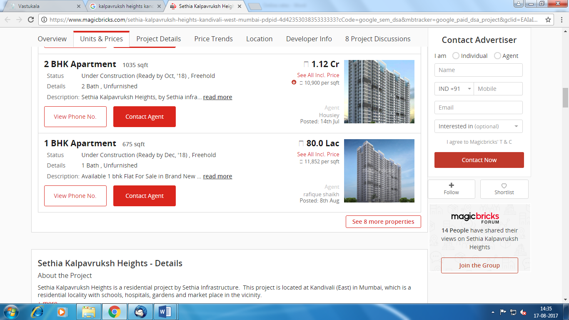
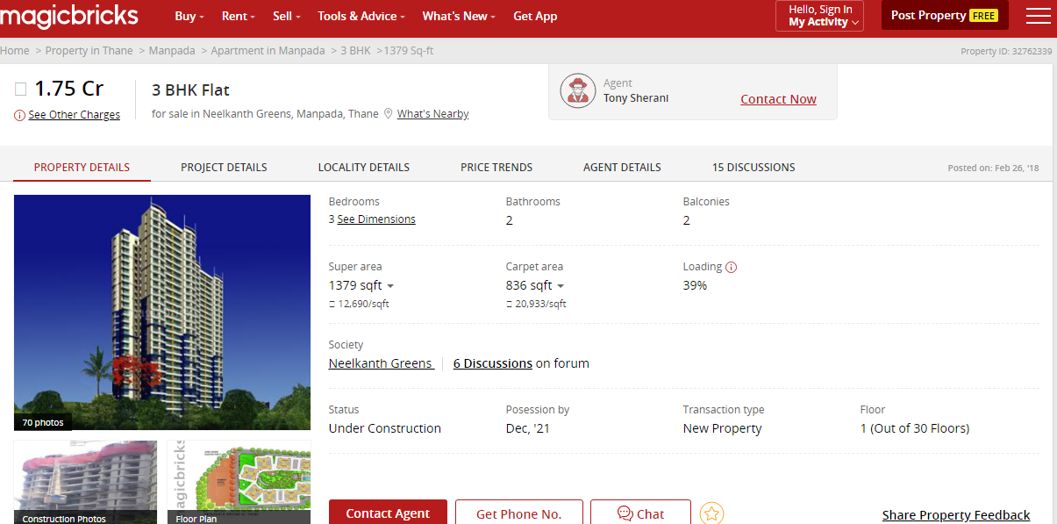

DEFINITION OF VALUE FOR THIS SPECIFIC PURPOSE

This exercise is to assess Master Valuation of the property under reference as on 15th March 2018.

The term Fair Market Value is defined as

“The most probable price, as of a specified date, in cash, terms equivalent to cash, or in other precisely revealed terms for which the specified property rights would sell after reasonable exposure in a competitive market under all conditions requisite to a fair sale, with the buyer and seller each acting prudently knowledgeably and for self-interest assuming that neither is under undue duress”.

Fundamental assumptions and conditions presumed in this definition are:

1. Buyer and seller are motivated by self-interest.
2. Buyer and seller are well informed and are acting prudently.
3. The property is exposed for a reasonable time on the open market.
4. Payment is made in cash or equivalent or in specified financing terms.

UNDER LYING ASSUMPTIONS
1. We assume no responsibility for matters of legal nature affecting the property appraised or the title thereto, nor do we render our opinion as to the title, which is assumed to be good and marketable.
2. The property is valued as though under responsible ownership.
3. It is assumed that the property is free of liens and encumbrances.
4. It is assumed that there are no hidden or unapparent conditions of the subsoil or structure that would render it more or less valuable. No responsibility is assumed for such conditions or for engineering that might be required to discover such factors.

Sharad B. Chalikwar
Chartered Engineer (India)
Govt. Reg. Valuer
Reg. No. (N) CCIT/1-14/52/2008-09

DECLARATION OF PROFESSIONAL FEES CHARGED

We hereby declare that, our professional fees are not contingent upon the valuation findings. However, if the statute AND/OR clients demands that, the fees should be charged on the percentage of assessed value then, with the full knowledge of the AND/OR end user, it is being charged accordingly.

VALUATION OF THE PROPERTY PREMISES

Considering various parameters recorded herein above, existing economic scenario, and the information that is available with reference to the development of neighborhood and method selected for valuation, we are of the opinion that, the property premises can be assessed and valued for this particular purpose as per the details provided.

STATEMENT OF LIMITING CONDITIONS

1. Assumptions are made to the best of our knowledge and belief. Reliance is based on the information furnished to us by the identifier AND/OR client.
2. The valuer shall not be responsible for matters of legal nature that affects the value and opinion expressed by us.
3. If our appearance is required, we will be pleased to appear and give the necessary clarification, provided the fees for each appearance (excluding traveling, dearness allowance and out of pocket expenses) is pre-determined before the acceptance of the assignment under reference.
4. In no event shall the valuer be held responsible or liable for special, direct, indirect or consequential damages, as the assignment has been completed on best efforts, available knowledge and in good intentions of persons concerned and belief.
5. If it is proved that there is an apparent negligence on the part of a valuer, liability of this assignment (whether arising from this assignment, negligence or whatsoever) is limited in respect of anyone event or series of events to the actual loss or damage sustained subject to maximum of 80% of the professional fees for the services rendered and in any case not exceeding the amount of ` 1,000/- (Rupees one Thousand Only). All the claims against us shall expire after three month from the date of submission of the valuation report provided by us.
6. We hereby declare that, the information furnished above is true and correct to the best of our knowledge and belief. We have no direct or indirect interest in the assets valued. We have not been convicted of any offence and sentenced to a term of imprisonment. We have not been found guilty of misconduct in our professional capacity.

Sharad B. Chalikwar
Chartered Engineer (India)
Govt. Reg. Valuer
Reg. No. (N) CCIT/1-14/52/2008-09

