Vastu/Mumbai/02/2024/007162/2302957  
11/16-154-SKVS  
 Date: 23.02.2024

**Structural Stability Report**

Structural Observation Residential Plot / Row House on Plot No. B-4, Sector – 12, Village – Kharghar, Taluka – Panvel, District – Raigad, Navi Mumbai - 410210, State - Maharashtra, Country – India.

Name of Owner: **Mr. Pankaj Singh, Mr. Neeraj Singh, Mrs. Geeta Singh & Mr. Brajbhushan Singh**

This is to certify that on visual inspection, it appears that the structure of the at Plot No. B-4, Sector – 12 is in normal condition and the future life can be reasonably taken under good condition and with proper periodic repairs & maintenance is about 41 years.

**General Information**:

|  |  |  |
| --- | --- | --- |
| **A.** | **Introduction** | |
| 1 | Name of Building | Residential Plot / Row House on Plot No. B-4 |
| 2 | Property Address | Residential Plot / Row House on Plot No. B-4, Sector – 12, Village – Kharghar, Taluka – Panvel, District – Raigad, Navi Mumbai - 410210, State - Maharashtra, Country – India |
| 3 | Type of Building | Residential used |
| 4 | No. of Floors | Ground + 2 Upper Floors |
| 5 | Whether stilt / podium / open parking provided | Stilt floor converted into shop |
| 6 | Type of Construction | R.C.C. Framed Structure |
| 7 | Type of Foundation | R.C.C. Footing |
| 8 | Thickness of the External Walls | 9” thick brick walls both sides plastered |
| 9 | Type of Compound | Brick Masonry Walls |
| 10 | Year of Construction | 2005 (As per occupancy certificate) |
| 11 | Present age of building | 19 years |
| 12 | Residual age of the building | 41 years Subject to proper, preventive periodic maintenance & structural repairs. |
| 13 | No. of flats (Per Floor) | Entire Row House |
| 14 | Methodology adopted | As per visual site inspection |

|  |  |  |
| --- | --- | --- |
| **B.** | **External Observation of the Building** | |
| 1 | Plaster | Nor Found |
| 2 | Chajjas | Nor Found |
| 3 | Plumbing | Nor Found |
| 4 | Cracks on the external walls | Nor Found |
| 5 | Filling cracks on the external walls | Nor Found |
| 6 | Cracks on columns & beams | Nor Found |
| 7 | Vegetation | Nor Found |
| 8 | Leakages of water in the drainage pipes or water pipes | Nor Found |
| 9 | Dampness external in the wall due to leakages | Nor Found |
| 10 | Any other observation about the condition of external side of the building | 1. **As per approved plan, the property is a row house of stilt + 2 upper floors, but as per site visit the owner has converted stilt into shop. Revised permission for the same is not available.** 2. **Structural Stability Report from licensed structural engineers not provided for our verification.** |
| **C** | **Internal Observation of the common areas of the building and captioned premises** | |
| 1 | Beams (Cracks & Leakages) | Not Found |
| 2 | Columns (Cracks & Leakages) | Not Found |
| 3 | Ceiling (Cracks & Leakages) | Not Found |
| 4 | Leakages inside the property | Not Found |
| 5 | Painting inside the property | Normal |
| 6 | Maintenance of staircase & cracks | Good |

|  |  |  |
| --- | --- | --- |
| **D** | **Common Observation** | |
| 1 | Structural Audit of the Building Under Bye – Laws No. 77 of the Model Bye Laws (Co-Operative Societies Act / Rules) | As per bye Laws No. 77 of Co-Op. Societies bye Laws under the Act the society shall conduct a Structural Audit of the building of the society as follows |
| 2 | Remark | No Structural Audit Report is furnished for the perusal. |

|  |  |
| --- | --- |
| **E** | **Conclusion** |
| The captioned building is having Ground + 2 Upper Floors which are constructed in year 2005 as per site information. Estimated future life under present circumstances is about 41 years subject to proper, preventive periodic maintenance & structural repairs.  The inspection dated 30.01.2024 reveals minor structural damage or deterioration to the building. The building is well as the property is maintained in normal condition & will stand future life subject to proper, preventive periodic maintenance & Good structural repairs.  Our Observations about the structure are given above.  The above assessment is based on visual inspection only. Separate structural audit from licensed structural engineers is advised to assess exact balance life of structure. | |

## Sharadkumar B. Chalikwar

Govt. Reg. Valuer

Chartered Engineer (India)

Reg. No. (N) CCIT/1-14/52/2008-09

BOB Empanelment No.: ZO:MZ:ADV:46:941

**Actual Site Photographs**

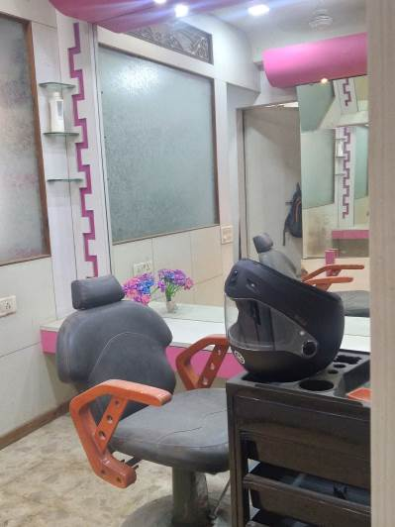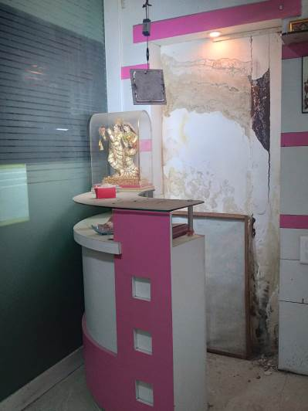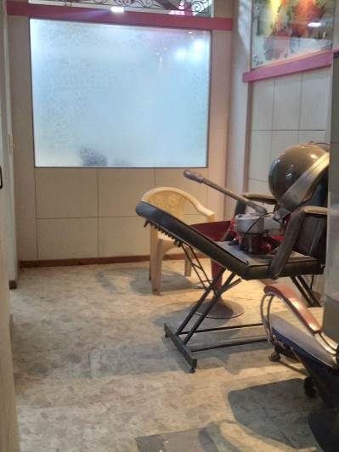

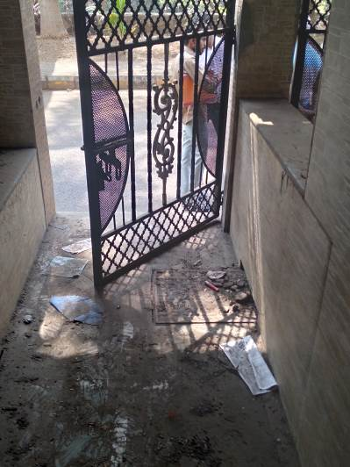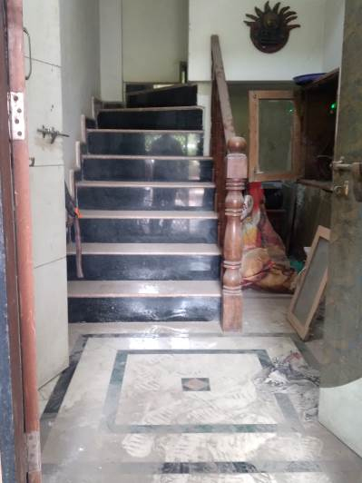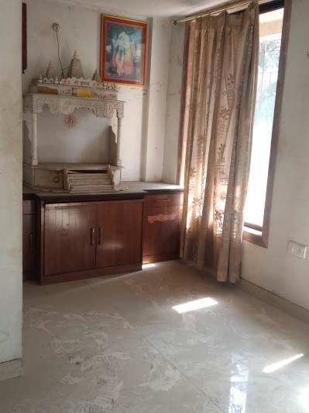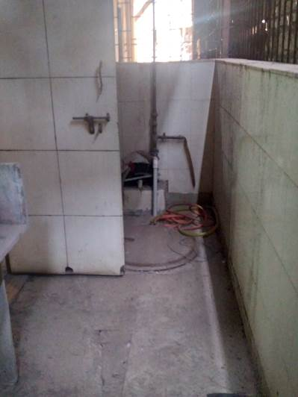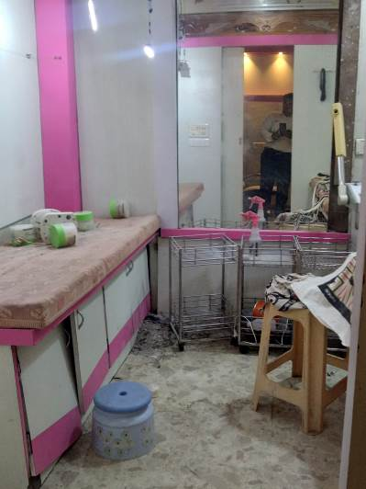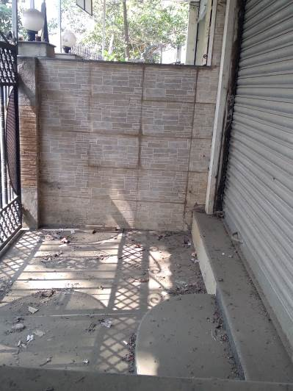**Actual Site Photographs**

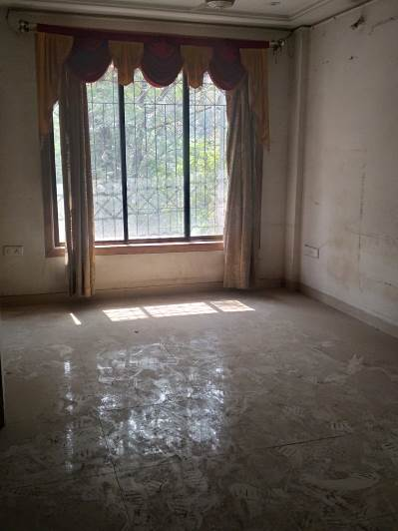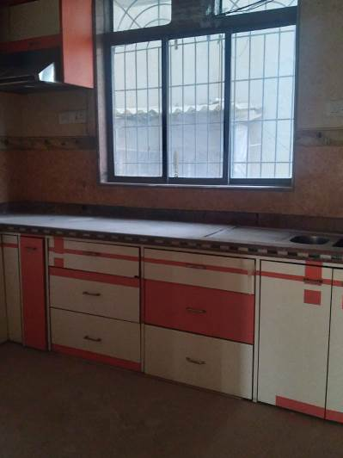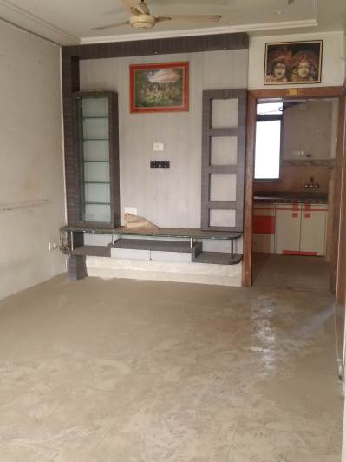

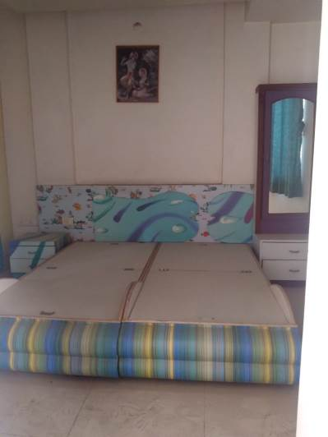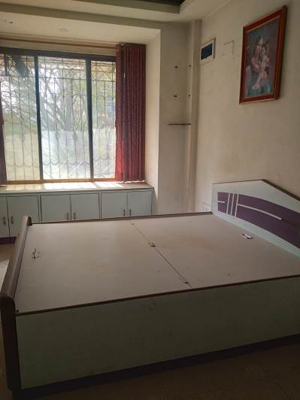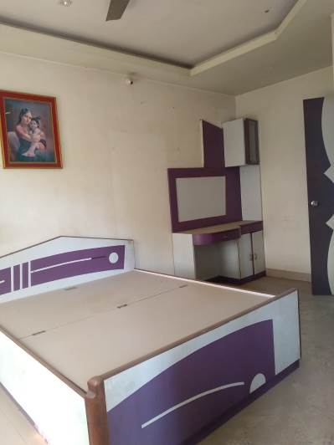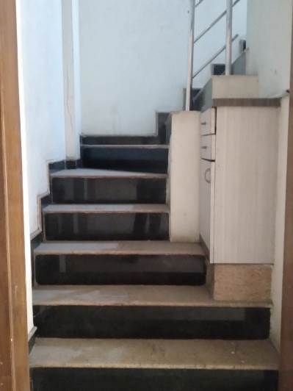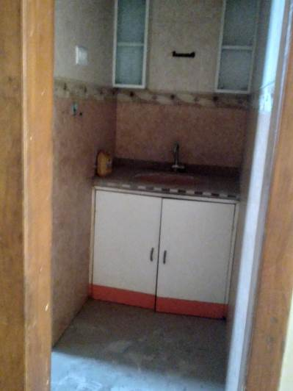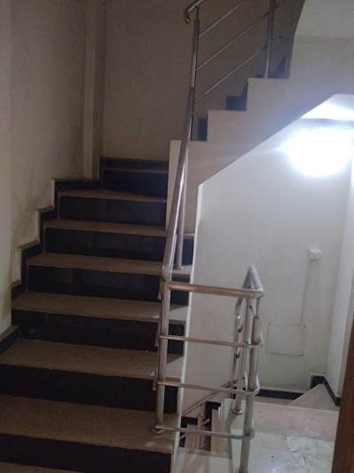 **Actual Site Photographs**

