Vastu/Nashik/02/2024/007160/2305110
22/23-332-RYBS
Date: 22.02.2024

To,
The Branch Manager,
State Bank of lndia
Maharashtra Eng. Research Institute Branch
Dindori Road, MERI, Nashik, Maharashtra, Nashik - 422004,
State - Maharashtra, Country - lndia.

Sub: Vetting of Extra Work

Sir,

With reference to above subject, we have evaluated the Extra Work for Residential Row House On Plot No. 05, “ Sai Bhakti Row House ”, Survey No. 248/ 2, Near At Pawar Ashram Shala, Renuka Nagar, Mhasrul Link Road, Village – Mhasrul, Taluka & District – Nashik, PIN – 422 004, State – Maharashtra, Country – India Name of Owner: Shri. Abhimanyu Ganpat Gawali & Sau. Yogita Abhimanyu Gawali.

We have verified the rates quoted as per current market rates. Details of Extra Work considered as per copy of Extra Work Agreement between Shri. Abhimanyu Ganpat Gawali & Sau. Yogita Abhimanyu Gawali. (First Party). Shri. Ramani Pratikkumar Shantilal (Second Party) received on dated 21.02.2024. The Extra Work amount is Rs. 3,00,000/- (Rupees Three Lakh Only)

The said Cost Vetting Certificate is valid upto next 6 months Only.

Thanking you

Sincerely yours

Manoj B. Chalikwar
Registered Valuer
Chartered Engineer (India)
Reg. No. CAT-I-F-1763
SBI Empanelment No.: SME/TCC/2021-22/86/3
Encl. Valuation Report

Agreement for Extra Work
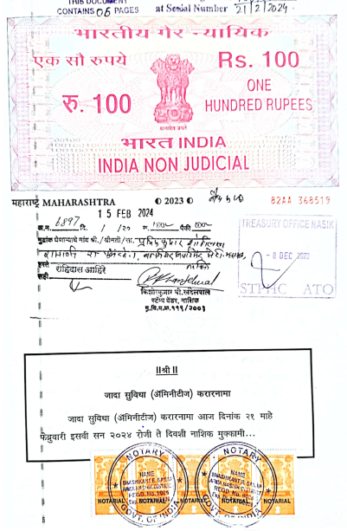
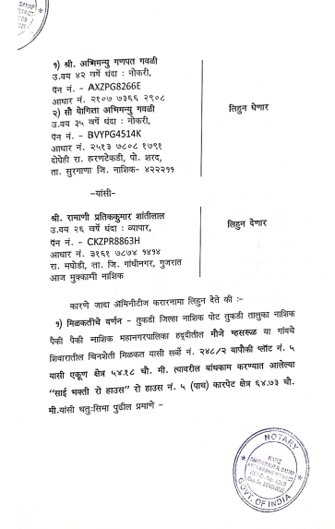

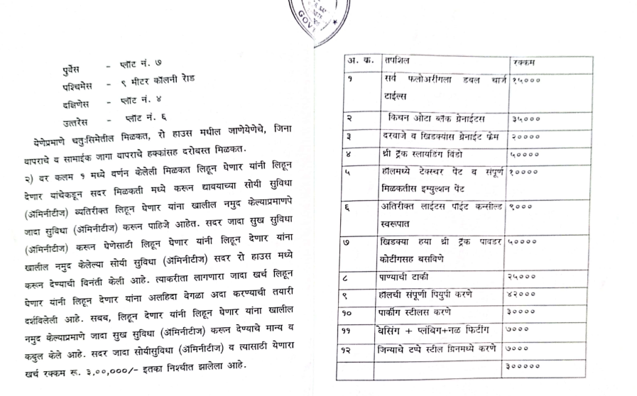
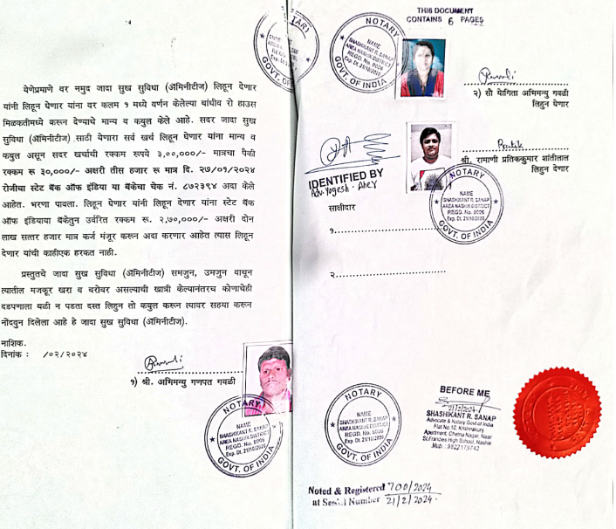

The Extra Work amount is Rs. 3,00,000/- (Rupees Three Lakh Only)

