Vastu/Nashik/12/2023/005870/2304160
23/20-389-RPBS
Date: 22.02.2024

To,
The Branch Manager,
State Bank of India
RACC Nashik Branch
RBO.2, The Wave Building, 1st Floor, Opposite Shell Petrol Pump, Pathardi Road,
Nashik - 422 010, State - Maharashtra, Country - lndia.

Sub: Vetting of Extra Amenities

Sir,

With reference to above subject, we have evaluated the Extra Amenities for Residential Row House No. 04, Ground + First + Second Floor, “Shri Vallabh Row Houses”, Survey No. 527+528+529+530, Plot No11+12/1 to 6, Near Kids Kingdom Pre School, Sagar Village, Mumbai - Agra National Highway, Jatra Hotel, Village – Adgaon, Taluka & District - Nashik, PIN Code - 422 003, State - Maharashtra, Country - India belongs Name of Proposed Purchaser: Shri. Kunal Subhash Kankriya. Name of Owner: Shri. Gyandev Digambar patil & Sau. Meenakshi Bharat Patil.

We have verified the rates quoted as per current market rates. Details of Extra Amenities considered as per copy of Extra Amenities Agreement between Shri. Kunal Subhash Kankriya (First Party). Sau. Vrushali Rishikesh Patil (Second Party) received on dated 22.12.2023. The Extra Amenities amount is Rs. 7,50,000/- (Rupees Seven Lakh Fifty Thousand Only).

The said Cost Vetting Certificate is valid upto next 6 months Only.

Thanking you

Sincerely yours

Sharadkumar B. Chalikwar

Govt. Reg. Valuer
Chartered Engineer (India)
Reg. No. (N) CCIT/1-14/52/2008-09
SBI Empanelment No.: SME/TCC/2021-22/85/13
Encl: Valuation report

Agreement for Extra Amenities
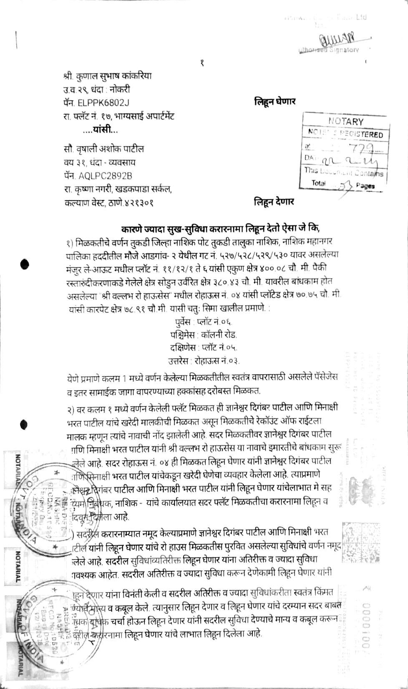

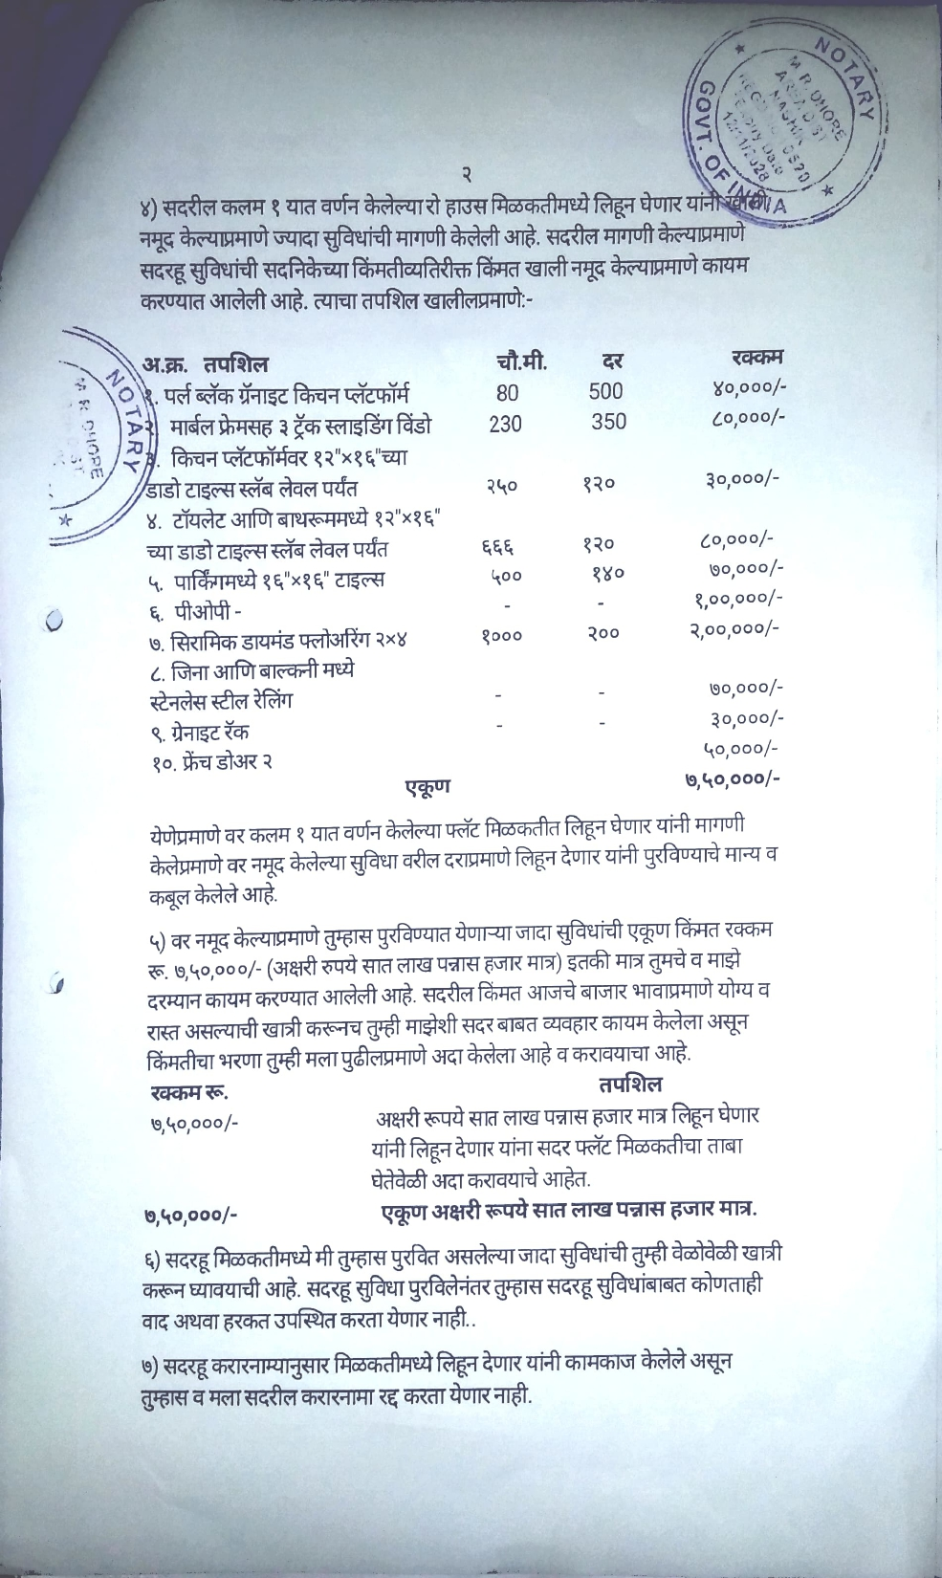
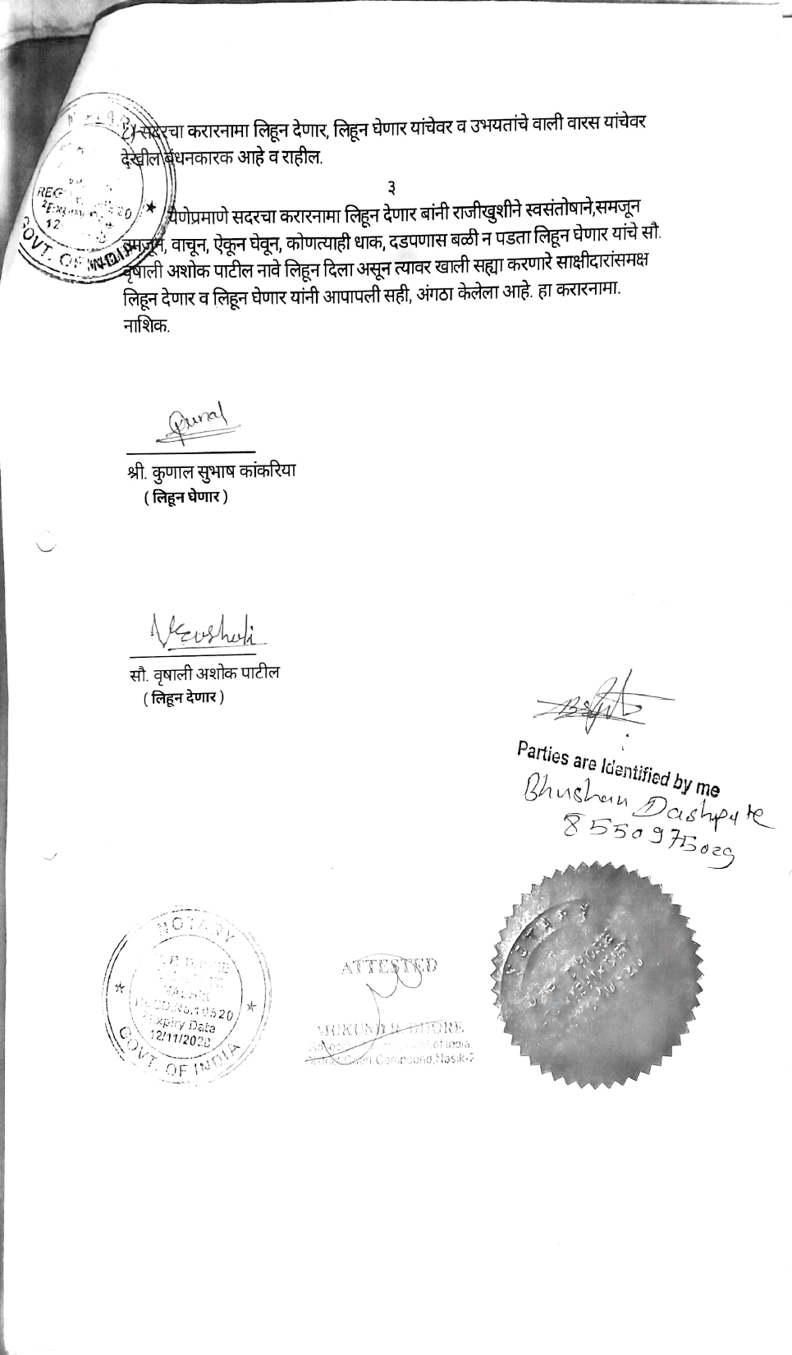

The Extra Amenities amount is Rs. 7,50,000/- (Rupees Seven Lakh Fifty Thousand Only)

