#

Valuation Report of the Immovable Property

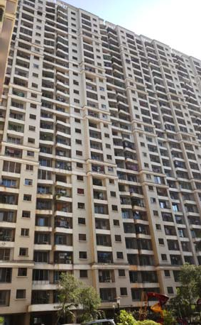

## Details of the property under consideration:

Name of Owner: **Mr. Swapnil Suhas Narwankar**

Residential Flat No. 42, 4th Floor, Building No. 12, **“Kaveri Co-op. Hsg. Soc. Ltd.”**, Kalpataru Kamdhenu Complex, Hari Om Nagar, Mulund (East), Mumbai – 400 081, State - Maharashtra, Country – India

### Latitude Longitude: 19°10'27.3"N 72°58'23.7"E

**Valuation Done for:**

**Private Valuation**

Vastukala Consultants (I) Pvt. Ltd.

# Mumbai • Delhi NCR • Aurangabad • Nanded • Indore • Pune Raipur • Jaipur • Ahmedabad • Rajkot • Thane • Nashik

**VALUATION OPINION REPORT**

This is to certify that the property bearing Residential Flat No. 42, 4th Floor, Building No. 12, **“Kaveri Co-op. Hsg. Soc. Ltd.”**, Kalpataru Kamdhenu Complex, Hari Om Nagar, Mulund (East), Mumbai – 400 081, State - Maharashtra, Country – India belongs to **Mr. Swapnil Suhas Narwankar**



Boundaries of the property.

North : Internal Road

South : Open Space

East : Open Space

West : Yogeshwar CHSL

Considering various parameters recorded, existing economic scenario, and the information that is available with reference to the development of neighborhood and method selected for valuation, we are of the opinion that, the property premises can be assessed and Fair Market Value Purpose at **` 1,76,18,000.00 (Rupees One Crore Seventy Six Lakh Eighteen Thousand Only).**

The valuation of the property is based on the documents produced by the concern. Legal aspects have not been taken into considerations while preparing this valuation report.

Hence certified

**Vastukala Consultants (I) Pvt. Ltd.**

121, 1st Floor, Ackruti Star, Central Road, MIDC, Andheri (E), Mumbai - 400 093

## VALUATION REPORT (IN RESPECT OF FLAT)

|  |  |  |  |  |  |
| --- | --- | --- | --- | --- | --- |
| I | **General** | | | | |
| 1. | Purpose for which the valuation is made | | | : | To assess Fair Market value of the property for **Fair**  **Market Value Purpose**. |
| 2. | a) | | Date of inspection | : | 01.04.2022 |
|  | b) | | Date on which the valuation is made | : | 11.04.2022 |
| 3. | List of documents produced for perusal | | | : | 1. Copy of Agreement for Sale dated 19.12.2006. 2. Copy of Electricity Bill for the month of March 2022 in the name of Mr. Swapnil Suhas Narwankar |
| 4. | Name of the owner(s) and his / their address (es) with Phone no. (details of share of each owner in case of joint ownership) | | | : | **Mr. Swapnil Suhas Narwankar**  **Address:** Residential Flat No. 42, 4th Floor, Building No. 12, **“Kaveri Co-op. Hsg. Soc. Ltd.”**, Kalpataru Kamdhenu Complex, Hari Om Nagar, Mulund (East), Mumbai – 400 081, State - Maharashtra, Country – India  Contact Person:  Mr. Swapnil Narwankar (Owner) Contact No. 9167273331  Sole Ownership |
| 5. | Brief description of the property (Including Leasehold / freehold etc.) | | | : | The property is a Residential No. 42 is located on 4th floor. The composition of Flat is Living Room + Dinning  + 2 Bedrooms + Small Room + Kitchen + WC + Bath.  The property is at 2.6 KM distance from nearest railway station Mulund. |
| 6. | Location of property | | | : |  |
|  | a) | Plot No. / Survey No. | | : | C.T.S. No. 88/3, 89, 90, 91, 92, 93, 94/4, 94/5, 95/6,  95/7, 95/8, 95/9, 95/10 and 95/11 |
|  | b) | Door No. | | : | Residential Flat No. 42 |
|  | c) | C.T.S. No. / Village | | : | C.T.S. No. 88/3, 89, 90, 91, 92, 93, 94/4, 94/5, 95/6,  95/7, 95/8, 95/9, 95/10 and 95/11 Village – Mulund |
|  | d) | Ward / Taluka | | : | Taluka - Kurla |
|  | e) | Mandal / District | | : | District - Mumbai |
|  | f) | Date of issue and validity of layout of  approved map / plan | | : | Copy of Approved Plan not provided for our verification. |
|  | g) | Approved map / plan issuing authority | | : |
|  | h) | Whether genuineness or authenticity  of approved map/ plan is verified | | : | N.A. |
|  | i) | Any other comments by our | |  | N.A. |

|  |  |  |  |  |  |
| --- | --- | --- | --- | --- | --- |
|  |  | empanelled valuers on authentic of  approved plan |  |  | |
| 7. | Postal address of the property | | : | Residential Flat No. 42, 4th Floor, Building No. 12, **“Kaveri Co-op. Hsg. Soc. Ltd.”**, Kalpataru Kamdhenu Complex, Hari Om Nagar, Mulund (East), Mumbai –  400 081, State - Maharashtra, Country – India | |
| 8. | City / Town | | : | Mumbai | |
|  | Residential area | | : | Yes | |
|  | Commercial area | | : | No | |
|  | Industrial area | | : | No | |
| 9. | Classification of the area | | : |  | |
|  | i) High / Middle / Poor | | : | Middle Class | |
|  | ii) Urban / Semi Urban / Rural | | : | Urban | |
| 10. | Coming under Corporation limit / Village  Panchayat / Municipality | | : | Village – Mulund  Municipal Corporation of Greater Mumbai | |
| 11. | Whether covered under any State / Central Govt. enactments (e.g., Urban Land Ceiling Act) or notified under agency area/ scheduled  area / cantonment area | | : | No | |
| 12. | **Boundaries of the property** | |  | **As per Site** | **As per Documents** |
|  | North | | : | Internal Road | Details not available |
|  | South | | : | Open Space | Details not available |
|  | East | | : | Open Space | Details not available |
|  | West | | : | Yogeshwar CHSL | Details not available |
| 13 | Dimensions of the site | |  | N. A. as property under consideration is Flat in building. | |
|  |  | |  | A  As per the Deed | B  Actuals |
|  | North | | : | - | - |
|  | South | | : | - | - |
|  | East | | : | - | - |
|  | West | | : | - | - |
| 14. | Extent of the site | | : | **Carpet Area in Sq. Ft. = 766.00 (Area as Agreement for Sale)**  Built Up Area Sq. Ft. = 919.00 (Carpet Area + 20%) | |
| 14.1 | Latitude, Longitude & Co-ordinates of Flat | | : | 19°10'27.3"N 72°58'23.7"E | |
| 15. | Extent of the site considered for Valuation  (least of 13A& 13B) | | : | Carpet Area in Sq. Ft. = 766.00  (Area as Agreement for Sale) | |
| 16 | Whether occupied by the owner / tenant? If occupied by tenant since how long? Rent received per month. | | : | Owner Occupied | |



|  |  |  |  |
| --- | --- | --- | --- |
| **II** | **APARTMENT BUILDING** |  |  |
| 1. | Nature of the Apartment | : | Residential Zone |
| 2. | Location | : |  |
|  | C.T.S. No. | : | C.T.S. No. 88/3, 89, 90, 91, 92, 93, 94/4, 94/5, 95/6,  95/7, 95/8, 95/9, 95/10 and 95/11 Village – Mulund |
|  | Block No. | : | - |
|  | Ward No. | : | - |
|  | Village / Municipality / Corporation | : | Village – Mulund  Municipal Corporation of Greater Mumbai |
|  | Door No., Street or Road (Pin Code) | : | Residential Flat No. 42 |
| 3. | Description of the locality Residential /  Commercial / Mixed | : | Residential |
| 4. | Year of Construction | : | 2007 (As per site information) |
| 5. | Number of Floors | : | Ground (p) + Stilt (p) + 27 upper floors. |
| 6. | Type of Structure | : | R.C.C. Framed Structure |
| 7. | Number of Dwelling units in the building | : | - |
| 8. | Quality of Construction | : | Good |
| 9. | Appearance of the Building | : | Good |
| 10. | Maintenance of the Building | : | Good |
| 11. | Facilities Available | : |  |
|  | Lift | : | 3 lifts |
|  | Protected Water Supply | : | Municipal Water supply |
|  | Underground Sewerage | : | Connected to Municipal Sewerage System |
|  | Car parking - Open / Covered | : | Stilt Car Parking |
|  | Is Compound wall existing? | : | Yes |
|  | Is pavement laid around the Building | : | Yes |

|  |  |  |  |
| --- | --- | --- | --- |
| **III** | **Residential** |  |  |
| 1 | The floor in which the Flat is situated | : | 4th Floor |
| 2 | Door No. of the Flat | : | Residential Flat No. 42 |
| 3 | Specifications of the Flat | : |  |
|  | Roof | : | R.C.C. Slab |
|  | Flooring | : | Vitrified, Granite flooring |
|  | Doors | : | Teak Wood door frame with Flush doors |
|  | Windows | : | Alluminum sliding windows |
|  | Fittings | : | Concealed plumbing with C.P. fittings. Electrical wiring with Concealed. |
|  | Finishing | : | Cement Plastering |
| 4 | House Tax | : |  |
|  | Assessment No. | : | Details not available |
|  | Tax paid in the name of : | : | Details not available |
|  | Tax amount : | : | Details not available |
| 5 | Electricity Service connection No. : | : | Consumer No. 000096220995 |
|  | Meter Card is in the name of : | : | Mr. Swapnil Suhas Narwankar |
| 6 | How is the maintenance of the Flat? | : | Good |
| 7 | Agreement executed in the name of | : | **Mr. Swapnil Suhas Narwankar** |

|  |  |  |  |
| --- | --- | --- | --- |
| 8 | What is the undivided area of land as per Sale Deed? | : | Details not available |
| 9 | What is the plinth area of the Residential ? | : | Built Up Area Sq. Ft. = 919.00  (Carpet Area + 20%) |
| 10 | What is the floor space index (app.) | : | As per MCGM norms |
| 11 | What is the Carpet Area of the Flat? | : | **Carpet Area in Sq. Ft. = 766.00**  **(Area as Agreement for Sale)** |
| 12 | Is it Posh / I Class / Medium / Ordinary? | : | Middle Class |
| 13 | Is it being used for Residential or Commercial purpose? | : | Residential purpose |
| 14 | Is it Owner-occupied or let out? | : | Owner Occupied |
| 15 | If rented, what is the monthly rent? | : | ` 36,000.00 Expected rental income per month |
| **IV** | **MARKETABILITY** | : |  |
| 1 | How is the marketability? | : | Good |
| 2 | What are the factors favouring for an extra Potential Value? | : | Located in developed area |
| 3 | Any negative factors are observed which affect the market value in general? | : | No |
| **V** | **Rate** | : |  |
| 1 | After analyzing the comparable sale instances, what is the composite rate for a similar Flat with same specifications in the adjoining locality? - (Along with details / reference of at - least two latest deals / transactions with respect to adjacent properties in the areas) | : | ` 22,000.00 to ` 23,000.00 per Sq. Ft. on Carpet Area |
| 2 | Assuming it is a new construction, what is the adopted basic composite rate of the Flat under valuation after comparing with the specifications and other factors with the Flat  under comparison (give details). | : | ` 23,000.00 per Sq. Ft. |
| 3 | Break – up for the rate | : |  |
|  | I. Building + Services | : | ` 3,000.00 per Sq. Ft. |
|  | II. Land + others | : | ` 20,000.00 per Sq. Ft. |
| 4 | Guideline rate obtained from the Registrar's Office (an evidence thereof to be enclosed) | : | ` 1,42,910.00 per Sq. M.  i.e. ` 13,277.00 per Sq. Ft. |
|  | Guideline rate (after Deprecation) | : | ` 1,28,386.00 per Sq. M.  i.e. ` 11,927.00 per Sq. Ft. |
| 5 | In case of variation of 20% or more in the valuation proposed by the Valuer and the Guideline value provided in the State Govt. notification or Income Tax Gazette justification on variation has to be given | : | It is a foregone conclusion that market value is always more than the RR price. As the RR Rates area Fixed by respective State Government for computing Stamp Duty  / Rgstn. Fees. Thus the differs from place to place and  Location, Amenities per se as evident from the fact than even RR Rates Decided by Government Differs. |
| **VI** | **COMPOSITE RATE ADOPTED AFTER DEPRECIATION** |  |  |
| **a** | Depreciated building rate | : |  |
|  | Replacement cost of Flat with Services (v(3)i) | : | - |

|  |  |  |  |
| --- | --- | --- | --- |
|  | Age of the building | : | 15 years |
|  | Life of the building estimated | : | 45 years Subject to proper, preventive periodic maintenance & structural repairs. |
| **b** | **Total composite rate arrived for Valuation** | : | **c 23,000.00 per Sq. Ft.** |

### Details of Valuation:

|  |  |  |  |  |
| --- | --- | --- | --- | --- |
| **Sr.**  **No.** | **Description** | **Qty.** | **Rate per unit (c)** | **Estimated Value (c)** |
| 1 | Present value of the Flat | 766.00 Sq. Ft. | 23,000.00 | **c 1,76,18,000.00**# |

The sales comparison approach uses the market data of sale prices to estimate the value of a real estate property. Property valuation in this method is done by comparing a property to other similar properties that have been recently sold. Comparable properties, also known as comparables, or comps, must share certain features with the property in question. Some of these include physical features such as square footage, number of rooms, condition, and age of the building; however, the most important factor is no doubt the location of the property. Adjustments are usually needed to account for differences as no two properties are exactly the same. To make proper adjustments when comparing properties, real estate appraisers must know the differences between the comparable properties and how to value these differences. The sales comparison approach is commonly used for Residential Flat, where there are typically many comparables available to analyze. As the property is a Residential Flat, we have adopted Sale Comparison Approach Method for the purpose of valuation. The Price for similar type of property in the nearby vicinity is in the range of c 21,000.00 to c 23,000.00 per Sq. Ft. on Carpet Area. Considering the rate with attached report, current market conditions, demand and supply position, Flat size, location, upswing in real estate prices, sustained demand for Residential Flat, all round development of commercial and residential application in the locality etc. We estimate c 23,000.00 per Sq. Ft. for valuation.



***j B. Ch***

Value

g neer

V / 0 6

763

**Actual site photographs**

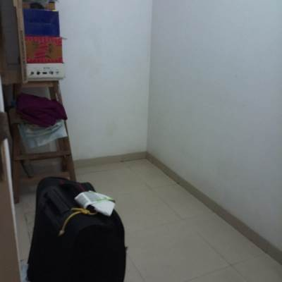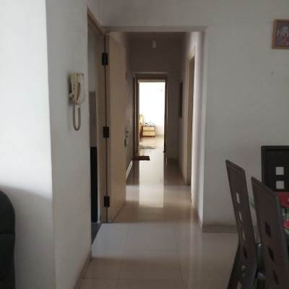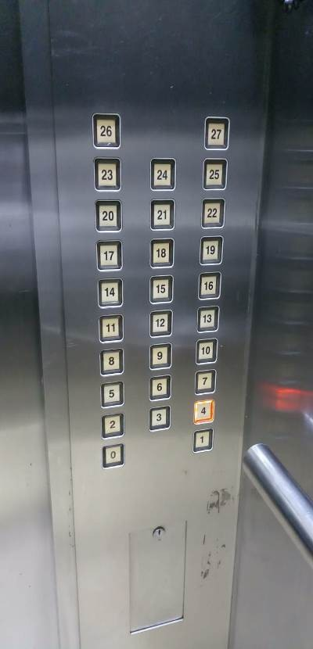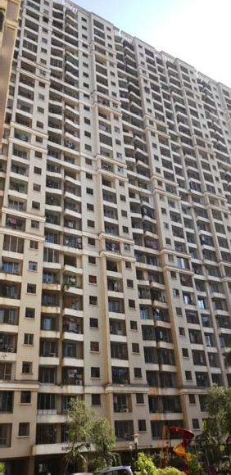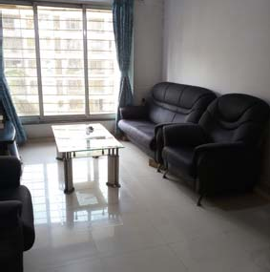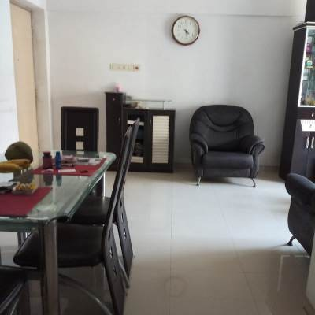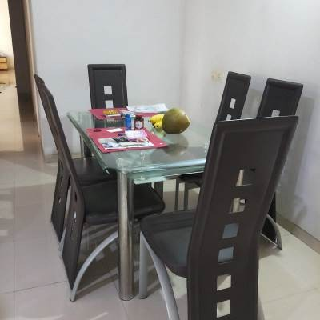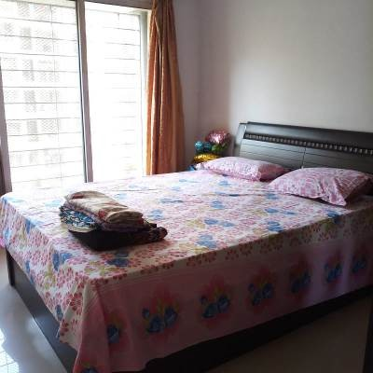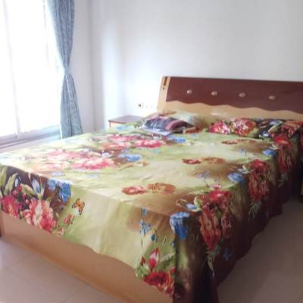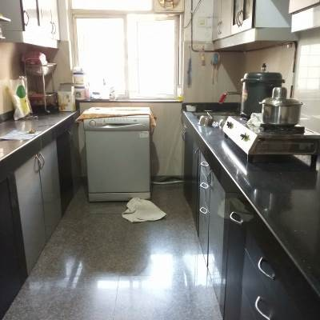

**Route Map of the property**

### Site u/r

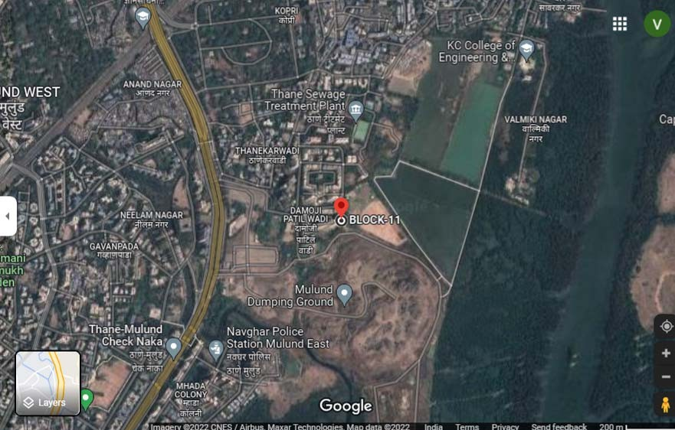

**Latitude Longitude: 19°10'27.3"N 72°58'23.7"E**

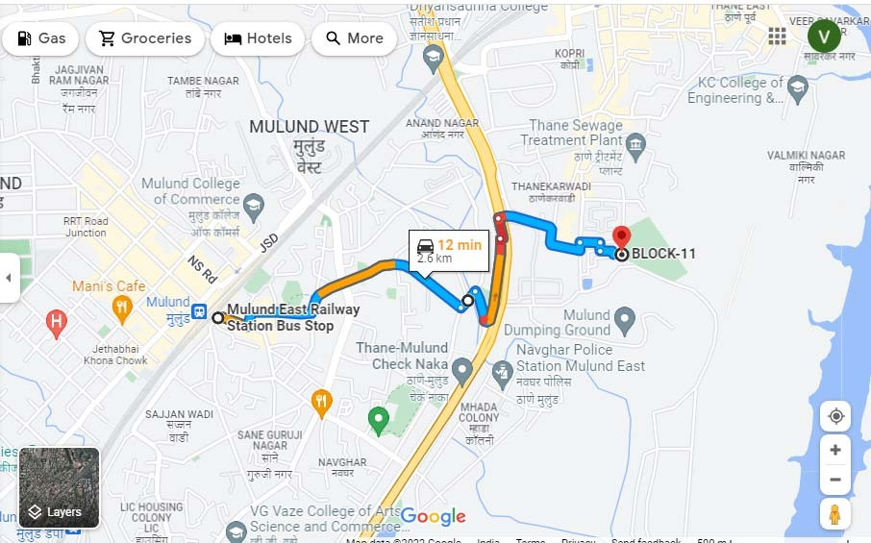

**Note:** The Blue line shows the route to site from nearest railway station (Mulund – 2.6 KM)

**`**

**Ready Reckoner Rate**

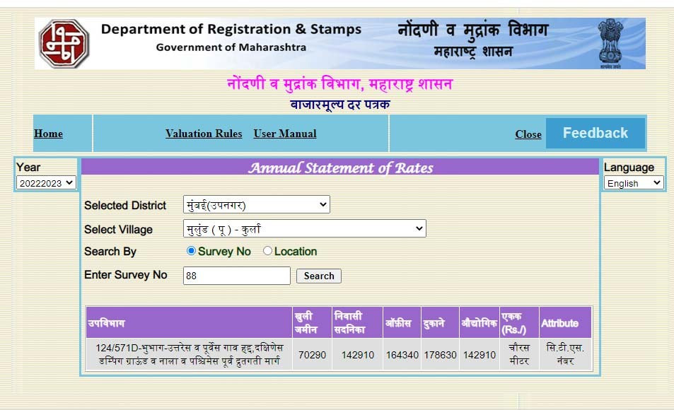

**Sale Instance**

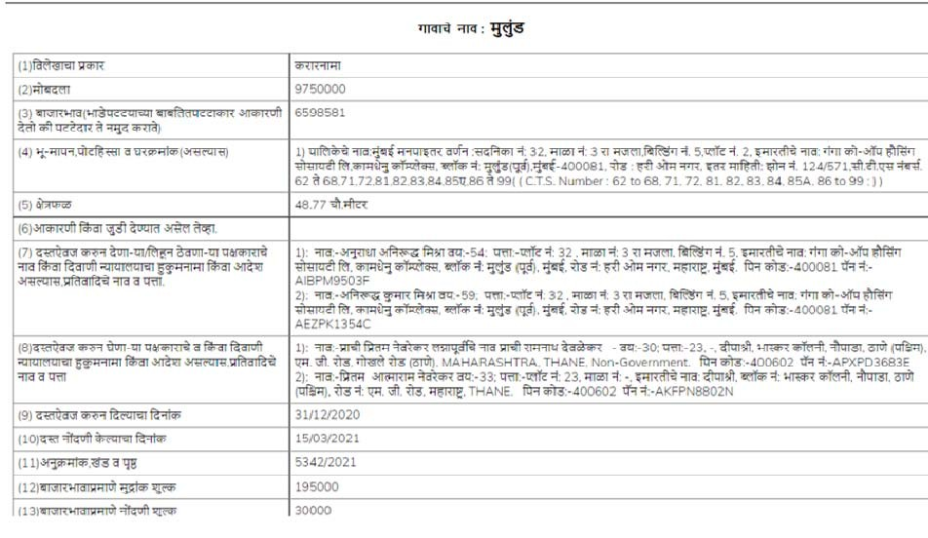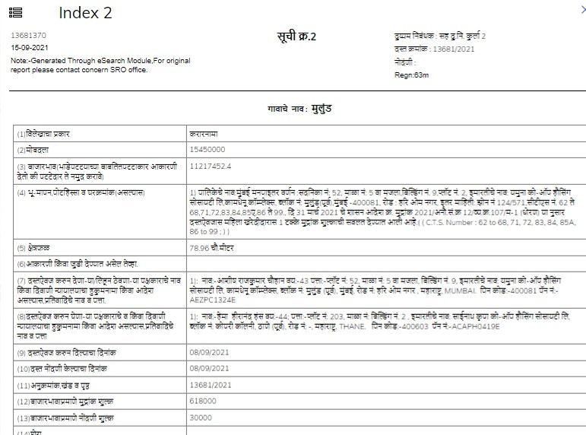

**Price Indicators**

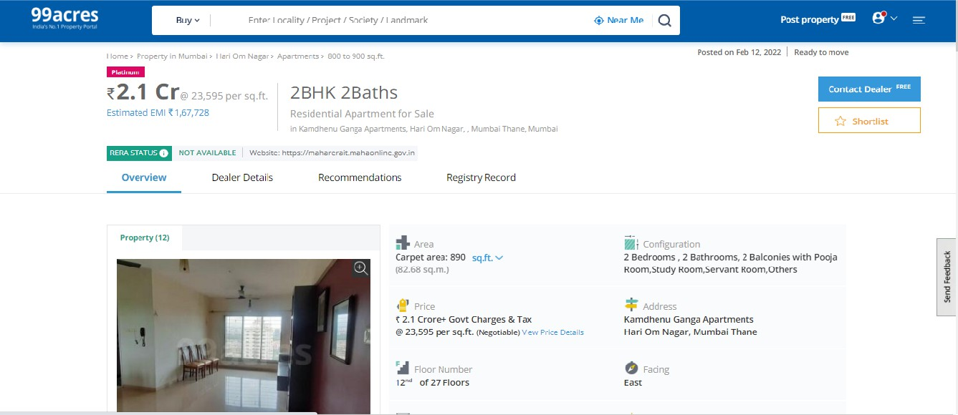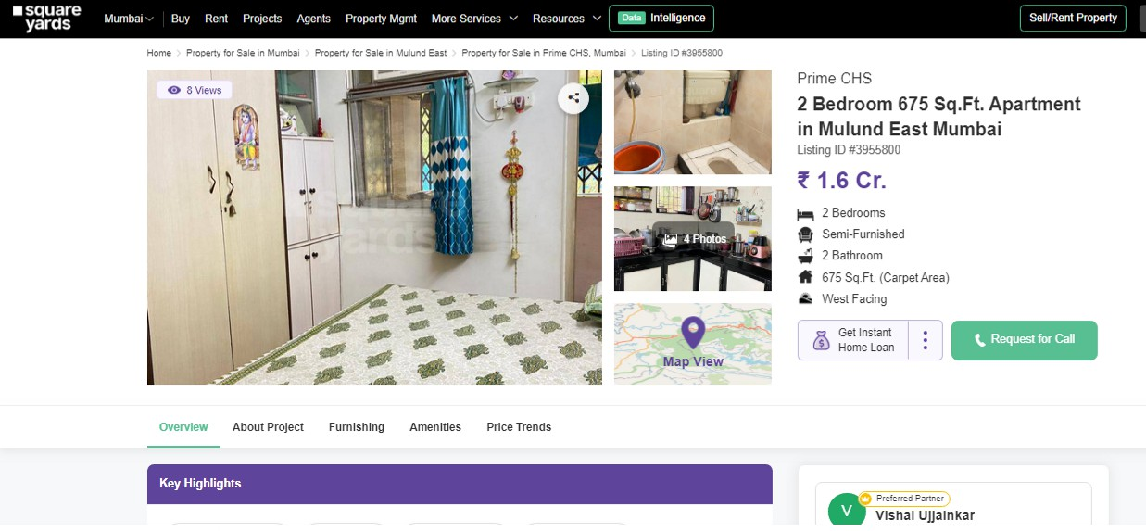

**Justification for price /rate**

The Market Value of the property is based on facts of markets discovered by us during our enquiries, however the government rate value in this case is more than the market value arrived by us. We are of the opinion that the value arrive by us will prove to be correct if an Auction of the subject property is carried out. As far as Market Value in Index II is concerned, it is not possible to comment on same, may be government rates are fixed by sampling during same point of time in part and whereas, Market values change every month.



In most of the cases the actual deal amount or Transaction value is not reflected in Index II because of various Market practices. As Valuer, we always try to give a value which is correct reflection of actual transaction value irrespective of any factors in market.

We hope this will satisfy your requirements

As a result of my appraisal and analysis, it is my considered opinion that the **Fair Market Value** of the above property in the prevailing condition with aforesaid specifications is **c 1,76,18,000.00 (Rupees One Crore Seventy Six Lakh Eighteen Thousand Only).**



## (Annexure-IV)

**DECLARATION-CUM-UNDERTAKING**

I, Manoj Chalikwar son of Shri. Baburao Chalikwar do hereby solemnly affirm and state that:

1. I am a citizen of India.
2. I will not undertake valuation of any assets in which I have a direct or indirect interest or become so interested at any time during a period of three years prior to my appointment as valuer or three years after the valuation of assets was conducted by me.



1. The information furnished in my valuation report dated 11.04.2022 is true and correct to the best of my knowledge and belief and I have made an impartial and true valuation of the property.
2. I/ my authorized representative have personally inspected the property on 01.04.2022. The work is not sub - contracted to any other valuer and carried out by myself.
3. Valuation report is submitted in the format as prescribed by the bank.
4. I have not been depanelled / delisted by any other bank and in case any such depanelment by other banks during my empanelment with you, I will inform you within 3 days of such depanelment.
5. I have not been removed / dismissed from service / employment earlier.
6. I have not been convicted of any offence and sentenced to a term of imprisonment
7. I have not been found guilty of misconduct in my professional capacity.
8. I have not been declared to be unsound mind
9. I am not an undischarged bankrupt, or has not applied to be adjudicated as a bankrupt;
10. I am not an undischarged insolvent.
11. I have not been levied a penalty under section 271J of Income-tax Act, 1961 (43 of 1961) and time limit for filing appeal before Commissioner of Income-tax (Appeals) or Income-tax Appellate Tribunal, as the case may be has expired, or such penalty has been confirmed by Income-tax Appellate Tribunal, and five years have not elapsed after levy of such penalty
12. I have not been convicted of an offence connected with any proceeding under the

Income Tax Act 1961, Wealth Tax Act 1957 or Gift Tax Act 1958 and

1. My PAN Card number as applicable is AERPC9086P
2. I undertake to keep you informed of any events or happenings which would make me ineligible for empanelment as a valuer
3. I have not concealed or suppressed any material information, facts and records and I have made a complete and full disclosure



1. I have read the Handbook on Policy, Standards and procedure for Real Estate Valuation, 2011 of the IBA and this report is in conformity to the "Standards" enshrined for valuation in the Part - B of the above handbook to the best of my ability.
2. I have read the International Valuation Standards (IVS) and the report submitted to the Bank for the respective asset class is in conformity to the "Standards" as enshrined for valuation in the IVS in "General Standards" and "Asset Standards" as applicable. The valuation report is submitted in the prescribed format of the bank.
3. I abide by the Model Code of Conduct for empanelment of valuer in the Bank. (Annexure V - A signed copy of same to be taken and kept along with this declaration)
4. I am registered under Section 34 AB of the Wealth Tax Act, 1957.
5. I am valuer registered with Insolvency & Bankruptcy Board of India (IBBI)
6. My CIBIL Score and credit worthiness is as per Bank's guidelines.
7. I am Director of the company, who is competent to sign this valuation report.
8. I will undertake the valuation work on receipt of Letter of Engagement generated from the system (i.e. LLMS / LOS) only.
9. Further, I hereby provide the following information.

|  |  |  |
| --- | --- | --- |
| **Sr.**  **No.** | **Particulars** | **Valuer comment** |
| 1. | background information of the asset being valued; | The property under consideration was purchased by Swapnil Suhas Narwankar from Kamdhenu Constructions vide Agreement for  Sale dated 19.12.2006. |
| 2. | purpose of valuation and appointing authority | As per the request Privet Valuation, to assess  value of the property for **Fair Market Value.** |

|  |  |  |
| --- | --- | --- |
| 3. | identity of the valuer and any other experts involved in the valuation; | Manoj B. Chalikwar – Regd. Valuer  Sameer Sutar – Valuation Engineer Vaishali Sarmalkar – Technical Manager |
| 4. | disclosure of valuer interest or conflict, if any; | We have no interest, either direct or indirect, in the property valued. Further to state that we do not have relation or any connection with property owner / applicant directly or indirectly. Further to state that we are an independent Valuer and in no way related to  property owner / applicant |
| 5. | date of appointment, valuation date and date of  report; | Date of Appointment - 01.04.2022 Valuation Date – 11.04.2022  Date of Report - 11.04.2022 |
| 6. | inspections and/or investigations undertaken; | Physical Inspection done on 01.04.2022 |
| 7. | nature and sources of the information used or relied upon; | Market Survey at the time of site visit Ready Reckoner rates / Circle rates Online search for Registered Transactions  Online Price Indicators on real estate portals Enquiries with Real estate consultants Existing data of Valuation assignments  carried out by us |
| 8. | procedures adopted in carrying out the  valuation and valuation standards followed; | Sales Comparative Method |
| 9. | restrictions on use of the report, if any; | This valuation is for the use of the party to whom it is addressed and for no other purpose. No responsibility is accepted to any third party who may use or rely on the whole or any part of this valuation. The valuer has no pecuniary interest that would conflict with  the proper valuation of the property. |
| 10. | major factors that were taken into account during the valuation; | current market conditions, demand and supply position, Residential Flat size, location, upswing in real estate prices, sustained demand for Residential Flat, all round development of commercial and  residential application in the locality etc. |
| 11. | Caveats, limitations and disclaimers to the extent they explain or elucidate the limitations faced by valuer, which shall not be for the purpose of limiting his responsibility for the  valuation report. | Attached |

# Assumptions, Disclaimers, Limitations & Qualifications

### Value Subject to Change

The subject appraisal exercise is based on prevailing market dynamics as on **11th April 2022** and does not take into account any unforeseeable developments which could impact the same in the future.

### Our Investigations

We are not engaged to carry out all possible investigations in relation to the subject property. Where in our report we identify certain limitations to our investigations, this is to enable the reliant party to instruct further investigations where considered appropriate or where we recommend as necessary prior to reliance. Vastukala Consultants India Pvt. Ltd. (VCIPL) is not liable for any loss occasioned by a decision not to conduct further investigations



### Assumptions

Assumptions are a necessary part of undertaking valuations. VCIPL adopts assumptions for the purpose of providing valuation advise because some matters are not capable of accurate calculations or fall outside the scope of our expertise, or out instructions. The reliant party accepts that the valuation contains certain specific assumptions and acknowledge and accept the risk of that if any of the assumptions adopted in the valuation are incorrect, then this may have an effect on the valuation.

### Information Supplied by Others

The appraisal is based on the information provided by the client. The same has been assumed to be correct and has been used for appraisal exercise. Where it is stated in the report that another party has supplied information to VCIPL, this information is believed to be reliable but VCIPL can accept no responsibility if this should prove not to be so.

### Future Matters

To the extent that the valuation includes any statement as to a future matter, that statement is provided as an estimate and/or opinion based on the information known to VCIPL at the date of this document. VCIPL does not warrant that such statements are accurate or correct.

### Map and Plans

Any sketch, plan or map in this report is included to assist the reader while visualising the property and assume no responsibility in connection with such matters.

### Site Details

Based on inputs received from Client and site visit conducted, we understand that the subject property is Residential Flat, **Carpet Area Sq. Ft. = 766.00** in the name of **Mr. Swapnil Suhas Narwankar.** Further, VCIPL has assumed that the subject property is free from any encroachment and is available as on the date of the appraisal.

### Property Title

Based on our discussion with the Client, we understand that the subject property is owned by **Mr. Swapnil Suhas Narwankar.** For the purpose of this appraisal exercise, we have assumed that the subject property has a clear title and is free from any encumbrances, disputes and claims. VCIPL has made no further enquiries with the relevant local authorities in this regard and does not certify the property as having a clear and marketable title. Further, no legal advice regarding the title and ownership of the subject property has been obtained for the purpose of this appraisal exercise. It has been assumed that the title deeds are clear and marketable.



### Environmental Conditions

We have assumed that the subject property is not contaminated and is not adversely affected by any existing or proposed environmental law and any processes which are carried out on the property are regulated by environmental legislation and are properly licensed by the appropriate authorities.

### Area

Based on the information provided by the Client, we understand that the Residential Flat, admeasuring

### Carpet Area Sq. Ft. = 766.00 Condition & Repair

In the absence of any information to the contrary, we have assumed that there are no abnormal ground conditions, nor archaeological remains present which might adversely affect the current or future occupation, development or value of the property. The property is free from rat, infestation, structural or latent defect. No currently known deleterious or hazardous materials or suspect techniques will be used in the construction of or subsequent alteration or additions to the property and comments made in the property details do not purport to express an opinion about , or advise upon, the condition of uninspected parts and should not be taken as making an implied representation or statement about such parts

### Valuation Methodology

For the purpose of this valuation exercise, the valuation methodology used is Direct Comparison Approach Method and proposed Highest and Best Use model is used for analysing development potential.

The Direct Comparison Approach involves a comparison of the property being valued to similar properties that have actually been sold in arms - length transactions or are offered for sale. This approach demonstrates what buyers have historically been willing to pay (and sellers willing to accept) for similar properties in an open and competitive market and is particularly useful in estimating the value of the Flat and properties that are typically traded on a unit basis.

In case of inadequate recent transaction activity in the subject micro-market, the appraiser would collate details of older transactions. Subsequently, the appraiser would analyse rental / capital value trends in the

subject micro-market in order to calculate the percentage increase / decrease in values since the date of the identified transactions. This percentage would then be adopted to project the current value of the same.

Where reliance has been placed upon external sources of information in applying the valuation methodologies, unless otherwise specifically instructed by Client and/or stated in the valuation, VCIPL has not independently verified that information and VCIPL does not advise nor accept it as reliable. The person or entity to whom the report is addressed acknowledges and accepts the risk that if any of the unverified information in the valuation is incorrect, then this may have an effect on the valuation.

### Not a Structural Survey



We state that this is a valuation report and not a structural survey

### Other Legal

All measurements, areas and ages quoted in our report are approximate

We have not made any allowances with respect to any existing or proposed local legislation relating to

taxation on realization of the sale value of the subject property. VCIPL is not required to give testimony or to appear in court by reason of this appraisal report, with reference to the property in question, unless arrangement has been made thereof. Further, no legal advice on any aspects has been obtained for the purpose of this appraisal exercise

### Property specific assumptions

Based on inputs received from the client and site visit conducted, we understand that the subject property is Residential Flat, admeasuring **Carpet Area Sq. Ft. = 766.00**

### ASSUMPTIONS, CAVEATS, LIMITATION AND DISCLAIMERS

1. We assume no responsibility for matters of legal nature affecting the property appraised or the title thereto, nor do we render our opinion as to the title, which is assumed to be good and marketable.
2. The property is valued as though under responsible ownership.
3. It is assumed that the property is free of liens and encumbrances.
4. It is assumed that there are no hidden or unapparent conditions of the subsoil or structure that would render it more or less valuable. No responsibility is assumed for such conditions or for engineering that might be required to discover such factors.
5. There is no direct/ indirect interest in the property valued.
6. The rates for valuation of the property are in accordance with the Govt. approved rates and prevailing market rates.

### DEFINITION OF VALUE FOR THIS SPECIFIC PURPOSE

As per the request Privet Valuation, to assess value of the property for **Fair Market Value** Purpose under reference as on **11th April 2022.**

The term **Fair Market Value** is defined as

*“The most probable price, as of a specified date, in cash, terms equivalent to cash, or in other precisely revealed terms for which the specified property rights would sell after reasonable exposure in a competitive market under all conditions requisite to a fair sale, with the buyer and seller each acting prudently knowledgeably and for self interest assuming that neither is under undue duress”.*



Fundamental assumptions and conditions presumed in this definition are:

1. Buyer and seller are motivated by self-interest.
2. Buyer and seller are well informed and are acting prudently.
3. The property is exposed for a reasonable time on the open market.
4. Payment is made in cash or equivalent or in specified financing terms.

### DECLARATION OF PROFESSIONAL FEES CHARGED

We hereby declare that, our professional fees are not contingent upon the valuation findings. However, if the statute AND/OR clients demands that, the fees should be charged on the percentage of assessed value then, with the full knowledge of the AND/OR end user, it is being charged accordingly.

### VALUATION OF THE PROPERTY PREMISES

Considering various parameters recorded herein above, existing economic scenario, and the information that is available with reference to the development of neighborhood and method selected for valuation, we are of the opinion that, the property premises can be assessed and Fair Market value for this **Fair Market Value purpose** at **c 1,76,18,000.00 (Rupees One Crore Seventy Six Lakh Eighteen Thousand Only).**