Vastu/Nashik/02/32024/007040/2305031
17/19-253-RYBS
Date: 17.02.2024

To,
The Branch Manager,
Bank of Baroda
Regional Office
BSNL Building, Datta Mandir Road, Nashik Road,
Nashik, PIN – 422 101, State - Maharashtra, Country - India.

Sub: Vetting of Extra Work

Sir,

With reference to above subject, we have evaluated the Extra Work For Residential Flat No. 106, Second Floor, " Goda Prestige ", Survey No. Survey No. 338/ 340/ 341, Plot No. 27+ 28, Near Hotel Madhuban, Vishvendu Nagar, Mungsare - Chandshi Road, Village - Jalalpur, Taluka & District - Nashik, PIN Code – 422003, State – Maharashtra, Country – India. belongs to Name of Proposed Purchaser: Shri. Digambar Ramgiri Giri & Sau. Sunita Digambar Giri. Name of Owner: Shri. Atul Bhausaheb Kale & Shri. Shashikant Vaman Khule.

We have verified the rates quoted as per current market rates. Details of Extra Work considered as per copy of Extra Work Agreement between Shri. Digambar Ramgiri Giri & Sau. Sunita Digambar Giri. (First Party). M/s. J.K Builders (Second Party) received on dated.16.02.2024. The Extra Work amount is Rs. 2,00,000/- (Rupees Two Lakh Only)

The said Cost Vetting Certificate is valid upto next 6 months Only.

Thanking you

Sincerely yours

Manoj B. Chalikwar
Registered Valuer
Chartered Engineer (India)
Reg. No. CAT-I-F-1763
Reg. No. IBBI/RV/07/2018/10366
BOB Empanelment No.: ZO:MZ:ADV:46:941
Encl: Valuation report.

Agreement for Extra Work
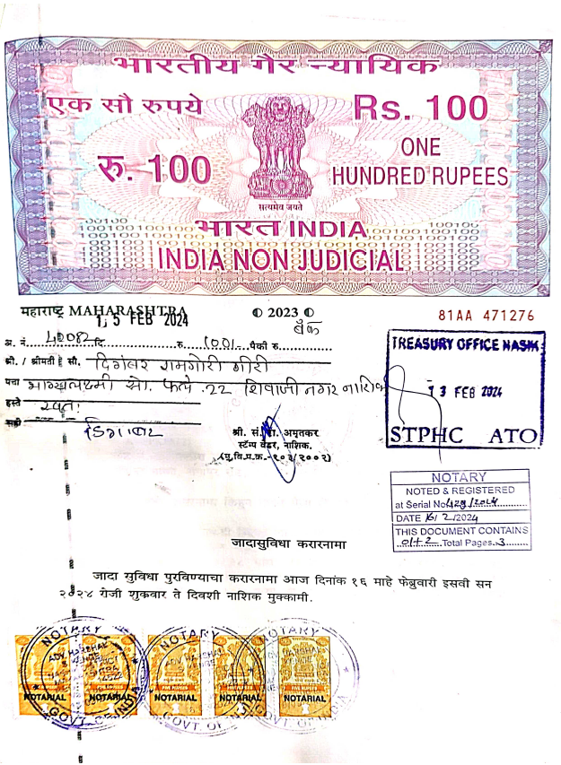
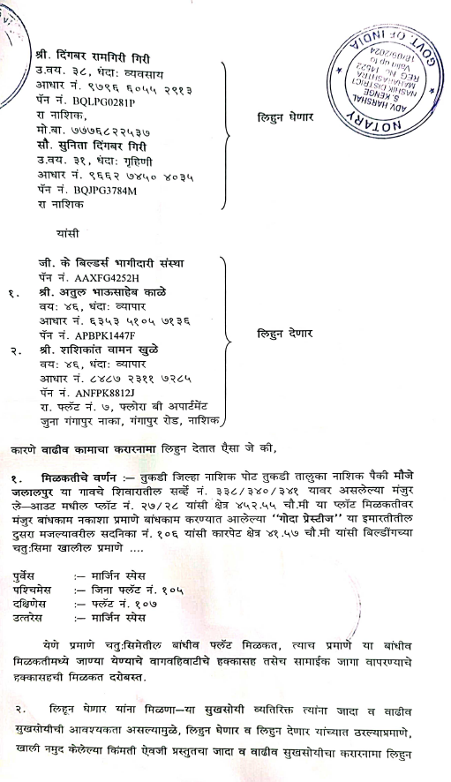

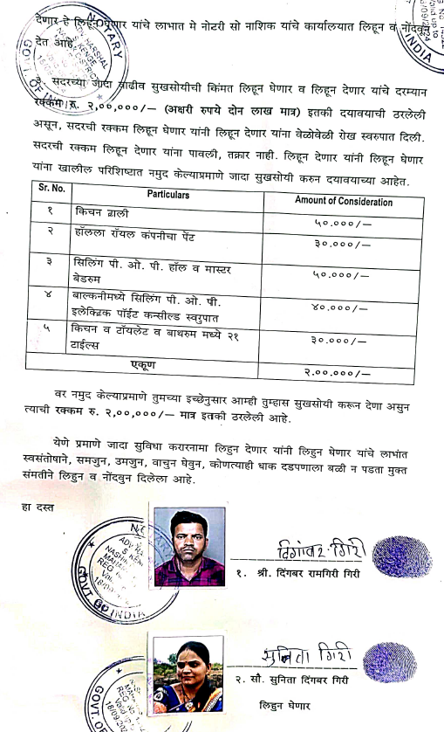
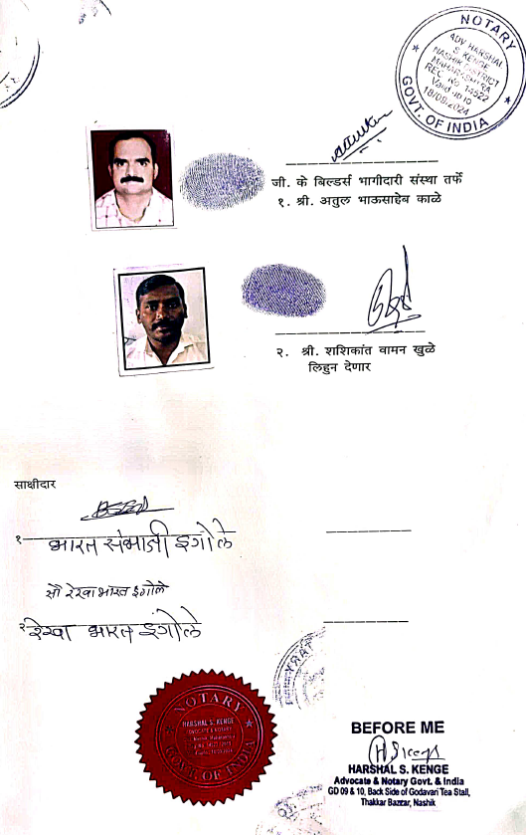

The Extra Work amount is Rs. 2,00,000/- (Rupees Two Lakh Only)

