Valuation Report of the Immovable Property

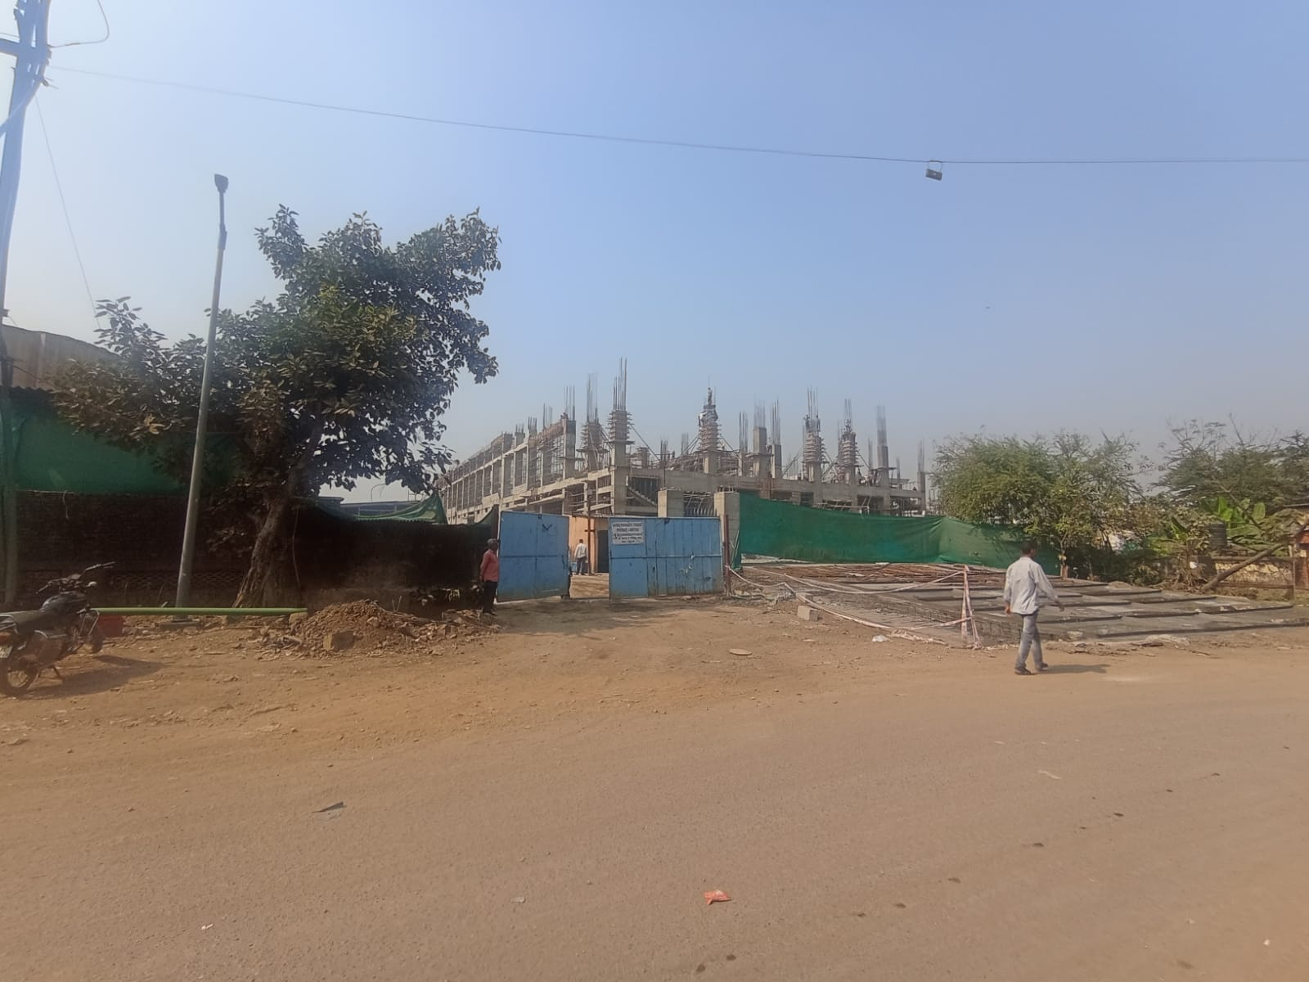

Details of the property under consideration:

Name of Owner: M/s. Gayatri Shakti Paper & Boards Ltd.

Industrial Open Land bearing Open Khata No. 445, Survey No. 127/P1, Village- Chhiri, Taluka-Vapi,
District - Valsad - 396 195, State- Gujarat, Country – India.

Latitude Longitude: 20°22'17.0"N 72°56'31.7"E

Valuation Done for:

Bank of India
Large Corporate Branch, Andheri (W)
Bank Of India Bldg., 1ST Floor, 28, S.V. Road, Andheri (West), Mumbai - 400058,
State - Maharashtra, Country - India

Vastukala Consultants (I) Pvt. Ltd.
Mumbai • Delhi NCR • Aurangabad • Nanded

Vastu/Thane/02/2024/7034/2305027
17/15-249-APU
Date: 17.02.2024

VALUATION OPINION REPORT

This is to certify that the property bearing Industrial Open Land bearing Open Khata No. 445, Survey No. 127/P1, Village- Chhiri, Taluka-Vapi, District - Valsad - 396 195, State- Gujarat, Country - India belongs to M/s. Gayatri Shakti Paper & Boards Ltd.
Boundaries of the property.

North | : | Huber Group India Pvt. Ltd.
South | : | Open Plot (Property of M/s. Gayatri Shakti Paper & Boards Ltd.)
East | : | Internal road
West | : | Huber Group India Pvt. Ltd.

Considering various parameters recorded, existing economic scenario, and the information that is available with reference to the development of neighborhood and method selected for valuation, we are of the opinion that, the property premises can be assessed and valued for purpose at ` 7,28,46,000.00 (Rupees Seven Crores Twenty-Eight Lakh Forty-Six Thousand Only).

The valuation of the property is based on the documents produced by the concern. Legal aspects have not been taken into considerations while preparing this valuation report.

Hence certified

Sharadkumar B. Chalikwar
Govt. Reg. Valuer
Chartered Engineer (India)
Reg. No. (N) CCIT/1-14/52/2008-09
Encl: Valuation report.

Vastukala Consultants (I) Pvt. Ltd.
121, 1st Floor, Ackruti Star, Central Road, MIDC, Andheri (E), Mumbai - 400 093

To,
The Branch Manager,
Bank of India
Large Corporate Branch, Andheri (W)
Bank Of India Bldg., 1ST Floor,
28, S.V. Road, Andheri (West), Mumbai - 400058,
State - Maharashtra, Country - India

VALUATION REPORT (IN RESPECT OF OPEN INDUSTRIAL LAND)
I | General
1. | Purpose for which the valuation is made |  |  | : | As per the request from Bank of India, Large Corporate Branch, Andheri (W) to assess fair market value of the property for banking loan purpose.
2. | a) | Date of inspection |  | : | 20.01.2024
 | b) | Date on which the valuation is made |  | : | 17.02.2024
3. | List of documents produced for perusal |  |  | :
- Sale deed dated 16.04.2012 between M/s. Payal Properties Pvt. Ltd. (Seller) and M/s. Gayatri Shakti Paper & Boards Ltd.
- Title Clearance Certificate dated 08.11.2017 issued by Charu Bhatt, Advocate.
4. | Name of the owner(s) and his / their address (es) with Phone no. (details of share of each owner in case of joint ownership) |  |  | : | M/s. Gayatri Shakti Paper & Boards Ltd.  Address – Industrial Open Land bearing Open Khata No. 445, bearing Survey No. 127/P1, Village- Chhiri, Taluka-Vapi, District - Valsad - 396 195, State- Gujarat, Country - India  Contact Person:  Mr. Samit Bose (DGM – DST Customs & License)  Contact No. 9723329964  Ltd. Company Ownership
5. | Brief description of the property (Including Leasehold / freehold etc.) |  |  | :
The property under valuation is freehold open land bearing No. Khata No. 445, Survey No. 127/P1 situated at Village- Chhiri. It is at about 4.6 kms. away from Vapi railway station. All the civic amenities are available nearby and within easy reach.

The plot demarcated by compound walls all around the periphery of the plot (i.e. brick masonry wall on West & North Side and Cable fencing on South & East Side).

As per Sale Deed and Title Clearance Certificate, the Plot area is 4,047.00 Sq. M. which is considered for valuation.
 | Location of property |  |  | :
 | a) |  | Plot No. / Survey No. | : | Khata No. 445, Survey No. 127/P1
 | b) |  | Door No. | : | N.A.
 | c) |  | T.S. No. / Village | : | Village – Chhiri
 | d) |  | Ward / Taluka | : | Taluka – Vapi
 | e) |  | Mandal / District | : | District – Valsad
7. | Postal address of the property |  |  | : | Industrial Open Land bearing Open Khata No. 445, Survey No. 127/P1, Village- Chhiri, Taluka-Vapi, District - Valsad - 396 195, State- Gujarat, Country - India
8. | City / Town |  |  | : | Valsad
 | Residential area |  |  | : | No
 | Commercial area |  |  | : | No
 | Industrial area |  |  | : | Yes
9. | Classification of the area |  |  | :
 | i) High / Middle / Poor |  |  | : | Middle Class
 | ii) Urban / Semi Urban / Rural |  |  | : | Rural
10. | Coming under Corporation limit / Village Panchayat / Municipality |  |  | : | Village Panchayat
11. | Whether covered under any State / Central Govt. enactments (e.g., Urban Land Ceiling Act) or notified under agency area/ scheduled area / cantonment area |  |  | : | No
12. | In Case it is Agricultural land, any conversion to house site plots is contemplated |  |  | : | N.A.
13. | Boundaries of the property |  |  |  | As per Title Report | As per Site
 | North |  |  | : | By Bayer and Com. | Huber Group India Pvt. Ltd.
 | South |  |  | : | By Rishi Roop Polymers (Plot No. 1301) | Open Plot (Property of M/s. Gayatri Shakti Paper & Boards Ltd.)
 | East |  |  | : | By Huber Bayer (Formerly known as Mitsu Chemicals) | Internal road
 | West |  |  | : | By plot No. 808, D/508, C/10.00 mtrs. Green space and access Road. | Huber Group India Pvt. Ltd.
14.1 | Dimensions of the site |  |  |  | N. A. as the land is irregular in shape
 |  |  |  |  | A As per the Deed | B Actuals
 | North |  |  | : | - | -
 | South |  |  | : | - | -
 | East |  |  | : | - | -
 | West |  |  | : | - | -
14.2 | Latitude, Longitude & Co-ordinates of property |  |  | : | 20°22'17.0"N 72°56'31.7"E
15. | Extent of the site |  |  | : | As mentioned above
16. | Extent of the site considered for Valuation (least of 14A& 14B) |  |  | : | As mentioned above
17. | Whether occupied by the owner / tenant? If occupied by tenant since how long? Rent received per month. |  |  | : | Plot of land in the possession of owner.
II | CHARACTERSTICS OF THE SITE
 | Classification of locality |  |  | : | Located in Middle class locality
 | Development of surrounding areas |  |  | : | Industrial development
 | Possibility of frequent flooding/ sub-merging |  |  | : | No
 | Feasibility to the Civic amenities like School, Hospital, Bus Stop, Market etc. |  |  | : | Available at Vapi.
 | Level of land with topographical conditions |  |  | : | Plain
 | Shape of land |  |  | : | Irregular
 | Type of use to which it can be put |  |  | : | For Industrial purpose
 | Any usage restriction |  |  | : | Industrial
 | Is plot in town planning approved layout? |  |  | : | Not applicable
 | Corner plot or intermittent plot? |  |  | : | Intermittent
 | Road facilities |  |  | : | Yes
 | Type of road available at present |  |  | : | B. T. Road
 | Width of road – is it below 20 ft. or more than 20 ft. |  |  | : | More than 20 ft
 | Is it a Land – Locked land? |  |  | : | No
 | Water potentiality |  |  | : | No
 | Underground sewerage system |  |  | : | No
 | Is Power supply is available in the site |  |  | : | No
 | Advantages of the site |  |  | : | Located in Industrial Area
 | Special remarks, if any like threat of acquisition of land for publics service purposes, road widening or applicability of CRZ provisions etc.(Distance from sea-cost / tidal level must be incorporated) |  |  | : | No
Part – A (Valuation of land)
1 | Size of plot |  |  | : | 4,047.00 Sq. M.  (As per Sale Deed & Title Report)
 | North & South |  |  | : | -
 | East & West |  |  | : | -
2 | Total extent of the plot |  |  | : | 4,047.00 Sq. M.  (As per Sale Deed & Title Report)
3 | Prevailing market rate ( Along With details / reference of at least two latest deals / transactions with respect to adjacent properties in the areas) |  |  | : | ` 17,000.00 to ` 19,000.00 per Sq. M. for land  Details of recent transactions/online listings are attached with the report.
4 | Jantri rate obtained from the Stamp Duty Ready Reckoner for land ( an evidence thereof to be enclosed) |  |  | : | ` 553.00 per Sq. M. for land (in Year 2011)
5 | Assessed / adopted rate of valuation |  |  | : | ` 18,000.00 per Sq. M.
6 | Estimated value of land |  |  | : | ` 7,28,46,000.00
Part – B (Valuation of Building)
1 | Technical details of the building |  |  | :
 | - Type of Building (Residential / Commercial / Industrial) |  |  | : | Not applicable being valuation of open plot of land only.
 | - Type of construction (Load bearing / RCC / Steel Framed) |  |  | : | Not applicable being valuation of open plot of land only.
 | - Year of construction |  |  | : | Not applicable being valuation of open plot of land only.
 | - Number of floors and height of each floor including basement, if any |  |  | : | Not applicable being valuation of open plot of land only.
 | - Plinth area floor-wise |  |  | : | Not applicable being valuation of open plot of land only.
 | - Condition of the building |  |  | : | Not applicable being valuation of open plot of land only.
 | - Exterior – Excellent, Good, Normal, Poor |  |  | : | Not applicable being valuation of open plot of land only.
 | - Interior – Excellent, Good, Normal, Poor |  |  | : | Not applicable being valuation of open plot of land only.
 | - Date of issue and validity of layout of approved map |  |  | : | Not applicable being valuation of open plot of land only.
 | - Approved map / plan issuing authority |  |  | : | Not applicable being valuation of open plot of land only.
 | - Whether genuineness or authenticity of approved map / plan is verified |  |  | : | Not applicable being valuation of open plot of land only.
 | - Any other comments by our empanelled valuers on authentic of approved plan |  |  | : | No

Specifications of construction (floor-wise) in respect of
Sr.  No. | Description
 | Foundation | : | Not applicable being valuation of open plot of land only.
 | Basement | : | Not applicable being valuation of open plot of land only.
 | Superstructure | : | Not applicable being valuation of open plot of land only.
 | Joinery / Doors & Windows (Please furnish details about size of frames, shutters, glazing, fitting etc. and specify the species of timber | : | Not applicable being valuation of open plot of land only.
 | RCC Works | : | Not applicable being valuation of open plot of land only.
 | Plastering | : | Not applicable being valuation of open plot of land only.
 | Flooring, Skirting, dado | : | Not applicable being valuation of open plot of land only.
 | Special finish as marble, granite, wooden paneling, grills etc. | : | Not applicable being valuation of open plot of land only.
 | Roofing including weather proof course | : | Not applicable being valuation of open plot of land only.
 | Drainage | : | Not applicable being valuation of open plot of land only.

2. | Compound Wall | :
 | Height | : | The plot demarcated by compound walls all around the periphery of the plot (i.e. brick masonry wall on West & North Side and Cable fencing on South & East Side).
 | Length | :
 | Type of construction | :
3. | Electrical installation | : | Not applicable being valuation of open plot of land only.
 | Type of wiring | : | -
 | Class of fittings (superior / ordinary / poor) | : | -
 | Number of light points | : | -
 | Fan points | : | -
 | Spare plug points | : | -
 | Any other item | : | -
4. | Plumbing installation |  | Not applicable being valuation of open plot of land only.
 | - No. of water closets and their type | : | -
 | - No. of wash basins | : | -
 | - No. of urinals | : | -
 | - No. of bath tubs | : | -
 | - Water meters, taps etc. | : | -
 | - Any other fixtures | : | -

Part – C (Extra Items) |  | : | Amount in `
 | Portico | : | Not applicable being valuation of open plot of land only.
 | Ornamental front door | :
 | Sit out / Verandah with steel grills | :
 | Overhead water tank | :
 | Extra steel / collapsible gates | :
 | Total
Part – D (Amenities) |  | : | Amount in `
 | Wardrobes | : | Not applicable being valuation of open plot of land only.
 | Glazed tiles | :
 | Extra sinks and bath tub | :
 | Marble / ceramic tiles flooring | :
 | Interior decorations | :
 | Architectural elevation works
 | Paneling works
 | Aluminum works
 | Aluminum hand rails
 | False ceiling
 | Total
Part – E (Miscellaneous) |  | : | Amount in `
 | Separate toilet room | : | Not applicable being valuation of open plot of land only.
 | Separate lumber room | :
 | Separate water tank / sump | :
 | Trees, gardening | :
 | Total
Part – F (Services) |  | : | Amount in `
 | Water supply arrangements | : | Not applicable being valuation of open plot of land only.
 | Drainage arrangements | :
 | Compound wall | :
 | C.B. deposits, fittings etc. | :
 | Pavement
 | Total

Total abstract of the entire property:-

Part – A | Land | : | ` 7,28,46,000.00
Part – B | Building | :
Part – C | Compound wall | :
Part - D | Amenities | :
Part – E | Pavement | :
Part – F | Services | :
 | Fair Market Value | : | ` 7,28,46,000.00
 | Realizable Value | : | ` 6,55,61,400.00
 | Distress Sale Value | : | ` 5,82,76,800.00
 | Insurable Value | : | -

Land cost can be estimated using the Sales Comparison Approach by studying recent sales of land close to the subject property, and these sales should be comparable in size and location with subject property.
As the property is an Industrial open land, we have adopted Sale Comparison approach for the purpose of valuation. The Price for similar type of property in the nearby vicinity is in the range of ` 17,000.00 to ` 19,000.00 per Sq. M. for land. Considering the rate with attached report, current market conditions, demand and supply position, Land size, location, upswing in real estate prices, sustained demand for Factory / Plot, all round development of commercial and industrial application in the locality etc. Land Rate of the said land is ` 18,000.00 per Sq. M. is considered for our valuation.
.
The saleability of the property is : Normal
Likely rental values in future in: Amount Rs. N.A.
Any likely income it may generate: Rental Income

Sharadkumar B. Chalikwar
Govt. Reg. Valuer
Chartered Engineer (India)
Reg. No. (N) CCIT/1-14/52/2008-09

Place : Mumbai
Date : 17.02.2024

Actual Site Photographs

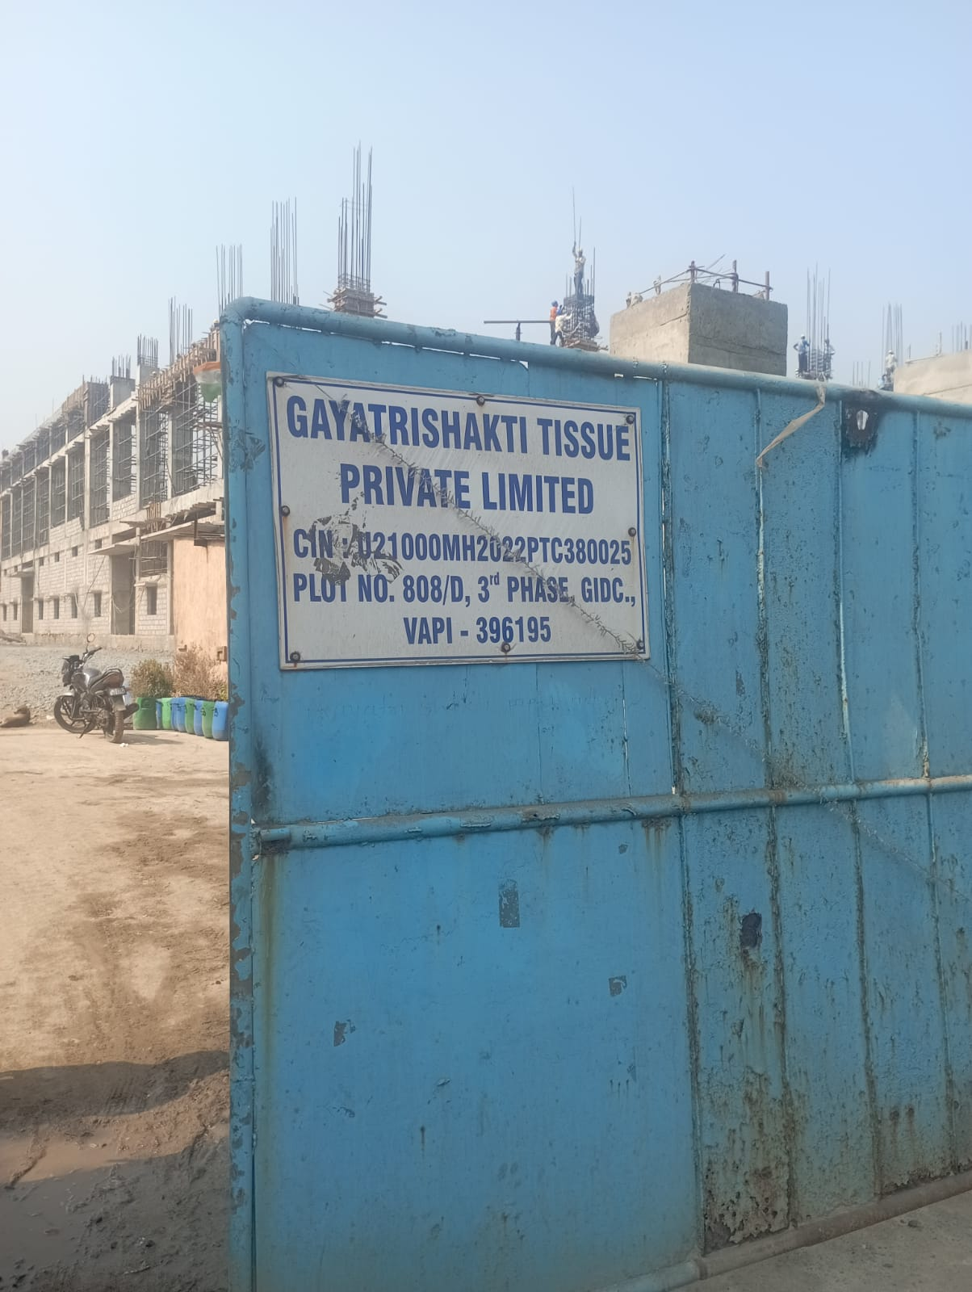
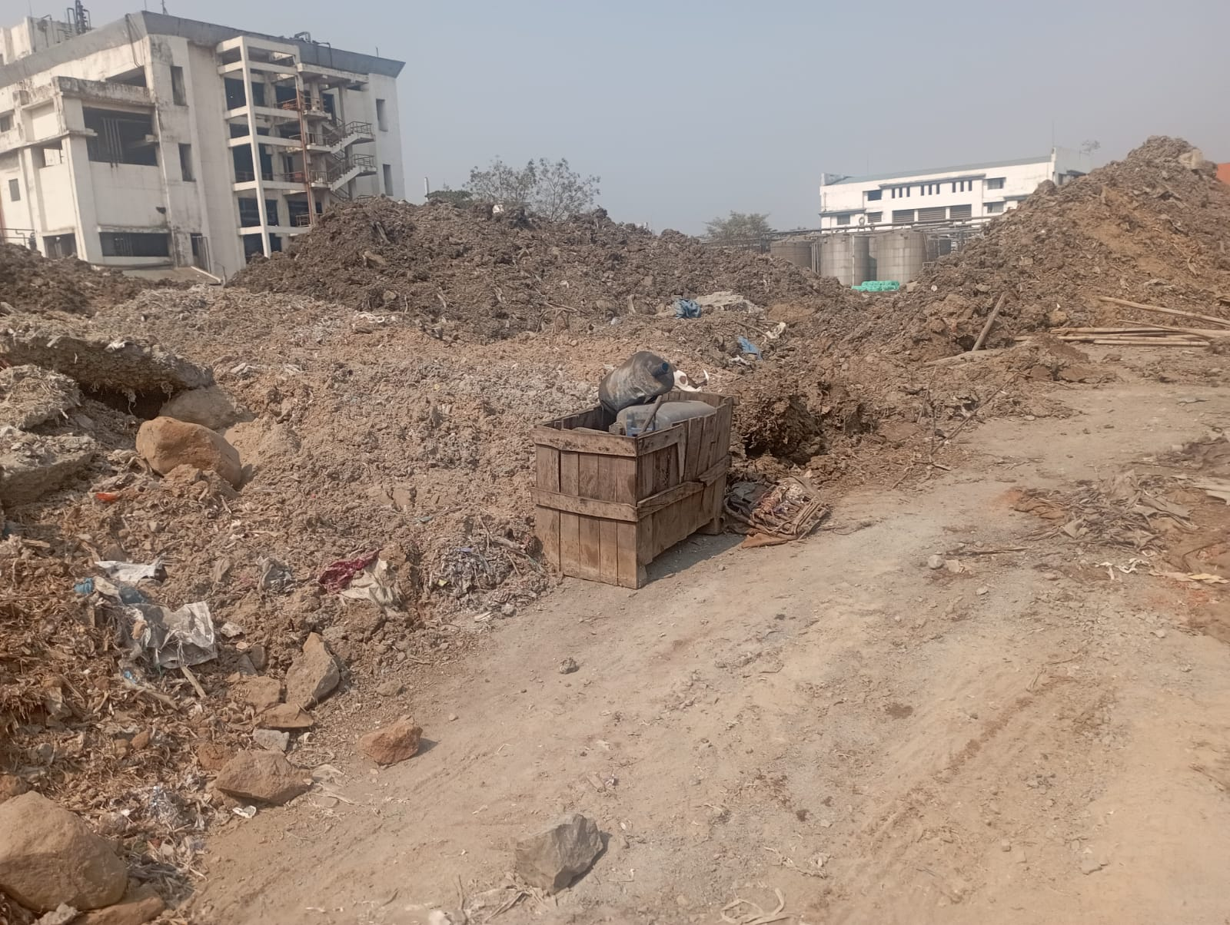
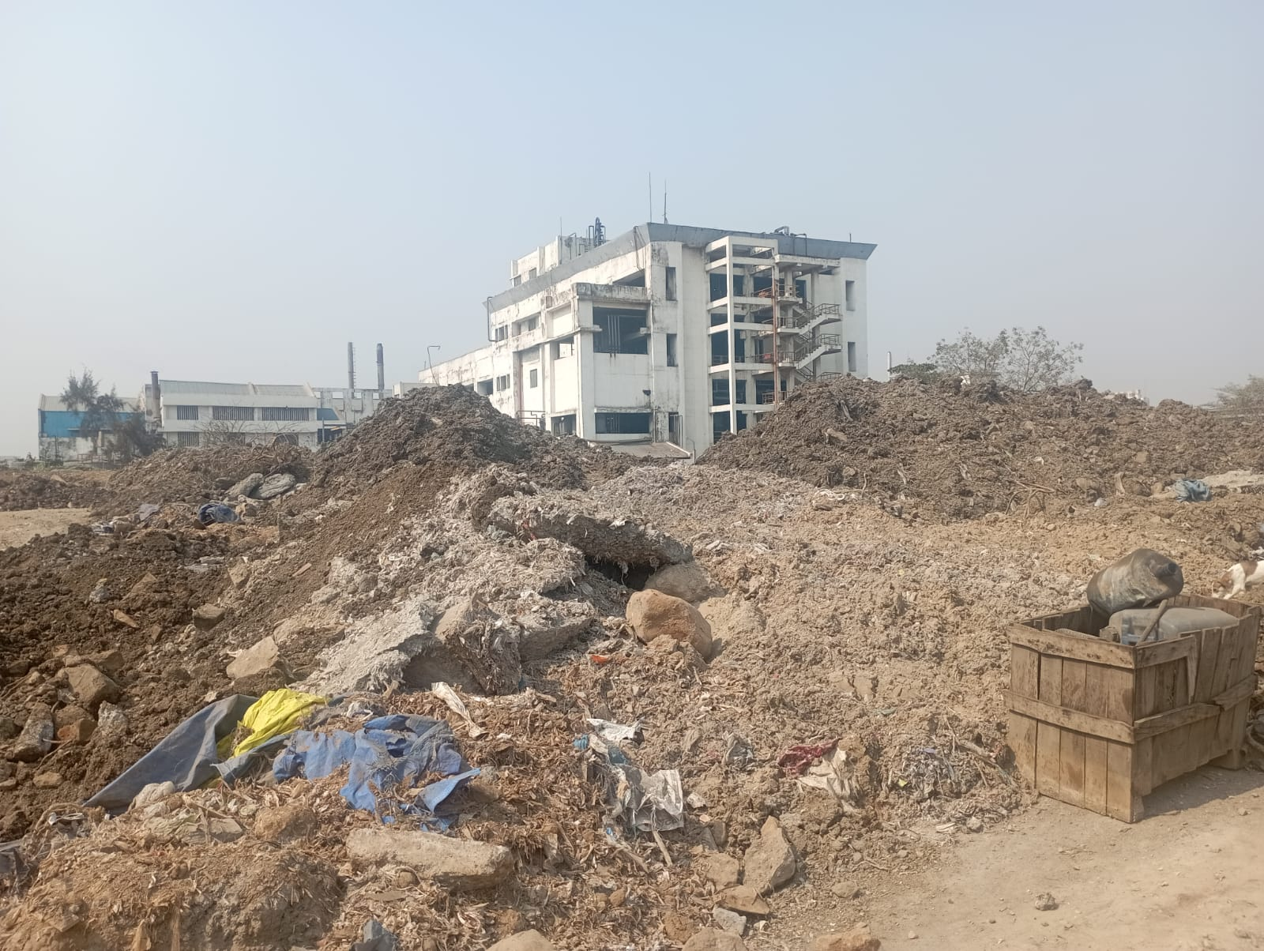
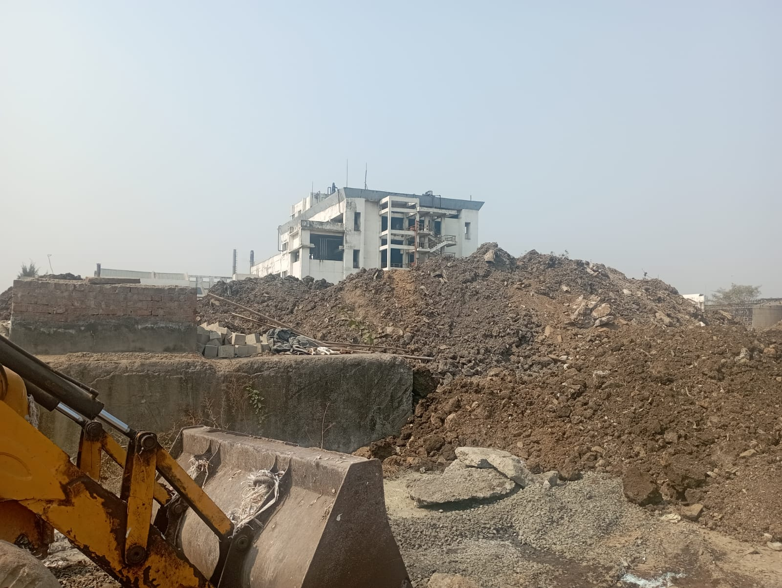
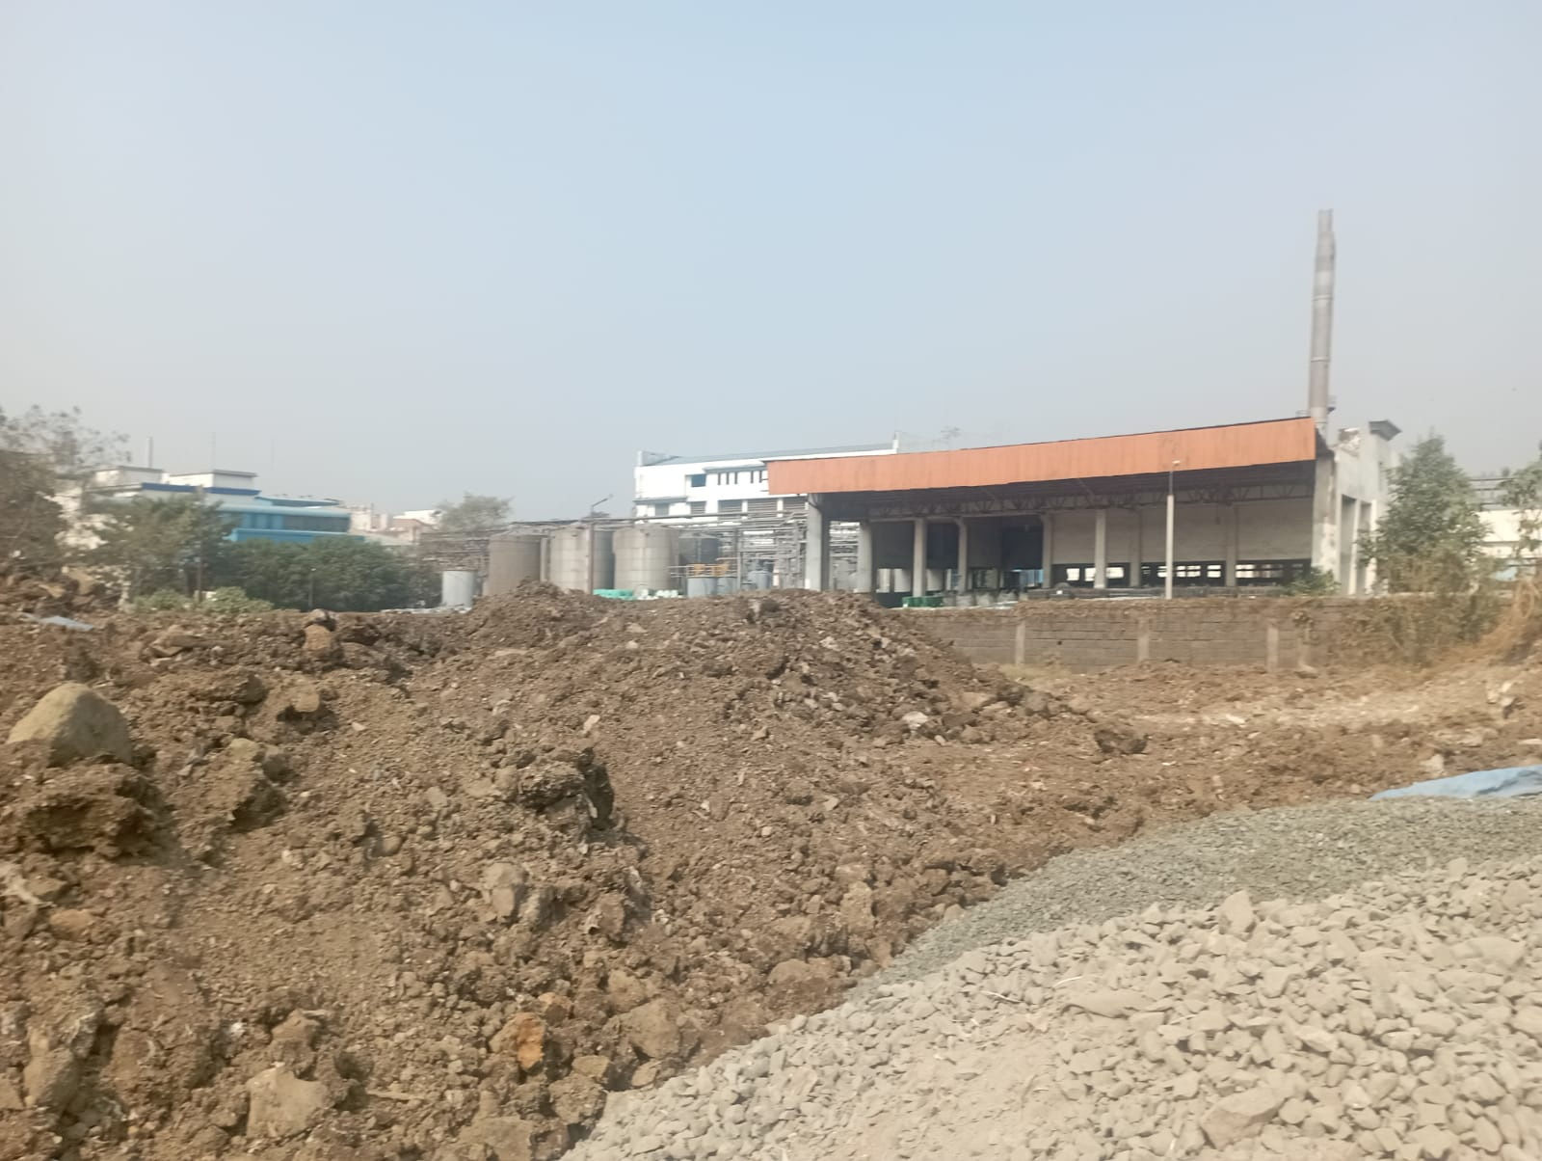
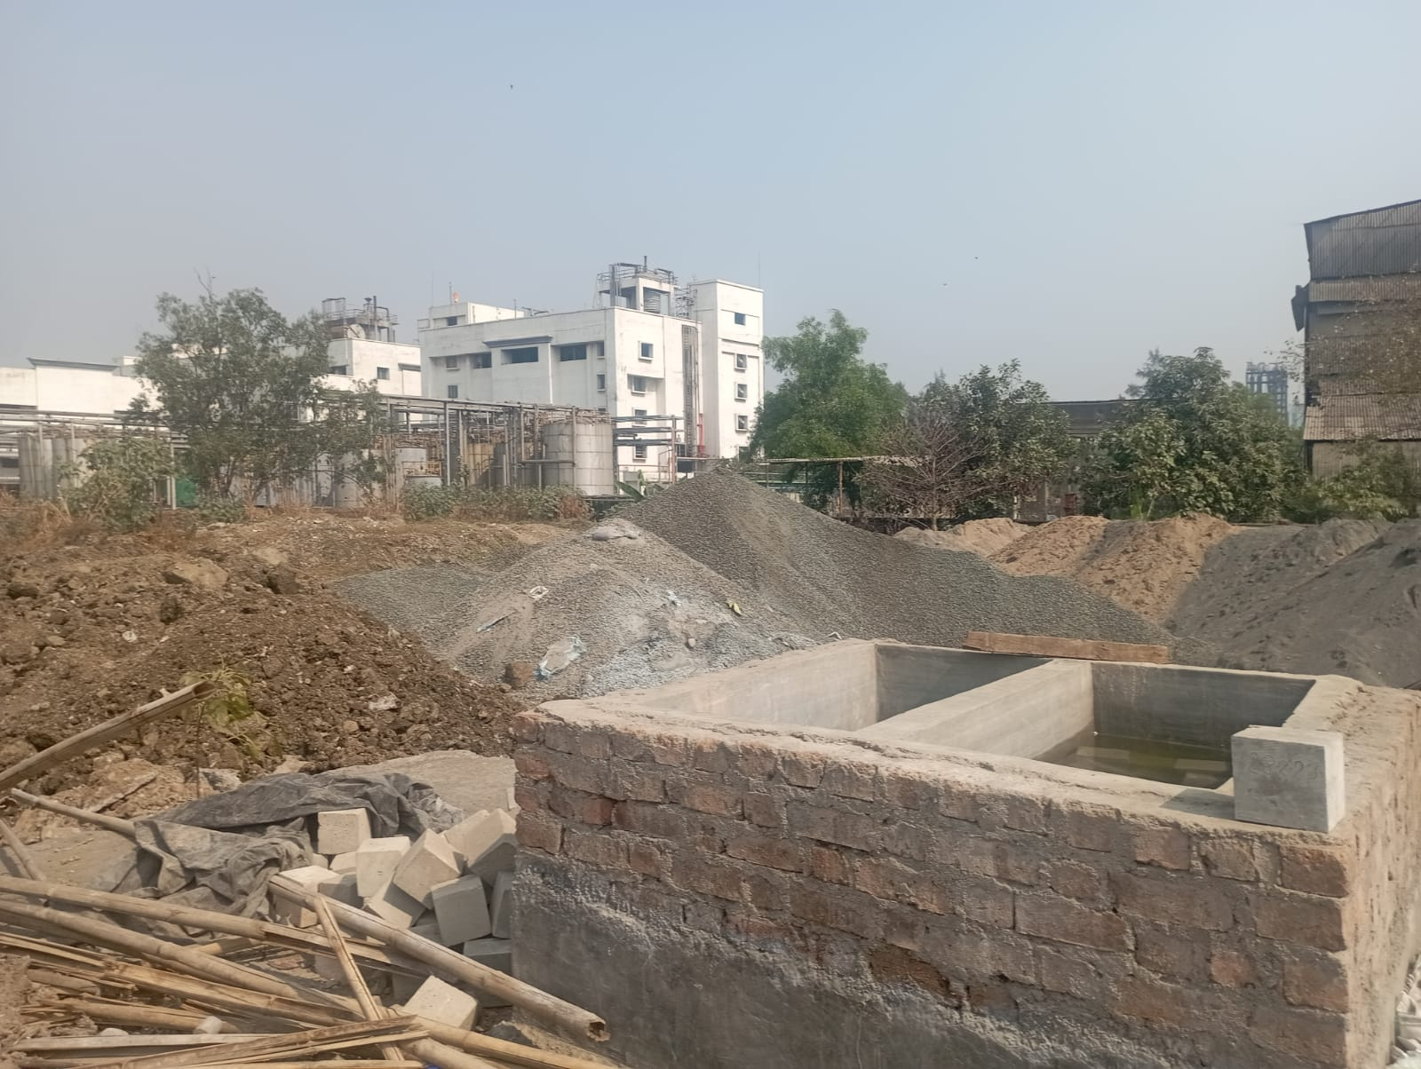
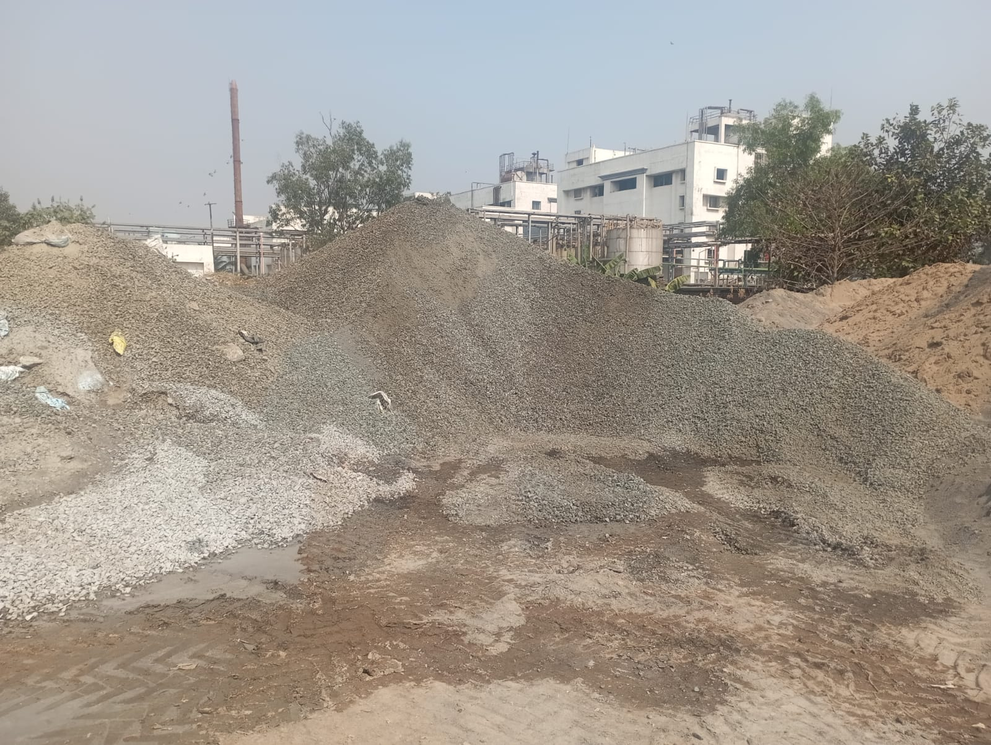
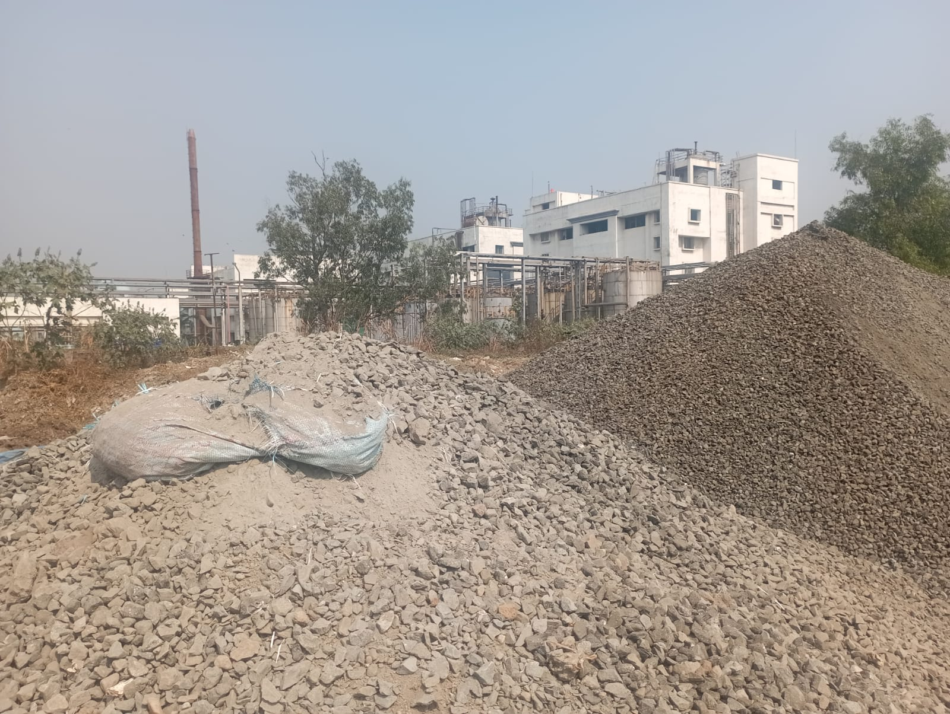
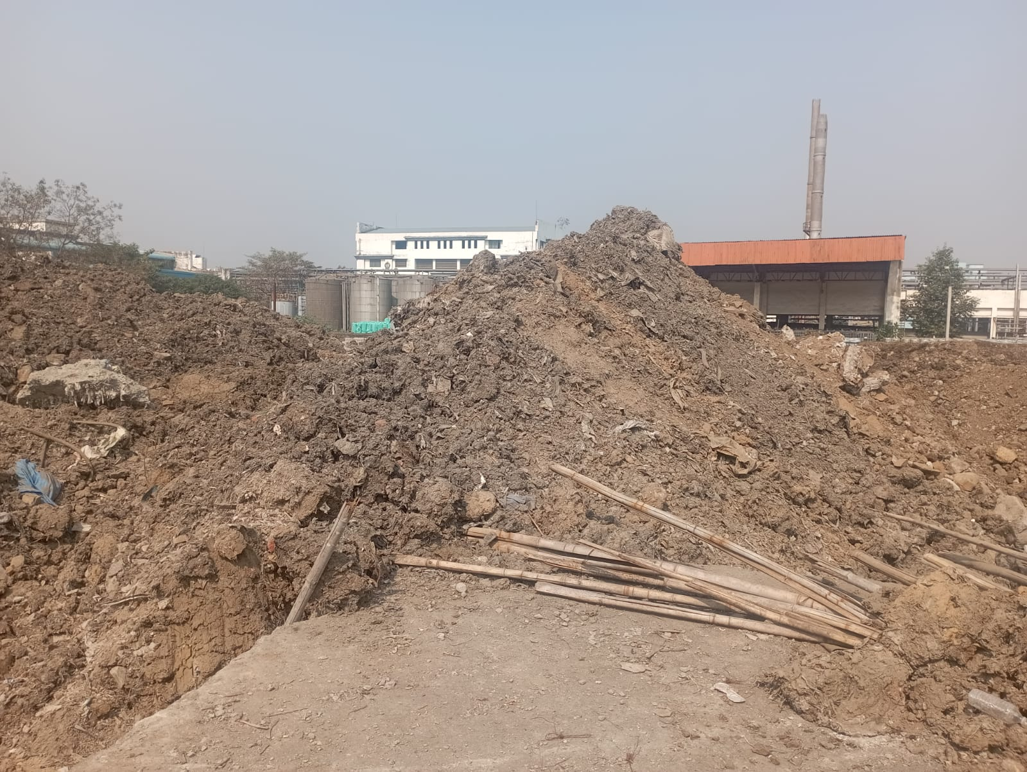
Route Map of the property
Site u/r

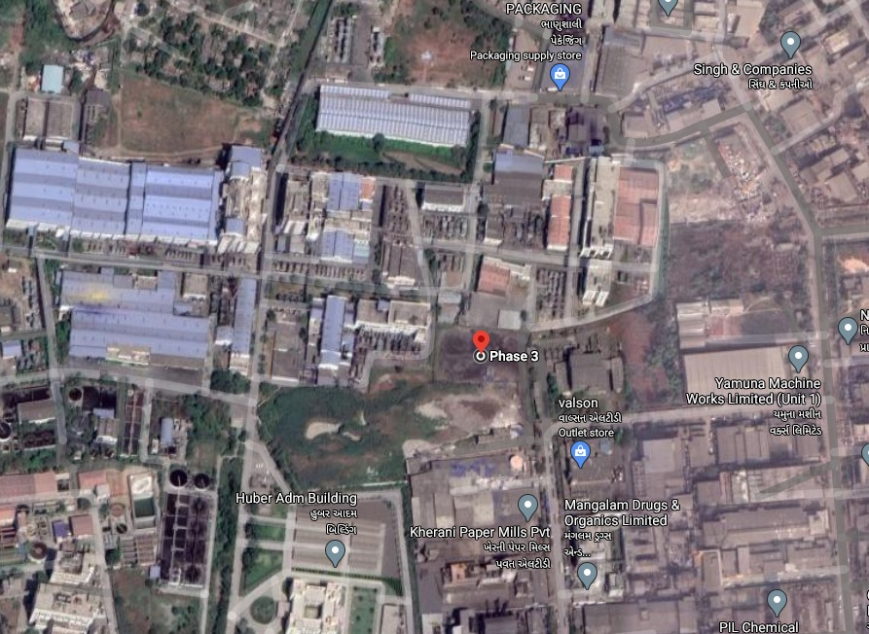

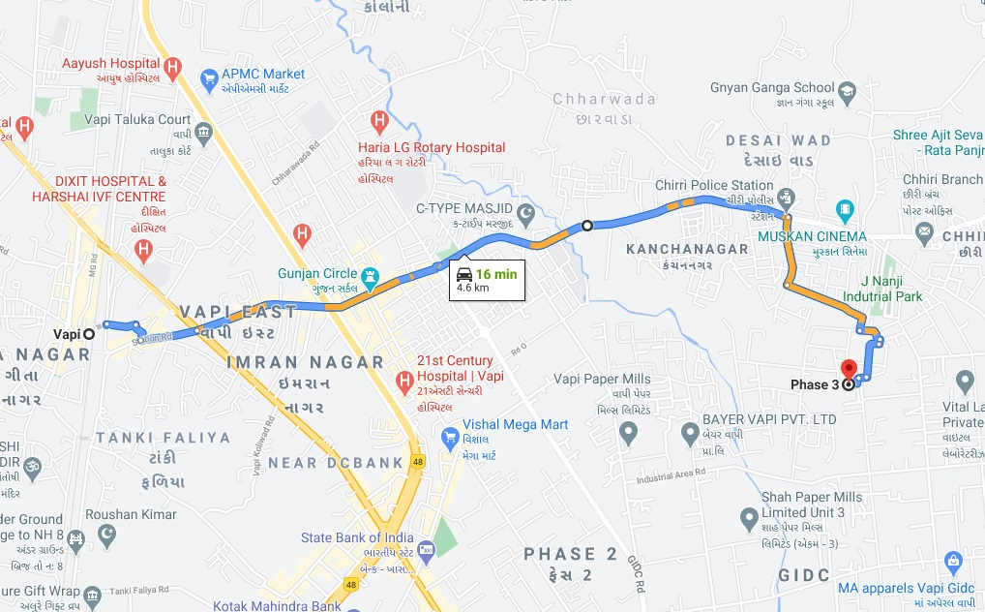

Longitude Latitude: 20°22'17.0"N 72°56'31.7"E
Note: The Blue line shows the route to site from nearest railway station (Vapi – 4.6 Km.)
GIDC Rate
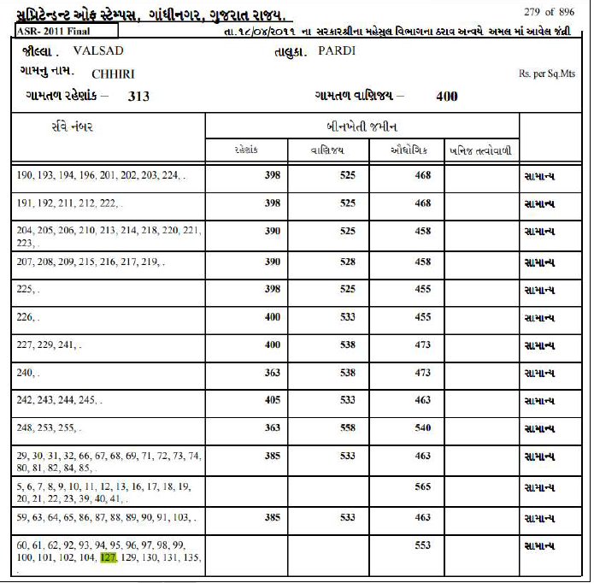

Price Indicators
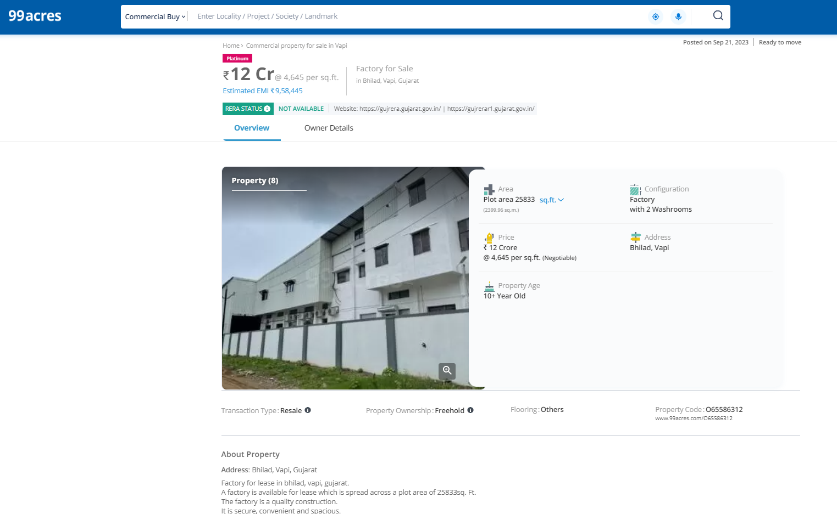
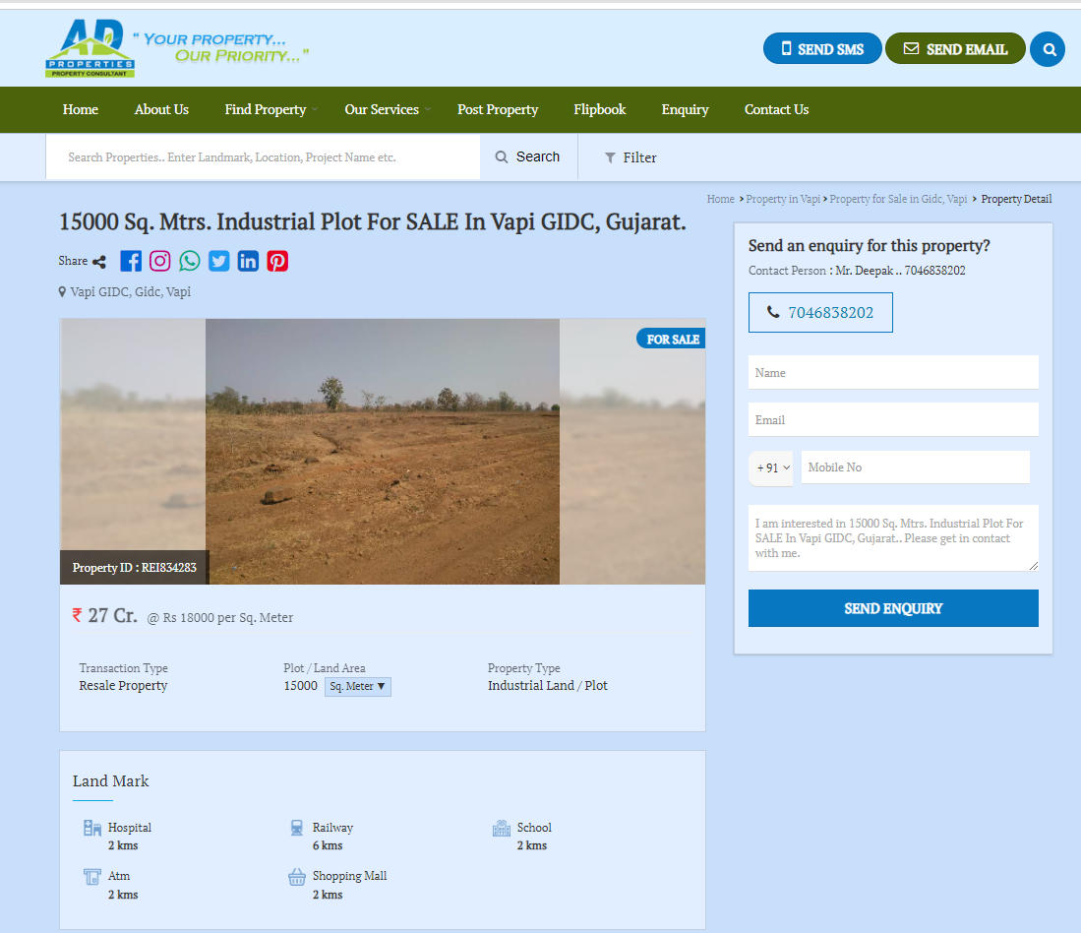
Price Indicators
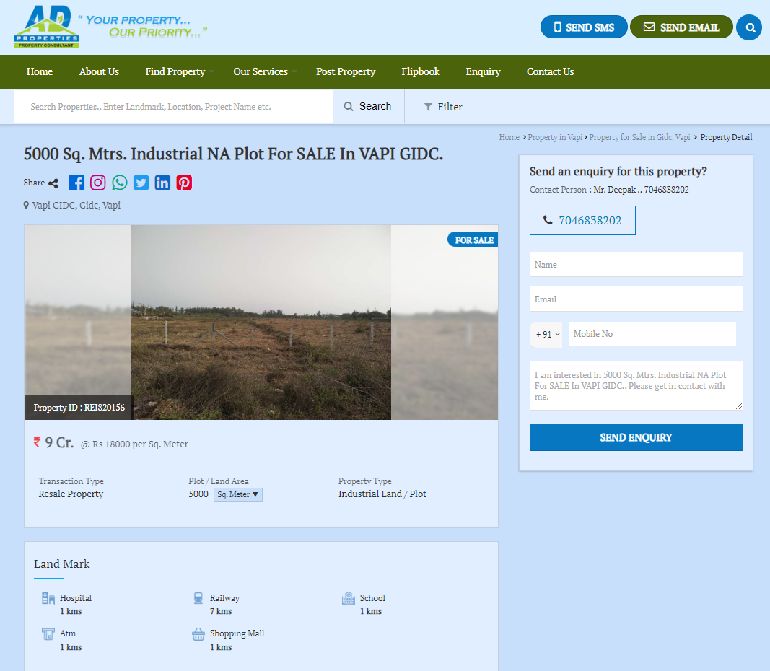

As a result of my appraisal and analysis, it is my considered opinion that the present fair market value of the above property in the prevailing condition with aforesaid specifications is ` 7,28,46,000.00 (Rupees Seven Crores Twenty-Eight Lakh Forty-Six Thousand Only). The Realizable Value of the above property is
` 6,55,61,400.00 (Six Crore Fifty-Five Lakh Sixty-One Thousand Four Hundred Fifty Only) and the distress value is ` 5,82,76,800.00 (Rupees Five Crores Eighty-Two Lakh Seventy-Six Thousand Eight Hundred Only).

Place : Mumbai
Date : 17.02.2024

Sharadkumar B. Chalikwar
Govt. Reg. Valuer
Chartered Engineer (India)
Reg. No. (N) CCIT/1-14/52/2008-09

The undersigned has inspected the property detailed in the Valuation Report dated _______________________

on ____________________. We are satisfied that the fair and reasonable market value of the property is

`_________________________ (Rupees ________________________________________________________

________________________________________only).

Date
Signature
(Name of the Branch Manager with Official seal)

Assumptions, Disclaimers, Limitations & Qualifications
Value Subject to Change
The subject appraisal exercise is based on prevailing market dynamics as on 17th February 2024 and does not take into account any unforeseeable developments which could impact the same in the future.
Our Investigations
We are not engaged to carry out all possible investigations in relation to the subject property. Where in our report we identify certain limitations to our investigations, this is to enable the reliant party to instruct further investigations where considered appropriate or where we recommend as necessary prior to reliance. Vastukala Consultants India Pvt. Ltd. (VCIPL) is not liable for any loss occasioned by a decision not to conduct further investigations
Assumptions
Assumptions are a necessary part of undertaking valuations. VCIPL adopts assumptions for the purpose of providing valuation advise because some matters are not capable of accurate calculations or fall outside the scope of our expertise, or out instructions. The reliant party accepts that the valuation contains certain specific assumptions and acknowledge and accept the risk of that if any of the assumptions adopted in the valuation are incorrect, then this may have an effect on the valuation.
Information Supplied by Others
The appraisal is based on the information provided by the client. The same has been assumed to be correct and has been used for appraisal exercise. Where it is stated in the report that another party has supplied information to VCIPL, this information is believed to be reliable but VCIPL can accept no responsibility if this should prove not to be so.
Future Matters
To the extent that the valuation includes any statement as to a future matter, that statement is provided as an estimate and/or opinion based on the information known to VCIPL at the date of this document. VCIPL does not warrant that such statements are accurate or correct.
Map and Plans
Any sketch, plan or map in this report is included to assist the reader while visualising the property and assume no responsibility in connection with such matters.
Site Details
Based on inputs received from Client's representative and site visit conducted, we understand that the subject property is owner occupied, contiguous and non-agricultural land parcel admeasuring 4,047.00 Sq. M. and is a freehold land in the name of M/s. Gayatri Shakti Paper & Boards Ltd. Further, VCIPL has assumed that the subject property is free from any encroachment and is available as on the date of the appraisal.

Property Title
Based on our discussion with the Client, we understand that the subject property is owned by
M/s. Gayatri Shakti Paper & Boards Ltd. For the purpose of this appraisal exercise, we have assumed that the subject property has a clear title and is free from any encumbrances, disputes and claims. VCIPL has made no further enquiries with the relevant local authorities in this regard and does not certify the property as having a clear and marketable title. Further, no legal advice regarding the title and ownership of the subject property has been obtained for the purpose of this appraisal exercise. It has been assumed that the title deeds are clear and marketable.
Environmental Conditions
We have assumed that the subject property is not contaminated and is not adversely affected by any existing or proposed environmental law and any processes which are carried out on the property are regulated by environmental legislation and are properly licensed by the appropriate authorities.
Town Planning
The permissible land use, zoning, achievable FSI, area statement adopted for purpose of this valuation is based on the information provided by the Client's representative and the same has been adopted for this valuation purpose. VCIPL has assumed the same to be correct and permissible. VCIPL has not validated the same from any authority.
Area
Based on the information provided by the Client's representative, we understand that the subject property is a owner occupied, contiguous and non-agricultural land parcel admeasuring 4,047.00 Sq. M.
Condition & Repair
In the absence of any information to the contrary, we have assumed that there are no abnormal ground conditions, nor archaeological remains present which might adversely affect the current or future occupation, development or value of the property. The property is free from rat, infestation, structural or latent defect. No currently known deleterious or hazardous materials or suspect techniques will be used in the construction of or subsequent alteration or additions to the property and comments made in the property details do not purport to express an opinion about, or advise upon, the condition of uninspected parts and should not be taken as making an implied representation or statement about such parts
Valuation Methodology
For the purpose of this valuation exercise, the valuation methodology used is Sale Comparison Approach Method and proposed Current use / Existing use premise is considered for this assignment.
The Direct Comparison Approach involves a comparison of the property being valued to similar properties that have actually been sold in arms - length transactions or are offered for sale. This approach demonstrates what buyers have historically been willing to pay (and sellers willing to accept) for similar properties in an open and competitive market and is particularly useful in estimating the value of the land and properties that are typically traded on a unit basis.
In case of inadequate recent transaction activity in the subject micro-market, the appraiser would collate details of older transactions. Subsequently, the appraiser would analyse rental / capital value trends in the subject micro-market in order to calculate the percentage increase / decrease in values since the date of the identified transactions. This percentage would then be adopted to project the current value of the same.
Where reliance has been placed upon external sources of information in applying the valuation methodologies, unless otherwise specifically instructed by Client and/or stated in the valuation, VCIPL has not independently verified that information and VCIPL does not advise nor accept it as reliable. The person or entity to whom the report is addressed acknowledges and accepts the risk that if any of the unverified information in the valuation is incorrect, then this may have an effect on the valuation.
Not a Structural Survey
We state that this is a valuation report and not a structural survey
Other
All measurements, areas and ages quoted in our report are approximate
Legal
We have not made any allowances with respect to any existing or proposed local legislation relating to taxation on realization of the sale value of the subject property. VCIPL is not required to give testimony or to appear in court by reason of this appraisal report, with reference to the property in question, unless arrangement has been made thereof. Further, no legal advice on any aspects has been obtained for the purpose of this appraisal exercise
Property specific assumptions
Based on inputs received from the client and site visit conducted, we understand that the subject property is currently owner occupied, contiguous and non-agricultural land parcel admeasuring approx. 4,047.00 Sq. M.

ASSUMPTIONS, CAVEATS, LIMITATION AND DISCLAIMERS
- We assume no responsibility for matters of legal nature affecting the property appraised or the title thereto, nor do we render our opinion as to the title, which is assumed to be good and marketable.
- The property is valued as though under responsible ownership.
- It is assumed that the property is free of liens and encumbrances.
- It is assumed that there are no hidden or unapparent conditions of the subsoil or structure that would render it more or less valuable. No responsibility is assumed for such conditions or for engineering that might be required to discover such factors.
- There is no direct/ indirect interest in the property valued.
- The rates for valuation of the property are in accordance with the Govt. approved rates and prevailing market rates

DEFINITION OF VALUE FOR THIS SPECIFIC PURPOSE

This exercise is to assess Fair Market Value of the property under reference as on 17th February 2024.

The term Fair Market Value is defined as

“The most probable price, as of a specified date, in cash, terms equivalent to cash, or in other precisely revealed terms for which the specified property rights would sell after reasonable exposure in a competitive market under all conditions requisite to a fair sale, with the buyer and seller each acting prudently knowledgeably and for self interest assuming that neither is under undue duress”.

Fundamental assumptions and conditions presumed in this definition are:

1. Buyer and seller are motivated by self-interest.
2. Buyer and seller are well informed and are acting prudently.
3. The property is exposed for a reasonable time on the open market.
4. Payment is made in cash or equivalent or in specified financing terms.
DECLARATION OF PROFESSIONAL FEES CHARGED

We hereby declare that, our professional fees are not contingent upon the valuation findings. However, if the statute AND/OR clients demands that, the fees should be charged on the percentage of assessed value then, with the full knowledge of the AND/OR end user, it is being charged accordingly.

VALUATION OF THE PROPERTY PREMISES

Considering various parameters recorded, existing economic scenario, and the information that is available with reference to the development of neighborhood and method selected for valuation, we are of the opinion that, the property premises can be assessed and valued for purpose at ` 7,28,46,000.00 (Rupees Seven Crores Twenty-Eight Lakh Forty-Six Thousand Only).

Sharadkumar B. Chalikwar
Govt. Reg. Valuer
Chartered Engineer (India)
Reg. No. (N) CCIT/1-14/52/2008-09

