Valuation Report of the Immovable Property

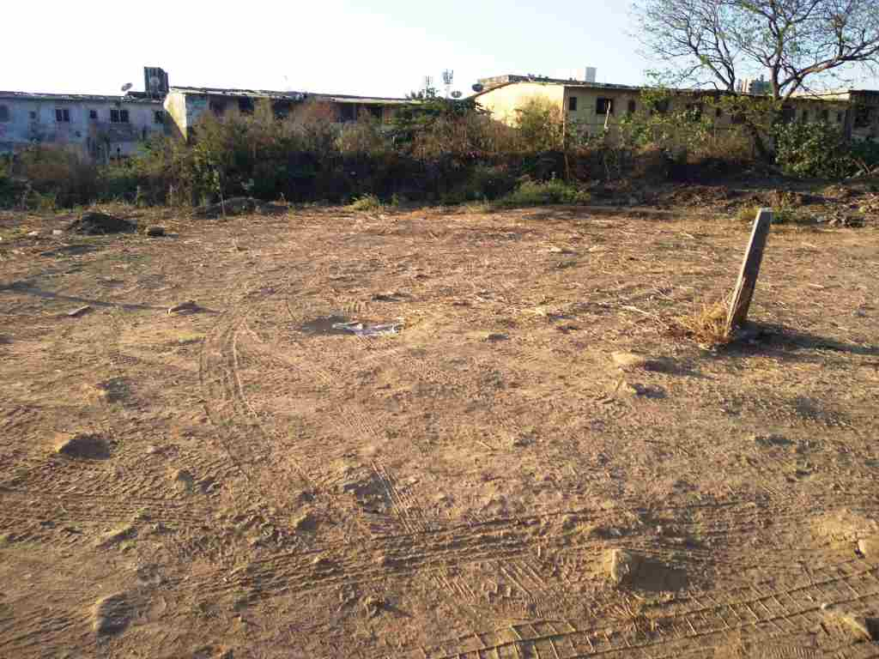

**Details of the property under consideration:**

Name of Owner: **Mr. Rahul Siddharth Waghmare (Proprietor of M/s. Siddhartha Enterprises)**

Industrial Plot No. KAC - 64, **T.T.C. Industrial Area**, M.I.D.C., Village – Kalwa & Dighe, Navi Mumbai, Taluka & District -Thane, State - Maharashtra, Country – India

# Latitude Longitude - 19°10'53.5"N 72°59'31.2"E

# 

**Valuation Done for:**

**Cosmos Bank**

# Ghodbandar Road Branch

# Shop No. 4, Cosmos Heritage, Tikujini Wadi, Off Ghodbandar Road, Manpada, Thane (West), PIN - 400 610,

# State – Maharashtra, Country – India

Vastu/Mumbai/02/2024/6980/2305084

21/22-306 -JABS Date: 21.02.2024

# VALUATION OPINION REPORT

The property Industrial Plot No. KAC - 64, **T.T.C. Industrial Area**, M.I.D.C., Village – Kalwa & Dighe, Navi Mumbai, Taluka & District -Thane, State - Maharashtra, Country – India belongs to **Mr. Rahul Siddharth Waghmare (Proprietor of M/s. Siddhartha Enterprises).**

**Boundaries of the property.**

|  |  |  |  |
| --- | --- | --- | --- |
| **Building** | : | **As per actual site** | **As per Documents** |
| North | : | 30 mtrs. Road | Nalla |
| South | : | MIDC Nalla | Road (R/W 12 Meters) |
| East | : | Plot No. KAC-63, Mahanagar Plot No. B-69 | Plot No. KAC-63 |
| West | : | Open Plot No. OS-5 | Plot No. OS-5 |

Considering various parameters recorded, existing economic scenario, and the information that is available with reference to the development of neighborhood and method selected for valuation, we are of the opinion that, the property premises can be assessed and valued for banking purpose for –

|  |  |  |  |
| --- | --- | --- | --- |
| **Particulars** | **Fair Market Value In (₹)** | **Realizable Value In (₹)** | **Distress Sale Value In (₹)** |
| Industrial Plot | 57,50,000.00 | 51,75,000.00 | 46,00,000.00 |

The valuation of the property is based on the documents produced by the concern. Legal aspects have not been taken into considerations while preparing this valuation report.

Hence certified

## Manoj B. Chalikwar

## Registered Valuer

## Chartered Engineer (India)

## Reg. No. CAT-I-F-1763

## Cosmos Emp. No. H.O./Credit/67/2019-20

Encl. Valuation Report

Valuation Report of Industrial Plot No. KAC - 64, **T.T.C. Industrial Area**, M.I.D.C., Village – Kalwa & Dighe, Navi Mumbai, Taluka & District -Thane, State – Maharashtra, Country – India.

*Form 0-1*

*(See Rule 8 D)*

REPORT OF VALUATION OF IMMOVABLE PROPERTY (OTHER THAN AGRICULTURAL LANDS, PLANTATIONS, FORESTS, MINES AND QUARRIES)

GENERAL:

|  |  |  |  |
| --- | --- | --- | --- |
| 1 | Purpose for which the valuation is made | | To assess the Fair Market Value as on 21.02.2024 for Bank Loan Purpose |
| 2 | Date of inspection | | 19.02.2024 |
|  | Name of the owner/ owners | | **Mr. Rahul Siddharth Waghmare**  **(Proprietor of M/s. Siddhartha Enterprises)** |
| 4 | If the property is under joint ownership / co-ownership, share of each such owner. Are the shares undivided? | | Company Ownership |
| 5 | Brief description of the property | | **Address:** Industrial Plot No. KAC - 64, **T.T.C. Industrial Area**, M.I.D.C., Village – Kalwa & Dighe, Navi Mumbai, Taluka & District -Thane, State – Maharashtra, Country – India.  **Contact Person:**  Mr. Rahul (Owner’s Representative)  Contact No. +91 9702815241 |
| 6 | Location, street, ward no | | Industrial Plot No. KAC - 64, **T.T.C. Industrial Area**, M.I.D.C., Village – Kalwa & Dighe, Navi Mumbai, Taluka & District -Thane |
| 7 | Survey/ Plot no. of land | | Industrial Plot No. KAC - 64 |
| 8 | Is the property situated in residential/ commercial/ mixed area/ industrial area? | | Industrial Area |
| 9 | Classification of locality-high class/ middle class/poor class | | Middle Class |
| 10 | Proximity to civic amenities like schools, Hospitals, Offices, market, cinemas etc. | | All the amenities are available in the vicinity |
| 11 | Means and proximity to surface communication by which the locality is served | | Served by Buses, Taxies, Auto and Private cars |
|  | *LAND* | |  |
| 12 | Area of land supported by documentary proof. Shape, dimension and physical features | | Land Area – 100.00 Sq. M.  (Area as per Agreement) |
| 13 | Roads, Streets or lanes on which the land is abutting | | Airoli Knowledge Park Road / Mugalsan Road |
| 14 | If freehold or leasehold land | | Leasehold Land of MIDC |
| 15 | If leasehold, the name of Lessor/lessee, nature of lease, date of commencement and termination of lease and terms of renewal of lease. | | Lease period – 95 years commencing from 02.01.2023  Lease Amount of Consideration – information not available  Lease Rent – Yearly rent Rs.1/- |
| (i) Initial premium | |
| (ii) Ground rent payable per annum | |
| (iii) Unearned increase payable to the Lessor in the event of sale or transfer | |
| 16 | Is there any restriction covenant in regard to use of land? If so attach a copy of the covenant. | | Industrial |
| 17 | Are there any agreements of easements? If so, attach a copy of the covenant | | Information not available |
| 18 | Does the land fall in an area included in any Town Planning Scheme or any Development Plan of Government or any statutory body? If so, give Particulars. | | Coming under M.I.D.C. layout |
| 19 | Has any contribution been made towards development or is any demand for such contribution still outstanding? | | Information not available |
| 20 | Has the whole or part of the land been notified for acquisition by government or any statutory body? Give date of the notification. | | No |
| 21 | Attach a dimensioned site plan | | Not applicable, being valuation of open plot only |
|  | *IMPROVEMENT* | |  |
| 22 | Attach plans and elevations of all structures standing on the land and a lay-out plan. | | Not applicable, being valuation of open plot only |
| 23 | Furnish technical details of the building on a separate sheet (The Annexure to this form may be used) | | Not applicable, being valuation of open plot only |
| 24 | Is the building owner occupied/tenanted/both? | | Open plot in the name of Mr. Rahul Siddharth Waghmare (Proprietor of M/s. Siddhartha Enterprises). |
|  | If the property owner occupied, specify portion and extent of area under owner-occupation | | N.A. |
| 25 | What is the Floor Space Index permissible and Percentage actually utilized? | | N.A. |
| 26 | *RENTS* | |  |
|  | (i) | Names of tenants/ lessees/ licensees, etc. | N.A. |
|  | (ii) | Portions in their occupation | N.A. |
|  | (iii) | Monthly or annual rent/ compensation / license fee, etc. paid by each | N.A. |
|  | (iv) | Gross amount received for the whole property | N.A. |
| 27 | Are any of the occupants related to, or close to business associates of the owner? | | N. A. |
| 28 | Is separate amount being recovered for the use of fixtures, like fans, geysers, refrigerators, cooking ranges, built-in wardrobes, etc. or for services charges? If so, give details | | N. A. |
| 29 | Give details of the water and electricity charges, if any, to be borne by the owner | | N. A. |
| 30 | Has the tenant to bear the whole or part of the cost repairs and maintenance? Give particulars | | N. A. |
| 31 | If a lift is installed, who is to bear the cost of maintenance and operation- owner or tenant? | | N. A. |
| 32 | If a pump is installed, who is to bear the cost of maintenance and operation- owner or tenant? | | N. A. |
| 33 | Who has to bear the cost of electricity charges for lighting of common space like entrance hall, stairs, passage, compound, etc. owner or tenant? | | N. A. |
| 34 | What is the amount of property tax? Who is to bear it? Give details with documentary proof | | N. A. |
| 35 | Is the building insured? If so, give the policy no., amount for which it is insured and the annual premium | | N. A. |
| 36 | Is any dispute between landlord and tenant regarding rent pending in a court of rent? | | N. A. |
| 37 | Has any standard rent been fixed for the premises under any law relating to the control of rent? | | N. A. |
|  | *SALES* | |  |
| 38 | Give instances of sales of immovable property in the locality on a separate sheet, indicating the Name and address of the property, registration No., sale price and area of land sold. | | As per sub registrar of assurance records |
| 39 | Land rate adopted in this valuation | | ` 57,500.00 per Sq. M. |
| 40 | If sale instances are not available or not relied up on, the basis of arriving at the land rate | | Online Price Indicators, Location, development of surrounding area, type of land and construction, construction specifications, age of building, condition of the premises & building, facilities provided and its prevailing market rate. |
|  | *COST OF CONSTRUCTION* | |  |
| 41 | Year of commencement of construction and year of completion | | N.A. |
| 42 | What was the method of construction, by contract / By employing Labour directly / both? | | N.A. |
| 43 | For items of work done on contract, produce copies of agreements | | N.A. |
| 44 | For items of work done by engaging Labour directly, give basic rates of materials and Labour supported by documentary proof. | | N.A. |
|  | **Remark**: | | |

*PART II- VALUATION*

GENERAL:

Under the instruction of Cosmos Bank, Ghodbandar Road Branch to assess fair market value as on 21.02.2024 for Industrial Plot No. KAC - 64, **T.T.C. Industrial Area**, M.I.D.C., Village – Kalwa & Dighe, Navi Mumbai, Taluka & District -Thane, State – Maharashtra, Country – India belongs to **Mr. Rahul Siddharth Waghmare (Proprietor of M/s. Siddhartha Enterprises).**

**We are in receipt of the following documents:**

|  |  |
| --- | --- |
| 1 | Copy of Agreement dated 09.05.2023 between Maharashtra Industrial Development Corporation (the Grantor) AND Mr. Rahul Siddharth Waghmare, trading as a Proprietor in the name of M/s. Siddhartha Enterprises (the Licensee) |
| 2 | Copy of Letter No. MIDC / RO / Mahape / TTC / KAC-64 / 5327 dated 09.05.2023 regarding Execution of Agreement to Lease of Plot NO. KAC-64 from TTC Industrial Area in the name of Mr. Rahul Siddharth Waghmare (Proprietor of M/s. Siddhartha Enterprises) issued by MIDC. |

**LOCATION:**

The said property is located at **T.T.C. Industrial Area**, M.I.D.C., Village – Kalwa & Dighe, Navi Mumbai, Taluka & District -Thane. The property falls in Industrial Zone. It is at a travelling distance of 950. travelling distance from Digha Gaon railway station.

**Valuation as on 21st February 2024:**

1. **Land Valuation:**

|  |  |  |  |
| --- | --- | --- | --- |
| **Fair Market Value** |  | | |
| A) Plot | **Area in Sq. M.** | **Rate in `** | **Fair Market Value in `** |
| 100.00 | 57,500/- | **57,50,000/-** |

1. **Valuation of Structures.**

The Built-up area of the building : **Not applicable, being valuation of open plot only**

**Deduct Depreciation:**

Year of Construction of the building : N.A.

Expected total life of building : N.A.

Age of the building as on 2024 : N.A.

Cost of Construction : N.A.

Depreciation : N.A.

Amount of depreciation : N.A.

**Depreciated cost of construction** : N.A.

**Government Value:**

|  |  |  |  |
| --- | --- | --- | --- |
| **Particulars** | **Area in Sq. M.** | **Rate in `** | **Value in `** |
| Plot | 100.00 | 25,108/- | 25,10,800/- |
| **Total** |  |  | **25,10,800/-** |

**TOTAL VALUE OF THE PROPERTY:**

|  |  |
| --- | --- |
| **Particulars** | **Value (`)** |
| **Land** | 57,50,000.00 |
| **Land Development** | - |
| **Building** | - |
| **Fair Market Value** | **57,50,000.00** |
| **Realizable Value** | **51,75,000.00** |
| **Distress Sale Value** | **46,00,000.00** |
| **Insurable value**  **(Depreciated Cost of Construction** | **-** |

Taking into consideration above said facts, we can evaluate the value of Industrial Plot No. KAC - 64, **T.T.C. Industrial Area**, M.I.D.C., Village – Kalwa & Dighe, Navi Mumbai, Taluka & District -Thane, State - Maharashtra, Country – India for this particular purpose at **` 57,50,000.00 (Rupees Fifty Seven Lakh Fifty Thousand Only)** as on **21st February 2024.**

**NOTES**

1. I, Manoj B. Chalikwar with my experience and ability to judgment I am of the considered opinion that the fair market value of the property as on 21st February 2024 is ` 57,50,000.00 (Rupees Fifty Seven Lakh Fifty Thousand Only). Value varies with time and purpose and hence this value should not be referred for any purpose other than mentioned in this report.
2. This valuation is done on the basis of information, which the valuer has obtained by information provided by the client about the premises and location of the surrounding area and also prevailing rates in the surrounding area, and further subject to document as mentioned in valuation report.
3. This valuer should not be held responsible for authentication of documents, clear title and other such related matters. For that purpose, Latest Legal Opinion should be sought.

*PART III- DECLARATION*

I hereby declare that

* + 1. The information furnished in part I is true and correct to the best of my knowledge and belief;
    2. I have no direct or indirect interest in the property valued:

ANNEXURE TO FORM 0-1

Technical details Building

|  |  |  |
| --- | --- | --- |
| 1. | No. of floors and height of each floor | Not applicable, being valuation of open plot only |
| 2. | Plinth area floor wise as per IS- 1225 | Not applicable |
| 3 | Year of construction | Not applicable |
| 4 | Estimated future life | Not applicable |
| 5 | Type of construction- load bearing walls/RCC frame/ steel frame | Not applicable |
| 6 | Type of foundations | Not applicable |
| 7 | Walls | Not applicable |
| 8 | Partitions | Not applicable |
| 9 | Doors and Windows | Not applicable |
| 10 | Flooring | Not applicable |
| 11 | Finishing | Not applicable |
| 12 | Roofing and terracing | Not applicable |
| 13 | Special architectural or decorative features, if any | Not applicable |
| 14 | |  |  | | --- | --- | | (i) | Internal wiring – surface or conduit | | (ii) | Class of fittings: Superior/ Ordinary/ Poor. | | Not applicable |
| 15 | Sanitary installations   |  |  | | --- | --- | | (i) | No. of water closets | | (ii) | No. of lavatory basins | | (iii) | No. of urinals | | (iv) | No. of sinks |   Class of fittings: Superior colored / superior white/ordinary. | Not applicable |
| 16 | Compound wall  Height and length  Type of construction | - |
| 17 | No. of lifts and capacity | Not applicable |
| 18 | Underground sump – capacity and type of construction | Not applicable |
| 19 | Over-head tank Location, capacity Type of construction | Not applicable |
| 20 | Pumps- no. and their horse power | Not applicable |
| 21 | Roads and paving within the compound approximate area and type of paving | BT Road |
| 22 | Sewage disposal – whereas connected to public sewers, if septic tanks provided, no. and capacity | Not applicable |
| 23 | General Remarks |  |
|  |  | |

**Actual site photographs**

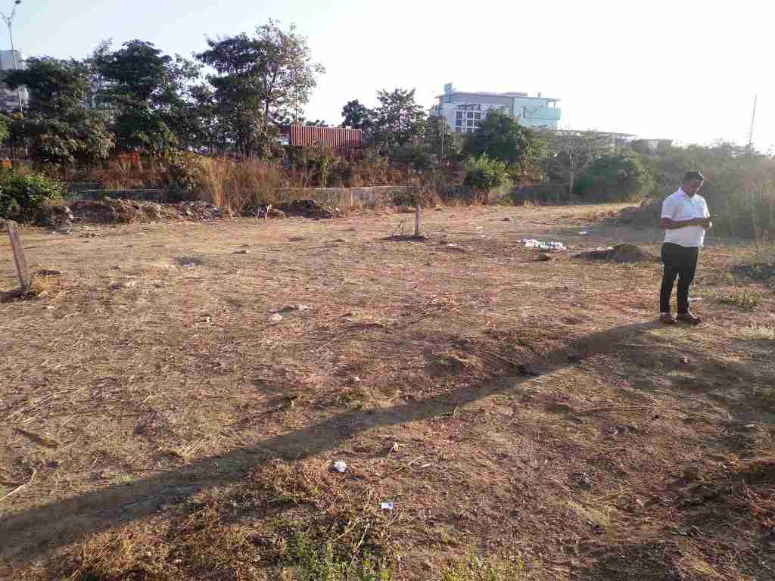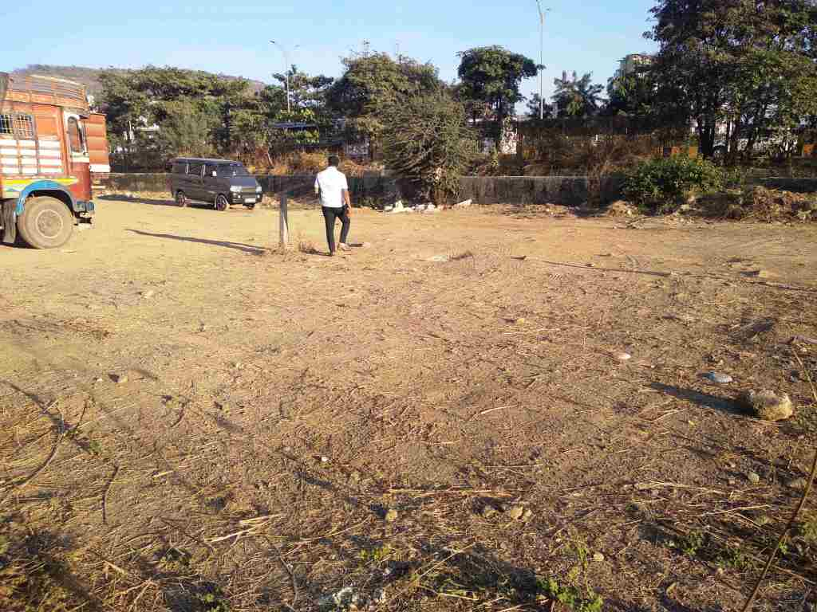

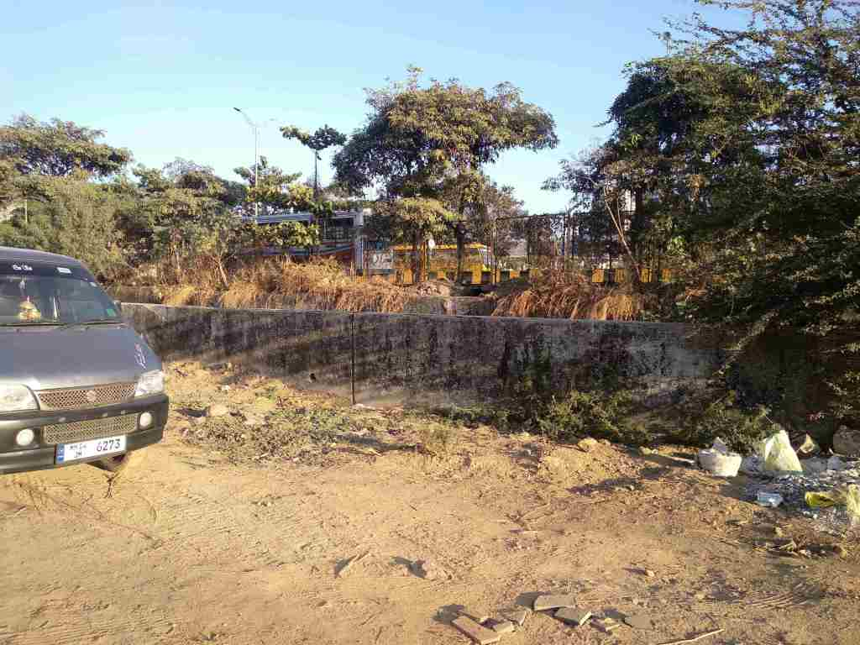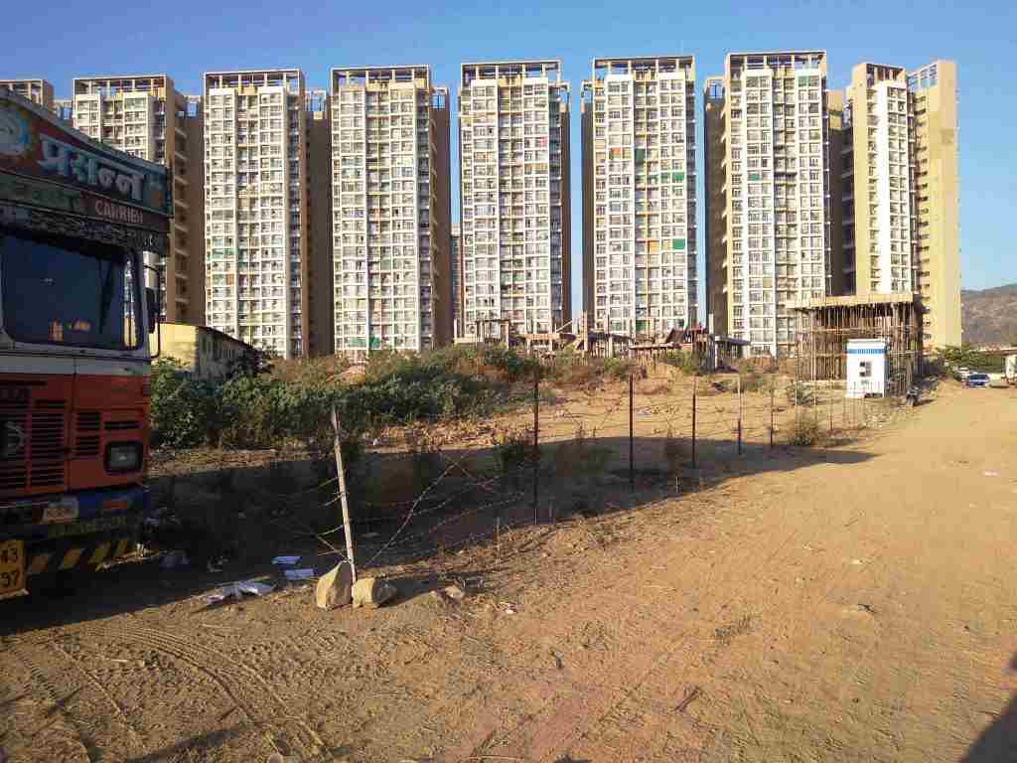

**Route Map of the property**

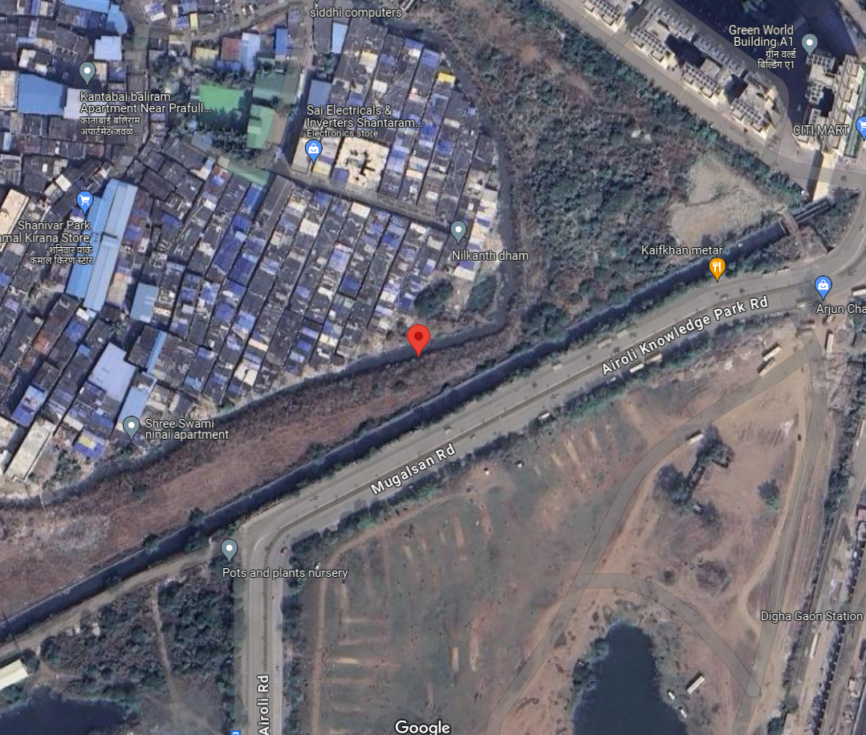**Site u/r**

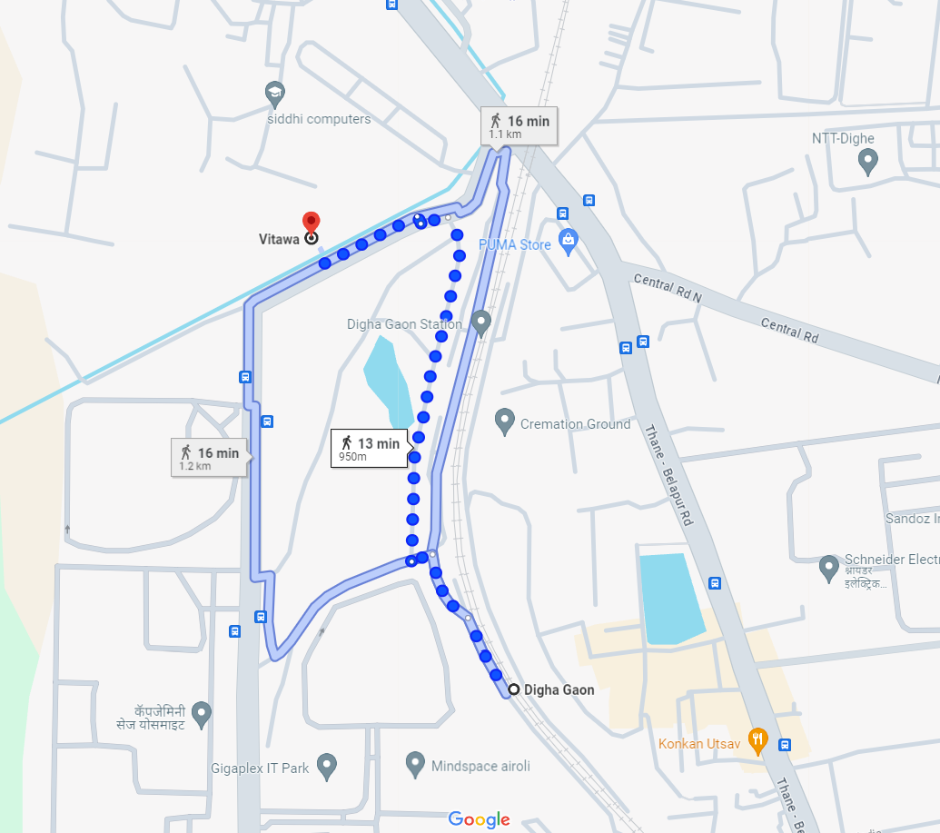

# Latitude Longitude - 19°10'53.5"N 72°59'31.2"E

**Note:** The Blue line shows the route to site from nearest railway station (Digha Gaon – 950m)

**READY RECKONER RATE**

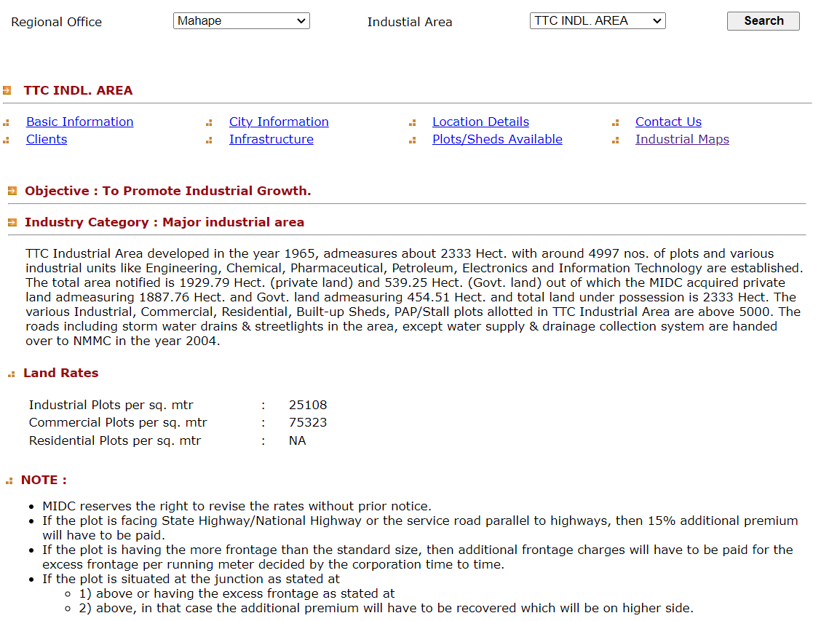

**M.I.D.C. MAP**

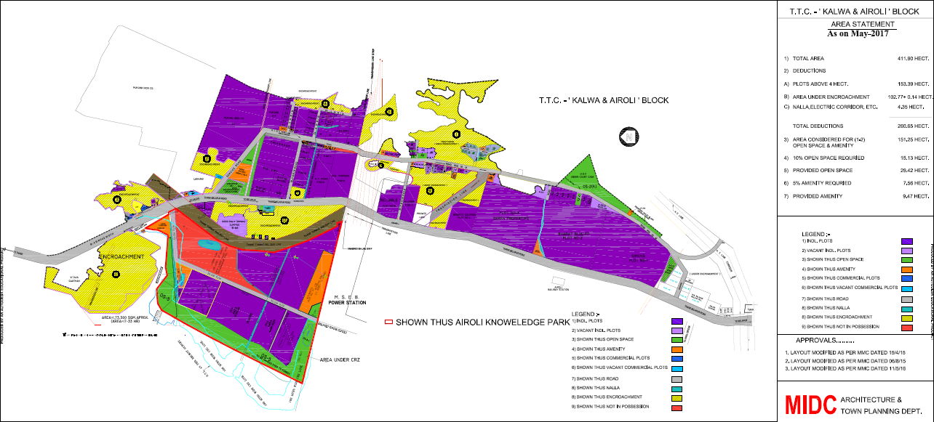

**Location plan**

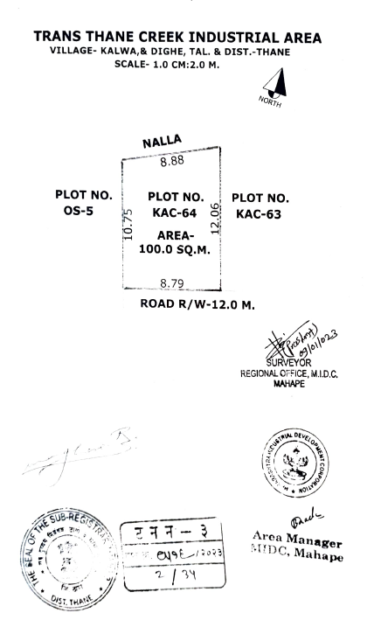

**Price Indicators**

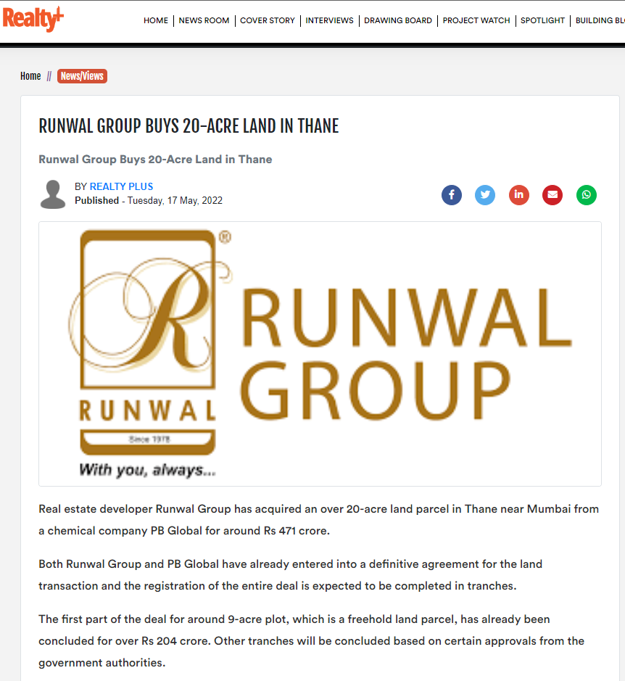

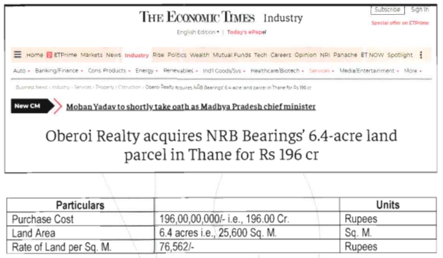

**DEFINITION OF VALUE FOR THIS SPECIFIC PURPOSE**

This exercise is to assess **Fair Market Value** of the property under reference as on **21st February 2024.**

The term **Fair Market Value** is defined as

*“The most probable price, as of a specified date, in cash, terms equivalent to cash, or in other precisely revealed terms for which the specified property rights would sell after reasonable exposure in a competitive market under all conditions requisite to a fair sale, with the buyer and seller each acting prudently knowledgeably and for self-interest assuming that neither is under undue duress”.*

Fundamental assumptions and conditions presumed in this definition are:

1. Buyer and seller are motivated by self-interest.

2. Buyer and seller are well informed and are acting prudently.

3. The property is exposed for a reasonable time on the open market.

4. Payment is made in cash or equivalent or in specified financing terms.

#### UNDER LYING ASSUMPTIONS

1. We assume no responsibility for matters of legal nature affecting the property appraised or the title thereto, nor do we render our opinion as to the title, which is assumed to be good and marketable.

2. The property is valued as though under responsible ownership.

3. It is assumed that the property is free of liens and encumbrances.

4. It is assumed that there are no hidden or unapparent conditions of the subsoil or structure that would render it more or less valuable. No responsibility is assumed for such conditions or for engineering that might be required to discover such factors.

5. There is no direct/ indirect interest in the property valued

6. The rates for valuation of the property are in accordance with the Govt. approved rates and prevailing market rates.

##### DECLARATION OF PROFESSIONAL FEES CHARGED

We hereby declare that, our professional fees are not contingent upon the valuation findings. However, if the statute AND/OR clients demands that, the fees should be charged on the percentage of assessed value then, with the full knowledge of the AND/OR end user, it is being charged accordingly.

# VALUATION OF THE PROPERTY PREMISES

Considering various parameters recorded herein above, existing economic scenario, and the information that is available with reference to the development of neighborhood and method selected for valuation, we are of the opinion that, the property premises can be assessed and valued for banking purpose as on day for ` 57,50,000.00 (Rupees Fifty-Seven Lakh Fifty Thousand Only).

## Manoj B. Chalikwar

## Registered Valuer

## Chartered Engineer (India)

## Reg. No. CAT-I-F-1763

## Cosmos Emp. No. H.O./Credit/67/2019-20