Vastu/Nashik/06/32014/2301224
22/20-325-RYBS
Date: 14.02.2024

To,
The Branch Manager,
State Bank of India
RACPC Nashik Branch
1st Floor, Patel Plaza, N.D. Patel Road,
Opp. BSNL, Landmark Seawoods Navratna Hotel,
Nashik - 422001, State – Maharashtra, Country – India.

Sub: Vetting of Extra Work

Sir,

With reference to above subject, we have evaluated the Extra Work for Residential Flat No. 304, Third Floor, " Omkar Heights ", Survey No. 99+100/ D/ 2, Plot No. 16+17, Next to Bhor Township, Near Tirupati Multispeciality Hospital, Ambad Satpur Link Road, Village – Chunchale, Taluka & District - Nashik, PIN Code – 422 010, State – Maharashtra, Country – India belongs to Name of Proposed Purchaser : Shri. Nitin Ashok Bhandure & Sau. Sheetal Nitin Bhandure. Name of Owner : M/s. Five Star Enterprises.

We have verified the rates quoted as per current market rates. Details of Extra Work considered as per copy of Extra Work Agreement between Shri. Nitin Ashok Bhandure & Sau. Sheetal Nitin Bhandure (First Party). Shri. Hariram Satan Pandit (Second Party) received on dated 14.02.2024. The Extra Work amount is Rs. 1,89,000/- (Rupees One Lakh Eighty Nine Thousand Only)

The said Cost Vetting Certificate is valid upto next 6 months Only.

Thanking you

Sincerely yours

Manoj B. Chalikwar
Registered Valuer
Chartered Engineer (India)
Reg. No. CAT-I-F-1763
SBI Empanelment No.: SME/TCC/2021-22/86/3
Encl. Valuation Report

Agreement for Extra Work
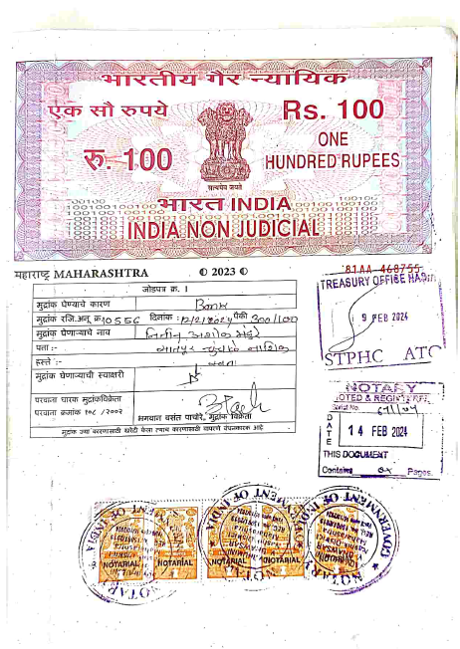
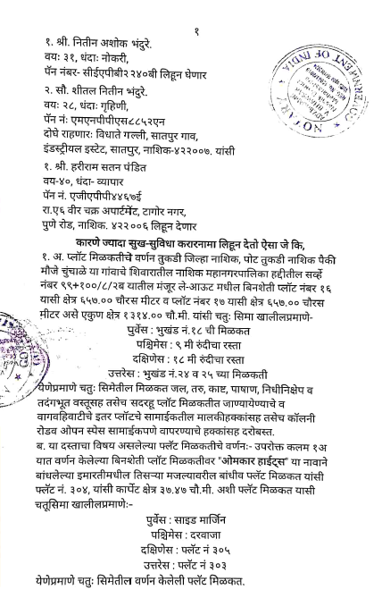

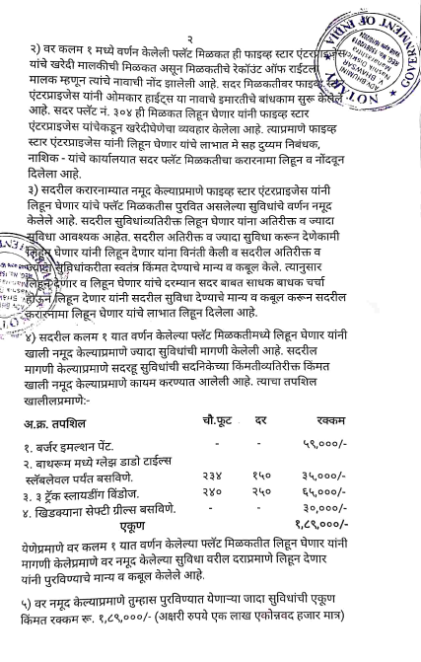
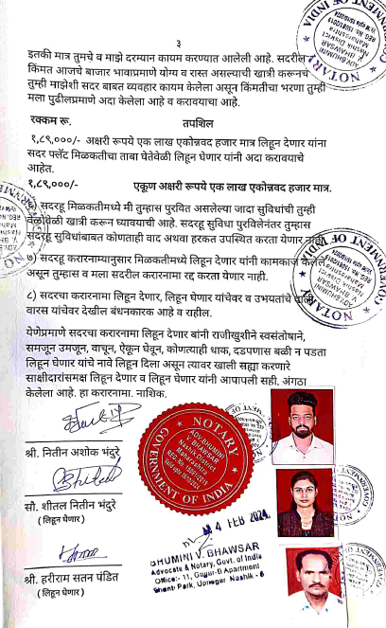

The Extra Work amount is Rs. 1,89,000/- (Rupees One Lakh Eighty Nine Thousand Only)

