Vastu/Nashik/02/2024/006936/2304946
13/9-168-CCBS
Date: 13.02.2024

To,
The Branch Manager,
Bank of Baroda
Regional Office
BSNL Building, Datta Mandir Road, Nashik Road,
Nashik, PIN – 422 101, State - Maharashtra, Country - India.

Sub: Vetting of Extra Work

Sir,

With reference to above subject, we have evaluated the Extra Work for Residential Flat No. 402, Fourth Floor, D-Wing, "Rosewood", Gut No.154, Plot No.5, Venkatesh Nagar, Bhawali Dam Road, At-Pimprisadroddin, Taluka – Igatpuri, District - Nashik, PIN Code – 422403, State – Maharashtra, Country – India belongs to Mr.Datta Bhanudas Khurde.

We have verified the rates quoted as per current market rates. Details of Extra Work considered as per copy of Extra Work Quotation between Mr. Datta Bhanudas Khurde. (First Party). H.K Interio (Second Party) received on dated.12.02.2024. The Extra Work amount is Rs. 3,15,000/- (Rupees Three Lakh Fifteen Thousand Only)

The said Cost Vetting Certificate is valid upto next 6 months Only.

Thanking you

Sincerely yours

Manoj B. Chalikwar
Registered Valuer
Chartered Engineer (India)
Reg. No. CAT-I-F-1763
Reg. No. IBBI/RV/07/2018/10366
BOB Empanelment No.: ZO:MZ:ADV:46:941
Encl: Valuation report.

Quotation for Extra Work
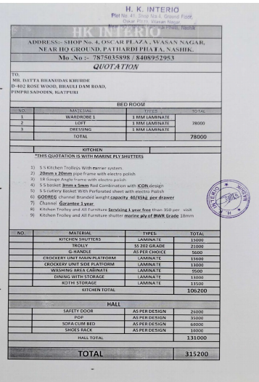

The Extra Work amount is Rs. 3,15,000/- (Rupees Three Lakh Fifteen Thousand Only)

