1. CTS No.2624 – Khadkeshwar

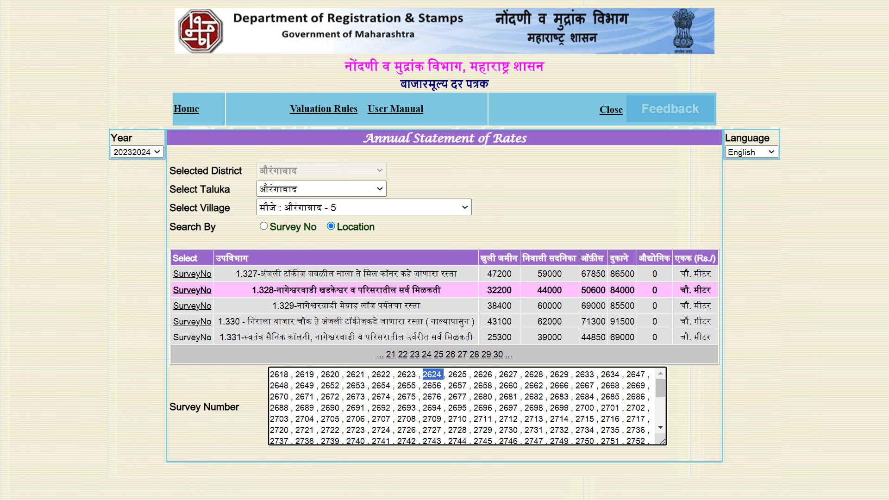



1. Shops & Godown – CTS No.19408

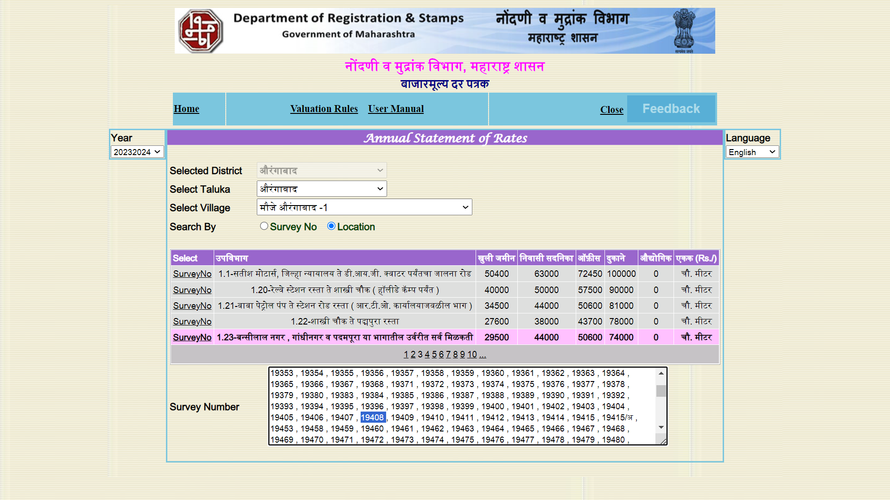

1. CTS No.4801 – Open Plot Paithan

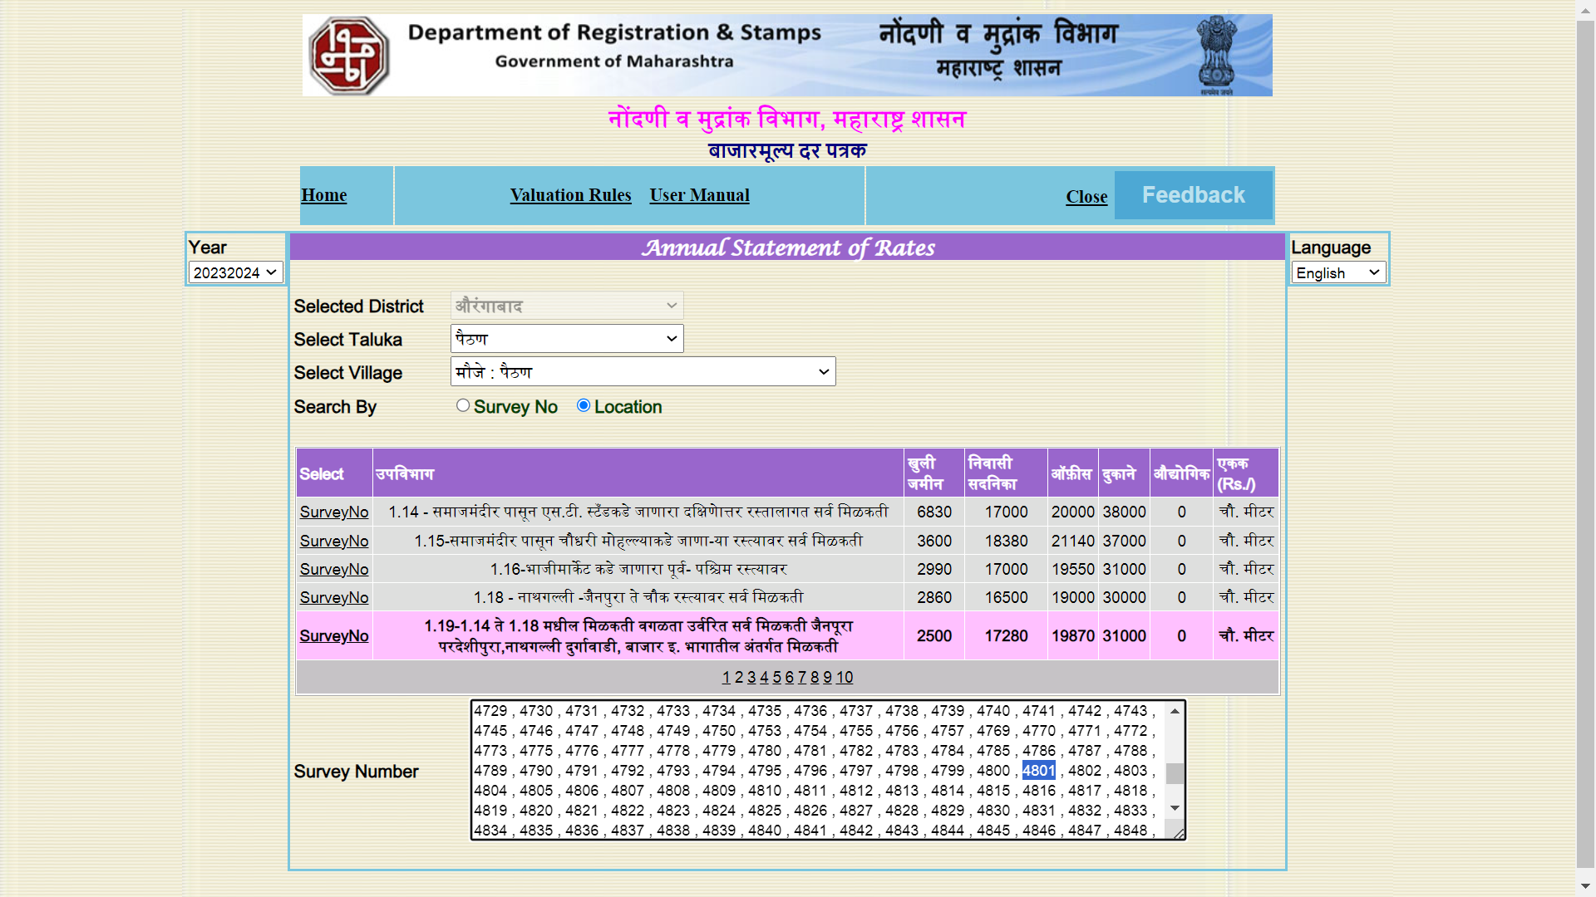

1. Agriculture Land – Village Katpur

