**Valuation Report of the Immovable Property**

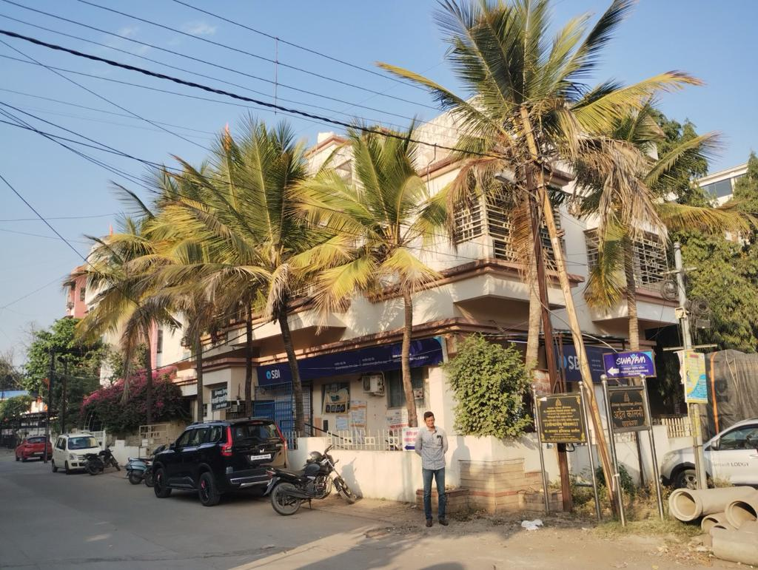

**Details of the property under Consideration:**

**Name of Owner: Mr. Ashok Shankarrao Chavan.**

The property Sai Shankar, M.H.No. 5-6-31, Ward No.A/410/19, CTS No 2624, Kotwalpura, Khadkeshwar, Aurangabad, PIN Code – 431 001, State – Maharashtra, Country – India.

# **Longitude Latitude: 19°53'04.4"N 75°19'08.4"E**

**Valuation Done for:**

**Private Client**

Vastu/Nanded/6924/2304933

12/22-155-NIPP Date: 12.02.2024

# **VALUER’S OPINION REPORT**

This is to certify that the property situated on The property Sai Shankar, M.H.No. 5-6-31, Ward No.A/410/19, CTS No 2624, Kotwalpura, Khadkeshwar, Aurangabad, PIN Code – 431 001, State – Maharashtra, Country – India belongs to **Mr. Ashok Shankarrao Chavan.**

|  |  |  |
| --- | --- | --- |
| Boundaries of the property are as under: | | |
| North | : | Open plot of owner CTS No. 2624 | |
| South | : | Mill corner to Anjali Talkies 24 m wide Road | |
| East | : | House of Shri Saoji | |
| West | : | 9.00 m wide Road | |
|  |  |  | |

Considering various parameters recorded, existing economic scenario, and the information that is available with reference to the development of neighborhood and method selected for valuation, we are of the opinion that, the property premises can be assessed and valued for this particular purpose as under.

|  |  |
| --- | --- |
| **Market value of the property / Guideline Value** | **` 2,81,35,016.00** |
| **Realizable Value of the property.** | **` 2,53,21,514.00** |
| **Distress / Forced Sale Value of the property.** | **` 2,25,08,013.00** |

The valuation of the property is based on the documents produced by the concern. Legal aspects have not been taken into considerations while preparing this valuation report.

Hence certified.

**For, Vastukala Consultants (I) Pvt. Ltd.**

**Sharadkumar B. Chalikwar**

B.E. (Civil), M.E. (Civil), M.Sc. (Real Estate Valuation), M.Sc. (P&M Valuation), FIE (I), FIV, FIWRS

Chairman & Managing Director

Govt. Reg. Valuer

Chartered Engineer (India)

Reg. No. (N) CCIT/1-14/52/2008-09

IBBI Reg. No. IBBI/RV/07/2019/11744

Encl: Valuation report.

|  |  |  |  |  |
| --- | --- | --- | --- | --- |
|  |  | |  |  |
| **VALUATION REPORT**  (IN RESPECT OF LAND & BUILDING)   |  |  |  |  |  |  |  |  |  |  |  | | --- | --- | --- | --- | --- | --- | --- | --- | --- | --- | --- | | I. | **General** | | | | | | | | | | | 1. | Purpose for which the valuation is made. | | | | | | To Assess Fair Market Value of the Property. | | | | | 2. | a) | | | Date of inspection | | | 09.02.2024 | | | | | b) | | | Date on which the valuation is made | | | 12.02.2024 | | | | | c) | | | Date of Valuation Report | | | 12.022024 | | | | | 3. | **List of documents produced for perusal** | | | | | | | | | | | 1 | | Photo Copy of Valuation Certificate dated 14.03.2019 prepared by valuer Vastukala Consultants (I) Pvt. Ltd. | | | | | | | | | 2 | | Photo Copy of Valuation Certificate dated 19.03.2014 prepared by valuer Shri. Alhad Deshpande | | | | | | | | | 3 | | Photo Copy of Copy of Occupancy Certificate No 1638, (File No.1002/17/94 B.P. No.241/94 Dated 8.09.1994), Aurangabad Municipal Corporation c/c 225/17/96 Dated 9.01.1996. | | | | | | | | |  | 4 | | Copy of CTS No. 2624/1,2 | | | | | | | | |  | 5 | | Copy Of Aurangabad Municipal Corporation Property Tax receipt No.AS/A2923 DATED 14.03.2019 FOR Rs.20,113.00 | | | | | | | | |  | 6 | | Copy of Aurangabad Municipal-Corporation No Dues Certificate No. 16855 of M.H.No.5-6-31, A/410/19 of dated 14.03.2019. | | | | | | | | | 4. | Name of the owner(s) and his / their address (es) with Phone no. (details of share of each owner in case of joint ownership) | | | | | | **Mr. Mr. Ashok Shankarrao Chavan.** | | | | | 5. | Brief description of the property  (Including Leasehold / freehold etc.) | | | | | | Basement + GF + FF + SF Storeyed Residential cum Commercial Building | | | | | 6. | Location of property | | | | | | | | | | |  | a) | Plot No. / Survey No. | | | | | CTS No. 2624/1,2 | | | | | b) | Door No. | | | | | Sai Shankar, M.H.No. 5-6-31 | | | | | c) | T.S. No. / Village | | | | | Mouje - Khandakeshwar | | | | | d) | Ward / Taluka | | | | | Taluka – Aurangabad | | | | | e) | Mandal / District | | | | | District – Aurangabad | | | | | 7. | Postal address of the property | | | | | | Sai Shankar, M.H.No. 5-6-31, Ward No.A/410/19, CTS No 2624, Kotwalpura, Khadkeshwar, Aurangabad, PIN Code – 431 001, State – Maharashtra, Country – India. | | | | | 8. | Type of property | | | | | | Residential. | | | | | 9. | Classification of the area | | | | | | | | | | | i) High / Middle / Poor | | | | | | | Middle Class | | | | ii) Urban / Semi Urban / Rural | | | | | | | Urban. | | | | 10. | Coming under Corporation limit / Village Panchayat / Municipality | | | | | | | Aurangabad Municipal Corporation | | | | 11. | Whether covered under any State / Central Govt. enactments (e.g., Urban Land Ceiling Act) or notified under agency area/ scheduled area / cantonment area. | | | | | | | No. | | | | 12. | **Boundaries of the property** | | | | | **As Per Documents** | | | | **As Per Actual** | | **North** | | | | | Details not available | | | | Open plot of owner CTS No. 2624 | | **South** | | | | | Details not available | | | | Mill corner to Anjali Talkies 24 m wide Road | | **East** | | | | | Details not available | | | | House of Shri Saoji | | **West** | | | | | Details not available | | | | 9.00 m wide Road | | 13 | Whether occupied by the owner / tenant? If Occupied by tenant since how long? Rent Received per month. | | | | | | Partly occupied by State Bank of India and DCC Bank | | | | | **II** | **CHARACTERSTICS OF THE SITE** | | | | | | | | | | |  | Classification of locality. | | | | | | Higher class. | | | | |  | Development of surrounding areas. | | | | | | Developed. | | | | |  | Possibility of frequent flooding/ sub-merging. | | | | | | No | | | | |  | Feasibility to the Civic amenities like School, Hospital, Bus Stop, Market etc. | | | | | | All available near by | | | | |  | Level of land with topographical conditions. | | | | | | Plain | | | | |  | Shape of land. | | | | | | Levelled | | | | |  | Type of use to which it can be put. | | | | | | Residential cum Commercial Purposed | | | | |  | Is plot in town planning approved layout? | | | | | | Information not available | | | | |  | Corner plot or intermittent plot? | | | | | | Corner | | | | |  | Road facilities. | | | | | | Yes. | | | | |  | Type of road available at present | | | | | | BT | | | | |  | Width of road – is it below 20 ft. or more than 20 ft. | | | | | | 24.00 m wide road | | | | |  | Is it a Land – Locked land? | | | | | | Yes | | | | |  | Water potentiality. | | | | | | Bore Well  Municipal Water Supply | | | | |  | Underground sewerage system. | | | | | | Municipal Drainage | | | | |  | Is Power supply is available in the site. | | | | | | Yes | | | | |  | Advantages of the site. | | | | | | Property is situated on mill corner to Anjali Talkies 24 m wide road, Khadakeshwar i.e., in the heart of Aurangabad business center. | | | | |  | Special remarks, if any like threat of acquisition of land for publics service purposes, road widening or applicability of CRZ provisions etc. (Distance from sea-cost / tidal level must be incorporated.) | | | | | | No. | | | | | **Valuation of the property:** | | | | | | | | | | | | 1 | Total area of the Land | | | | | | **609.00 Sqm.** | | | | | 2 | Prevailing market rate | | | | | | **` 32,200.00 per Sqm.** | | | | | 3 | Land Value | | | | | | **` 1,96,09,800.00 per Sqm.** | | | | |  | **Building** | | | | | |  | | | | | 1 | **F.S.I. Consumed** | | | | | | **0.952** | | | | | 2 | Total Built up Area | | | | | | **579.76 Sqm.** | | | | | 3 | Rate per Sqm | | | | | | **` 20,000.00 per Sqm.** | | | | | 4 | Cost of Construction | | | | | | **` 1,15,95,200 per Sqm.** | | | | | 5 | Age of Building | | | | | | **28 Years** | | | | | 6 | Total life of Building Considered | | | | | | **60 Years** | | | | | 7 | Depreciation Factor | | | | | | **42.00** | | | | | 8 | Depreciation | | | | | | **` 48,69,984.00** | | | | | 9 | Depreciated cost of construction | | | | | | **` 67,25,216.00** | | | | | 10 | Other amenities: Lift, Interiors, Compound wall ect. L.S. | | | | | | **` 18,00,000.00** | | | | |  | The Fair Value of the property | | | | | | **` 2,81,35,016.00** | | | | |  | The Realizable value of the property | | | | | | **` 2,53,21,514.00** | | | | |  | The Distress Value of the property | | | | | | **` 2,25,08,013.00** | | | | | **Part – B (Valuation of Building)** | | | | | | | | | | | | 1 | Technical details of the building | | | | | | | | | | |  | | | | Type of Building (Residential / Commercial / Industrial) | | Residential cum Commercial Building | | | | |  | | | | Type of construction  (Load bearing / RCC / Steel Framed) | | RCC Framed structure | | | | |  | | | | Year of construction. | | 1996 | | | | |  | | | | Number of floors and height of each floor including basement, if any | | Basement + Ground + First + Second Floor | | | | |  | | | | Plinth area floor-wise | | N.A.  Only Land Cost is Considered for Valuation. | | | | |  | | | | **Condition of the building** | | | | | | |  | | | | i. Exterior : Excellent, Good, Normal, Poor | | | | Good | | | ii. Interior : Excellent, Good, Normal, Poor | | | | Good | |   **Specifications of construction in respect of**   |  |  |  |  |  | | --- | --- | --- | --- | --- | | **Sr. No.** | | **Description** | **Ground Floor** | | |  | | Foundation | RCC Raft/Footing | | |  | | Basement | RCC | | |  | | Superstructure | II BBM | | |  | | Joinery / Doors & Windows | CCTW / Aluminium Sliding windows / Rolling Shutter | | |  | | RCC Works | RCC, Column, Beam, Slab etc | | |  | | Plastering | Cement mortar | | |  | | Flooring, Skirting, dado | Vitrified/Ceramic/kota etc | | |  | | Pantry Platform | Granite | | |  | | Whether any proof course is provided? | Yes | | |  | | Drainage | Connected to Municipal sewer | | | 11 | | Compound Wall | Compound wall MS gate | | | 12 | | Electric Installation (Type of wire, Class of Superior  construction) | Superior | | | 13 | | Plumbing Installation | Provided as per rule | | | 14 | | Bore Well | Yes | | | 15 | | Wardrobes, if any | Yes | | | 16 | | Development of open area | CC with pavers. | | | **Valuation of proposed construction/additions/renovation if any :** | | | | Amount in **`** | |  | **SUMMARY OF VALUATION:** | | | | |  | Part I Land | | | **`** 1,96,09,800.00 | |  | Part II Building | | | **`** 67,25,216.00 | |  | Part III Other amenities /Miscellaneous | | | **`** 18,00,000.00 | |  | Part IV Proposed construction | | | Nil. | |  | **VALUE OF THE PROPERTY / GUIDELINE VALUE** | | | **` 2,81,35,016.00** | |  | The realizable value of the property | | | **` 2,53,21,514.00** | |  | Distress value of the property | | | **` 2,25,08,013.00** | | |

I/ my authorized representative have personally inspected the property on 12.02.2024

The rates for valuation of the property are accordance with the govt approved rates and prevailing market rates.

There is no direct / indirect interest in the property value

The undersigned has inspected the property detailed in the valuation report Dated 12.02.2024, we are satisfied that the **Fair and reasonable value** of the property is **` 2,81,35,016.00 (Rupees Two Crore Eighty One Lakh Thirty Five Thousand Sixteen Only).**

For, **Vastukala Consultants (I) Pvt. Ltd.**

**Sharadkumar B. Chalikwar**

B.E. (Civil), M.E. (Civil), M.Sc. (Real Estate Valuation), M.Sc. (P&M Valuation), FIE (I), FIV, FIWRS

Chairman & Managing Director

Govt. Reg. Valuer

Chartered Engineer (India)

Reg. No. (N) CCIT/1-14/52/2008-09

IBBI Reg. No. IBBI/RV/07/2019/11744

**Actual site photographs**

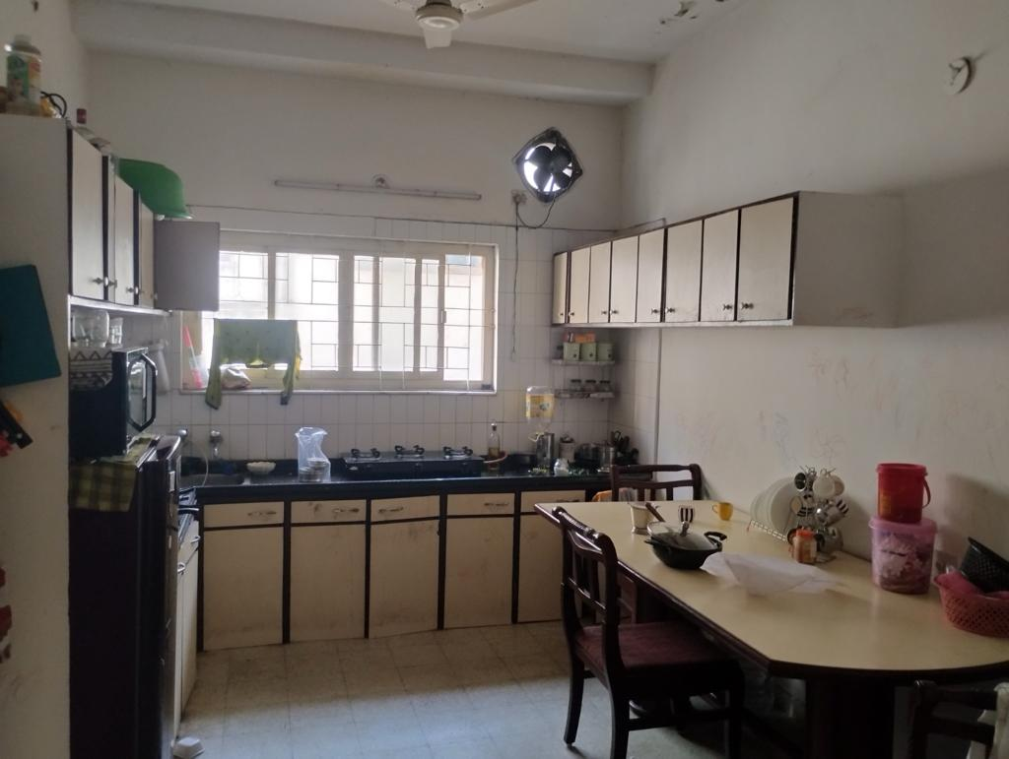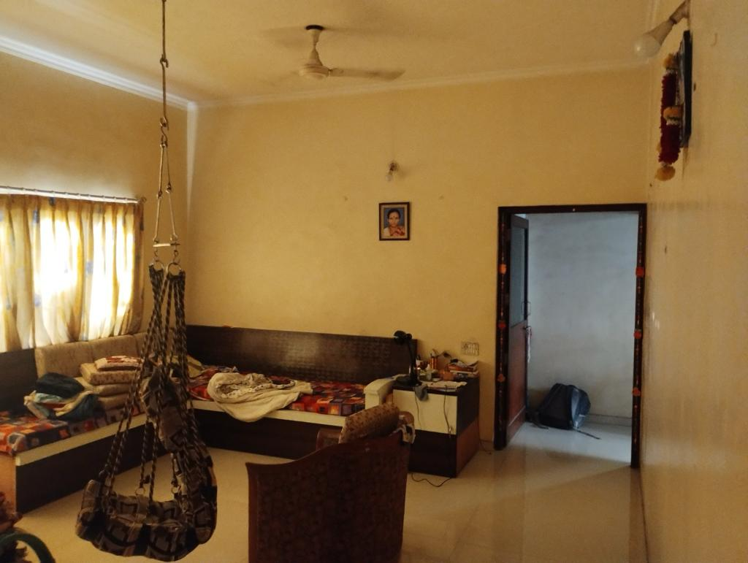

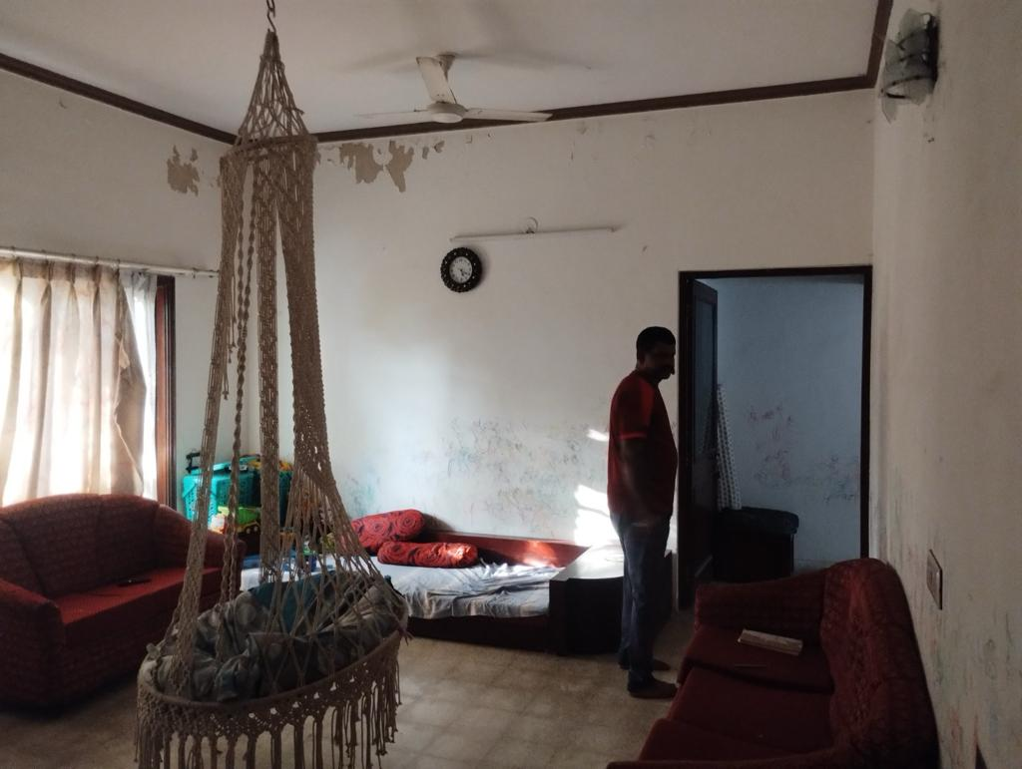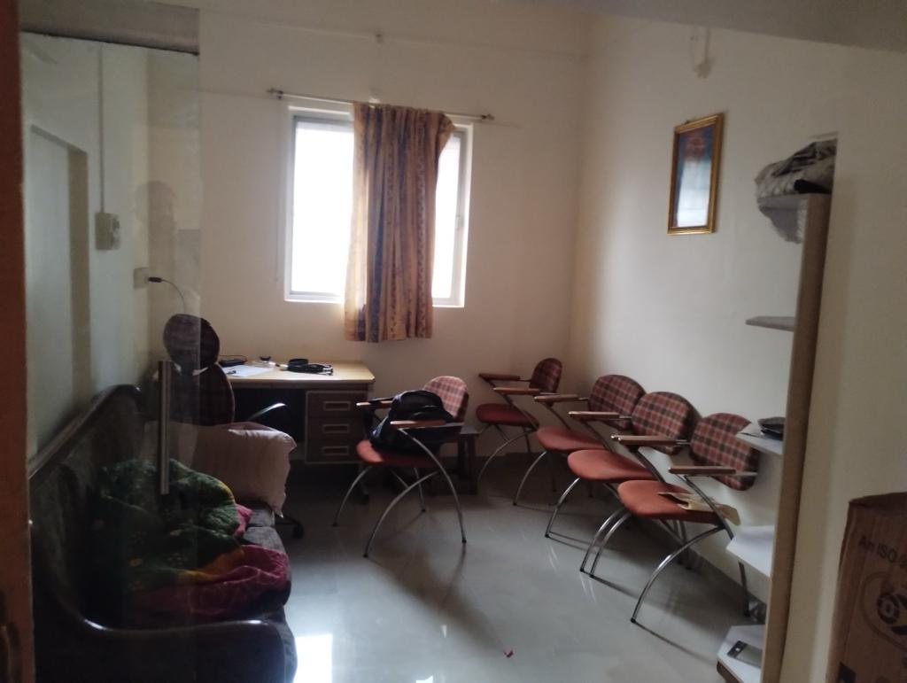

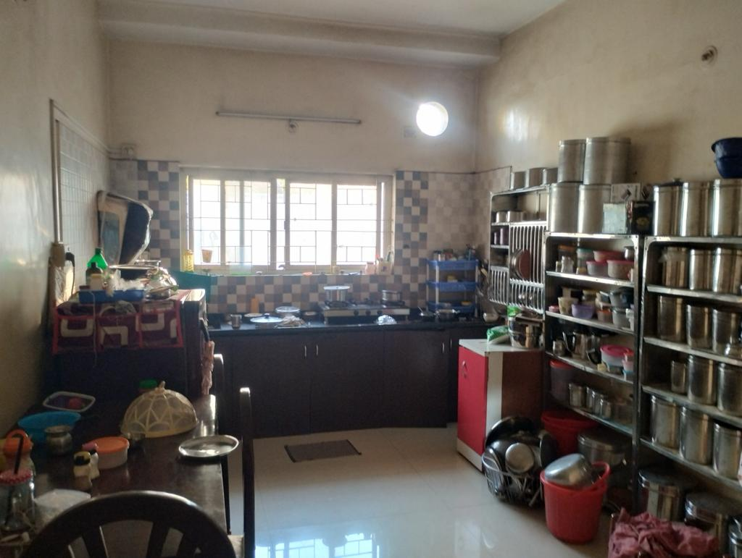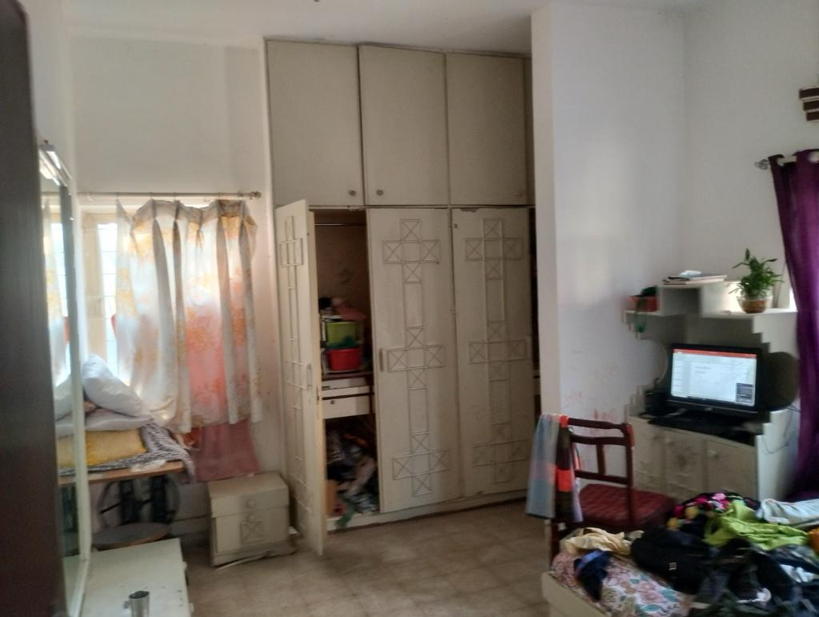

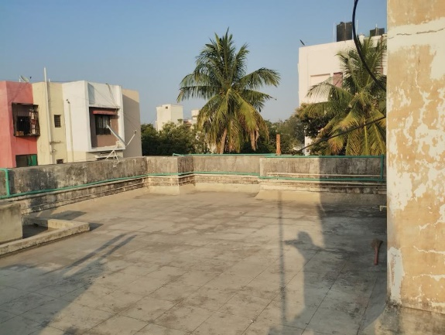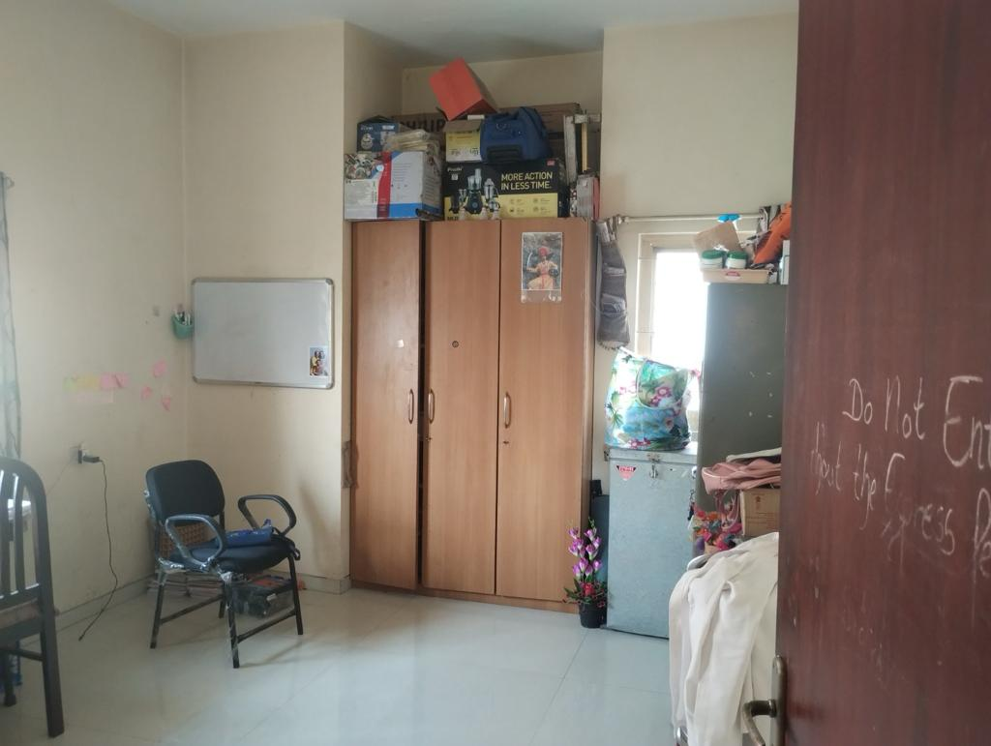

**Actual site photographs**

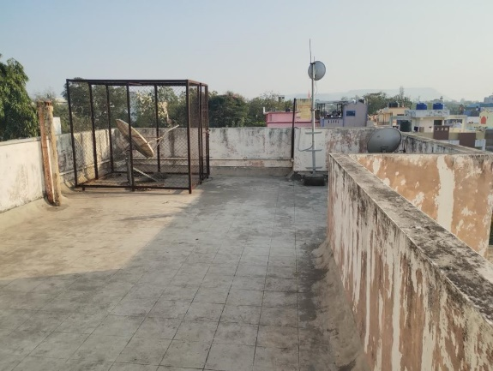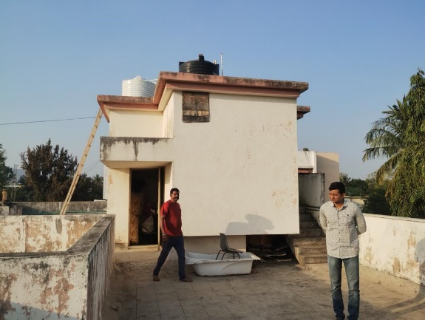

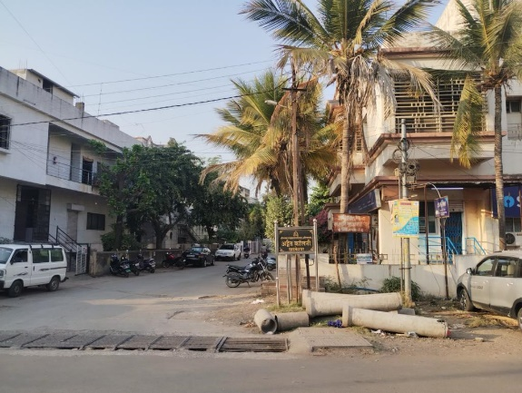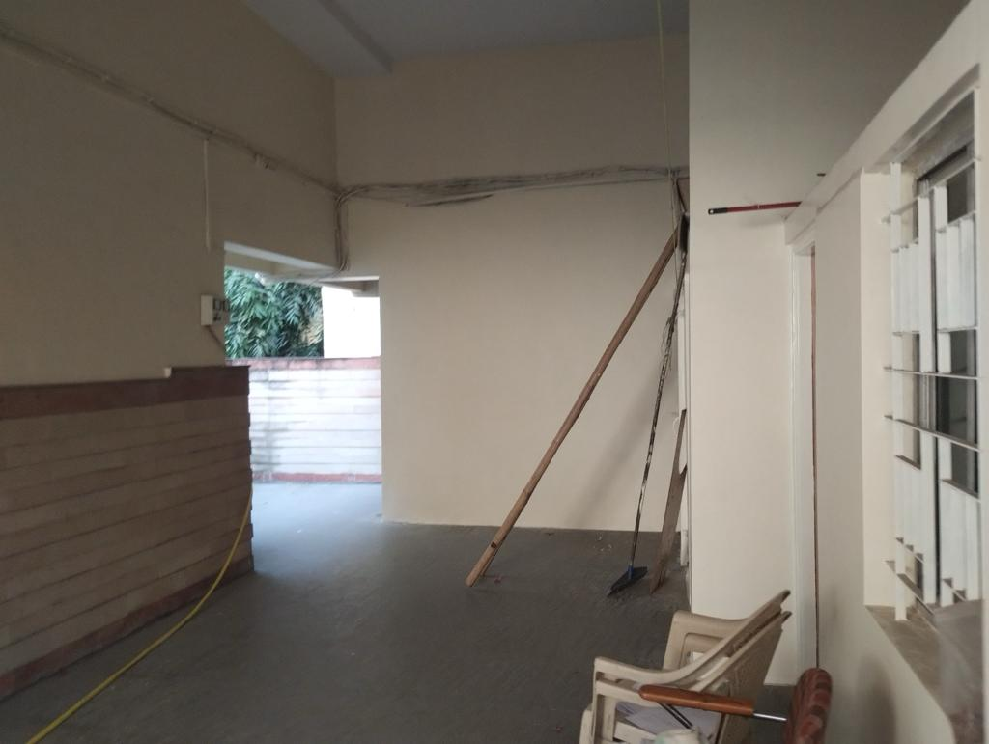

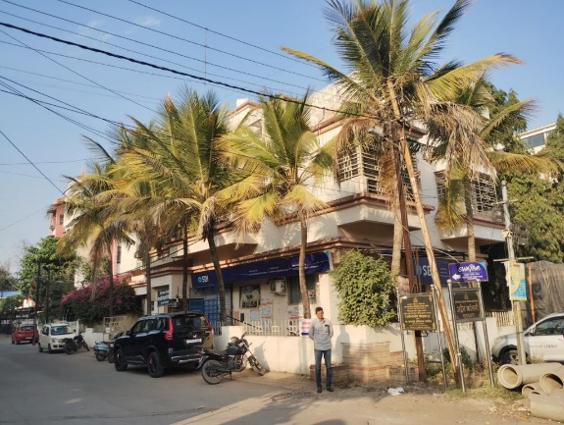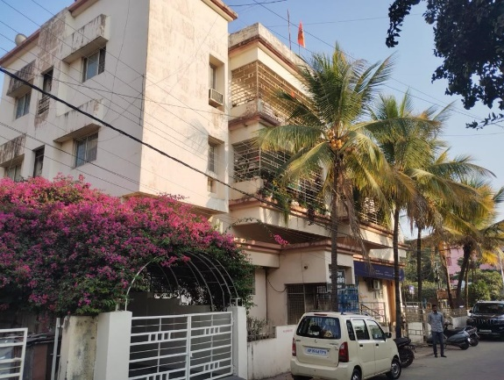

**Route Map of the property**

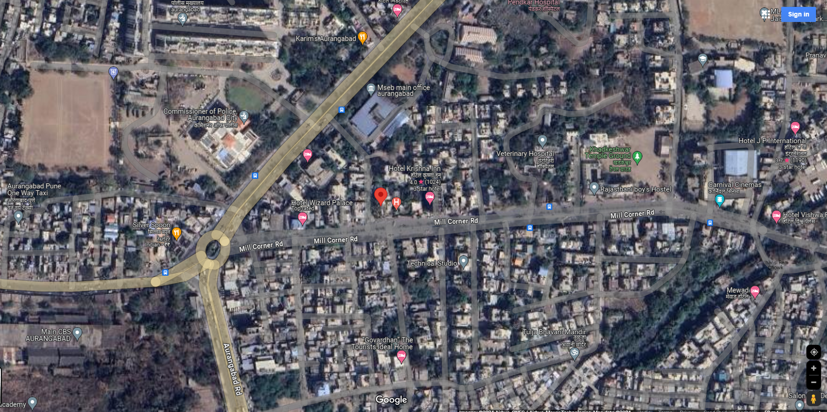

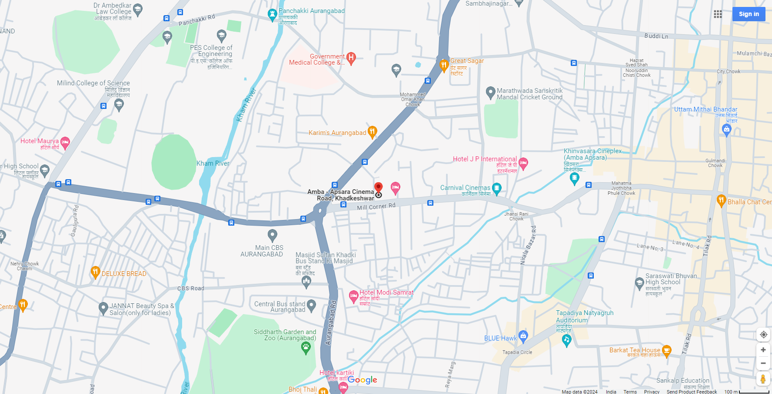

**Longitude Latitude: 19°53'04.4"N 75°19'08.4"E**

**Note**:

* Red Pointer shows Approx. Property Location

**Ready Reckoner Rate**

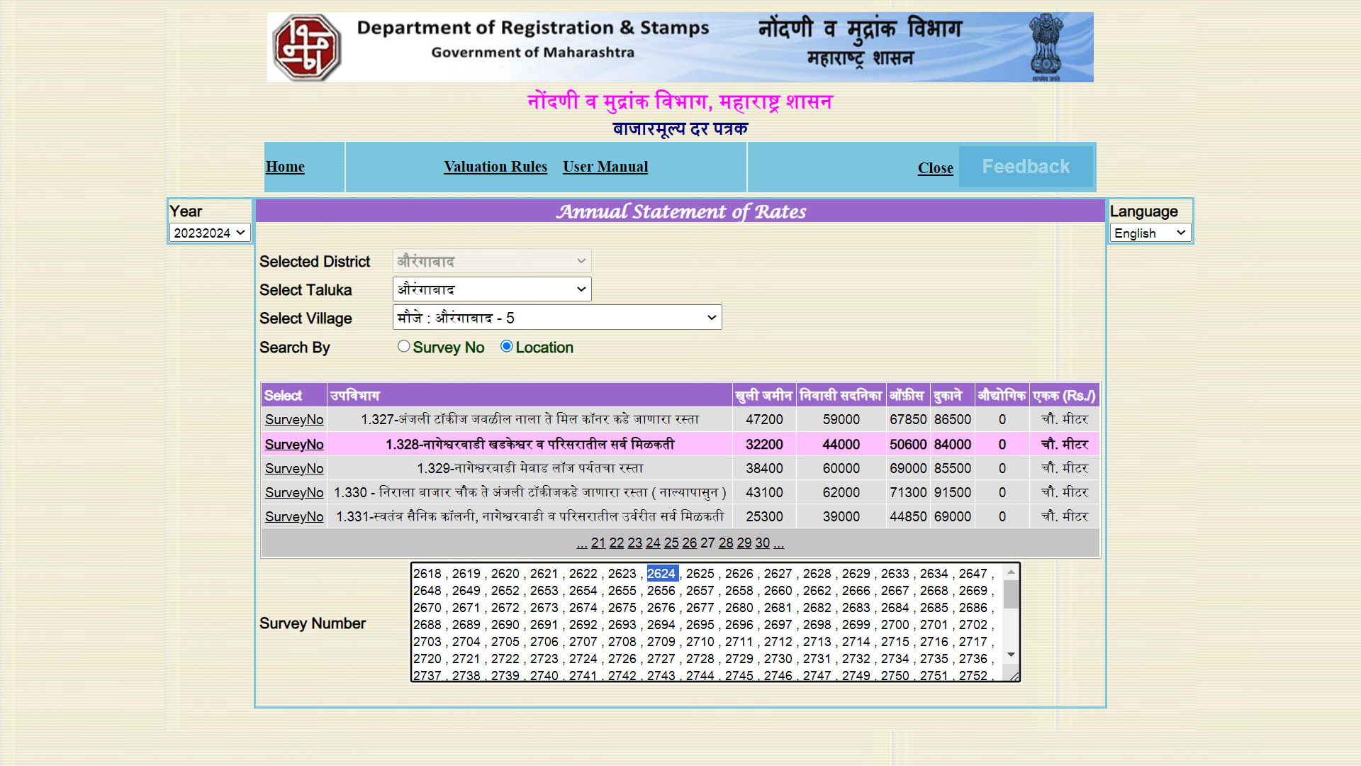

**DEFINITION OF VALUE FOR THIS SPECIFIC PURPOSE**

This exercise is to assess **Fair Market Value** of the property under reference as on dated **12th February, 2024.**

The term Fair Market Value is defined as

*"The most probable price, as of a specified date, in cash, terms equivalent to cash, or in other precisely revealed terms for which the specified property rights would sell after reasonable exposure in a competitive market under all conditions requisite to a fair sale, with the buyer and seller each acting prudently knowledgeably and for self-interest assuming that neither is under undue duress"*

Fundamental assumptions and conditions presumed in this definition are:

1. Buyer and seller are motivated by self-interest.
2. Buyer and seller are well informed and are acting prudently.
3. The property is exposed for a reasonable time on the open market.
4. Payment is made in cash or equivalent or in specified financing terms.

**UNDER LYING ASSUMPTIONS**

1. We assume no responsibility for matters of legal nature affecting the property appraised or the title thereto, nor do we render our opinion as to the title, which is assumed to be good and marketable
2. The property is valued as though under responsible ownership.
3. It is assumed that the property is free of liens and encumbrances.
4. It is assumed that there are no hidden or unapparent conditions of the subsoil or structure that would render it more or less valuable. No responsibility is assumed for such conditions or for engineering that might be required to discover such factors.

For, **Vastukala Consultants (I) Pvt. Ltd.**

**Sharadkumar B. Chalikwar**

B.E. (Civil), M.E. (Civil), M.Sc. (Real Estate Valuation), M.Sc. (P&M Valuation), FIE (I), FIV, FIWRS

Chairman & Managing Director

Govt. Reg. Valuer

Chartered Engineer (India)

Reg. No. (N) CCIT/1-14/52/2008-09

IBBI Reg.No. IBBI/RV/07/2019/11744

**DECLARATION OF PROFESSIONAL FEES CHARGED**

We hereby declare that, our professional fees are not contingent upon the valuation findings. However, if the statute AND/OR clients demands that, the fees should be charged on the percentage of assessed value then, with the full knowledge of the AND/OR end user, it is being charged accordingly.

**VALUATION OF THE PROPERTY PREMISES**

Considering various parameters recorded herein above, existing economic scenario, and the information that is available with reference to the development of neighbourhood and method selected for valuation, we are of the opinion that, the property premises can be assessed and valued for Banking Purpose as on day for **` 2,81,35,016.00 (Rupees Two Crore Eighty One Lakh Thirty Five Thousand Sixteen Only).**

**STATEMENT OF LIMITING CONDITIONS**

1. Assumptions are made to the best of our knowledge and belief. Reliance is based on the information furnished to us by the identifier AND/OR client.
2. The Valuer shall not be responsible for matters of legal nature that affects the value and opinion expressed by us.
3. If our appearance is required, we will be pleased to appear and give the necessary clarification, provided the fees for each appearance (excluding travelling, dearness allowance and out of pocket expenses) is pre-determined before the acceptance of the assignment under reference.
4. In no event shall the Valuer be held responsible or liable for special, direct, indirect or consequential damages, as the assignment has been completed on best efforts, available knowledge and in good intentions of persons concerned and belief.
5. **If it is proved that there is an apparent negligence on the part of a Valuer**, liability of this assignment (whether arising from this assignment, negligence or whatsoever) is limited in respect of anyone event or series of events to the actual loss or damage sustained subject to maximum of 80% of the professional fees for the services rendered and in any case not exceeding the amount of **` 1,000 (Rupees One Thousand Only). All the claims against us shall expire after three month from the date of submission of the valuation report provided by us.**
6. We hereby declare that, the information furnished above is true and correct to the best of our knowledge and belief. We have no direct or indirect interest in the assets valued. We have not been convicted of any offence and sentenced to a term of imprisonment. We have not been found guilty of misconduct in our professional capacity. We have personally inspected the assets.

For, **Vastukala Consultants (I) Pvt. Ltd.**

**Sharadkumar B. Chalikwar**

B.E. (Civil), M.E. (Civil), M.Sc. (Real Estate Valuation), M.Sc. (P&M Valuation), FIE (I), FIV, FIWRS

Chairman & Managing Director

Govt. Reg. Valuer

Chartered Engineer (India)

Reg. No. (N) CCIT/1-14/52/2008-09

IBBI Reg.No. IBBI/RV/07/2019/11744