**Valuation Report of the Immovable Property**

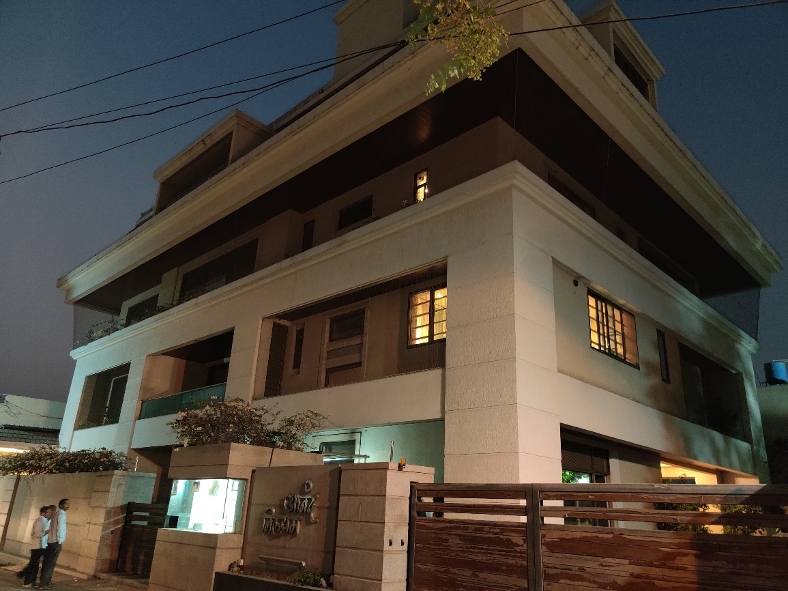

**Details of the property under consideration:**

Name of Owner: **Mr. Ashok Shankarrao Chavan & Mrs. Ameeta Ashokrao Chavan**

“Anand Nilayam”, M. H. No. 1-2-162, 1-2-163, 1-2-164, C.T.S No.4487, 4488 & 4489,

The House Building Co.op. Society Ltd., Shivaji Nagar, Nanded, PIN – 431 602,

State – Maharashtra, Country – India.

# **Latitude Longitude - 19°09'47.1"N 77°18'13.2"E**

**Valuation Report Prepared For**

**Private Clients**

Vastu/Mumbai/02/2024/006921/2304936

12/25-158-RJPY

Date: 12.02.2024

**VALUATION OPINION REPORT**

The property bearing “Anand Nilayam”, M. H. No. 1-2-162, 1-2-163, 1-2-164, C.T.S No.4487, 4488 & 4489, The House Building Co.op. Society Ltd., Shivaji Nagar, Nanded, PIN – 431 602, State – Maharashtra, Country – India. is belongs to **Mr. Ashok Shankarrao Chavan & Mrs. Ameeta Ashokrao Chavan**

|  |  |
| --- | --- |
| Boundaries of the property. | |
| North | Phule Nagar |
| South | Road |
| East | House of Shri. Santosh Waghmare |
| West | House of Shri. Govind Yerawar |

Considering various parameters recorded, existing economic scenario, and the information that is available with reference to the development of neighbourhood and method selected for valuation, we are of the opinion that, the property premises can be assessed and valued for purpose is as under:

|  |  |  |
| --- | --- | --- |
| **I. LAND** | **Mr. Ashok S. Chavan** | **Mrs. Ameeta Chavan** |
| **Inherited Land Acquired** | **` 47,68,977.00** | **` 21,74,240.00** |
| **Self - Acquired Land** | **` 41,67,124.00** | **` 19,59,864.00** |
| **II. BUILDING** |  |  |
| **Total Building Share Value** | **` 3,11,01,279.00** | **` 1,44,28,334.00** |
| **Total Land & Building Value** | **` 4,00,37,380.00** | **` 1,85,62,438.00** |
| **A. Total Value of Ashok S. Chavan Property Share** | **` 4,00,37,380.00** | |
| **B. Total Value of Ameeta Chavan Property Share** | **` 1,85,62,438.00** | |
| **Total Value of Property (A+ B)** | **` 5,85,99,818.00** | |
| **Total Realizable value of the Property** | **` 5,27,39,836.00** | |
| **Distress value of Property** | **` 4,68,79,854.00** | |

The valuation of the property is based on the documents produced by the concern. Legal aspects have not been taken into considerations while preparing this report.

Hence certified

**Sharadkumar B. Chalikwar**

B.E. (Civil), M.E. (Civil), M.Sc. (Real Estate Valuation), M.Sc. (P&M Valuation), FIE (I), FIV, FIWRS

Chairman & Managing Director

Govt. Reg. Valuer

Chartered Engineer (India)

Reg. No. (N) CCIT/1-14/52/2008-09

IBBI Reg. No. IBBI/RV/07/2019/11744

**VALUATION REPORT IN RESPECT (LAND & BUILDING) PROPERTY**

|  |  |  |  |  |  |  |
| --- | --- | --- | --- | --- | --- | --- |
|  | GENERAL | |  | | | |
| 1 | Date of Inspection | | 09.02.2024 | | | |
| 2 | Date on which the valuation is made | | 12.02.2024 | | | |
|  | Date of Valuation Report | | 12.02.2024 | | | |
|  | Purpose of valuation | | As per request from Private Clients, to assess Fair Market Value of the property | | | |
| 4 | List of Documents Handed Over to The Valuer By The Client | | | | | |
|  | 1. Copy of Conveyance Deed No. 5930, dated 19.11.2005 2. Copy of Conveyance Deed No. 4984, dated 30.06.2008 3. Copy of Conveyance Deed No. 4333/2013, dated 13.06.2013 4. Copy of Partition Deed No. 1512 dated. 05.03.2014 5. Copy of P. R. Card C.T.S No. 4487, dated 20.02.2017, TILR, Nanded 6. Copy of P. R. Card C.T.S No. 4488, dated 02.04.2013, TILR, Nanded 7. Copy of P. R. Card C.T.S No. 4489, dated 02.04.2013, TILR, Nanded 8. Copy of Letter of Society to Ashok S. Chavan dated 29.07.2003 9. Copy of Letter of Society to Ashokrao Chavan dated 09.09.2012 10. Copy of Letter by Society to Sow. Amita Ashokrao Chavan issued by Society dated. 15.11.2012 11. Copy of Ownership certificate issued by Society dated. 09.09.2012 12. Copy of Ownership Certificate issued by Society dated. 14.01.2014 13. Copy of No Objection Certificate issued by Society dated. 15.11.2012 14. Copy of Construction permission letter No. dated. 31.12.2012, issued by NWCMC, Nanded. 15. Copy of Construction permission letter No. NWCMC/TP/1069/13, dated. 10.01.2014, issued by NWCMC, Nanded. 16. Copy of construction permission plan. 17. Copy of Tax Receipt No. R/PT/0818/154, dated 07.08.2018 18. Copy of Insurance policy (Standard Fire & special Perils Policy), The New India Assurance Co. Ltd. Policy No. 16090011170100000030, dated. 10.04.2017 from 10.04.2017 to 09.04.2018 19. Copy of Search Report Adv. Pradeep A. Atharkar, dated. 09.04.2014. 20. Copy of Previous Valuation Report Dated. 15.03.2019 issued by Vastukala Consultant Pvt. Ltd. | | | | | |
| 5 | Details of enquiries made/ visited to government offices for arriving fair market value. | | Market analysis and as per sub-registrar value. | | | |
| 6 | Factors for determining its market value. | | Location, development of surrounding area, type of construction, construction specifications, age of building, condition of the premises & building, facilities provided and its prevailing market rate. | | | |
| 7 | ANY CRITICAL ASPECTS ASSOCIATED WITH PROPERTY | | No | | | |
| 8 | Present/Expected Income from the property | |  | | | |
|  | **Property Details** | |  | | | |
| 9 | Name(s) of the Owner and Postal address of the property under consideration. | | **Mrs. Ameeta Ashok Chavan and**  **Mr. Ashok Shankarrao Chavan** | | | |
|  |  | | “Anand Nilayam”, M. H. No. 1-2-162, 1-2-163, 1-2-164, C.T.S No.4487, 4488 & 4489, The House Building Co.op. Society Ltd., Shivaji Nagar, Nanded, PIN – 431 602, State – Maharashtra, Country – India. | | | |
| 10 | If the property is under joint ownership/ co-ownership share of each such owner/ are the share is undivided. | | Joint Ownership | | | |
| Mr. Ashok S. Chavan | | Mrs. Ameeta Ashok Chavan | |
|  | |  |  |  |  | | --- | --- | --- | --- | | Inherited Land Acquired in Sqm | | 375.51 | 171.20 | | Self-Acquired Land in Sqm | | 173.80 | Nil | | Land Acquired from NWCMC in sqm | | 154.32 | 154.32 | | Total area of Plot in Sqm. | 1029.15 | 703.63 | 325.52 | | Inherited Land Share | | 36.49% | 16.63% | | Self-Acquired Land Share | | 31.88% | 15.00% | | Total Share Holding | | 68.31% | 31.69% | | | | | | |
| 11 | Brief description of the property. | | |  |  | | --- | --- | | G + 4 Storeyed Residential Bungalow, | | | Plot Area | | | CTS No. 4487 | 171.20 Sqm | | CTS No. 4488 | 173.80 Sqm | | CTS No. 4489 | 375.51 Sqm | | Acquired from NWCMC Conveyance Deed | 308.64 Sqm | | Total Plot area as per Acquisition | 1029.15 Sqm | | Total Area as per NWCMC Sanction Plan | 1027.29 Sqm | | Built up Area (As per Sanctioned Plan) | | | Ground Floor | 233.47 Sqm | | First Floor | 269.57 Sqm | | Second Floor | 256.88 Sqm | | Third & Fourth Floor | 248.49 Sqm | | Total Built up Area | 1008.41 Sqm | | FSI Allowed | 1.10 | | FSI Consumed | 0.94 | | | | |
|  | **If under construction, extent of completion** | | 100% Completed | | | |
| 12 | Location of the property (C.T.S. No., Survey No., Hissa No., Plot No., etc.). | | “Anand Nilayam”, M. H. No. 1-2-162, 1-2-163, 1-2-164, C.T.S No.4487, 4488 & 4489, The House Building Co.op. Society Ltd., Shivaji Nagar, Nanded, PIN – 431 602, State – Maharashtra, Country – India | | | |
| 13 | **Boundaries** | **As on site** | | **As per documents** | | |
|  | North | Phule Nagar | | Phule Nagar | | |
|  | South | Road | | Road | | |
|  | East | House of Shri. Santosh Waghmare | | House of Shri. Santosh Waghmare | | |
|  | West | House of Shri. Govind Yerawar | | House of Shri. Govind Yerawar | | |
| 14 | Matching of Boundaries | | Yes. | | | |
| 15 | Route map | | Enclosed | | | |
| 16 | Any specific identification marks | | Shivaji Nagar, Nanded | | | |
| 17 | Whether covered under Corporation/ Panchayat/ Municipality. | | Municipal Corporation | | | |
| 18 | Whether covered under any land ceiling of State/ Central Government. | | No | | | |
| 19 | Is the land freehold/ leasehold. | | Free Hold | | | |
| 20 | Are there any restrictive covenants in regard to use of Land? If so attach a copy of the covenant. | |  | | | |
| 21 | Type of the property | | Residential | | | |
| 22 | Year of acquisition/ purchase. | | |  | | --- | | Ancestral Property. | | 19.11.2005 (CTS No. 4488) | | 30.06.2008 (CTS No. 4487) | | 13.06.2013 from NWCMC | | | | |
| 23 | Purchase value as per document | | |  |  | | --- | --- | | Ancestral Property | Nil | | Self-Acquired | ` 6,65,000.00 | | From NWCMC | ` 22,34,320.00 | | Mr. Ashok Chavan | ` 17,82,160.00 | | Mrs. Ameeta Chavan | ` 11,17,160.00 | | | | |
| 24 | Whether the property is occupied by owner or tenant. If occupied by tenant since how long he is staying and the amount of rent being paid. | | Owner occupied | | | |
| 25 | Classification of the site | |  | | | |
|  | 1. Population group | | Urban | | | |
|  | 1. High/ Middle/ Poor class | | High Class | | | |
|  | 1. Residential/ Non-residential | | Residential | | | |
|  | 1. Development of surrounding area | | Developed | | | |
|  | 1. Possibility of any threat to the property (Floods, calamities etc.). | | No | | | |
| 26 | Proximity of civic amenities (like school, hospital, bus stop, market etc.). | | All Available Near by | | | |
| 27 | Level of the land (Plain, rock etc.) | | Plain | | | |
| 28 | Terrain of the Land. | | Levelled | | | |
| 29 | Shape of the land (Square/ rectangle etc.). | | Regular | | | |
| 30 | Type of use to which it can be put (for construction of house, factory etc.). | | Residential | | | |
| 31 | Whether the plot is under town planning approved layout? | | Yes | | | |
| 32 | Whether the building is intermittent or corner? | | Intermittent | | | |
| 33 | Whether any road facility is available? | | Yes | | | |
| 34 | Type of road available (B.T/Cement Road etc.). | | C.C. Road | | | |
| 35 | Front Width of the Road? | |  | | | |
| 36 | Source of water & water potentiality. | | Bore well & Municipal Water Supply | | | |
| 37 | Type of Sewerage System. | | Connected to Municipal Sewer line | | | |
| 38 | Availability of power supply. | | Yes | | | |
| 39 | Advantages of the site. | | Prime Developed Area | | | |
| 40 | Disadvantages of the site. | | No | | | |
| 41 | Give instances of sales of immovable property in the locality on a separate sheet, indicating the name & address of the property, registration No. sale price and area of land sold. | | As per Sub-Registrar Nanded | | | |
|  | **Valuation of the property :** | | | | | |
| 42 | Total area of the Plot | | 1027.29 sqm. | | | |
| 43 | Prevailing market rate. | | We have considered land rate as per guideline rate of ` **12,700.00 per Sqm.** | | | |
| 47 | Guideline rate obtained from the Stamp Duty Ready Reckoner. | | ` 12,700.00 per Sqm | | | |
|  | |  |  | | --- | --- | | Assessed/ Adopted rate of valuation. | ` 12,700.00 per Sqm | | **Mr. Ashok Shankarrao Chavan** |  | | Inherited Land Acquired in Sqm | ` 47,68,977.00 | | Self-Acquired Land in Sqm. | ` 41,67,124.00 | | Land Acquired from NWCMC in Sqm | | **Total Land Share Value Mr. Ashok Chavan** | ` 89,36,101.00 | | **Mrs. Ameeta Ashok Chavan** |  | | Inherited Land Acquired in Sqm | ` 21,74,240.00 | | Self-Acquired Land in Sqm. | ` 19,59,864.00 | | Land Acquired from NWCMC in Sqm | | **Total Land Share Value Mrs. Ameeta Chavan** | ` 41,34,104.00 | | | | | | |
| 48 | Total Land Value | | ` 1,30,70,205.00 | | | |
| 49 | The realizable value of the Land | | ` 1,17,63,185.00 | | | |
| 50 | Distress value of the Land | | ` 1,04,56,164.00 | | | |
|  | **Technical details of the building:** | | | | | |
| 52 | Type of building (Residential/ Commercial/ Industrial). | | Residential Building | | | |
| 53 | Year of construction. | | 2014 - 2015 approx. | | | |
| 54 | Future life of the property. | | 51 years Subject to proper, preventive periodic maintenance and structural repai` | | | |
| 55 | No. of floors and height of each floor including basement. | | N. A | | | |
|  | **Type of construction** | | | | | |
| 56 | (Load bearing/ R.C.C./ Steel framed) | | R.C.C. Framed Structure | | | |
|  | **Condition of the building.** | | | | | |
| 57 | External (excellent/ good/ normal/ poor) | | Excellent | | | |
| 58 | Internal (excellent/ good/ normal/ poor). | | Excellent | | | |
| 59 | Whether the Residential Flat is constructed strictly according to the sanctioned plan, details of variations noticed if any and effect of the same on the valuation | | Yes | | | |
| 60 | Remark | | Mr. Ashok Chavan Share Holding: 68.31%  Mrs. Ameeta Chavan Share Holding: 31.69% | | | |
|  | Valuation of construction/ additions / renovation if any: | | | | | |
| 61 | **Building** | | | | | |
| G.F, F.F, S.F, T.F & Fourth Floor | |  | | | |
| Total Built up area | | 1008.41 Sqm. | | | |
| Rate of Construction per Sqm. | | ` 35,000/- | | | |
| Cost of Construction | | `. 3,52,94,350.00 | | | |
| Depreciated Percentage | | 14% | | | |
| Amount of Depreciation | | ` 47,64,737 | | | |
| Depreciated Cost of Construction | | ` 3,05,29,613.00 | | | |
| 62 | Other Amenities:  Compound Wall, Borewell, Railing, M.S. Gate, A.C, Lift Furniture & Interiors etc. | | ` 1,50,00,000.00 | | | |
|  | Total (61 + 62) | | ` 4,55,29,613.00 | | | |
| A | Total Building Share Value of  M` Ashok Chavan  (4,55,29,613.00 @ 68.31%) | | ` 3,11,01,279.00 | | | |
| B | Total Building Share Value of  Mrs. Ameeta Ashok Chavan  (4,55,29,613.00 @ 31.69%) | | ` 1,44,28,344.00 | | | |
| 63 | Summary of Valuation | |  | | |  |
|  | 1. **LAND** | | Mr. Ashok S. Chavan | | | Mrs. Ameeta Chavan |
|  | Inherited Land Acquired | | ` 47,68,977.00 | | | ` 21,74,240.00 |
|  | Self-Acquired Land | | ` 41,67,124.00 | | | ` 19,59,864.00 |
|  | 1. **BUILDING** | |  | | |  |
|  | Total Building Share Value | | ` 3,11,01,279.00 | | | ` 1,44,28,334.00 |
|  | Total Land & Building Value | | ` 5,85,99,818.00 | | | |
|  | **FAIR MARKET VALUE of the property / Guideline Value** | | **` 5,85,99,818.00** | | | |
|  | **The Realizable value of the property** | | **` 5,27,39,836.00** | | | |
|  | **Distress value of the land of the property** | | **` 4,68,79,854.00** | | | |

I certify that,

I/ my authorized representative, has inspected the subject property on 09.02.2024. Mr. Rakesh (owner's employee) has shown the property.

The rates for valuation of the property are in accordance with the Govt. approved rates and prevailing market rates.

There is no direct/ indirect interest in the property valued.

The fair value of the property as on 12.02.2024 is: **` 5,85,99,818.00 (Rupees Five Cores Eighty-Five Thousand Ninety-Nine Thousand Eight Hundred Eighteen Only).**

Mr. Ashok S. Chavan**: ` 4,00,37,380.00 (Rupees Four Cores Thirty-Seven Thousand Three Hundred Eighty Only).**

Mrs. Ameeta Chavan: **` 1,85,62,438.00 (Rupees One Cores Eighty-Five Lakhs Sixty-Two Thousand Four Hundred Thirty-Eight Only).**

Date: 12.02.2024

Place: Mumbai

**Sharadkumar B. Chalikwar**

B.E. (Civil), M.E. (Civil), M.Sc. (Real Estate Valuation), M.Sc. (P&M Valuation), FIE (I), FIV, FIWRS

Chairman & Managing Director

Govt. Reg. Valuer

Chartered Engineer (India)

Reg. No. (N) CCIT/1-14/52/2008-09

IBBI Reg. No. IBBI/RV/07/2019/11744

**Actual site photographs**

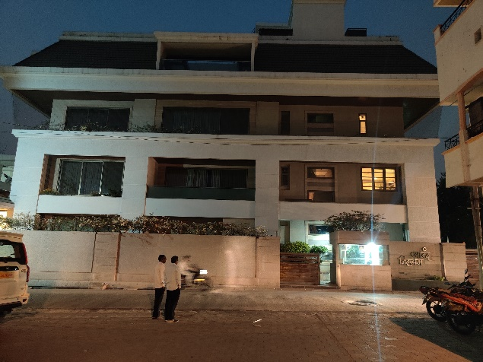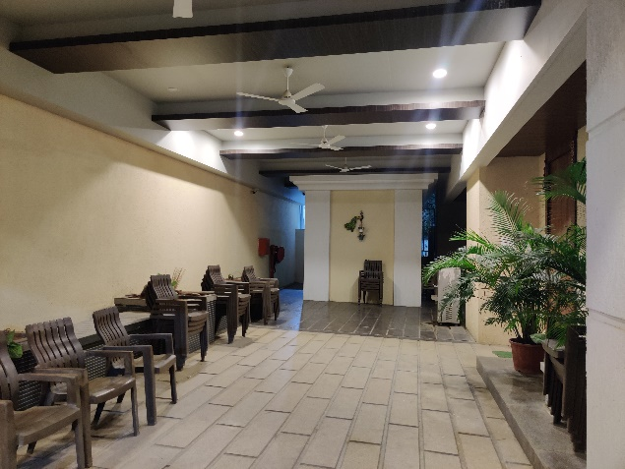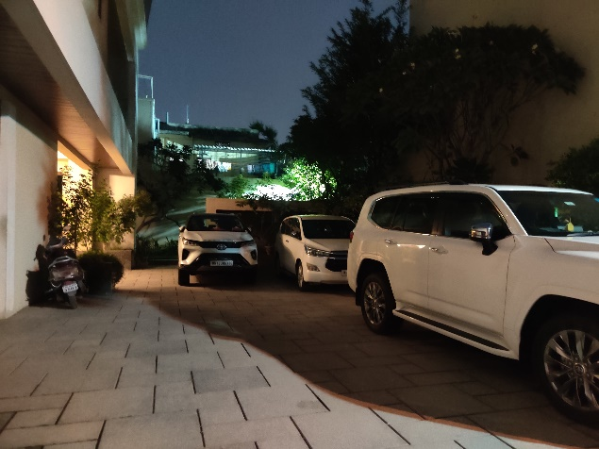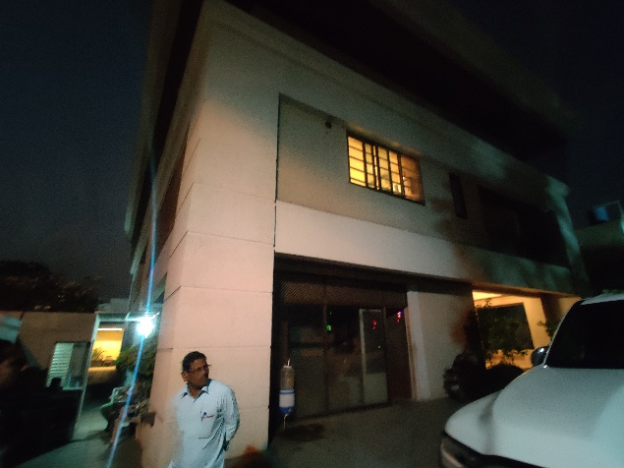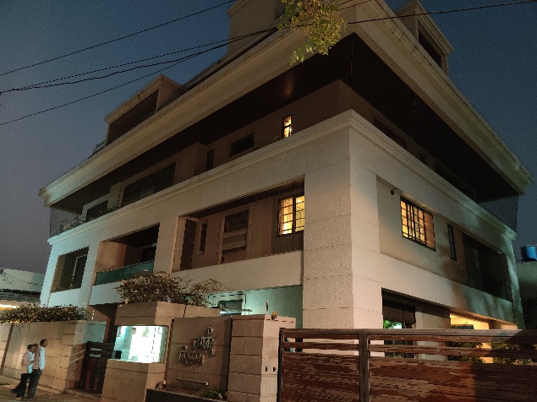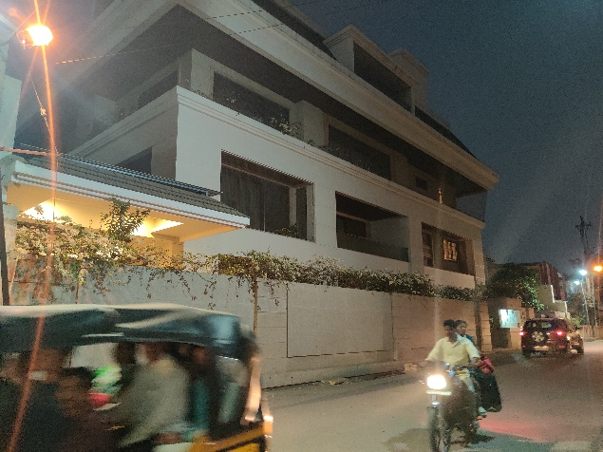**Route Map of the property**

**Site u/r**

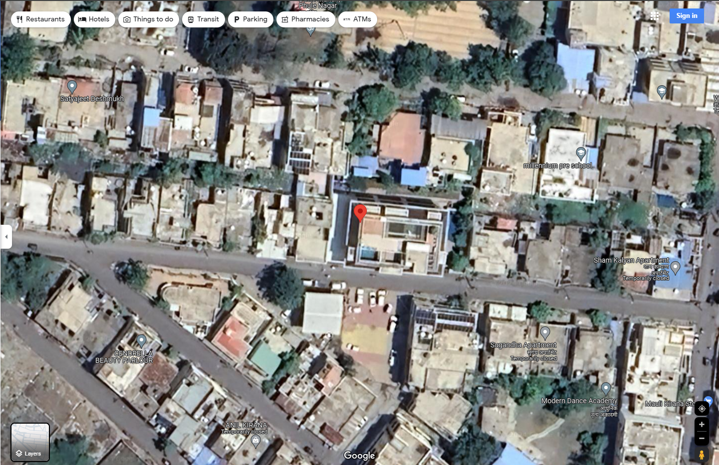

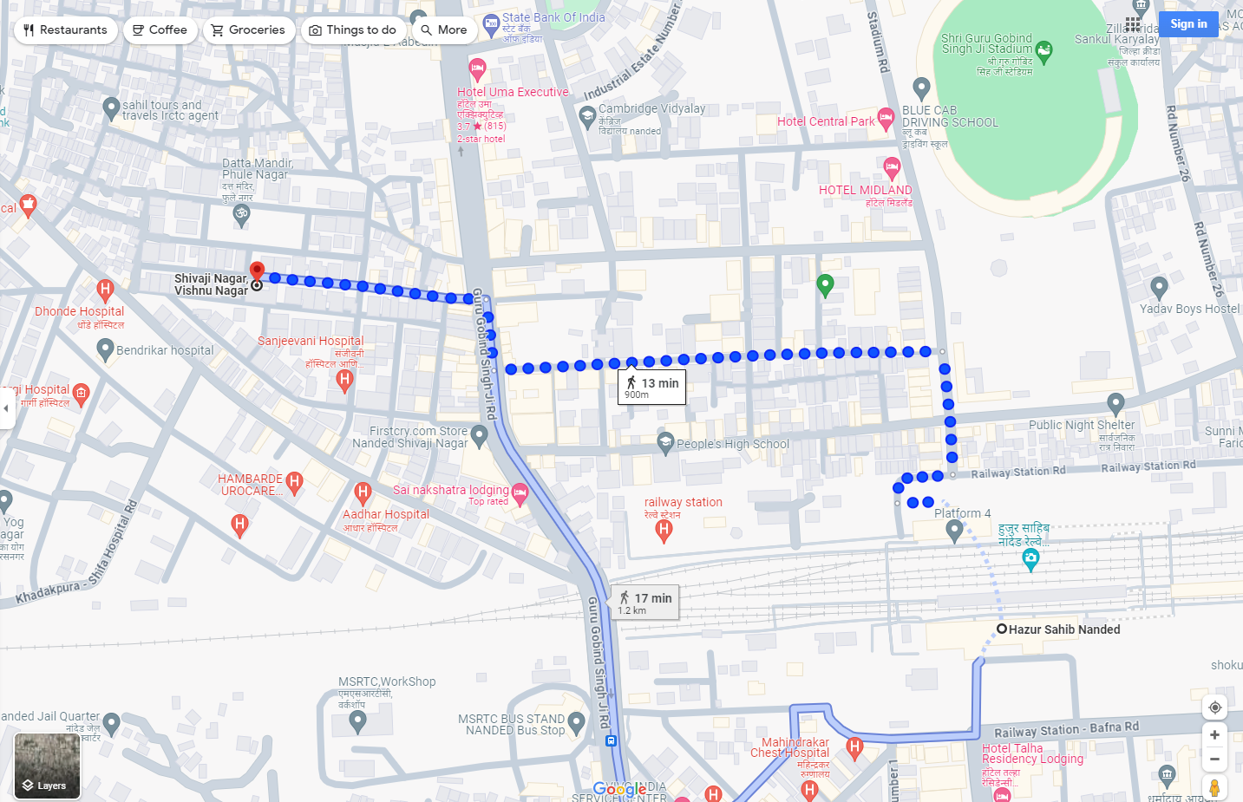

**Latitude Longitude - 19°09'47.1"N 77°18'13.2"E**

**Note**: The Blue line shows the route to site from nearest railway station (Nanded - 900 M)

**DEFINITION OF VALUE FOR THIS SPECIFIC PURPOSE**

This exercise is to assess **Fair Market Value** of the property under reference for **Fair Market Value** purpose as on dated **12**th **February 2024.**

The term Fair Market Value is defined as

*"The most probable price, as of a specified date, in cash, terms equivalent to cash, or in other precisely revealed terms for which the specified property rights would sell after reasonable exposure in a competitive market under all conditions requisite to a fair sale, with the buyer and seller each acting prudently knowledgeably and for self-interest assuming that neither is under undue duress"*

Fundamental assumptions and conditions presumed in this definition are:

1. Buyer and seller are motivated by self-interest.
2. Buyer and seller are well informed and are acting prudently.
3. The property is exposed for a reasonable time on the open market.
4. Payment is made in cash or equivalent or in specified financing terms.

**UNDER LYING ASSUMPTIONS**

1. We assume no responsibility for matters of legal nature affecting the property appraised or the title thereto, nor do we render our opinion as to the title, which is assumed to be good and marketable
2. The property is valued as though under responsible ownership.
3. It is assumed that the property is free of liens and encumbrances.
4. It is assumed that there are no hidden or unapparent conditions of the subsoil or structure that would render it more or less valuable. No responsibility is assumed for such conditions or for engineering that might be required to discover such facto`

**Sharadkumar B. Chalikwar**

B.E. (Civil), M.E. (Civil), M.Sc. (Real Estate Valuation), M.Sc. (P&M Valuation), FIE (I), FIV, FIWRS

Chairman & Managing Director

Govt. Reg. Valuer

Chartered Engineer (India)

Reg. No. (N) CCIT/1-14/52/2008-09

IBBI Reg. No. IBBI/RV/07/2019/11744

**DECLARATION OF PROFESSIONAL FEES CHARGED**

We hereby declare that, our professional fees are not contingent upon the valuation findings. However, if the statute AND/OR clients demands that, the fees should be charged on the percentage of assessed value then, with the full knowledge of the AND/OR end user, it is being charged accordingly.

**VALUATION OF THE PROPERTY PREMISES**

Considering various parameters recorded herein above, existing economic scenario, and the information that is available with reference to the development of neighbourhood and method selected for valuation, we are of the opinion that, the property premises can be assessed and valued for Visa Application Purpose as on day for The fair value of the property as on 12.02.2024 is: **` 5,85,99,818.00 (Rupees Five Cores Eighty-Five Thousand Ninety-Nine Thousand Eight Hundred Eighteen Only).**

Mr. Ashok S. Chavan**: ` 4,00,37,380.00 (Rupees Four Cores Thirty-Seven Thousand Three Hundred Eighty Only).**

Mrs. Ameeta Chavan: **` 1,85,62,438.00 (Rupees One Cores Eighty-Five Lakhs Sixty-Two Thousand Four Hundred Thirty-Eight Only).**

**STATEMENT OF LIMITING CONDITIONS**

1. Assumptions are made to the best of our knowledge and belief. Reliance is based on the information furnished to us by the identifier AND/OR client.
2. The Valuer shall not be responsible for matters of legal nature that affects the value and opinion expressed by us.
3. If our appearance is required, we will be pleased to appear and give the necessary clarification, provided the fees for each appearance (excluding traveling, dearness allowance and out of pocket expenses) is pre-determined before the acceptance of the assignment under reference.
4. In no event shall the Valuer be held responsible or liable for special, direct, indirect or consequential damages, as the assignment has been completed on best efforts, available knowledge and in good intentions of persons concerned and belief.
5. **If it is proved that there is an apparent negligence on the part of a Valuer**, liability of this assignment (whether arising from this assignment, negligence or whatsoever) is limited in respect of anyone event or series of events to the actual loss or damage sustained subject to maximum of 80% of the professional fees for the services rendered and in any case not exceeding the amount of **`1,000 (Rupees One Thousand Only). All the claims against us shall expire after three month from the date of submission of the valuation report provided by us.**
6. We hereby declare that, the information furnished above is true and correct to the best of our knowledge and belief. We have no direct or indirect interest in the assets valued. We have not been convicted of any offence and sentenced to a term of imprisonment. We have not been found guilty of misconduct in our professional capacity. We have personally inspected the assets.

**Sharadkumar B. Chalikwar**

B.E. (Civil), M.E. (Civil), M.Sc. (Real Estate Valuation), M.Sc. (P&M Valuation), FIE (I), FIV, FIWRS

Chairman & Managing Director

Govt. Reg. Valuer

Chartered Engineer (India)

Reg. No. (N) CCIT/1-14/52/2008-09

IBBI Reg. No. IBBI/RV/07/2019/11744