**Valuation Report of the Immovable Property**

**Details of the property under consideration:**

Name of Owner: **Kum. Sreejaya Ashok Chavan**

Commercial Office No. 23-R, 12th Floor,  **"Navjivan Commercial Premises Co-Op. Soc. Ltd. "**, Dr. D. Bhadkamkar Marg (Lamington Road), Mumbai Central, Mumbai - 400 008, State - Maharashtra, Country - India.

**Latitude Longitude - 18°57'56.7"N 72°49'10.1"E**

**Vastukala Consultants (I) Pvt. Ltd.**

|  |  |  |  |  |  |  |
| --- | --- | --- | --- | --- | --- | --- |
| **Mumbai** | **.** | **Navi Mumbai** | **.** | **Aurangabad** | **.** | **Nanded** |

Vastu/Mumbai/03/2019/0014316/29785

12/14-67-PDM

Date: 12.03.2019

**VALUATION OPINION REPORT**

The property bearing Commercial Office No. 23-R, 12th Floor,  **"Navjivan Commercial Premises Co-Op. Soc. Ltd. "**, Dr. D. Bhadkamkar Marg, (Lamington Road), Mumbai Central, Mumbai - 400 008, State - Maharashtra, Country - India belongs to **Mrs. Ameeta Ashok Chavan and Mr. Ashok Shankarrao Chavan.**

|  |  |
| --- | --- |
| Boundaries of the property. | |
| North | Lamington Road / Navjivan CHSL |
| South | Geeta Bhavan |
| East | Internal Road |
| West | Shradhanand Road |

Considering various parameters recorded, existing economic scenario, and the information that is available with reference to the development of neighbourhood and method selected for valuation, we are of the opinion that, the property premises can be assessed and valued for Visa Application purpose at **`51,62,500.00 (Rupees Fifty One Lac Sixty Two Thousand Five Hundred Only).**

The valuation of the property is based on the documents produced by the concern. Legal aspects have not been taken into considerations while preparing this report.

Hence certified

**Manoj B. Chalikwar**

Approved Valuer & Chartered Engineer

Reg. No. CAT-I-F-1763

Encl.: Valuation report

**VALUATION REPORT IN RESPECT OF IMMOVABLE PROPERTY**

|  |  |  |  |  |
| --- | --- | --- | --- | --- |
| 1 | Date of Inspection | | 07.03.2019 | |
| 2 | Purpose of valuation | | As per request from Private Clients, to assess Fair Market Value of the property under reference for Visa Application purpose | |
| 3 | Name and address of the Valuer | | **Manoj B. Chalikwar**  **Vastukala Consultants (I) Pvt. Ltd.**  121, 1st Floor, Ackruti Star, Central Road, MIDC, Andheri (E), Mumbai - 400 093 | |
| 4 | List Of Documents Handed Over To The Valuer By The Client | | 1. Copy of Sale Deed dated 29.01.2003 2. Copy of Share Certificate Document Number. 311 Transfer dated 26.02.2003. 3. Copy of Society Maintenance Bill No. 01104 dated 01.10.2018 | |
| 5 | Details of enquiries made/ visited to government offices for arriving fair market value. | | Market analysis and as per sub-registrar value. | |
| 6 | Factors for determining its market value. | | Location, development of surrounding area, type of construction, construction specifications, age of building, condition of the premises & building, facilities provided and its prevailing market rate. | |
| 7 | ANY CRITICAL ASPECTS ASSOCIATED WITH PROPERTY | | No | |
| 8 | Present/Expected Income from the property | | `11,000.00 Expected rental income per month. | |
|  | **Property Details** | |  | |
| 9 | Name(s) of the Owner and Postal address of the property under consideration. | | **Mrs. Ameeta Ashok Chavan and**  **Mr. Ashok Shankarrao Chavan** | |
|  |  | | Commercial Office No. 23-R, 12th Floor,  **"Navjivan Commercial Premises Co-Op. Soc. Ltd. "**, Dr. D. Bhadkamkar Marg, (Lamington Road), Mumbai Central, Mumbai - 400 008, State - Maharashtra, Country - India. | |
| 10 | If the property is under joint ownership/ co-ownership share of each such owner/ are the share is undivided. | | Joint Ownership | |
| 11 | Brief description of the property. | | Commercial Office  The property is a Commercial Office located on 12th Floor. The composition of Commercial Office is Hall + 1 Cabin . The property is at 450 M. from nearest railway station Mumbai Central. | |
|  | **If under construction, extent of completion** | | **N.A.** | |
| 12 | Location of the property (C.T.S. No., Survey No., Hissa No., Plot No., etc.). | | C. S. No. 1/ 255 of Tardeo Division | |
| 13 | **Boundaries** | **As on site** | | **As per documents** |
|  | North | Lamington Road / Navjivan CHSL | | Details not provided |
|  | South | Geeta Bhavan | | Details not provided |
|  | East | Internal Road | | Details not provided |
|  | West | Shradhanand Road | | Details not provided |
| 14 | Matching of Boundaries | | N.A. | |
| 15 | Route map | | N.A. | |
| 16 | Any specific identification marks | | Near Navjeevan Society | |
| 17 | Whether covered under Corporation/ Panchayat/ Municipality. | | Municipal Corporation of Greater Mumbai | |
| 18 | Whether covered under any land ceiling of State/ Central Government. | | No | |
| 19 | Is the land freehold/ leasehold. | | Free Hold | |
| 20 | Are there any restrictive covenants in regard to use of Land? If so attach a copy of the covenant. | | As Per Agreement | |
| 21 | Type of the property | | Commercial | |
| 22 | Year of acquisition/ purchase. | | 29.01.2003 | |
| 23 | Purchase value as per document | | 7,78,800.00 | |
| 24 | Whether the property is occupied by owner or tenant. If occupied by tenant since how long he is staying and the amount of rent being paid. | | Vacant | |
| 25 | Classification of the site | |  | |
|  | 1. Population group | | Urban | |
|  | 1. High/ Middle/ Poor class | | Middle Class | |
|  | 1. Residential/ Non-residential | | Commercial | |
|  | 1. Development of surrounding area | | Developed | |
|  | 1. Possibility of any threat to the property (Floods, calamities etc.). | | No | |
| 26 | Proximity of civic amenities (like school, hospital, bus stop, market etc.). | | All Available Near by | |
| 27 | Level of the land (Plain, rock etc.) | | Plain | |
| 28 | Terrain of the Land. | | Levelled | |
| 29 | Shape of the land (Square/ rectangle etc.). | | Irregular | |
| 30 | Type of use to which it can be put (for construction of house, factory etc.). | | Commercial purpose | |
| 31 | Whether the plot is under town planning approved layout? | | Information Not Available | |
| 32 | Whether the building is intermittent or corner? | | Intermittent | |
| 33 | Whether any road facility is available? | | Yes | |
| 34 | Type of road available (B.T/Cement Road etc.). | | B.T. Road | |
| 35 | Front Width of the Road? | | 12.00 Wide Mtr. Road | |
| 36 | Source of water & water potentiality. | | Municipal Water Supply | |
| 37 | Type of Sewerage System. | | Connected to Municipal Sewerage System | |
| 38 | Availability of power supply. | | Yes | |
| 39 | Advantages of the site. | | Located in developed area | |
| 40 | Disadvantages of the site. | | No | |
| 41 | Give instances of sales of immovable property in the locality on a separate sheet, indicating the name & address of the property, registration No. sale price and area of land sold. | | As per Sub-Registrar of Assurance records | |

|  |  |  |  |
| --- | --- | --- | --- |
|  | **Valuation of the property :** | | |
| 42 | Total area of the Residential Flat | | Carpet Area = 123.00  (Area as per actual site measurement) |
|  |  | | **Built up area in Sq. Ft. = 147.50**  **(area as per agreement)** |
| 43 | Prevailing market rate. | | `35,000.00 per Sq. Ft. |
| 44 | Floor Rise Rate per Sq. Ft. | | `0.00 |
| 45 | PLC Rate per Sq. Ft. | | `0.00 |
| 46 | Total Rate per Sq. Ft. | | `35,000.00 |
| 47 | Guideline rate obtained from the Stamp Duty Ready Reckoner. | | ` 2,44,200.00 per Sq. M. i.e.  ` 22,686.73 per Sq. Ft. |
|  | Guideline rate obtained from the  Stamp Duty Ready Reckoner after  depreciate | | ` 2,34,512.00 per Sq. M. i.e.  ` 21,786.73 per Sq. Ft. |
| 48 | Value of the property | | `51,62,500.00 |
| 49 | The realizable value of the property | | `46,46,250.00 |
| 50 | Distress value of the property | | `41,30,000.00 |
| 51 | Insurable value of the property | | ` 4,42,500.00 |
|  | **Technical details of the building :** | | |
| 52 | Type of building (Residential/ Commercial/ Industrial). | | Commercial |
| 53 | Year of construction. | | 1994 approx. |
| 54 | Future life of the property. | | 35 years Subject to proper, preventive periodic maintenance and structural repairs. |
| 55 | No. of floors and height of each floor including basement. | | Ground +14 upper floors. |
|  | **Type of construction** | | |
| 56 | (Load bearing/ R.C.C./ Steel framed) | | R.C.C. Framed Structure |
|  | **Condition of the building.** | | |
| 57 | External (excellent/ good/ normal/ poor) | | Normal |
| 58 | Internal (excellent/ good/ normal/ poor). | | Normal |
| 59 | Whether the Residential Flat is constructed strictly according to the sanctioned plan, details of variations noticed if any and effect of the same on the valuation | | Approved Building plans were not provided and not verified. |
|  |  |  | |
|  | Remark |  | |
|  |  | | |
|  | **Specifications of Construction :** | | |
| **sr.** | **Description** | | **12th Floor** |
| a | Foundation | | R.C.C. Foundation |
| b | Basement | | Not Provided |
| c | Superstructure | | R.C.C. frame work with 9 inch thick B. B. Masonry for external walls.6 inch thick B.B. Masonry for internal walls |
| d | Joinery/Doors/Windows | | Granite door frame, Flush doors shutters, Plain Aluminium Sliding windows |
| e | RCC Work | | R.C.C. Framed Structure |
| f | Plastering | | Cement Plastering + POP finish |
| g | Flooring, Skirting | | Vitrified Tile Flooring |
| h | Pantry Platform | | No |
| i | Whether any proof course is provided? | | Yes |
| j | Drainage | | Connected to Municipal Sewerage System |
| k | Compound Wall(Height, length and type of construction) | | 5.6" Height |
| l | Electric Installation (Type of wire, Class of construction) | | Concealed |
| m | Plumbing Installation (No. of closets and wash basins etc.) | | Concealed |
| n | Bore Well | | Not Provided |
| o | Wardrobes, if any | | No. |
| p | Development of open area | | Open Parking. Chequered tile in open spaces, etc. |
|  |  | | |
|  | **Valuation of proposed construction/ additions/ renovation if any :** | | |
| 61 | **SUMMARY OF VALUATION :** | |  |
|  | Part I Land | | `0.00 |
|  | Part II Building | | `51,62,500.00 |
|  | Part III Other amenities/ Miscellaneous | | `0.00 |
|  | Part IV Proposed construction | | `0.00 |
|  | **TOTAL.** | | `51,62,500.00 |
|  |  | | |
|  | **Calculation:** | | |
| **1** | **Construction** | |  |
| 1.01 | Built up Area of Residential Flat | | 147.50 Sq. Ft. |
| 1.02 | Rate per Sq. Ft. | | `3,000.00 |
| 1.03 | Cost of Construction = (1.01x1.02) | | `4,42,500.00 |
| **2** | **Value of property** | |  |
| 2.01 | Built up Area of Residential Flat | | 147.50 Sq. Ft. |
| 2.02 | Rate per Sq. Ft. | | `35,000.00 |
| 2.03 | Floor Rise Rate per Sq. Ft. | | `0.00 |
| 2.04 | PLC Rate per Sq. Ft. | | `0.00 |
| 2.05 | Total Rate per Sq. Ft. | | `35,000.00 |
| 2.06 | Value of Residential Flat = (2.01x2.05) | | `51,62,500.00 |
| **3** | **The value of the property.** | | **`51,62,500.00** |

I certify that,

I/ my authorized representative, has inspected the subject property on 07.03.2019. Mr. Rakesh (owner's employee) has shown the property.

The rates for valuation of the property are in accordance with the Govt. approved rates and prevailing market rates.

There is no direct/ indirect interest in the property valued.

The fair value of the property as on 12.03.2019 is **`51,62,500.00 (Rupees Fifty One Lac Sixty Two Thousand Five Hundred Only).**

Date: 12.03.2019

Place: Mumbai

**Manoj B. Chalikwar**

Approved Valuer & Chartered Engineer

Reg. No. CAT-I-F-1763

**Actual site photographs**

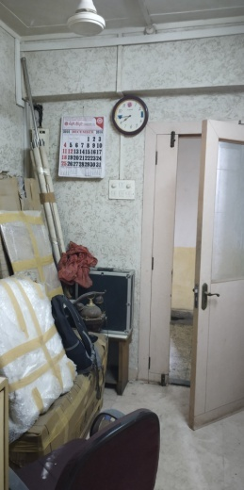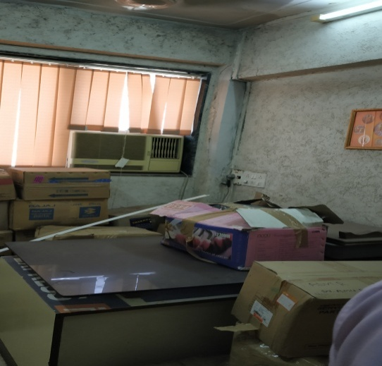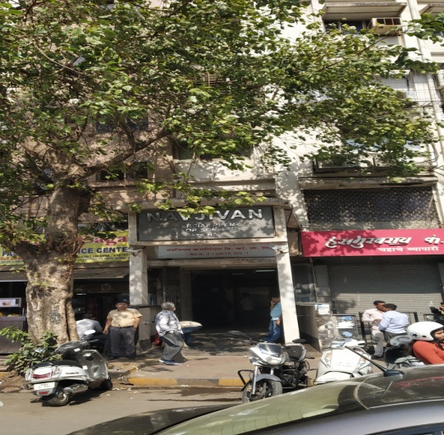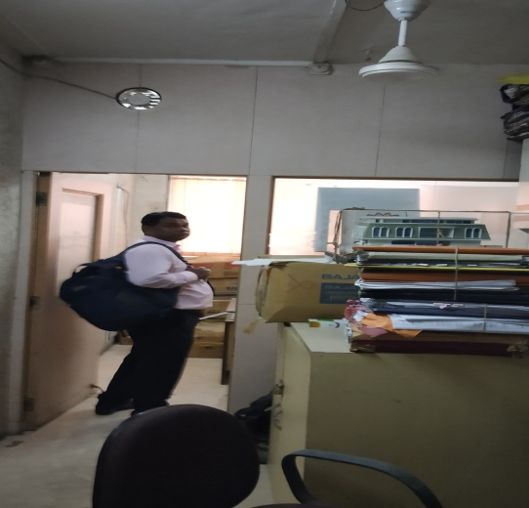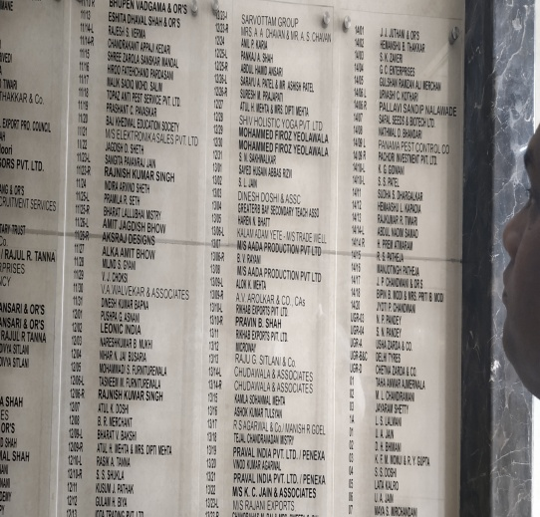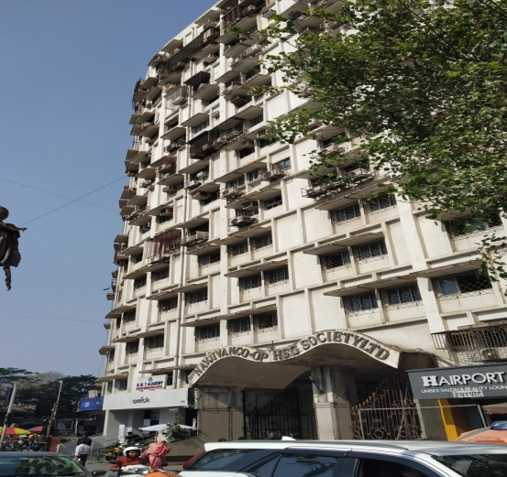

**Route Map of the property**

**Site u/r**

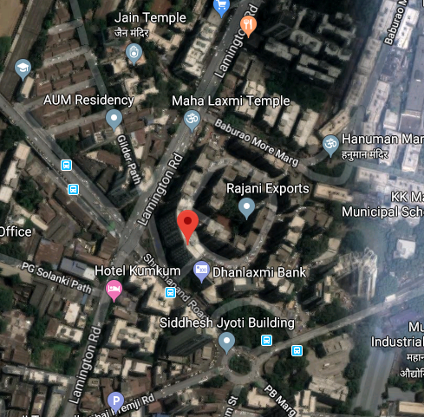

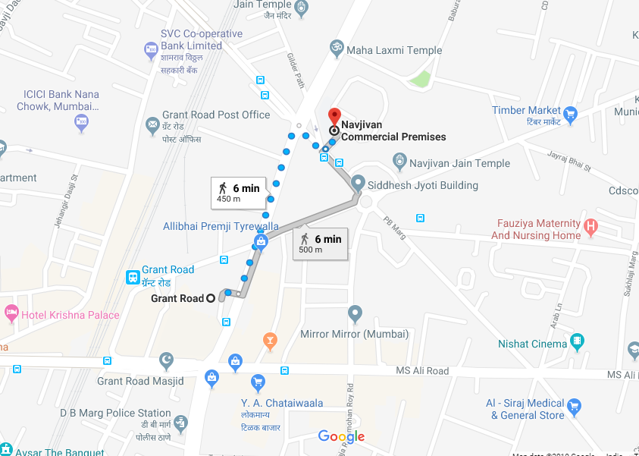

**Latitude Longitude - 18°57'56.7"N 72°49'10.1"E**

**Note**: The Blue line shows the route to site from nearest railway station (Mumbai Central - 450 M)

**DEFINITION OF VALUE FOR THIS SPECIFIC PURPOSE**

This exercise is to assess **Fair Market Value** of the property under reference for **Fair Market Value** purpose as on dated **12**th **March 2017.**

The term Fair Market Value is defined as

*"The most probable price, as of a specified date, in cash, terms equivalent to cash, or in other precisely revealed terms for which the specified property rights would sell after reasonable exposure in a competitive market under all conditions requisite to a fair sale, with the buyer and seller each acting prudently knowledgeably and for self-interest assuming that neither is under undue duress"*

Fundamental assumptions and conditions presumed in this definition are:

1. Buyer and seller are motivated by self-interest.
2. Buyer and seller are well informed and are acting prudently.
3. The property is exposed for a reasonable time on the open market.
4. Payment is made in cash or equivalent or in specified financing terms.

**UNDER LYING ASSUMPTIONS**

1. We assume no responsibility for matters of legal nature affecting the property appraised or the title thereto, nor do we render our opinion as to the title, which is assumed to be good and marketable
2. The property is valued as though under responsible ownership.
3. It is assumed that the property is free of liens and encumbrances.
4. It is assumed that there are no hidden or unapparent conditions of the subsoil or structure that would render it more or less valuable. No responsibility is assumed for such conditions or for engineering that might be required to discover such factors.

**Manoj B. Chalikwar**

Approved Valuer & Chartered Engineer

Reg. No. CAT-I-F-1763

**DECLARATION OF PROFESSIONAL FEES CHARGED**

We hereby declare that, our professional fees are not contingent upon the valuation findings. However, if the statute AND/OR clients demands that, the fees should be charged on the percentage of assessed value then, with the full knowledge of the AND/OR end user, it is being charged accordingly.

**VALUATION OF THE PROPERTY PREMISES**

Considering various parameters recorded herein above, existing economic scenario, and the information that is available with reference to the development of neighbourhood and method selected for valuation, we are of the opinion that, the property premises can be assessed and valued for Visa Application Purpose as on day for **`51,62,500.00 (Rupees Fifty One Lac Sixty Two Thousand Five Hundred Only).**

**STATEMENT OF LIMITING CONDITIONS**

1. Assumptions are made to the best of our knowledge and belief. Reliance is based on the information furnished to us by the identifier AND/OR client.
2. The Valuer shall not be responsible for matters of legal nature that affects the value and opinion expressed by us.
3. If our appearance is required, we will be pleased to appear and give the necessary clarification, provided the fees for each appearance (excluding traveling, dearness allowance and out of pocket expenses) is pre-determined before the acceptance of the assignment under reference.
4. In no event shall the Valuer be held responsible or liable for special, direct, indirect or consequential damages, as the assignment has been completed on best efforts, available knowledge and in good intentions of persons concerned and belief.
5. **If it is proved that there is an apparent negligence on the part of a Valuer**, liability of this assignment (whether arising from this assignment, negligence or whatsoever) is limited in respect of anyone event or series of events to the actual loss or damage sustained subject to maximum of 80% of the professional fees for the services rendered and in any case not exceeding the amount of **`1,000 (Rupees One Thousand Only). All the claims against us shall expire after three month from the date of submission of the valuation report provided by us.**
6. We hereby declare that, the information furnished above is true and correct to the best of our knowledge and belief. We have no direct or indirect interest in the assets valued. We have not been convicted of any offence and sentenced to a term of imprisonment. We have not been found guilty of misconduct in our professional capacity. We have personally inspected the assets.

**Manoj B. Chalikwar**

Approved Valuer & Chartered Engineer

Reg. No. CAT-I-F-1763