**Valuation Report of the Immovable Property**

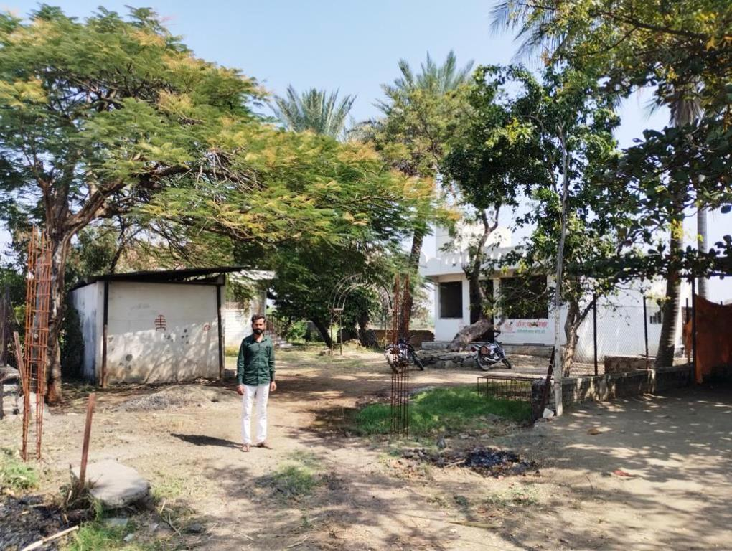

**Details of the property under Consideration:**

**Name of Owner: Mr. Ashok Shankarrao Chavan**

Land & Structure at Gut No. 67/2, Village - Katpur, Taluka - Paithan, District - Aurangabad,

PIN – 431 148, State - Maharashtra, India

# **Longitude Latitude: 19°30'37.3"N 75°23'30.8"E**

**Valuation Done for:**

**Private Valuation**

# 

Vastu/Nanded/02/2024/11189 Date: 12.02.2024

# **VALUER’S OPINION REPORT**

This is to certify that the property situated on Land & Structure at Gut No. 67/2, Village - Katpur, Taluka - Paithan, District - Aurangabad, PIN – 431 148, State - Maharashtra, India is belongs to **Mr. Ashok Shankarrao Chavan.**

|  |  |  |
| --- | --- | --- |
| Boundaries of the property are as under: | | |
| North | : | Other Agricultural Land | |
| South | : | Other Agricultural Land / Road | |
| East | : | Other Agricultural Land | |
| West | : | Internal Kachha Road | |
|  |  |  | |

Considering various parameters recorded, existing economic scenario, and the information that is available with reference to the development of neighborhood and method selected for valuation, we are of the opinion that, the property premises can be assessed and valued for this particular purpose as under.

|  |  |
| --- | --- |
| **Guideline value of the property.** | **` 65,21,782.00** |
| **Fair Market value of the property** | **` 69,21,782.00** |
| **Realizable Value of the property.** | **` 62,29,604.00** |
| **Distress / Forced Sale Value of the property.** | **` 55,37,426.00** |

The valuation of the property is based on the documents produced by the concern. Legal aspects have not been taken into considerations while preparing this valuation report.

Hence certified.

For, **Vastukala Consultants (I) Pvt. Ltd.**

**Sharadkumar B. Chalikwar**

B.E. (Civil), M.E. (Civil), M.Sc. (Real Estate Valuation), M.Sc. (P&M Valuation), FIE (I), FIV, FIWRS

Chairman & Managing Director

Govt. Reg. Valuer

Chartered Engineer (India)

Reg. No. (N) CCIT/1-14/52/2008-09

IBBI Reg. No. IBBI/RV/07/2019/11744

Encl: Valuation report.

|  |  |  |  |  |
| --- | --- | --- | --- | --- |
|  |  | |  |  |
| **VALUATION REPORT**  (IN RESPECT OF LAND / SITE & STRUCTURE)   |  |  |  |  |  |  |  |  |  |  |  | | --- | --- | --- | --- | --- | --- | --- | --- | --- | --- | --- | | I. | **General** | | | | | | | | | | | 1. | Purpose for which the valuation is made. | | | | | | To assess Fair Market value of the property for **Private Purpose**. | | | | | 2. | a) | | | Date of inspection | | | 09.02.2024 | | | | | b) | | | Date on which the valuation is made | | | 09.02.2024 | | | | | c) | | | Date of Valuation Report | | | 12.02.2024 | | | | | 3. | **List of documents produced for perusal** | | | | | | | | | | | 1 | | Copy of Previous Valuation Report dated 15.03.2019 | | | | | | | | | 4 | | Copy of 7/12 Revenue Extract | | | | | | | | |  | | Copy of Labh Kshetra Vikas Pradhikaran Jaiyakwadi Prakulp,Aurangabad Certificate No. 23289 dated 13.03.2019 | | | | | | | | | 4. | Name of the owner(s) and his / their address (es) with Phone no. (details of share of each owner in case of joint ownership) | | | | | | **Mr. Mr. Ashokrao Shankarrao Chavan.**  **Address:** Land & Structure at Gut No. 67/2, Village - Katpur, Taluka - Paithan, District - Aurangabad, PIN – 431 148, State - Maharashtra, India.    Sole Ownership | | | | | 5. | Brief description of the property  (Including Leasehold / freehold etc.) | | | | | | The immovable property comprises of Agricultural Land and Farm House and Servant Quarter thereof. The property is located in an undeveloped area having basic infrastructure, well connected by road and train. It is located at about 4.5 km. travelling distance from Paithan Bus Stop, Railway Station. | | | | | 6. | Location of property | | | | | | | | | | |  | a) | Plot No. / Survey No. | | | | | Gut No. 67/2 | | | | | b) | Door No. | | | | | - | | | | | c) | T.S. No. / Village | | | | | Village - Katpur | | | | | d) | Ward / Taluka | | | | | Taluka - Paithan | | | | | e) | Mandal / District | | | | | District - Aurangabad | | | | | 7. | Postal address of the property | | | | | | Land & Structure at Gut No. 67/2, Village - Katpur, Taluka - Paithan, District - Aurangabad, PIN – 431 148, State - Maharashtra, India. | | | | | 8. | Type of property | | | | | | Agricultural Land with Farm House and Servant Quarter | | | | | 9. | Classification of the area | | | | | | | | | | | i) High / Middle / Poor | | | | | | | Middle Class | | | | ii) Urban / Semi Urban / Rural | | | | | | | Rural | | | | 10. | Coming under Corporation limit / Village Panchayat / Municipality | | | | | | | Coming under Grampanchayat limits | | | | 11. | Whether covered under any State / Central Govt. enactments (e.g., Urban Land Ceiling Act) or notified under agency area/ scheduled area / cantonment area. | | | | | | | No. | | | | 12. | **Boundaries of the property** | | | | | **As Per Documents** | | | | **As Per Actual** | | **North** | | | | | Details not available | | | | Other Agricultural Land | | **South** | | | | | Details not available | | | | Other Agricultural Land / Road | | **East** | | | | | Details not available | | | | Other Agricultural Land | | **West** | | | | | Details not available | | | | Internal Kachha Road | | 13 | Whether occupied by the owner / tenant? If Occupied by tenant since how long? Rent Received per month. | | | | | | Owner Occupied | | | | | **II** | **CHARACTERSTICS OF THE SITE** | | | | | | | | | | |  | Classification of locality. | | | | | | Middle class | | | | |  | Development of surrounding areas. | | | | | | Undeveloped Agricultural land | | | | |  | Possibility of frequent flooding/ sub-merging. | | | | | | No | | | | |  | Feasibility to the Civic amenities like School, Hospital, Bus Stop, Market etc. | | | | | | Not available | | | | |  | Level of land with topographical conditions. | | | | | | Plain | | | | |  | Shape of land. | | | | | | Irregular | | | | |  | Type of use to which it can be put. | | | | | | Agriculture | | | | |  | Is plot in town planning approved layout? | | | | | | No | | | | |  | Corner plot or intermittent plot? | | | | | | Intermittent | | | | |  | Road facilities. | | | | | | Yes | | | | |  | Type of road available at present | | | | | | B.T. Road | | | | |  | Width of road – is it below 20 ft. or more than 20 ft. | | | | | | 6.00 m Wide Road | | | | |  | Is it a Land – Locked land? | | | | | | No | | | | |  | Water potentiality. | | | | | | Borewell, Well lift irrigation | | | | |  | Underground sewerage system. | | | | | | Septic tank | | | | |  | Is Power supply is available in the site. | | | | | | Available | | | | |  | Advantages of the site. | | | | | | None | | | | |  | Special remarks, if any like threat of acquisition of land for publics service purposes, road widening or applicability of CRZ provisions etc. (Distance from sea-cost / tidal level must be incorporated.) | | | | | | No | | | | | **Part – A (Valuation of land)** | | | | | | | | | | | | 1 | Total extent of the plot | | | | | | **4.14 Hectare** | | | | | 2 | Prevailing market rate ( Along With details / reference of at least two latest deals / transactions with respect to adjacent properties in the areas) | | | | | | **` 12,00,000.00 to ` 13,00,000.00 per Hectare.** according to location, approach road and infra structure facilities available. | | | | | 3 | Guideline rate obtained from the Register’s Office  (an evidence thereof to be enclosed) | | | | | | **` 12,61,300.00 per Hectare** | | | | | 4 | Assessed / adopted rate of valuation | | | | | | **` 12,61,300.00 per Hectare** | | | | | 5 | Estimated value of land | | | | | | **` 52,21,782.00** | | | | | **Part – B (Valuation of Building)** | | | | | | | | | | | | 1 | Technical details of the building | | | | | | | | | | |  | | | | Type of Building (Residential / Commercial / Industrial) | | Farm House and Servant Quarter | | | | |  | | | | Type of construction  (Load bearing / RCC / Steel Framed) | | RCC Structure. | | | | |  | | | | Year of construction. | | Information not available | | | | |  | | | | Number of floors and height of each floor including basement, if any | | Ground floor structure only | | | | |  | | | | Plinth area floor-wise | | Information not available | | | | |  | | | | **Condition of the building** | | | | | | |  | | | | i. Exterior: Excellent, Good, Normal, Poor | | | | Normal | | | ii. Interior: Excellent, Good, Normal, Poor | | | | Normal | |   **Specifications of construction in respect of**   |  |  |  |  |  | | --- | --- | --- | --- | --- | | **Sr. No.** | | **Description** | **Ground Floor** | | |  | | Foundation | RCC | | |  | | Basement | No | | |  | | Superstructure | R.C.C. frame work with 9" thick B. B. Masonry for external walls. 6" Thick. B.B. Masonry for internal walls | | |  | | Joinery / Doors & Windows | MS Grill Windows, MS Collapsible grill to main entrance | | |  | | RCC Works | Footings, Columns, Beams, Slab | | |  | | Plastering | Cement plastering | | |  | | Flooring, Skirting, dado | External visit only | | |  | | Special finish as marble, granite, wooden paneling, grills etc. | Normal | | |  | | Roofing including weather proof course | R.C.C. Slab | | |  | | Drainage | Connected to Grampanchayat Sewerage System | | | **2.** | | **Compound Wall** | No | | | **3.** | | **Electrical installation** | | | | Type of wiring | External visit only | | | Class of fittings (superior / ordinary / poor) | External visit only | | | Number of light points | External visit only | | | Fan points | External visit only | | | Spare plug points | External visit only | | | Power point | External visit only | | | **4.** | | **Plumbing installation** | | | | 1. No. of water closets and their type | External visit only | | | 1. No. of wash basins | External visit only | | | 1. No. of urinals | External visit only | | | 1. No. of bath tubs | External visit only | | | 1. Water meters, taps etc. | External visit only | | | 1. Any other fixtures | External visit only | | | **Valuation of proposed construction/additions/renovation if any:** | | | | Amount in Rs. | |  | **SUMMARY OF VALUATION:** | | | | |  | Part I Land | | | **` 52,21,782.00** | |  | Part II Building (Farm House) | | | **` 10,00,000.00** | |  | Servant Quarter | | | **` 3,00,000.00** | |  | Part III Other amenities /Miscellaneous (Well, Bore Well, Lift Irrigation) | | | **` 4,00,000.00** | |  | Part IV Proposed construction | | | Nil | |  | Guideline rate of the property | | | **` 65,21,782.00** | |  | **TOTAL VALUE OF THE PROPERTY** | | | **` 69,21,782.00** | |  | The realizable value of the property | | | **` 62,29,604.00** | |  | Distress value of the property | | | **` 55,37,426.00** | | |

I/ my authorized representative have personally inspected the property on 09.02.2024.

The rates for valuation of the property are accordance with the govt approved rates and prevailing market rates.

There is no direct / indirect interest in the property value

The undersigned has inspected the property detailed in the valuation report dated 12.02.2024, we are satisfied that the **Fair and reasonable value** of the property is **` 69,21,782.00 (Rupees Sixty Nine Lakh Twenty One Thousand Seven Hundred Eight Two Only).**

For, **Vastukala Consultants (I) Pvt. Ltd.**

**Sharadkumar B. Chalikwar**

B.E. (Civil), M.E. (Civil), M.Sc. (Real Estate Valuation), M.Sc. (P&M Valuation), FIE (I), FIV, FIWRS

Chairman & Managing Director

Govt. Reg. Valuer

Chartered Engineer (India)

Reg. No. (N) CCIT/1-14/52/2008-09

IBBI Reg. No. IBBI/RV/07/2019/11744

Actual site photographs

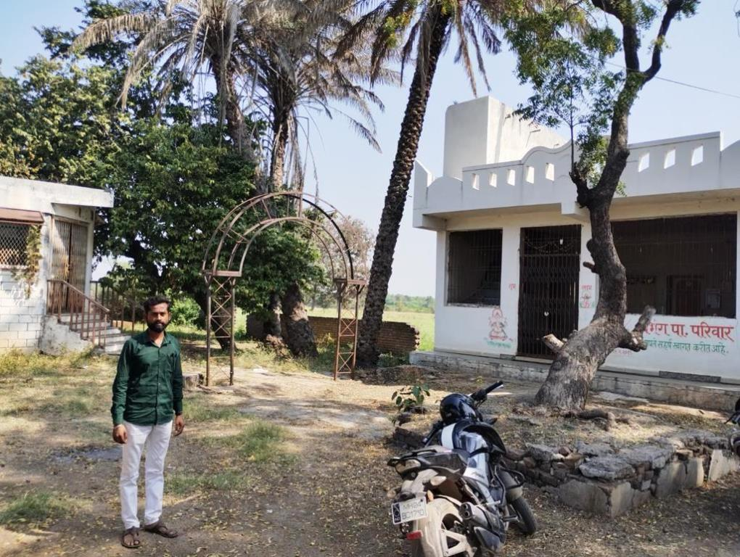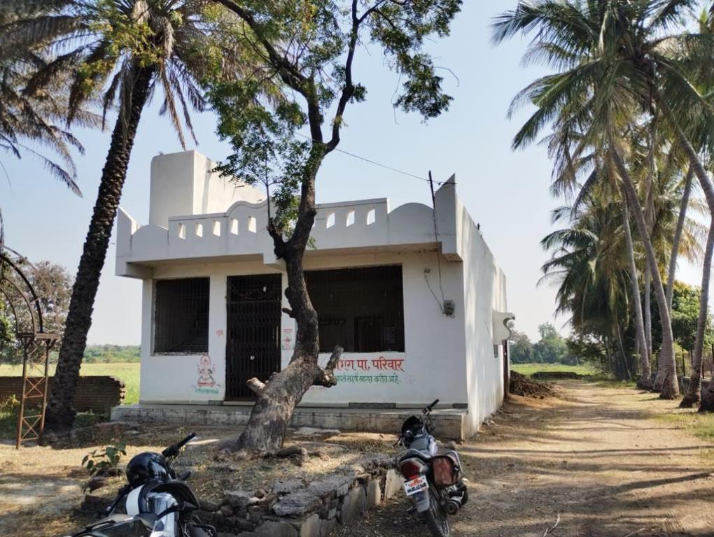

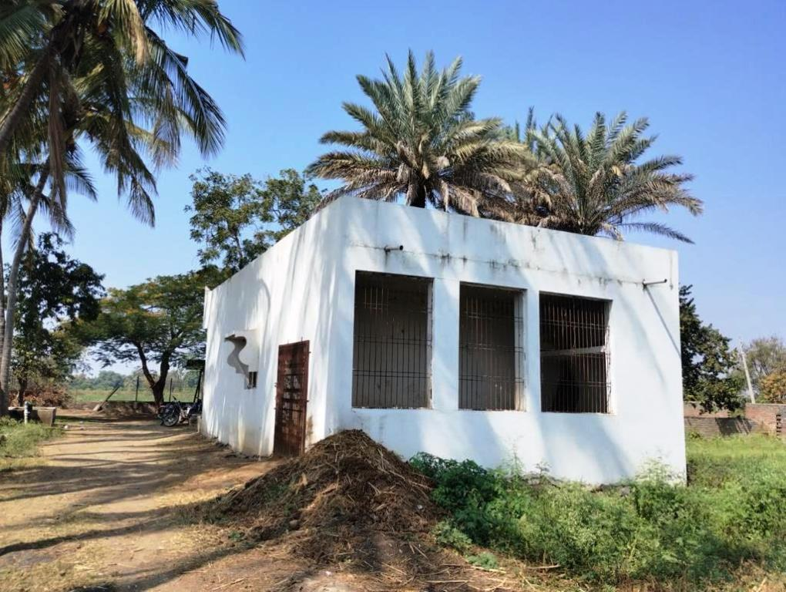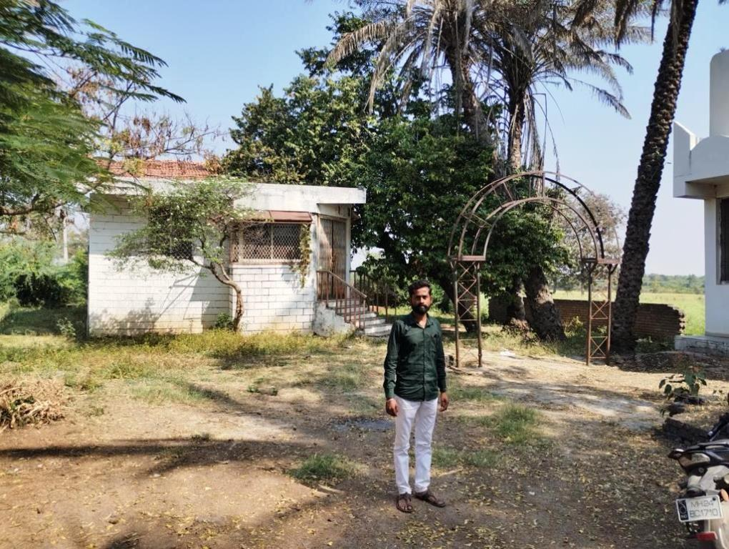

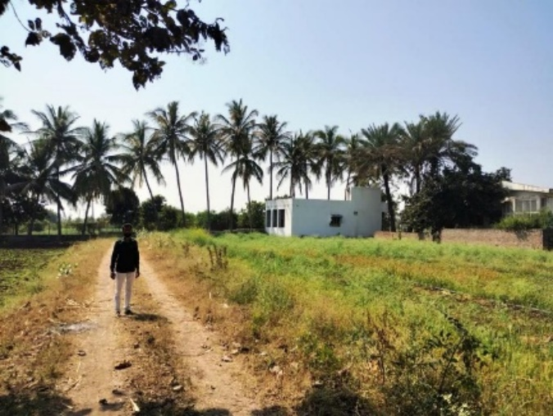

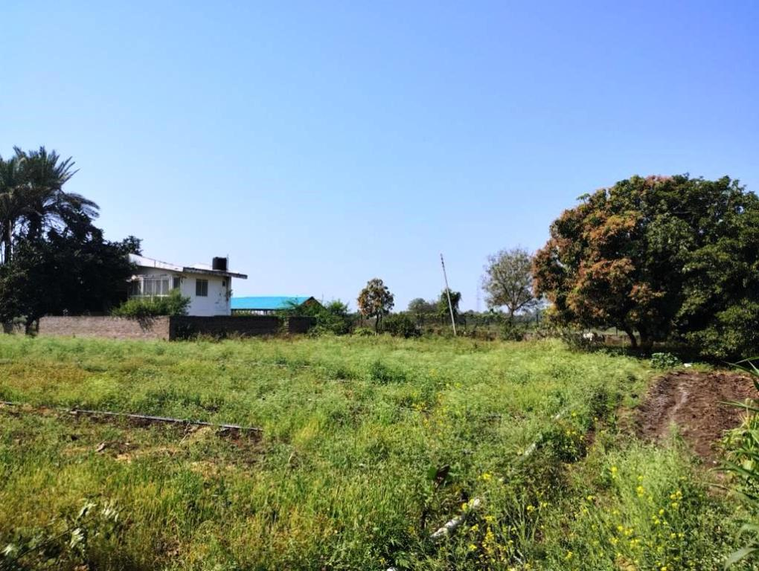

Actual site photographs

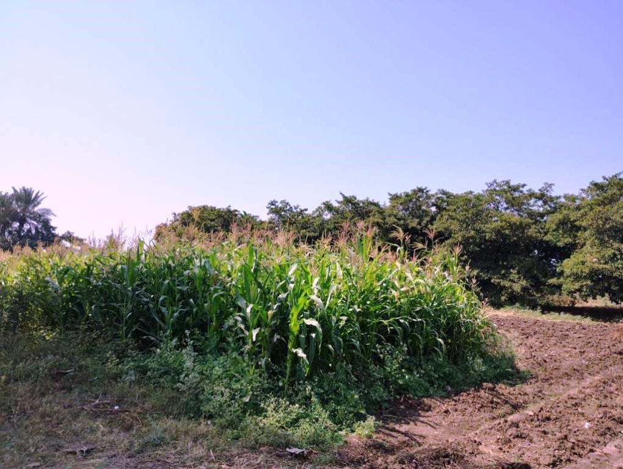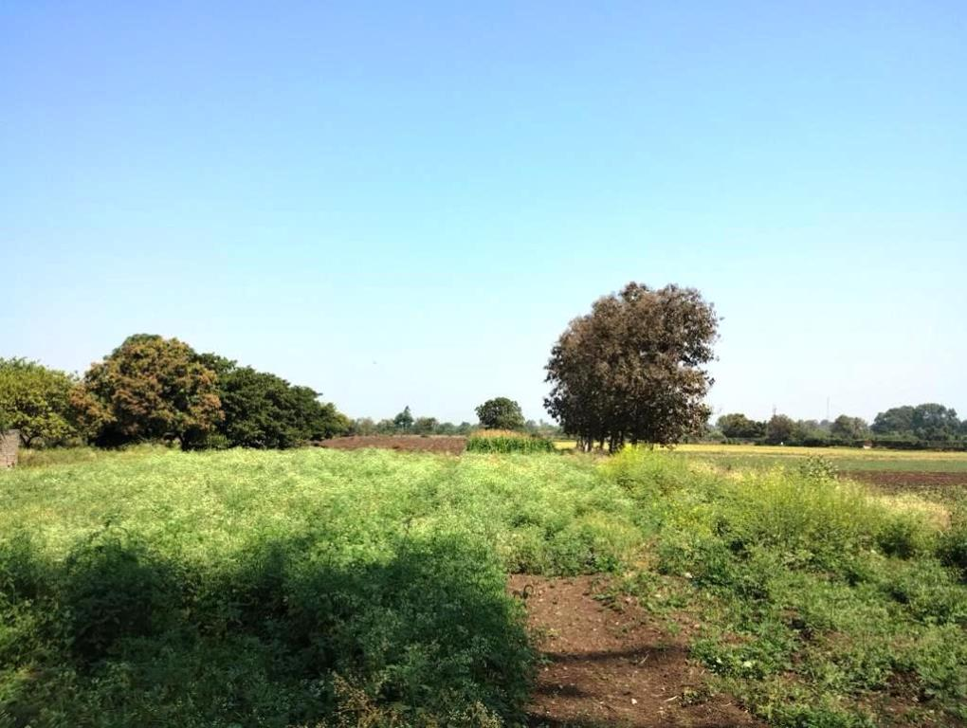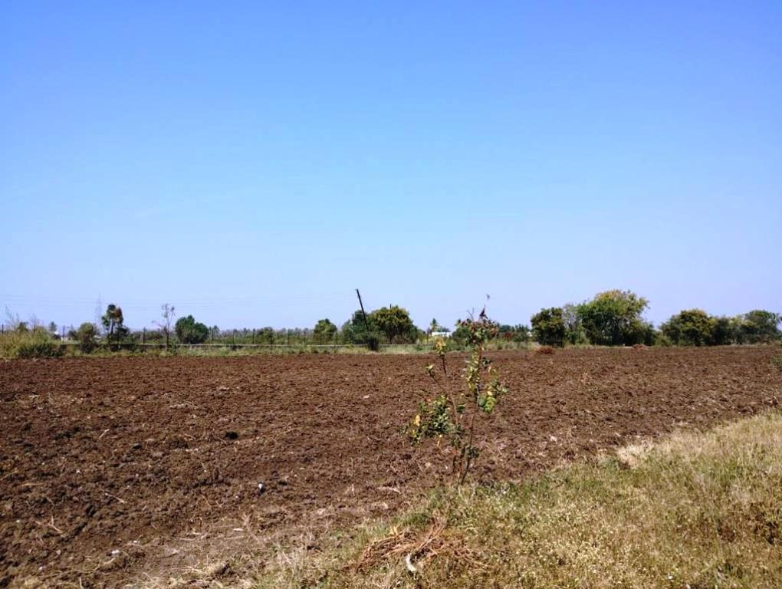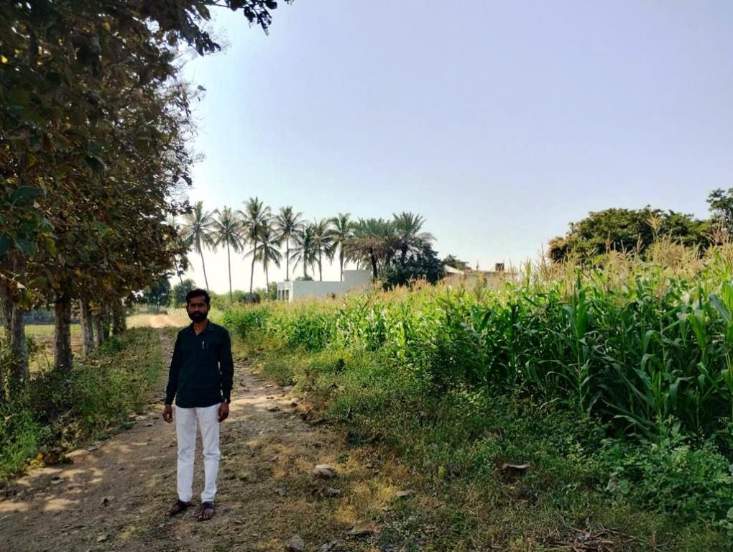

**Route Map of the property**

**Site u/r**

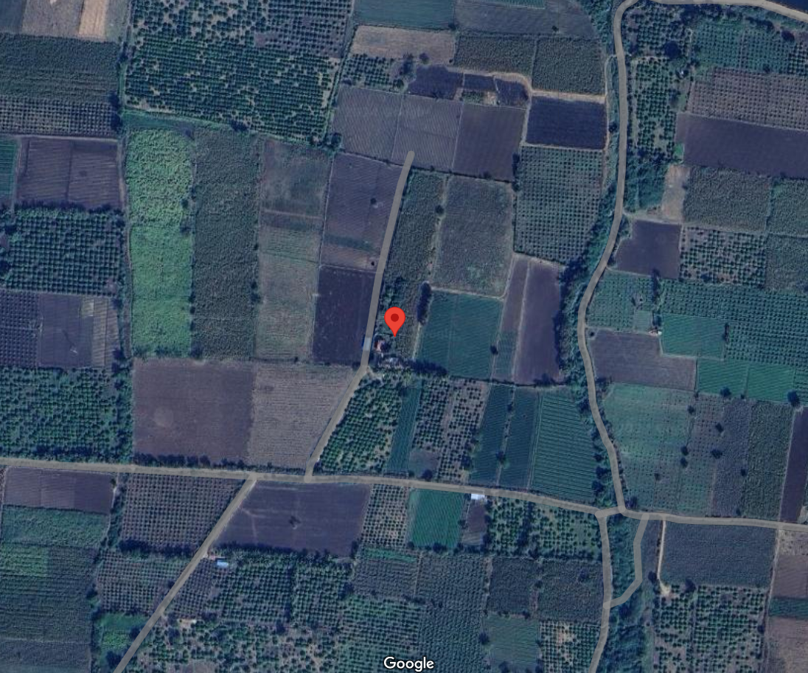

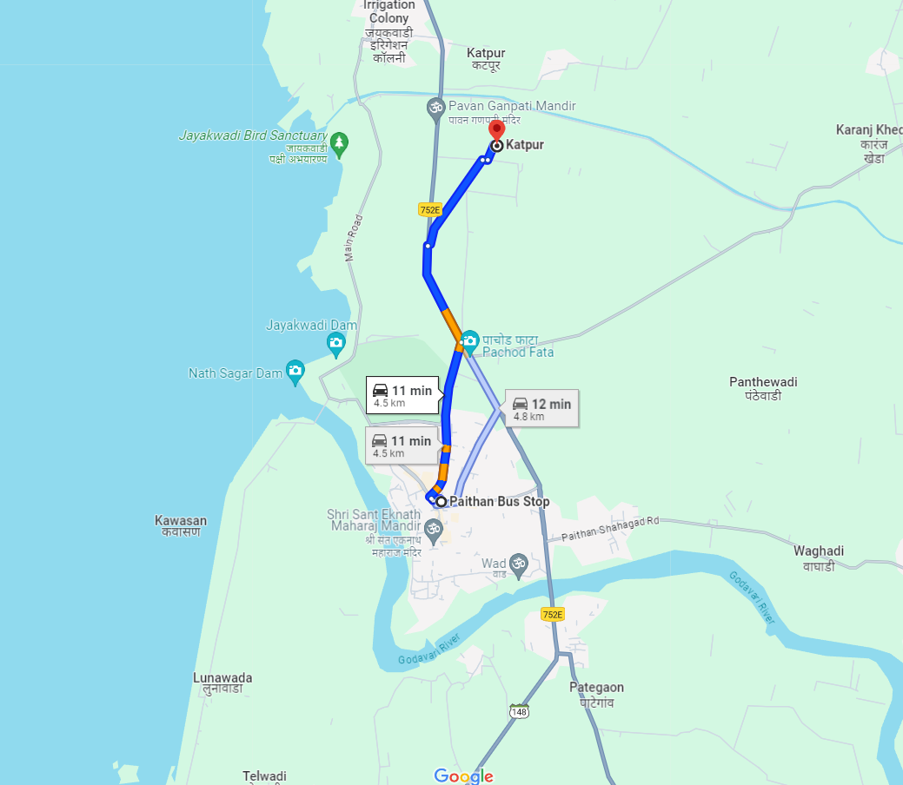

**Longitude Latitude: 19°30'37.3"N 75°23'30.8"E**

**Note**: The Blue line shows the route to site from nearest Bus Stio(Paithan - 4.5 M)

**Ready Reckoner Rate**

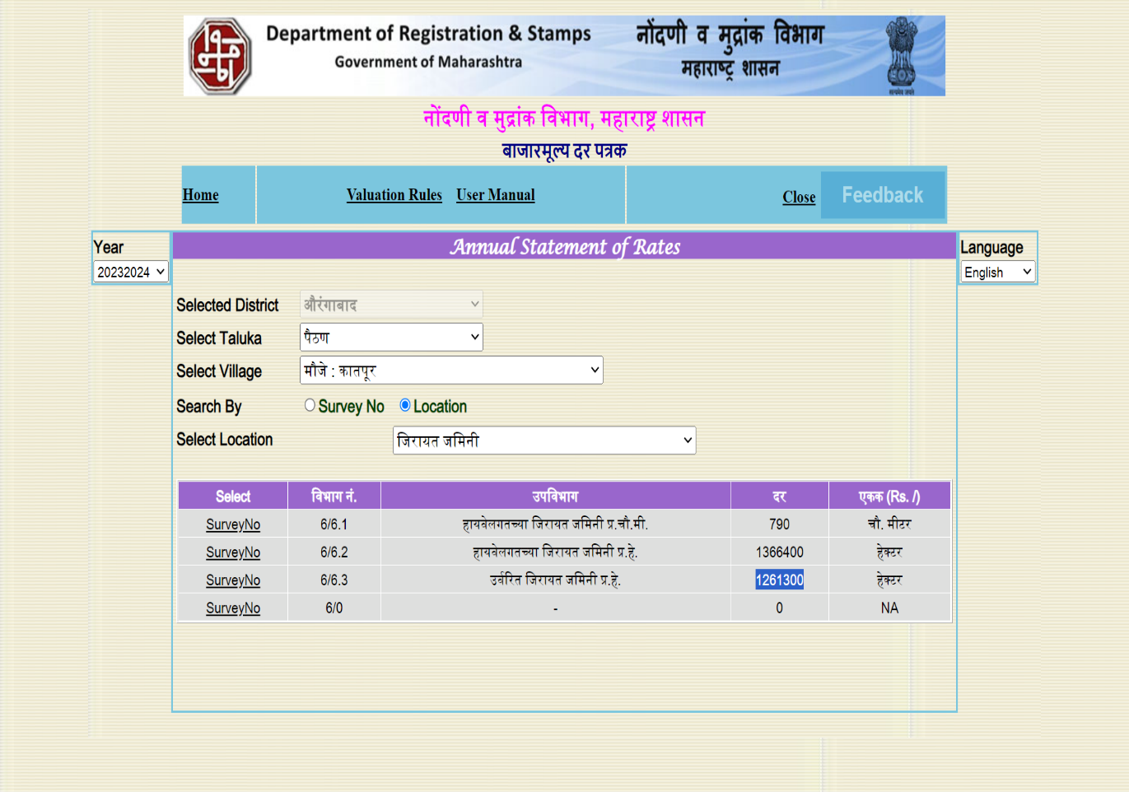

**DEFINITION OF VALUE FOR THIS SPECIFIC PURPOSE**

This exercise is to assess **Fair Market Value** of the property under reference as on dated **12th February 2024.**

The term Fair Market Value is defined as

*"The most probable price, as of a specified date, in cash, terms equivalent to cash, or in other precisely revealed terms for which the specified property rights would sell after reasonable exposure in a competitive market under all conditions requisite to a fair sale, with the buyer and seller each acting prudently knowledgeably and for self-interest assuming that neither is under undue duress"*

Fundamental assumptions and conditions presumed in this definition are:

1. Buyer and seller are motivated by self-interest.
2. Buyer and seller are well informed and are acting prudently.
3. The property is exposed for a reasonable time on the open market.
4. Payment is made in cash or equivalent or in specified financing terms.

**UNDER LYING ASSUMPTIONS**

1. We assume no responsibility for matters of legal nature affecting the property appraised or the title thereto, nor do we render our opinion as to the title, which is assumed to be good and marketable
2. The property is valued as though under responsible ownership.
3. It is assumed that the property is free of liens and encumbrances.
4. It is assumed that there are no hidden or unapparent conditions of the subsoil or structure that would render it more or less valuable. No responsibility is assumed for such conditions or for engineering that might be required to discover such factors.

For, **Vastukala Consultants (I) Pvt. Ltd.**

**Sharadkumar B. Chalikwar**

B.E. (Civil), M.E. (Civil), M.Sc. (Real Estate Valuation), M.Sc. (P&M Valuation), FIE (I), FIV, FIWRS

Chairman & Managing Director

Govt. Reg. Valuer

Chartered Engineer (India)

Reg. No. (N) CCIT/1-14/52/2008-09

IBBI Reg.No. IBBI/RV/07/2019/11744

**DECLARATION OF PROFESSIONAL FEES CHARGED**

We hereby declare that, our professional fees are not contingent upon the valuation findings. However, if the statute AND/OR clients demands that, the fees should be charged on the percentage of assessed value then, with the full knowledge of the AND/OR end user, it is being charged accordingly.

**VALUATION OF THE PROPERTY PREMISES**

Considering various parameters recorded herein above, existing economic scenario, and the information that is available with reference to the development of neighbourhood and method selected for valuation, we are of the opinion that, the property premises can be assessed and valued for Banking Purpose as on day for

**` 69,21,782.00 (Rupees Sixty Nine Lakh Twenty One Thousand Seven Hundred Eight Two Only).**

**STATEMENT OF LIMITING CONDITIONS**

1. Assumptions are made to the best of our knowledge and belief. Reliance is based on the information furnished to us by the identifier AND/OR client.
2. The Valuer shall not be responsible for matters of legal nature that affects the value and opinion expressed by us.
3. If our appearance is required, we will be pleased to appear and give the necessary clarification, provided the fees for each appearance (excluding travelling, dearness allowance and out of pocket expenses) is pre-determined before the acceptance of the assignment under reference.
4. In no event shall the Valuer be held responsible or liable for special, direct, indirect or consequential damages, as the assignment has been completed on best efforts, available knowledge and in good intentions of persons concerned and belief.
5. **If it is proved that there is an apparent negligence on the part of a Valuer**, liability of this assignment (whether arising from this assignment, negligence or whatsoever) is limited in respect of anyone event or series of events to the actual loss or damage sustained subject to maximum of 80% of the professional fees for the services rendered and in any case not exceeding the amount of ` **1,000 (Rupees One Thousand Only). All the claims against us shall expire after three month from the date of submission of the valuation report provided by us.**
6. We hereby declare that, the information furnished above is true and correct to the best of our knowledge and belief. We have no direct or indirect interest in the assets valued. We have not been convicted of any offence and sentenced to a term of imprisonment. We have not been found guilty of misconduct in our professional capacity. We have personally inspected the assets.

For, **Vastukala Consultants (I) Pvt. Ltd.**

**Sharadkumar B. Chalikwar**

B.E. (Civil), M.E. (Civil), M.Sc. (Real Estate Valuation), M.Sc. (P&M Valuation), FIE (I), FIV, FIWRS

Chairman & Managing Director

Govt. Reg. Valuer

Chartered Engineer (India)

Reg. No. (N) CCIT/1-14/52/2008-09

IBBI Reg.No. IBBI/RV/07/2019/11744