Vastu/Nashik/06/32014/2301224
22/20-325-RYBS
Date: 12.02.2024

To,
The Branch Manager,
Bank of Baroda
Regional Office
BSNL Building, Datta Mandir Road, Nashik Road,
Nashik, PIN – 422 101, State - Maharashtra, Country - India.

Sub: Vetting of Extra Work

Sir,

With reference to above subject, we have evaluated the Extra Work For Residential Flat No. A - 802, 8th Floor, A-Wing "Millennium Tower", Survey No. 200/ 6/ 1, Plot No.1A, Behind Laxminarayan Yeola Pathaini Sarees, Sai Nagar, Ayodhya Nagari, SaiNagar Road, Village – Nashik, Taluka- Nashik, District - Nashik, PIN Code – 422 003, State – Maharashtra, Country – India. belongs to Name of Owner: Mr. Saurabh Narayan Balve.

We have verified the rates quoted as per current market rates. Details of Extra Work considered as per copy of Extra Work Agreement between Mr. Saurabh Narayan Balve. (First Party). M/s. Nasa Constructions Pvt. Ltd (Second Party) received on dated.09.02.2024. The Extra Work amount is Rs. 10,00,000/- (Rupees Ten Lakh Only)

The said Cost Vetting Certificate is valid upto next 6 months Only.

Thanking you

Sincerely yours

Manoj B. Chalikwar
Registered Valuer
Chartered Engineer (India)
Reg. No. CAT-I-F-1763
Reg. No. IBBI/RV/07/2018/10366
BOB Empanelment No.: ZO:MZ:ADV:46:941
Encl: Valuation report.

Agreement for Extra Work
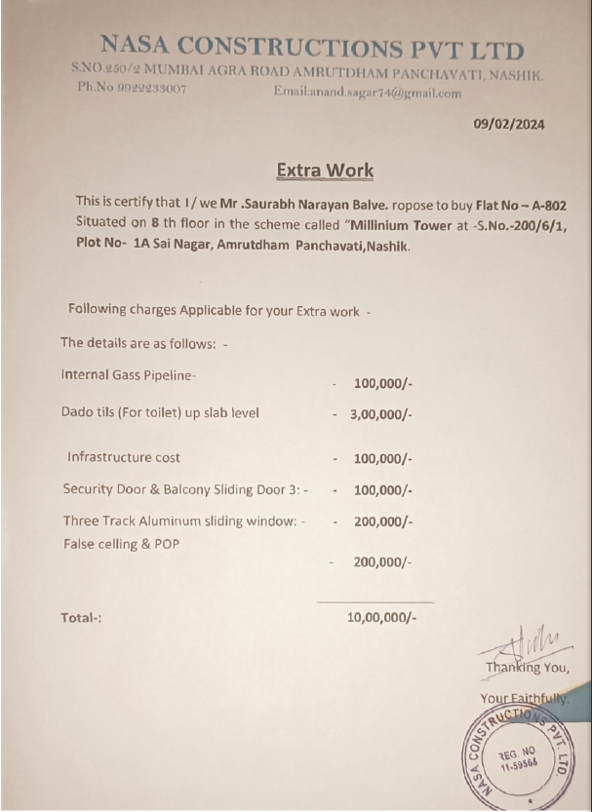

The Extra Work amount is Rs. 10,00,000/- (Rupees Ten Lakh Only)

