Valuation Report of the Immovable Property

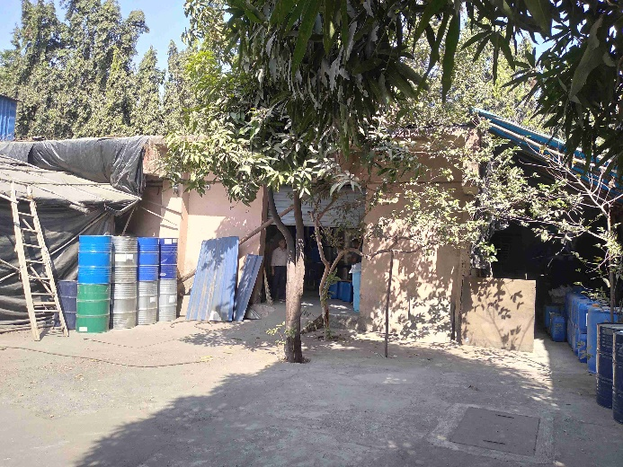

**Details of the property under consideration:**

Name of Owner: **M/s. Leo Fragrances**

**Industrial Land & Building** on Plot No. D-14/7, T.T.C., M.I.D.C. Industrial Area, H Maitri Foods & Cold Storage Pvt. Ltd., Village – Bonsari & Kukshet, Taluka – Thane, District – Thane – 400 703,

State – Maharashtra, Country – India

# Latitude Longitude - 19°03'52.4"N 73°01'51.0"E

# 

**Valuation Prepared for:**

**Cosmos Bank**

**Naupada Branch**

Kusumanjali, Opp. Devdhar Hospital, Naupada, Thane (West) - 400 602, State - Maharashtra, Country - India

Vastu/Thane/02/2024/6894/2305125

23/13-347-VSM Date: 23.02.2024

# VALUATION OPINION REPORT

The property bearing **Industrial Land & Building** on Plot No. D-14/7, T.T.C., M.I.D.C. Industrial Area, H Maitri Foods & Cold Storage Pvt. Ltd., Village – Bonsari & Kukshet, Taluka – Thane, District – Thane – 400 703, State – Maharashtra, Country – India belongs to **M/s. Leo Fragrances.**

|  |  |  |
| --- | --- | --- |
| **Boundaries of the property.** | | |
| North | : | Plot No. D – 15/4 | |
| South | : | 13.70 mtrs. Wide MIDC Road | |
| East | : | Plot No. D – 14/6 | |
| West | : | Plot No. D – 14/8 | |

Considering various parameters recorded, existing economic scenario, and the information that is available with reference to the development of neighborhood and method selected for valuation, we are of the opinion that, the property premises can be assessed and valued for banking purpose as below –

|  |  |
| --- | --- |
| **Particulars** | **Value (`)** |
| **Fair Market Value** | **3,54,89,093.00** |
| **Realizable Value** | **3,19,40,184.00** |
| **Distress Sale Value** | **2,83,91,274.00** |
| **Insurance Value** | **10,80,225.00** |

The valuation of the property is based on the documents produced by the concern. Legal aspects have not been taken into considerations while preparing this valuation report.

Hence certified

## Manoj B. Chalikwar

Registered Valuer

Chartered Engineer (India)

Reg. No. IBBI / RV / 07/2018/10366

Reg. No. CAT-I-F-1763

**Valuation Report of Industrial Land & Building** on Plot No. D-14/7, T.T.C., M.I.D.C. Industrial Area, H Maitri Foods & Cold Storage Pvt. Ltd., Village – Bonsari & Kukshet, Taluka – Thane, District – Thane – 400 703,

State – Maharashtra, Country – India

*Form 0-1*

*(See Rule 8 D)*

REPORT OF VALUATION OF IMMOVABLE PROPERTY (OTHER THAN AGRICULTURAL LANDS, PLANTATIONS, FORESTS, MINES AND QUARRIES)

GENERAL:

|  |  |  |  |
| --- | --- | --- | --- |
| 1 | Purpose for which the valuation is made | | To assess the Fair Market Value as on 23.02.2024 for Bank loan Purpose |
| 2 | Date of inspection | | 07.02.2024 |
|  | Name of the owner/ owners | | **M/s. Leo Fragrances** |
| 4 | If the property is under joint ownership / co-ownership, share of each such owner. Are the shares undivided? | | Partnership Firm |
| 5 | Brief description of the property | | **Industrial Land & Building** on Plot No. D-14/7, T.T.C., M.I.D.C. Industrial Area, H Maitri Foods & Cold Storage Pvt. Ltd., Village – Bonsari & Kukshet, Taluka – Thane, District – Thane – 400 703, State – Maharashtra, Country – India |
| 6 | Location, street, ward no | | S Central Road |
| 7 | Survey/ Plot no. of land | | Plot No. D-14/7 |
| 8 | Is the property situated in residential/ commercial/ mixed area/ industrial area? | | Industrial area |
| 9 | Classification of locality-high class/ middle class/poor class | | Middle Class |
| 10 | Proximity to civic amenities like schools, Hospitals, Offices, market, cinemas etc. | | All the amenities are available in the vicinity |
| 11 | Means and proximity to surface communication by which the locality is served | | Served by Buses and Private cars |
|  | *LAND* | |  |
| 12 | Area of land supported by documentary proof. Shape, dimension and physical features | | Plot area – 600.32 Sq. M.  (Area as per Sub Lease Deed) |
| 13 | Roads, Streets or lanes on which the land is abutting | | 13.70 mtrs. Wide MIDC Road |
| 14 | If freehold or leasehold land | | Leasehold of MIDC |
| 15 | If leasehold, the name of Lessor/lessee, nature of lease, date of commencement and termination of lease and terms of renewal of lease. | | Lessor – MIDC  Sub Lessor – Chemical and Alkali Industrial And Warehousing Co- Op. Soc. Ltd.  Sub Lessee (Assignor) – Shri. Yash K. Mehta & Shri. Viraj J. Mehta  Assignee – M/s. Leo Fragrances  Date of Commencement - 01.06.1978 for the period of 95 years  Balance lease period – 49 years. |
| (i) Initial premium | | Not applicable |
| (ii) Ground rent payable per annum | | Not applicable |
| (iii) Unearned increase payable to the Lessor in the event of sale or transfer | | Not applicable |
| 16 | Is there any restriction covenant in regard to use of land? If so attach a copy of the covenant. | | Industrial purpose |
| 17 | Are there any agreements of easements? If so, attach a copy of the covenant | | Information not available |
| 18 | Does the land fall in an area included in any Town Planning Scheme or any Development Plan of Government or any statutory body? If so, give Particulars. | | No |
| 19 | Has any contribution been made towards development or is any demand for such contribution still outstanding? | | Information not available |
| 20 | Has the whole or part of the land been notified for acquisition by government or any statutory body? Give date of the notification. | | No |
| 21 | Attach a dimensioned site plan | | Copy of Approved Plan not provided for our verification. |
|  | *IMPROVEMENT* | |  |
| 22 | Attach plans and elevations of all structures standing on the land and a lay-out plan. | | Attached |
| 23 | Furnish technical details of the building on a separate sheet (The Annexure to this form may be used) | | Attached |
| 24 | Is the building owner occupied/tenanted/both? | | Owner Occupied |
|  | If the property owner occupied, specify portion and extent of area under owner-occupation | | Owner Occupied |
| 25 | What is the Floor Space Index permissible and Percentage actually utilized? | | As per local norms |
| 26 | *RENTS* | |  |
|  | (i) | Names of tenants/ lessees/ licensees, etc. | N.A. |
|  | (ii) | Portions in their occupation | N.A. |
|  | (iii) | Monthly or annual rent/ compensation / license fee, etc. paid by each | N.A. |
|  | (iv) | Information not available | N.A. |
| 27 | Are any of the occupants related to, or close to business associates of the owner? | | N.A. |
| 28 | Is separate amount being recovered for the use of fixtures, like fans, geysers, refrigerators, cooking ranges, built-in wardrobes, etc. or for services charges? If so, give details | | N.A. |
| 29 | Give details of the water and electricity charges, if any, to be borne by the owner | | Information not available |
| 30 | Has the tenant to bear the whole or part of the cost repairs and maintenance? Give particulars | | N.A. |
| 31 | If a lift is installed, who is to bear the cost of maintenance and operation- owner or tenant? | | No lift |
| 32 | If a pump is installed, who is to bear the cost of maintenance and operation- owner or tenant? | | N.A. |
| 33 | Who has to bear the cost of electricity charges for lighting of common space like entrance hall, stairs, passage, compound, etc. owner or tenant? | | N.A. |
| 34 | What is the amount of property tax? Who is to bear it? Give details with documentary proof | | Information not available |
| 35 | Is the building insured? If so, give the policy no., amount for which it is insured and the annual premium | | Information not available |
| 36 | Is any dispute between landlord and tenant regarding rent pending in a court of rent? | | N.A. |
| 37 | Has any standard rent been fixed for the premises under any law relating to the control of rent? | | As per MIDC norms |
|  | *SALES* | |  |
| 38 | Give instances of sales of immovable property in the locality on a separate sheet, indicating the Name and address of the property, registration No., sale price and area of land sold. | | As per sub registrar of assurance |
| 39 | Land rate adopted in this valuation | | ` 57,000.00 Per Sq. M. including Land Development such as plot levelling, plot filling, M.S. gate, Compound wall, partition wall, lean to shed and other miscellaneous items. |
| 40 | If sale instances are not available or not relied up on, the basis of arriving at the land rate | | Online Price Indicators, Location, development of surrounding area, type of land and construction, construction specifications, age of building, condition of the premises & building, facilities provided and its prevailing market rate. |
|  | *COST OF CONSTRUCTION* | |  |
| 41 | Year of commencement of construction and year of completion | | 2007 (As per Building Completion Certificate) |
| 42 | What was the method of construction, by contract / By employing Labour directly / both? | | Information not available |
| 43 | For items of work done on contract, produce copies of agreements | | Information not available |
| 44 | For items of work done by engaging Labour directly, give basic rates of materials and Labour supported by documentary proof. | | Information not available |

*PART II- VALUATION*

GENERAL:

Under the instruction of Cosmos Bank, Naupada Branch, to assess fair market value as on **23rd February 2024** for **Industrial Land & Building** on Plot No. D-14/7, T.T.C., M.I.D.C. Industrial Area, H Maitri Foods & Cold Storage Pvt. Ltd., Village – Bonsari & Kukshet, Taluka – Thane, District – Thane – 400 703, State – Maharashtra, Country – India belongs to **M/s. Leo Fragrances.**

We are in receipt of the following documents:

|  |  |
| --- | --- |
|  | Copy of Lease dated 16.07.2012 between MIDC (Lessor) Chemical and Alkali Industrial And Warehousing Co- Op. Soc. Ltd. (Lessee). |
|  | Copy of Sub – Lease dated 24.07.2015 between Chemical and Alkali Industrial And Warehousing Co- Op. Soc. Ltd. (Sub – Lessor) Shri Yash K. Mehta & Shri. Viraj J. Mehta (Sub - Lessee). |
|  | Copy of Deed of Assignment dated 05.10.2015 between Shri Yash K. Mehta & Shri. Viraj J. Mehta (Assignor) and M/s. Leo Fragrances (Assignees). |
|  | Copy of Letter vide No. 108 / 14-15 dated 09.09.2015 for transfer of Plot No. D-14/7 in the name of M/s. Leo Fragrances issued by Chemical and Alkali Industrial And Warehousing Co- Op. Soc. Ltd. |
|  | Copy of Letter vide No. MIDC / RO / Mahape / TTC / D – 14/7 / 2576 dated 11.09.2015 issued by MIDC as acceptance of M/s. Leo Fragrances as Sub – Lesee. |
|  | Copy of Occupancy Certificate vide No. DE / MHP (C) / D – 14/7 / 3908 dated 27.11.2007 issued by MIDC. |
|  | Copy of Electricity Bill for the month of January 2024 in the name of M/s. Leo Fragrances. |

**Land:**

The plot under valuation is Leasehold MIDC industrial plot for the with structure standing thereon. At the time of visit we observed that Plot Nos. D-14/7 and D-14/8 are internally amalgamated having separate entrance. Both the plots can easily demarcated as partition brick wall with door available at site. The said valuation is of Plot No. D – 14/7.

The said plot is leased out for 95 years commencing from 01.06.1978. Balance lease period is 49 years. **As per Lease Deed Plot area is 600.32 Sq. M., which is considered for valuation.**

**Structure:**

As per site there is one RCC ground floor structure having AC Sheet roof and one temporary shed. the details of the same are as under:

|  |  |  |
| --- | --- | --- |
| **Particular** | **Details** | **Measured Area (Sq. M.)** |
| Ground floor RCC structure | Storage | 113.00 |

**As per Building Completion Certificate Built up area is 122.08 Sq. M., which is considered for valuation.**

The structure is finished with vitrified tiles flooring, Open wiring, MS Rolling shutter.

**VALUATION OF THE PROPERTY :**

1. **Value of Land:**

|  |  |
| --- | --- |
| Plot area | 600.32 Sq. M. |
| Rate adopted for valuation | ` 57,000.00 per Sq. M. |
| **Value** | **`** **3,42,18,240.00** |

1. **Value of Structures:**

The Built-up area of the building : As per valuation table below

**Deduct Depreciation:**

Year of Construction of the building : 2007 (As per Building Completion Certificate)

Expected total life of building : 50 years

Age of the building as on 2024 : 17 years

Cost of Construction : `15,000.00 per Sq. M.

Depreciation : 30.60%

|  |  |  |  |  |
| --- | --- | --- | --- | --- |
| **Particulars** | **Built up Area in**  **Sq. M.** | **Estimated Replacement Rate in `** | **Depreciated Rate in `** | **Depreciated Value in `** |
| Ground floor | 122.08 | 15,0000 | 10,410.00 | 12,70,853.00 |
|  |  |  | **TOTAL** | **12,70,853.00** |

**Government Value**

|  |  |  |  |
| --- | --- | --- | --- |
| **Particulars** | **Area in Sq. M.** | **Rate in `** | **Value in `** |
| Land | 600.32 | 25,108.00 | 1,50,72,834.00 |
| Structure | As per valuation table | | 12,70,853.00 |
| **Total** |  |  | **1,63,43,687.00** |

**TOTAL VALUE OF THE PROPERTY:**

|  |  |
| --- | --- |
| **Particulars** | **Value (`)** |
| Cost of Land | 3,42,18,240.00 |
| Cost of Buildings | 12,70,853.00 |
| **Total Fair Market Value** | **3,54,89,093.00** |
| **Realizable Value** | **3,19,40,184.00** |
| **Distress Sale Value** | **2,83,91,274.00** |
| **Insurance Value** | **10,80,225.00** |

Taking into consideration above said facts, we can evaluate the value of **Industrial Land & Building** on Plot No. D-14/8, T.T.C., M.I.D.C. Industrial Area, H Maitri Foods & Cold Storage Pvt. Ltd., Village – Bonsari & Kukshet, Taluka – Thane, District – Thane – 400 703, State – Maharashtra, Country – India for this particular purpose at **` 3,54,89,093.00 (Amount in words Rupees Three Crore Fifty Four Lakh Eighty Nine Thousand Ninety Three Only)** as on **23rd February 2024.**

**NOTES**

1. I, Manoj B. Chalikwar with my experience and ability to judgment I am of the considered opinion that the fair market value of the property as on 23rd February 2024 is ` 3,54,89,093.00 (Amount in words Rupees Three Crore Fifty Four Lakh Eighty Nine Thousand Ninety Three Only).
2. Value varies with time and purpose and hence this value should not be referred for any purpose other than mentioned in this report.
3. This valuation is done on the basis of information, which the valuer has obtained by information provided by the client about the premises and location of the surrounding area and also prevailing rates in the surrounding area, and further subject to document as mentioned in valuation report.
4. This valuer should not be held responsible for authentication of documents, clear title and other such related matters. For that purpose, Latest Legal Opinion should be sought.

*PART III- DECLARATION*

I hereby declare that

* + 1. The information furnished in part I is true and correct to the best of my knowledge and belief;
    2. I have no direct or indirect interest in the property valued:

ANNEXURE TO FORM 0-1

Technical details Main Building

|  |  |  |
| --- | --- | --- |
| 1. | No. of floors and height of each floor | As per brief description |
| 2. | Plinth area floor wise as per IS- 1225 | Plot Area = 600.32 Sq. M.  Structure - As per valuation table |
| 3 | Year of construction | Year – 2007  (As per Building Completion Certificate) |
| 4 | Estimated future life | 33 Years Subject to proper, preventive periodic maintenance and structural repairs. |
| 5 | Type of construction- load bearing walls/RCC frame/ steel frame | RCC framed structure |
| 6 | Type of foundations | R.C.C. slab |
| 7 | Walls | All external walls are 9” thick and partition walls are 6” thick. |
| 8 | Partitions | 6” thick brick wall |
| 9 | Doors and Windows | M.S. Rolling Shutter |
| 10 | Flooring | Cement |
| 11 | Finishing | Internal walls are finished with Neeru Finish. External walls are finished with sand faced plaster. |
| 12 | Roofing and terracing | RCC slabs |
| 13 | Special architectural or decorative features, if any | No |
| 14 | |  |  | | --- | --- | | (i) | Internal wiring – surface or conduit | | (ii) | Class of fittings: Superior/ Ordinary/ Poor. | | Concealed wiring  Ordinary |
| 15 | Sanitary installations   |  |  | | --- | --- | | (i) | No. of water closets | | (ii) | No. of lavatory basins | | (iii) | No. of urinals | | (iv) | No. of sinks |   Class of fittings: Superior colored / superior white/ordinary. | As per requirement  Ordinary |
| 16 | Compound wall  Height and length  Type of construction | Compound wall of R.C.C. columns with Brick Masonry wall |
| 17 | No. of lifts and capacity | No lift |
| 18 | Underground sump – capacity and type of construction | R.C.C. |
| 19 | Over-head tank Location, capacity Type of construction | R.C.C. |
| 20 | Pumps- no. and their horse power | Information not available |
| 21 | Roads and paving within the compound approximate area and type of paving | Concrete cement finish in open spaces, etc. |
| 22 | Sewage disposal – whereas connected to public sewers, if septic tanks provided, no. and capacity | Connected to local sewer line |

**Location Map**

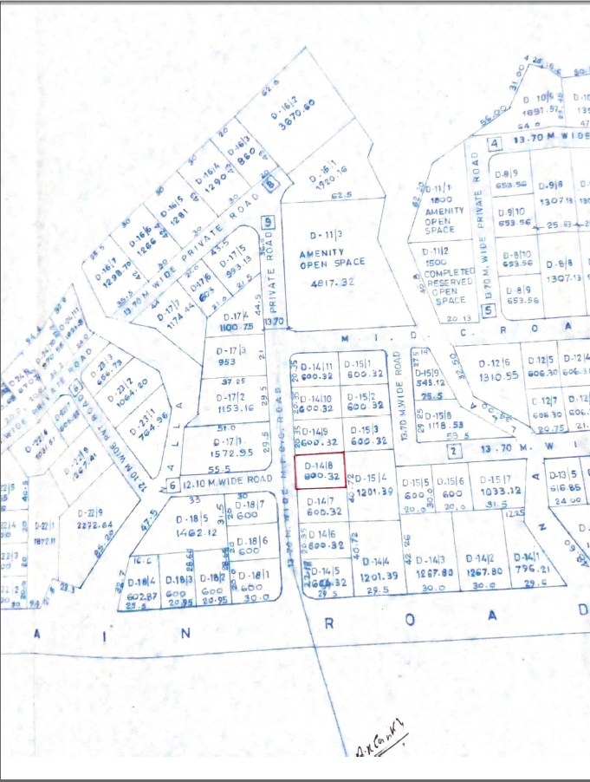

**Surveyor’s Plan**

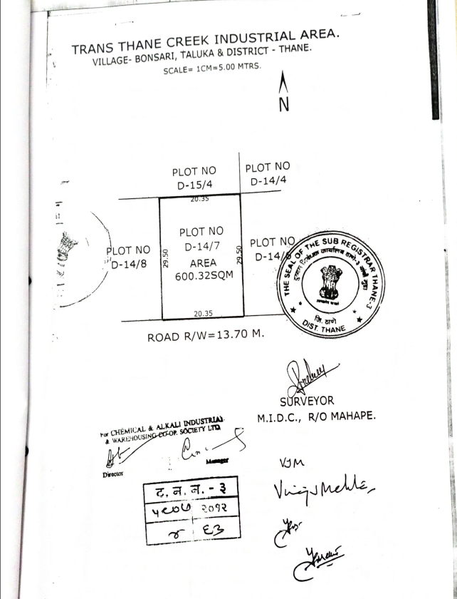

**MIDC MAP**

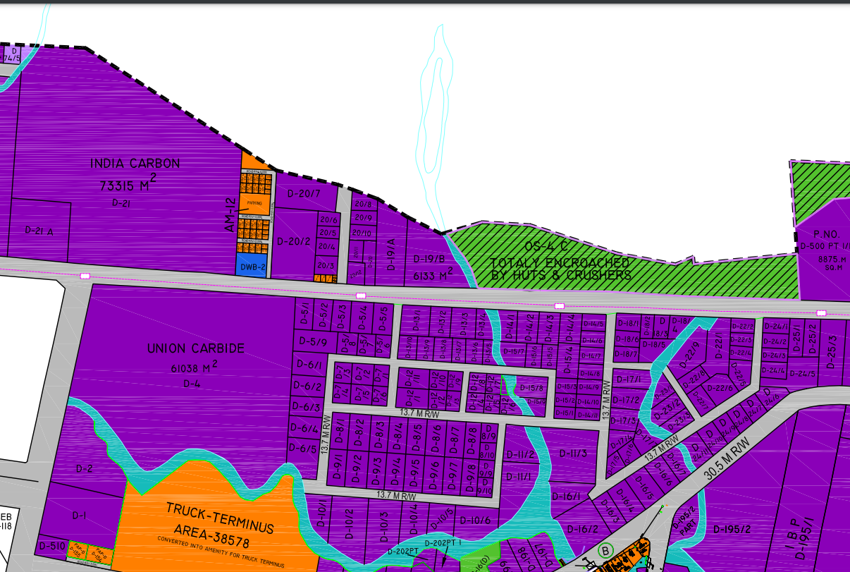

**Actual site photographs**

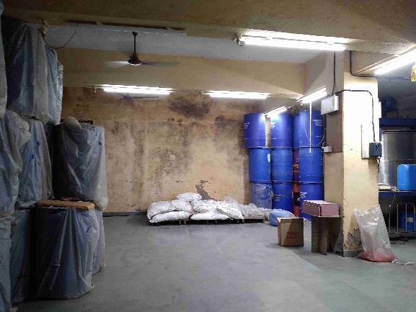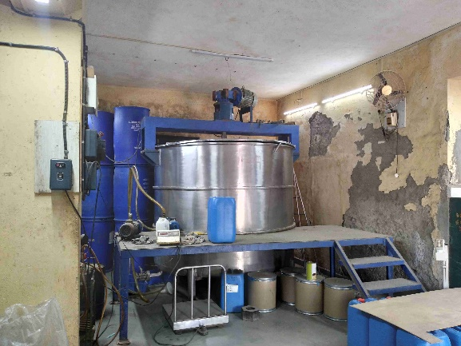

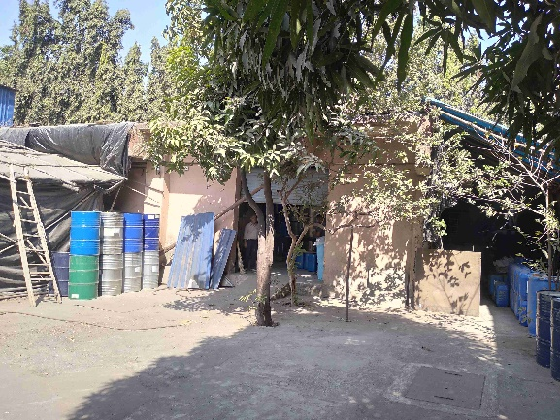

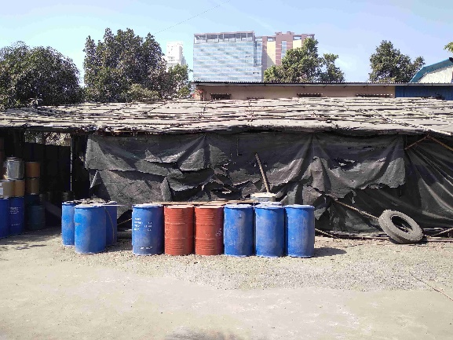

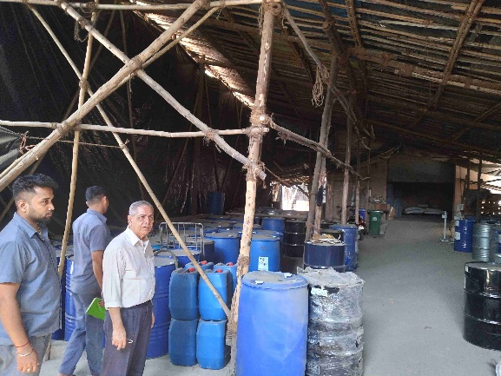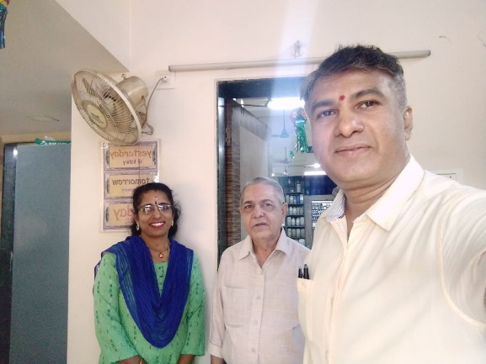

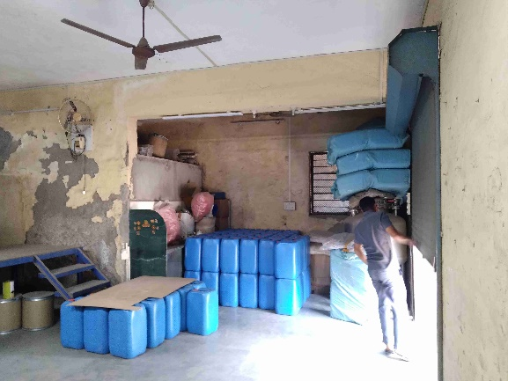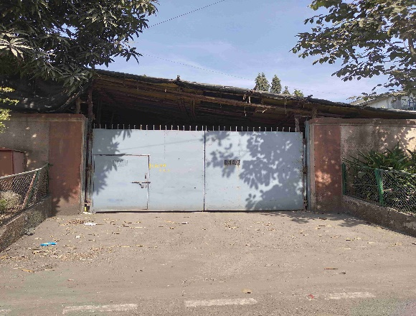

**Route Map of the property**

**Site u/r**

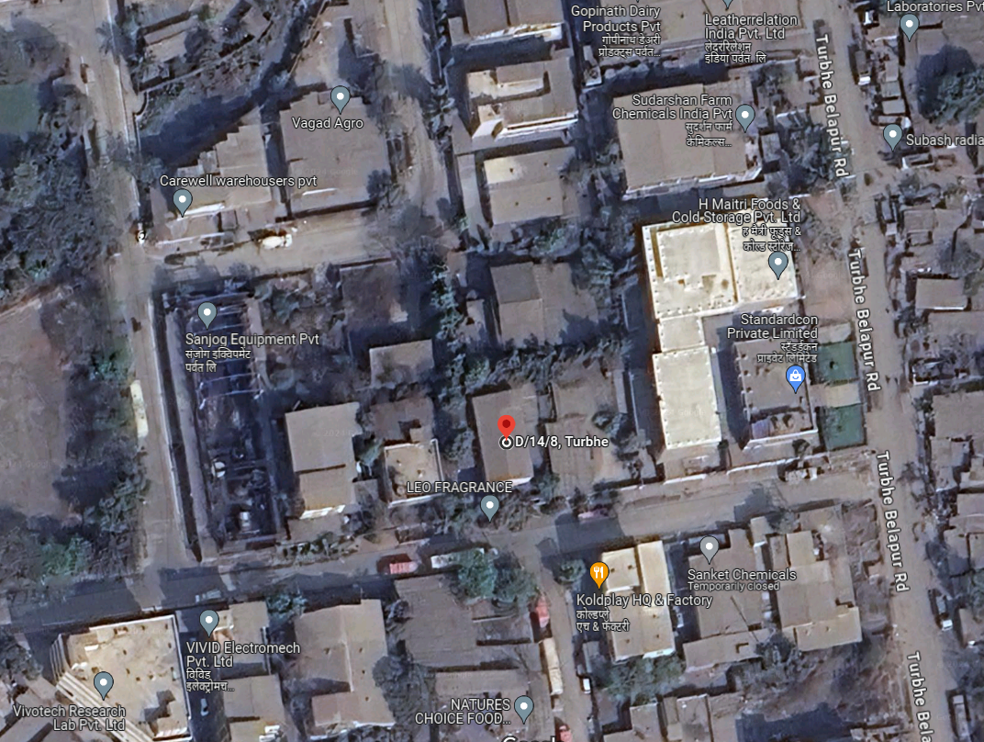

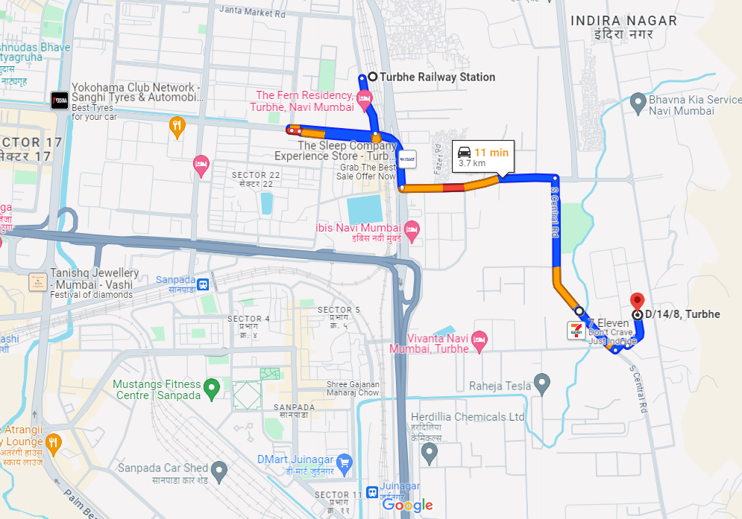

# Latitude Longitude - 19°03'52.4"N 73°01'51.0"E

# Note: The Blue line shows the route to site from nearest Railway Station (Turbhe – 3.7 KM.)

**MIDC RATE**

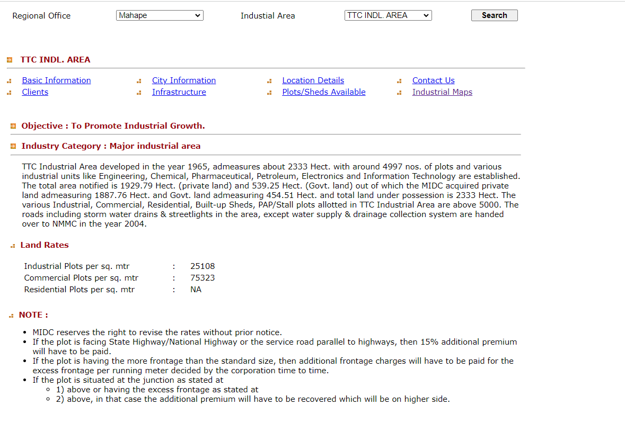

**Price Indicators**

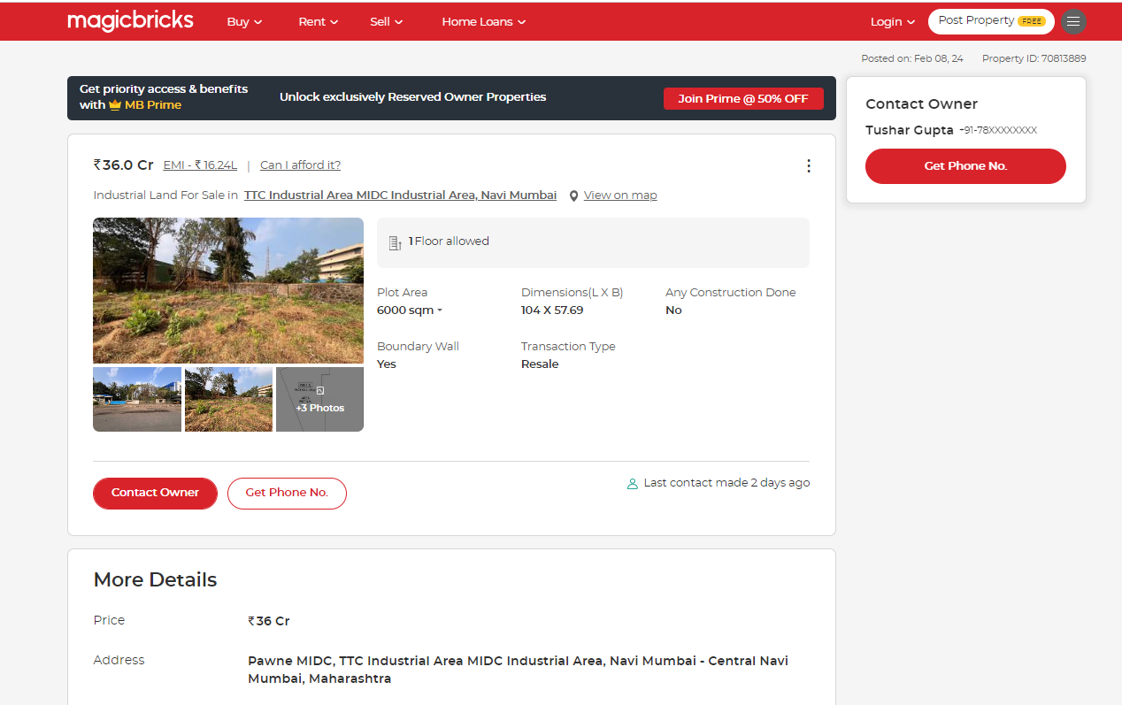

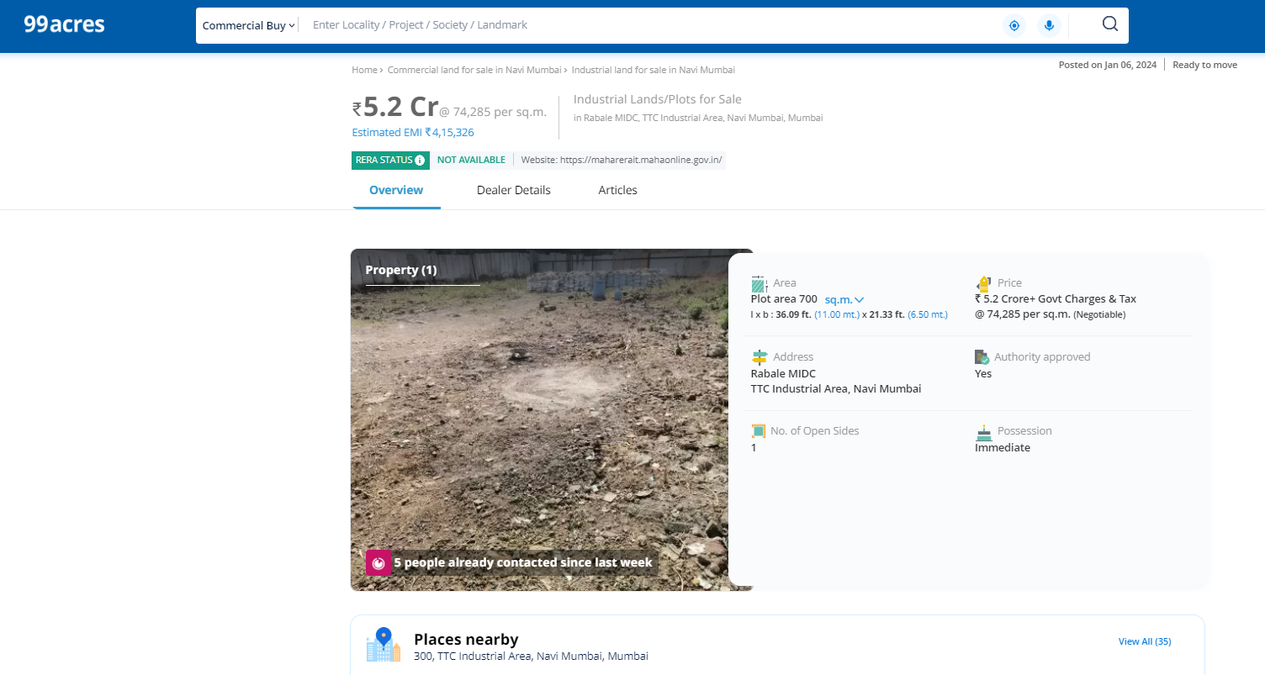

**Price Indicators**

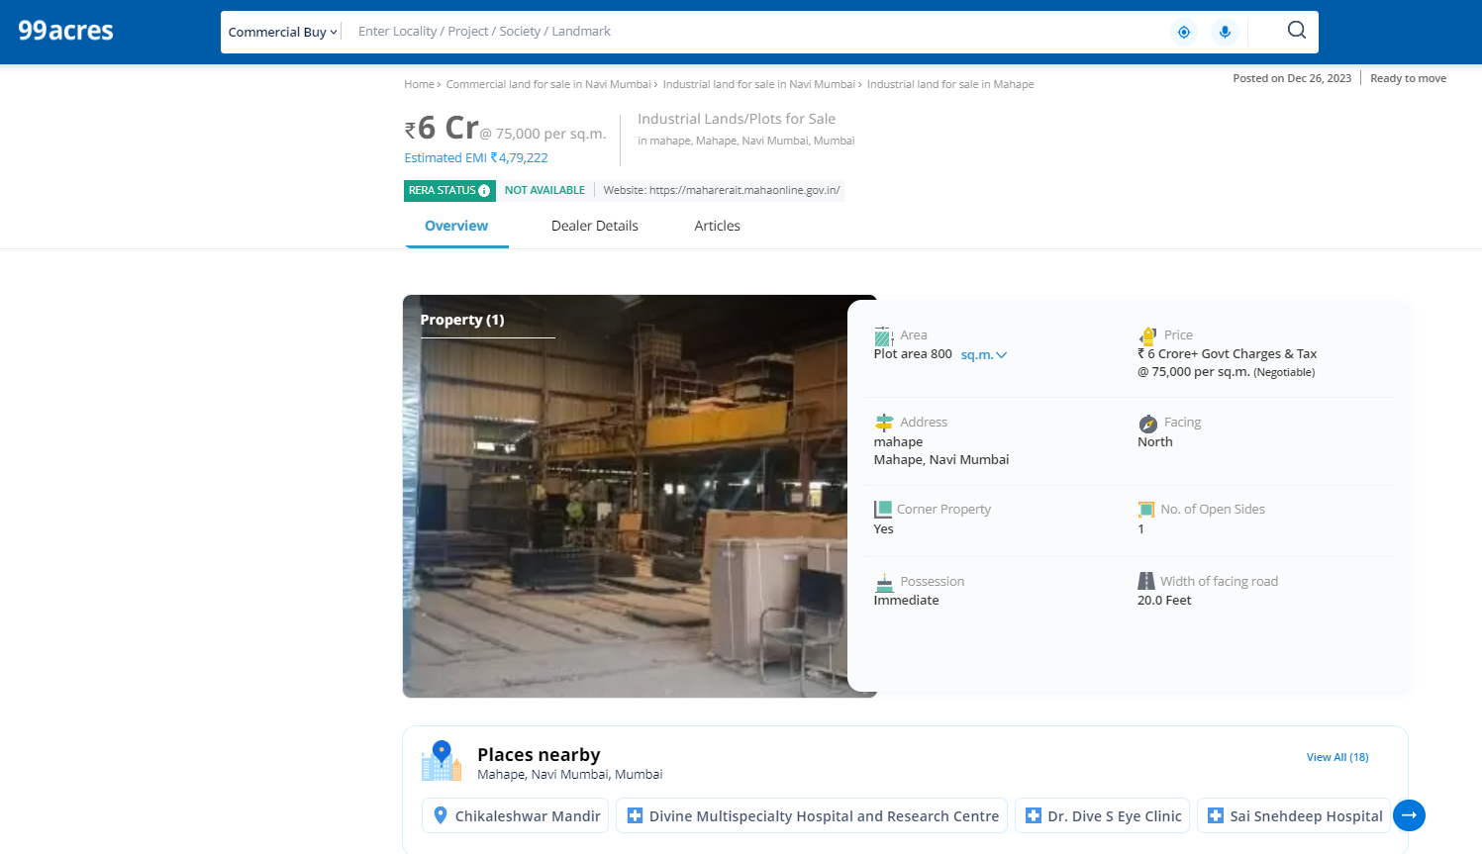

**DEFINITION OF VALUE FOR THIS SPECIFIC PURPOSE**

This exercise is to assess **Fair Market Value** of the property under reference as on **23rd February 2024.**

The term **Fair Market Value** is defined as

*“The most probable price, as of a specified date, in cash, terms equivalent to cash, or in other precisely revealed terms for which the specified property rights would sell after reasonable exposure in a competitive market under all conditions requisite to a fair sale, with the buyer and seller each acting prudently knowledgeably and for self-interest assuming that neither is under undue duress”.*

Fundamental assumptions and conditions presumed in this definition are:

1. Buyer and seller are motivated by self-interest.

2. Buyer and seller are well informed and are acting prudently.

3. The property is exposed for a reasonable time on the open market.

4. Payment is made in cash or equivalent or in specified financing terms.

#### UNDER LYING ASSUMPTIONS

1. We assume no responsibility for matters of legal nature affecting the property appraised or the title thereto, nor do we render our opinion as to the title, which is assumed to be good and marketable.

2. The property is valued as though under responsible ownership.

3. It is assumed that the property is free of liens and encumbrances.

4. It is assumed that there are no hidden or unapparent conditions of the subsoil or structure that would render it more or less valuable. No responsibility is assumed for such conditions or for engineering that might be required to discover such factors.

5. There is no direct/ indirect interest in the property valued

6. The rates for valuation of the property are in accordance with the Govt. approved rates and prevailing market rates.

## Sharadkumar B. Chalikwar

Govt. Reg. Valuer

Chartered Engineer (India)

Reg. No. (N) CCIT/1-14/52/2008-09