Valuation Report of the Immovable Property
(For Capital Gain Purpose)
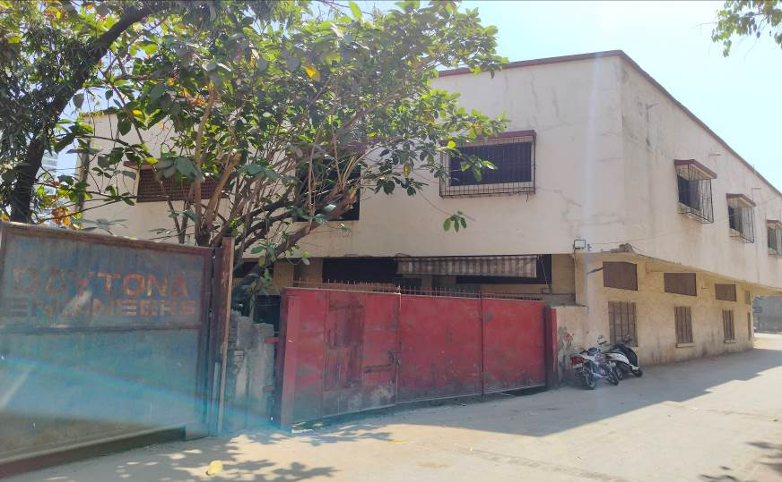

Details of the property under consideration:

Name of Clients: J. K. Parikh Family Trust
(Trustee – Mr. Dinesh Jayantilal Parikh & Mr. Sharad Jayantilal Parikh)

Commercial land and Building (House No. 214A & 214B as per Property Tax Bill), bearing S. No. 57, Hissa No. 5 (Part), Behind National Plastic, Service Road, Kashimira Flyover, Mira Road (East), Thane – 401 107,
State – Maharashtra, Country – India

Latitude Longitude: 19°16'14.0"N 72°52'55.1"E

Table of Contents
1. VALUATION OPINION REPORT 3
2. Part-1 Form 0-1 5
2.1. GENERAL: 5
2.2. LAND 6
2.3. IMPROVEMENTS 7
2.4. RENTS 7
2.5. SALES 8
2.6. COST OF CONSTRUCTION 8
3. PART II- VALUATION 8
3.1. General: 8
3.2. Location: 9
3.3. Building / Property: 9
3.4. History: 9
3.5. Method: 12
3.6. Valuation as on 1st April 2001 of the Property: 13
3.6.1. Indexed Cost of Acquisition 16
3.7. NOTES 16
4. ANNEXURE TO FORM 0-1 16
5. PART III- DECLARATION 17
5.1. DECLARATION OF PROFESSIONAL FEES CHARGED 18
5.2. DEFINITION OF VALUE FOR THIS SPECIFIC PURPOSE 18
5.3. UNDER LYING ASSUMPTIONS 18
6. Actual site photographs 19
7. Route Map of the property 20
8. Ready Reckoner Rate for Year 2001 21
8.1. Rate for Property 21
8.2. Construction Rate 21
9. VALUATION OF THE PROPERTY PREMISES 22

Vastu/Mumbai/03/2024/6887/2305519
15/7-267-VSM
Date: 15.03.2024

VALUATION OPINION REPORT

This is to certify that the property bearing Commercial land and Building (House No. 214A & 214B as per Property Tax Bill), bearing S. No. 57, Hissa No. 5 (Part), Behind National Plastic, Service Road, Kashimira Flyover, Mira Road (East), Thane – 401 107, State – Maharashtra, Country – India was belonged to J. K. Parikh Family Trust (Trustee – Mr. Jayantilal Kalidas Parikh, Mr. Dinesh Jayantilal Parikh & Mr. Sharad Jayantilal Parikh). Mr. Jayantilal Kalidas Parikh expired as on 10.07.1999. After his death, Mr. Dinesh Jayantilal Parikh & Mr. Sharad Jayantilal Parikh are the legal owners of the land on the deceased behalf.

Boundaries of the property.
North | : | Internal Road
South | : | Open Plot
East | : | Daytona Engineers
West | : | Building and Service Road

- The purpose of this report is to ascertain the Indexed Cost of Acquisition ( F. Y. 2023 - 24) of the property as detailed above.
- The property premises can be assessed and valued for calculation of Capital Gain Tax purpose as on 1st April 2001 at ` 1,48,50,627.00 (Rupees One Crore Forty Eight Lakh Fifty Thousand Six Hundred Twenty Seven Only)
- The Indexed Cost of Acquisition of Property under consideration as on 2023 – 24 is ` 5,16,80,182.00 (Rupees Five Crore Sixteen Lakh Eighty Thousand One Hundred Twenty Two Only) without any major Renovation & improvement after 2001.

- The following documents were perused :
- Copy of Conveyance Deed dated 30.05.2012 between M/s. Amar Stones (Sellers) & J. K. Parikh Family Trust (Purchasers)
- Copy of Declaration dated 22.09.2007 made by Mr. Dinesh Jayantilal Parikh & Mr. Sharad Jayantilal Parikh.
- Copy of Agreement dated 07.12.1989 between M/s. Amar Stones (Vendors) & Mr. Jayantilal Kalidas Parikh, Mr. Dinesh Jayantilal Parikh & Mr. Sharad Jayantilal Parikh (Trustee of J. K. Parikh Family Trust).
- Copy of Death Certificate dated 17.07.1999 of Mr. Jayantilal Kalidas Parikh.
- Copy of 7/12 Extract
- Copy of Floor Plan vide Drg Ref. no. RH / TS / 1373 /13 – 14 dated 13.01.2014 issued by Survyor (Rajan D. Hate).
- Copy of Property Tax Bill dated 10.10.2001 in the name of Amar Stone issued by Mira Bhayander Municipal Corporation
- Copy of Property Tax Bill dated 01.05.2023 for the period of 01.04.2023 to 31.03.2024 for House No. 214A in the name of J.K. Parikh Family Trust / Mr. Dinesh J Parikh & Mr. Sharad J Parikh issued by Mira Bhayander Municipal Corporation.
- Copy of Property Tax Bill dated 01.05.2023 for the period of 01.04.2023 to 31.03.2024 for House No. 214B in the name of Mr. Dinesh J Parikh & Mr. Sharad J Parikh issued by Mira Bhayander Municipal Corporation.

This assignment is undertaken based on the request from our client Mr. Sharad Jayantilal Parikh.

The valuation of the property is based on the documents produced by the concern. Legal aspects have not been taken into considerations while preparing this valuation report.

Hence certified.

For Vastukala Architects & Engineers

Sharadkumar B. Chalikwar
Govt. Reg. Valuer
Chartered Engineer (India)
Reg. No. (N) CCIT/1-14/52/2008-09
Encl: Valuation report in Form – 01
Valuation Report of Commercial land and Building (House No. 214A & 214B as per Property Tax Bill), bearing S. No. 57, Hissa No. 5 (Part), Behind National Plastic, Service Road, Kashimira Flyover, Mira Road (East),
Thane – 401 107, State – Maharashtra, Country – India

Part-1 Form 0-1

(See Rule 8 D)
REPORT OF VALUATION OF IMMOVABLE PROPERTY (OTHER THAN AGRICULTURAL LANDS, PLANTATIONS, FORESTS, MINES AND QUARRIES)

GENERAL:

1 | Purpose for which the valuation is made | To assess the Fair Market Value as on 01-04-2001 for computation of Capital Gains Tax.
2 | Date of Report | 15.03.2024
3 | Name of the Owner | J. K. Parikh Family Trust (Trustee – Mr. Jayantilal Kalidas Parikh, Mr. Dinesh Jayantilal Parikh & Mr. Sharad Jayantilal Parikh). Mr. Jayantilal Kalidas Parikh expired as on 10.07.1999. After his death, Mr. Dinesh Jayantilal Parikh & Mr. Sharad Jayantilal Parikh are the legal owners of the land on the deceased behalf.
4 | If the property is under joint ownership, Ownership / co-ownership, share of each such owner. Are the shares undivided? | Trustee
5 | Brief description of the property | Commercial land and Building (House No. 214A & 214B as per Property Tax Bill), bearing S. No. 57, Hissa No. 5 (Part), Behind National Plastic, Service Road, Kashimira Flyover, Mira Road (East), Thane – 401 107, State – Maharashtra, Country – India
6 | Location, street, ward no | Behind National Plastic, Service Road
7 | Survey/ Plot no. of land | S. No. 57, Hissa No. 5 (Part), Revenue Village Mira, Taluka & District Thane
8 | Is the property situated in Residential / commercial/ mixed area/ industrial area? | Residential cum commercial
9 | Classification of locality-high class/ middle class/poor class | Middle Class
10 | Proximity to civic amenities like schools, Hospitals, Offices, market, cinemas etc. | All the amenities are available in the vicinity.
11 | Means and proximity to surface communication by which the locality is served | Served by BEST Buses, Auto, Taxies, and Private Vehicles

LAND

12 | Area of land supported by documentary proof. Shape, dimension and physical features | Plot Area = 1287.44 Sq. M.  (Area as per Conveyance Deed)  Area as per Property Tax Bill:
  Floor | Built up area (Sq. Ft.)
  House No. 214A | 7,080.00
  House No. 214B | 8,000.00
  Total | 15,080.00
  Area in Sq. M. | 1,400.97
13 | Roads, Streets or lanes on which the land is abutting | Behind National Plastic, Service Road, Kashimira Flyover, Mira Road
14 | If freehold or leasehold land | Freehold
15 | If leasehold, the name of Lessor/lessee, nature of lease, date of commencement and termination of lease and terms of renewal of lease.  (i) Initial premium  (ii) Ground rent payable per annum  (iii) Unearned increase payable to the Lessor in the event of sale or transfer | N.A.
16 | Is there any restriction covenant in regard to use of land? If so attach a copy of the covenant. | As per documents
17 | Are there any agreements of easements? If so attach a copy of the covenant | Information not available
18 | Does the land fall in an area included in any Town Planning Scheme or any Development Plan of Government or any statutory body? If so give Particulars. | Mira Bhayander Municipal Corporation
19 | Has any contribution been made towards development or is any demand for such contribution still outstanding. | Information not available
20 | Has the whole or part of the land been notified for acquisition by government or any statutory body? Give date of the notification. | No
21 | Attach a dimensioned site plan | Attached

IMPROVEMENTS

22 | Attach plans and elevations of all structures standing on the land and a lay-out plan. | Year of construction - 2001 (As per Property Tax Bill)
23 | Furnish technical details of the building on a separate sheet (The Annexure to this form may be used) | Not applicable
24 | Is the building owner occupied/ tenanted/ both? | Vacant
 | If the property owner occupied, specify portion and extent of area under owner-occupation | Vacant
25 | What is the Floor Space Index permissible and Percentage actually utilized? | - Floor Space Index Permissible – As per Development Control of Regulation of Municipal Corporation of Greater Mumbai  - FSI percentage actually utilized - Information not available

RENTS

26 | (i) | Names of tenants/ lessees/ licensees, etc | Not applicable
 | (ii) | Portions in their occupation | Not applicable
 | (iii) | Monthly or annual rent /compensation/license fee, etc. paid by each | Not applicable
 | (iv) | Gross amount received for the whole property | Not applicable
27 | Are any of the occupants related to, or close to business associates of the owner? |  | Not applicable
28 | Is separate amount being recovered for the use of fixtures, like fans, geysers, refrigerators, cooking ranges, built-in wardrobes, etc. or for services charges? If so, give details |  | Not applicable
29 | Give details of the water and electricity charges, If any, to be borne by the owner |  | Not applicable
30 | Has the tenant to bear the whole or part of the cost repairs and maintenance? Give particulars |  | Not applicable
31 | If a lift is installed, who is to bear the cost of maintenance and operation- owner or tenant? |  | Not applicable
32 | If a pump is installed, who is to bear the cost of maintenance and operation- owner or tenant? |  | Not applicable
33 | Who has to bear the cost of electricity charges for lighting of common space like entrance hall, stairs, passage, compound, etc. owner or tenant? |  | Not applicable
34 | What is the amount of property tax? Who is to bear it? Give details with documentary proof` |  | Not applicable
35 | Is the building insured? If so, give the policy no., amount for which it is insured and the annual premium |  | Not applicable
36 | Is any dispute between landlord and tenant regarding rent pending in a court of rent? |  | Not applicable
37 | Has any standard rent been fixed for the premises under any law relating to the control of rent? |  | Not applicable

SALES

38 | Give instances of sales of immovable property in the locality on a separate sheet, indicating the Name and address of the property, registration No., sale price and area of land sold. | As per sub registrar of assurance records.
39 | Land rate adopted in this valuation | Land Rate - ` 5,550.00  (As per Ready Reckoner 2001)
40 | If sale instances are not available or not relied up on, the basis of arriving at the land rate | Copy of Stamp Duty Ready Reckoner for the year 2001 attached

COST OF CONSTRUCTION

41 | Year of commencement of construction and year of completion | Year of Construction – 2001 (As per Property Tax Bill).
42 | What was the method of construction, by contract/By employing Labour directly/ both? | Information not available
43 | For items of work done on contract, produce copies of agreements | N. A.
44 | For items of work done by engaging Labour directly, give basic rates of materials and Labour supported by documentary proof. | N. A.

PART II- VALUATION

General:

Under the instructions of Mr. Sharad Jayantilal Parikh, we have valued the Commercial land and Building (House No. 214A & 214B as per Property Tax Bill), bearing S. No. 57, Hissa No. 5 (Part), Behind National Plastic, Service Road, Kashimira Flyover, Mira Road (East), Thane – 401 107, State – Maharashtra, Country – India to ascertain the market value of said property, as on 1st April 2001 for computation of Capital Gains Tax.

We are in receipt of the following documents:

- Copy of Conveyance Deed dated 30.05.2012 between M/s. Amar Stones (Sellers) & J. K. Parikh Family Trust (Purchasers)
- Copy of Declaration dated 22.09.2007 made by Mr. Dinesh Jayantilal Parikh & Mr. Sharad Jayantilal Parikh.
- Copy of Agreement dated 07.12.1989 between M/s. Amar Stones (Vendors) & Mr. Jayantilal Kalidas Parikh, Mr. Dinesh Jayantilal Parikh & Mr. Sharad Jayantilal Parikh (Trustee of J. K. Parikh Family Trust).
- Copy of Death Certificate dated 17.07.1999 of Mr. Jayantilal Kalidas Parikh.
- Copy of 7/12 Extract
- Copy of Floor Plan vide Drg Ref. no. RH / TS / 1373 /13 – 14 dated 13.01.2014 issued by Survyor (Rajan D. Hate).
- Copy of Property Tax Bill dated 10.10.2001 in the name of Amar Stone issued by Mira Bhayander Municipal Corporation
- Copy of Property Tax Bill dated 01.05.2023 for the period of 01.04.2023 to 31.03.2024 for House No. 214A in the name of J.K. Parikh Family Trust / Mr. Dinesh J Parikh & Mr. Sharad J Parikh issued by Mira Bhayander Municipal Corporation.
- Copy of Property Tax Bill dated 01.05.2023 for the period of 01.04.2023 to 31.03.2024 for House No. 214B in the name of Mr. Dinesh J Parikh & Mr. Sharad J Parikh issued by Mira Bhayander Municipal Corporation.

Location:
The said commercial land and building is bearing S. No. 57, Hissa No. 5 (Part), Revenue Village Mira, Taluka & District Thane in Mira Bhayander Municipal Corporation. The property falls in residential Zone. It is at 4.1 KM. travel distance from Mira Railway Station.

Building / Property:

The original building was of Ground floor RCC framed structure, which was demolished due to poor condition and new construction of Ground + Mezzanine + 1 upper floor completed in the 2001. At the time of visit building was under renovation.

History:

J. K. Parikh Family Trust (Trustee – Mr. Jayantilal Kalidas Parikh, Mr. Dinesh Jayantilal Parikh & Mr. Sharad Jayantilal Parikh). Mr. Jayantilal Kalidas Parikh expired as on 10.07.1999. After his death, Mr. Dinesh Jayantilal Parikh & Mr. Sharad Jayantilal Parikh are the legal owners of the land on the deceased behalf.

Value of land as on 1st April 2001:

Plot area | 1,287.44 Sq. M.
Rate as on 2001 | ` 5,550.00 per Sq. M.
Value of plot | ` 71,45,292.00

Cost of Construction as on 2001:

Built up area | 1,400.97 Sq. M.
Cost of Construction as on 2001 | ` 5,500.00 Per Sq. M.
Value of Construction as on 01.04.2001 | ` 77,05,335.00

Total value of the Land and Building as on 01.04.2001

Value of plot | ` 71,45,292.00
Value of Construction | ` 77,05,335.00
Total Value | ` 1,48,50,627.00

Indexed Cost of Acquisition for Cost of Construction
- Cost Inflation Index for 2001 : 100
(Considering the transaction shall be made
after 01.04.2017)
- Cost Inflation Index for 2023 - 24 : 348

- Indexed Cost of Acquisition : ` 5,16,80,182.00
(` 1,48,50,627.00 * 348/100)

Taking into consideration above said facts, we can evaluate the value of Commercial land and Building (House No. 214A & 214B as per Property Tax Bill), bearing S. No. 57, Hissa No. 5 (Part), Behind National Plastic, Service Road, Kashimira Flyover, Mira Road (East), Thane – 401 107, State – Maharashtra, Country – India for this particular purpose at ` 1,48,50,627.00 (Rupees One Crore Forty Eight Lakh Fifty Thousand Six Hundred Twenty Seven Only) as on 1st April 2001.

NOTES
- I, Sharadkumar B. Chalikwar with my experience and ability to judgment I am of the considered opinion that the fair market value of the property as on 1st April 2001 is ` 1,48,50,627.00 (Rupees One Crore Forty Eight Lakh Fifty Thousand Six Hundred Twenty Seven Only). Value varies with time and purpose and hence this value should not be referred for any purpose other than mentioned in this report.

- This valuation is done on the basis of information, which the valuer has obtained by information provided by the client about the premises and location of the surrounding area and also prevailing rates in the surrounding area, and further subject to document as mentioned in valuation report.

- This valuer should not be held responsible for authentication of documents, clear title and other such related matters. For that purpose Latest Legal Opinion should be sought.

ANNEXURE TO FORM 0-1

1. | No. of floors and height of each floor | Ground + Mezzanine + 1st Upper floor
2. | Plinth area floor wise as per IS 3361-1966 | -
3 | Year of construction | 2001
4 | Estimated future life as on year 2001 | 60 years (Subject to proper and regular maintenance of the building)
5 | Type of construction- load bearing walls/RCC frame/ steel frame | RCC framed structure
6 | Type of foundations | RCC
7 | Walls | All external walls are 9” thick and partition walls are 6” thick.
8 | Partitions | 6” thick brick wall
9 | Doors and Windows | Under renovation
10 | Flooring | Under renovation
11 | Finishing | Under renovation
12 | Roofing and terracing | RCC Slab
13 | Special architectural or decorative features, if any | Under renovation
14 |  | Under renovation
  (i) | Internal wiring – surface or conduit
  (ii) | Class of fittings: Superior / Ordinary / Poor.
15 | Sanitary installations  Class of fittings: Superior colored / superior white/ordinary. | Under renovation
  (i) | No. of water closets
  (ii) | No. of lavatory basins
  (iii) | No. of urinals
  (iv) | No. of sinks
16 | Compound wall  Height and length  Type of construction | 3’ to 7’ brick masonry wall for the entire boundary
17 | No. of lifts and capacity | No lift
18 | Underground sump – capacity and type of construction | Information not available
19 | Over-head tank  Location, capacity  Type of construction | Not found
20 | Pumps- no. and their horse power | Information not available
21 | Roads and paving within the compound approximate area and type of paving | Under renovation
22 | Sewage disposal – whereas connected to public sewers, if septic tanks provided, no. and capacity | Connected to municipal sewer.

PART III- DECLARATION
I hereby declare that
    - The information furnished in part I is true and correct to the best of my knowledge and belief;
    - I have no direct or indirect interest in the property valued:

DECLARATION OF PROFESSIONAL FEES CHARGED

We hereby declare that, our professional fees are not contingent upon the valuation findings. However, if the statute AND/OR clients demands that, the fees should be charged on the percentage of assessed value then, with the full knowledge of the AND/OR end user, it is being charged accordingly.

DEFINITION OF VALUE FOR THIS SPECIFIC PURPOSE

This exercise is to assess Fair Market Value of the property under reference as on 01st April 2001 for calculation of Capital Gains Tax.

The term Fair Market Value is defined as

“The most probable price, as of a specified date, in cash, terms equivalent to cash, or in other precisely revealed terms for which the specified property rights would sell after reasonable exposure in a competitive market under all conditions requisite to a fair sale, with the buyer and seller each acting prudently knowledgeably and for self-interest assuming that neither is under undue duress”.
Fundamental assumptions and conditions presumed in this definition are:

1. Buyer and seller are motivated by self-interest.

2. Buyer and seller are well informed and are acting prudently.

3. The property is exposed for a reasonable time on the open market.

- Payment is made in cash or equivalent or in specified financing terms.

UNDER LYING ASSUMPTIONS
1. We assume no responsibility for matters of legal nature affecting the property appraised or the title thereto, nor do we render our opinion as to the title, which is assumed to be good and marketable.
2. The property is valued as though under responsible ownership.
3. It is assumed that the property is free of liens and encumbrances.
4. It is assumed that there are no hidden or unapparent conditions of the subsoil or structure that would render it more or less valuable. No responsibility is assumed for such conditions or for engineering that might be required to discover such factors.

Actual site photographs
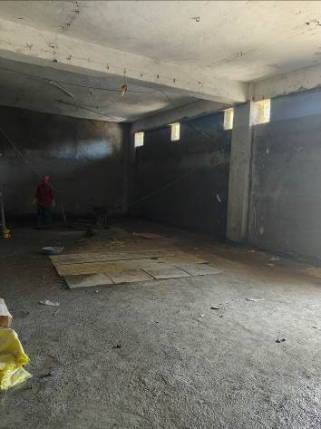
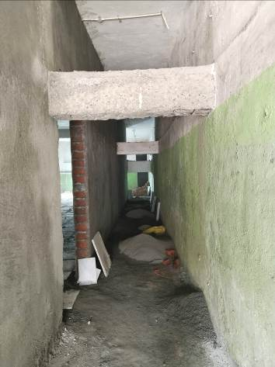
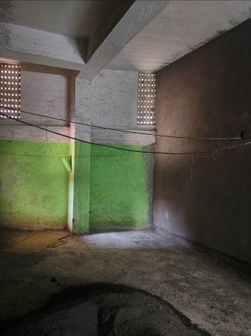

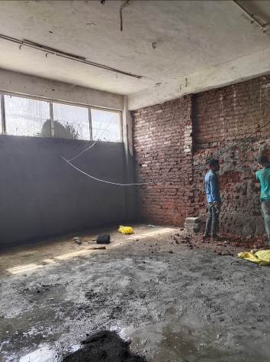
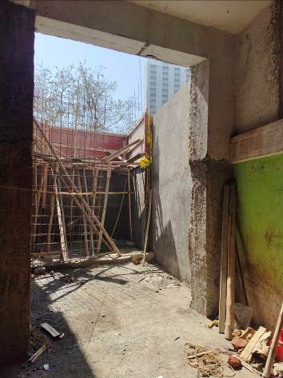
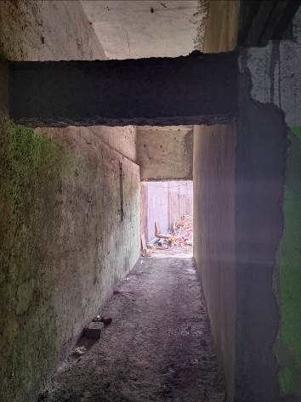

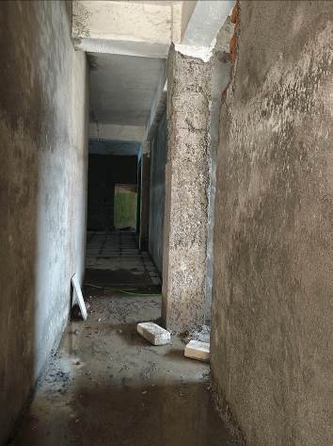
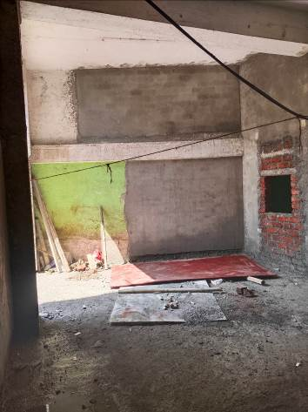
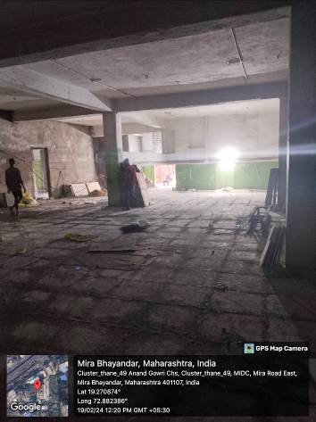

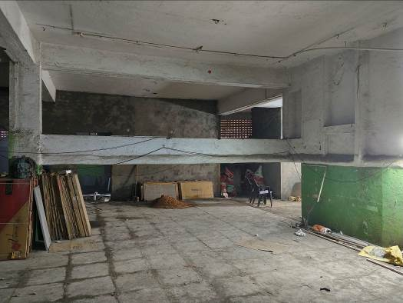
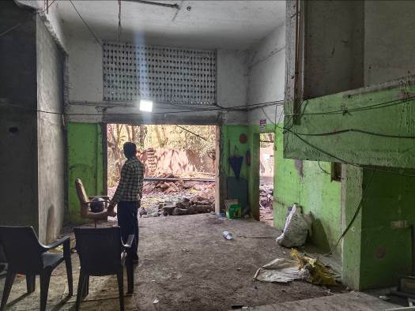
Actual Site Photographs

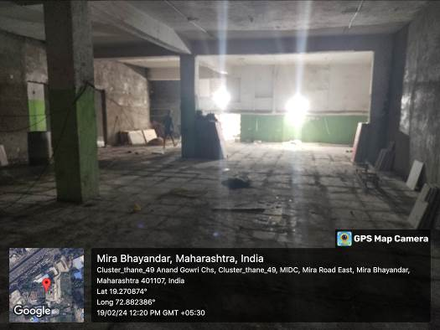
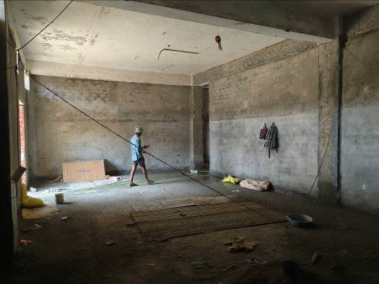
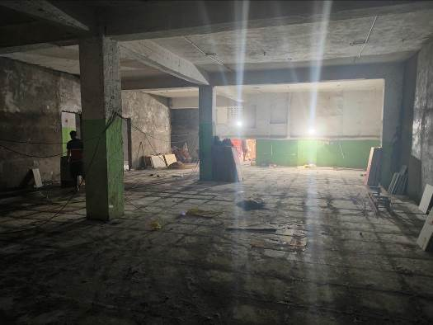
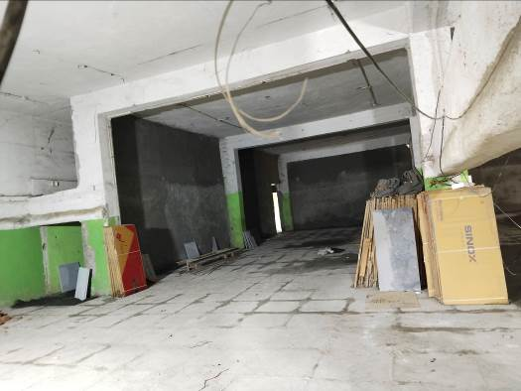
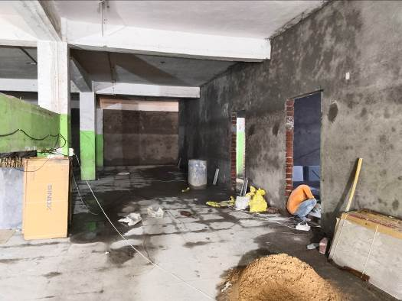
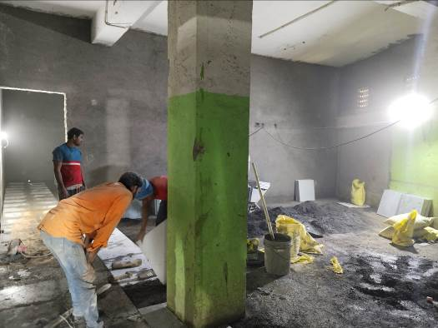
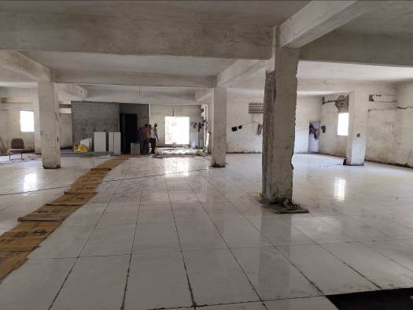
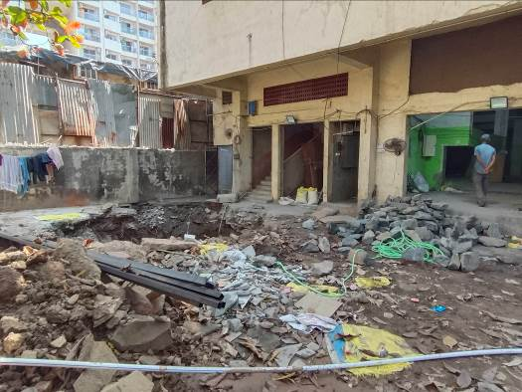
Actual Site Photographs

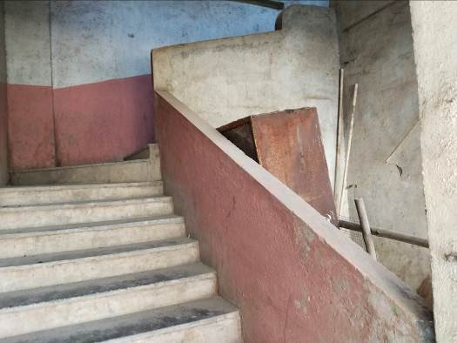
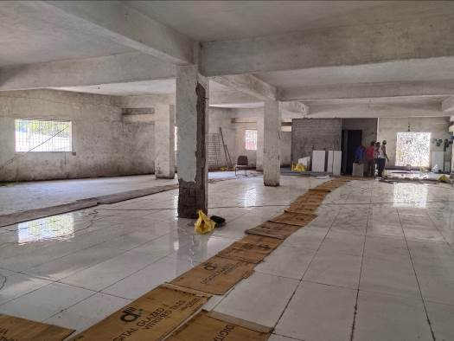
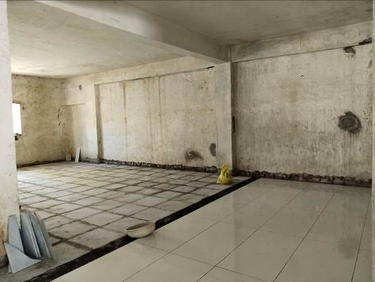
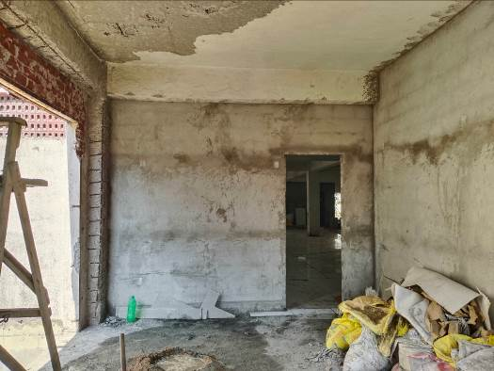
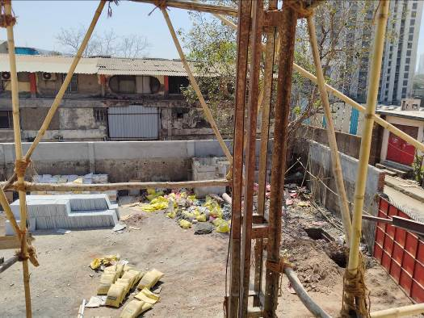
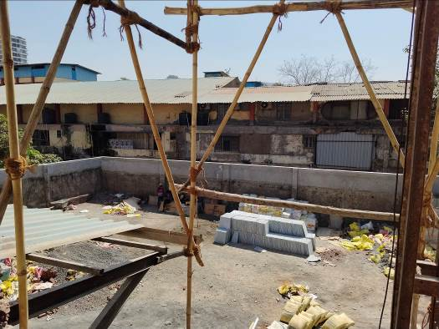
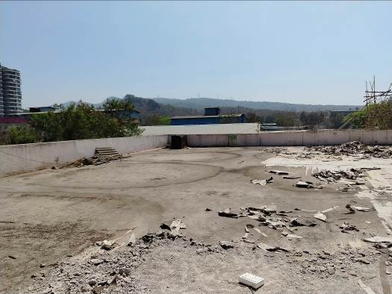
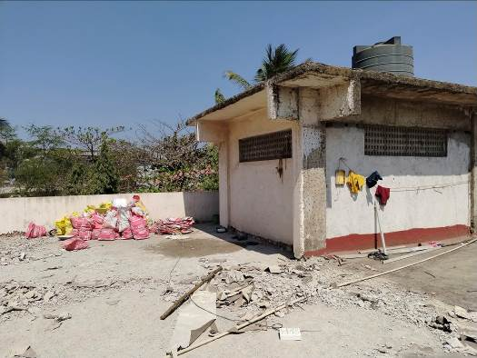
Actual Site Photographs

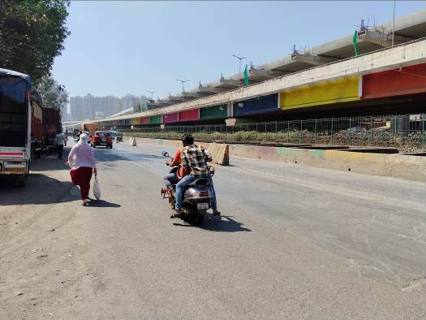
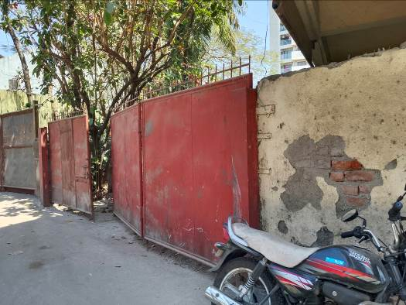
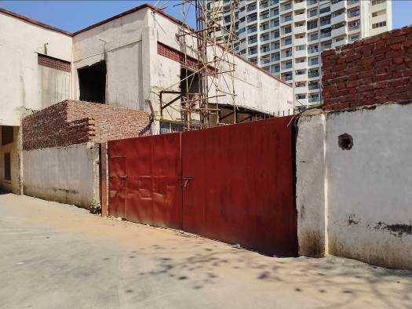
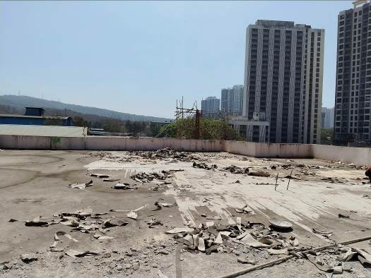
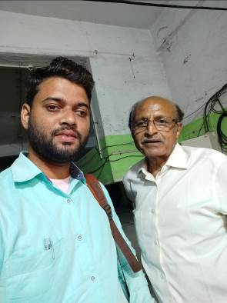

Route Map of the property
Site U/R
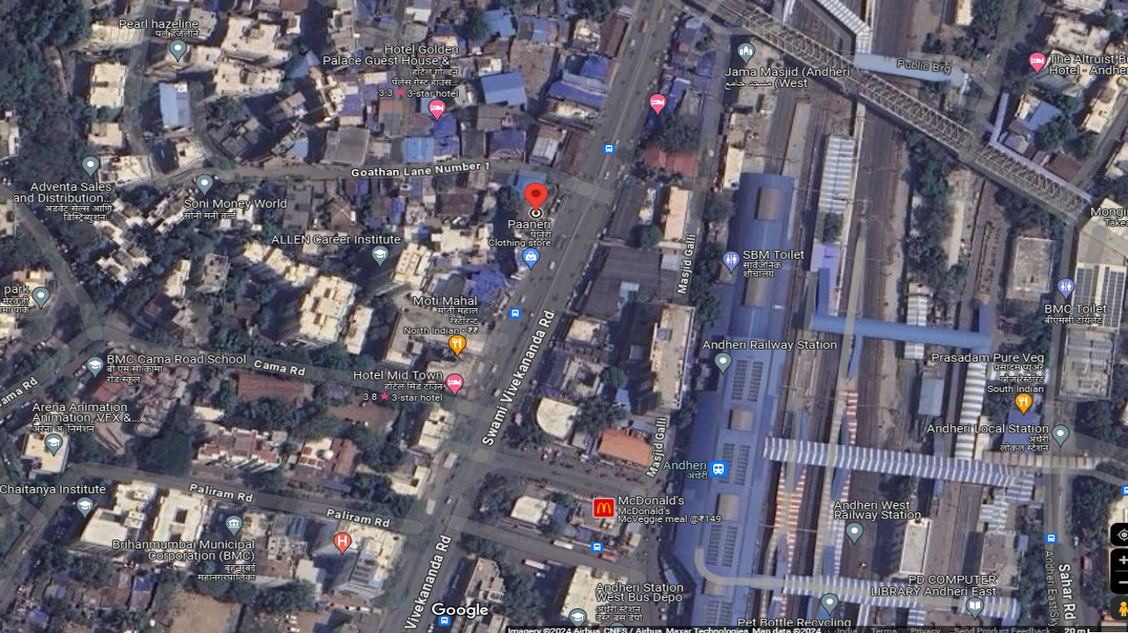

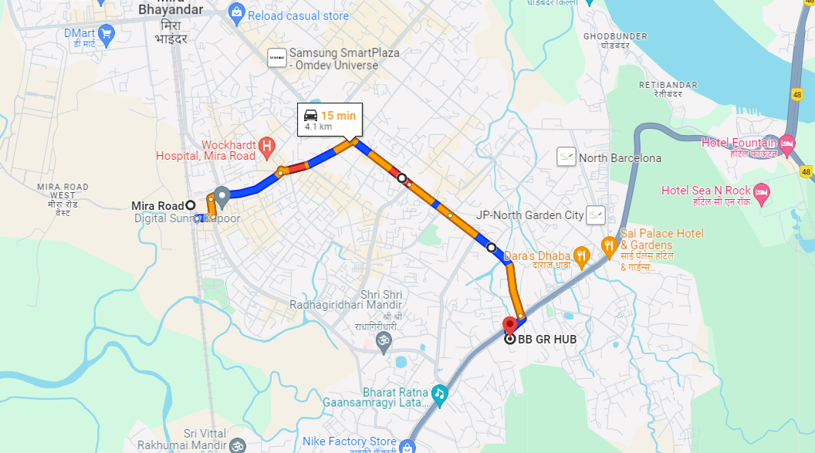

Latitude Longitude: 19°16'14.0"N 72°52'55.1"E

Note: The Blue line shows the route to site from nearest Railway station (Mira Road – 4.1 KM.)

Ready Reckoner Rate for Year 2001

Rate for Property
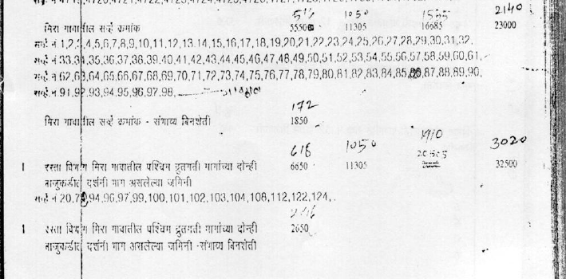

Construction Rate

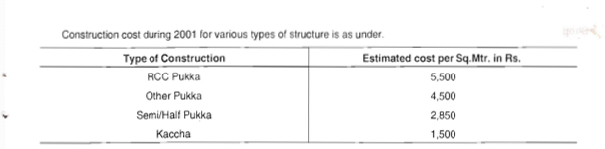

VALUATION OF THE PROPERTY PREMISES

Considering various parameters recorded herein above, existing economic scenario, and the information that is available with reference to the development of neighbourhood and method selected for valuation, we are of the opinion that, the property premises can be assessed and valued for calculation of Capital Gain Tax as on 1st April 2001 for ` 1,48,50,627.00 (Rupees One Crore Forty Eight Lakh Fifty Thousand Six Hundred Twenty Seven Only).

For Vastukala Architects & Engineers

Sharadkumar B. Chalikwar
Govt. Reg. Valuer
Chartered Engineer (India)
Reg. No. (N) CCIT/1-14/52/2008-09

