Valuation Report of the Immovable Property

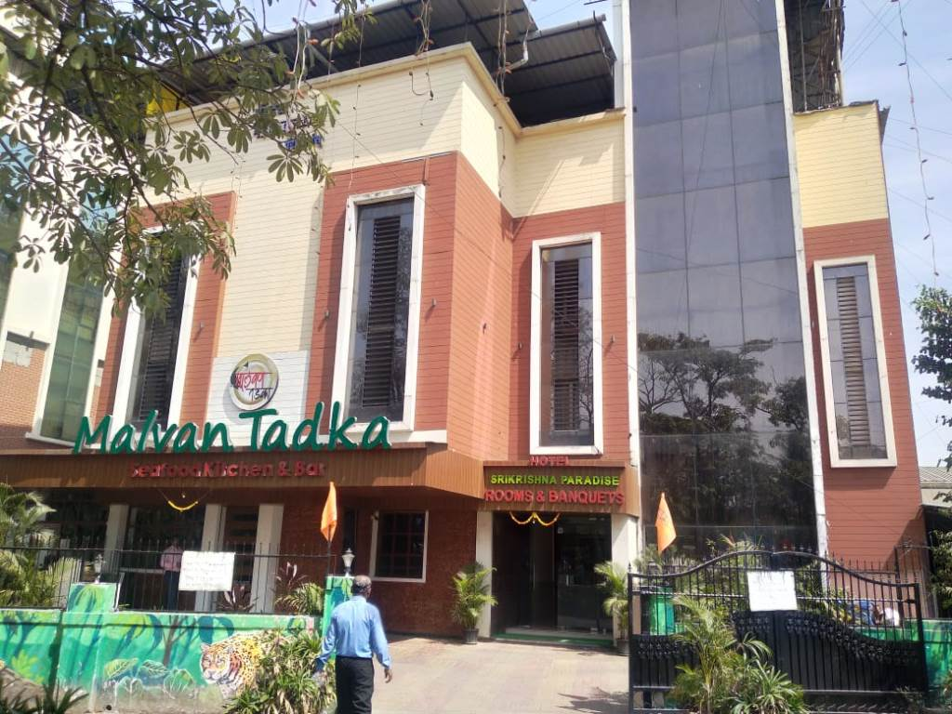

**Details of the property under consideration:**

Name of Owner: **Shri. Kushal S. Shetty (Proprietor of M/s. Srikrishna Paradise Hotel)**

Commercial Land & Hotel Building on Plot No. KX-15, Phase ‘K’ & Plot No. X-2/1, Kalwa Block, T.T.C. Industrial Area M.I.D.C., Ganapati Pada, Village - Dighe, Navi Mumbai, Taluka & District -Thane, PIN – 400 708

State - Maharashtra, Country – India

# Latitude Longitude - 19°11'07.8"N 72°59'35.4"E

# 

**Valuation Done for:**

**Cosmos Bank**

# Naupada Branch

# Kusumanjali, Opp. Devdhar Hospital, Naupada, Thane (West) - 400 602

# State – Maharashtra, Country – India

Vastu/Thane/02/2023/006851/2304992

15/12-214-JABS Date: 15.02.2024

# VALUATION OPINION REPORT

The property bearing Commercial Land & Hotel Building on Plot No. KX-15, Phase ‘K’ & Plot No. X-2/1, Kalwa Block, T.T.C. Industrial Area, M.I.D.C. Ganapati Pada, Village - Dighe, Navi Mumbai, Taluka & District -Thane, PIN – 400 708, State - Maharashtra, Country – India belongs to **Shri. Kushal S. Shetty (Proprietor of M/s. Srikrishna Paradise Hotel).**

**Boundaries of the property.**

|  |  |  |  |  |
| --- | --- | --- | --- | --- |
| **Particulars** | **North** | **South** | **East** | **West** |
| **As per Memorandum of Entry** | | | | |
| Plot No. KX-15 | By H. T. Line Under Ground Strip, M.I.D.C. Land | By Plot No. X-2/1 | By H. T. Line Under Ground Strip, M.I.D.C. Land | By Nalla, Thane - Belapur Road (R/W 61 Meter) |
| Plot No. X-2/1 | Plot No. KX-15 | MIDC Service Road | Plot No. X-2/2 | By Nalla, Thane - Belapur Road (R/W 61 Meter) |
| **As per Site Visit** | | | | |
| Amalgamated Plot No. KX-15 & X-2/1 | Plot No. X-1/2 | H. P. Petrol Pump Road | Satkar (Rutuja) family Restaurant And Bar | Thane – Belapur Road |

Considering various parameters recorded, existing economic scenario, and the information that is available with reference to the development of neighborhood and method selected for valuation, we are of the opinion that, the property premises can be assessed and valued for banking purpose for –

|  |  |  |  |  |
| --- | --- | --- | --- | --- |
| **Particulars** | **Fair Market Value In (₹)** | **Realizable Value In (₹)** | **Distress Sale Value In (₹)** | **Insurable Value In**  **(₹)** |
| Industrial Land & Hotel Building | 5,02,58,570.00 | 4,52,32,713.00 | 4,02,06,856.00 | 97,58,340.00 |

The valuation of the property is based on the documents produced by the concern. Legal aspects have not been taken into considerations while preparing this valuation report.

Hence certified

## Manoj B. Chalikwar

## Registered Valuer

## Chartered Engineer (India)

## Reg. No. CAT-I-F-1763

## Cosmos Emp. No. H.O./Credit/67/2019-20

Encl. Valuation Report

Valuation Report of Commercial Land & Hotel Building on Plot No. KX-15, Phase ‘K’ & Plot No. X-2/1, Kalwa Block, T.T.C. Industrial Area, M.I.D.C., Ganapati Pada, Village - Dighe, Navi Mumbai, Taluka & District -Thane, PIN – 400 708, State – Maharashtra, Country – India.

*Form 0-1*

*(See Rule 8 D)*

REPORT OF VALUATION OF IMMOVABLE PROPERTY (OTHER THAN AGRICULTURAL LANDS, PLANTATIONS, FORESTS, MINES AND QUARRIES)

GENERAL:

|  |  |  |  |
| --- | --- | --- | --- |
| 1 | Purpose for which the valuation is made | | To assess the Fair Market Value as on 15.02.2024 for Bank Loan Purpose |
| 2 | Date of inspection | | 08.02.2024 |
|  | Name of the owner/ owners | | **Shri. Kushal S. Shetty (Proprietor of M/s. Srikrishna Paradise Hotel)** |
| 4 | If the property is under joint ownership / co-ownership, share of each such owner. Are the shares undivided? | | Proprietorship Concern |
| 5 | Brief description of the property | | **Address:** Commercial Land & Hotel Building on Plot No. KX-15, Phase ‘K’ & Plot No. X-2/1, Kalwa Block, T.T.C. Industrial Area, M.I.D.C. Ganapati Pada, Village - Dighe, Navi Mumbai, Taluka & District -Thane, PIN – 400 708, State – Maharashtra, Country – India.  **Contact Person:**  Mr. Mithun Shetty (Representative of Owner)  Contact No. +91 7977755676  **Landmark:** Near Green World Complex |
| 6 | Location, street, ward no | | Plot No. KX-15, Phase ‘K’ & Plot No. X-2/1, ‘Kalwa Block’ T.T.C. Industrial Area, Near Vitava Kalwa Octroi Naka |
| 7 | Survey/ Plot no. of land | | Plot No. KX-15, Phase ‘K’ & Plot No. X-2/1, ‘Kalwa Block’ |
| 8 | Is the property situated in residential/ commercial/ mixed area/ industrial area? | | Commercial & Industrial Area |
| 9 | Classification of locality-high class/ middle class/poor class | | Middle Class |
| 10 | Proximity to civic amenities like schools, Hospitals, Offices, market, cinemas etc. | | All the amenities are available in the vicinity |
| 11 | Means and proximity to surface communication by which the locality is served | | Served by Buses, Taxies, Auto and Private cars |
|  | *LAND* | |  |
| 12 | Area of land supported by documentary proof. Shape, dimension and physical features | | **Land Area – 733.00 Sq. M.**  (Area as per Deed of Mortgage for Additional Security)   |  |  | | --- | --- | | Plot No. | Area in Sq. M. | | Plot No. KX-15, Phase ‘K’ | 350.00 | | Plot No. X-2/1, ‘Kalwa Block’ | 383.00 | | **Total** | **733.00** | |
| 13 | Roads, Streets or lanes on which the land is abutting | | Thane - Belapur Road |
| 14 | If freehold or leasehold land | | Leasehold Land of MIDC |
| 15 | If leasehold, the name of Lessor/lessee, nature of lease, date of commencement and termination of lease and terms of renewal of lease. | | Lease period – 95 years commencing from 27.12.2017 Lease Amount of Consideration – Information not available  Lease Rent – Information not available |
| (i) Initial premium | |
| (ii) Ground rent payable per annum | |
| (iii) Unearned increase payable to the Lessor in the event of sale or transfer | |
| 16 | Is there any restriction covenant in regard to use of land? If so attach a copy of the covenant. | | Commercial |
| 17 | Are there any agreements of easements? If so, attach a copy of the covenant | | Information not available |
| 18 | Does the land fall in an area included in any Town Planning Scheme or any Development Plan of Government or any statutory body? If so, give Particulars. | | Coming under M.I.D.C. layout |
| 19 | Has any contribution been made towards development or is any demand for such contribution still outstanding? | | Information not available |
| 20 | Has the whole or part of the land been notified for acquisition by government or any statutory body? Give date of the notification. | | No |
| 21 | Attach a dimensioned site plan | | Copy of Approved Site Plan not available for our verification. |
|  | *IMPROVEMENT* | |  |
| 22 | Attach plans and elevations of all structures standing on the land and a lay-out plan. | | Copy of Building Completion Certificate, Letter No. DE / MHP ( C ) / X-2/1 / 696 dated 13.04.2006 in the name of M/s. Kushal Shetty, of Plot No. X-2/1, in T.T.C. Indl. Area, have completed the Factory Building on the above said Plot, issued by MIDC sub Dn II (Civil) Mahape. |
| 23 | Furnish technical details of the building on a separate sheet (The Annexure to this form may be used) | | Attached |
| 24 | Is the building owner occupied/tenanted/both? | | Owner Occupied in the name of M/s. Srikrishna Paradise Hotel |
|  | If the property owner occupied, specify portion and extent of area under owner-occupation | | N.A. |
| 25 | What is the Floor Space Index permissible and Percentage actually utilized? | | Floor Space Index permissible - As per local norms  Percentage actually utilized – Information not available |
| 26 | *RENTS* | |  |
|  | (i) | Names of tenants/ lessees/ licensees, etc. | N.A. |
|  | (ii) | Portions in their occupation | N.A. |
|  | (iii) | Monthly or annual rent/ compensation / license fee, etc. paid by each | N.A. |
|  | (iv) | Gross amount received for the whole property | N.A. |
| 27 | Are any of the occupants related to, or close to business associates of the owner? | | N. A. |
| 28 | Is separate amount being recovered for the use of fixtures, like fans, geysers, refrigerators, cooking ranges, built-in wardrobes, etc. or for services charges? If so, give details | | N. A. |
| 29 | Give details of the water and electricity charges, if any, to be borne by the owner | | N. A. |
| 30 | Has the tenant to bear the whole or part of the cost repairs and maintenance? Give particulars | | N. A. |
| 31 | If a lift is installed, who is to bear the cost of maintenance and operation- owner or tenant? | | N. A. |
| 32 | If a pump is installed, who is to bear the cost of maintenance and operation- owner or tenant? | | N. A. |
| 33 | Who has to bear the cost of electricity charges for lighting of common space like entrance hall, stairs, passage, compound, etc. owner or tenant? | | N. A. |
| 34 | What is the amount of property tax? Who is to bear it? Give details with documentary proof | | N. A. |
| 35 | Is the building insured? If so, give the policy no., amount for which it is insured and the annual premium | | N. A. |
| 36 | Is any dispute between landlord and tenant regarding rent pending in a court of rent? | | N. A. |
| 37 | Has any standard rent been fixed for the premises under any law relating to the control of rent? | | N. A. |
|  | *SALES* | |  |
| 38 | Give instances of sales of immovable property in the locality on a separate sheet, indicating the Name and address of the property, registration No., sale price and area of land sold. | | As per sub registrar of assurance records |
| 39 | Land rate adopted in this valuation | | ` 57,500.00 per Sq. M. |
| 40 | If sale instances are not available or not relied up on, the basis of arriving at the land rate | | Online Price Indicators, Location, development of surrounding area, type of land and construction, construction specifications, age of building, condition of the premises & building, facilities provided and its prevailing market rate. |
|  | *COST OF CONSTRUCTION* | |  |
| 41 | Year of commencement of construction and year of completion | | Year of Construction – 2006 (As per Building Completion Certificate) |
| 42 | What was the method of construction, by contract / By employing Labour directly / both? | | Information not available |
| 43 | For items of work done on contract, produce copies of agreements | | Information not available |
| 44 | For items of work done by engaging Labour directly, give basic rates of materials and Labour supported by documentary proof. | | Information not available |
|  | **Remark**: | | |

*PART II- VALUATION*

GENERAL:

Under the instruction of Cosmos Bank, Naupada Branch to assess fair market value as on 15.02.2024 for Commercial Land & Hotel Building on Plot No. KX-15, Phase ‘K’ & Plot No. X-2/1, Kalwa Block, T.T.C. Industrial Area, M.I.D.C. Ganapati Pada, Village - Dighe, Navi Mumbai, Taluka & District -Thane, PIN – 400 708, State – Maharashtra, Country – India belongs to **Shri. Kushal S. Shetty (Proprietor of M/s. Srikrishna Paradise Hotel).**

**We are in receipt of the following documents:**

|  |  |
| --- | --- |
| 1 | Copy of Deed of Mortgage for Additional Security dated 06.02.2018 between M/s. Srikrishna Paradise Hotel, through Sole Proprietor Mr. Kushal Sheenappa Shetty (the Borrower / Mortgagor) AND The Cosmos Co-Operative Bank Ltd., a Multi-State Co-op. Bank, Mulund West Branch, through its Authorized Officer Sachin Khose (the Bank / the Mortgagee) |
| 2 | Copy of Building Completion Certificate, Letter No. DE / MHP ( C ) / X-2/1 / 696 dated 13.04.2006 in the name of M/s. Kushal Shetty, of Plot No. X-2/1, in T.T.C. Indl. Area, have completed the Factory Building on the above said Plot, issued by MIDC sub Dn II (Civil) Mahape. |
| 3 | Copy of Composite Deed of Mortgage & Hypothecation dated 02.03.2017 between M/s. Srikrishna Paradise Hotel, through Sole Proprietor Mr. Kushal Sheenappa Shetty (the Borrower / Mortgagor Firm) AND The Cosmos Co-Operative Bank Ltd., a Multi-State Co-op. Bank, Mulund West Branch, through its Authorized Officer Kashmira Pradhan (the Bank / the Mortgagee) |
| 4 | Copy of T.T.C. Industrial Area, Allotment of Land under Expansion Purpose, Order No. MIDC / ROMHP / TTC / X-2/1 80 dated 17.01.2017 for Plot No. KX-15 issued by Maharashtra Industrial Development Corporation. |
| 5 | Copy of Advance Possession Receipt dated 23.02.2017 on the behalf of the Maharashtra Industrial Development Corporation and Shri Kushal S. Shetty, Proprietor on behalf of M/S. Srikrishna Paradise Hotel, handed over and taken over the possession of Plot No. KX-15 in Phase ‘K’ of TTC Industrial Area issued by Maharashtra Industrial Development Corporation. |
| 6 | Copy of T.T.C. Industrial Area, Plot No. KX-15 Creation of Mortgage / Charge in respect of, Consent No. MIDC / RO (ROMP) / TTC / LMS-5916 / 79 dated 12.01.2018 issued by Maharashtra Industrial Development Corporation. |

**LOCATION:**

The said property is Commercial Land & Building on Plot No. KX-15, Phase ‘K’ & Plot No. X-2/1, Kalwa Block, T.T.C. Industrial Area, M.I.D.C., Village - Dighe, Navi Mumbai, Taluka & District -Thane. The property falls in Industrial Zone. It is at a travelling distance of 1.2 km. travelling distance from Thane C. Cabin railway station.

**BUILDING:**

The property under reference is main factory building is of Ground / Stilt + 2nd upper floors (On Plot No. X-2/1). It is as RCC framed structure with 9" thick external walls and 6" thick internal brick walls. The walls are having sand faced plaster from outside. The building external condition is good. The building is used for Commercial purpose.

As per site inspection, an amalgamated land consists of 2 buildings is of Basement + Ground + 3rd upper floors on Plot No. KX-15 and other building is Ground + 2nd upper floors on Plot No. X-2/1. Both buildings area adjacent to each other. Building on Plot No. X-2/1 is in irregular in shape and other construction in the premises have been raise, hence measurement not possible.

**As per Building Completion Certificate Construction Built-up Area is 382.68 Sq. M., which is considered for valuation.**

**Valuation as on 15th February 2024:**

1. **Land Valuation:**

|  |  |  |  |
| --- | --- | --- | --- |
| **Fair Market Value** |  | | |
| A) Land | **Area in Sq. M.** | **Rate in `** | **Fair Market Value in `** |
| Plot No. KX-15 | 350.00 | 57,500/- | **2,01,25,000/-** |
| Plot No. X-2/1 | 383.00 | 57,500/- | **2,20,22,500/-** |
| Total | | | **4,21,47,500/-** |

1. **Valuation of Structures.**

The Built-up area of the building : As per valuation table below

**Deduct Depreciation:**

Year of Construction of the building : 2006 (As per BCC)

Expected total life of building : 60 Years

Age of the building as on 2024 : 18 Years

Cost of Construction : As per valuation table below

Depreciation : As per valuation table below

Amount of depreciation : As per valuation table below

**Depreciated cost of construction** : As per valuation table below

**Government Value:**

|  |  |  |  |
| --- | --- | --- | --- |
| **Particulars** | **Area in Sq. M.** | **Rate in `** | **Value in `** |
| Land | 733.00 | 63,000/- | 4,61,79,000/- |
| Structure | As per valuation table | | 77,60,750/- |
| **Total** |  |  | **5,39,39,750/-** |

**B) Structure:**

|  |  |  |  |  |  |  |  |  |
| --- | --- | --- | --- | --- | --- | --- | --- | --- |
| **Floor** | **Built up Area in**  **Sq. M.** | **Year of Const.** | **Total Life of Structure** | **Replacement Rate** (`) | **Age Of Build. (Years)** | **Depreciated Rate** (`) | **Depreciated Value** (`) | **Full Value** (`) |
| Ground | 59.14 | 2006 | 50 | 30,000/- | 18 | 20,280/- | 11,99,359**/-** | 17,74,200**/-** |
| First | 171.76 | 2006 | 50 | 30,000/- | 18 | 20,280/- | 34,83,293**/-** | 51,52,800**/-** |
| Second | 151.78 | 2006 | 50 | 30,000/- | 18 | 20,280/- | 30,78,098**/-** | 45,53,400**/-** |
| **Total** | | | | | | | **77,60,750/-** | **1,14,80,400/-** |

|  |  |  |  |
| --- | --- | --- | --- |
| Land Development |  | | |
| Land | **Area in Sq. M.** | **Rate in `** | **Fair Market Value in `** |
| 350.32 | 1,000/- | **3,50,320/-** |

**TOTAL VALUE OF THE PROPERTY:**

|  |  |
| --- | --- |
| **Particulars** | **Value (`)** |
| **Land** | 4,21,47,500.00 |
| **Land Development** | 3,50,320.00 |
| **Building** | 77,60,750.00 |
| **Fair Market Value** | **5,02,58,570.00** |
| **Realizable Value** | **4,52,32,713.00** |
| **Distress Sale Value** | **4,02,06,856.00** |
| **Insurable value**  **(Depreciated Cost of Construction (1,14,80,400/-) – Subsoil structure cost (15%)** | **97,58,340.00** |

Taking into consideration above said facts, we can evaluate the value of Industrial Land & Hotel Building on Plot No. KX-15, Phase ‘K’ & Plot No. X-2/1, Kalwa Block, T.T.C. Industrial Area, M.I.D.C., Ganapati Pada, Village - Dighe, Navi Mumbai, Taluka & District -Thane, PIN – 400 708, State - Maharashtra, Country – India for this particular purpose at **` 5,02,58,570.00 (Rupees Five Crore Two Lakh Fifty Eight Thousand Five Hundred Seventy Only)** as on **15th February 2024.**

**NOTES**

1. I, Manoj B. Chalikwar with my experience and ability to judgment I am of the considered opinion that the fair market value of the property as on 15th February 2024 is ` 5,02,58,570.00 (Rupees Five Crore Two Lakh Fifty-Eight Thousand Five Hundred Seventy Only). Value varies with time and purpose and hence this value should not be referred for any purpose other than mentioned in this report.
2. This valuation is done on the basis of information, which the valuer has obtained by information provided by the client about the premises and location of the surrounding area and also prevailing rates in the surrounding area, and further subject to document as mentioned in valuation report.
3. This valuer should not be held responsible for authentication of documents, clear title and other such related matters. For that purpose, Latest Legal Opinion should be sought.

*PART III- DECLARATION*

I hereby declare that

* + 1. The information furnished in part I is true and correct to the best of my knowledge and belief;
    2. I have no direct or indirect interest in the property valued:

ANNEXURE TO FORM 0-1

Technical details Building

|  |  |  |
| --- | --- | --- |
| 1. | No. of floors and height of each floor | 1. Ground + 1st to 3rd upper floors 2. Ground / Stilt + 2nd upper floors |
| 2. | Plinth area floor wise as per IS- 1225 | As per valuation table |
| 3 | Year of construction | 2006 (As per BCC) |
| 4 | Estimated future life | 42 Years Subject to proper, preventive periodic maintenance & structural repairs |
| 5 | Type of construction- load bearing walls/RCC frame/ steel frame | RCC Framed Structure |
| 6 | Type of foundations | R.C.C. foundation |
| 7 | Walls | All external walls are 9” thick and partition walls are 6” thick. |
| 8 | Partitions | 6” thick brick wall |
| 9 | Doors and Windows | Teak wood door frame with flush shutters, powder coated Allumnium sliding windows |
| 10 | Flooring | Vitrified tiles flooring |
| 11 | Finishing | Cement plastering |
| 12 | Roofing and terracing | RCC slab roof |
| 13 | Special architectural or decorative features, if any | N.A. |
| 14 | |  |  | | --- | --- | | (i) | Internal wiring – surface or conduit | | (ii) | Class of fittings: Superior/ Ordinary/ Poor. | | Concealed wiring |
| 15 | Sanitary installations   |  |  | | --- | --- | | (i) | No. of water closets | | (ii) | No. of lavatory basins | | (iii) | No. of urinals | | (iv) | No. of sinks |   Class of fittings: Superior colored / superior white/ordinary. | As per requirements |
| 16 | Compound wall  Height and length  Type of construction | Yes |
| 17 | No. of lifts and capacity | 2 lifts |
| 18 | Underground sump – capacity and type of construction | As per requirements |
| 19 | Over-head tank Location, capacity Type of construction | As per requirements |
| 20 | Pumps- no. and their horse power | As per requirements |
| 21 | Roads and paving within the compound approximate area and type of paving | Tar Road |
| 22 | Sewage disposal – whereas connected to public sewers, if septic tanks provided, no. and capacity | Connected to Municipal Sewerage System |
| 23 | General Remarks | As per site inspection, an amalgamated land consists of 2 buildings, one of Basement + Ground + 3rd upper floors on Plot No. KX-15 and other building is Ground + 2nd upper floors on Plot No. X-2/1. Both buildings area adjacent to each other. Building on Plot No. X-2/1 is in irregular in shape and other construction in the premises have been raise, hence measurement not possible. |

**Actual site photographs**

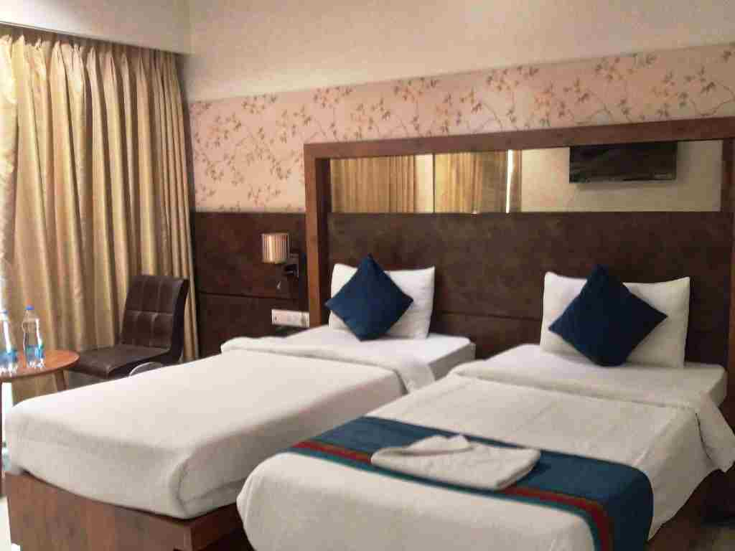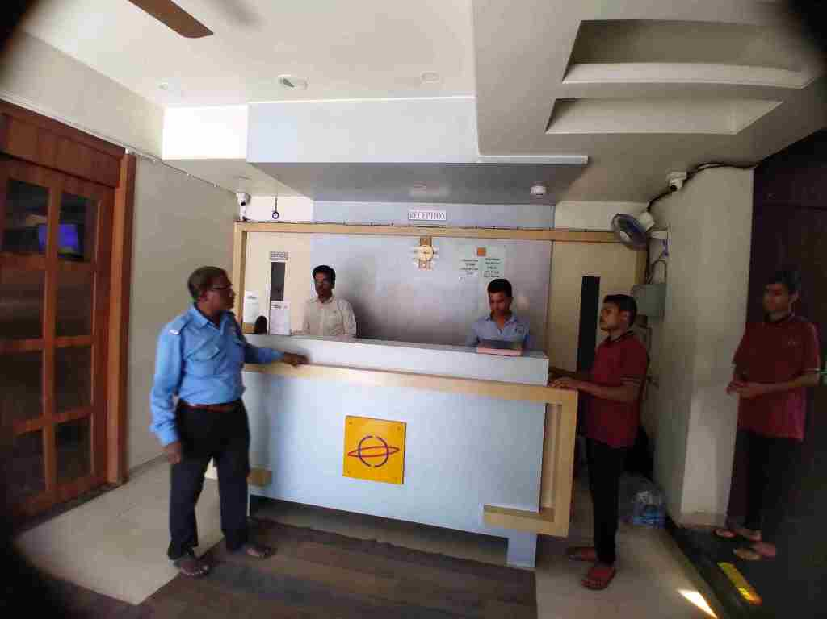

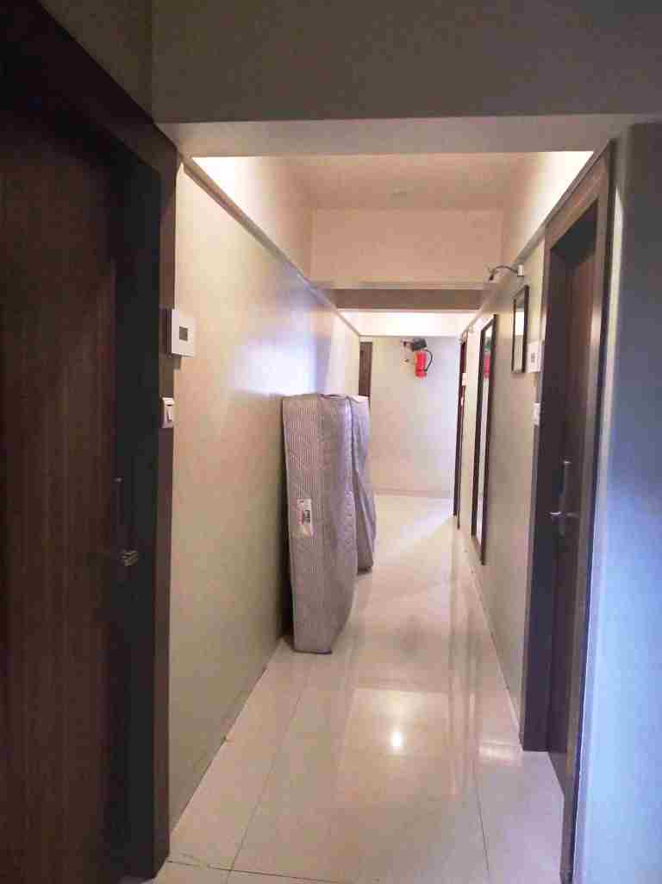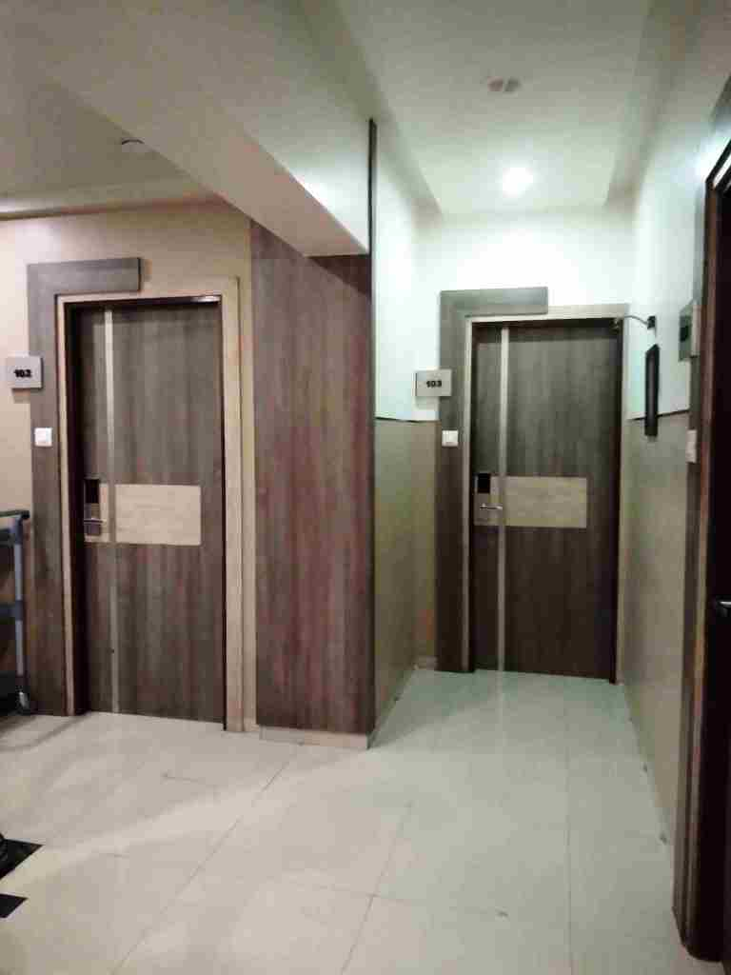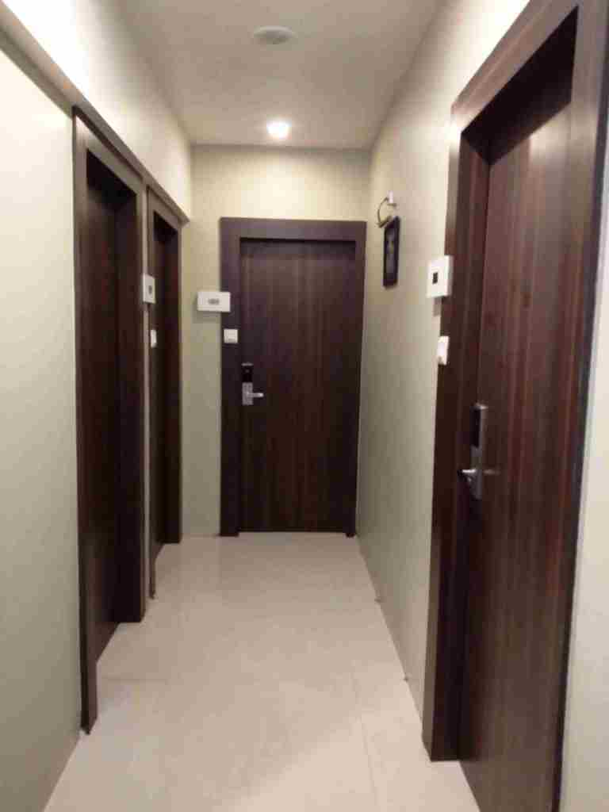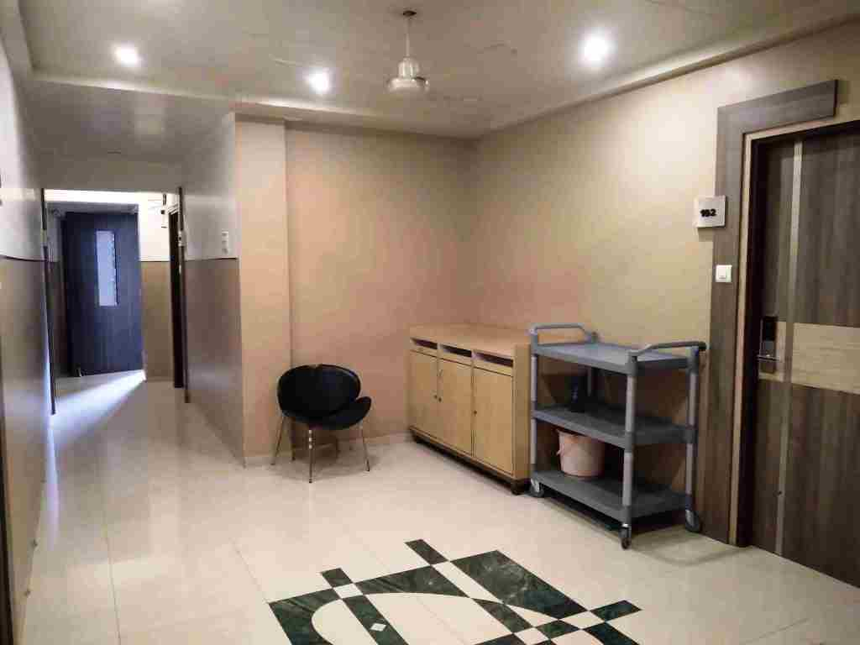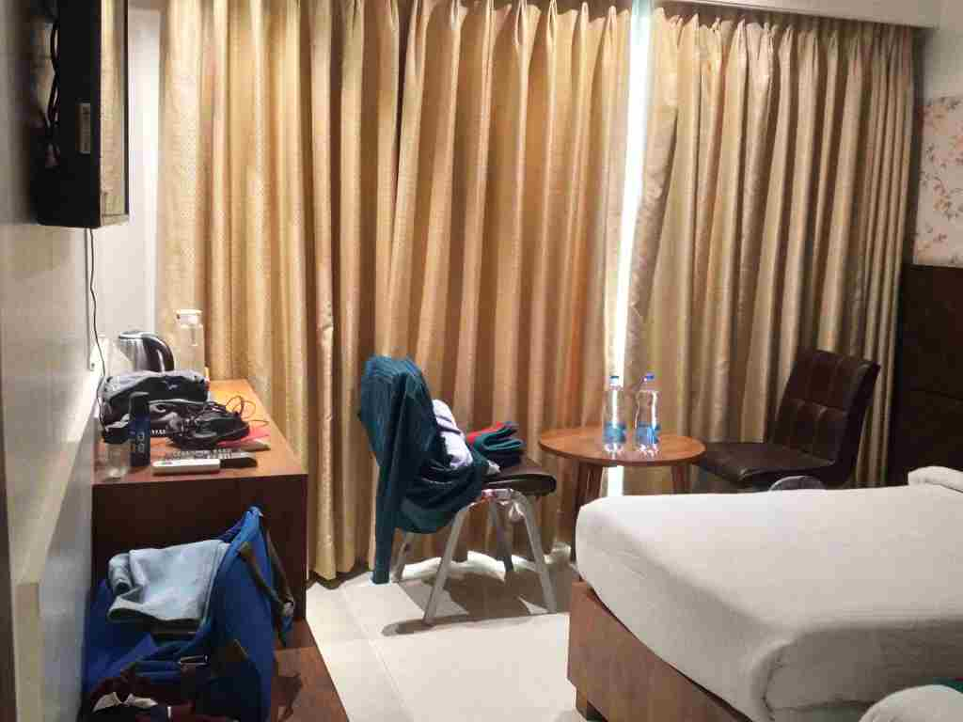

**Actual site photographs**

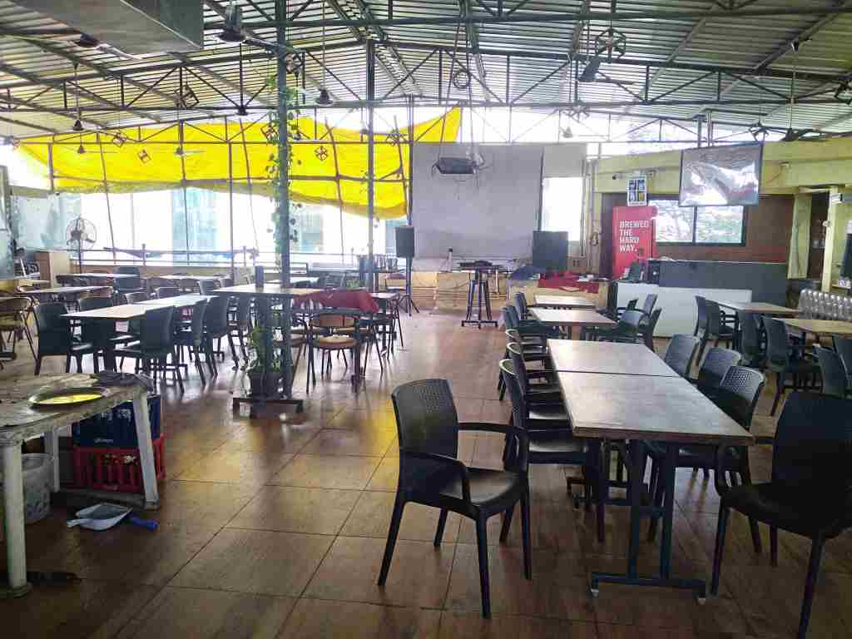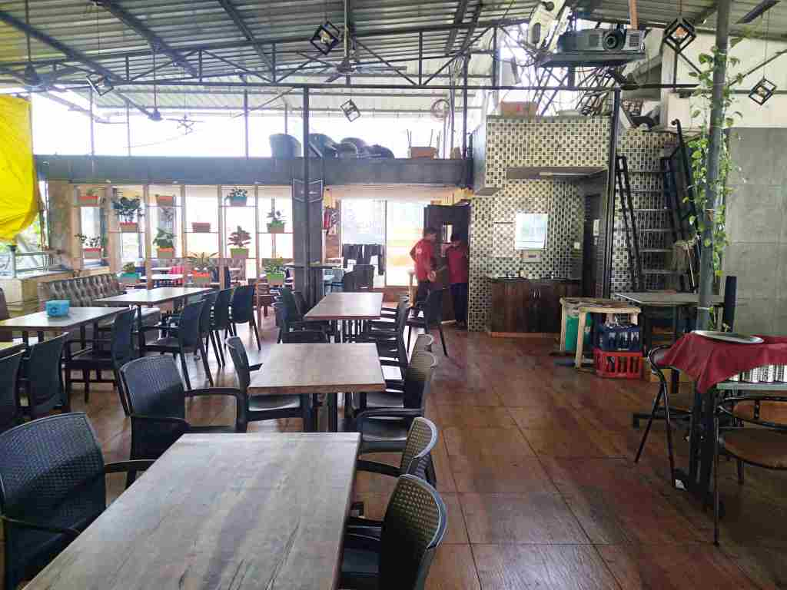

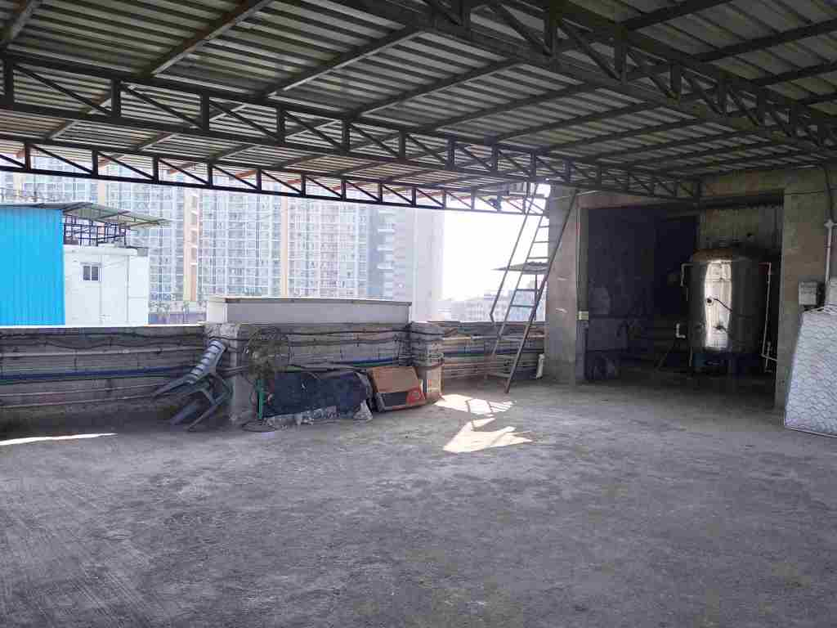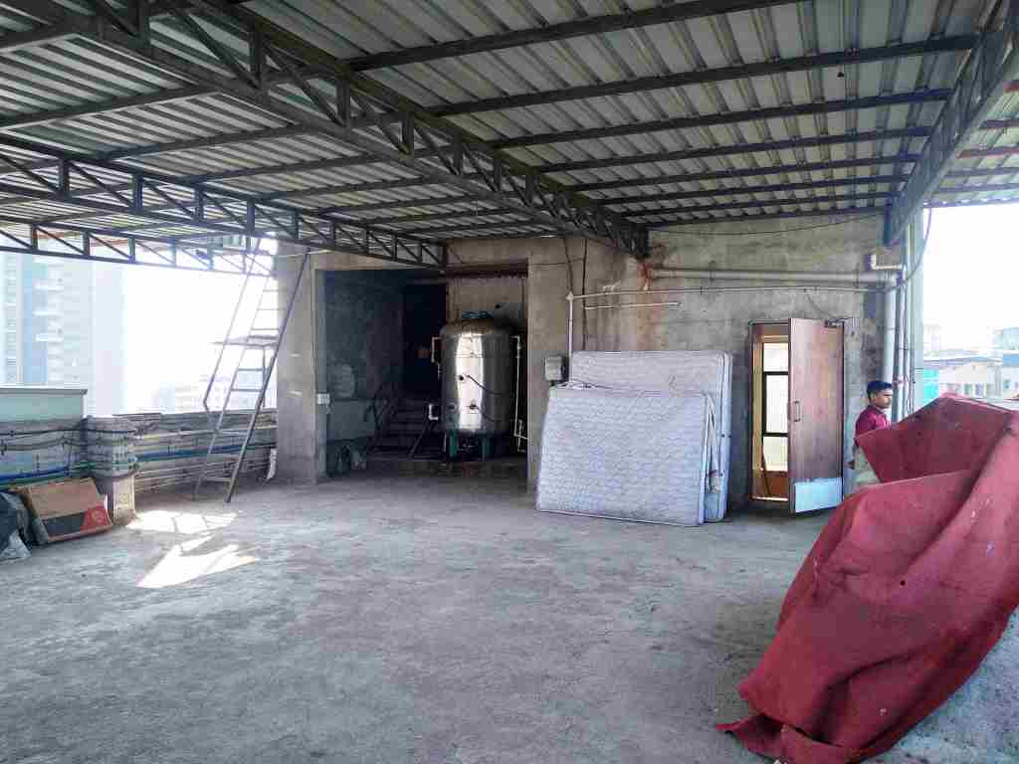

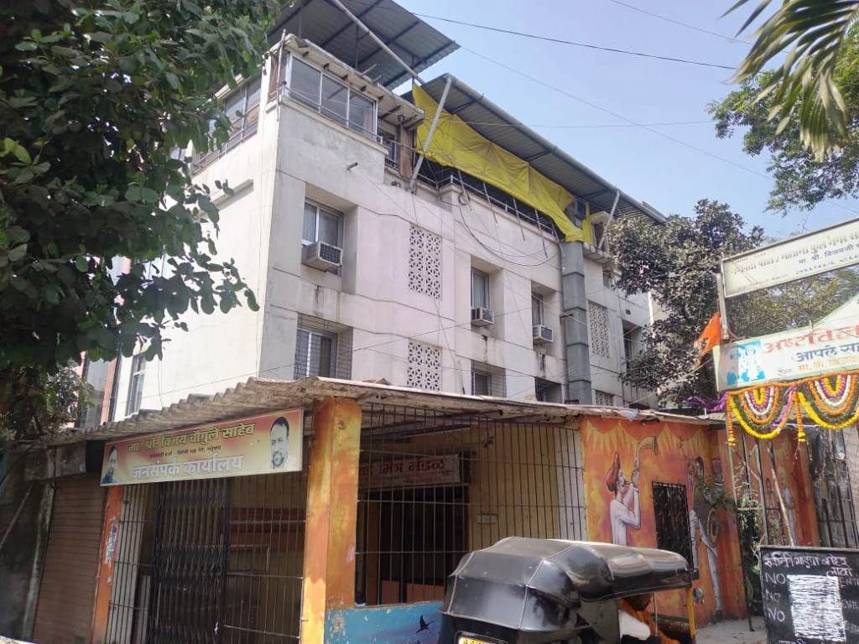

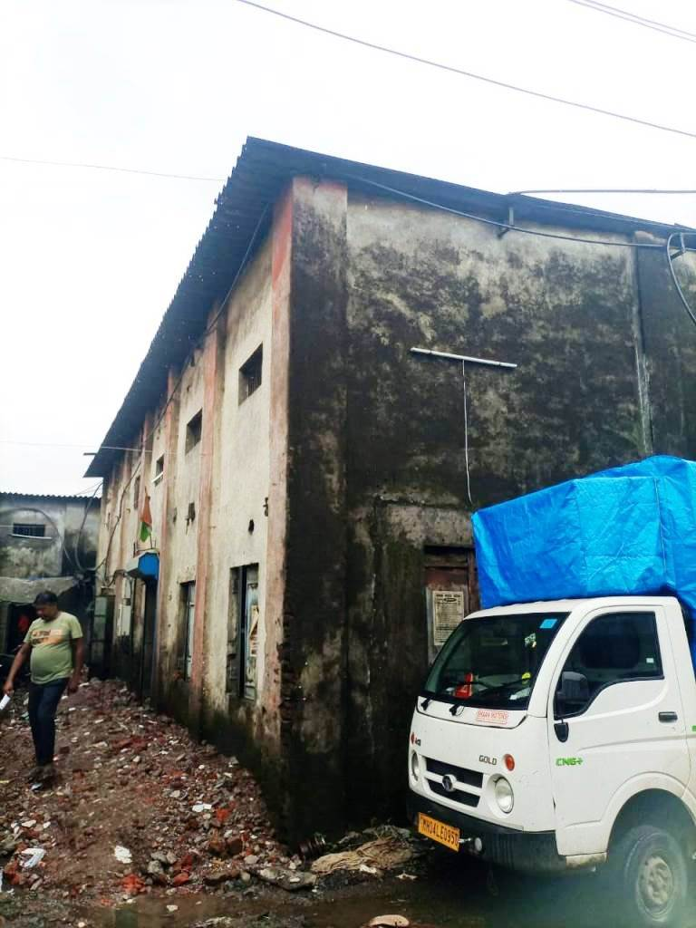

**Actual site photographs**

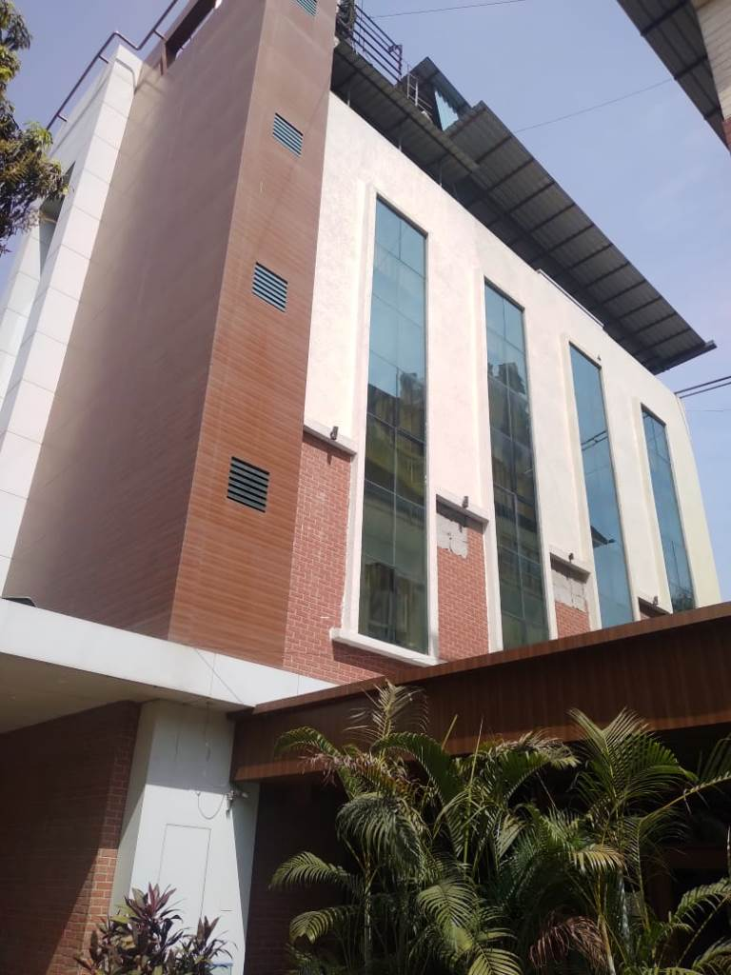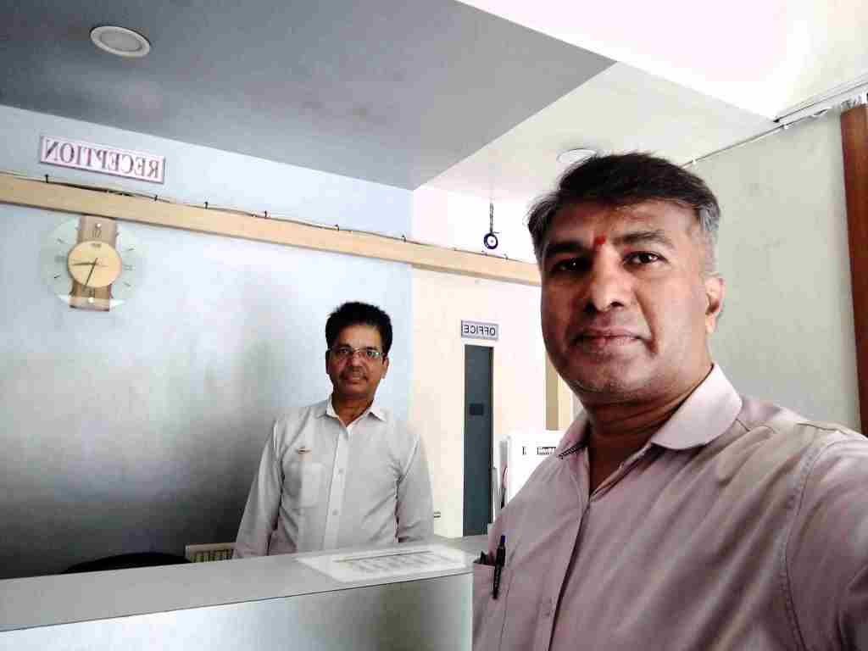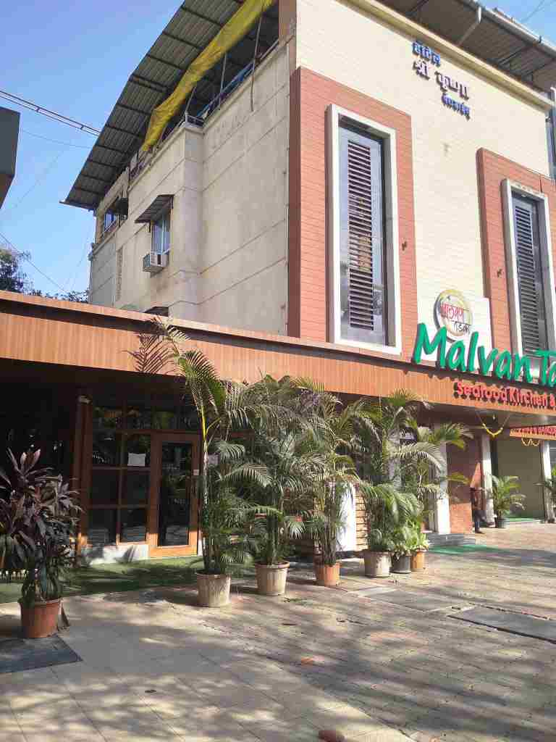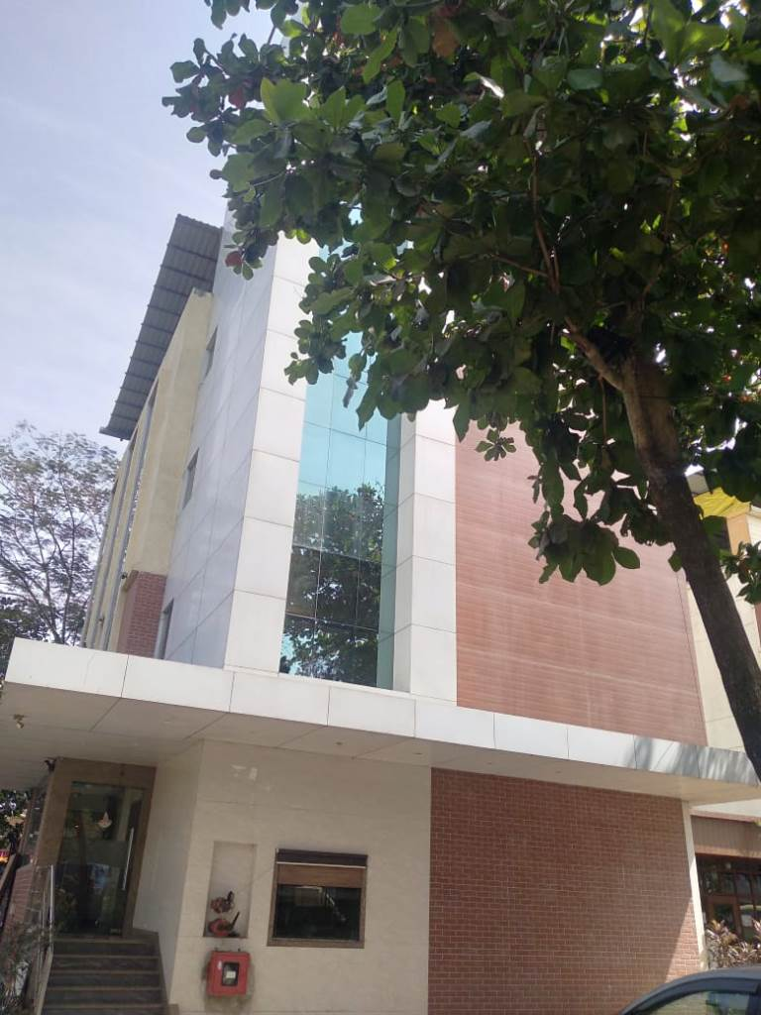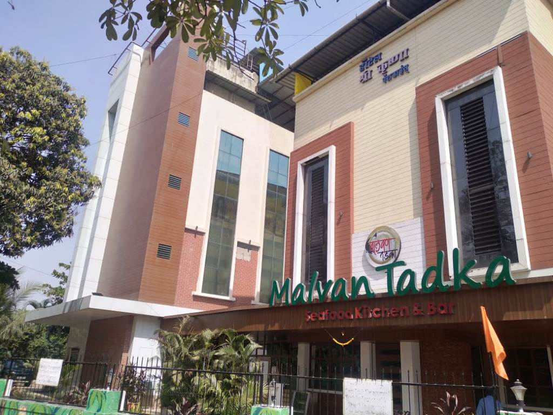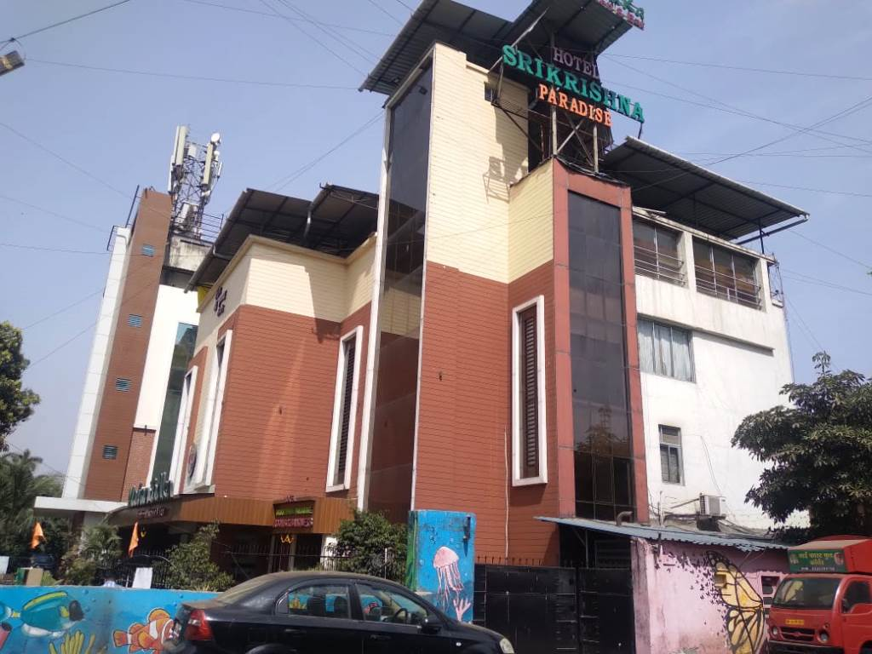

**Route Map of the property**

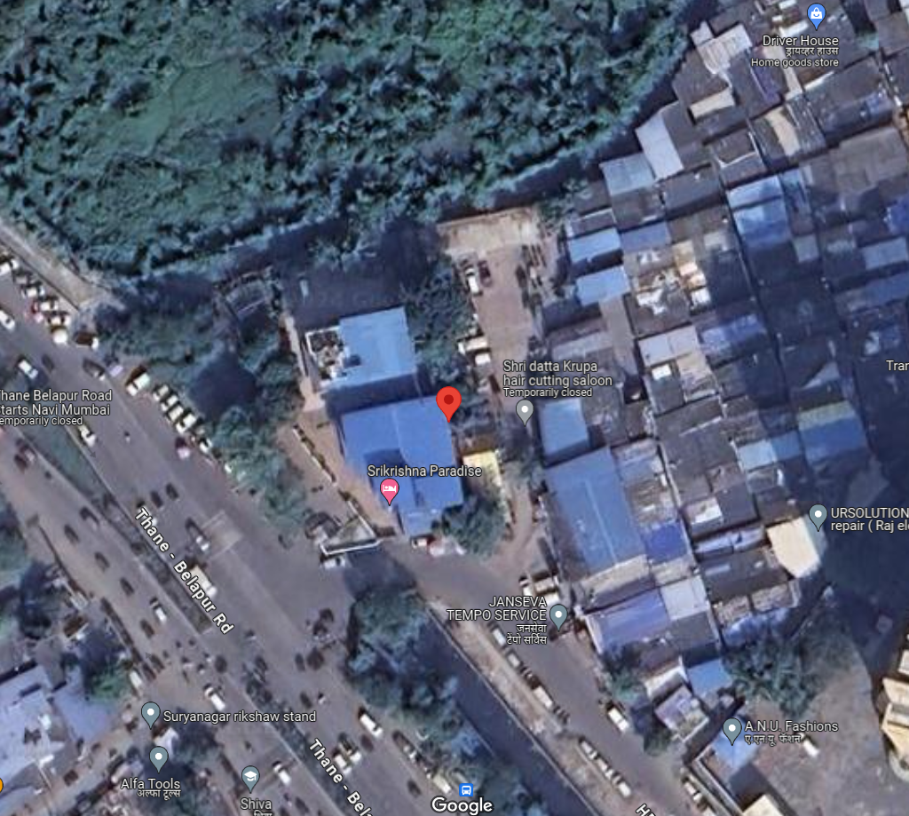**Site u/r**

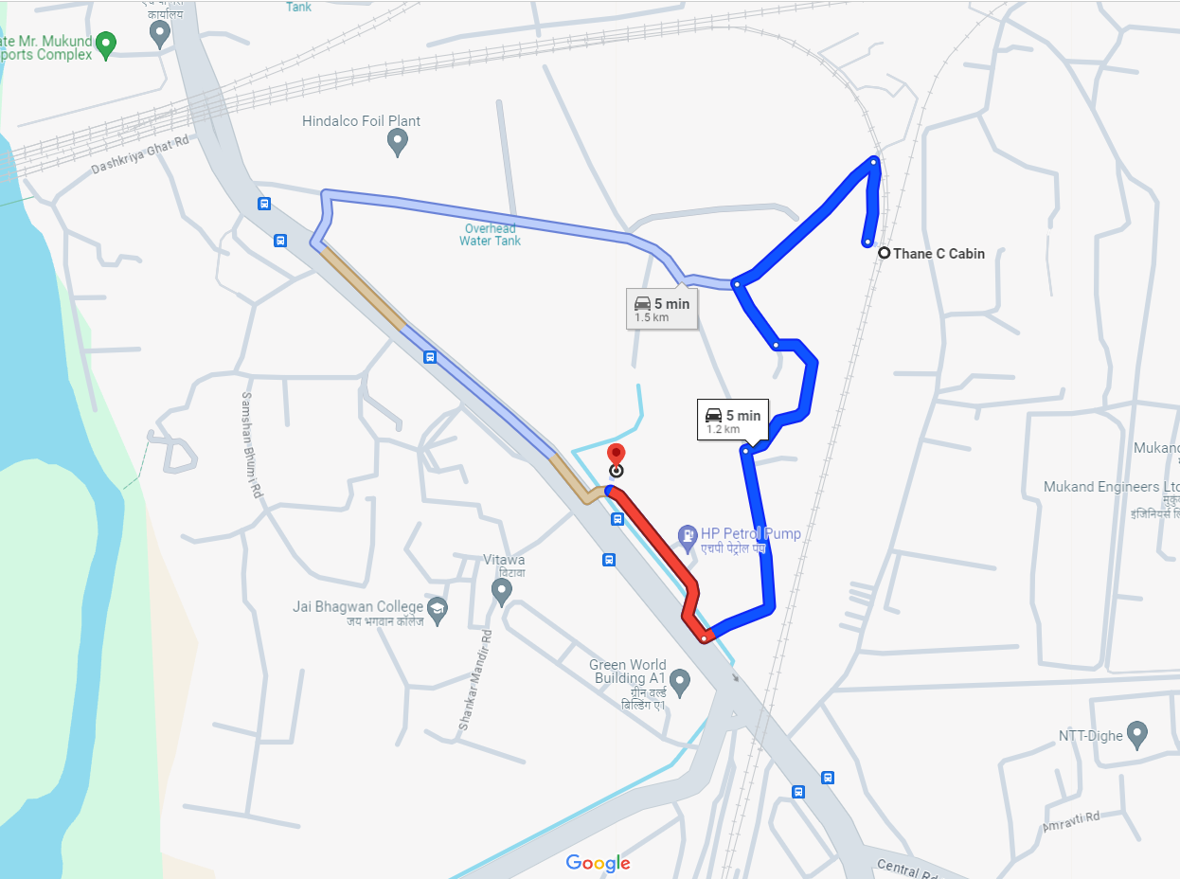

# Latitude Longitude - 19°11'07.8"N 72°59'35.4"E

**Note:** The Blue line shows the route to site from nearest Metro station (Thane C. Cabin – 1.2 km)

**READY RECKONER RATE**

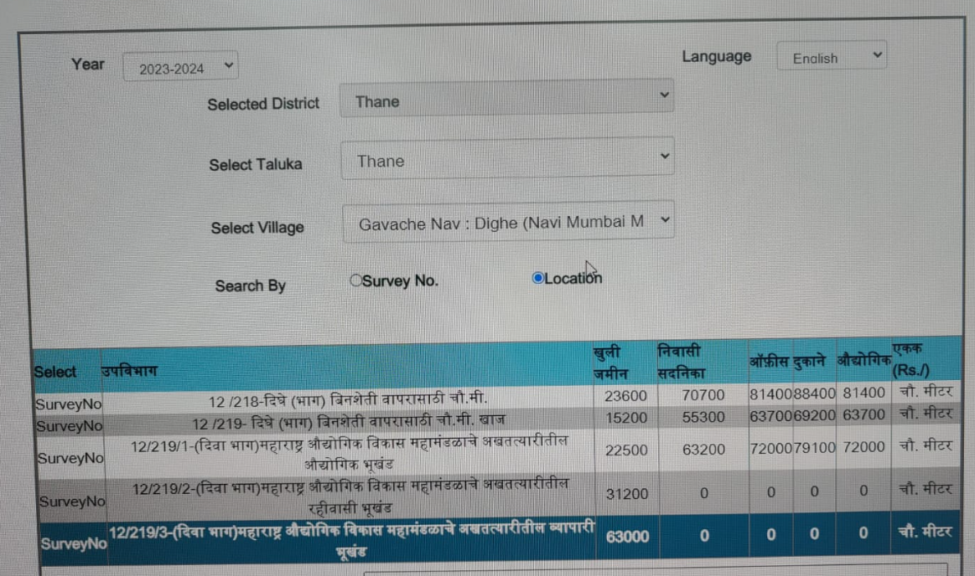

**M.I.D.C. MAP**

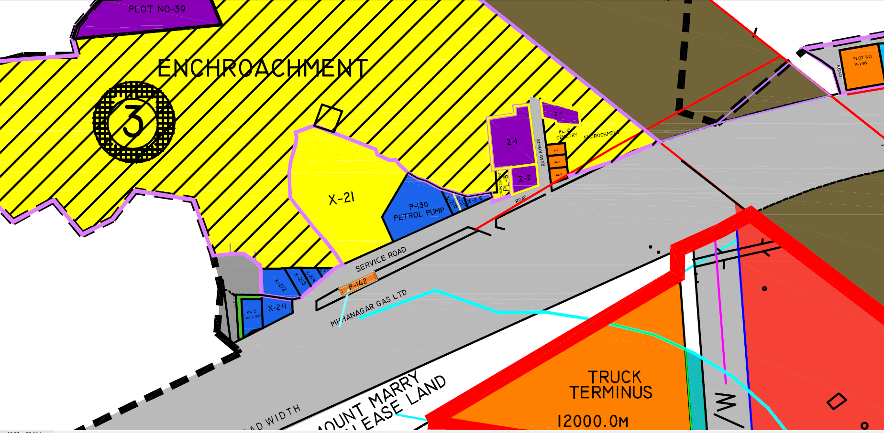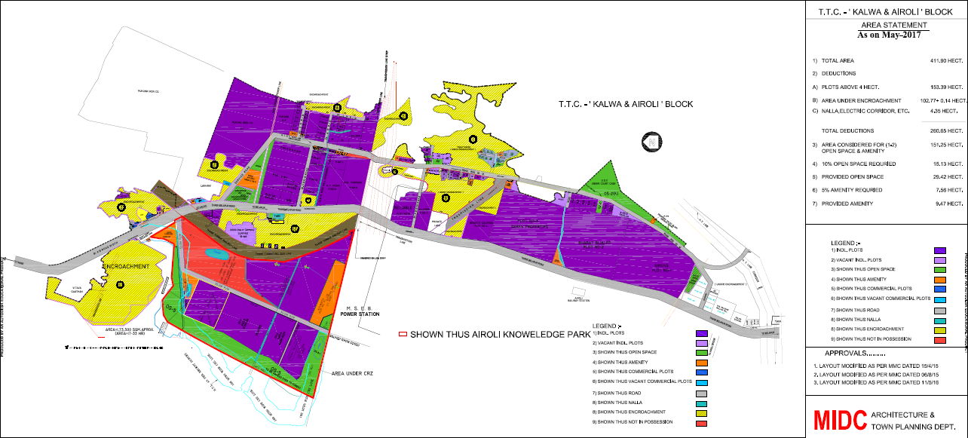

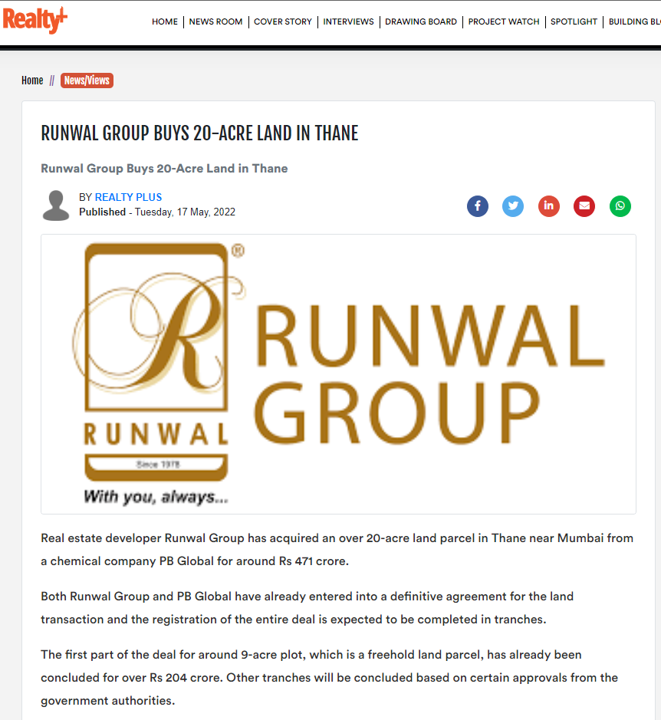**Price Indicators**

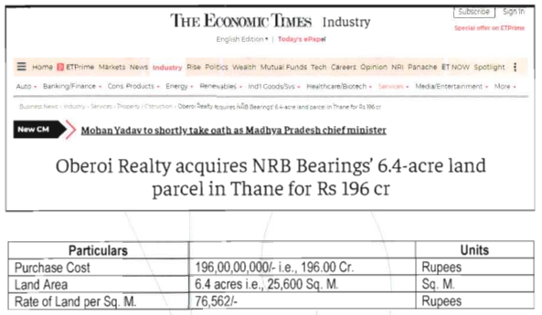

**Plot details**

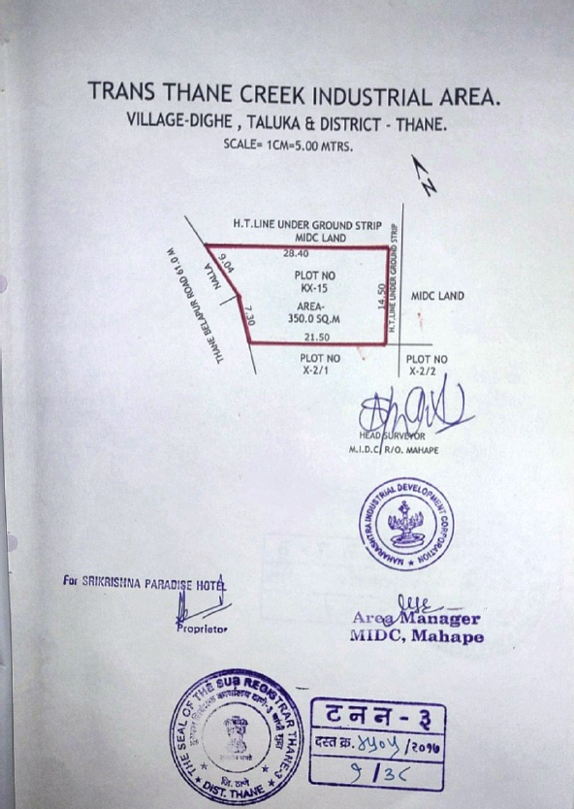

**Advance Possession Receipt**

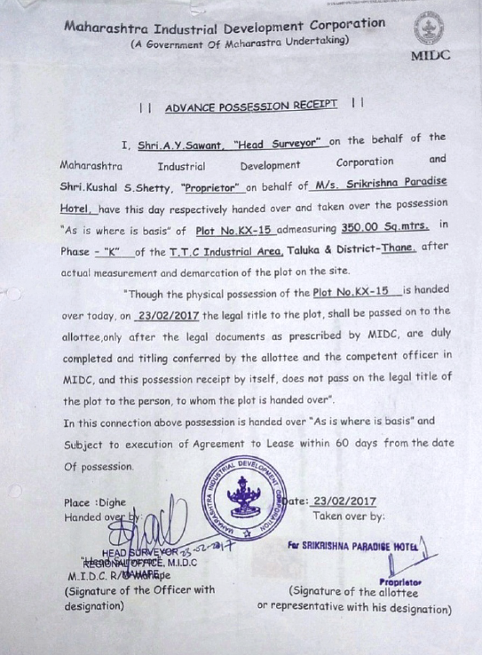

**Building Completion Certificate of Plot No. X-2/1**

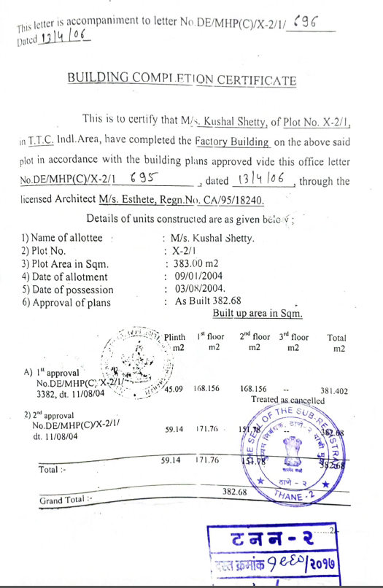

**DEFINITION OF VALUE FOR THIS SPECIFIC PURPOSE**

This exercise is to assess **Fair Market Value** of the property under reference as on **15th February 2024.**

The term **Fair Market Value** is defined as

*“The most probable price, as of a specified date, in cash, terms equivalent to cash, or in other precisely revealed terms for which the specified property rights would sell after reasonable exposure in a competitive market under all conditions requisite to a fair sale, with the buyer and seller each acting prudently knowledgeably and for self-interest assuming that neither is under undue duress”.*

Fundamental assumptions and conditions presumed in this definition are:

1. Buyer and seller are motivated by self-interest.

2. Buyer and seller are well informed and are acting prudently.

3. The property is exposed for a reasonable time on the open market.

4. Payment is made in cash or equivalent or in specified financing terms.

#### UNDER LYING ASSUMPTIONS

1. We assume no responsibility for matters of legal nature affecting the property appraised or the title thereto, nor do we render our opinion as to the title, which is assumed to be good and marketable.

2. The property is valued as though under responsible ownership.

3. It is assumed that the property is free of liens and encumbrances.

4. It is assumed that there are no hidden or unapparent conditions of the subsoil or structure that would render it more or less valuable. No responsibility is assumed for such conditions or for engineering that might be required to discover such factors.

5. There is no direct/ indirect interest in the property valued

6. The rates for valuation of the property are in accordance with the Govt. approved rates and prevailing market rates.

##### DECLARATION OF PROFESSIONAL FEES CHARGED

We hereby declare that, our professional fees are not contingent upon the valuation findings. However, if the statute AND/OR clients demands that, the fees should be charged on the percentage of assessed value then, with the full knowledge of the AND/OR end user, it is being charged accordingly.

# VALUATION OF THE PROPERTY PREMISES

Considering various parameters recorded herein above, existing economic scenario, and the information that is available with reference to the development of neighborhood and method selected for valuation, we are of the opinion that, the property premises can be assessed and valued for banking purpose as on day for ` 5,02,58,570.00 (Rupees Five Crore Two Lakh Fifty-Eight Thousand Five Hundred Seventy Only).

## Manoj B. Chalikwar

## Registered Valuer

## Chartered Engineer (India)

## Reg. No. CAT-I-F-1763

## Cosmos Emp. No. H.O./Credit/67/2019-20