Valuation Report of the Immovable & Movable Property

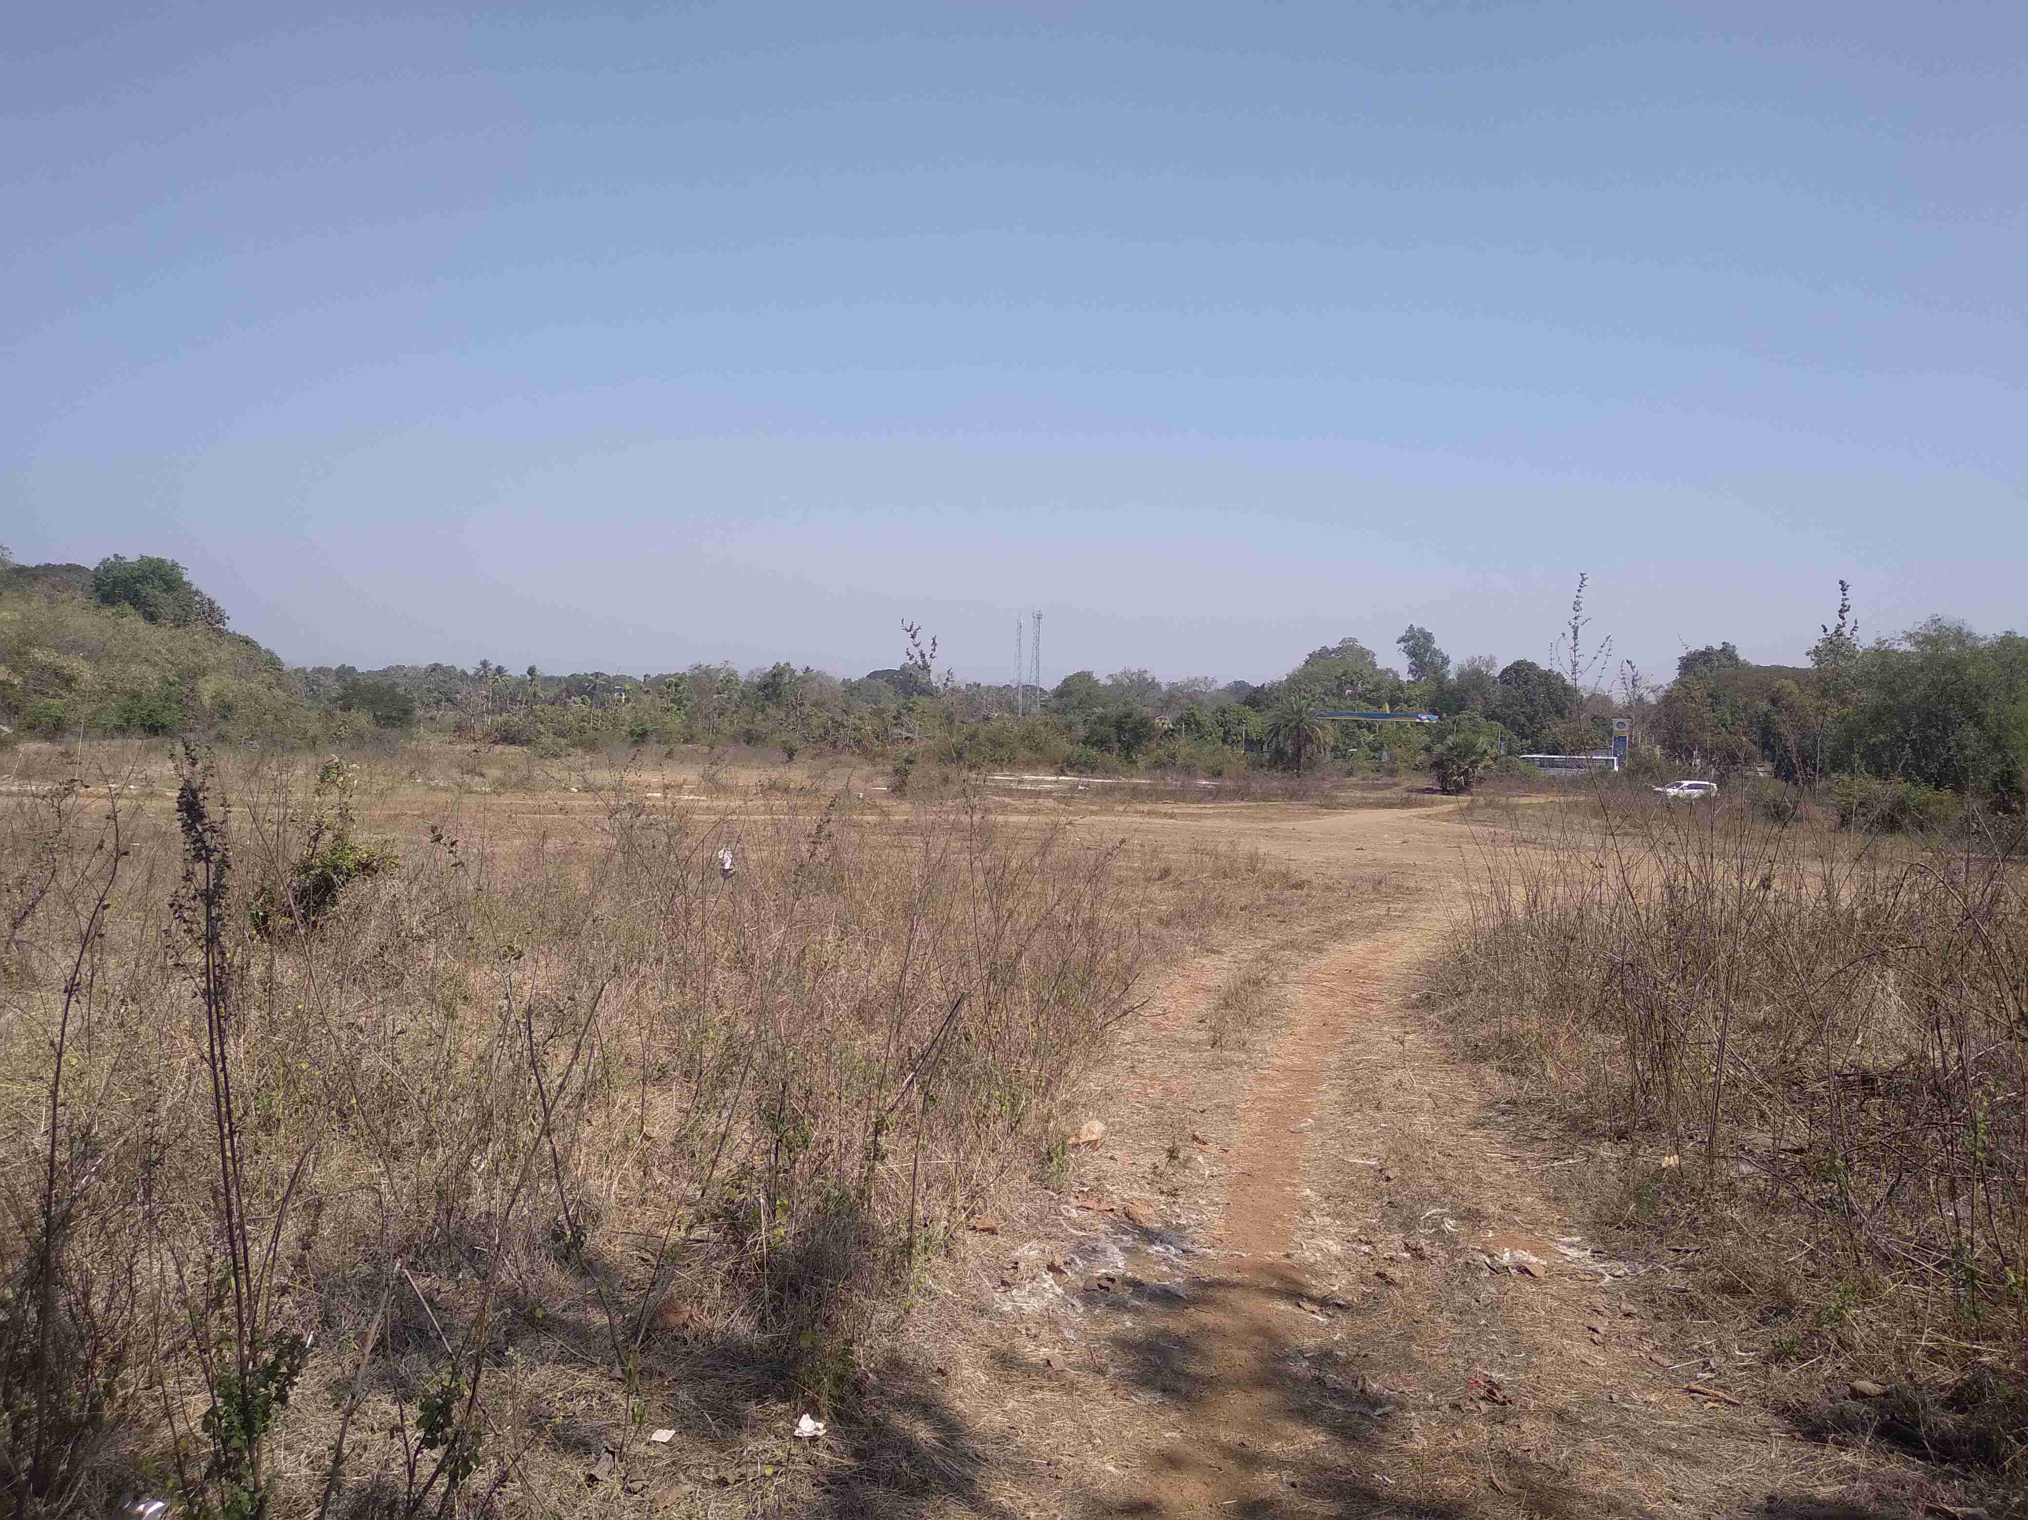

Details of the property under consideration:
(M/s. Jijau Infrastructure MU Project Pvt. Ltd.)

Name of Owner: Mr. Nilesh Bhagwan Sambre

Residential Land bearing Plot Nos. 21 to 27, 30 to 40, 43 to 46, S. No. 93, Near Jai Matadi Petrol Pump, Village – Onde, Taluka – Vikramgad, District – Palghar - 401605, State - Maharashtra, Country – India

Longitude Latitude: 19°46'12.1"N 73°05'15.8"E

Valuation Done for:

State Bank of India
Diamond Branch (BKC)
D/3, West Core, Bharat Dimond Bourse, Bandra-Kurla Complex, Bandra (East), Mumbai - 400 051,
State - Maharashtra, Country - India.

Vastu/Mumbai/02/2024/6843/2305237
29/16-459-VSM
Date:29.02.2024

VALUATION OPINION REPORT

This is to certify that the property bearing Residential Land bearing Plot Nos. 21 to 27, 30 to 40, 43 to 46, S. No. 93, Near Jai Matadi Petrol Pump, Village – Onde, Taluka – Vikramgad, District – Palghar - 401605, State - Maharashtra, Country – India belongs to Mr. Nilesh Bhagwan Sambre.

Boundaries of the property.

North | : | Open Plot
South | : | Open Plot and Vikramgad – Wada Road
East | : | Open Plot
West | : | Open Plot
Considering various parameters recorded, existing economic scenario, and the information that is available with reference to the development of neighborhood and method selected for valuation, we are of the opinion that, the property premises can be assessed and valued for this particular purpose at ` 3,78,73,050.00 (Rupees Three Crore Seventy Eight Lakh Seventy Three Thousand Fifty Only).

The valuation of the property is based on the documents produced by the concern. Legal aspects have not been taken into considerations while preparing this valuation report.

Hence certified

Sharadkumar B. Chalikwar
Govt. Reg. Valuer
Chartered Engineer (India)
Reg. No. (N) CCIT/1-14/52/2008-09
SBI Empanelment No.: SME/TCC/2021-22/85/13
Encl: Valuation report.
Vastukala Consultants (I) Pvt. Ltd.
B1-001, U/B Floor, Boomerang, Chandivali Farm Road, Powai, Andheri (East), Mumbai – 400 072

To,
The Branch Manager,
State Bank of India
Diamond Branch (BKC)
D/3, West Core, Bharat Dimond Bourse, Bandra-Kurla Complex,
Bandra (East), Mumbai - 400 051,
State - Maharashtra, Country - India

VALUATION REPORT (IN RESPECT OF LAND)
I | General
1. | Purpose for which the valuation is made |  |  | : | As per the request from State Bank of India, Diamond Branch (BKC), to assess Fair market value.
2. | a) | Date of inspection |  | : | 10.02.2024
 | b) | Date on which the valuation is made |  | : | 29.02.2024
3. | List of documents produced for perusal
- Copy of 7/12 Extract of each plot.
- Copy of Gav Namuma 6 of each plot.
- Copy of Agreement dated 16.09.2011 between Mr. Nilesh Bhagwan Sambre (Purchaser) and Mr. Kashinath Janardan Gharat & Mr. Ketan Janardan Gharat (Sellers).
- Copy of N.A. Order vide No. Mahsul / Binsheti / S R 1 / 93 dated 24.09.1993 issued by Office of Tahsildar, Javhar.
4. | Name of the owner(s) and his / their address (es) with Phone no. (details of share of each owner in case of joint ownership) |  |  | : | Mr. Nilesh Bhagwan Sambre  Address – Residential Land bearing Plot Nos. 21 to 27, 30 to 40, 43 to 46, S. No. 93, Near Jai Matadi Petrol Pump, Village – Onde, Taluka – Vikramgad, District – Palghar - 401605, State - Maharashtra, Country – India  Contact Person – Mr. Rupesh Jage (Representative of owner)  Contact No.: 96732 95949  Sole Ownership
5. | Brief description of the property (Including Leasehold / freehold etc.) |  |  | :
Property
The property is open plot of land located in rural area having developing infrastructure, connected by road. It is located at about 19.7 KM. from Wada Bus Depot.

This property is in the form of undeveloped residential open plots in a sanctioned layout as per N.A. Order located in the village Onde. The area is having all basic infrastructure facilities such as good approach road.
As per Agreement plot areas are as under and the same is considered for valuation.
S. No. | Plot area (Sq. M.)
93/21 | 350.75
93/22 | 300.00
93/23 | 300.00
93/24 | 300.00
93/25 | 300.00
93/26 | 300.00
93/27 | 350.75
93/30 | 446.05
93/31 | 300.00
93/32 | 396.00
93/33 | 300.00
93/34 | 300.00
93/35 | 300.00
93/36 | 288.00
93/37 | 288.00
93/38 | 256.50
93/39 | 288.00
93/40 | 276.00
93/43 | 608.00
93/44 | 1,287.30
93/45 | 1,982.00
93/46 | 3,107.00
TOTAL | 12,624.35

For the purpose of valuation we have considered total plot area of 12,624.35 Sq. M. which is as per Purchase Agreement.

As on date layout is undeveloped and individual plots are not demarcated on site. Compound wall or any demarcation for each plot is not available. All the plots are amalgamated at site.

N.A. Order vide No. Mahsul / Binsheti / S R 1 / 93 dated 24.09.1993 the land use proposed for residential purpose. As per N.A. Order plot should be developed for given purpose within the time limit of 1 year. At the time of visit we observed that plot is still undeveloped. Under these circumstances, there is a risk that the N.A. Order may be revoked from the competent authority. The valuation is subject to revalidation / renewal of existing NA order or approval by way of new N.A. Permission. Separate legal opinion is advised in this regard.

6. | Location of property |  |  | :
 | a) |  | Plot No. / Survey No. | : | Plot Nos. 21 to 27, 27 to 30, 30 to 40, 43 to 43, S. No. 93
 | b) |  | Door No. | : | Not applicable
 | c) |  | T.S. No. / Village | : | Village Onde
 | d) |  | Ward / Taluka | : | Taluka Vikramgad
 | e) |  | Mandal / District | : | District Palghar
7. | Postal address of the property |  |  | : | Residential Land bearing Plot Nos. 21 to 27, 27 to 30, 30 to 40, 43 to 43, S. No. 93, Near Jai Matadi Petrol Pump, Village – Onde, Taluka – Vikramgad, District – Palghar - 401605, State - Maharashtra, Country – India
8. | City / Town |  |  | : | City
 | Residential area |  |  | : | Yes
 | Commercial area |  |  | : | No
 | Industrial area |  |  | : | No
9. | Classification of the area |  |  | :
 | i) High / Middle / Poor |  |  | : | Middle Class
 | ii) Urban / Semi Urban / Rural |  |  | : | Rural
10. | Coming under Corporation limit / Village Panchayat / Municipality |  |  | : | Within limits of Grampanchayat Onde
11. | Whether covered under any State / Central Govt. enactments (e.g., Urban Land Ceiling Act) or notified under agency area/ scheduled area / cantonment area |  |  | : | No
12. | In Case it is Agricultural land, any conversion to house site plots is contemplated |  |  | : | N.A.
13. | Boundaries of the property |  |  |  | Actual |  | As per document
 | North |  |  | : | Open Plot |  | Plot Nos. 20, 28, 6 & 5
 | South |  |  | : | Open Plot and Vikramgad – Wada Road |  | Plot Nos. 41 & 42
 | East |  |  | : | Open Plot |  | Pali – Vikramgad Road
 | West |  |  | : | Open Plot |  | Plot of Gut No. 92
14.1 | Dimensions of the site |  |  |  | N. A. as the plot under consideration is irregular in shape.
 |  |  |  |  | A As per the Deed | B Actual
 | North |  |  | : | - | -
 | South |  |  | : | - | -
 | East |  |  | : | - | -
 | West |  |  | : | - | -
14.2 | Latitude, Longitude & Co-ordinates of property |  |  | : | 19°46'12.1"N 73°05'15.8"E
14. | Extent of the site |  |  | : | Plot area = 12,624.35 Sq. M.  (Area as per Agreement)
15. | Extent of the site considered for Valuation (least of 14A& 14B) |  |  | :
16 | Whether occupied by the owner / tenant? If occupied by tenant since how long? Rent received per month. |  |  | : | Open plot in the possession of Mr. Nilesh Bhagwan Sambre.
II | CHARACTERSTICS OF THE SITE
 | Classification of locality |  |  | : | Middle class
 | Development of surrounding areas |  |  | : | Developing area
 | Possibility of frequent flooding/ sub-merging |  |  | : | No
 | Feasibility to the Civic amenities like School, Hospital, Bus Stop, Market etc. |  |  | : | All available in village area
 | Level of land with topographical conditions |  |  | : | Plain
 | Shape of land |  |  | : | Irregular
 | Type of use to which it can be put |  |  | : | For residential purpose
 | Any usage restriction |  |  | : | Residential
 | Is plot in town planning approved layout? |  |  | : | Not applicable
 | Corner plot or intermittent plot? |  |  | : | Intermittent
 | Road facilities |  |  | : | Yes
 | Type of road available at present |  |  | : | Tar Road
 | Width of road – is it below 20 ft. or more than 20 ft. |  |  | : | Below 20 ft.
 | Is it a Land – Locked land? |  |  | : | No
 | Water potentiality |  |  | : | No
 | Underground sewerage system |  |  | : | No
 | Is Power supply is available in the site |  |  | : | No
 | Advantages of the site |  |  | : | Nil
 | Special remarks, if any like threat of acquisition of land for publics service purposes, road widening or applicability of CRZ provisions etc.(Distance from sea-cost / tidal level must be incorporated) |  |  | : | No
Part – A (Valuation of land)
1 | Size of plot |  |  | : | Plot area = 12,624.35 Sq. M.  (Area as per Agreement)
 | North & South |  |  | : | -
 | East & West |  |  | : | -
2 | Total extent of the plot |  |  | : | Plot area = 12,624.35 Sq. M.  (Area as per Agreement)
3 | Prevailing market rate ( Along With details / reference of at least two latest deals / transactions with respect to adjacent properties in the areas) |  |  | : | ` 2,000.00 to ` 4,000.00 per Sq. M.  Details of recent transactions/online listings are attached with the report.
4 | Guidelines Rates from Government Portal ( an evidence thereof to be enclosed) |  |  | : | ` 2,410.00 per Sq. M.
5 | Assessed / adopted rate of valuation |  |  | : | ` 3,000.00 per Sq. M.
6 | Estimated value of land |  |  | : | ` 3,78,73,050.00
Part – B (Valuation of Building)
1 | Technical details of the building |  |  | :
 | - Type of Building (Residential / Commercial / Industrial) |  |  | : | Not applicable being valuation of open plot of land
 | - Type of construction (Load bearing / RCC / Steel Framed) |  |  | : | Not applicable being valuation of open plot of land
 | - Year of construction |  |  | : | Not applicable being valuation of open plot of land
 | - Number of floors and height of each floor including basement, if any |  |  | : | Not applicable being valuation of open plot of land
 | - Plinth area floor-wise |  |  | : | Not applicable being valuation of open plot of land
 | - Condition of the building |  |  | :
 | - Exterior – Excellent, Good, Normal, Poor |  |  | : | Not applicable being valuation of open plot of land
 | - Interior – Excellent, Good, Normal, Poor |  |  | : | Not applicable being valuation of open plot of land
 | - Date of issue and validity of layout of approved map |  |  | : | Not applicable being valuation of open plot of land
 | - Approved map / plan issuing authority |  |  | :
 | - Whether genuineness or authenticity of approved map / plan is verified |  |  | : | Not applicable being valuation of open plot of land
 | - Any other comments by our empanelled valuers on authentic of approved plan |  |  | : | No

Specifications of construction (floor-wise) in respect of

Sr.  No. | Description
 | Foundation | : | Not applicable being valuation of open plot of land
 | Basement | : | Not applicable being valuation of open plot of land
 | Superstructure | : | Not applicable being valuation of open plot of land
 | Joinery / Doors & Windows (Please furnish details about size of frames, shutters, glazing, fitting etc. and specify the species of timber | : | Not applicable being valuation of open plot of land
 | RCC Works | : | Not applicable being valuation of open plot of land
 | Plastering | : | Not applicable being valuation of open plot of land
 | Flooring, Skirting, dado | : | Not applicable being valuation of open plot of land
 | Special finish as marble, granite, wooden paneling, grills etc. | : | Not applicable being valuation of open plot of land
 | Roofing including weather proof course | : | Not applicable being valuation of open plot of land
 | Drainage | : | By Municipal Drainage.
2. | Compound Wall | :
 | Height | : | Compound wall not found
 | Length | : | -
 | Type of construction | : | -
3. | Electrical installation | :
 | Type of wiring | : | Not applicable being valuation of open plot of land
 | Class of fittings (superior / ordinary / poor) | : | Not applicable being valuation of open plot of land
 | Number of light points | : | Not applicable being valuation of open plot of land
 | Fan points | : | Not applicable being valuation of open plot of land
 | Spare plug points | : | Not applicable being valuation of open plot of land
 | Any other item | : | -
4. | Plumbing installation
 | - No. of water closets and their type | : | Not applicable being valuation of open plot of land
 | - No. of wash basins | : | Not applicable being valuation of open plot of land
 | - No. of urinals | : | Not applicable being valuation of open plot of land
 | - No. of bath tubs | : | Not applicable being valuation of open plot of land
 | - Water meters, taps etc. | : | Not applicable being valuation of open plot of land
 | - Any other fixtures | : | Not applicable being valuation of open plot of land

Part – C (Extra Items) |  | : | Amount in `
 | Portico | : | Not applicable being valuation of open plot of land
 | Ornamental front door | :
 | Sit out / Verandah with steel grills | :
 | Overhead water tank | :
 | Extra steel / collapsible gates | :
 | Total

Part – D (Amenities) |  | : | Amount in `
 | Wardrobes | : | Not applicable being valuation of open plot of land
 | Glazed tiles | :
 | Extra sinks and bath tub | :
 | Marble / ceramic tiles flooring | :
 | Interior decorations | :
 | Architectural elevation works
 | Paneling works
 | Aluminum works
 | Aluminum hand rails
 | False ceiling
 | Total

Part – E (Miscellaneous) |  | : | Amount in `
 | Separate toilet room | : | Not applicable being valuation of open plot of land
 | Separate lumber room | :
 | Separate water tank / sump | :
 | Trees, gardening | :
 | Total

Part – F (Services) |  | : | Amount in `
 | Water supply arrangements | : | Not applicable being valuation of open plot of land
 | Drainage arrangements | :
 | Compound wall | :
 | C.B. deposits, fittings etc. | :
 | Pavement
 | Total

Government Value

Particulars | Area in Sq. M. | Rate in ` | Value in `
Land | 12,624.35 | 2,410.00 | 3,04,24,684.00
Total |  |  | 3,04,24,684.00

Total abstract of the entire property

Part – A | Land | : | ` 3,78,73,050.00
Part – B | Building | :
Part – C | Compound wall | :
Part - D | Amenities | :
Part – E | Pavement | :
Part – F | Services | :
 | Fair Market Value | : | ` 3,78,73,050.00
 | Realizable Value | : | ` 3,40,85,745.00
 | Distress Sale Value | : | ` 3,02,98,440.00
 | Insurance Value | : | -
Remarks | - As on date layout is undeveloped and individual plots are not demarcated on site. Compound wall or any demarcation for each plot is not available. All the plots are amalgamated at site.  - N.A. Order vide No. Mahsul / Binsheti / S R 1 / 93 dated 24.09.1993 the land use proposed for residential purpose. As per N.A. Order plot should be developed for given purpose within the time limit of 1 year. At the time of visit we observed that plot is still undeveloped. Under these circumstances, there is a risk that the N.A. Order may be revoked from the competent authority. The valuation is subject to revalidation / renewal of existing NA order or approval by way of new N.A. Permission. Separate legal opinion is advised in this regard.  - We have considered total plot area of 12,624.35 Sq. M. as per Purchase Agreement

Land cost can be estimated using the Sales Comparison Approach by studying recent sales of land close to the subject property, and these sales should be comparable in size and location with subject property.

As the property is an residential land, we have adopted Sale Comparison approach Method for the purpose of valuation. The Price for similar type of property in the nearby vicinity is in the range of ` 2,000.00 to ` 4,000.00 per Sq. M. for land Considering the rate with attached report, current market conditions, demand and supply position, Land size, location, sustained demand for residential building / Plot, all round development of commercial and residential application in the locality etc.

We estimate ` 3,000.00 per Sq. M. for Land

The saleability of the property is : Normal
Likely rental values in future in: N.A.
Any likely income it may generate: N.A.

Sharadkumar B. Chalikwar
Govt. Reg. Valuer
Chartered Engineer (India)
Reg. No. (N) CCIT/1-14/52/2008-09
SBI Empanelment No.: SME/TCC/2021-22/85/13

Actual Site Photographs
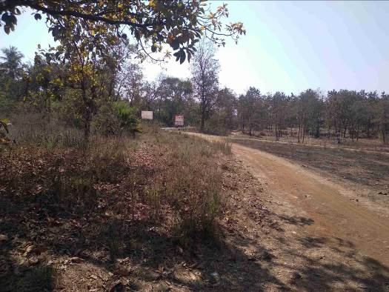
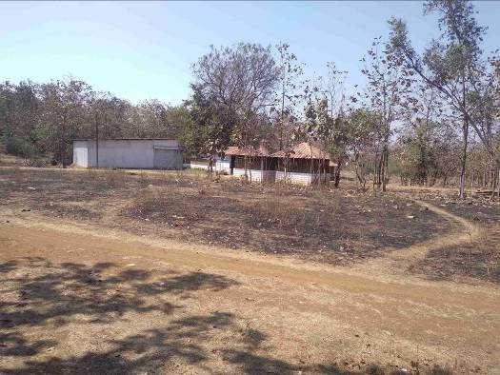

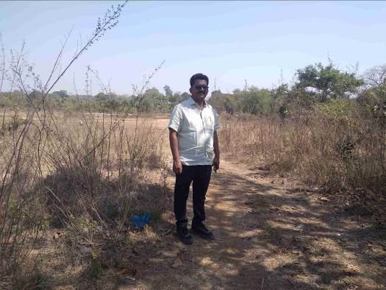
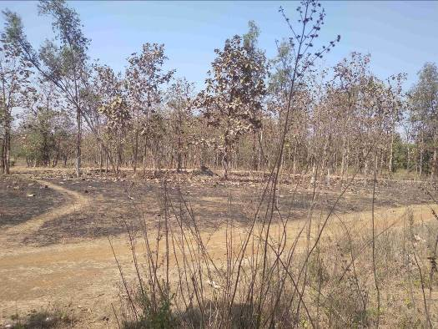
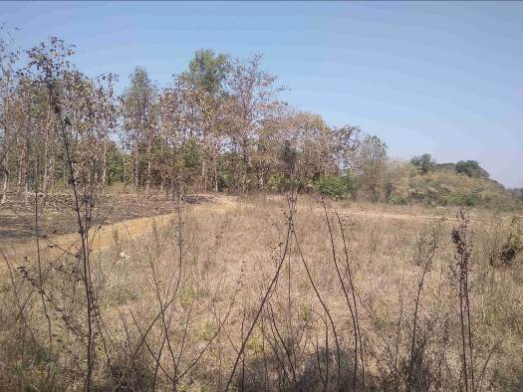
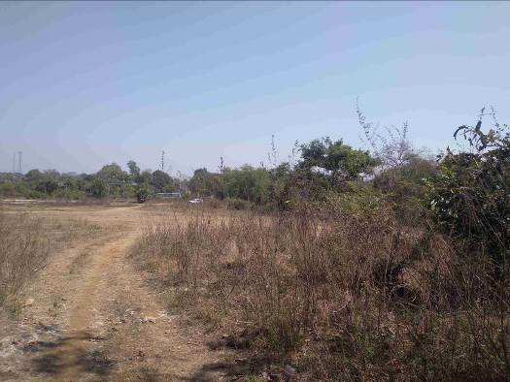
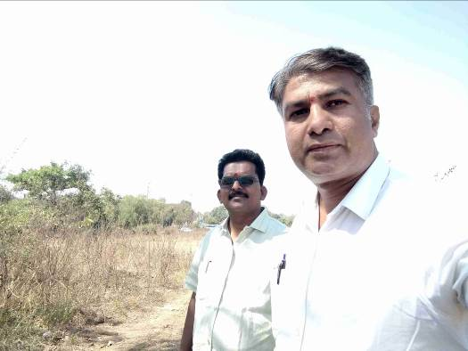
Route Map of the property
Site u/r
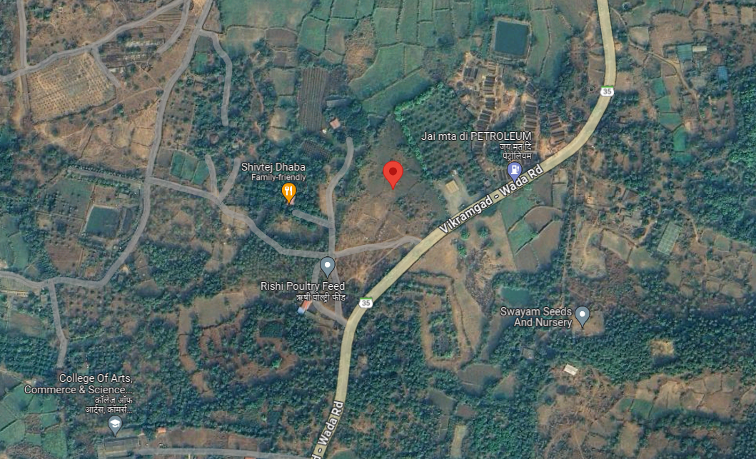

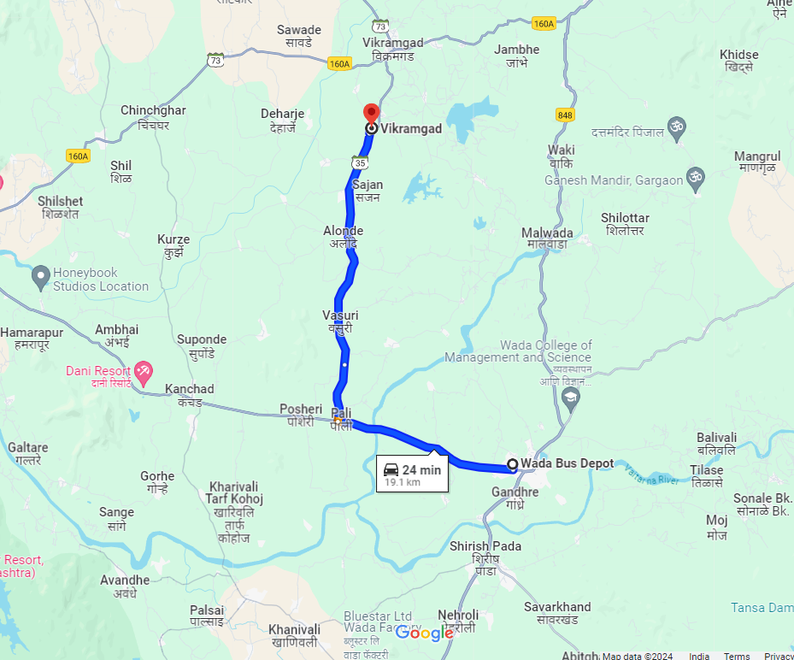

Longitude Latitude: 19°46'12.1"N 73°05'15.8"E

Note: The Blue line shows the route to site from nearest Bus Depot (Wada – 19.1 KM.)

Ready Reckoner Rate

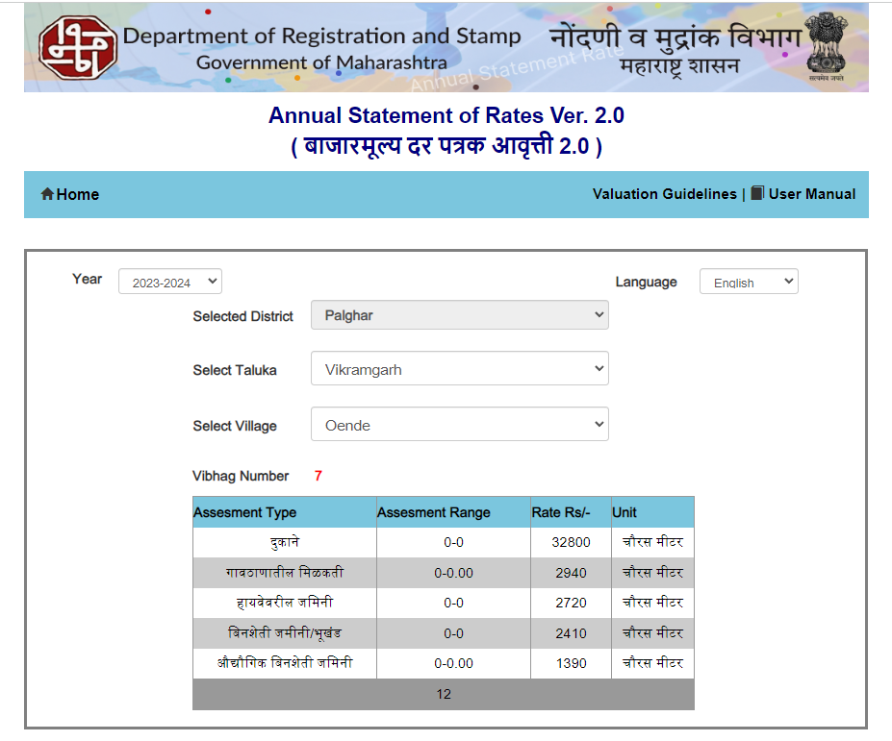
Price Indicators
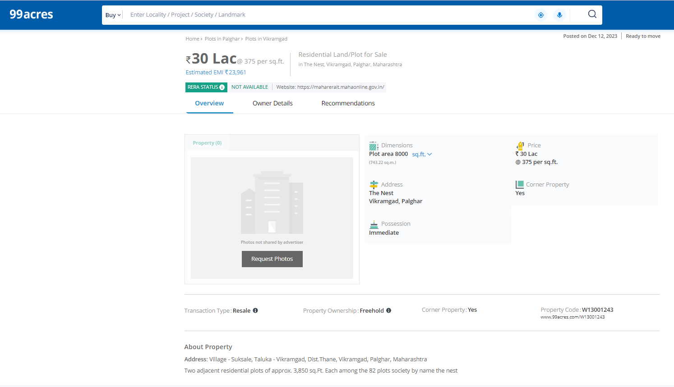

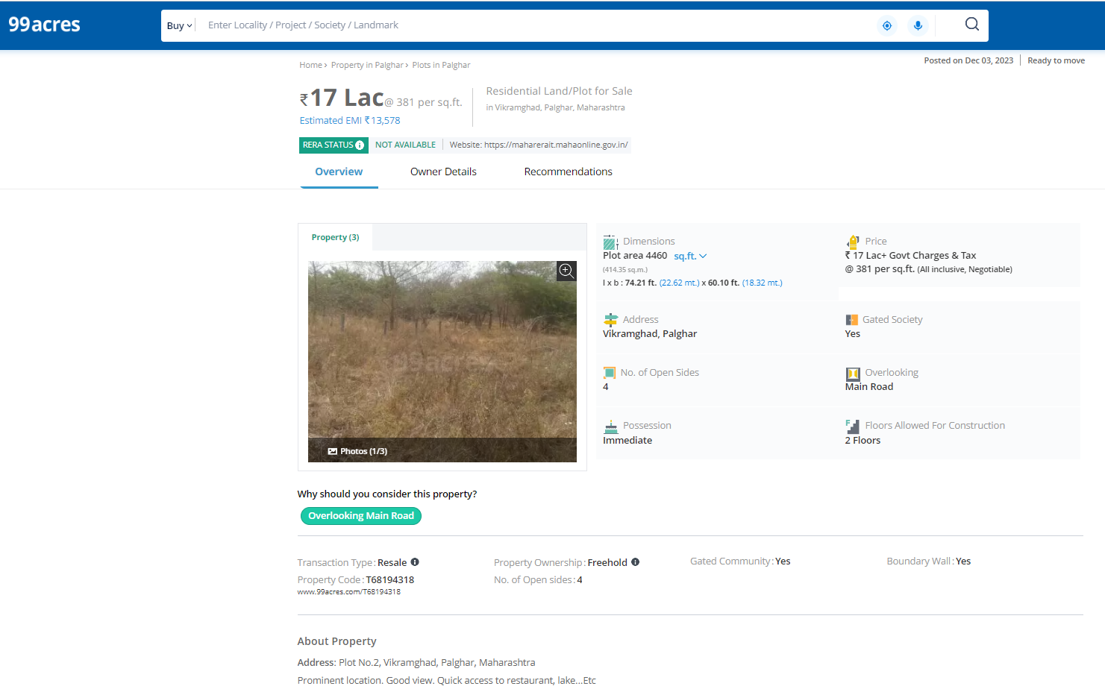
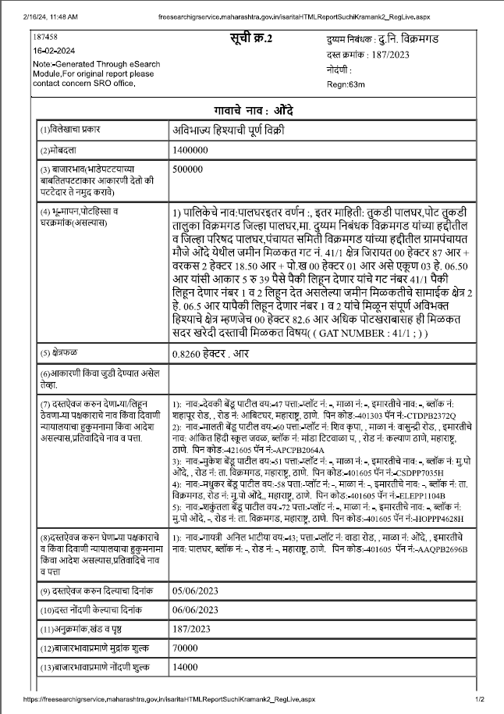
Sale Instance

Justification for price / rate
The Market Value of the property is based on facts of markets discovered by us during our enquiries, however the government rate value in this case is less than the market value arrived by us. We are of the opinion that the value arrive by us will prove to be correct if an Auction of the subject property is carried out. As far as Market Value in Index II is concerned, it is not possible to comment on same, may be government rates are fixed by sampling during same point of time in part and whereas, Market values change every month.

In most of the cases the actual deal amount or Transaction value is not reflected in Index II because of various Market practices. As Valuer, we always try to give a value which is correct reflection of actual transaction value irrespective of any factors in market
As a result of my appraisal and analysis, it is my considered opinion that Fair Market Value of the above property in the prevailing condition with aforesaid specification ` 3,78,73,050.00 (Rupees Three Crore Seventy Eight Lakh Seventy Three Thousand Fifty Only). The Realizable value of the above property is ` 3,40,85,745.00 (Rupees Three Crore Forty Lakh Eighty Five Thousand Seven Hundred Forty Five Only) and the Distress Sale Value is ` 3,02,98,440.00 (Rupees Three Crore Two Lakh Ninety Eight Thousand Four Hundred Forty Only).

Sharadkumar B. Chalikwar
Govt. Reg. Valuer
Chartered Engineer (India)
Reg. No. (N) CCIT/1-14/52/2008-09
SBI Empanelment No.: SME/TCC/2021-22/85/13

The undersigned has inspected the property detailed in the Valuation Report dated _______________________

on ____________________. We are satisfied that the fair and reasonable market value of the property is `_________________________ (Rupees ________________________________________________________

________________________________________only).

Date
Signature
(Name of the Branch Manager with office Seal)

Enclosures
 | Declaration From Valuers (Annexure- II) | Attached
 | Model code of conduct for valuer - (Annexure III) | Attached

(Annexure-I)

DECLARATION-CUM-UNDERTAKING

I, Sharadkumar Chalikwar son of Shri. Baburao Chalikwar do hereby solemnly affirm and state that:

- I am a citizen of India.

- I will not undertake valuation of any assets in which I have a direct or indirect interest or become so interested at any time during a period of three years prior to my appointment as valuer or three years after the valuation of assets was conducted by me.

- The information furnished in my valuation report dated 29.02.2024 is true and correct to the best of my knowledge and belief and I have made an impartial and true valuation of the property.

- I/ my authorized representative have personally inspected the property on 10.02.2024. The work is not sub - contracted to any other valuer and carried out by myself.

- Valuation report is submitted in the format as prescribed by the bank.

- I have not been depanelled / delisted by any other bank and in case any such depanelment by other banks during my empanelment with you, I will inform you within 3 days of such depanelment.

- I have not been removed / dismissed from service / employment earlier.

- I have not been convicted of any offence and sentenced to a term of imprisonment

- I have not been found guilty of misconduct in my professional capacity.

- I have not been declared to be unsound mind

- I am not an undischarged bankrupt, or has not applied to be adjudicated as a bankrupt;

- I am not an undischarged insolvent.

- I have not been levied a penalty under section 271J of Income-tax Act, 1961 (43 of 1961) and time limit for filing appeal before Commissioner of Income-tax (Appeals) or Income-tax Appellate Tribunal, as the case may be has expired, or such penalty has been confirmed by Income-tax Appellate Tribunal, and five years have not elapsed after levy of such penalty

- I have not been convicted of an offence connected with any proceeding under the Income Tax Act 1961, Wealth Tax Act 1957 or Gift Tax Act 1958 and

- My PAN Card number as applicable is AEAPC0117Q

- I undertake to keep you informed of any events or happenings which would make me ineligible for empanelment as a valuer

- I have not concealed or suppressed any material information, facts and records and I have made a complete and full disclosure

- I have read the Handbook on Policy, Standards and procedure for Real Estate Valuation, 2011 of the IBA and this report is in conformity to the "Standards" enshrined for valuation in the Part - B of the above handbook to the best of my ability.

- I have read the International Valuation Standards (IVS) and the report submitted to the Bank for the respective asset class is in conformity to the "Standards" as enshrined for valuation in the IVS in "General Standards" and "Asset Standards" as applicable. The valuation report is submitted in the prescribed format of the bank.

- I abide by the Model Code of Conduct for empanelment of valuer in the Bank. (Annexure V - A signed copy of same to be taken and kept along with this declaration)

- I am registered under Section 34 AB of the Wealth Tax Act, 1957.

- I am valuer registered with Insolvency & Bankruptcy Board of India (IBBI)

- My CIBIL Score and credit worthiness is as per Bank's guidelines.

- I am Chairman & Managing Director of the company, who is competent to sign this valuation report.

- I will undertake the valuation work on receipt of Letter of Engagement generated from the system (i.e. LLMS / LOS) only.

- Further, I hereby provide the following information.

 | Particulars | Valuer comment
 | Background information of the asset being valued; | The land under valuation is belongs to Mr. Nilesh Bhagwan Sambre
 | Purpose of valuation and appointing authority | As per the request from State Bank of India, Diamond Branch (BKC) to assess Fair Market value of the property.
 | Identity of the Valuer and any other experts involved in the valuation; | Sharadkumar B. Chalikwar – Regd. Valuer  Manoj B. Chalikwar – Regd. Valuer  Vaibhav Bhagat - Site Engineer  Vaishali Sarmalkar – Technical Manager.
 | Disclosure of Valuer interest or conflict, if any; | We have no interest, either direct or indirect, in the property valued. Further to state that we do not have relation or any connection with property owner / applicant directly or indirectly. Further to state that we are an independent Valuer and in no way related to property owner / applicant
 | Date of appointment, valuation date and date of report; | Date of Appointment – 10.02.2024  Valuation Date – 29.02.2024  Date of Report – 29.02.2024
 | Inspections and/or investigations undertaken; | Physical Inspection done on date 10.02.2024
 | Nature and sources of the information used or relied upon; | Market Survey at the time of site visit  Ready Reckoner rates / Circle rates  Online search for Registered Transactions  Online Price Indicators on real estate portals  Enquiries with Real estate consultants  Existing data of Valuation assignments carried out by us
 | Procedures adopted in carrying out the valuation and valuation standards followed; | Comparative Sales Method (For Land component)
 | Restrictions on use of the report, if any; | This valuation is for the use of the party to whom it is addressed and for no other purpose. No responsibility is accepted to any third party who may use or rely on the whole or any part of this valuation. The valuer has no pecuniary interest that would conflict with the proper valuation of the property.
- . | Major factors that were taken into account during the valuation; | Current market conditions, demand and supply position, industrial land size, location, sustained demand for industrial land, all round development of commercial and industrial application in the locality etc.
 | Caveats, limitations and disclaimers to the extent they explain or elucidate the limitations faced by valuer, which shall not be for the purpose of limiting his responsibility for the valuation report. | Attached

ASSUMPTIONS, DISCLAIMERS, LIMITATIONS & QUALIFICATIONS

Value Subject to Change
The subject appraisal exercise is based on prevailing market dynamics as on 29th February 2024 and does not take into account any unforeseeable developments which could impact the same in the future.

Our Investigations
We are not engaged to carry out all possible investigations in relation to the subject property. Where in our report we identify certain limitations to our investigations, this is to enable the reliant party to instruct further investigations where considered appropriate or where we recommend as necessary prior to reliance. Vastukala Consultants India Pvt. Ltd. (VCIPL) is not liable for any loss occasioned by a decision not to conduct further investigations

Assumptions
Assumptions are a necessary part of undertaking valuations. VCIPL adopts assumptions for the purpose of providing valuation advise because some matters are not capable of accurate calculations or fall outside the scope of our expertise, or out instructions. The reliant party accepts that the valuation contains certain specific assumptions and acknowledge and accept the risk of that if any of the assumptions adopted in the valuation are incorrect, then this may have an effect on the valuation.

Information Supplied by Others
The appraisal is based on the information provided by the client. The same has been assumed to be correct and has been used for appraisal exercise. Where it is stated in the report that another party has supplied information to VCIPL, this information is believed to be reliable but VCIPL can accept no responsibility if this should prove not to be so.

Future Matters
To the extent that the valuation includes any statement as to a future matter, that statement is provided as an estimate and/or opinion based on the information known to VCIPL at the date of this document. VCIPL does not warrant that such statements are accurate or correct.

Map and Plans
Any sketch, plan or map in this report is included to assist the reader while visualizing the property and assume no responsibility in connection with such matters.

Site Details
Based on inputs received from Client's representative and site visit conducted, we understand that the subject property is currently a contiguous and non-agricultural land parcel admeasuring 12,624.35 Sq. M. The property is owned by Mr. Nilesh Bhagwan Sambre. At present, the property is currently Owner occupied. Further, VCIPL has assumed that the subject property is free from any encroachment and is available as on the date of the appraisal.

Property Title
Based on our discussion with the Client, we understand that the property is owned by Mr. Nilesh Bhagwan Sambre. For the purpose of this appraisal exercise, we have assumed that the subject property has a clear title and is free from any encumbrances, disputes and claims. VCIPL has made no further enquiries with the relevant local authorities in this regard and does not certify the property as having a clear and marketable title. Further, no legal advice regarding the title and ownership of the subject property has been obtained for the purpose of this appraisal exercise. It has been assumed that the title deeds are clear and marketable.

Environmental Conditions
We have assumed that the subject property is not contaminated and is not adversely affected by any existing or proposed environmental law and any processes which are carried out on the property are regulated by environmental legislation and are properly licensed by the appropriate authorities.

Town Planning
The permissible land use, zoning, achievable FSI, area statement adopted for purpose of this valuation is based on the information provided by the Client's representative and the same has been adopted for this valuation purpose. VCIPL has assumed the same to be correct and permissible. VCIPL has not validated the same from any authority.

Area
Based on the documents, we understand that the subject property is contiguous and non-agricultural land parcel admeasuring 12,624.35 Sq. M.

Condition & Repair
In the absence of any information to the contrary, we have assumed that there are no abnormal ground conditions, nor archaeological remains present which might adversely affect the current or future occupation, development or value of the property. The property is free from rat, infestation, structural or latent defect. No currently known deleterious or hazardous materials or suspect techniques will be used in the construction of or subsequent alteration or additions to the property and comments made in the property details do not purport to express an opinion about, or advise upon, the condition of uninspected parts and should not be taken as making an implied representation or statement about such parts

Valuation Methodology
For the purpose of this valuation exercise, the valuation methodology used is Direct Comparison Approach Method and proposed Highest and Best Use model is used for analysing development potential.
The Direct Comparison Approach involves a comparison of the property being valued to similar properties that have actually been sold in arms - length transactions or are offered for sale. This approach demonstrates what buyers have historically been willing to pay (and sellers willing to accept) for similar properties in an open and competitive market and is particularly useful in estimating the value of the land and properties that are typically traded on a unit basis.
In case of inadequate recent transaction activity in the subject micro-market, the appraiser would collate details of older transactions. Subsequently, the appraiser would analyse rental / capital value trends in the subject micro-market in order to calculate the percentage increase / decrease in values since the date of the identified transactions. This percentage would then be adopted to project the current value of the same.
Where reliance has been placed upon external sources of information in applying the valuation methodologies, unless otherwise specifically instructed by Client and/or stated in the valuation, VCIPL has not independently verified that information and VCIPL does not advise nor accept it as reliable. The person or entity to whom the report is addressed acknowledges and accepts the risk that if any of the unverified information in the valuation is incorrect, then this may have an effect on the valuation.

Not a Structural Survey
We state that this is a valuation report and not a structural survey

Other
All measurements, areas and ages quoted in our report are approximate

Legal
We have not made any allowances with respect to any existing or proposed local legislation relating to taxation on realization of the sale value of the subject property. VCIPL is not required to give testimony or to appear in court by reason of this appraisal report, with reference to the property in question, unless arrangement has been made thereof. Further, no legal advice on any aspects has been obtained for the purpose of this appraisal exercise

Property specific assumptions
Based on inputs received from the client and site visit conducted, we understand that the subject property is currently vacant, contiguous and non-agricultural land parcel admeasuring 12,624.35 Sq. M.

ASSUMPTIONS, CAVEATS, LIMITATION AND DISCLAIMERS
1. We assume no responsibility for matters of legal nature affecting the property appraised or the title thereto, nor do we render our opinion as to the title, which is assumed to be good and marketable.
2. The property is valued as though under responsible ownership.
3. It is assumed that the property is free of liens and encumbrances.
4. It is assumed that there are no hidden or unapparent conditions of the subsoil or structure that would render it more or less valuable. No responsibility is assumed for such conditions or for engineering that might be required to discover such factors.
5. There is no direct/ indirect interest in the property valued.
6. The rates for valuation of the property are in accordance with the Govt. approved rates and prevailing market rates.
(Annexure - II)

MODEL CODE OF CONDUCT FOR VALUERS

Integrity and Fairness
- A valuer shall, in the conduct of his/its business, follow high standards of integrity and fairness in all his/its dealings with his/its clients and other valuers.
- A valuer shall maintain integrity by being honest, straightforward, and forthright in all professional relationships.
- A valuer shall endeavour to ensure that he/it provides true and adequate information and shall not misrepresent any facts or situations.
- A valuer shall refrain from being involved in any action that would bring disrepute to the profession.
- A valuer shall keep public interest foremost while delivering his services.

Professional Competence and Due Care
- A valuer shall render at all times high standards of service, exercise due diligence, ensure proper care and exercise independent professional judgment.
- A valuer shall carry out professional services in accordance with the relevant technical and professional standards that may be specified from time to time.
- A valuer shall continuously maintain professional knowledge and skill to provide competent professional service based on up-to-date developments in practice, prevailing regulations / guidelines and techniques.
- In the preparation of a valuation report, the valuer shall not disclaim liability for his/its expertise or deny his/its duty of care, except to the extent that the assumptions are based on statements of fact provided by the company or its auditors or consultants or information available in public domain and not generated by the valuer.
- A valuer shall not carry out any instruction of the client insofar as they are incompatible with the requirements of integrity, objectivity and independence.
- A valuer shall clearly state to his client the services that he would be competent to provide and the services for which he would be relying on other valuers or professionals or for which the client can have a separate arrangement with other valuers.

Independence and Disclosure of Interest
- A valuer shall act with objectivity in his/its professional dealings by ensuring that his/its decisions are made without the presence of any bias, conflict of interest, coercion, or undue influence of any party, whether directly connected to the valuation assignment or not.
- A valuer shall not take up an assignment if he/it or any of his/its relatives or associates is not independent in terms of association to the company.
- A valuer shall maintain complete independence in his/its professional relationships and shall conduct the valuation independent of external influences.
- A valuer shall wherever necessary disclose to the clients, possible sources of conflicts of duties and interests, while providing unbiased services.
- A valuer shall not deal in securities of any subject company after any time when he/it first becomes aware of the possibility of his / its association with the valuation, and in accordance with the Securities and Exchange Board of India (Prohibition of Insider Trading)Regulations,2015 or till the time the valuation report becomes public, whichever is earlier.
- A valuer shall not indulge in "mandate snatching" or offering "convenience valuations" in order to cater to a company or client's needs.
- As an independent valuer, the valuer shall not charge success fee.
- In any fairness opinion or independent expert opinion submitted by a valuer, if there has been a prior engagement in an unconnected transaction, the valuer shall declare the association with the company during the last five years.
Confidentiality
- A valuer shall not use or divulge to other clients or any other party any confidential information about the subject company, which has come to his / its knowledge without proper and specific authority or unless there is a legal or professional right or duty to disclose.
Information Management
- A valuer shall ensure that he/ it maintains written contemporaneous records for any decision taken, the reasons for taking the decision, and the information and evidence in support of such decision. This shall be maintained so as to sufficiently enable a reasonable person to take a view on the appropriateness of his /its decisions and actions.
- A valuer shall appear, co-operate and be available for inspections and investigations carried out by the authority, any person authorised by the authority, the registered valuers organisation with which he/it is registered or any other statutory regulatory body.
- A valuer shall provide all information and records as may be required by the authority, the Tribunal, Appellate Tribunal, the registered valuers organisation with which he/it is registered, or any other statutory regulatory body.
- A valuer while respecting the confidentiality of information acquired during the course of performing professional services, shall maintain proper working papers for a period of three years or such longer period as required in its contract for a specific valuation, for production before a regulatory authority or for a peer review. In the event of a pending case before the Tribunal or Appellate Tribunal, the record shall be maintained till the disposal of the case.
Gifts and hospitality:
- A valuer or his / its relative shall not accept gifts or hospitality which undermines or affects his independence as a valuer.
Explanation: For the purposes of this code the term 'relative' shall have the same meaning as defined in clause (77) of Section 2 of the Companies Act, 2013 (18 of 2013).
- A valuer shall not offer gifts or hospitality or a financial or any other advantage to a public servant or any other person with a view to obtain or retain work for himself / itself, or to obtain or retain an advantage in the conduct of profession for himself / itself.
Remuneration and Costs.
- A valuer shall provide services for remuneration which is charged in a transparent manner, is a reasonable reflection of the work necessarily and properly undertaken, and is not inconsistent with the applicable rules.
- A valuer shall not accept any fees or charges other than those which are disclosed in a written contract with the person to whom he would be rendering service.
Occupation, employability and restrictions.
- A valuer shall refrain from accepting too many assignments, if he/it is unlikely to be able to devote adequate time to each of his/ its assignments.
- A valuer shall not conduct business which in the opinion of the authority or the registered valuer organisation discredits the profession.
Miscellaneous
- A valuer shall refrain from undertaking to review the work of another valuer of the same client except under written orders from the bank or housing finance institutions and with knowledge of the concerned valuer.
- A valuer shall follow this code as amended or revised from time to time.

DEFINITION OF VALUE FOR THIS SPECIFIC PURPOSE

This exercise is to assess Value of the property under reference as on 29th February 2024.

The term Fair Market Value is defined as

“The most probable price, as of a specified date, in cash, terms equivalent to cash, or in other precisely revealed terms for which the specified property rights would sell after reasonable exposure in a competitive market under all conditions requisite to a fair sale, with the buyer and seller each acting prudently knowledgeably and for self interest assuming that neither is under undue duress”.
Fundamental assumptions and conditions presumed in this definition are:
1. Buyer and seller are motivated by self-interest.
2. Buyer and seller are well informed and are acting prudently.
3. The property is exposed for a reasonable time on the open market.
4. Payment is made in cash or equivalent or in specified financing terms.
DECLARATION OF PROFESSIONAL FEES CHARGED

We hereby declare that, our professional fees are not contingent upon the valuation findings. However, if the statute AND/OR clients demands that, the fees should be charged on the percentage of assessed value then, with the full knowledge of the AND/OR end user, it is being charged accordingly.

VALUATION OF THE PROPERTY PREMISES

Considering various parameters recorded, existing economic scenario, and the information that is available with reference to the development of neighborhood and method selected for valuation, we are of the opinion that, the property premises can be assessed and valued for this particular purpose at ` 3,78,73,050.00 (Rupees Three Crore Seventy Eight Lakh Seventy Three Thousand Fifty Only).

Sharadkumar B. Chalikwar
Govt. Reg. Valuer
Chartered Engineer (India)
Reg. No. (N) CCIT/1-14/52/2008-09
SBI Empanelment No.: SME/TCC/2021-22/85/13

