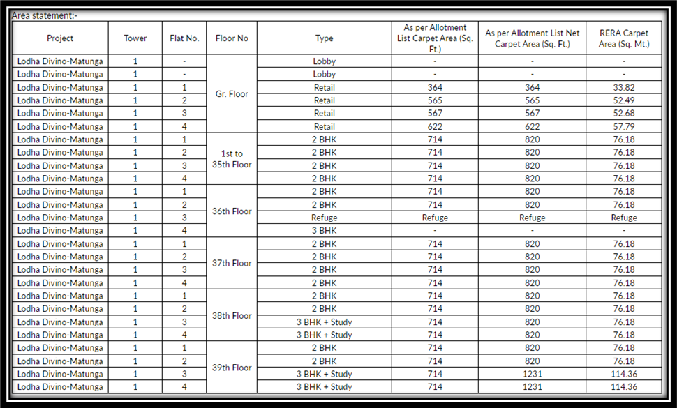
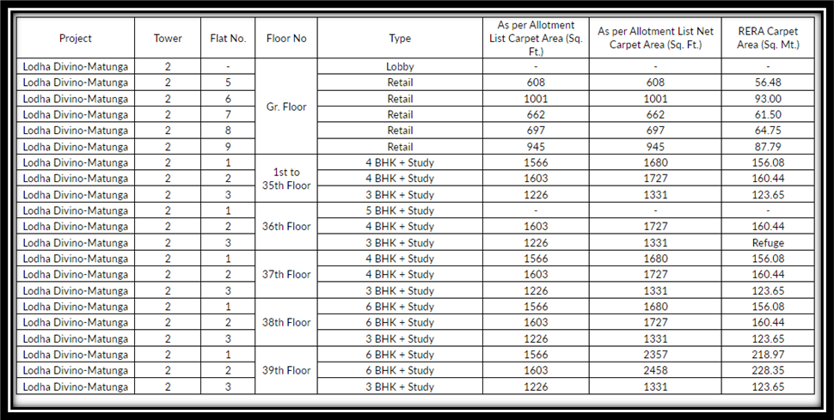
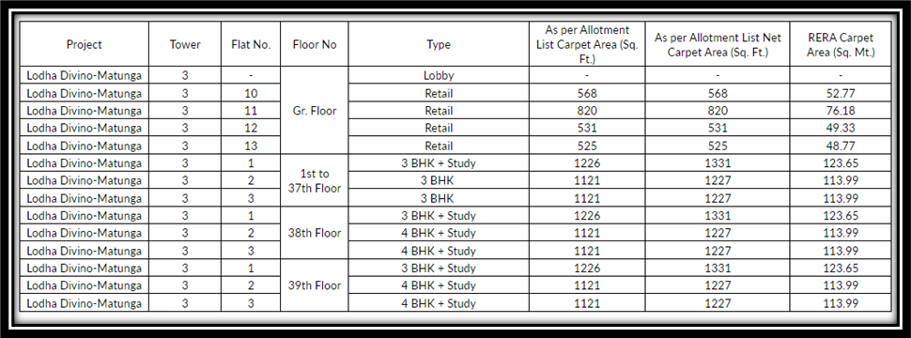

5184 -Rishit Suresh Dholakia, Lata Suresh Dholakia & Hetal Rishit Dholakia - Residential Flat No. 3202, 32nd Floor, Tower - 1, Wing - A, "Bellissimo Matunga ", Vishramvadi , Bhau Daji Road, Sion (West), Mumbai , PIN Code - 400 022, State - Maharashtra, India

5008 - Residential Flat No. 3201, 32nd Floor, Building No Tower - 1, Wing - A, "Bellissimo Matunga", Vishramvadi, Bhau Daji Road, Village - Sion, Municipality Ward No. F - North, Sion (West), Mumbai, District - Mumbai District, PIN Code - 400 022, State - Maharashtra, India belongs to Hetal Rishit Dholakia & Rishit Suresh Dholakia.

