Valuation Report of the Immovable Property

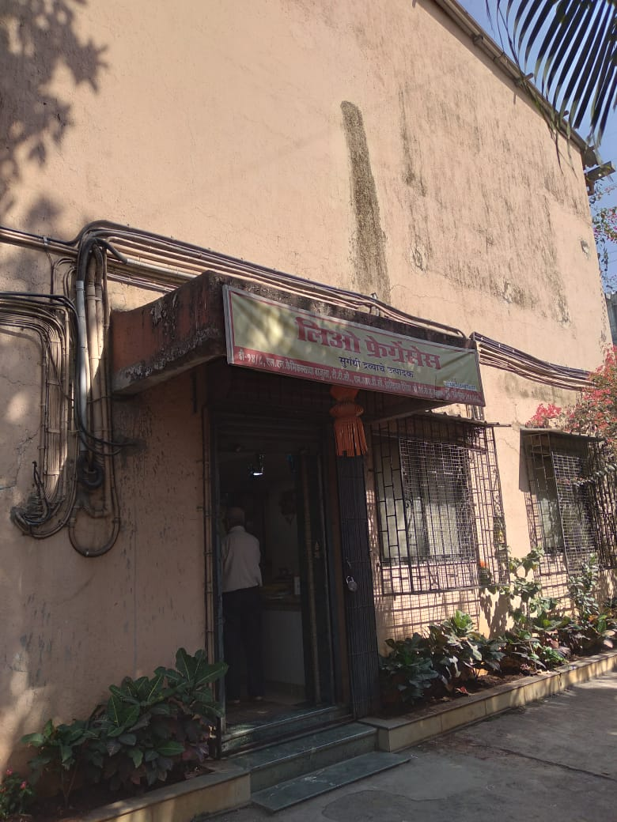

Details of the property under consideration:

Name of Owner: M/s. Leo Fragrances

Industrial Land & Building on Plot No. D-14/8, T.T.C., M.I.D.C. Industrial Area, H Maitri Foods & Cold Storage Pvt. Ltd., Village – Bonsari & Kukshet, Taluka – Thane, District – Thane – 400 703,
State – Maharashtra, Country – India

Latitude Longitude - 19°03'52.4"N 73°01'51.0"E

Valuation Prepared for:

Cosmos Bank
Naupada Branch
Kusumanjali, Opp. Devdhar Hospital, Naupada, Thane (West) - 400 602, State - Maharashtra, Country - India

Vastu/Thane/02/2024/6802/2305126
23/14-348-VSM Date: 23.02.2024

VALUATION OPINION REPORT

The property bearing Industrial Land & Building on Plot No. D-14/8, T.T.C., M.I.D.C. Industrial Area, H Maitri Foods & Cold Storage Pvt. Ltd., Village – Bonsari & Kukshet, Taluka – Thane, District – Thane – 400 703, State – Maharashtra, Country – India belongs to M/s. Leo Fragrances.

Boundaries of the property.
North | : | Plot No. D – 15/4
South | : | 13.70 mtrs. Wide MIDC Road
East | : | Plot No. D – 14/7
West | : | Plot No. D – 14/9

Considering various parameters recorded, existing economic scenario, and the information that is available with reference to the development of neighborhood and method selected for valuation, we are of the opinion that, the property premises can be assessed and valued for banking purpose as below –
Particulars | Value (`)
Fair Market Value | 3,60,91,020.00
Realizable Value | 3,24,81,918.00
Distress Sale Value | 2,88,72,816.00
Insurance Value | 15,91,863.00

The valuation of the property is based on the documents produced by the concern. Legal aspects have not been taken into considerations while preparing this valuation report.

Hence certified

Manoj B. Chalikwar
Registered Valuer
Chartered Engineer (India)
Reg. No. IBBI / RV / 07/2018/10366

Reg. No. CAT-I-F-1763

Valuation Report of Industrial Land & Building on Plot No. D-14/8, T.T.C., M.I.D.C. Industrial Area, H Maitri Foods & Cold Storage Pvt. Ltd., Village – Bonsari & Kukshet, Taluka – Thane, District – Thane – 400 703,
State – Maharashtra, Country – India

Form 0-1

(See Rule 8 D)

REPORT OF VALUATION OF IMMOVABLE PROPERTY (OTHER THAN AGRICULTURAL LANDS, PLANTATIONS, FORESTS, MINES AND QUARRIES)

GENERAL:

1 | Purpose for which the valuation is made |  | To assess the Fair Market Value as on 23.02.2024 for Bank loan Purpose
2 | Date of inspection |  | 07.02.2024
 | Name of the owner/ owners |  | M/s. Leo Fragrances
4 | If the property is under joint ownership / co-ownership, share of each such owner. Are the shares undivided? |  | Partnership Firm
5 | Brief description of the property |  | Industrial Land & Building on Plot No. D-14/8, T.T.C., M.I.D.C. Industrial Area, H Maitri Foods & Cold Storage Pvt. Ltd., Village – Bonsari & Kukshet, Taluka – Thane, District – Thane – 400 703, State – Maharashtra, Country – India
6 | Location, street, ward no |  | S Central Road
7 | Survey/ Plot no. of land |  | Plot No. D-14/8
8 | Is the property situated in residential/ commercial/ mixed area/ industrial area? |  | Industrial area
9 | Classification of locality-high class/ middle class/poor class |  | Middle Class
10 | Proximity to civic amenities like schools, Hospitals, Offices, market, cinemas etc. |  | All the amenities are available in the vicinity
11 | Means and proximity to surface communication by which the locality is served |  | Served by Buses and Private cars
 | LAND
12 | Area of land supported by documentary proof. Shape, dimension and physical features |  | Plot area – 600.32 Sq. M.  (Area as per Sub Lease Deed)
13 | Roads, Streets or lanes on which the land is abutting |  | 13.70 mtrs. Wide MIDC Road
14 | If freehold or leasehold land |  | Leasehold of MIDC
15 | If leasehold, the name of Lessor/lessee, nature of lease, date of commencement and termination of lease and terms of renewal of lease. |  | Lessor – MIDC  Sub Lessor – Chemical and Alkali Industrial And Warehousing Co- Op. Soc. Ltd.  Sub Lessee (Assignor) – Shri. Ashok K. Parikh  Assignee – M/s. Leo Fragrances  Date of Commencement - 01.06.1978 for the period of 95 years  Balance lease period – 49 years.
 | (i) Initial premium |  | Not applicable
 | (ii) Ground rent payable per annum |  | Not applicable
 | (iii) Unearned increase payable to the Lessor in the event of sale or transfer |  | Not applicable
16 | Is there any restriction covenant in regard to use of land? If so attach a copy of the covenant. |  | Industrial purpose
17 | Are there any agreements of easements? If so, attach a copy of the covenant |  | Information not available
18 | Does the land fall in an area included in any Town Planning Scheme or any Development Plan of Government or any statutory body? If so, give Particulars. |  | No
19 | Has any contribution been made towards development or is any demand for such contribution still outstanding? |  | Information not available
20 | Has the whole or part of the land been notified for acquisition by government or any statutory body? Give date of the notification. |  | No
21 | Attach a dimensioned site plan |  | Copy of Approved Plan subject to MIDC Letter vide No.D/14/8/492 dated 06.04.1988 issued by Additional Town Planning Officer, CIDCO Ltd.
 | IMPROVEMENT
22 | Attach plans and elevations of all structures standing on the land and a lay-out plan. |  | Attached
23 | Furnish technical details of the building on a separate sheet (The Annexure to this form may be used) |  | Attached
24 | Is the building owner occupied/tenanted/both? |  | Owner Occupied
 | If the property owner occupied, specify portion and extent of area under owner-occupation |  | Owner Occupied
25 | What is the Floor Space Index permissible and Percentage actually utilized? |  | FSI – 1
26 | RENTS
 | (i) | Names of tenants/ lessees/ licensees, etc. | N.A.
 | (ii) | Portions in their occupation | N.A.
 | (iii) | Monthly or annual rent/ compensation / license fee, etc. paid by each | N.A.
 | (iv) | Information not available | N.A.
27 | Are any of the occupants related to, or close to business associates of the owner? |  | N.A.
28 | Is separate amount being recovered for the use of fixtures, like fans, geysers, refrigerators, cooking ranges, built-in wardrobes, etc. or for services charges? If so, give details |  | N.A.
29 | Give details of the water and electricity charges, if any, to be borne by the owner |  | Information not available
30 | Has the tenant to bear the whole or part of the cost repairs and maintenance? Give particulars |  | N.A.
31 | If a lift is installed, who is to bear the cost of maintenance and operation- owner or tenant? |  | No lift
32 | If a pump is installed, who is to bear the cost of maintenance and operation- owner or tenant? |  | N.A.
33 | Who has to bear the cost of electricity charges for lighting of common space like entrance hall, stairs, passage, compound, etc. owner or tenant? |  | N.A.
34 | What is the amount of property tax? Who is to bear it? Give details with documentary proof |  | Information not available
35 | Is the building insured? If so, give the policy no., amount for which it is insured and the annual premium |  | Information not available
36 | Is any dispute between landlord and tenant regarding rent pending in a court of rent? |  | N.A.
37 | Has any standard rent been fixed for the premises under any law relating to the control of rent? |  | As per MIDC norms
 | SALES
38 | Give instances of sales of immovable property in the locality on a separate sheet, indicating the Name and address of the property, registration No., sale price and area of land sold. |  | As per sub registrar of assurance
39 | Land rate adopted in this valuation |  | ` 57,000.00 Per Sq. M. including Land Development such as plot levelling, plot filling, M.S. gate, Compound wall, partition wall, lean to shed and other miscellaneous items.
40 | If sale instances are not available or not relied up on, the basis of arriving at the land rate |  | Online Price Indicators, Location, development of surrounding area, type of land and construction, construction specifications, age of building, condition of the premises & building, facilities provided and its prevailing market rate.
 | COST OF CONSTRUCTION
41 | Year of commencement of construction and year of completion |  | 1990 (As per Occupancy Certificate)
42 | What was the method of construction, by contract / By employing Labour directly / both? |  | Information not available
43 | For items of work done on contract, produce copies of agreements |  | Information not available
44 | For items of work done by engaging Labour directly, give basic rates of materials and Labour supported by documentary proof. |  | Information not available

PART II- VALUATION

GENERAL:
Under the instruction of Cosmos Bank, Naupada Branch, to assess fair market value as on 23rd February 2024 for Industrial Land & Building on Plot No. D-14/8, T.T.C., M.I.D.C. Industrial Area, H Maitri Foods & Cold Storage Pvt. Ltd., Village – Bonsari & Kukshet, Taluka – Thane, District – Thane – 400 703, State – Maharashtra, Country – India belongs to M/s. Leo Fragrances.

We are in receipt of the following documents:
Copy of Agreement dated 26.06.2006 between Shri. Ashok Kantilal Parikh (Vendor) & Mr. Pravin Chimanlal Suvarnkar (Purchaser).
Copy of Sub – Lease dated 28.03.2007 between Chemical and Alkali Industrial And Warehousing Co- Op. Soc. Ltd. (Sub – Lessor) & Shri Ashok K. Parikh (Sub – Lessee).
Copy of Lease Deed dated 20.03.2007 between MIDC (Lessor) & Chemical and Alkali Industrial And Warehousing Co- Op. Soc. Ltd. (Lessee)
Copy of Deed of Assignment dated 28.12.2007 between Shri Ashok K. Parikh (Assignor) and M/s. Leo Fragrances (Assignees).
Copy of Letter vide No. 272/06 dated 12.02.2008 for transfer of Plot No. D-14/8 in the name of M/s. Leo Fragrances issued by Chemical and Alkali Industrial And Warehousing Co- Op. Soc. Ltd.
Copy of Letter vide No. MIDC / RO / Mahape / TTC / D – 14/8 / 2217 dated 29.04.2008 issued by MIDC as acceptance of M/s. Leo Fragrances as Sub – Lesee.
Copy of Occupancy Certificate vide No. CIDCO / EE (BP) / TTC / D-14/8 / 1077 dated 22.12.1990 issued by CIDCO.
Copy of No Objection Certificate vide No. MIDC / TA / BMR / TTC / D-14/8 / 2217 dated 29.04.2008 issued by MIDC for no objection for establishment of a new industrial unit.
Copy of Approved Plan subject to MIDC Letter vide No. IND / TTC / D/14/8/492 dated 06.04.1988 issued by Additional Town Planning Officer, CIDCO Ltd.
Copy of Electricity Bill for the month of January 2024 in the name of M/s. Leo Fragrances.

Land:
The plot under valuation is Leasehold MIDC industrial plot for the with structure standing thereon. At the time of visit we observed that Plot Nos. D-14/7 and D-14/8 are internally amalgamated having separate entrance. Both the plots can easily demarcated as partition brick wall with door available at site. The said valuation is of Plot No. D – 14/8.

The said plot is leased out for 95 years commencing from 01.06.1978. Balance lease period is 49 years. As per Lease Deed Plot area is 600.32 Sq. M., which is considered for valuation.

Structure:
As per site there is one RCC ground floor structure having RCC slab roof. the details of the same are as under:
Particular | Details | Measured Area (Sq. M.)
Ground floor RCC structure | Reception + Cabin + Working Area + Meeting Room + Storage + Lab | 191.10

As per Occupancy Certificate Built up area is 191.10 Sq. M., which is considered for valuation.
The structure is finished vitrified tiles flooring, POP false ceiling, Concealed wiring, Wooden flush doors in office area. Industrial & open wiring in working area.

VALUATION OF THE PROPERTY :

- Value of Land:
Plot area | 600.32 Sq. M.
Rate adopted for valuation | ` 57,000.00 per Sq. M.
Value | ` 3,42,18,240.00

- Value of Structures:
The Built-up area of the building : As per valuation table below
Deduct Depreciation:
Year of Construction of the building : 1990 (As per Occupancy Certificate)
Expected total life of building : 60 years
Age of the building as on 2024 : 34 years
Cost of Construction : ` 20,000.00 per Sq. M.
Depreciation : 51%

Particulars | Built up Area in  Sq. M. | Estimated Replacement Rate in ` | Depreciated Rate in ` | Depreciated Value in `
Ground floor | 191.10 | 20,000.00 | 9,800.00 | 18,72,780.00
 |  |  | TOTAL | 18,72,780.00

Government Value

Particulars | Area in Sq. M. | Rate in ` | Value in `
Land | 600.32 | 25,108.00 | 1,50,72,834.00
Structure | As per valuation table |  | 18,72,780.00
Total |  |  | 1,69,45,614.00

TOTAL VALUE OF THE PROPERTY:

Particulars | Value (`)
Cost of Land | 3,42,18,240.00
Cost of Buildings | 18,72,780.00
Total Fair Market Value | 3,60,91,020.00
Realizable Value | 3,24,81,918.00
Distress Sale Value | 2,88,72,816.00
Insurance Value | 15,91,863.00

Taking into consideration above said facts, we can evaluate the value of Industrial Land & Building on Plot No. D-14/8, T.T.C., M.I.D.C. Industrial Area, H Maitri Foods & Cold Storage Pvt. Ltd., Village – Bonsari & Kukshet, Taluka – Thane, District – Thane – 400 703, State – Maharashtra, Country – India for this particular purpose at ` 3,60,91,020.00 (Amount in words Rupees Three Crore Sixty Lakh Ninety One Thousand Twenty Only) as on 23rd February 2024.

NOTES

I, Manoj B. Chalikwar with my experience and ability to judgment I am of the considered opinion that the fair market value of the property as on 23rd February 2024 is ` 3,60,91,020.00 (Amount in words Rupees Three Crore Sixty Lakh Ninety One Thousand Twenty Only).

Value varies with time and purpose and hence this value should not be referred for any purpose other than mentioned in this report.

This valuation is done on the basis of information, which the valuer has obtained by information provided by the client about the premises and location of the surrounding area and also prevailing rates in the surrounding area, and further subject to document as mentioned in valuation report.

This valuer should not be held responsible for authentication of documents, clear title and other such related matters. For that purpose, Latest Legal Opinion should be sought.

PART III- DECLARATION

I hereby declare that

The information furnished in part I is true and correct to the best of my knowledge and belief;

I have no direct or indirect interest in the property valued:

ANNEXURE TO FORM 0-1

Technical details Main Building
1. | No. of floors and height of each floor | As per brief description
2. | Plinth area floor wise as per IS- 1225 | Plot Area = 600.32 Sq. M.  Structure - As per valuation table
3 | Year of construction | Year – 1990  (As per Occupancy Certificate)
4 | Estimated future life | 26 Years Subject to proper, preventive periodic maintenance and structural repairs.
5 | Type of construction- load bearing walls/RCC frame/ steel frame | RCC framed structure
6 | Type of foundations | R.C.C. slab
7 | Walls | All external walls are 9” thick and partition walls are 6” thick.
8 | Partitions | 6” thick brick wall
9 | Doors and Windows | M.S. gate, Rolling Shutter, Wooden flush doors
10 | Flooring | Vitrified and cement
11 | Finishing | Internal walls are finished with Neeru Finish. External walls are finished with sand faced plaster.
12 | Roofing and terracing | RCC slabs
13 | Special architectural or decorative features, if any | POP false ceiling in office area
14 | (i) Internal wiring – surface or conduit  (ii) Class of fittings: Superior/ Ordinary/ Poor. | Concealed wiring  Ordinary
15 | Sanitary installations  (i) No. of water closets  (ii) No. of lavatory basins  (iii) No. of urinals  (iv) No. of sinks  Class of fittings: Superior colored / superior white/ordinary. | As per requirement  Ordinary
16 | Compound wall  Height and length  Type of construction | Compound wall of R.C.C. columns with Brick Masonry wall
17 | No. of lifts and capacity | No lift
18 | Underground sump – capacity and type of construction | R.C.C.
19 | Over-head tank Location, capacity Type of construction | R.C.C.
20 | Pumps- no. and their horse power | Information not available
21 | Roads and paving within the compound approximate area and type of paving | Concrete cement finish in open spaces, etc.
22 | Sewage disposal – whereas connected to public sewers, if septic tanks provided, no. and capacity | Connected to local sewer line

Location Map
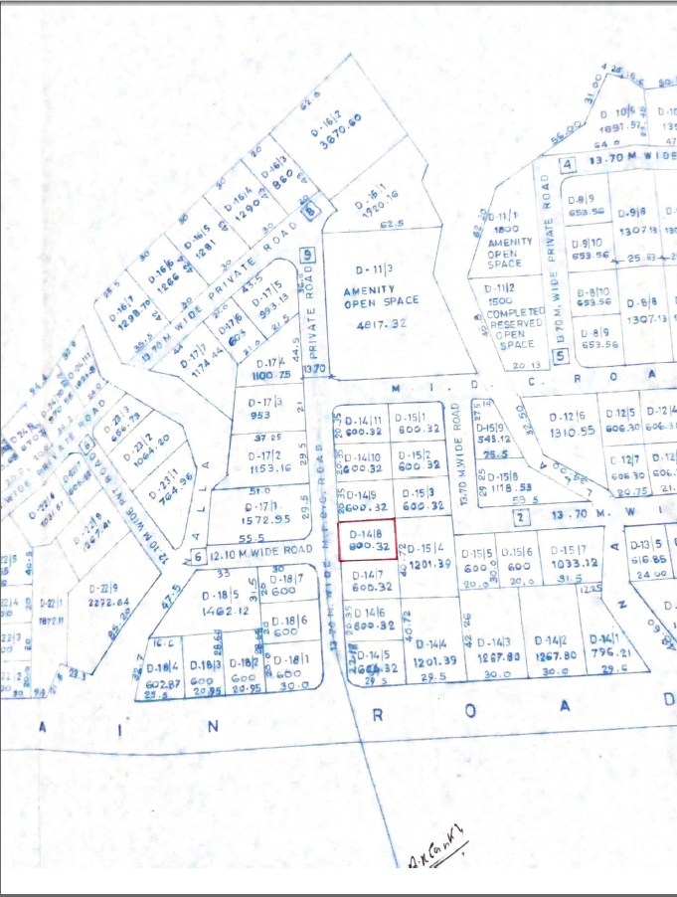

Block Plan
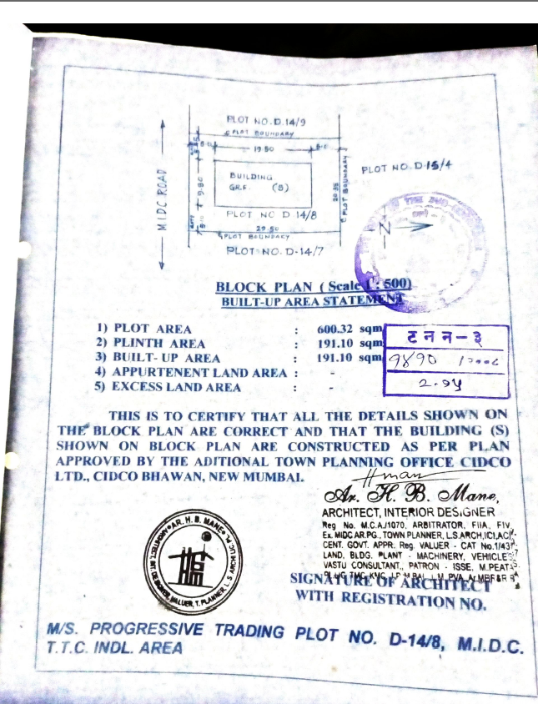

MIDC MAP
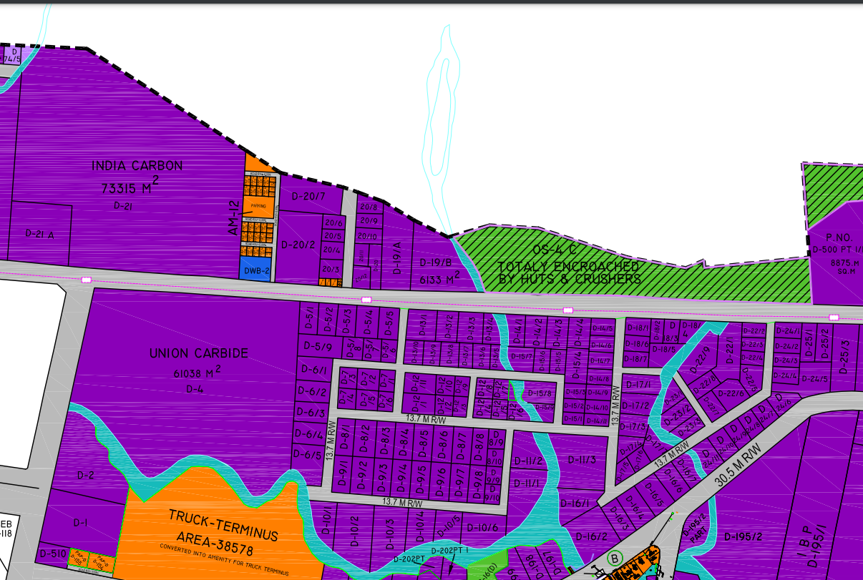

Actual site photographs
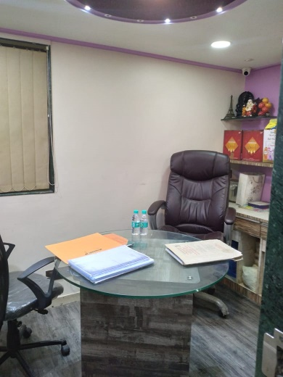
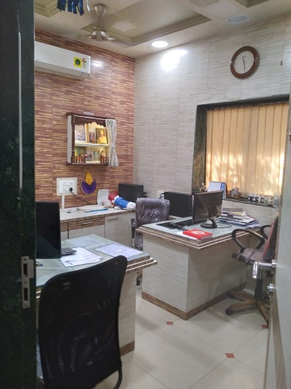
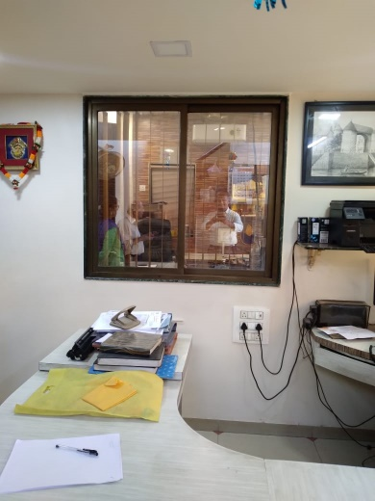

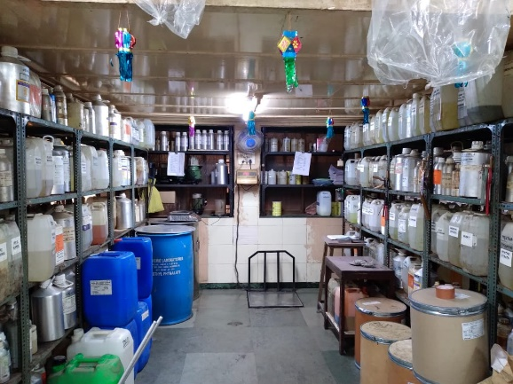
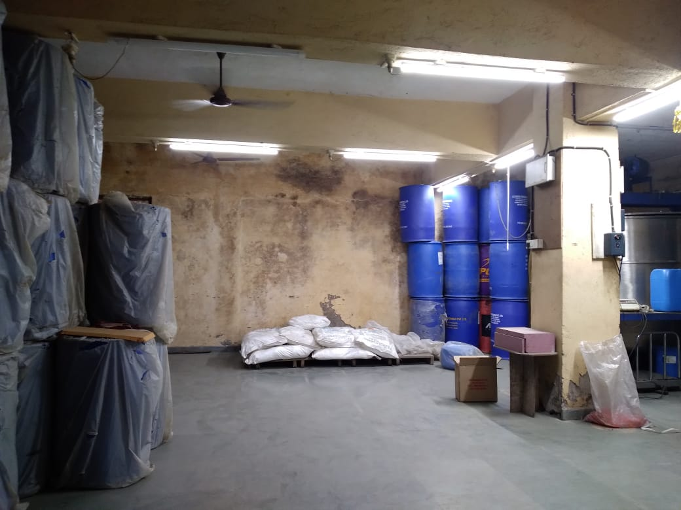

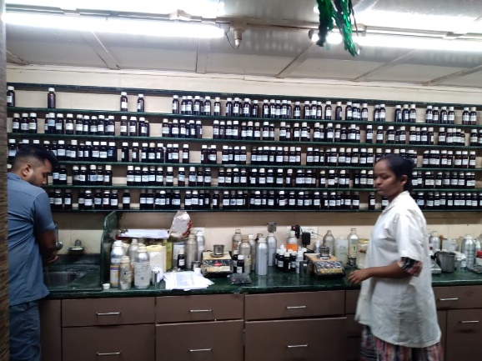
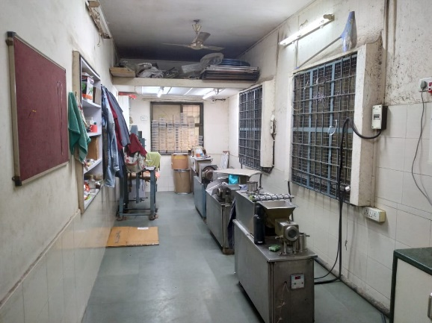

Actual site photographs
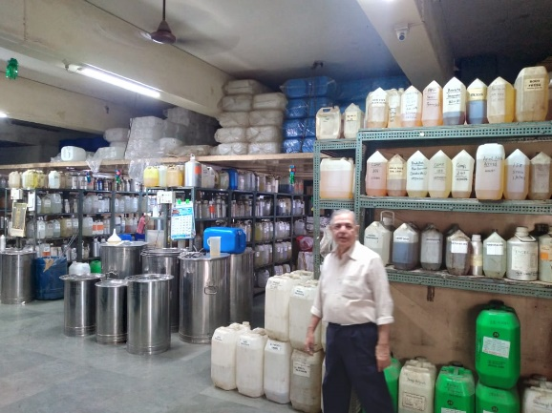
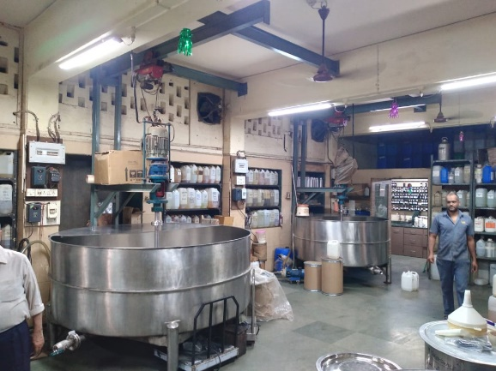

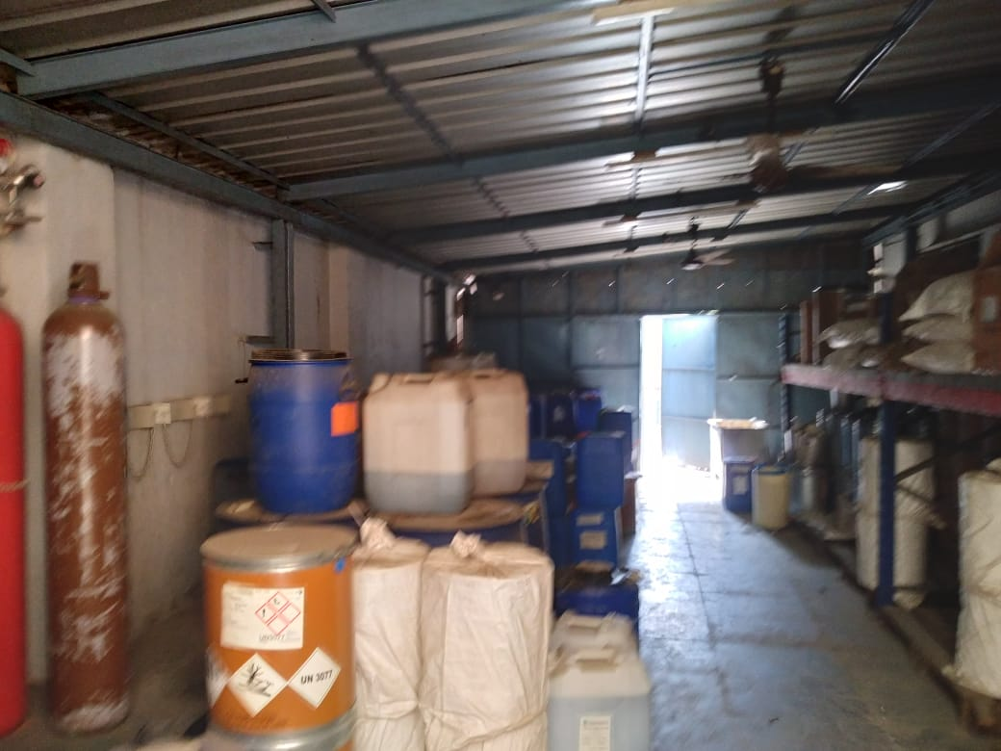
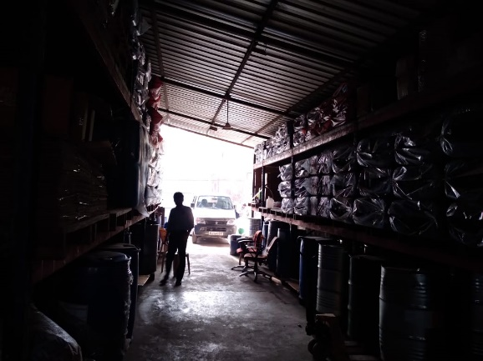
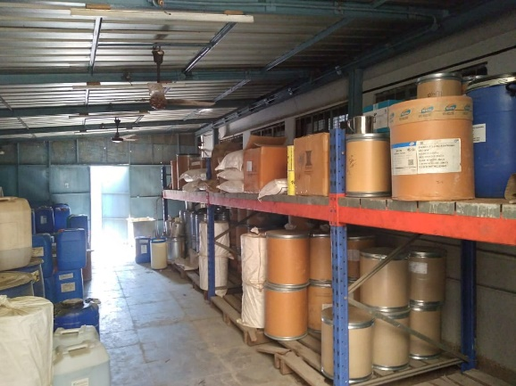
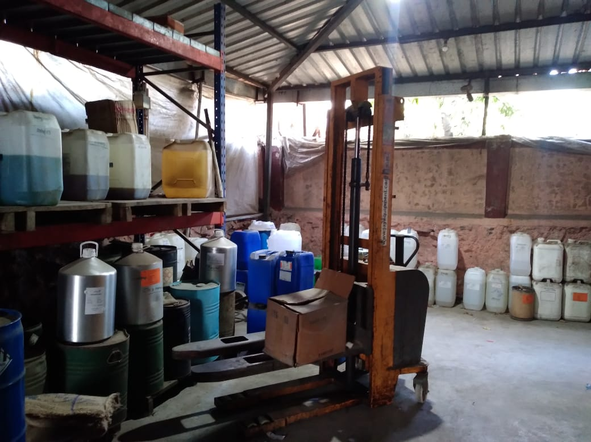
Actual site photographs
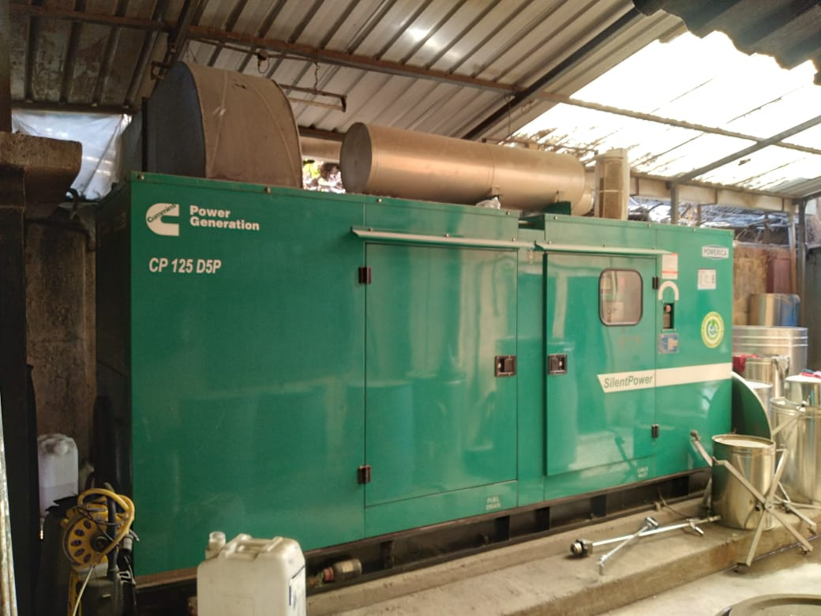
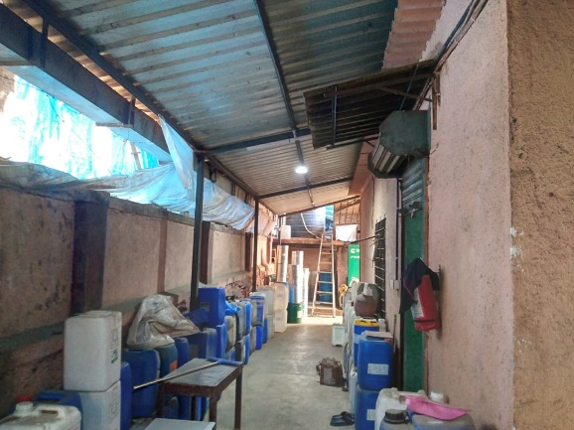

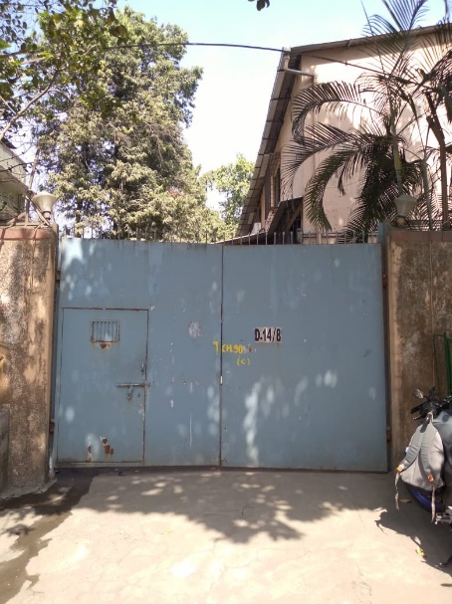
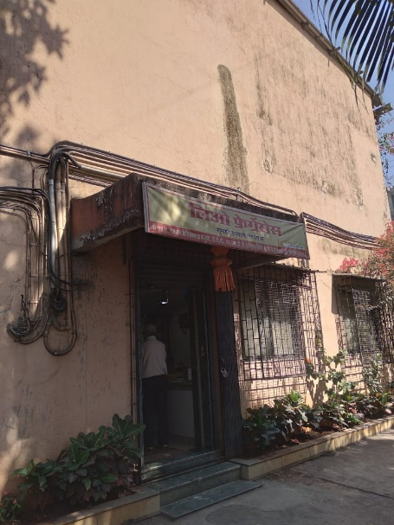
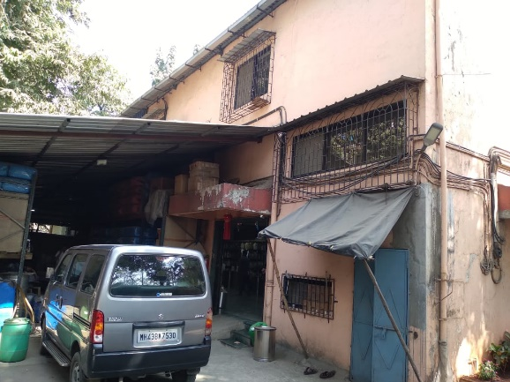
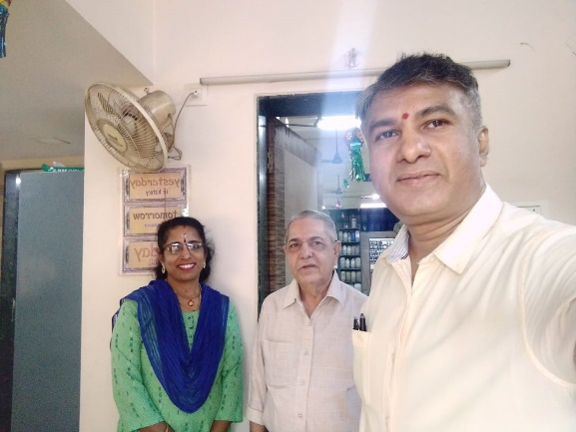
Route Map of the property
Site u/r
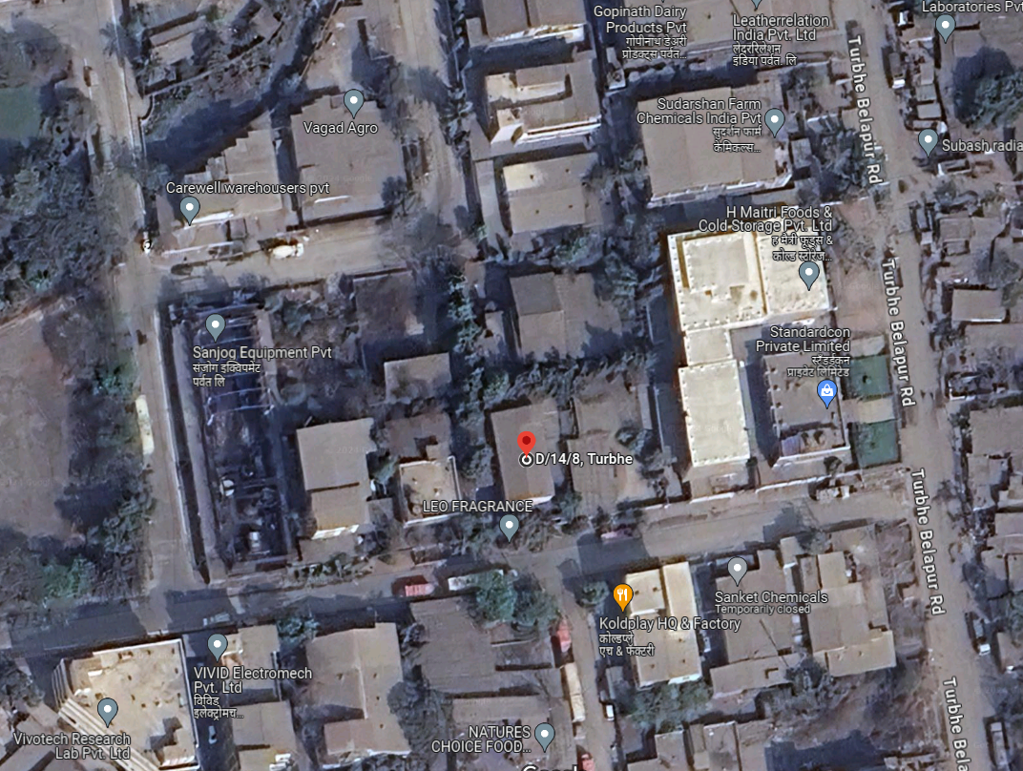

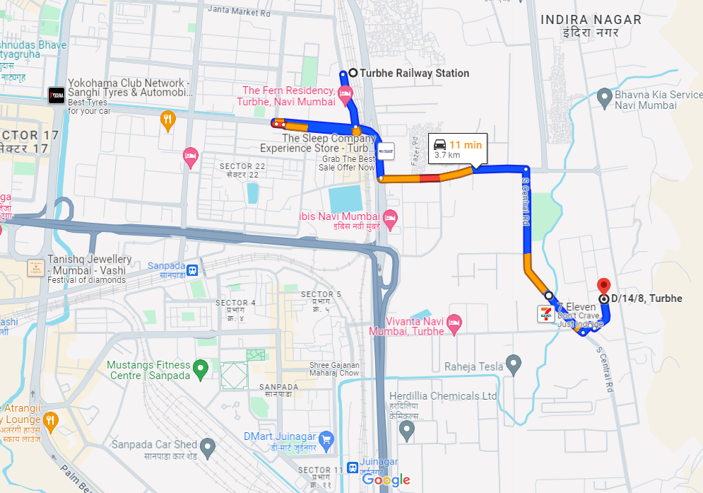

Latitude Longitude - 19°03'52.4"N 73°01'51.0"E

Note: The Blue line shows the route to site from nearest Railway Station (Turbhe – 3.7 KM.)

MIDC RATE

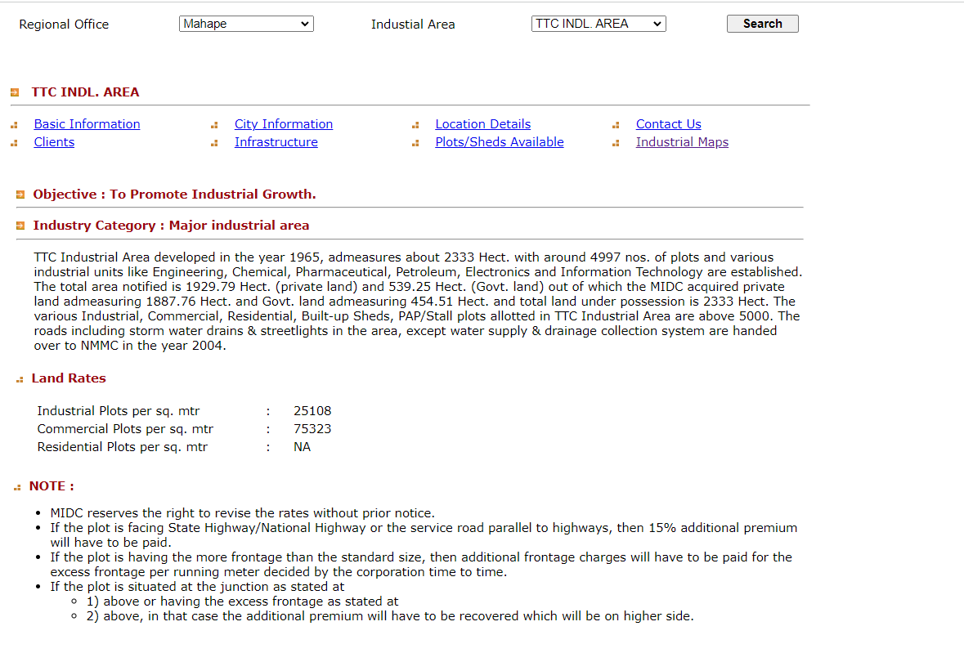

Price Indicators
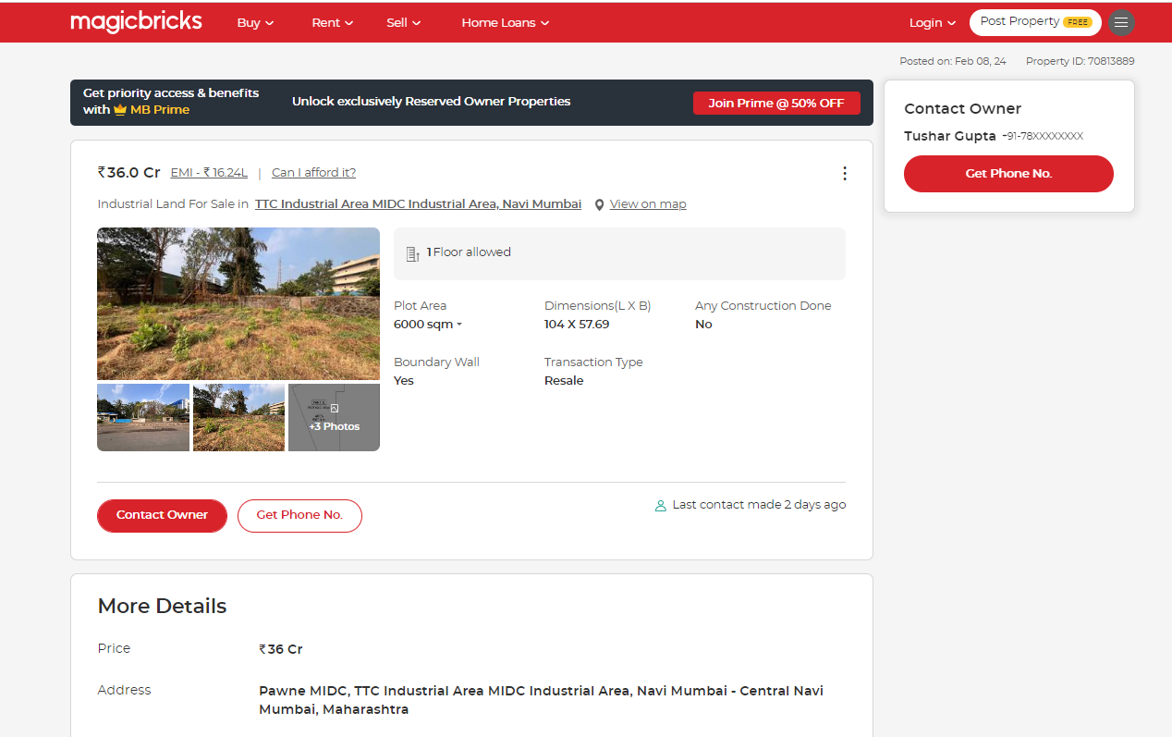

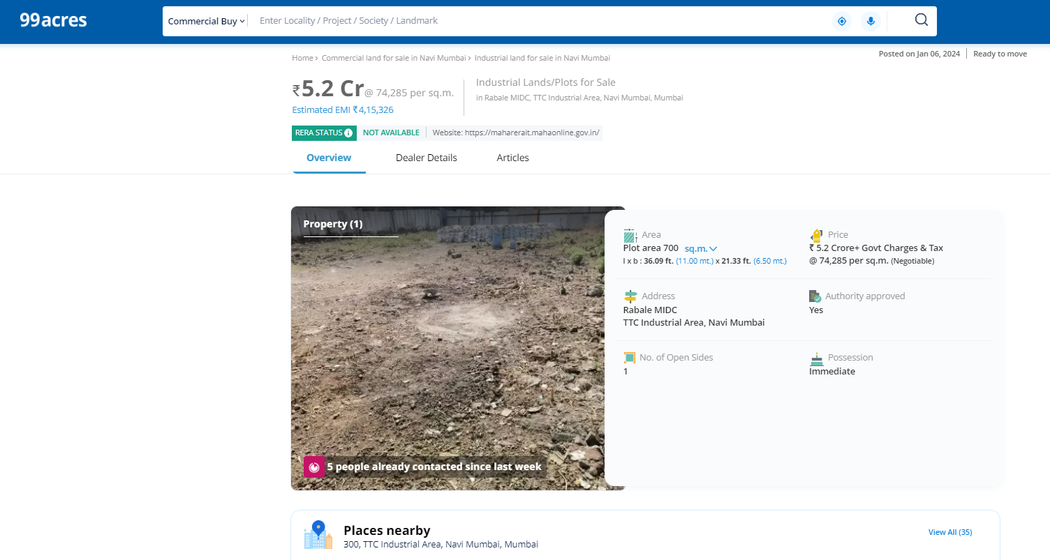
Price Indicators
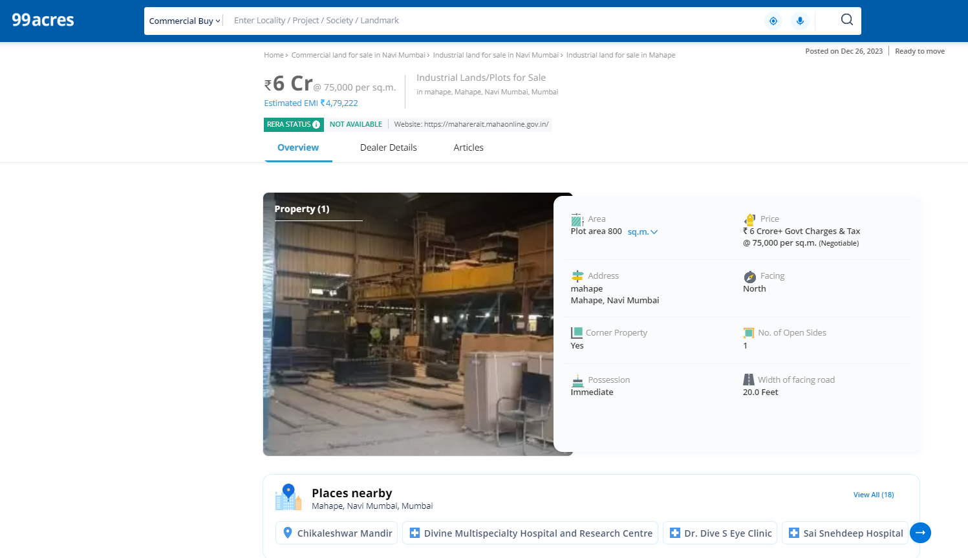

DEFINITION OF VALUE FOR THIS SPECIFIC PURPOSE
This exercise is to assess Fair Market Value of the property under reference as on 23rd February 2024.

The term Fair Market Value is defined as

“The most probable price, as of a specified date, in cash, terms equivalent to cash, or in other precisely revealed terms for which the specified property rights would sell after reasonable exposure in a competitive market under all conditions requisite to a fair sale, with the buyer and seller each acting prudently knowledgeably and for self-interest assuming that neither is under undue duress”.
Fundamental assumptions and conditions presumed in this definition are:

1. Buyer and seller are motivated by self-interest.

2. Buyer and seller are well informed and are acting prudently.

3. The property is exposed for a reasonable time on the open market.

4. Payment is made in cash or equivalent or in specified financing terms.

UNDER LYING ASSUMPTIONS
1. We assume no responsibility for matters of legal nature affecting the property appraised or the title thereto, nor do we render our opinion as to the title, which is assumed to be good and marketable.
2. The property is valued as though under responsible ownership.
3. It is assumed that the property is free of liens and encumbrances.
4. It is assumed that there are no hidden or unapparent conditions of the subsoil or structure that would render it more or less valuable. No responsibility is assumed for such conditions or for engineering that might be required to discover such factors.
5. There is no direct/ indirect interest in the property valued
6. The rates for valuation of the property are in accordance with the Govt. approved rates and prevailing market rates.

Sharadkumar B. Chalikwar
Govt. Reg. Valuer
Chartered Engineer (India)
Reg. No. (N) CCIT/1-14/52/2008-09

