Vastu/Nashik/02/2024/006739/2304810
03/6-32-RPBS
Date: 03.02.2024

To,
The Branch Manager,
Punjab National Bank

Canada Corner Branch
Shop No.2,3,4 Prestige Point, Opp. Vasant Market, Canada Corner
Nashik – 422 005, State – Maharashtra, Country – India.

Sub: Vetting of Extra Amenities

Sir,

With reference to above subject, we have evaluated the Extra Amenities for Residential Flat No. B - 212, B - Wing, Second Floor, " Ganesh Atria Apartment ", Survey No. 222/ 4C/ A/ 1 to 9/ C, Plot No. 3+4+5, Behind Little Flowers English Medium School, DGP Nagar, Ambad Kamatwade Road, Village – Ambad Khurd, Taluka & District - Nashik, PIN Code – 422 010, State – Maharashtra, Country – India belongs to Name of Proposed Purchaser: Shri. Parmanand Shankarsing Raul & Sau. Anita Parmanand Raul. Name of Owner: M/s. Zenith Developers

We have verified the rates quoted as per current market rates. Details of work and Extra Amenities considered as per copy of Agreement for Extra Amenities Agreement Between Shri. Parmanand Shankarsing Raul & Sau. Anita Parmanand Raul (First Party) and M/s. Zenith Developers. (Second Party) received on dated 29.01.2024. The Extra Amenities amount is Rs.1,60,000/- ( Rupees One Lakh Sixty Thousand Only. )

The said Cost Vetting Certificate is valid upto next 6 months Only.

Thanking you

Sincerely yours

Sharadkumar B. Chalikwar
Govt. Reg. Valuer
Chartered Engineer (India)
Reg. No. (N) CCIT/1-14/52/2008-09
PNB Empanelment No. ZO:SAMD:1138
Encl: Vetting Report.

Agreement for Extra Amenities

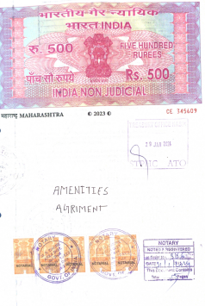
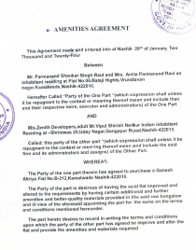

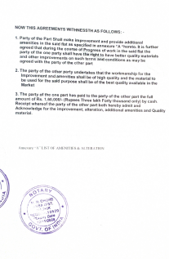
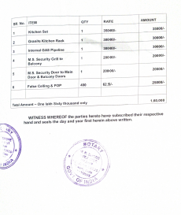

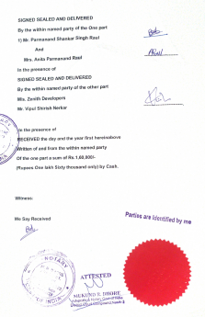

The Extra Amenities amount is Rs.1,60,000/- (Rupees One Lakh Sixty Thousand Only. )

