Vastu/Nashik/02/2024/006738/2304813
03/9-35 -CCBS
Date: 03.02.2024

To,
The Branch Manager
Punjab National Bank

Canada Corner Branch
Shop No.2,3,4 Prestige Point, Opp. Vasant Market, Canada Corner
Nashik – 422 005, State – Maharashtra, Country – India.

Sub: Vetting of Estimate

Sir,

With reference to above subject, we have evaluated the Estimate for Residential Land and Proposed Additional Extension to Existing Building in Tenement No. N-52/AD-1/20/04, Proposed Ground + First Floor, Neighborhood Ashadha, Housing Scheme No. 5th, Near Marchant Co. Op. Bank, Rajratna Nagar, at CIDCO, Taluka & District - Nashik, PIN Code – 422 010, State - Maharashtra, Country - India belongs to Mr. Nandkishor Shankar Mandlik

We have verified the rates quoted as per current market rates. Details of Estimate considered as per copy of Estimate Provided by Samarth Associates received on dated 20.10.2023. The Estimate amount is Rs.9,42,975/- (Rupees Nine Lakh Forty-Two Thousand Nine Hundred Seventy-Five Only.)

Note:1) The said Cost Vetting Certificate is valid upto next 6 months Only.

Thanking you

Sincerely yours

Sharadkumar B. Chalikwar
Govt. Reg. Valuer
Chartered Engineer (India)
Reg. No. (N) CCIT/1-14/52/2008-09
PNB Empanelment No. ZO:SAMD:1138
Encl: Vetting Report

Estimate
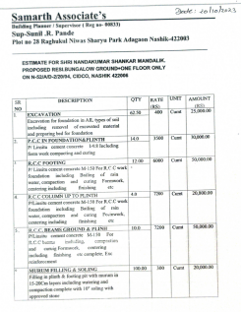
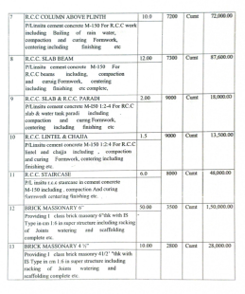

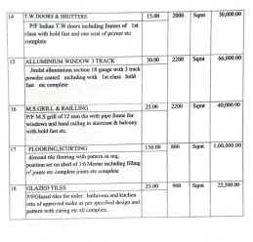
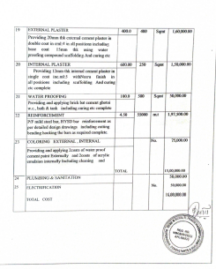

The Estimate amount is Rs.9,42,975/- (Rupees Nine Lakh Forty-Two Thousand Nine Hundred Seventy-Five Only.)

